Table 1. Optimization of reaction conditions.
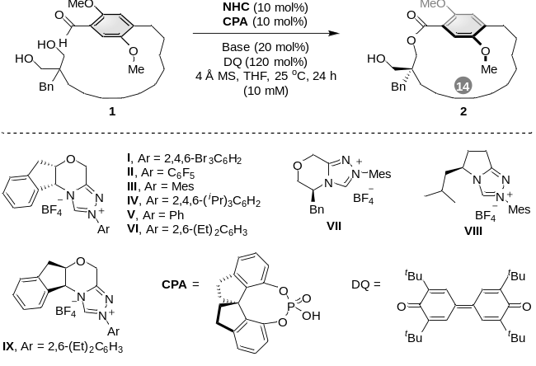
Entry^{[a]} | NHC | Base | Yield (%)^{[b]} | dr^{[c]} | ee (%)^{[d,e]}
1 | I | K₂CO₃ | 62 | 10:1 | 70
2 | II | K₂CO₃ | 56 | 4:1 | 91
3 | III | K₂CO₃ | 71 | 9:1 | 91
4 | IV | K₂CO₃ | 69 | 5:1 | 98
5 | V | K₂CO₃ | 55 | 9:1 | 96
6 | VI | K₂CO₃ | 61 | 14:1 | 96
7 | VII | K₂CO₃ | 65 | 7:1 | 77
8 | VIII | K₂CO₃ | 50 | 5:1 | 62
9 | II | K₂CO₃ | 70 | 11:1 | 96
10 | VI | K₂CO₃ | 54 | 17:1 | 96
11^{[f]} | IX | K₂CO₃ | 73 | 19:1 | 98
12^{[f]} | IX | DBU | trace | - | -
13^{[f]} | IX | DIPEA | 23 | 17:1 | 98
14^{[f]} | IX | Et₃N | 41 | 18:1 | 98
15^{[f]} | IX | DMAP | 11 | 19:1 | 98
16^{[f]} | IX | 2,6-Lutidine | trace | - | -
17^{[f]} | IX | Na₂CO₃ | 42 | 17:1 | 98
18^{[g]} | IX | K₂CO₃ | 33 | 19:1 | 98
19^{[h]} | IX | K₂CO₃ | 31 | 18:1 | 98
[a] Reaction conditions: A mixture of 1 (0.10 mmol), DQ (0.12 mmol), base (20 mol%), 4 Å MS (50 mg), and NHC (10 mol%) in THF (10.0 mL) was stirred at 25 °C for 24 h. [b] Isolated yield of 2. [c] The dr was determined using ¹H NMR spectroscopy. [d] The ee value of 2 was determined by high-performance liquid chromatography (HPLC) using a chiral stationary phase. [e] The ee of the major isomer is indicated. [f] CPA (10 mol%) was employed. [g] CH₂Cl₂ (10.0 mL) was used as the solvent. [h] Toluene (10.0 mL) was used as the solvent. DBU = 1,8-diazabicyclo[5.4.0]undec-7-ene; DIPEA = N,N-diisopropylethylamine; DMAP = 4-dimethylaminopyridine. The number in the grey circle represents the ansa chain length.

