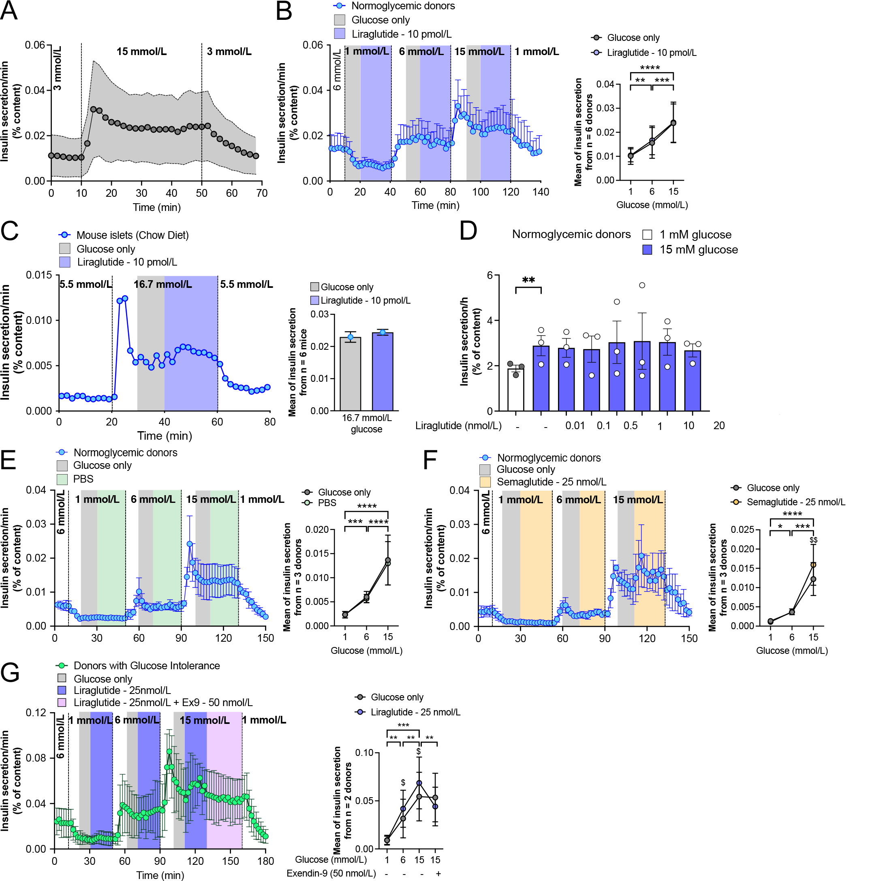
Supplementary Figure 1: Dose-Dependent Effects of GLP-1R Agonists on Insulin Secretion in Normoglycemic Islets.
(A) Dynamic insulin secretion profile of study islets (n = 42) at 3 and 15 mmol/L glucose, normalized to insulin content. (B) Dynamic insulin secretion from normoglycemic donor islets (n = 6) at 1, 6, and 15 mmol/L glucose ± 10 pmol/L liraglutide. Right: comparison of glucose alone (grey) vs. liraglutide (blue). *p < 0.05, **p < 0.01, ***p < 0.001, ****p < 0.0001. (C) Dynamic insulin secretion from chow-fed mouse islets (n = 6) at 5.5 and 16.7 mmol/L glucose ± 10 pmol/L liraglutide, normalized to insulin content. Right: mean secretion comparison. (D) Static GSIS from normoglycemic donor islets (n = 3) at 1 mmol/L (white) or 15 mmol/L (grey) glucose ± liraglutide (0.01-20 nmol/L). **p < 0.01. (E,F) Dynamic insulin secretion from normoglycemic donor islets (n = 3) at 1, 6, and 15 mmol/L glucose with PBS (E) or semaglutide (25 nmol/L) (F). Right: secretion profiles. E: ***p < 0.001, ****p < 0.0001. F: *p < 0.05, ***p < 0.001, ****p < 0.0001, $$p < 0.01 (semaglutide effect). (G) Dynamic insulin secretion from glucose-intolerant donor islets (n = 2) at 1, 6, and 15 mmol/L glucose ± liraglutide (25 nmol/L) ± Exendin-9 (Ex9, 50 nmol/L). Right: secretion profiles. **p < 0.01, ***p < 0.001 (glucose effect); $p < 0.05 (liraglutide effect); **p < 0.01 (Ex9 effect). Data presented as means ± SEM. Statistics: Two-way ANOVA with Tukey's or Fisher's post hoc tests (B,D-G) or unpaired t-test (C). All insulin secretion normalized to insulin content.

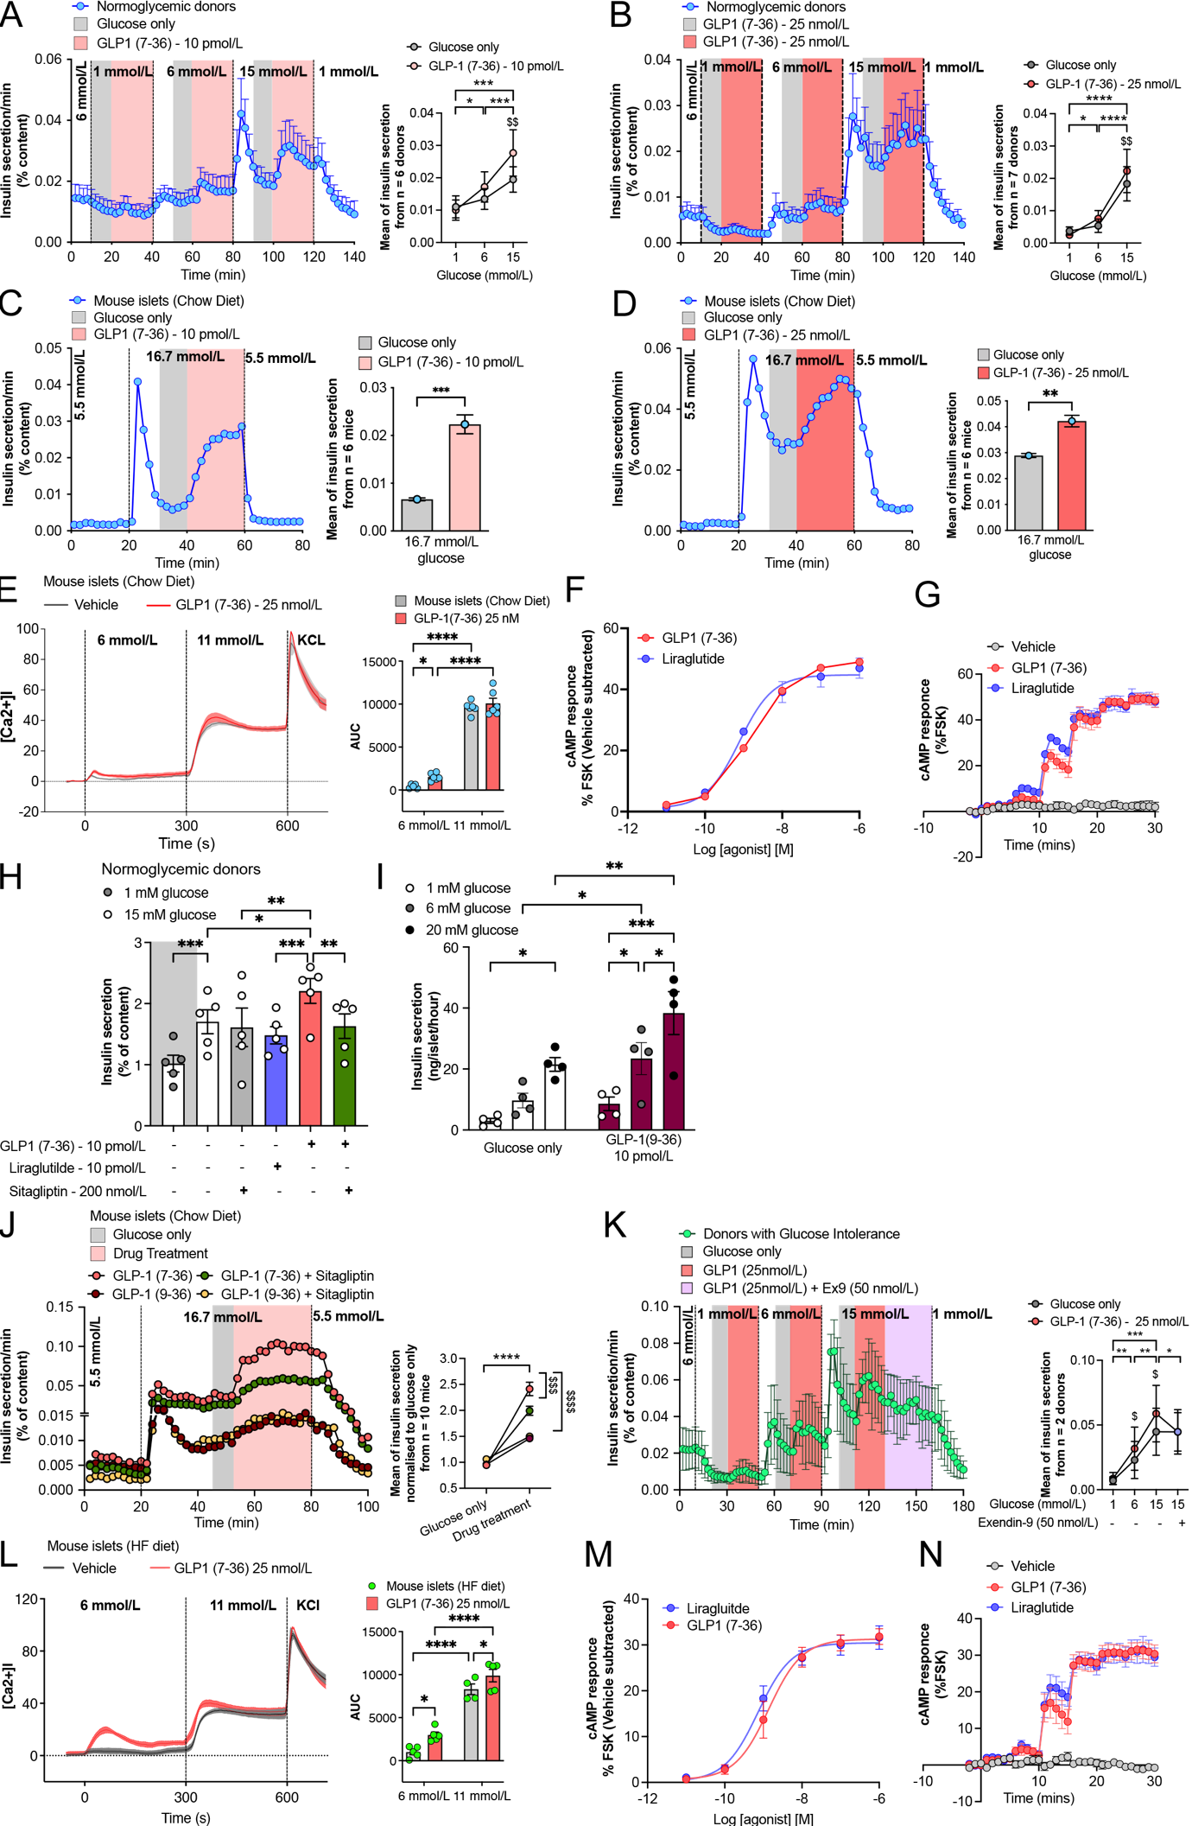
Supplementary Figure 2: Comparative Effects of GLP-1 7-36 and GLP-1 9-36 on Insulin Secretion and Signaling.
(A,B) Dynamic insulin secretion from normoglycemic donor islets (n = 7) at 1, 6, and 15 mmol/L glucose ± GLP-1 7-36 at 10 pmol/L (A) or 25 nmol/L (B). Right: secretion profiles for glucose alone (grey) vs. GLP-1 7-36 (red). *p < 0.05, **p < 0.01, ***p < 0.001, $$p < 0.01 (drug effect). (C,D) Dynamic insulin secretion from chow-fed mouse islets (n = 6) at 5.5 and 16.7 mmol/L glucose ± GLP-1 7-36 at 10 pmol/L (C) or 25 nmol/L (D). **p < 0.01, ***p < 0.001. (E) Intracellular Ca²⁺ levels in chow-fed mouse islets (n = 6, 3-12 islets/mouse) at 6 and 11 mmol/L glucose ± GLP-1 7-36 (25 nmol/L). *p < 0.05, ****p < 0.0001. (F,G) cAMP responses in dispersed mouse islets expressing cADDis sensor. (F) Time course with 10-fold concentration increases every 5 min. (G) Dose-response curves for GLP-1 7-36 (red) and liraglutide (blue) vs. vehicle (grey). (H) Static insulin secretion from normoglycemic donor islets (n = 5) at 1 and 15 mmol/L glucose ± sitagliptin (200 nmol/L), liraglutide (10 pmol/L), GLP-1 7-36 (10 pmol/L), or GLP-1 7-36 + sitagliptin. *p < 0.05, **p < 0.01, ***p < 0.001. (I) Static insulin secretion from normoglycemic donor islets (n = 4) at 1, 6, and 20 mmol/L glucose ± GLP-1 9-36 (10 pmol/L). *p < 0.05, **p < 0.01, ***p < 0.001. (J) Dynamic insulin secretion from chow-fed mouse islets showing effects of GLP-1 7-36, GLP-1 9-36 (25 nmol/L each) ± sitagliptin (200 nmol/L). ****p < 0.0001. (K-N) Responses in glucose-intolerant conditions:
(K) Dynamic insulin secretion from glucose-intolerant donor islets (n = 2) ± GLP-1 7-36 (25 nmol/L) ± Ex9 (50 nmol/L). *p < 0.05, **p < 0.01, ***p < 0.001. (L) Intracellular Ca²⁺ in high-fat-fed mouse islets ± GLP-1 7-36. *p < 0.05, ****p < 0.0001. (M,N) cAMP responses in high-fat-fed mouse islets as in (F,G). Data presented as means ± SEM. Statistics: Two-way ANOVA with appropriate post hoc tests or unpaired t-tests. All insulin secretion normalized to insulin content.
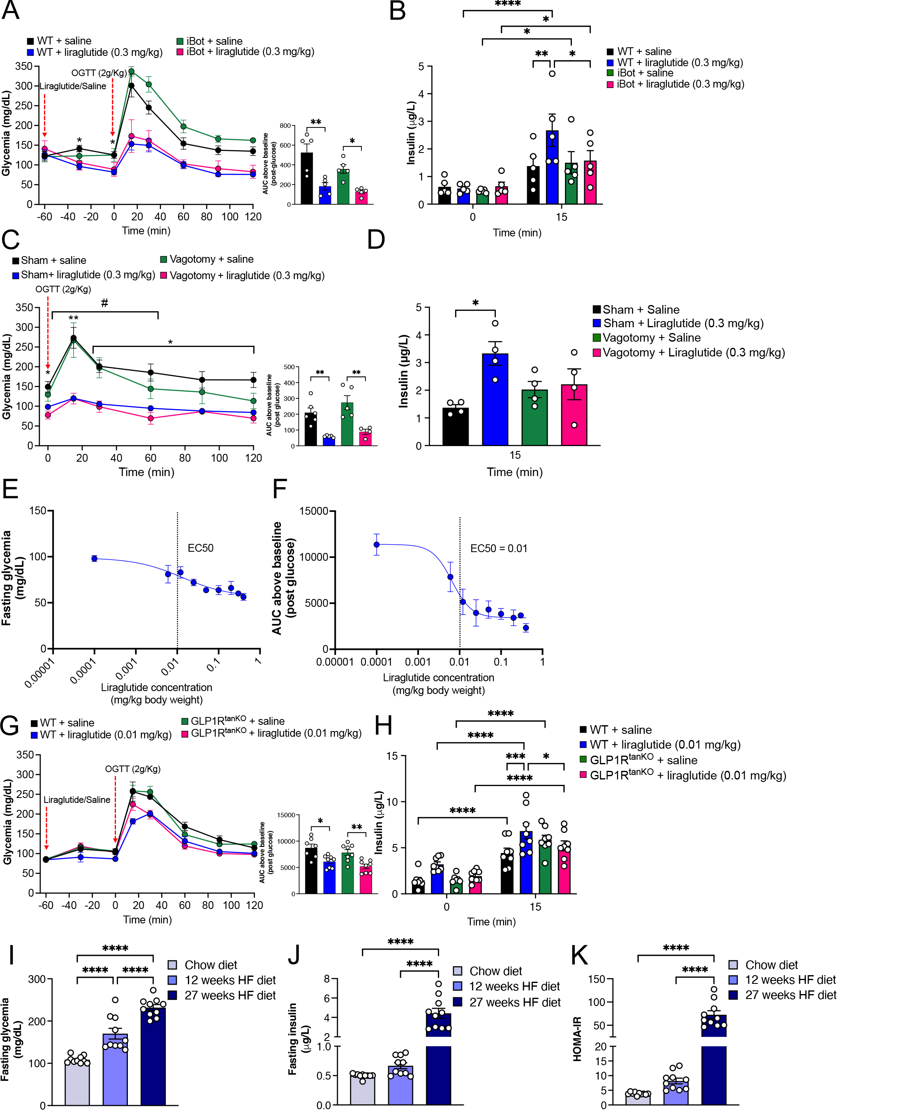
Supplementary Figure 3: Tanycytic and Vagal Regulation of Liraglutide's Effects on Glucose Homeostasis.
(A,B) Chow-fed WT and iBot mice responses to oral glucose (2 g/kg) ± liraglutide (0.3 mg/kg): (A) Blood glucose and AUC. *p < 0.05, **p < 0.05, ***p < 0.01. (B) Plasma insulin (n = 5/group). *p < 0.05, **p < 0.02, ***p < 0.01, ****p < 0.0001. (C,D) CVGX vs. sham-operated mice responses to oral glucose ± liraglutide: (C) Blood glucose and AUC. **p < 0.01, ***p < 0.01. (D) Plasma insulin (n = 4/group). *p < 0.05. (E,F) Liraglutide dose-response curves: (E) Fasting glucose EC50. (F) Post-glucose challenge AUC EC50 (0.01 mg/kg indicated by dotted line). (G,H) Chow-fed WT and GLP-1rTanycyteKD mice (n = 8/group) responses to oral glucose ± liraglutide (0.01 mg/kg): (G) Blood glucose and AUC. *p < 0.05, **p < 0.01. (H) Plasma insulin. **p < 0.05, ***p < 0.001, ****p < 0.0001. (I-K) Metabolic parameters in WT mice (n = 10/group) fed chow (light blue), 12-week HF diet (blue), or 27-week HF diet (dark blue): (I) Fasting glucose. (J) Fasting insulin. (K) HOMA-IR
****p < 0.0001 for all comparisons. Data presented as means ± SEM. Statistics: One- or Two-way ANOVA with Tukey's post hoc tests.

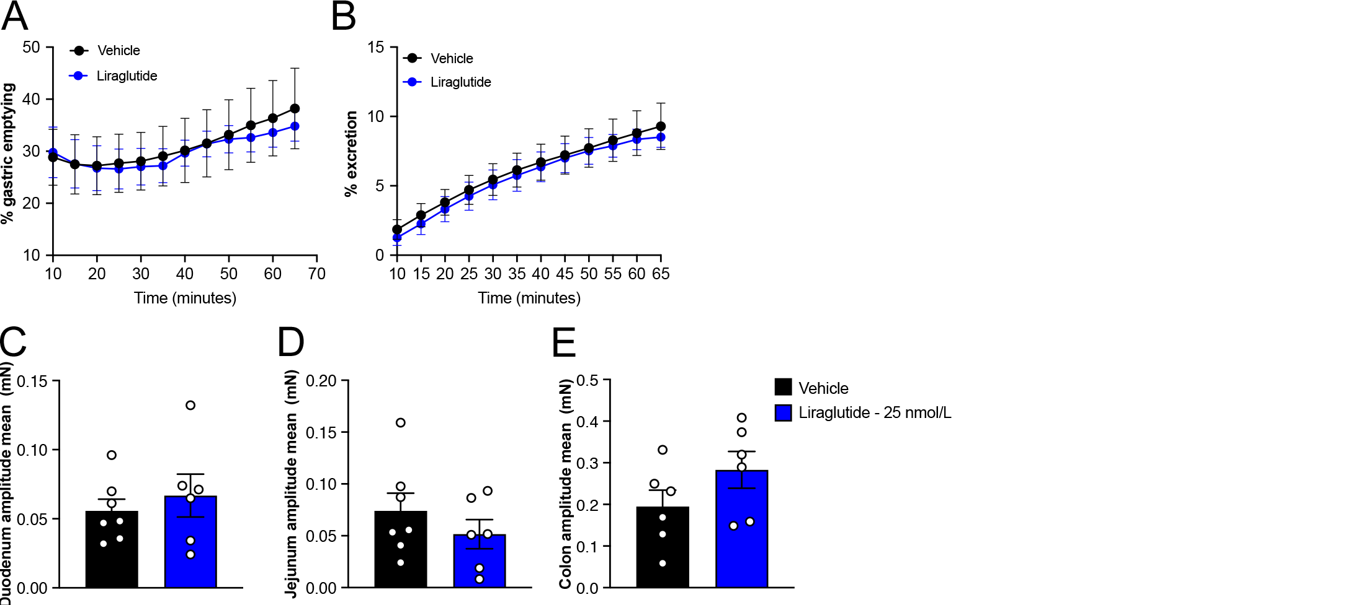

Supplementary Figure 4: Tissue-Specific Effects of Liraglutide on Gastrointestinal Function. (A,B) 18-FDG tracking in fasted mice 60 min after liraglutide or saline treatment: (A) Gastric emptying, (B) Urinary excretion. (C-E) Ex vivo isotonic contraction amplitude (mN) in response to liraglutide in fasted mice: (C) Duodenum, (D) Jejunum, (E) Colon. Data presented as means ± SEM. Statistics: Unpaired t-tests.

