Supplementary Figures and Movie
Supplementary Fig. S1: Blautia hydrogenotrophica neglects glucose when trehalose is present in the medium. (A) Illustration of a hypothetical PTS system that detects trehalose and inhibits the expression of the ABC transporter responsible for importing glucose. Although the detailed molecular mechanisms of this inhibition have not been fully elucidated, RNA-seq data clearly show inhibition of the ABC transporter when trehalose is present (refer to main Fig. 1A). Moreover, (B) supplementing WC medium with additional trehalose results in the (C) complete inhibition of glucose consumption (as compared with the 'glucose' plot in main Fig. 1D).
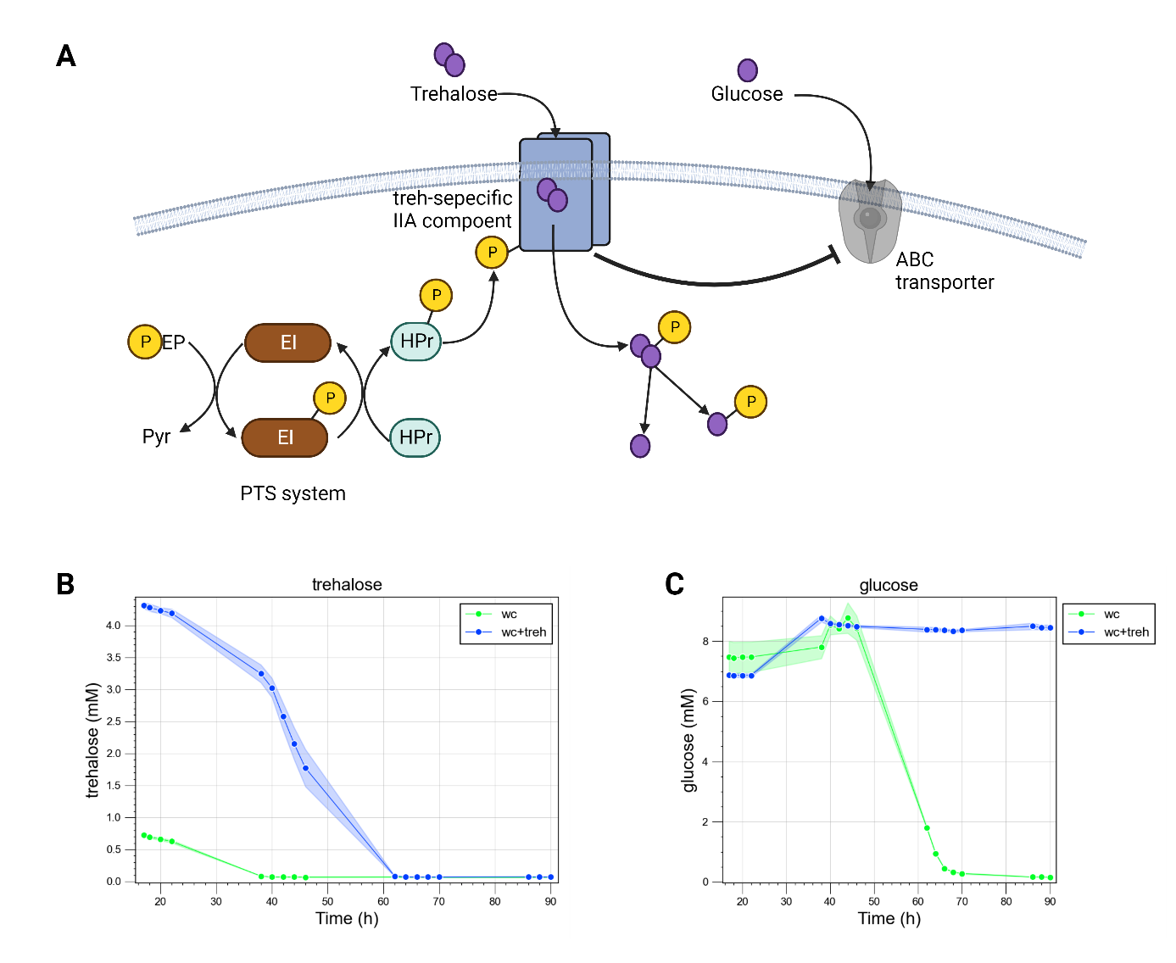

Supplementary Fig. S2: Growth kinetics and model validation for three human gut bacteria in co-culture. This figure presents experimental growth data over time alongside model simulations (indicated by dashed lines) for pairs of species and all three species co-cultured in WC medium. The growth data represent averages from six biological replicates. Simulation of initial conditions matched those of the experimental setups. In experiment (A), the HPLC analysis for formate failed, resulting in the absence of experimental data points. Only the metabolites that showed changes relative to the blank control are depicted. Other metabolites, such as propionate in all experiments, and trehalose in the co-culture of Bacteroides thetaiotaomicron and Roseburia intestinalis, were measured but remained at levels equivalent to the blank, which consisted of pure WC medium; hence, they are not included in these plots.
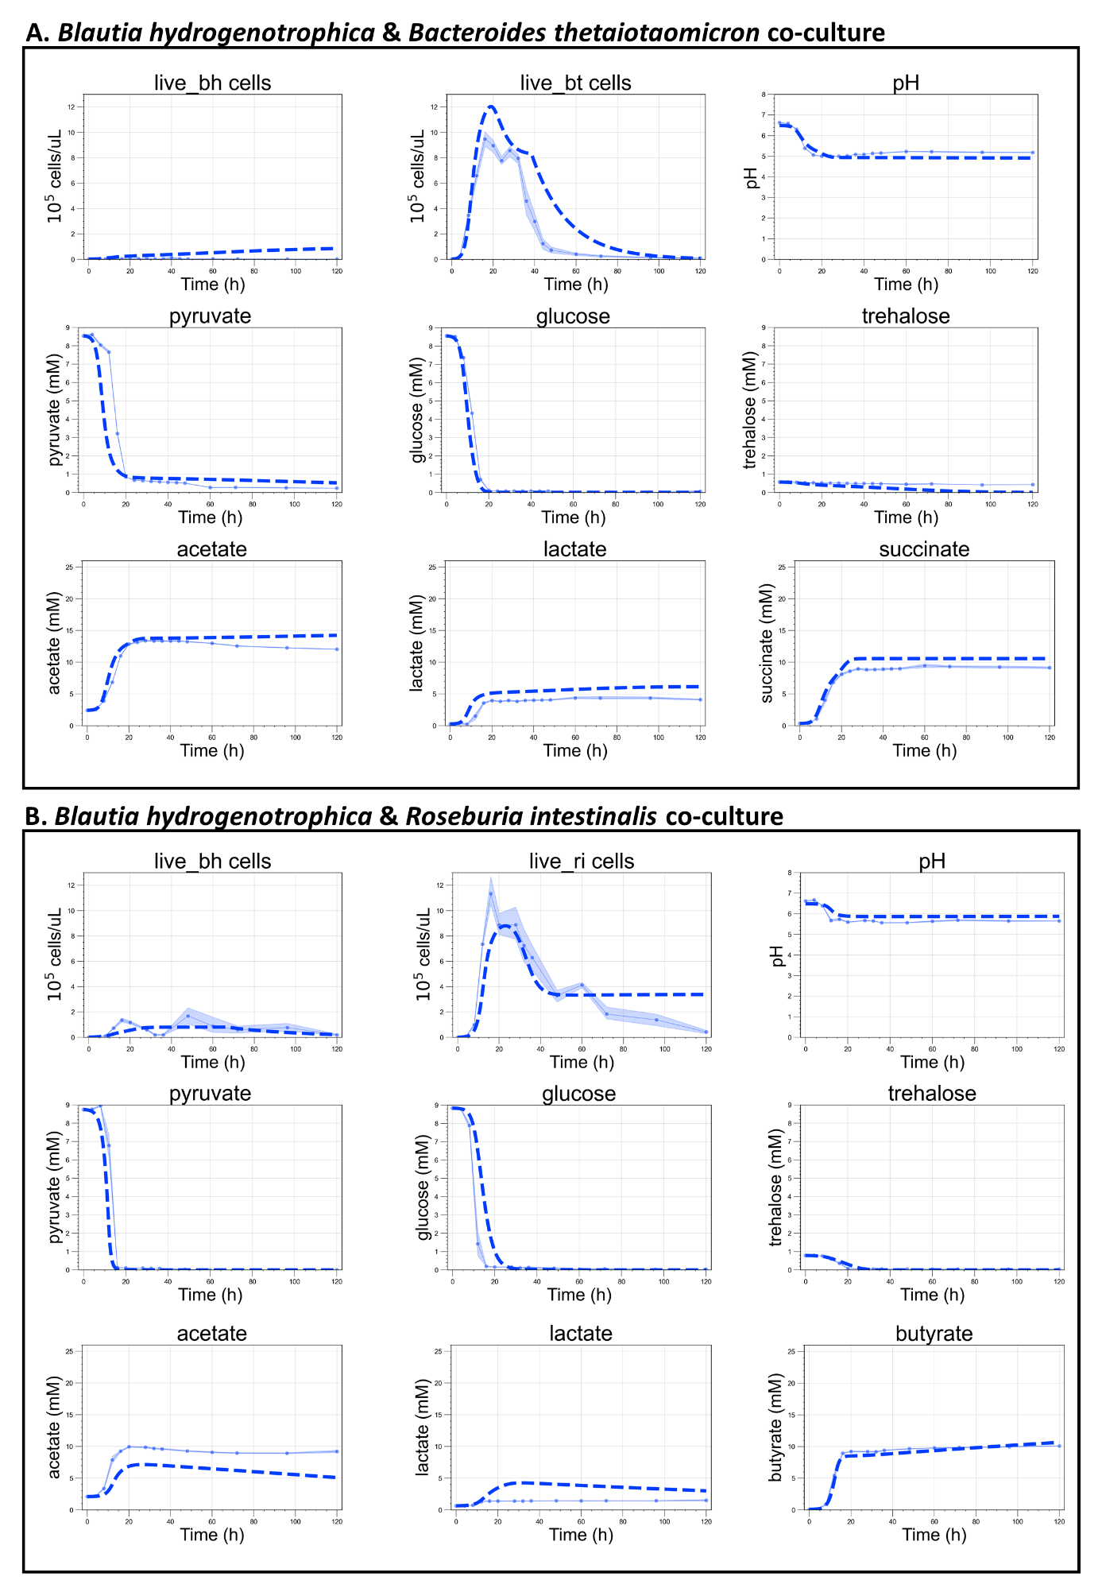
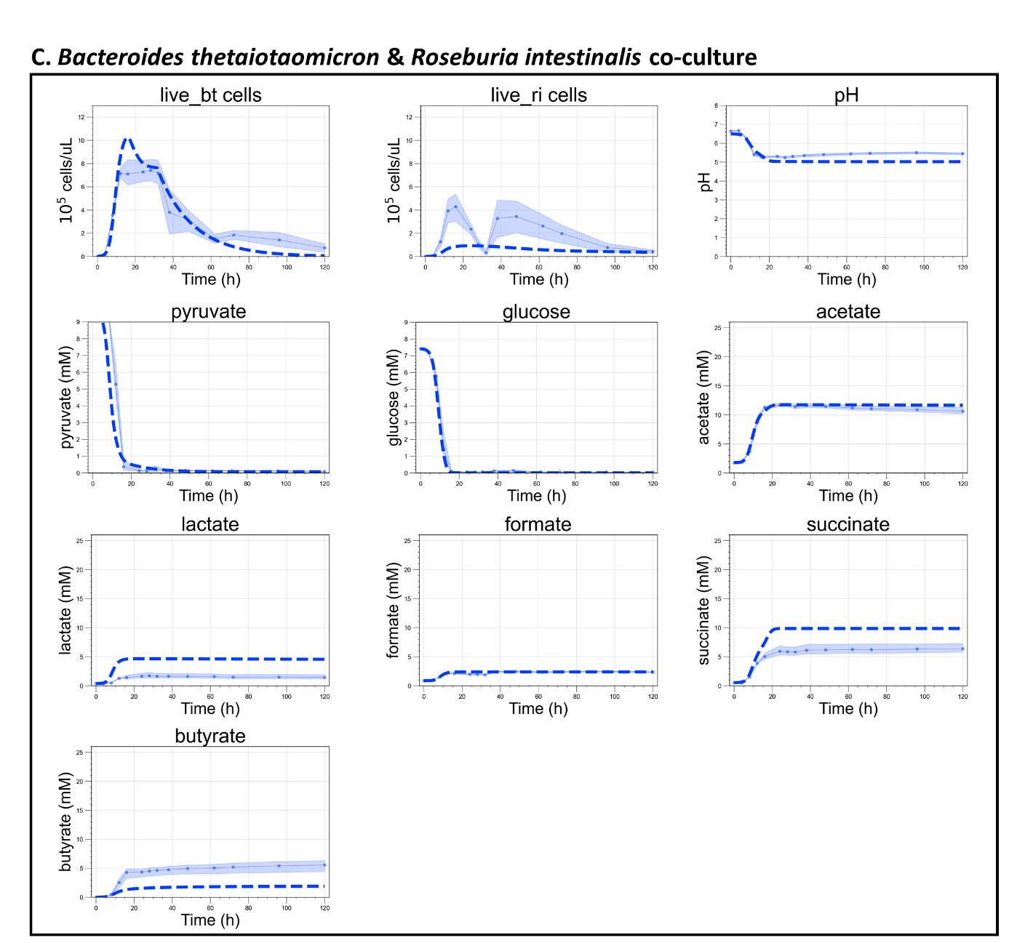
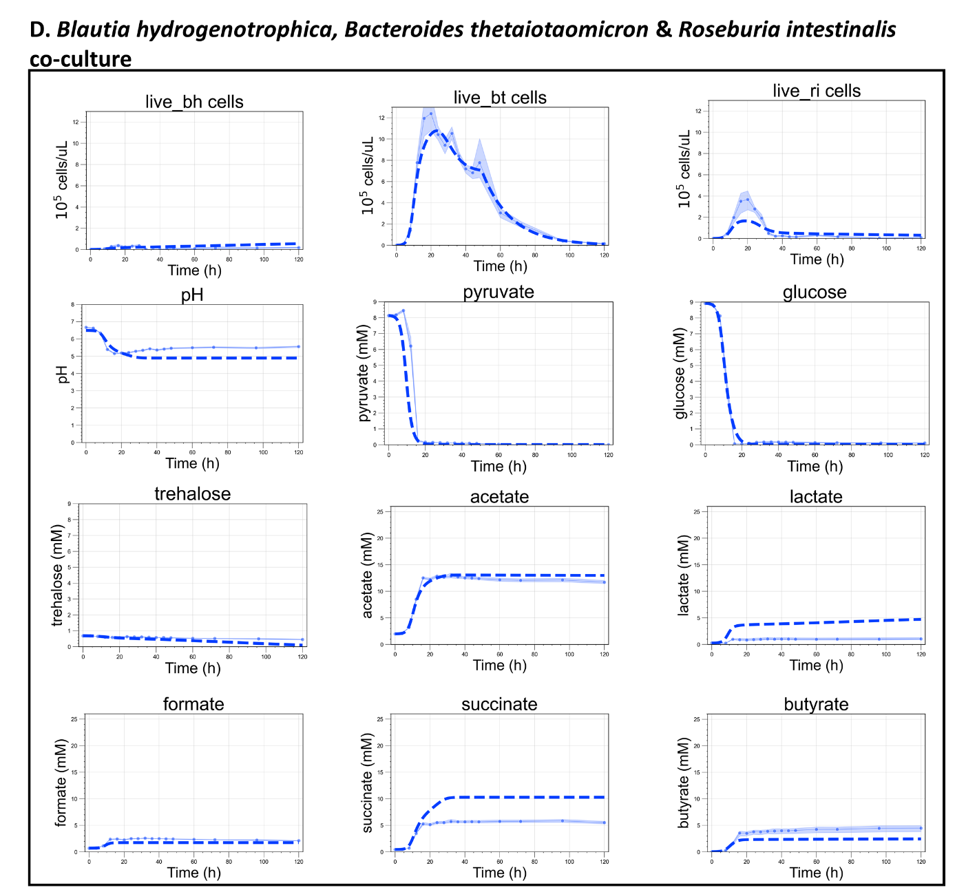

Supplementary Fig. S3: Two examples of history dependence in simulations using our mechanistic model. In (A), simulations began with dilution rates corresponding to the values on the x-axis and reached a steady state depicted in the top heatmap. After reaching this steady state, the dilution rate was set to zero for 24 hours and then restored to its previous value, allowing the system to achieve a second steady state up until 600 hours. This second steady-state is shown in the lower heatmap. Within a certain range of dilution rate values (indicated by the area enclosed in the white traced lines), the system settles into a different steady state than in the case where no perturbation was introduced (notice, the higher concentration of Blautia hydrogenotrophica and acetate and lower concentration of Roseburia intestinalis and butyrate). The two steady states have the same parameter values and emerge depending on the history of the system. This alternative steady state is maintained by feedback loops among phenotypically distinct subpopulations. For instance, if the initial population of Blautia hydrogenotrophica's glucose-consuming cells exceeds a tipping point, an increase in the steady-state concentration of trehalose (achieved by increasing the dilution rate) prompts B. hydrogenotrophica cells to switch to consuming the excess trehalose, keeping trehalose levels low and allowing glucose-consuming cells to persist. In other words, whether glucose-consuming cells persist or not depends on their initial population, which in turn depends on the history of the system. Using principal component analysis (PCA), the model state can be summarized by a single state value (its first principal component). In the lower plot, one clearly sees the coexistence of two states under the same parameter regime within the traced line (top unperturbed and bottom perturbed states).
(B) A similar example of history dependency can be seen by controlling the system’s pH at specific values (for instance, by adding a buffer). In these simulations, in the top heatmap we show the steady state reached by the system when the pH is fixed from the beginning at the values in the x-axis. While in the lower one, we instead initialize the system with a fixed pH of 5.6 for 60 h. A short time period that would not lead Roseburia intestinalis to extinction and not necessarily enough time to reach a steady state. After 60 h, we set the pH to the specific value in the x-axis and allow the system to reach steady state (for 600 h). Here, once more within the range indicated by the white traced lines, two alternative states were reached that depend on the system’s history. In other words, the concentration of subpopulations that emerge after the initial incubation at pH 5.6 is more robust to pH changes and stabilizes the system in a different state compared to the initial populations of a standard incubation.
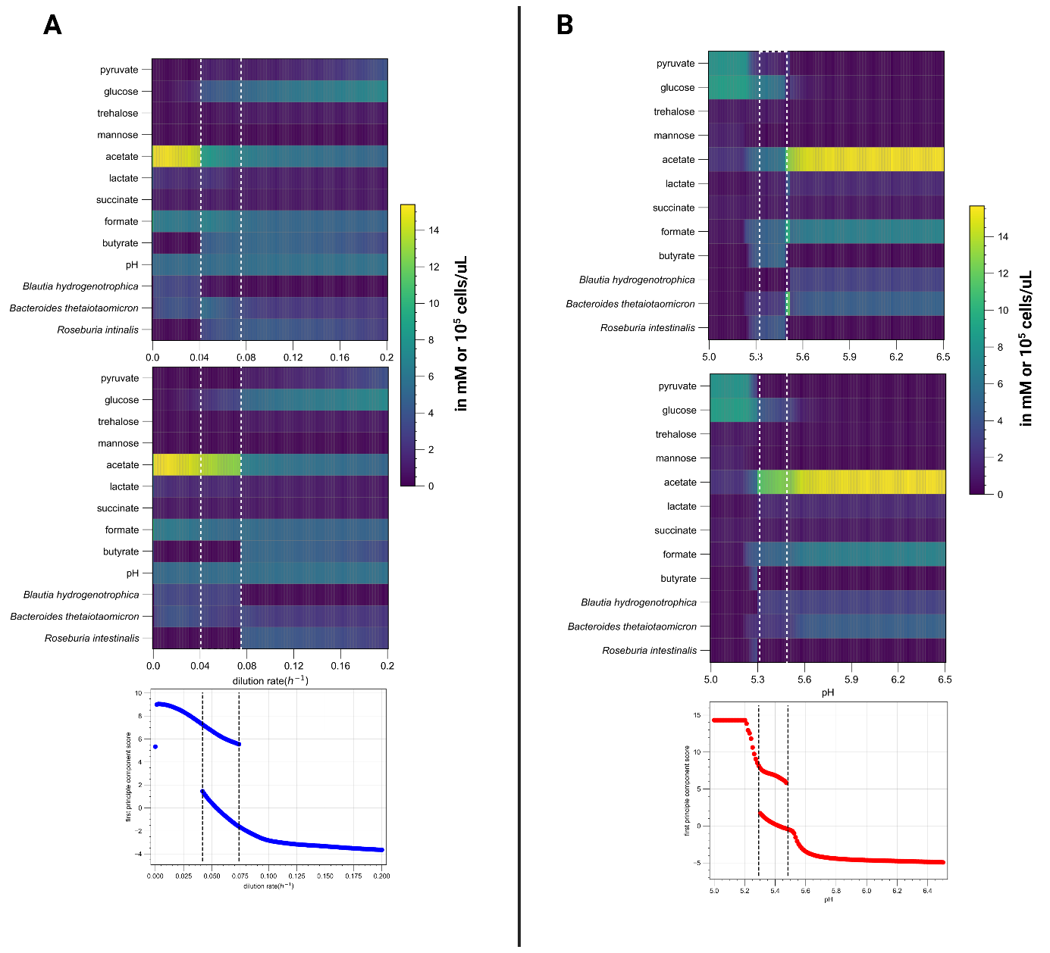

Supplementary Figure S4: Metabolite concentrations, bacterial abundances and pH for a 4-species community grown in minibioreactors. Relative abundances from 16S rRNA gene sequencing (copy-number corrected) were multiplied by total cell count from flow cytometry to obtain absolute abundance for six replicate vessels. Cells were grown in batch for 4 hours after which the emulated chemostat conditions were initiated. The red squares indicate the start and end of the pH perturbation, and the orange squares indicate the start and end of the starvation period (no feed added) followed by the addition of 5 ml medium.
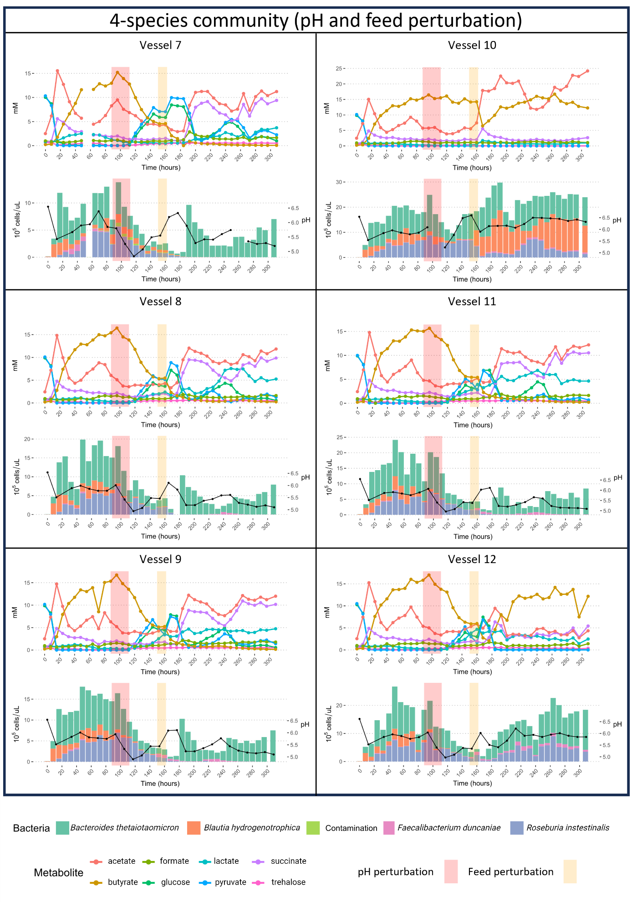

Supplementary Figure S5: Metabolite concentrations, bacterial abundances and pH for a 4-species community grown in minibioreactors. Relative abundances from 16S rRNA gene sequencing (copy-number corrected) were multiplied by total cell count from flow cytometry to obtain absolute abundance for six replicate vessels. Cells were grown in batch for 4 hours after which the emulated chemostat conditions were initiated. The orange squares indicate the start and end of the starvation period (no feed added) followed by the addition of 5 ml medium.
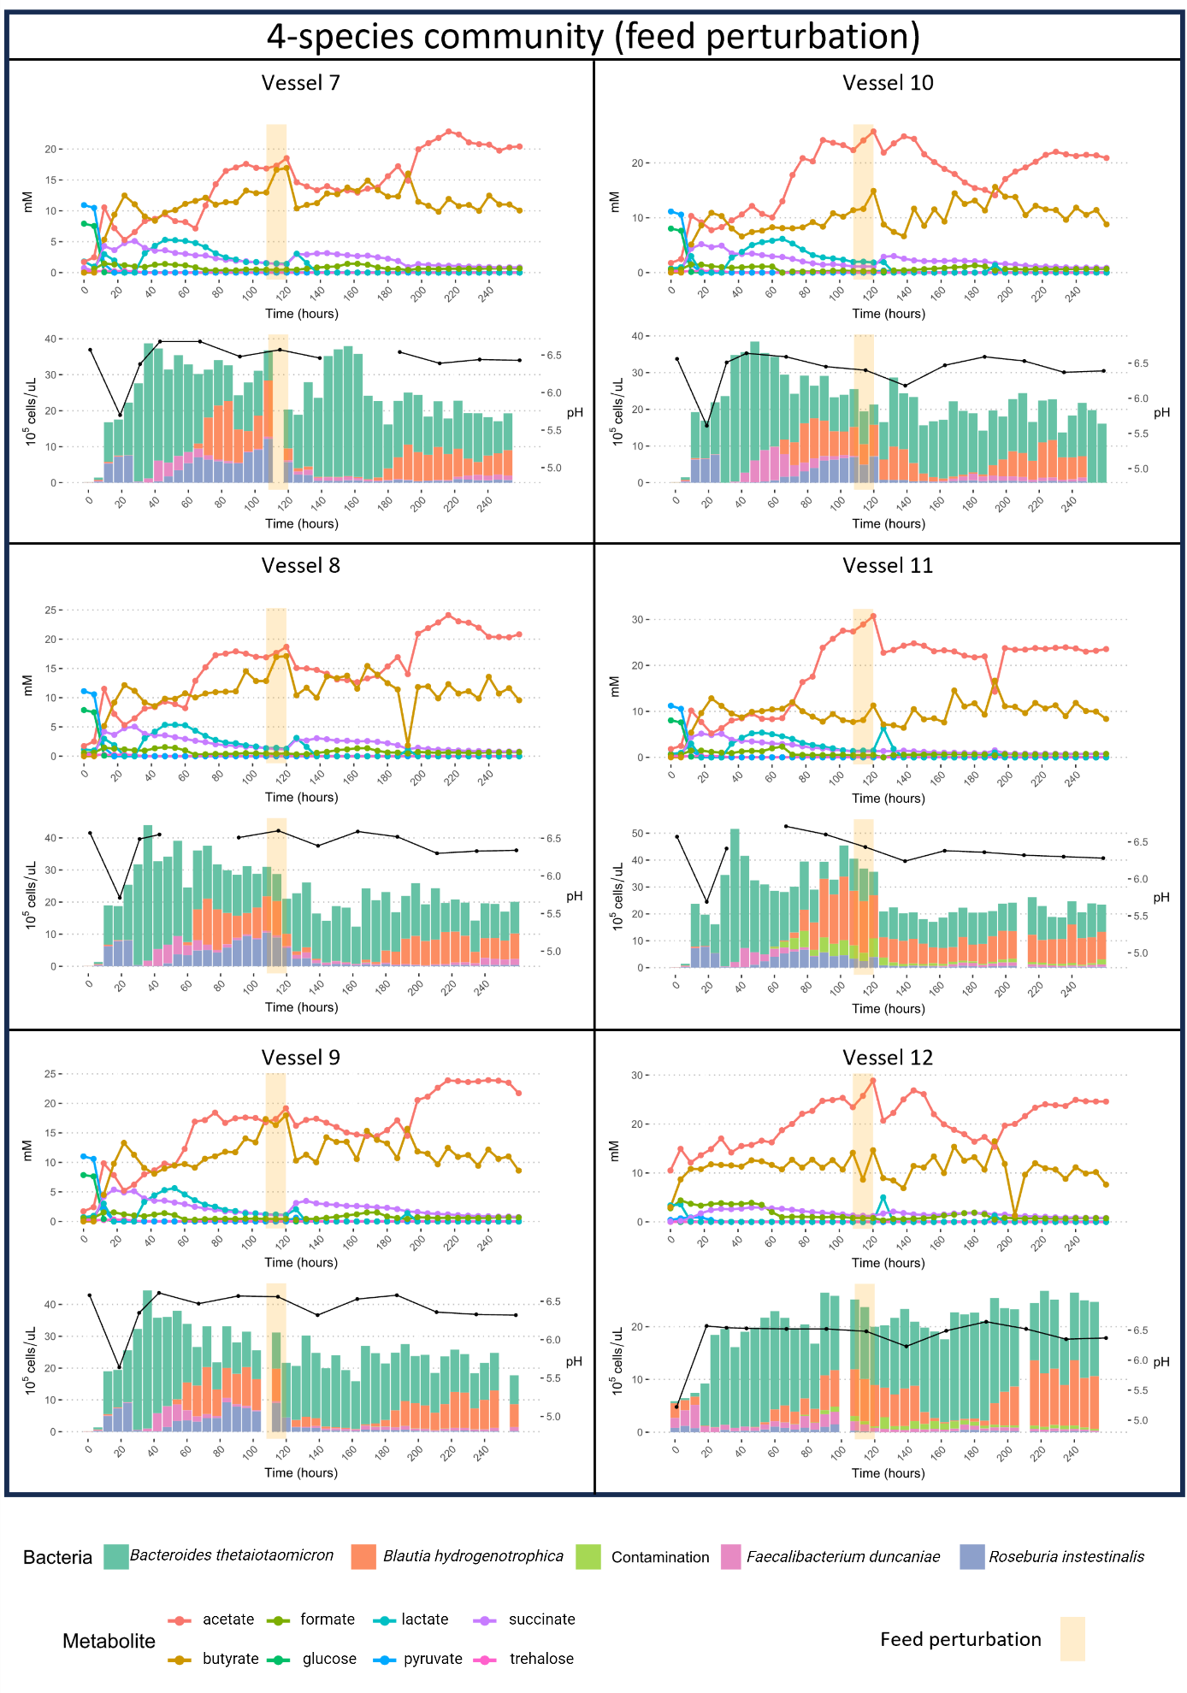

Supplementary Figure S6: Metabolite concentrations, bacterial abundances and pH for a 3-species community grown in minibioreactors. Relative abundances from 16S rRNA gene sequencing (copy-number corrected) were multiplied by total cell count from flow cytometry to obtain absolute abundance for six replicate vessels. Cells were grown in batch for 4 hours after which the emulated chemostat conditions were initiated. The red squares indicate the start and end of the pH perturbation, and the orange squares indicate the start and end of the starvation period (no feed added) followed by the addition of 5 ml medium.
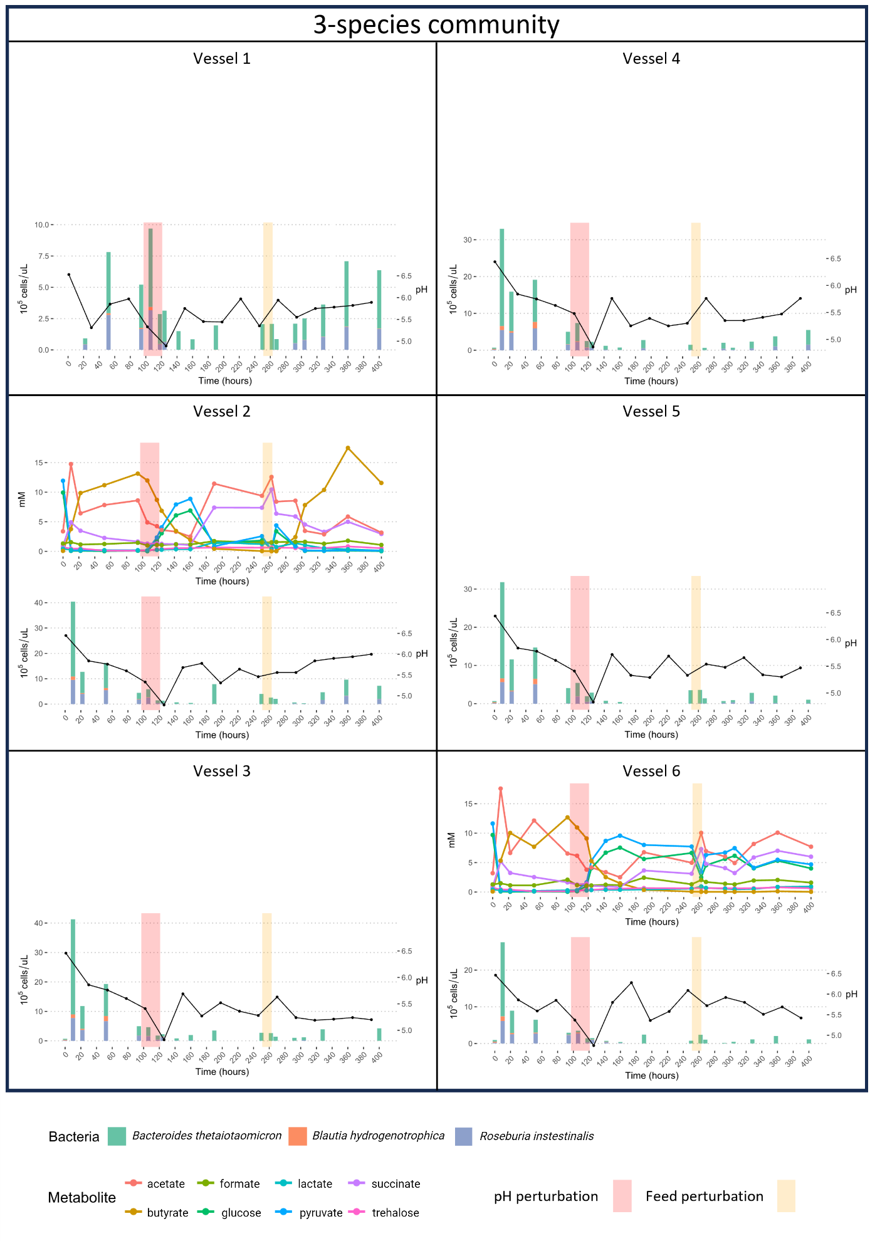
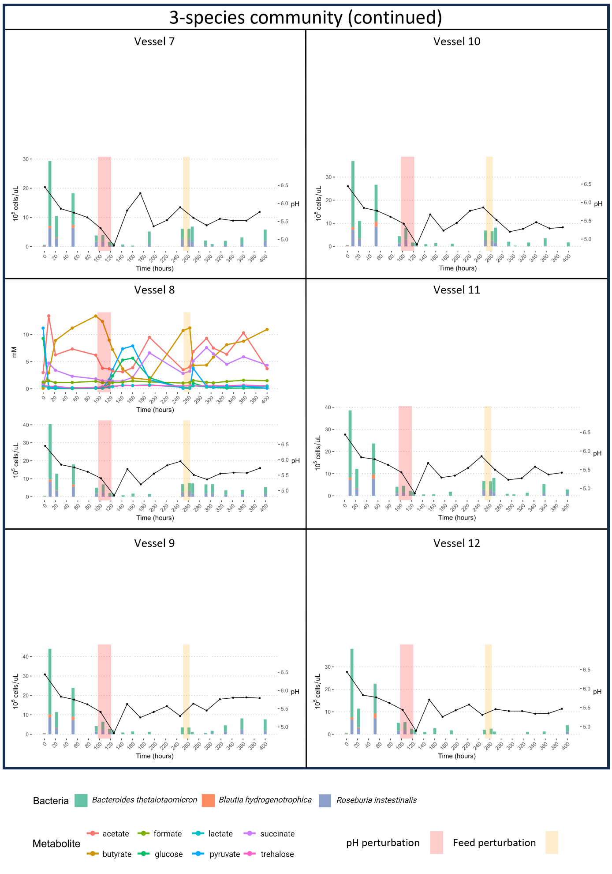

Supplementary Movie S1: flow cytometry time series of Blautia hydrogenotrophica's growth in WC medium, corresponding to experiment 1 shown in main Fig. 1D. ‘t' represents the hours of cultivation. The x-axis displays the intensity of the SYBR green staining, indicative of viable (non-permeable) cells, while the y-axis shows the intensity of propidium iodide staining, which marks non-viable (permeable) cells. Between 24 and 32 hours, two distinct subpopulations of similar sizes become apparent, which coincides with the uptake of glucose (see main Fig.1D). These subpopulations were not observed in the experiments where WC medium was supplemented with trehalose (see Supplementary Fig. S1).

