Contents
Table S1. Members of the RESILIENT Study Group 2
Table S2. Members of the The Early Life Cross Linkage in Research, Born in South London (eLIXIR-BiSL) Partnership 3
Box S1. Details on pregnancy costing methods 4
Box S2. Details on the ITS model predicting the impact of the pandemic on monthly maternity costs – Model specification 6
Figure S1. Temporal trends in covariates -Ethnicity 7
Figure S2. Temporal trends in covariates -Index of Multiple Deprivation (IMD) quintiles 7
Figure S3. Temporal trends in covariates -Maternal age 8
Figure S4. Temporal trends in covariates -Percentage of women that delivered each month 8
Box S3. Maternal organ system involved in medical conditions, as recorded at the registration visit 10
Box S4. Definition of GDm-Health app user 11
Box S5. Dealing with missing data in primary care 12
Table S4. Healthcare utilisation by care type and pandemic period 14
Figure S7. Percentage of virtual routine antenatal care over time 15
Table S5. Comparison of characteristics between GDm-Health app users and non-users 17
Table S6. Predicted and counterfactual monthly pregnancy costs 18
Table S7. Parameter estimates from the ITS model assessing the impact of the pandemic on monthly pregnancy costs – By ethnicity 19
Table S8. Predicted and counterfactual monthly pregnancy costs – By ethnicity 20
Figure S8. Predicted monthly pregnancy costs and the impact of implementing and lifting the lockdowns – By ethnicity 22
Table S9. The impact of virtual care on pregnancy costs by subgroups 23
Table S10. The impact of GDP app registration on pregnancy costs by subgroups 25
Table S11. Goodness of fit measures comparing OLS to GLM with gamma distribution and log link 27
Table S12. Results of sensitivity analyses for ITS Model assessing the impact of the pandemic on monthly pregnancy costs - Removing primary care from pregnancy costs 28
Table S13. Results of sensitivity analyses for ITS Model assessing the impact of the pandemic on monthly pregnancy costs -Changing routine antenatal costing assumption 29
Table S14. Results of sensitivity analyses for ITS Model assessing the impact of the pandemic on monthly pregnancy costs -Changing the start of the pandemic period from July 2021to August 2021 29

Table S1. Members of the RESILIENT Study Group
Chief Investigator
Professor Laura A. Magee | Professor of Women’s Health, King's College London (KCL)
Co-investigators
Professor Debra Bick | Professor of Clinical Trials in Maternal Health, Warwick Clinical Trials Unit, University of Warwick
Dr Harriet Boulding | Research Fellow, The Policy Institute at King's, KCL
Dr Kathryn Dalrymple | Lecturer in Nutritional Sciences, KCL
Ms Alice McGreevy | Research Assistant in Health Economics, KCL
Professor Peter von Dadelszen | Professor of Global Women's Health, KCL
Professor Emma L Duncan | Professor of Clinical Endocrinology, Twin Research & Genetic Epidemiology, KCL
Dr Abigail Easter | Senior Lecturer in Maternal & Newborn Health, KCL
Professor Julia Fox-Rushby | Professor of Health Economics, KCL
Professor Asma Khalil | Professor of Obstetrics and Maternal Fetal Medicine, St George's University Hospitals NHS Foundation Trust
Dr Hiten D. Mistry | Senior Research Fellow, Department of Women and Children's Health, KCL
Professor Eugene Nelson | Professor of Community and Family Medicine, The Geisel School of Medicine at Dartmouth, The Dartmouth Institute, USA
Professor Lucilla Poston, CBE | Tommy's Charity Professor of Maternal & Fetal Health; Head, School of Life Course Sciences, KCL
Mr Sergio A. Silverio | Research Associate in Social Science of Women’s Health, KCL
Dr Marina Soley-Bori | Lecturer in Health economics, KCL
Dr Florence Tydeman | Research Associate in Medical Statistics, KCL
Ms. Arica Van Citters | Senior Research Scientist, The Dartmouth institute for Health Policy and Clinical Practice, Hanover, USA
Dr Sara White | I am Clinical Senior Lecturer and maternal diabetes clinical research lead, and honorary consultant in metabolic medicine.
Dr Ingrid Wolfe | Director, Institute of Women and Children’s Health, KCL
Wang Yangzhong | Professor of Statistics and Head of Medical Statistics, KCL

Table S2. Members of the The Early Life Cross Linkage in Research, Born in South London (eLIXIR-BiSL) Partnership
Member | Role
Professor Lucilla Poston | eLIXIR-BiSL Chief Investigator, and Professor of Maternal & Fetal Health, Department of Women and Children’s Health, School of Life Course and Population Sciences, King’s College London
Professor Laura A Magee | Professor of Women’s Health, Department of Women and Children’s Health, School of Life Course and Population Sciences, King’s College London
Professor Robert Stewart | Professor of Psychiatric Epidemiology & Clinical Informatics, Department of Psychological Medicine, Institute of Psychiatry, Psychology and Neuroscience, King’s College London and NIHR Maudsley Biomedical Research Centre, South London and Maudsley NHS Foundation Trust, London. Consultant Psychiatrist at South London and Maudsley NHS Foundation Trust, London
Professor David Edwards | Chair in Paediatrics & Neonatal Medicine, Department of Perinatal Imaging and Health, King’s College London. Neonatal Consultant at Guy’s and St. Thomas’ NHS Foundation Trust
Professor Mark Ashworth | Professor of Primary Care, Department of Population Health Sciences, School of Life Course and Population Sciences, King’s College London
Professor Jane Sandall | Professor of Social Science & Women’s Health, Department of Women and Children’s Health, School of Life Course and Population Sciences, King’s College London
Dr Ingrid Wolfe | Professor of Paediatrics and Child Population Health, Department of Women and Children’s Health, School of Life Course and Population Sciences, King’s College London and Consultant in Children's Public Health Medicine and Director of the Evelina London Children’s Healthcare
Dr Cheryl Gillett | Head of Tissue Banking, Department of Comprehensive Cancer Centre, School of Cancer & Pharmaceutical Sciences, King’s College London
Dr Michael Absoud | Paediatric Consultant at Evelina London Children’s Healthcare
Dr Lucy Pickard | Consultant Paediatrician, King’s College Hospital NHS Foundation Trust
Ms Amanda Grey | Lay member of the eLIXIR Oversight Committee
Ms Sarah Spring | Lay member of the eLIXIR Oversight Committee
Ms Toyin Kazeem | Information Governance Operations Lead, South London and Maudsley NHS Foundation Trust, London
Ms Amelia Jewell | Clinical Data Linkage Service Lead, NIHR Maudsley Biomedical Research Centre, South London and Maudsley NHS Foundation Trust
Mr Matthew Broadbent | CRIS Clinical Informatics Lead, NIHR Maudsley Biomedical Research Centre, South London and Maudsley NHS Foundation Trust, London
Ms Finola Higgins | Research Informatics Programme Manager, Guy’s and St Thomas’ NHS Foundation Trust
Mr Leonardo de Jongh | Data Warehouse Manager, Guy’s and St. Thomas’s Hospital NHS Foundation Trust
Ms Tisha Dasgupta | Research Associate and eLIXIR Coordinator, Department of Women & Children’s Health, School of Life Course and Population Sciences, King’s College London
Dr Carolyn Gill | School Bioresource Manager, School of Life Course and Population Sciences, King’s College London.

Box S1. Details on pregnancy costing methods
Cost Component | Costing Method
Delivery costs | Costed per delivery type:  - Normal delivery (Currency codes NZ30A - NZ34C): £3,296.47  - Assisted delivery (NZ40A - NZ44C): £5,220.49  - Elective caesarean section (NZ50A - NZ50C): £5,032.21  - Emergency caesarean section (NZ51A - NZ51C): £7,193.10  - Not specified (NZ25Z): £2,411.00  Only 0.4% of the sample was ‘Not specified’.
Routine Antenatal Appointments | Costed per appointment, using weighted average unit costs from currency codes WF01A – WF02D for service codes 501 and 560¹. Costing for each pregnancy was based on whether a woman’s care plan was recorded as “Midwife only”, “Shared (Obstetrician and Midwife)” or “Obstetrician only”. ‘Midwife only’ was costed as 100% provided by midwives, and ‘Obstetrician only’ was costed as 100% obstetrician. Shared care was costed as 75% Midwife, 25% Obstetrician. The rationale for this was that women with Midwife only care had ~75% the number of appointments as the ‘Shared’ group, and therefore it was assumed that all appointments above the 75% were conducted by an Obstetrician. As a sensitivity analysis, ‘Shared care’ was costed as 90% Midwife, 10% Obstetrician also and the results for all three models did not change.  Mode of delivery (face-to-face or virtual) was also considered when selecting average unit costs. An appointment was deemed to have been ‘virtual’ if: (i) maternal blood pressure (BP), dipstick proteinuria, and fetal heart rate (FHR - after 16 weeks gestation) were missing from the visit record; or (ii) notes from the appointment contained one/more of the terms, ‘virtual’, ‘telephone’, ‘phone’, ‘call’, or ‘zoom’. Otherwise, the appointment was considered to have taken place face-to-face.  Antenatal appointments (‘follow-up’ appointments):  - Midwife only - £107 face-to-face (F2F), £78 virtual.  - Shared - £126 F2F, £96 virtual.  - Obstetrician only - £183 F2F, £152 virtual.  Antenatal registration appointments for all women were costed as a midwife ‘First’ appointment - £177 F2F, £143 virtual.
Maternity Assessment Unit | Costed at £161 per visit. Calculated using the weighted average cost of ‘Outpatient procedures’ for currency codes NZ22Z to NZ24B¹.
Inpatient stays | Costed per stay, using weighted average unit costs from currency codes NZ16Z-NZ27Z¹:  - Daycase - £330  - Non-elective short stay (<5 days) - £560  - Non-elective long stay (>=5 days) - £2,863  The cut-off point of 5 days is based on the trimpoints for maternity prices from the NHS National Tariffs.
Postnatal reviews | Costed at £142 per visit, the unit cost of an outpatient procedure for currency code NZ27Z¹.
Mental Health – Talking Therapy appointments | Costed per appointment based on the duration, provider type (Therapist, Psychologist etc.) and delivery type (face-to-face, group session etc.). The cost per hour of the provider type is multiplied by the duration of the appointment, and adjusted for delivery type where appropriate. Cost per hour for provider type is obtained from the PSSRU manual.  For example, a 30-minute face-to-face appointment with a Cognitive Behavioural Therapy (CBT) Therapist, with an hourly cost of £66 per hour, would be 66*(30/60) = £33.
Mental Health – community contact appointments | Same as talking therapy appointments.
Mental Health – Inpatient stays | Costed at £1,070 per bed day (‘Specialist perinatal – admitted’)³.
Primary care appointments | Costed per appointment based on the duration, provider type (GP, Nurse etc.) and delivery type (face-to-face, telephone etc.). Both average durations of appointments and costs per hour for provider type were obtained from the PSSRU manual³.  For example, a face-to-face GP consultation (average duration 9.22) would be costed at £265 * (9.22/60) = £40.72.

Box S2. Details on the ITS model predicting the impact of the pandemic on monthly maternity costs – Model specification
The ITS equation is specified as follows:

${Cost}_{it}=β_{0}+β_{1}Time+β_{2}Pandemic+β_{3}Time*Pandemic+$ $β_{4}PostLockdown+$
$β_{5}Time*PostLockdown + β_{7}Month+β_{6}{Hospital}_{i}++β_{8}{Ethnicity}_{i}+ {β_{9}{Delivered}_{it}+ β}_{10}{LagRes}_{it}$
( 1 )
Time is the number of months elapsed since the start of the study and captures the linear trend, and Pandemic is a dummy variable indicating the COVID-19 period (coded 1 for months between March 2020 and June 2021, otherwise 0). PostLockdown is a dummy variable indicating the post-lockdown period (coded 1 for months from July 2021 onwards, otherwise 0). $Hospital$ accounts for correlation in costs of women within the same hospital. Monthly dummy variables are included to adjust for seasonality. $LagRes$ represents the lagged residuals. Inspection of the autocorrelation and partial autocorrelation functions identified correlation among observations of the same individual over time (autocorrelation); to adjust for this, the model was first run without $LagRes$., and then the residuals from this model were extracted and lagged, and added as an explanatory variable for the main model (32). ITS models account for time-invariant covariates unless there are changes in the characteristics of the underlying population that might explain observed changes over the study period. As such, temporal trends in covariates (ethnicity, social deprivation, maternal age) were plotted and checked for stability. As there were changes in the ethnicity composition of the population, this was added as a control variable in the ITS model. The percentage of deliveries each month (a key cost-driver) was also unstable over the study period; to control for this, a binary variable, $Delivered$, was added to reflect the month in which the woman gave birth (Figures S1-S4, right below).

Figure S1. Temporal trends in covariates -Ethnicity
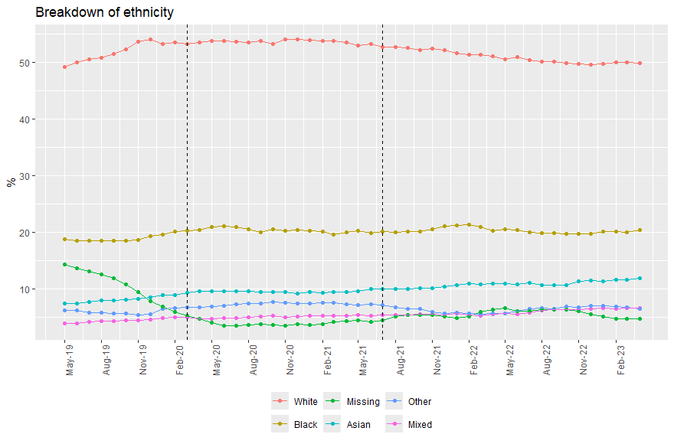

Figure S2. Temporal trends in covariates -Index of Multiple Deprivation (IMD) quintiles
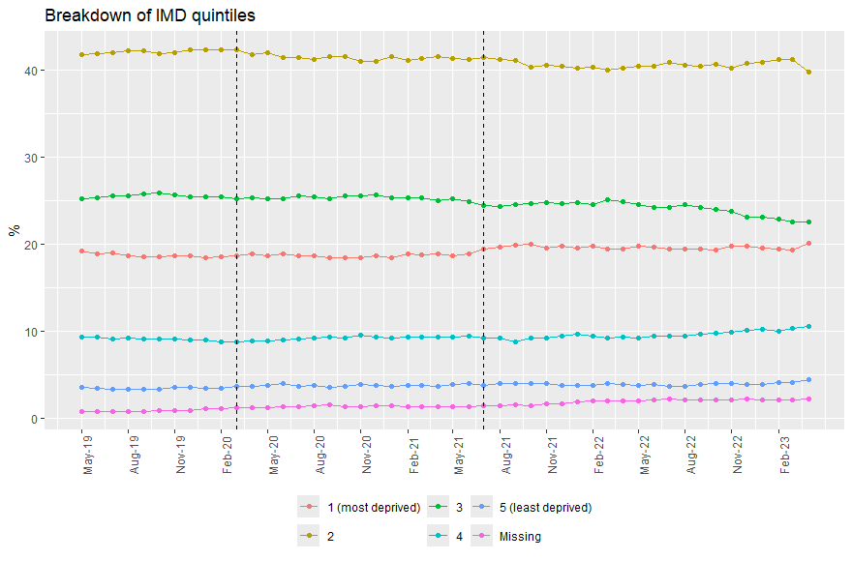

Figure S3. Temporal trends in covariates -Maternal age
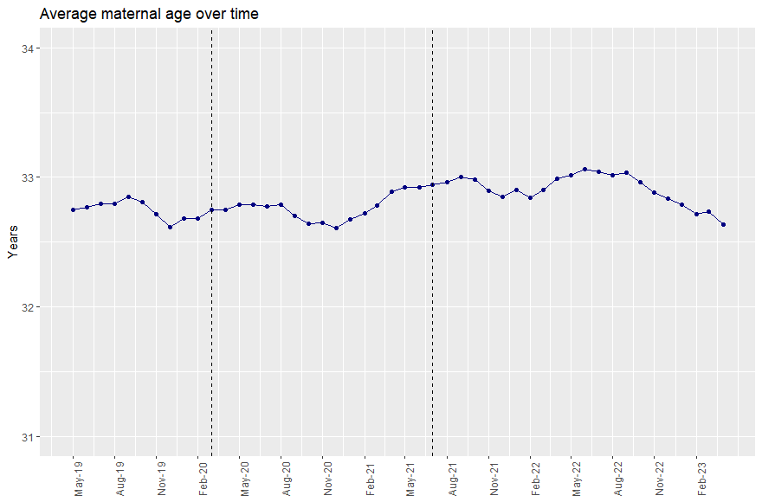

Figure S4. Temporal trends in covariates -Percentage of women that delivered each month
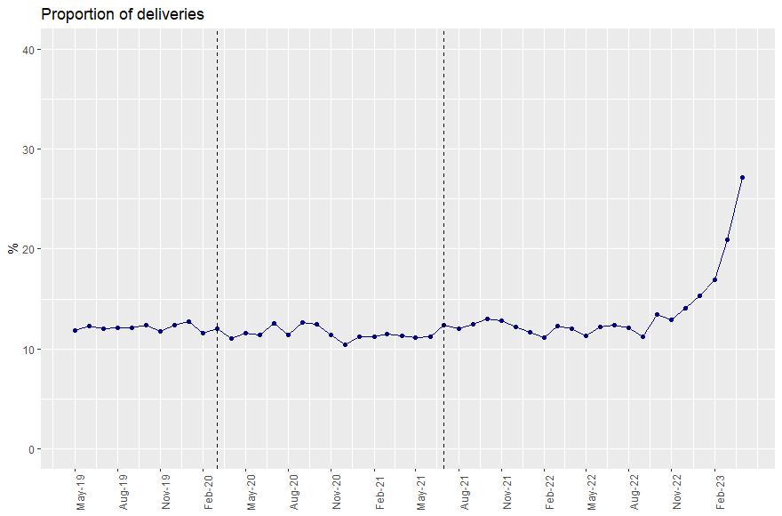
Note: The study sample includes women with an antenatal registration appointment on April 2023 or before, with no more women joining the sample after May 2023. This results in a higher percentage of deliveries towards the end of the study period as the remaining women in the sample give birth.

Box S3. Maternal organ system involved in medical conditions, as recorded at the registration visit

- Haematological  - Thrombosis  - Cardiac  - Hypertension  - Renal  - Asthma  - Lung disorders  - Diabetes  - Endocrine  - Autoimmune  - Epilepsy | - Neurological  - Gastrointestinal  - Gynaecological  - Liver  - Bone disorders  - Joint disorders  - Back problems  - Genetic disorders  - Congenital abnormality  - Mental health  - Other medical problems
Notes: These medical conditions were converted into a binary variable equal to 1 if the individual had at least one of them, 0 otherwise.

Box S4. Definition of GDm-Health app user
Individuals were considered as GDm-Health app users if they had a GDM diagnosis and evidence of sufficient active app usage. Sufficient app usage required a rate of readings per total days on the app of 1, a total length of app usage of at least 7 days, and at least 7 glucose readings over the app usage duration period. The code logic is as follows:
GDM Health Users == “Yes” is a further subset of GDM Health Diagnosis for those who have evidence of app active usages. (Step 1)
Those with “Reason for Closing” within the list of “non-user implications” then GDM_Health_Use == “No” e.g., non-user. (Step 2)
If the Rate_of_readings_per_day < 10th percentile of readings (~1 reading per day) then GDM_Health_Use == “No” OR
if Total Number of Gluscose Readings < 7 readings, then GDM_Health_Use == “No” OR
if the length_of_time_on_app (in days) < 7 days, then GDM_Health_Use == “No”.

Box S5. Dealing with missing data in primary care
Multiple imputation via Chained Equations (MICE) was conducted using the MICE package in R. Predictor variables in the multiple imputation model for primary care costs included:
    - IMD quintiles (missing labelled as “missing”)
    - Ethnicity (missing labelled as “missing”)
    - Maternal age at antenatal registration (continuous)
    - Hospital (GSTT/KCH)
    - Gestational age at start of month:
      - 0-12 weeks – “First”
      - 13-27 – “Second”
      - 28+ - “Third”
      - If delivered – “Delivered”.
    - Nulliparous – first time mum (y/n)
    - Smoker at antenatal registration (y/n/missing)
    - Care type (Midwife / Shared / Obstetrician / Missing)
    - Multiple birth (y/n)
    - Date_month
    - BadgerNet Cost
Results of MICE indicate overlapping primary care cost distributions between individuals with imputed (purple) and observed (pink) primary care costs, as displayed in the histograms right below.
Figure S5. Comparison of imputed and observed primary care cost distributions
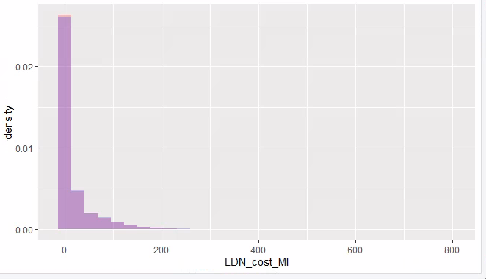
Notes: Purple = imputed population, Pink = In LDN dataset.
Descriptive statistics also support the similarity between the imputed and observed primary care cost groups.
Table S3. Comparison of imputed and observed primary care cost descriptives
Group | Average cost | Median cost | Standard deviation | Min cost | Max cost
Primary care costs -Imputed | 21.1 | 0 | 44.8 | 0 | 792
Primary care costs -Observed | 20.3 | 0 | 43.7 | 0 | 792

Figure S6. Breakdown of total costs over the three pandemic periods
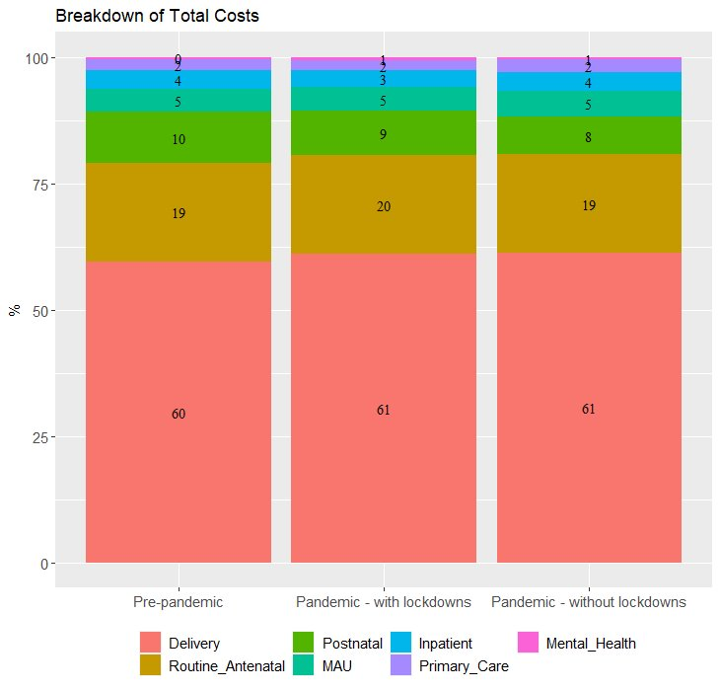

Table S4. Healthcare utilisation by care type and pandemic period
 | Pre-pandemic | Pandemic with lockdowns¹ | Pandemic without lockdowns²
 | N=13,284 | N=11,470 | N=10,233
Routine antenatal | 10.38 (6.26) | 12.56 (5.74)*** | 12.19 (5.99)***
Maternity assessment unit | 2.12 (2.00) | 2.32 (2.17)*** | 2.65 (2.55)***
Post-natal review | 5.46 (4.04) | 4.70 (4.16)*** | 4.13 (3.90)***
Primary care | 5.95 (5.42) | 6.53 (6.79)*** | 7.22 (7.25) ***
Talking therapy | 0.18 (1.27) | 0.26 (1.61)*** | 0.23 (1.44)***
Mental health community contacts | 0.21 (2.11) | 0.37 (3.5) | 0.36 (2.71)***
Mental health Inpatient stay days | 0.01 (0.53) | 0.03 (1.02) | 0.01 (0.7)

¹ The stars indicate statistical significance corresponding to the t-tests (Mann–Whitney U) comparing mean utilisation during the pandemic with lockdowns to pre-pandemic. ² The stars indicate statistical significance corresponding to the t-tests (Mann–Whitney U) comparing mean utilisation during the pandemic without lockdowns to pre-pandemic. *** <0.001; ** <0.01; * <0.05.

Figure S7. Percentage of virtual routine antenatal care over time

Table S5. Comparison of characteristics between GDm-Health app users and non-users
Characteristic | Users  N = 3,215 pregnancies | Non-users  N = 1,050 pregnancies | p-value
Maternal age at registration | 34.07, (5.26) | 33.97, (5.36) | >0.9
English as first language | 2,083 (65%) | 623 (59%) | 0.002
Difficulty speaking English | 286 (8.9%) | 114 (11%) | 0.067
Mental health condition | 756 (24%) | 220 (21%) | 0.094
Ethnicity |  |  | <0.001
White | 1,060 (33%) | 349 (33%)
Black | 941 (29%) | 249 (24%)
Asian | 628 (20%) | 188 (18%)
Mixed | 153 (4.8%) | 41 (3.9%)
Other | 304 (9.5%) | 93 (8.9%)
Missing | 129 (4.0%) | 130 (12%)
IMD quintile |  |  | 0.4
1 (most deprived) | 743 (23%) | 245 (23%)
2 | 1,326 (41%) | 443 (42%)
3 | 709 (22%) | 230 (22%)
4 | 265 (8.2%) | 69 (6.6%)
5 (least deprived) | 116 (3.6%) | 48 (4.6%)
Missing | 56 (1.7%) | 15 (1.4%)
Notes: p-values correspond to t-tests (Mann–Whitney U-test for continuous variables) and Pearson Chi-Squared tests (for categorical variables).

App users and non-users were similar in terms of maternal age at antenatal registration (~34 years), difficulty speaking English (~10%), prevalence of mental health conditions (just over 20%), and IMD distribution (~65% deprived). However, app users (vs. non-users) were more likely to speak English as their primary language (65% vs. 59%, p-value=0.002) and had a slightly different ethnicity distribution (p-value<0001), characterised by a lower percentage of individuals with missing ethnicity (4% vs. 12%) and slightly higher percentages of individuals of Black (29% vs. 24%), Asian (20% vs. 18%), mixed (5% vs. 4%), and other ethnicity (10% vs. 9%).

Table S6. Predicted and counterfactual monthly pregnancy costs
 | Average predicted cost | 95% CI | Average predicted cost of counterfactual | Relative Rate
Jun-19 | 1009.46 | (990.66,1028.26) | 1009.46 | 1.00
Jul-19 | 986.34 | (968.87,1003.8) | 986.34 | 1.00
Aug-19 | 981.08 | (964.49,997.67) | 981.08 | 1.00
Sep-19 | 984.91 | (968.83,1000.98) | 984.91 | 1.00
Oct-19 | 1019.93 | (1003.99,1035.86) | 1019.93 | 1.00
Nov-19 | 983.20 | (967.07,999.34) | 983.20 | 1.00
Dec-19 | 997.72 | (981.05,1014.39) | 997.72 | 1.00
Jan-20 | 1070.19 | (1052.48,1087.9) | 1070.19 | 1.00
Feb-20 | 960.61 | (941.81,979.4) | 960.61 | 1.00
Mar-20 (start of pandemic lockdowns) | 990.83 | (973.38,1008.29) | 1023.93 | 0.97
Apr-20 | 920.38 | (903.02,937.74) | 953.02 | 0.97
May-20 | 967.95 | (950.4,985.49) | 1000.12 | 0.97
Jun-20 | 962.21 | (945.8,978.62) | 993.93 | 0.97
Jul-20 | 1038.13 | (1022.19,1054.08) | 1069.40 | 0.97
Aug-20 | 947.40 | (931.75,963.06) | 978.21 | 0.97
Sep-20 | 1052.42 | (1036.86,1067.99) | 1082.77 | 0.97
Oct-20 | 1045.61 | (1030.04,1061.17) | 1075.50 | 0.97
Nov-20 | 987.04 | (971.47,1002.6) | 1016.47 | 0.97
Dec-20 | 907.22 | (891.5,922.94) | 936.20 | 0.97
Jan-21 | 990.88 | (974.71,1007.05) | 1019.40 | 0.97
Feb-21 | 962.23 | (945.68,978.78) | 990.30 | 0.97
Mar-21 | 1023.37 | (1006.6,1040.14) | 1050.98 | 0.97
Apr-21 | 975.77 | (958.67,992.88) | 1002.92 | 0.97
May-21 | 989.54 | (971.77,1007.31) | 1016.23 | 0.97
Jun-21 | 989.24 | (971.72,1006.76) | 1015.48 | 0.97
Jul-21 (start of post-lockdown period) | 1044.50 | (1028.04,1060.97) | 1093.83 | 0.95
Aug-21 | 1004.69 | (988.47,1020.9) | 1053.14 | 0.95
Sep-21 | 1049.62 | (1033.57,1065.67) | 1097.20 | 0.96
Oct-21 | 1104.55 | (1088.54,1120.57) | 1151.26 | 0.96
Nov-21 | 1097.03 | (1081.09,1112.96) | 1142.86 | 0.96
Dec-21 | 1034.37 | (1018.44,1050.3) | 1079.33 | 0.96
Jan-22 | 1038.82 | (1022.7,1054.93) | 1082.90 | 0.96
Feb-22 | 977.37 | (961.07,993.67) | 1020.58 | 0.96
Mar-22 | 1100.03 | (1084.11,1115.94) | 1142.36 | 0.96
Apr-22 | 1054.07 | (1037.98,1070.17) | 1095.53 | 0.96
Notes: Analyses were based on data up to April 2023 (results available upon request).

Table S7. Parameter estimates from the ITS model assessing the impact of the pandemic on monthly pregnancy costs – By ethnicity
Control | White - Baseline | Black | Asian | Mixed | Other | Missing
Pre-pandemic baseline at time=0 | 168.13*** | 4.11 | -42.61 | 1.9 | -23.64 | -57.31*
 | (141.61, 194.65) | (-41.98, 50.20) | (-100.20, 14.99) | (-67.23, 71.02) | (-93.28, 45.99) | (-102.92, -11.70)
Pre-pandemic trend (per month) | 0.56 | 6.53 | 13.69** | -0.87 | 10.74 | -1.93
 | (-3.35, 4.48) | (-1.84, 14.91) | (3.45, 23.93) | (-12.93, 11.18) | (-2.15, 23.63) | (-10.93, 7.07)
Pandemic lockdowns - change in level | -73.84*** | 103.44** | 127.82** | 20.49 | 46.02 | -23.1
 | (-109.29, -38.38) | (25.70, 181.17) | (37.57, 218.07) | (-91.45, 132.43) | (-64.31, 156.35) | (-132.07, 85.87)
Pandemic lockdowns- change in slope | 4.36* | -9.83* | -16.26** | -0.12 | -11.06 | 3.71
 | (0.21, 8.51) | (-18.94, -0.72) | (-27.20, -5.31) | (-13.13, 12.90) | (-24.76, 2.64) | (-6.73, 14.15)
Post-lockdown - change in level | -76.14** | 41.68 | 30.73 | -133 | -26.62 | 61.2
 | (-122.87, -29.41) | (-61.16, 144.52) | (-89.97, 151.42) | (-278.07, 12.06) | (-176.34, 123.10) | (-103.07, 225.48)
Post-lockdown - change in slope | 3.35 | -6.11 | -12.47* | 4.6 | -9.04 | 1.38
 | (-0.67, 7.36) | (-14.87, 2.65) | (-23.12, -1.81) | (-7.97, 17.17) | (-22.47, 4.38) | (-8.64, 11.40)
Note: 95% confidence interval is in the parentheses. ***p-value <0.001, **p-value<0.01, *p-value<0.05. Estimates for Black, Asian, Mixed and Other are expressed relative to White. For example, the change is level in the pandemic period for individuals of Black ethnicity compared to White is -£73.84 plus £103.44, which equals £29.60. If coefficients for ethnicities other than ‘White’ are not significant, this means that they are not significantly different from White.

Table S8. Predicted and counterfactual monthly pregnancy costs – By ethnicity
 | White – Baseline |  | Black |  | Asian |  | Mixed |  | Other |  | Missing
 | Average cost | 95% CI | Average cost | 95% CI | Average cost | 95% CI | Average cost | 95% CI | Average cost | 95% CI | Average cost | 95% CI
Jun-19 | 1038.53 | (1016.91,1060.15) | 992.65 | (959.86,1025.43) | 1059.98 | (1010.7,1109.26) | 982.68 | (916.69,1048.67) | 1118.93 | (1063.59,1174.26) | 864.20 | (825.39,903.01)
Jul-19 | 909.64 | (890.56,928.73) | 1102.15 | (1074.02,1130.28) | 1000.06 | (958.52,1041.6) | 1003.17 | (947.87,1058.47) | 1066.79 | (1020.27,1113.31) | 1067.18 | (1034.65,1099.72)
Aug-19 | 878.08 | (860.87,895.29) | 1124.42 | (1100.14,1148.71) | 970.28 | (935.29,1005.27) | 798.18 | (752.1,844.26) | 1182.51 | (1143.25,1221.77) | 1154.19 | (1126.36,1182.02)
Sep-19 | 883.35 | (867.31,899.38) | 1024.13 | (1002.45,1045.81) | 1007.81 | (977.55,1038.06) | 981.29 | (941.86,1020.73) | 1153.68 | (1119.43,1187.94) | 1264.55 | (1239.05,1290.05)
Oct-19 | 1065.89 | (1050.21,1081.57) | 1057.20 | (1036.41,1077.99) | 811.51 | (783.26,839.76) | 911.38 | (874.7,948.07) | 1003.64 | (971.05,1036.22) | 943.81 | (917.79,969.84)
Nov-19 | 981.11 | (964.94,997.27) | 1028.75 | (1007.02,1050.48) | 914.00 | (884.4,943.6) | 869.39 | (830.82,907.96) | 869.88 | (835.16,904.61) | 1073.13 | (1043.65,1102.6)
Dec-19 | 940.74 | (923.43,958.05) | 1056.48 | (1032.09,1080.86) | 976.44 | (942.6,1010.27) | 951.90 | (907.25,996.56) | 1174.34 | (1134.2,1214.49) | 1163.13 | (1128.06,1198.2)
Jan-20 | 1033.61 | (1014.38,1052.84) | 1100.45 | (1072.13,1128.78) | 1050.85 | (1010.73,1090.97) | 1131.28 | (1077.86,1184.7) | 1003.57 | (955.75,1051.4) | 1296.93 | (1255.01,1338.85)
Feb-20 | 918.56 | (897.11,940.01) | 1005.12 | (972.28,1037.96) | 989.30 | (941.78,1036.83) | 926.97 | (863.25,990.69) | 1149.07 | (1092.67,1205.47) | 979.34 | (929.92,1028.77)
Mar-20 (start of the pandemic period) | 953.98 | (935.24,972.72) | 1003.65 | (977.19,1030.11) | 1020.65 | (984,1057.31) | 932.48 | (883.27,981.69) | 988.25 | (945.85,1030.65) | 1309.45 | (1257.38,1361.51)
Apr-20 | 894.02 | (875.84,912.21) | 1024.63 | (999.76,1049.49) | 943.70 | (909.94,977.46) | 748.57 | (703.53,793.6) | 727.09 | (688.21,765.96) | 1163.15 | (1115.39,1210.92)
May-20 | 905.38 | (887.43,923.33) | 1049.09 | (1025.54,1072.65) | 962.75 | (931.46,994.05) | 1090.02 | (1048.66,1131.37) | 1074.33 | (1038.33,1110.33) | 1080.44 | (1036.55,1124.32)
Jun-20 | 956.98 | (940.47,973.49) | 1010.56 | (989.16,1031.97) | 1034.76 | (1006.42,1063.1) | 904.81 | (867.46,942.16) | 903.12 | (870.82,935.42) | 762.15 | (722.4,801.9)
Jul-20 | 1006.47 | (990.74,1022.21) | 1173.18 | (1153.16,1193.19) | 949.63 | (923.61,975.64) | 1111.77 | (1077.82,1145.71) | 987.53 | (958.03,1017.03) | 951.38 | (915.09,987.66)
Aug-20 | 932.31 | (917.15,947.46) | 944.34 | (925.43,963.25) | 888.91 | (864.74,913.09) | 1022.41 | (991.22,1053.6) | 1073.55 | (1046.36,1100.74) | 991.41 | (957.79,1025.03)
Sep-20 | 937.22 | (922.34,952.1) | 1161.59 | (1143.4,1179.78) | 1187.03 | (1164.09,1209.97) | 1076.84 | (1047.62,1106.05) | 1347.05 | (1321.36,1372.75) | 1160.00 | (1128.32,1191.68)
Oct-20 | 1025.88 | (1011.1,1040.66) | 1106.64 | (1088.75,1124.52) | 1172.77 | (1150.42,1195.13) | 785.18 | (757.11,813.25) | 945.34 | (920.47,970.2) | 1225.47 | (1194.61,1256.32)
Nov-20 | 949.03 | (934.22,963.85) | 1081.23 | (1063.3,1099.17) | 1025.81 | (1003.44,1048.19) | 838.97 | (811.04,866.91) | 1030.06 | (1005.49,1054.62) | 1053.52 | (1022.06,1084.97)
Dec-20 | 874.40 | (859.36,889.45) | 986.69 | (968.15,1005.23) | 946.52 | (923.48,969.57) | 871.85 | (842.97,900.73) | 877.93 | (852.65,903.21) | 968.30 | (936.04,1000.57)
Jan-21 | 976.69 | (960.99,992.39) | 1134.68 | (1115.19,1154.18) | 912.93 | (888.41,937.46) | 860.62 | (829.75,891.49) | 1026.81 | (999.88,1053.73) | 719.60 | (685.04,754.16)
Feb-21 | 971.05 | (954.73,987.37) | 868.44 | (847.84,889.04) | 1004.53 | (978.02,1031.03) | 1136.62 | (1103.13,1170.11) | 1011.65 | (982.51,1040.78) | 879.38 | (841.87,916.88)
Mar-21 | 993.11 | (976.28,1009.94) | 1169.23 | (1147.26,1191.2) | 897.63 | (869.11,926.14) | 896.13 | (859.58,932.68) | 1006.34 | (974.68,1038) | 1220.29 | (1179.33,1261.25)
Apr-21 | 957.71 | (940.2,975.22) | 983.65 | (960.14,1007.15) | 942.10 | (911.02,973.19) | 1314.95 | (1274.7,1355.2) | 1016.04 | (981.4,1050.68) | 757.99 | (713.23,802.74)
May-21 | 987.02 | (968.43,1005.62) | 1034.25 | (1008.87,1059.62) | 998.12 | (964.08,1032.16) | 906.41 | (862.18,950.65) | 992.97 | (954.84,1031.09) | 886.22 | (837.15,935.29)
Jun-21 | 951.76 | (932.9,970.62) | 1084.50 | (1057.74,1111.25) | 955.41 | (918.81,992.02) | 984.36 | (936.2,1032.52) | 1148.90 | (1107.49,1190.3) | 830.44 | (777.03,883.86)
Jul-21 (start of post-lockdown period) | 1024.14 | (1006.77,1041.5) | 1110.27 | (1085.92,1134.62) | 1052.22 | (1020.31,1084.12) | 860.80 | (818.76,902.84) | 1043.67 | (1004.58,1082.76) | 1195.31 | (1150.78,1239.83)
Aug-21 | 970.82 | (954,987.65) | 1142.61 | (1119.64,1165.59) | 1031.33 | (1001.4,1061.26) | 722.13 | (682.86,761.4) | 1176.33 | (1139.69,1212.96) | 809.03 | (767.57,850.5)
Sep-21 | 1006.23 | (989.9,1022.55) | 1021.23 | (999.42,1043.05) | 1069.49 | (1041.27,1097.71) | 976.35 | (939.61,1013.1) | 1036.42 | (1002.06,1070.78) | 1652.51 | (1613.84,1691.17)
Oct-21 | 1107.82 | (1091.84,1123.8) | 1104.45 | (1083.65,1125.25) | 1188.32 | (1161.62,1215.02) | 975.56 | (941.21,1009.92) | 1110.15 | (1077.99,1142.31) | 1049.71 | (1013.62,1085.8)
Nov-21 | 1053.58 | (1037.94,1069.22) | 1234.73 | (1214.78,1254.67) | 976.47 | (951.33,1001.62) | 1002.75 | (970.59,1034.91) | 1127.47 | (1097.21,1157.74) | 1302.30 | (1268.84,1335.75)
Dec-21 | 1025.88 | (1010.4,1041.35) | 1135.32 | (1116.09,1154.55) | 876.10 | (852.44,899.75) | 1166.18 | (1135.98,1196.38) | 1160.78 | (1132.21,1189.35) | 743.99 | (712.77,775.22)
Jan-22 | 1001.05 | (985.57,1016.53) | 1090.64 | (1071.87,1109.41) | 1047.73 | (1025.06,1070.41) | 1134.69 | (1106.05,1163.34) | 1113.47 | (1086.26,1140.68) | 1002.37 | (973.04,1031.7)
Feb-22 | 925.24 | (909.72,940.75) | 1109.90 | (1091.47,1128.32) | 957.51 | (935.65,979.36) | 937.60 | (910.37,964.83) | 958.47 | (932.48,984.46) | 1058.54 | (1030.54,1086.54)
Mar-22 | 1087.91 | (1072.85,1102.97) | 1031.60 | (1013.88,1049.33) | 1025.69 | (1004.83,1046.54) | 1168.26 | (1142.32,1194.2) | 1207.58 | (1182.73,1232.43) | 1475.13 | (1448.56,1501.69)
Apr-22 | 1003.86 | (988.75,1018.97) | 1195.23 | (1177.42,1213.03) | 996.52 | (976.02,1017.02) | 1094.53 | (1069.3,1119.76) | 1092.65 | (1068.15,1117.15) | 1040.25 | (1014.39,1066.11)
Notes: Analyses were based on data up to April 2023 (results available upon request).

Figure S8. Predicted monthly pregnancy costs and the impact of implementing and lifting the lockdowns – By ethnicity
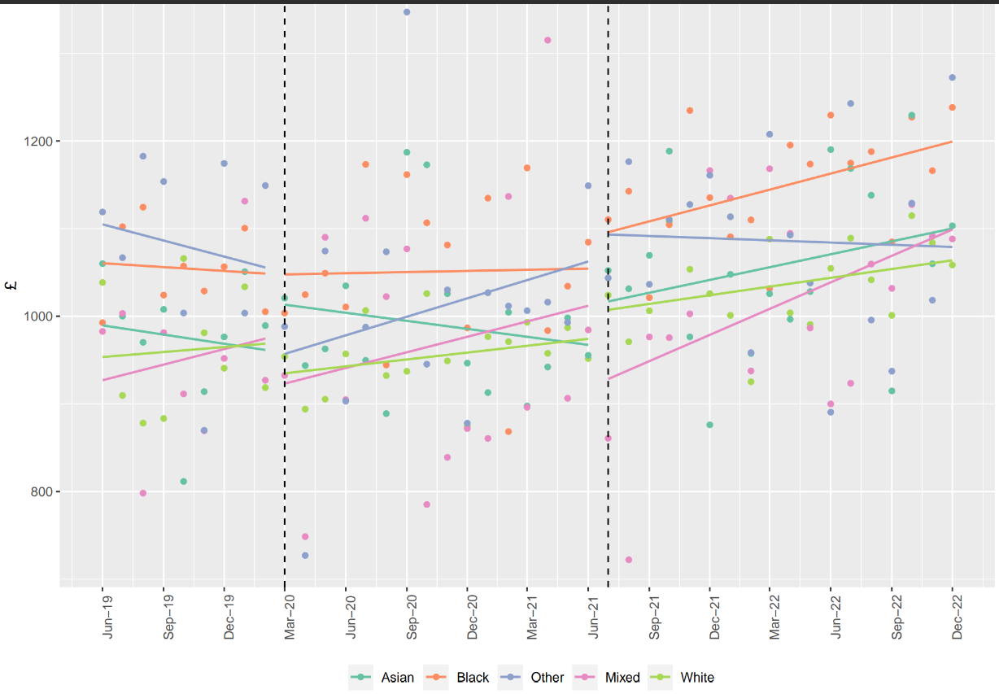

Table S9. The impact of virtual care on pregnancy costs by subgroups
Control | Ethnicity | IMD Quintiles | Two Most Deprived Quintiles | Difficulty Speaking English | Mental Health Condition
Virtual care | 7.86*** (3.53, 12.19) | 9.35* (1.06, 17.64) | 5.11* (0.78, 9.45) | 6.99*** (3.44, 10.53) | 5.71** (2.09, 9.32)
Virtual care*Ethnicity - Black | 0.98 (-8.07, 10.03)
Virtual care*Ethnicity - Asian | -0.93 (-9.66, 7.80)
Virtual care*Ethnicity - Mixed | -8.31 (-20.18, 3.57)
Virtual care*Ethnicity - Other | -7.44 (-17.21, 2.33
Virtual care*Ethnicity - Missing | -1.84 (-11.75, 8.07)
Virtual care*IMD – Quintile 2 |  | -1.58 (-10.73, 7.57)
Virtual care*IMD – Quintile 3 |  | -4.78 (-14.36, 4.80)
Virtual care*IMD – Quintile 4 |  | 0.98 (-10.29, 12.25)
Virtual care*IMD – Quintile 5 (least deprived) |  | -5.98 (-19.69, 7.73)
Virtual care*IMD – Missing |  | -16.90 (-40.85, 7.06)
Virtual care* Most deprived two quintiles |  |  | 3.11 (-2.54, 8.76)
Virtual care*Difficulty speaking English |  |  |  | 0.15 (-9.75, 10.04)
Virtual care*Mental health condition |  |  |  |  | 4.57 (-2.61, 11.74)
Notes: All models also adjust for proportion of care doing the pandemic, age (years), ethnicity, IMD, smoking status, antenatal care type, multiple births, difficulty speaking English, physical condition, mental health condition, and gestation at antenatal registration (weeks).

Table S10. The impact of GDM app registration on pregnancy costs by subgroups
Control | Ethnicity | IMD Quintiles | Two Most Deprived Quintiles | Difficulty Speaking English | Mental Health Condition
Self-monitoring | 159.97 (-145.79, 465.74)
Self-monitoring *Ethnicity - Black | -231.94 (-694.29, 230.41)
Self-monitoring *Ethnicity - Asian | 77.23 (-377.20, 531.65)
Self-monitoring *Ethnicity - Mixed | -103.88 (-857.42, 649.67)
Self-monitoring *Ethnicity - Other | 44.67 (-558.78, 648.11)
Self-monitoring *Ethnicity - Missing | 397.55 (-344.14, 1,139.24)
Self-monitoring *IMD – Quintile 2 |  | -163.92 (-592.49, 264.66)
Self-monitoring *IMD – Quintile 3 |  | -447.47 (-941.85, 46.91)
Self-monitoring *IMD – Quintile 4 |  | 85.41 (-613.37, 784.19)
Self-monitoring *IMD – Quintile 5 (least deprived) |  | -168.18 (-937.68, 601.32)
Self-monitoring *IMD – Missing |  | 2,211.65** (731.05, 3,692.24)
Self-monitoring * Most deprived two quintiles |  |  | 171.55 (-225.00, 568.10)
Self-monitoring *Difficulty speaking English |  |  |  | 462.40 (-32.46, 957.26)
Self-monitoring *Mental health condition |  |  |  |  | 95.74 (-338.75, 530.23)
Notes: All models also adjust for proportion of care doing the pandemic, age (years), ethnicity, IMD, smoking status, antenatal care type, multiple births, difficulty speaking English, physical condition, mental health condition, and gestation at antenatal registration (weeks).

Table S11. Goodness of fit measures comparing OLS to GLM with gamma distribution and log link
R² was generated to understand the proportion of the variation in costs explained by each model. Mean absolute errors (MAE), mean squared errors (MSE), and root mean squared error (RMSE) were computed to assess predictive accuracy, with lower values indicating better accuracy. A logged dependent variable model was also considered (35) but, as residuals were non-normally distributed and heteroskedastic (analyses available upon request), the smearing estimator to address the retransformation problem was not used (36–38).
ITS Model
Results of Breusch-Pagan test
BP | 12962
Df | 23
p-value | <0.001
 | OLS | Gamma
R-squared | 0.839 | 0.821
MAE | 381 | 394
MSE | 673230 | 761417
RMSE | 821 | 873
Self-Monitoring
Results of Breusch-Pagan test
BP | 134.64
Df | 76
p-value | <0.001
 | OLS | Gamma
R-squared | 0.331 | 0.330
MAE | 1845 | 1843
MSE | 5527290 | 5538171
RMSE | 2351 | 2353
Virtual Care
Results of Breusch-Pagan test
BP | 159
Df | 78
p-value | <0.001
 | OLS | Gamma
R-squared | 0.276 | 0.276
MAE | 1786 | 1786
MSE | 5556333 | 5553209
RMSE | 2357 | 2357

Table S12. Results of sensitivity analyses for ITS Model assessing the impact of the pandemic on monthly pregnancy costs - Removing primary care from pregnancy costs
Control | Parameter estimate | 95% CI
Constant | 130.00*** | (106.76, 153.24)
Time | 3.43* | (0.18, 6.68)
Pandemic - change in level | -35.61* | (-62.97, -8.25)
Pandemic - change in slope | 0.43 | (-2.95, 3.81)
Post lockdown - change in level | -70.10*** | (-105.92, -34.28)
Post lockdown - change in slope | 0.76 | (-2.53, 4.05)
Delivery | 5,655.56*** | (5,632.99, 5,678.13)
Ethnicity
Black | 51.06*** | (41.33, 60.79)
Asian | 33.26*** | (21.96, 44.57)
Mixed | 1.3 | (-12.86, 15.47)
Other | 16.56* | (2.34, 30.78)
Missing | -40.73*** | (-55.13, -26.34)
Note: *p<0.05; **p<0.01; ***p<0.001. Costs exclude primary care. Model also contains control for month, hospital and lagged residuals. Reference group for ethnicity is "White"

Table S13. Results of sensitivity analyses for ITS Model assessing the impact of the pandemic on monthly pregnancy costs -Changing routine antenatal costing assumption
Control | Parameter estimate | 95% CI
Constant | 137.82*** | (114.66, 160.99)
Time | 3.49* | (0.25, 6.74)
Pandemic - change in level | -37.55** | (-64.83, -10.26)
Pandemic - change in slope
Post lockdown - change in level | -73.37 | (-109.07, -37.66)
Post lockdown - change in slope
Delivery | 5,660.84*** | (5,638.30, 5,683.37)
Ethnicity
Black | 49.52*** | (39.82, 59.22)
Asian | 32.56*** | (21.29, 43.83)
Mixed | 1.78 | (-12.34, 15.91)
Other | 16.23* | (2.06, 30.40)
Missing | -39.76*** | (-54.11, -25.41)
Note: *p<0.05; **p<0.01; ***p<0.001. Model also contains control for month, hospital and lagged residuals. Reference group for ethnicity is "White".

Table S14. Results of sensitivity analyses for ITS Model assessing the impact of the pandemic on monthly pregnancy costs -Changing the start of the pandemic period from July 2021to August 2021
Control | Parameter estimate | 95% CI
Constant | 149.61*** | (126.44, 172.78)
Time | 3.19 | (-0.06, 6.43)
Pandemic - change in level | -34.91* | (-61.83, -7.98)
Pandemic - change in slope | 0.52 | (-2.88, 3.92)
Post lockdown - change in level | -77.07*** | (-116.48, -37.66)
Post lockdown - change in slope | 1.31 | (-2.03, 4.66)
Delivery | 5,659.14*** | (5,636.56, 5,681.72)
Ethnicity
Black | 51.26*** | (41.43, 61.08)
Asian | 33.45*** | (22.13, 44.77)
Mixed | 2.2 | (-12.02, 16.41)
Other | 15.71* | (1.48, 29.95)
Missing | -41.58*** | (-56.01, -27.15)
Note: *p<0.05; **p<0.01; ***p<0.001. Model also contains control for month, hospital and lagged residuals. Reference group for ethnicity is "White".

2021/22 National Cost Collection Data Publication: National Schedule of NHS Costs. NHS England. Available from: https://www.england.nhs.uk/publication/2021-22-national-cost-collection-data-publication/
2022/23 National Tariff Workbook (Annex A). NHS England. Available from: https://www.england.nhs.uk/publication/national-tariff-payment-system-documents-annexes-and-supporting-documents/
Jones KC, Weatherly H, Birch S, Castelli A, Chalkley M, Dargan A, et al. Unit Costs of Health and Social Care 2022 Manual. Available from: https://kar.kent.ac.uk/id/eprint/100519

