Supporting Information
The First Non-Pyrophoric Precursor for the Low Temperature Deposition of Metallic AluminIum
Erica N. Faria, Samuel P. Douglas, Shreya Mrig, Leonardo Santoni, Adam J. Clancy, Daniel W. N. Wilson, Caroline E. Knapp*
Department of Chemistry, 20 Gordon Street, WC1H 0AJ, University College London, London (UK). Email: caroline.knapp@ucl.ac.uk

Contents:
1. Results and discussion of compounds 1-5 [Al(R-acnac)₂Cl] (R = Me(1), Et (2), Ph (3), ^{i}Pr (4), Mes (5)) and [Li(12-crown-4][AlH₂(^{i}Pr-acnacH)AlH₃] (7).
2. Experimental details
3. Thermogravimetric Analysis (TGA)
4. Powder X-Ray Diffraction (PXRD)
5. X-Ray Photoelectron Spectroscopy (XPS)
6. Air- and moisture stability test of cluster 8 and dimethyl amine alane (DMEAA)
7. Transmission electron microscopy (TEM)
8. References

1. Results and discussion of compounds 1-5 [Al(R-acnac)₂Cl] (R = Me(1), Et (2), Ph (3), ^{i}Pr (4), Mes (5))
1.1. [Al(MeCN(Me)CHC=OMe)₂Cl] ([Al(Me-acnac)₂Cl], 1)
The crystal structure of compound 1 was determined via SCXRD and is displayed in Figure S1. Compound 1 crystallises in the orthorhombic space group Pbca. The complex is a monomer containing two β-ketoiminate ligands and one chloride bound to one aluminium atom, in a mildly distorted trigonal bipyramidal arrangement around the metal. The chelating β-ketoiminate ligands bind in a bidentate mode, the Cl and O atoms occupy the equatorial positions while the N atoms occupy the axial positions. This motif is likely preferred for ligands with less bulky R groups, with equatorial bonds often being shorter, allowing a stronger binding interaction between Al and O, which exhibit high affinity to bond to one another due to the electronegativities of the elements of 1.61 and 3.44 respectively, in the Pauling electronegativity scale.¹
The trigonal bipyramidal geometry is distorted with the two AlOC₃N six-membered rings, angling away from the large Cl atom, with the N(1)–Al(1)–Cl(1) and N(2)–Al(1)–Cl(1) angles being 91.20(4)°and 91.63(3)°, respectively. There is also distortion between the axial and equatorial positions caused by steric constraints of the ligand, displayed by the pincer angles O(1)–Al(1)–N(1) and O(2)–Al(1)–N(2) of 90.90(4) and 91.33(4)°, respectively. Finally, there are distortions between equatorial atoms, with O(1)–Al(1)–Cl(1) and O(2)–Al(1)–Cl(1) angles of 118.66(3) and 117.09(4)°, respectively, which deviates from the expected 120° angle, most likely caused by the presence of the large electronegative Cl atom.
As expected, the Al–O bond lengths of 1.7850(9) and 1.7872(9) Å are shorter compared to the Al–N bond lengths of 1.9949(12) and 1.9915(11) Å, as a result of the smaller size and larger ionic contribution of the oxygen atoms. The Al–Cl bond is 2.2197(5) Å and is comparable with the few examples in the literature.^{2–4} Bond lengths and angles of the two β-ketoiminate ligands vary only slightly and are, in most cases, within three estimated standard deviations of one another, hence, are crystallographically identical.
In addition to SCXRD characterisation, compound 1 was also identified via ¹H, ¹³C{¹H} NMR, MS and EA. As expected, the NH proton resonance of the β-ketoimine pro-ligand is absent in the ¹H NMR spectrum of 1, the doublet corresponding to the N-methyl peak has lost its multiplicity and all peaks are shifted compared to the pro-ligand. This shift is especially apparent for the N-substituent CH₃ group, which drastically shifted downfield by 1.11 ppm, due to N electron donation to the Al centre and the resulting hyperconjugation. ¹³C{¹H} NMR is in agreement with the ¹H NMR and also confirms the product.
1.2. [Al(MeCN(Et)CHC=OMe)₂Cl] ([Al(Et-acnac)₂Cl], 2)
The crystal structure of compound 2 was determined via SCXRD and is displayed in Figure S1. Compound 2 crystallised in the lower symmetry triclinic space group P–1. Two bidentate ligands bind to the metal in the same mode as with compound 1 (R = Me). There are two independent molecules in the unit cell for complex 2 and, due to their similarity, only one is described here. A trigonal bipyramidal arrangement is also observed around the metal, with the N atoms bonded axially.
Overall, there are smaller distortions in the ethyl analogue compared to the methyl, displayed by the N(1)–Al(1)–N(2), O(1)–Al(1)–Cl(1) and O(2)–Al(1)–Cl(1) angles of 178.81(5), 120.61(4), and 117.30(4)° respectively. Al–O bonds are marginally shorter (Al(1)–O(1): 1.7839(10) Å, Al(1)–O(2): 1.7817(10) Å), whilst Al–N bonds are marginally longer (Al(1)–N(1): 2.0009(11) Å, Al(1)–N(2): 2.0051(11) Å), most likely due to the added size of the ethyl group and delocalised nature of the ligands. The Al(1)–Cl(1) bond of the ethyl complex (2.2150(5) Å) is slightly shorter than in the methyl complex, which may be as a result of greater N atom electron donating effects caused by greater hyperconjugation from the longer carbon chain supplying more electron density to the Al atom which can, in turn donate more electron density to the Cl atom, producing a shorter bond.
In addition to SCXRD characterisation, compound 2 was also identified via ¹H, ¹³C NMR, MS and EA. As expected, the ¹H NMR spectrum of compound 2 does not show any resonances for the NH proton of the β-ketoimine pro-ligand, there is a loss of multiplicity at the N-adjacent methylene group and peaks are shifted. Interestingly, the complexation of this compound to the aluminium renders the methine proton diastereotopic and results in geminal coupling at the methylene, CH₂ groups, shown by the separation of the environment into two broad peaks at 3.80 and 3.41 ppm, in a 2:2 ratio. Coordination results in the proton environments becoming inequivalent. The methine proton is the most downfield peak, found at 4.81 ppm. The terminal protons for the keto and enamino groups on the backbone are observed at 1.78 and 1.47 ppm, respectively, both integrating to 6H each for the two ligands in the complex. The methyl protons at 1.20 ppm have been upfield shifted relative to 1, due to being one methylene group further away from the electron-withdrawing nitrogen atom. ¹³C NMR environments are in agreement with the ¹H NMR.
1.3. [Al(MeCN(^{i}Pr)CHC=OMe)₂Cl] ([Al(^{i}Pr-acnac)₂Cl], 3)
The crystal structure of compound 3 was determined via SCXRD (Figure S1) and it crystallised in the monoclinic space group C2/c. The two ligands bind to the metal in a bidentate mode, with the second ligand generated by symmetry via a twofold rotation axis that lies along the Al(1)–Cl(1) bond. The trigonal bipyramidal arrangement around the metal is distorted, with the N atoms bonding axially. The isopropyl analogue has marginally more distorted bond angles compared to the ethyl complex (2), with N(1)–Al(1)–N(1)′ and O(1)–Al(1)–Cl(1) of 178.34(8) and 119.37(4)° respectively, not being as distorted as the methyl analogue (1).
The O(1)–Al(1)–N(1) angle (92.03(5)°) departs the most from linearity compared the other synthesised structures of this motif, due the three-dimensional steric bulk of the isopropyl group, allowing it be further away from the adjacent backbone CH₃ group below it. Al–O (1.7720(11) Å) and Al–N (2.0259(12) Å) bonds follow the observed trends in increasing steric bulk of the N-substituent and there is a very marginal change in Al–Cl bond distance from the methyl and ethyl complexes (Al(1)–Cl(1): 2.2132(8) Å).
In addition to SCXRD characterisation, compound 3 was also identified via ¹H, ¹³C{¹H} NMR, MS and EA. As expected, the ¹H NMR spectrum of 3 does not show any resonances for the NH proton of the β-ketoimine pro-ligand, indicating coordination. There is a loss of multiplicity at the N-adjacent methylene group and peaks are shifted. Multiplicity is not resolved at the terminal methyl groups on the isopropyl R group. The peak corresponding to the methine proton on the ligand backbone is found at 4.75 ppm, closely followed by the methine proton adjacent to the N atom. The remaining peaks correspond to the terminal protons for the keto (1.76 ppm) and enamino (1.65 ppm) groups on the backbone, as well as the methyl groups of the isopropyl group (1.41 ppm). ¹³C{¹H} NMR environments are in agreement with the ¹H NMR, showing non-equivalent terminal methyl groups on the isopropyl group.
1.4. [Al(MeCN(Ph)CHC=OMe)₂Cl] ([Al(Ph-acnac)₂Cl], 4)
The crystal structure of compound 4 was determined via SCXRD and is displayed in Figure S1.
Compound 4 crystallised in the monoclinic space group C2/c. Two bidentate ligands bind to the metal in a bidentate mode with the second ligand generated by symmetry via a twofold rotation axis that lies along the Al(1)–Cl(1) bond. The trigonal bipyramidal arrangement around the metal is the most distorted from the idealised geometry, with the N atoms still bonded axially. The axial N(1)–Al(1)–N(1)′ angle of 172.99(6)° in 4 (compared to 178.34(8)° in 3) indicates the ligands bend further away from the Cl atom and may be a result of the orientation of the phenyl groups, as such to lower steric clash between the ligands. The O(1)–Al(1)–N(1) pincer angle of 90.16(4)° is the lowest among compounds 1-5, most likely due to the low axial N–Al–N angle. There is a small difference in the Al–O bond distance compared to the isopropyl analogue (1.7720(11) Å in 3 and 1.7718(9) Å in 4), however there is a noticeable difference in the Al–N bond distance (3: 2.0259(12) Å; 4: 2.0377(11) Å) with the longest axial Al–N bond length, due to the bulkier nature of the phenyl group. The longest axial Al–N bond length, results in the shortest Al–Cl length of 2.1896(7) Å.
In addition to SCXRD characterisation, compound 4 was also identified via ¹H, ¹³C{¹H] NMR, MS and EA. Compared to the ¹H NMR spectrum of the pro-ligand, the peaks are shifted and resonance corresponding to the NH is not present. Singlet peaks at 4.88 ppm (CH), 1.47 (CH₃CO), and 1.36 ppm (CH₃CN) in a 2:6:6 ratio agree with the formation of 4. The aromatic region in the ¹H NMR is difficult to fully characterise, due to their being broad overlapping peaks, as well as the NMR solvent residual peak of C₆D₆ at 7.16 ppm occurring in the same region, however the overall integration of this region sums to ten protons. ¹³C{¹H] NMR is consistent with the ¹H NMR.
1.5. [Al(MeCN(Mes)CHC=OMe)₂Cl] ([Al(Mes-acnac)₂Cl], 5)
The crystal structure of 5 was determined via SCXRD and is displayed in Figure S1. Complex 5 crystallises in the tetragonal space group P4₃2₁2, with the two ligands also binding to the metal in a bidentate mode and the second ligand is generated by symmetry via a two-fold rotation axis that lies along the Al(1)–Cl(1) bond. In this case, and unlike compounds 1-4, the O atoms occupy the axial positions of the trigonal bipyramidal geometry instead of the N atoms, with an O(1)–Al(1)–O(1)′ angle of 179.77(9)°, deviating only slightly from the linearity of 180°. Similar to the axial angle, the equatorial angles (N(1)–Al(1)–N(1)′: 119.82(8)°, N(1)–Al(1)–Cl(1): 120.09(4)°) deviate minimally from linearity. Comprehensibly, the Al–O bond length has increased (1.8286(12) Å) while the Al–N bond has decreased (1.9718(13) Å) compared to the complexes 1-4, due to the tendency of axial bonds being longer than equatorial bonds. The Al–Cl bond length of 2.2176(8) Å is comparable to all other four structures, apart from the phenyl analogue, which is shorter.
In addition to SCXRD characterisation, compound 5 was also identified via ¹H, ¹³C{¹H} NMR, MS and EA. The ¹H NMR spectrum of compound 5 does not show any resonances for the NH proton of the β-ketoimine pro-ligand, indicating ligand coordination, with all peaks shifted relative to the β-ketoimine pro-ligand. Complexation results in a splitting of the aryl protons Ar−H (6.84, 6.75 ppm) and ortho Ar−CH₃ (2.52, 2.00 ppm) signals, suggesting groups are no longer equivalent due to their inability to rotate about the N–C bond as a result of steric encumbrance. ¹³C{¹H} NMR environments are in agreement with the formation of 5.

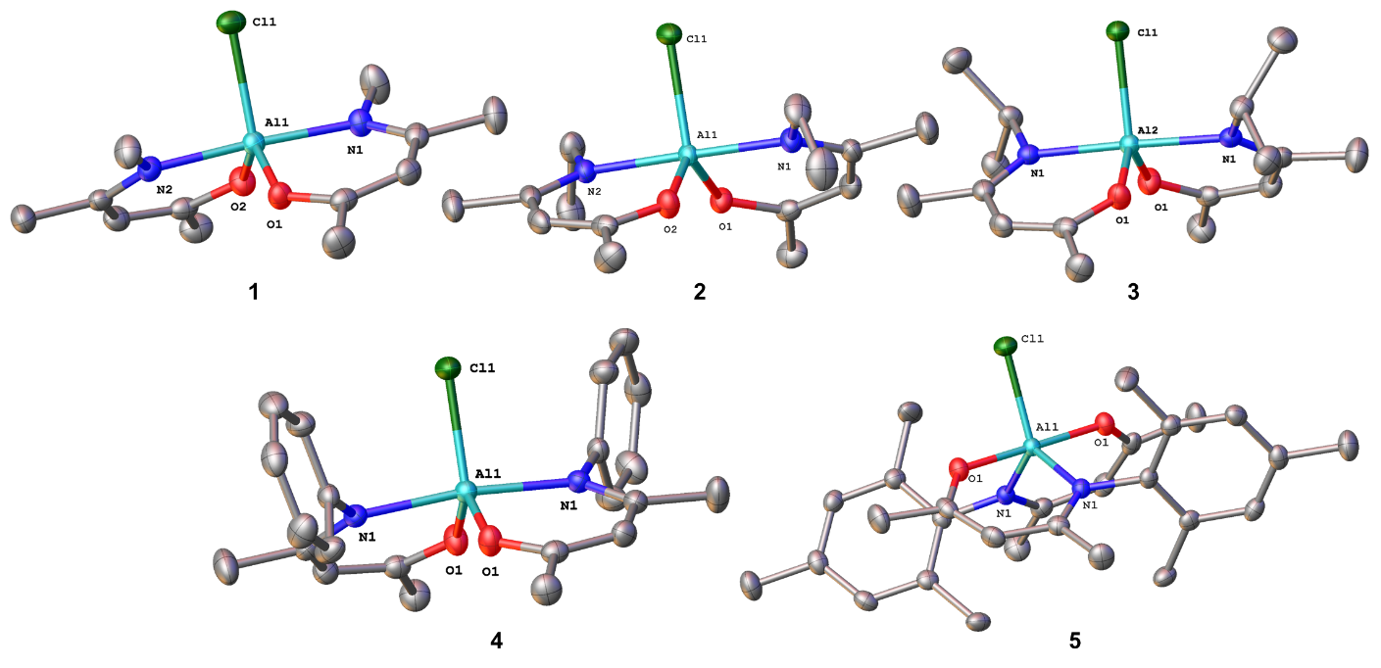
Figure S1: Molecular structures of compounds Al(R-acnac)₂Cl], where R = Me (1), Et (2), ^{i}Pr (3), Ph (4) and Mes (5). Thermal ellipsoids are drawn at 50% probability and hydrogen atoms are omitted for clarity.

1.6. Li[AlH₂(^{i}Pr-Hacnac)AlH₃]_{n} (6)

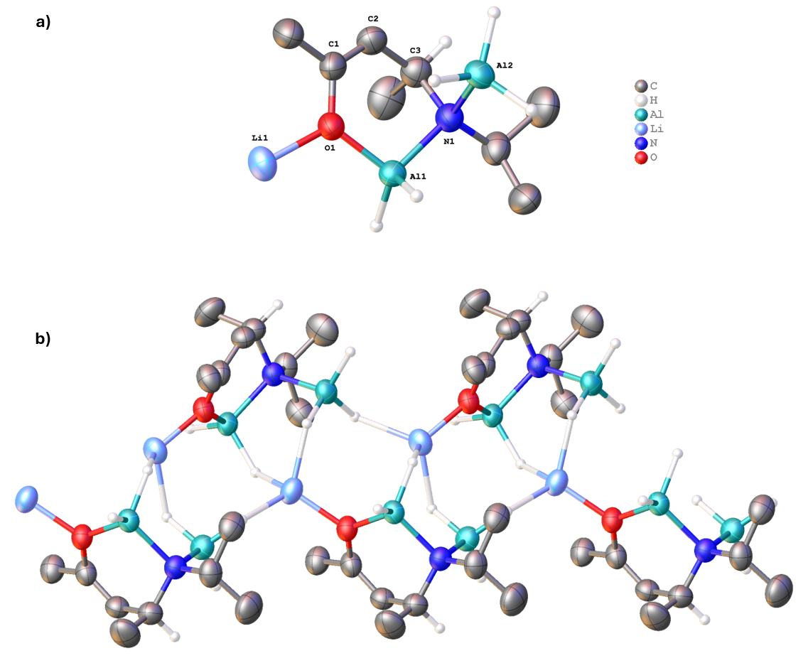

Figure S2: a) Repeating unit of 6; b) Extended polymeric structure of Li[AlH₂(^{i}Pr-Hacnac)AlH₃]_{n} (6). Thermal ellipsoids pictured at 50% probability. Some hydrogen atoms omitted for clarity. Selected bond lengths (Å): O1–Li1: 1.914(9); O1–Al1: 1.786(4); O1–C1: 1.376(6); C1–C2: 1.327(7); C2–C3: 1.502(7); C3–N1: 1.521(7); N1–Al1: 1.937(4); N1–Al2: 1.969(4).

1.7. [Li(12-crown-4][AlH₂(^{i}Pr-Hacnac)AlH₃] (7)

Scheme S1: Reaction of one equivalent of the polymer Li[AlH₂(R-Hacnac)AlH₃]_{n} (6) with a slight excess of 12-crown-4 to isolate the corresponding monomeric structure [Li(12-crown-4][AlH₂(^{i}Pr-Hacnac)AlH₃] (7).

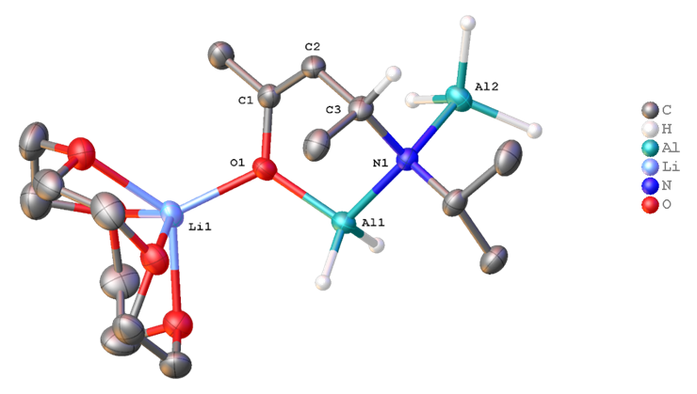
Figure S3: Molecular structure of [Li(12-crown-4][AlH₂(^{i}Pr-Hacnac)AlH₃] (7). Thermal ellipsoids pictured at 50% probability. Some hydrogen atoms omitted for clarity. Selected bond lengths (Å): O1–Li1: 1.937(5); O1–Al1: 1.795(2); O1–C1: 1.373(3); C1–C2: 1.333(4); C2–C3: 1.504(4); C3–N1: 1.523(4); N1–Al1: 1.952(2); N1–Al2: 1.993(2).

Compound 7 crystallises in the orthorhombic space group P2₁2₁2₁. The structure is a monomer featuring one chelating bidentate β-ketoiminate ligand bonding to one aluminium atom via both oxygen and nitrogen atoms and the backbone of the ligand remains protonated compared to the polymeric structure 6, therefore rendering the ligand not planar due to the presence of the chiral C3 carbon. The nitrogen atom remains additionally coordinated to a second aluminium that is now terminal, and the oxygen atom also remains bound to a lithium atom, but the latter now sits isolated in the electron-rich cavity of the 12-crown-4 sequestering agent. Both aluminium atoms adopt a tetrahedral geometry.
In comparison to the extended structure of 6, a slight lengthening of the O1–Al1 bond (1.795(2) for 7 and 1.786(4) for 6) is observed in the isolated monomer. A slight lengthening is also observed for the O1–Li1 and N1–Al2 bonds (1.937(5) and 1.993(2) in 7 compared to 1.914(9) and 1.969(4) for 6) while all other bonds remained similar.

1.8. [AlH₂AlH₂(N–Mes)₃(AlH₂ ּ Li(Et₂O)₂)₂] (8)
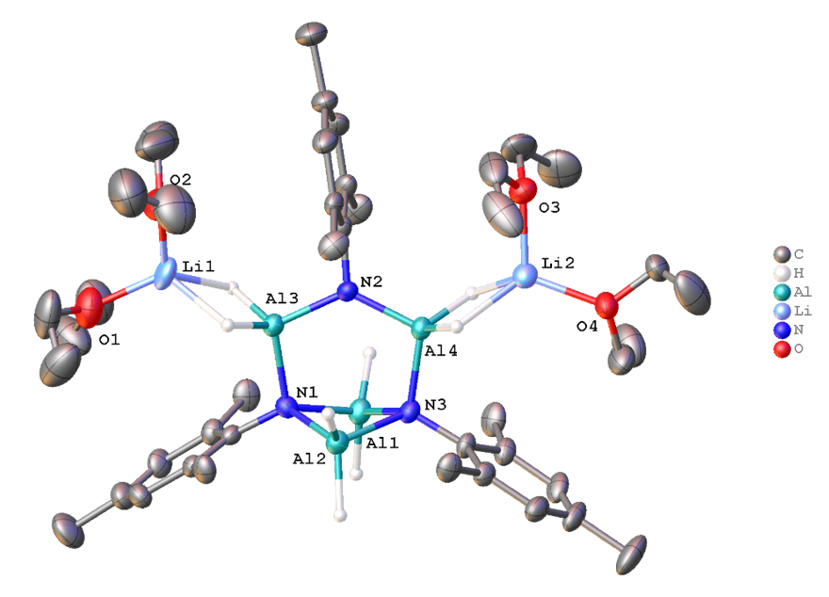
Figure S4: Molecular structure of [AlH₂AlH₂(N–Mes)₃(AlH₂ ּ Li(Et₂O)₂)₂] (8). Thermal ellipsoids pictured at 50% probability. Some hydrogen atoms omitted for clarity. Selected bond lengths (Å) and angles (deg): Al1–N1: 1.963(4); Al1–N3: 1.963(4); Al2–N1 1.977(4); Al2–N3: 1.956(4); N1–Al3: 1.902(4); Al3–N2: 1.815(4); N2–Al4: 1.816(4); Al4–N3: 1.903(4); Al3–N2–Al4: 128.7(2); Al3–N2–C10: 111.4(3); Al4–N2–C10 119.9(3).

2. Experimental details
2.1. General experimental details
All reactions and product manipulations were performed using standard Schlenk-line and glovebox techniques, both using N₂ as the inert gas. All glassware used in air-sensitive reactions were flamed dried prior to use.
All reagents were procured from Sigma Aldrich/Merck and used as received unless otherwise stated. All non-deuterated solvents were stored under N₂ in gas-tight ampoules over activated molecular sieves (3 or 4Å).⁵ Deuterated solvents were obtained from Cambridge Isotope Laboratories or Sigma Aldrich/Merck and were degassed before use and stored over 3Å molecular sieves. Amines were used as received for ligand synthesis and the β-ketokiminate ligands were synthesised according to previously reported literature from the group.⁶ LiAlH₄ powder, reagent grade 95%, was procured from Sigma Aldrich and purified by dissolution and recrystallisation from diethyl ether using a literature procedure.⁷
NMR spectroscopy: NMR samples were prepared inside an inert atmosphere glovebox in NMR tubes fitted with a gas-tight valve when necessary. ¹H and ¹³C{¹H} NMR spectra were collected on Bruker 400, 500 or 600 MHz NMR instruments at 298 K. ¹H and ¹³C{¹H} NMR spectra are reported relative to tetramethylsilane (TMS) and referenced to the most downfield residual solvent resonance where possible (d₆-benzene (C₆D₆): δ_{H} = 7.16 ppm, δ_{C} = 128.06 ppm). ¹H and ¹³C{¹H} NMR assignments were confirmed by ¹H–¹H (COSY) and ¹H–¹³C (HSQC and HMBC) experiments where necessary. Data analysis was performed using either MestreNova or TopSpin software.
Elemental Analysis (CHN): used to determine the percentage of C, H and N in each sample using a Carlo Erba CE1108 Elemental Analyser (London Metropolitan University). Samples were submitted in a vial inside a vial prepared in the glovebox.
Mass spectroscopy: compounds were dissolved in dry toluene, ionised using electrospray ionisation and detected in positive (ESI+) or negative mode (ESI-) on a Waters LCT Premier XE.
Thermogravimetric Analysis (TGA): Measurements were made using a PerkinElmer STA6000 TGA. The instrument had a sensitivity of 0.1 mg and used N₂ as shield gas. Samples were prepared in a glovebox, where they were placed in 85 μL aluminium pans and sealed. The pans were pierced just before measurement to allow for mass loss. The samples were heated from 30 °C (room temperature) up to a maximum of 500 °C, at a heating rate of 5−10 °C min^{–1} and under flow of shield gas (N₂).
Infrared Spectroscopy: ATR-IR spectra were recorded on a Shimadzu IRAffinity-1S Fourier Transform Infrared Spectrophotometer.
Single crystal X-ray diffraction (SCXRD): Single crystal X-ray diffraction data was collected using a SuperNova Atlas (Dual) diffractometer. Suitable crystals were selected under Foblin oil and mounted on a nylon loop. Data was collected at 150 K, using Cu Kα radiation (λ = 1.54184 Å). Structures were solved using Olex2 software.⁸ The structure of compounds 1-4 and 7 was solved with the olex2.solve⁹ structure solution program using Charge Flipping and refined with the olex2.refine⁹ refinement package using Gauss-Newton minimisation. The structure of 5 was solved with the olex2.solve⁹ structure solution program using Charge Flipping and refined with the ShelXL¹⁰ refinement package using Least Squares minimisation. 6 the structure was solved with the Unknown [2] structure solution program using Unknown and refined with the ShelXL¹⁰ refinement package using Least Squares minimisation. 8 was solved with the ShelXT ¹¹ structure solution program using Intrinsic Phasing and refined with the ShelXL ¹⁰ refinement package using Least Squares minimisation. Crystallographic details for 1-8 are available from the CSD (website) numbers: CSD-2405550-2405557

2.2. Synthesis of bis β-ketoiminate aluminium chloride compounds ([Al(R-acnac)₂Cl])
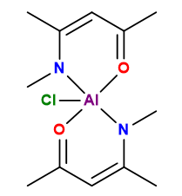
[Al(MeCN(Me)CHC=OMe)₂Cl] ([Al(Me-acnac)₂Cl], 1)
LiHMDS (1.02 g, 6.10 mmol) in 20 mL toluene was added to a solution of Me-acnacH (0.68 g, 6.01 mmol) in 20 mL toluene at −78 °C. The reaction mixture was stirred at room temperature overnight to form a transparent, pale-yellow solution. The volatiles were removed under vacuo to produce a pale-yellow solid, which was re-dissolved in 20 mL toluene and added to a slurry of AlCl₃ (0.40 g, 3.00 mmol) in 20 mL toluene at −78 °C. The reaction mixture was stirred at room temperature overnight to form a cloudy, pale-yellow solution, which was filtered, and the clear pale-yellow filtrate concentrated and stored at −20 °C. Overnight, white crystals suitable for single crystal X-ray measurement precipitated. The crystals were separated from the supernatant solution and dried under reduced pressure. Yield: 0.82 g (95%).
¹H NMR (500 MHz, C₆D₆) δ 4.81 (s, 2H, CH), 3.11 (s, 6H, CH₃), 1.79 (s, 6H, CH₃CO), 1.30 (s, 6H, CH₃CN).
¹³C{¹H} NMR (C₆D₆, 126 MHz) δ 173.92 (CH₃CO), 171.80 (CH₃CN), 100.57 (CH), 37.31 (CH₃), 24.82 (CH₃CO), 20.91 (CH₃CN).
MS: m/z [ESI+] 251 [M – Cl]⁺ .
CHN: Found (Calcd.) for C₁₂H₂₀O₂N₂AlCl: 50.11 (50.27), 7.07 (7.03), 9.50 (9.77).

Figure S5: ¹H NMR spectrum of a C₆D₆ solution of ([Al(Me-acnac)₂Cl], (1).

Figure S6: ¹³C{¹H} NMR spectrum of a C₆D₆ solution of ([Al(Me-acnac)₂Cl], (1).
Figure S7: COSY NMR spectrum of a C₆D₆ solution of ([Al(Me-acnac)₂Cl], (1).
Figure S8: HSQC NMR spectrum of a C₆D₆ solution of ([Al(Me-acnac)₂Cl], (1).
Figure S9: HMBC NMR spectrum of a C₆D₆ solution of ([Al(Me-acnac)₂Cl], (1).
[Al(MeCN(Et)CHC=OMe)₂Cl] ([Al(Et-acnac)₂Cl], 2)
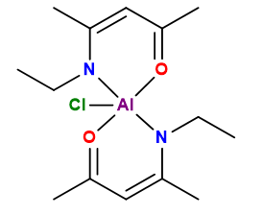
LiHMDS (1.00 g, 5.98 mmol) in 20 mL toluene was added to a solution of Et-acnacH (0.77 g, 6.05 mmol) in 20 mL toluene at −78 °C. The reaction mixture was stirred at room temperature overnight to form a transparent, pale-yellow solution. The volatiles were removed in vacuo to produce a pale-yellow solid, which was re-dissolved in 20 mL toluene and added to a slurry of AlCl₃ (0.40 g, 3.00 mmol) in 20 mL toluene at −78 °C. The reaction mixture was stirred at room temperature overnight to form a cloudy, pale-yellow solution, which was filtered to produce a clear solution of the same colour. The solvent was removed in vacuo to yield a pale-yellow solid, which was recrystallised from hexane and toluene overnight at −20 °C. White crystals suitable for single crystal X-ray measurement precipitated. The crystals were separated from the supernatant solution and dried under reduced pressure. Yield: 0.79 g (84%).
¹H NMR (C₆D₆, 500 MHz) δ 4.81 (2H, s, CH), 3.88 (2H, s, CH₂), 3.41 (2H, s, CH₂), 1.78 (6H, s, CH₃CO), 1.47 (6H, s, CH₃CN), 1.20 (6H, t, J = 7.1 Hz, CH₃).
¹³C{¹H} NMR (C₆D₆, 126 MHz) δ 173.33 (CH₃CO), 171.37 (CH₃CN), 100.99 (CH), 44.30 (CH₂), 24.60 (CH₃CO), 20.34 (CH₃CN), 15.30 (CH₃).
MS: m/z [ESI+] 315 [M]⁺, 279 [M – Cl]⁺.
CHN: Found (Calcd.) for C₁₄H₂₄O₂N₂AlCl: 52.95 (53.42), 7.72 (7.68), 8.72 (8.90).
Figure S10: ¹H NMR spectrum of a C₆D₆ solution of ([Al(Et-acnac)₂Cl], (2).
Figure S11: ¹³C{¹H} NMR spectrum of a C₆D₆ solution of ([Al(Et-acnac)₂Cl], (2).
Figure S12: COSY NMR spectrum of a C₆D₆ solution of ([Al(Et-acnac)₂Cl], (2).
Figure S13: HSQC NMR spectrum of a C₆D₆ solution of ([Al(Et-acnac)₂Cl], (2).
Figure S14: HMBC NMR spectrum of a C₆D₆ solution of ([Al(Et-acnac)₂Cl], (2).
[Al(MeCN(^{i}Pr)CHC=OMe)₂Cl] ([Al(^{i}Pr-acnac)₂Cl], 3)
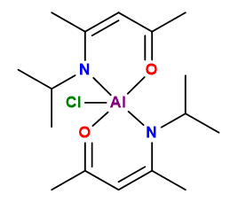
LiHMDS (0.58 g, 3.47 mmol) in 20 mL toluene was added to a solution of ^{i}Pr-acnacH (0.54 g, 3.85 mmol) in 20 mL toluene at −78 °C. The reaction mixture was stirred at room temperature overnight to form a cloudy, pale-yellow solution. The volatiles were removed in vacuo to produce a pale-yellow solid, which was redissolved in 20 mL toluene and added to a slurry of AlCl₃ (0.23 g, 1.72 mmol) in 20 mL toluene at −78 °C. The reaction mixture was stirred at room temperature overnight to form a cloudy, pale-yellow solution, which was filtered, with the clear pale-yellow filtrate concentrated and stored at −20 °C. Overnight, white crystals suitable for single crystal X-ray measurement precipitated. The crystals were separated from the supernatant solution and dried under reduced pressure. Yield: 0.51 g (86%).
¹H NMR (C₆D₆, 600 MHz) δ 4.75 (s, 2H, CH), 4.57 (br s, 2H, CH(CH₃)2), 1.76 (s, 6H, CH₃CO), 1.65 (s, 6H, CH₃CN), 1.41 (br s, 12H, CH₃).
¹³C{¹H} NMR (C₆D₆, 151 MHz) δ 171.90 (CH₃CO), 170.58 (CH₃CN), 101.77 (CH), 51.26 (CH(CH₃)2), 24.52 (CH₃CO), 23.66 (CH₃CN), 22.47, 21.85 (CH₃).
MS: m/z [ESI+] 283 [M – Al – Cl + 3H]⁺.
CHN: Found (Calcd.) for C₁₆H₂₈O₂N₂AlCl: 55.85 (56.05), 8.33 (8.23), 8.12 (8.17).
Figure S15: ¹H NMR spectrum of a C₆D₆ solution of ([Al(^{i}Pr-acnac)₂Cl], (3).

Figure S16: ¹³C{¹H} NMR spectrum of a C₆D₆ solution of ([Al(^{i}Pr-acnac)₂Cl], (3).
Figure S17: COSY NMR spectrum of a C₆D₆ solution of ([Al(^{i}Pr-acnac)₂Cl], (3).

Figure S18: HSQC NMR spectrum of a C₆D₆ solution of ([Al(^{i}Pr-acnac)₂Cl], (3).
Figure S19: HMBC NMR spectrum of a C₆D₆ solution of ([Al(^{i}Pr-acnac)₂Cl], (3).

[Al(MeCN(Ph)CHC=OMe)₂Cl] ([Al(Ph-acnac)₂Cl], 4)
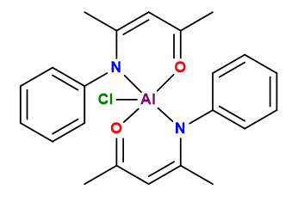
LiHMDS (1.00 g, 5.98 mmol) in 20 mL toluene was added to a solution of Ph-acnacH (1.11 g, 6.37 mmol) in 20 mL toluene at −78 °C. The reaction mixture was stirred at room temperature overnight to form a cloudy, pale-yellow solution. The volatiles were removed in vacuo to produce a pale-yellow solid, which was re-dissolved in 20 mL toluene to reform a cloudy, pale-yellow solution which was added to a slurry of AlCl₃ (0.40 g, 3.00 mmol) in 20 mL toluene at −78 °C. The reaction mixture was stirred at room temperature overnight to form a cloudy, pale-yellow solution, which was filtered, with the clear pale-yellow filtrate concentrated and stored at −20 °C. Overnight, white crystals suitable for single crystal X-ray measurement precipitated. The crystals were separated from the supernatant solution and dried under reduced pressure. Yield: 0.64 g (52%).
¹H NMR (C₆D₆, 500 MHz) δ 7.67, 7.16-6.99 (10H, m, Ar–H), 4.88 (3H, s, CH), 1.47 (6H, s, CH₃CO), 1.36 (6H, s, CH₃CN).
¹³C{¹H} NMR (C₆D₆, 126 MHz) δ 176.87 (CH₃CO), 173.03 (CH₃CN), 149.01, 126.62, 125.23 (Ar–C), 100.74 (CH), 24.02 (CH₃CO), 23.41 (CH₃CN).
MS: m/z [ESI+] 411 [M]⁺, 375 [M – Cl]⁺.
CHN: Found (Calcd.) for C₂₂H₂₄O₂N₂AlCl: 62.83 (64.31), 5.80 (5.89), 6.54 (6.82).

Figure S20: ¹H NMR spectrum of a C₆D₆ solution of ([Al(Ph-acnac)₂Cl], (4).

Figure S21: ¹³C{¹H} NMR spectrum of a C₆D₆ solution of ([Al(Ph-acnac)₂Cl], (4).
Figure S22: COSY NMR spectrum of a C₆D₆ solution of ([Al(Ph-acnac)₂Cl], (4).

Figure S23: HSQC NMR spectrum of a C₆D₆ solution of ([Al(Ph-acnac)₂Cl], (4).
Figure S24: HMBC NMR spectrum of a C₆D₆ solution of ([Al(Ph-acnac)₂Cl], (4).

[Al(MeCN(Mes)CHC=OMe)₂Cl] ([Al(Mes-acnac)₂Cl], 5), where Mes = 2,4,6-trimethylphenyl
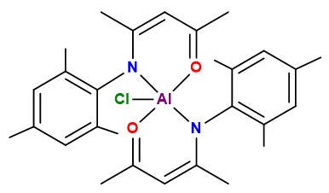
LiHMDS (1.00 g, 5.98 mmol) dissolved in 20 mL toluene was added to a solution of Mes-acnacH (1.37 g, 6.33 mmol) in 20 mL toluene at −78 °C. The reaction mixture was stirred at room temperature overnight to form a transparent, pale-yellow solution. The volatiles were removed in vacuo to produce a pale-yellow solid, which was re-dissolved in 20 mL toluene and added to a slurry of AlCl₃ (0.40 g, 3.00 mmol) in 20 mL toluene at −78 °C. The reaction mixture was stirred at room temperature overnight to form a cloudy, pale-yellow solution, which was filtered, with the clear pale-yellow filtrate concentrated and stored at −20 °C. Overnight, white crystals suitable for single crystal X-ray measurement precipitated. The crystals were separated from the supernatant solution and dried under reduced pressure. Yield: 0.78 g (53%).
¹H NMR (C₆D₆, 500 MHz) δ 6.84 (1H, s, Ar–H), 6,75 (1H, s, Ar–H), 4.97 (2H, s, CH), 2.52 (3H, s, CH₃), 2.19 (3H, s, CH₃), 2.00 (3H, s, CH₃), 1.35 (6H, s, CH₃CO), 1.29 (6H, s, CH₃CN).
¹³C{¹H} NMR (C₆D₆, 126 MHz) δ 181.53 (CH₃CO), 176.50 (CH₃CN), 146.01, 134.13, 133.55, 131.23, 129.81, 128.53, 128.35 (Ar–C), 99.91 (CH), 24.24 (CH₃CO), 23.80 (CH₃CN), 20.86, 19.45, 18.96 (CH₃).
MS: m/z [ESI-] 466 [M–Al–H]⁻.
CHN: Found (Calcd.) for C₂₈H₃₆O₂N₂AlCl: 66.47 (67.94), 7.27 (7.33), 5.50 (5.66).

Figure S25: ¹H NMR spectrum of a C₆D₆ solution of ([Al(Mes-acnac)₂Cl], (5).

Figure S26: ¹³C{¹H} NMR spectrum of a C₆D₆ solution of ([Al(Mes-acnac)₂Cl], (5).

Figure S27: COSY NMR spectrum of a C₆D₆ solution of ([Al(Mes-acnac)₂Cl], (5).
Figure S28: HSQC NMR spectrum of a C₆D₆ solution of ([Al(Mes-acnac)₂Cl], (5).
Figure S29: HMBC NMR spectrum of a C₆D₆ solution of ([Al(Mes-acnac)₂Cl], (5).
Li[AlH₂(^{i}Pr-acnacH)AlH₃]_{n} (6)
5mL of diethyl ether was added to 0.153 mg (0.447 mmol) of [Al(^{i}Pr-acnac)₂Cl]. In another Schlenk, 10 mL of diethyl ether was added to 50.9 mg (1.34mmol) of LiAlH₄ to form a cloudy colourless solution. The LiAlH₄ was dropwise added to the [Al(^{i}Pr-acnac)₂Cl] mixture at −78°C. The mixture was stirred at low temperature for one hour, then the cold bath was removed and the mixture stirred for further one hour. The colourless solution was filtered and the volatiles removed under reduced pressure to obtain a white solid. The solid was redissolved in ether and layered with hexane to obtain colourless crystals of the product. Crystalline yield: 25 mg (27%).
IR (cm⁻¹): 2969, 1834, 1738 [ν(Al−H)], 1658, 1373, 1314, 957, 887, 697, 613.
CHN: Found (Calcd.) for C₈H₁₈Al₂LiNO: 44.91(46.84), 9.25(8.84), 6.34(6.83).

Figure S30: IR spectrum of Li[AlH(^{i}Pr-acnacH)AlH₃]_{n}, (6).

[AlH₂AlH₂(N-Mes)₃(AlH₂ ּ Li(Et₂O)₂] (8)
40 mL of diethyl ether was added to 0.725 g (1.46 mmol) of [Al(Mes-acnac)₂Cl] to form a cloudy solution. In another Schlenk, 50 mL of diethyl ether was added to 166.7 mg (4.39 mmol) of LiAlH₄. The cloudy solution of LiAlH₄ was dropwise added to [Al(Mes-acnac)₂Cl] at −78°C. The mixture was stirred at low temperature for one hour, then the cold bath was removed and the mixture stirred for further 1.5 hours. The colourless solution was filtered and the volatiles removed under reduced pressure to form a foamy sticky solid that can be broken into a white powder when dipped into liquid nitrogen. The solid was redissolved in ether to obtain colourless crystals of the product at room temperature. Crystalline yield: 72.4 mg (6 %).
¹H NMR (C₆D₆, 500 MHz) δ 6.78 (1H, d, Ar–H), 6.74 (1H, d, Ar–H), 4.47 (s, AlH₂ ּ Et₂O), 4.22 (br s, AlH₂–NMes), 3.18 (q, O(CH₂CH₃)₂), 2.81 (3H, s, o-CH₃), 2.77 (3H, s, o-CH₃), 2.10 (3H, s, p-CH₃), 1.04 (t, O(CH₂CH₃)₂).
¹³C{¹H} NMR (C₆D₆, 126 MHz) δ 144.9 (C_{Ar}–N), 132.5, 132.07, 131.37, 131.27 (o-C_{Ar} and m-C_{Ar}), 130.89 (p-C_{Ar}), 66.38 (O(CH₂CH₃)₂), 25.79 (o-CH₃), 22.44 (o-CH₃), 20.64 (p-CH₃), 15.63 (O(CH₂CH₃)₂).
⁷Li NMR (C₆D₆, 194 MHz) δ 0.44 (bs)
²⁷Al NMR (C₆D₆, 130 MHz) δ 70.92 (bs)
IR (cm⁻¹): 2975, 2906, 1783 [ν(Al−H)], 1654, 1662, 1472, 1198, 1136, 823, 738, 673.
CHN: Found (Calcd.) for C₄₃H₈₁Al₄Li₂N₃O₄: 59.92(62.53), 8.78(9.89), 5.24(5.09).

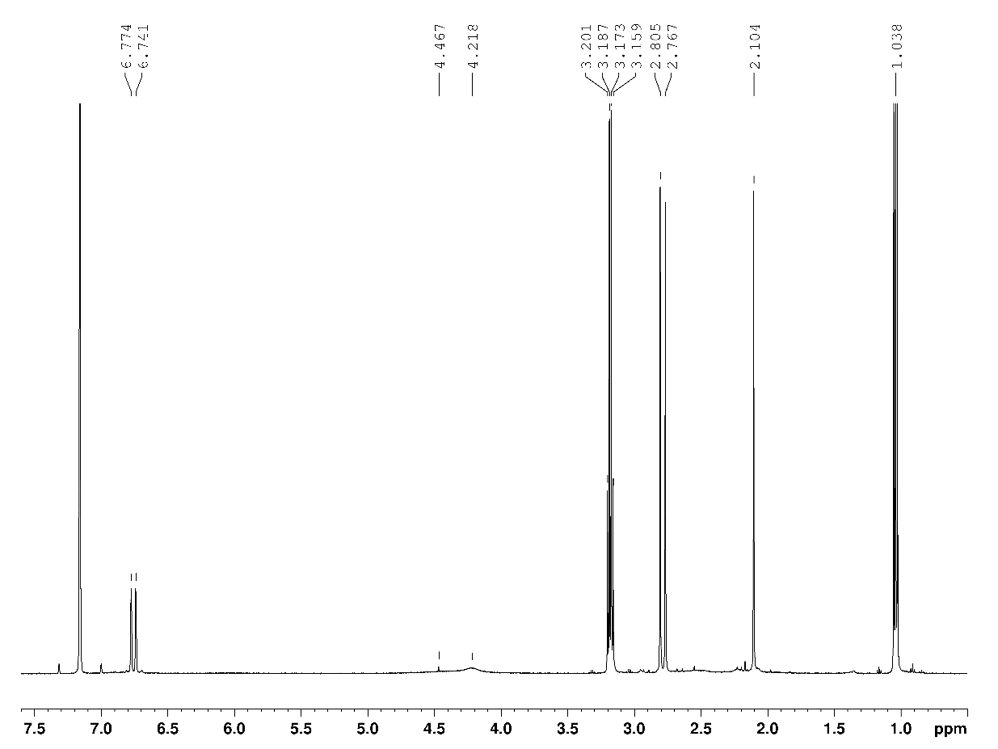
Figure S31: ¹H NMR spectrum of a C₆D₆ solution of [AlH₂AlH₂(N-Mes)₃(AlH₂ ּ Li(Et₂O)₂)₂] (8).
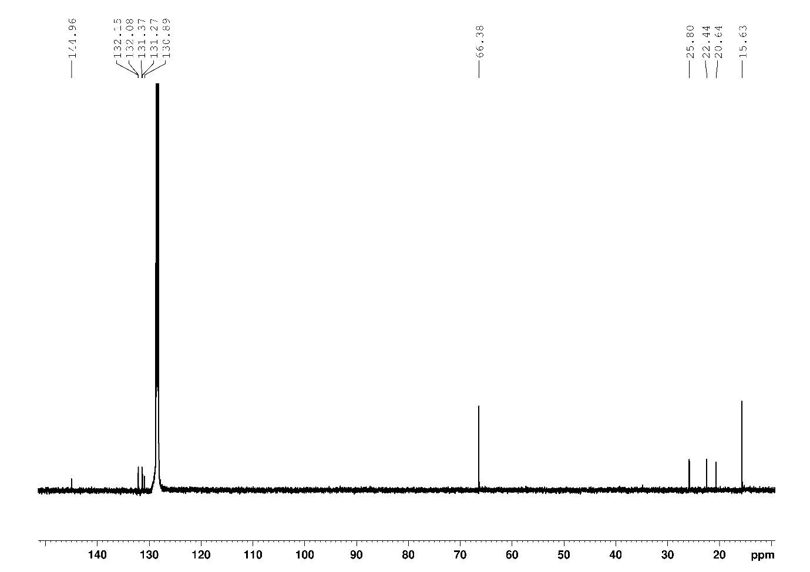
Figure S32: ¹³C{¹H} NMR spectrum of a C₆D₆ solution of [AlH₂AlH₂(N-Mes)₃(AlH₂ ּ Li(Et₂O)₂)₂] (8).
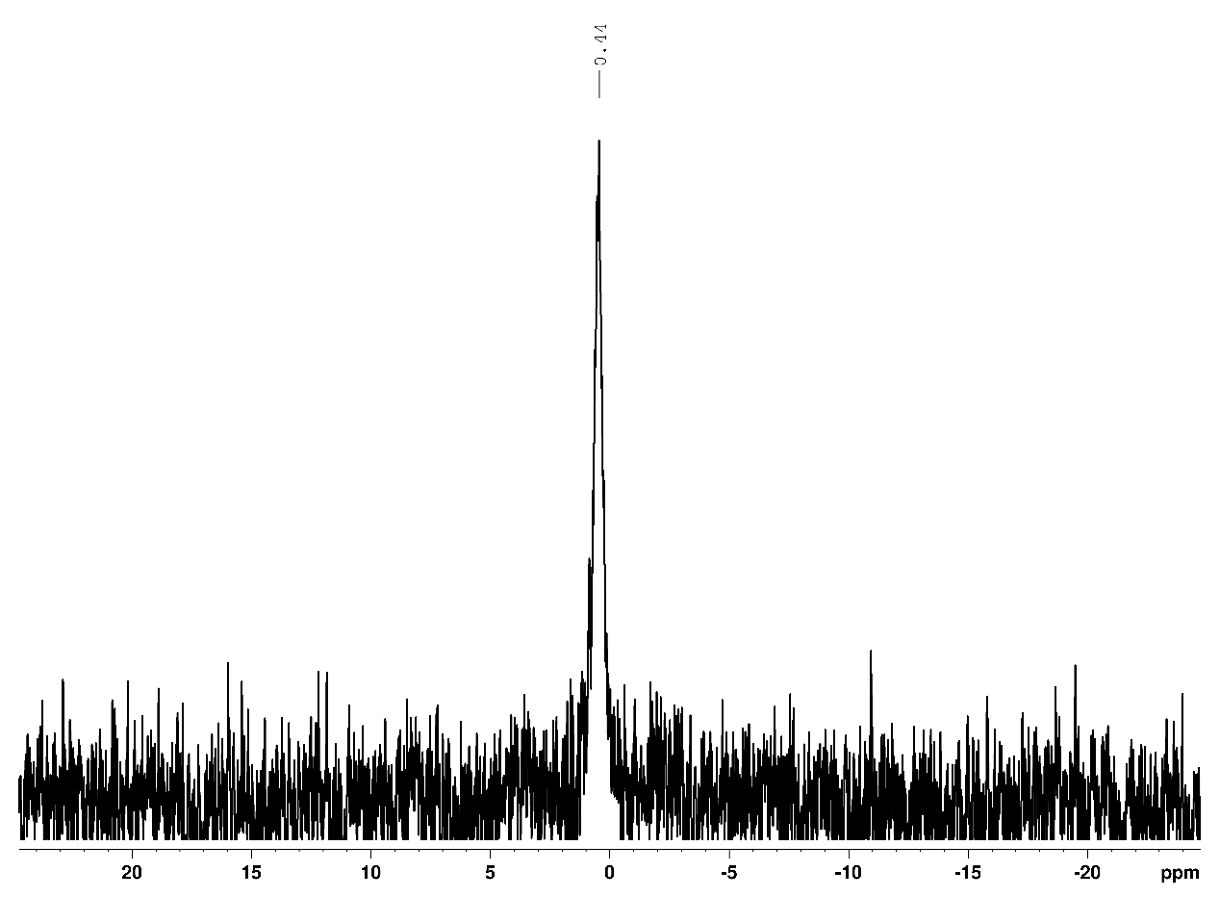
Figure S33: ⁷Li NMR spectrum of a C₆D₆ solution of [AlH₂AlH₂(N-Mes)₃(AlH₂ ּ Li(Et₂O)₂)₂] (8).
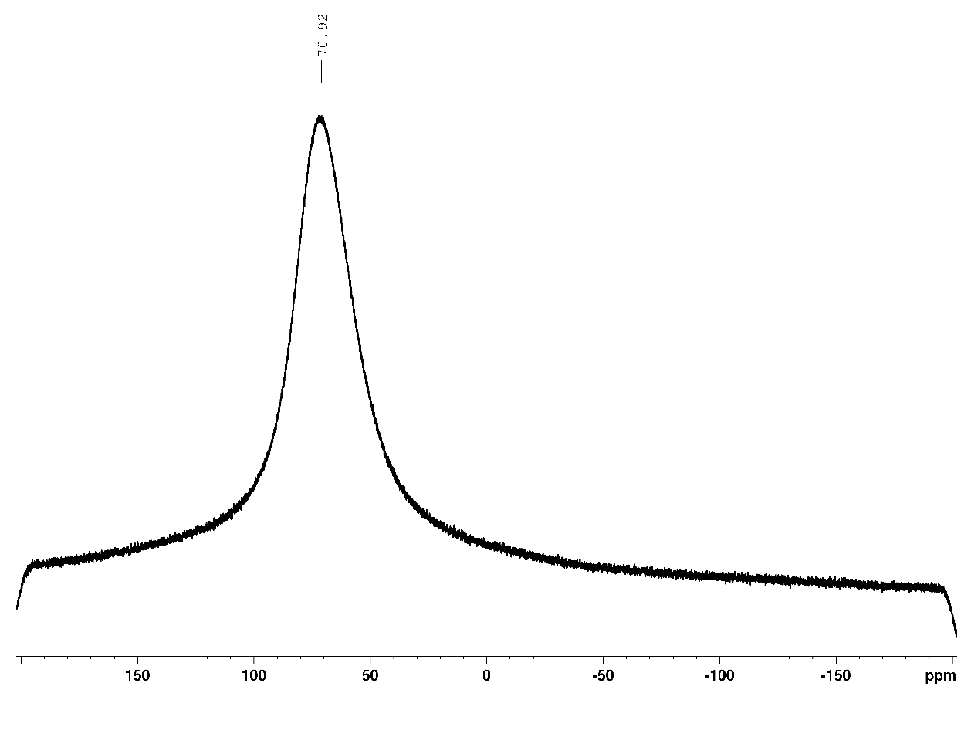
Figure S34: ²⁷Al NMR spectrum of a C₆D₆ solution of [AlH₂AlH₂(N-Mes)₃(AlH₂ ּ Li(Et₂O)₂)₂] (8).

Figure S35: IR spectrum of [AlH₂AlH₂(N-Mes)₃(AlH₂ ּ Li(Et₂O)₂)₂] (8).

Alternative route to obtain [AlH₂AlH₂(N-Mes)₃(AlH₂ ּ Li(Et₂O)₂] (8)
0.5 mL (3.70 mmol) of 2,4,6-trimethylaniline (NH₂–Mes) degassed prior use by the freeze, pump, thaw method was dissolved in 10 mL of diethyl ether in one Schlenk and added to another Schlenk containing 187 mg (4.93 mmol) of LiAlH₄ and 40 mL of diethyl ether at −78 °C. The mixture was stirred in the cold bath for 15 minutes, then the cold bath was removed and the mixture allowed to stir for further 40min. The resulting colourless solution was filtered the solvent removed to obtain a white foam that was turned into a solid by dipping the flask under vacuum in liquid nitrogen. Colourless crystals were obtained from diethyl ether at room temperature. Yield: 0.352 g (34%).
Scheme S2: Reaction of three equivalents of NH₂–Mes with four equivalents of LiAlH₄ to alternatively obtain compound 8.
3. Thermal analysis
3.1. Thermal decomposition analysis of the bis(β-ketoiminate) aluminium chloride compounds [Al(R-acnac)₂Cl] (1-5)
The thermal decomposition properties of the bis(β-ketoiminate) aluminium chloride compounds 1−5 were investigated by thermogravimetric analysis (TGA) to access their suitability to act as precursors for the deposition of metallic features. Inspection of the thermogravimetric analysis of all [Al(R-acnac)₂Cl] complexes (Figure S36) reveal that a simple variation of the R group of the N-substituted ligand directly affects the thermal properties of the resulting complexes.
Promisingly, most complexes exhibit the beginnings of significant mass loss within the desired temperature window of 50−200 °C. Complex 1 (R = Me) exhibits significant mass loss beginning at 166 °C, complex 2 (R = Et) at 116 °C, 3 (R = ^{i}Pr) at 186 °C and 4 (R = pH) at 199 °C, while complex 5 (R = Mes), starts decomposing at 278 °C.

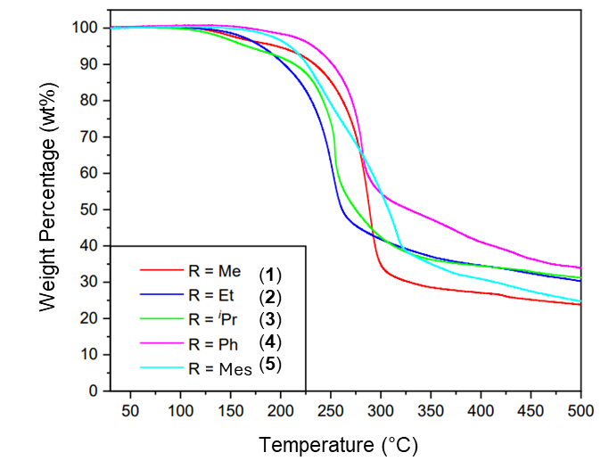
Figure S36: Overlapping thermograms of compounds 1-5.

3.2. Thermal decomposition analysis of the aluminium hydride compounds 6

Figure S37: Overlapping thermogram (full grey line) and derivative (dashed pink line) of compound 6.

4. Powder X-Ray Diffraction
All PXRD experiments were performed on glass capillaries sealed with wax.
4.1. Room temperature PXRD
Figure S38: PXRD of 6 (measured with Mo kα).

Figure S39: PXRD of crystalline 8 (measured with Mo kα).
Figure S40: PXRD of the mixture of synthons of 8 (measured with Cu kα).

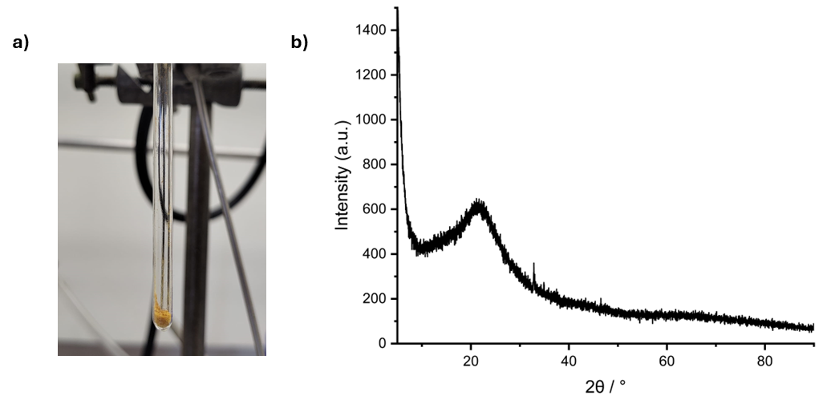
Figure S41: a) Cluster 8 after heating under nitrogen highlighting the clear colour change from white to light brown confirming the need to use vacuum to obtain a solid containing aluminium metallic; b) PXRD of the light brown solid (measured with Cu kα).

4.2. Variable-temperature PXRD
Variable-temperature PXRD (Mo kα) was measured for a wax-sealed sample under nitrogen. Changes onset at 50°C, agreeing with the TGA behaviour, with the disappearance of the peak at 15.69° and emergence of a peak at 13.53°. The crystalline structure remains stable until 80°C where several transformations are seen, firstly with the precursor peaks disappearing and a new peak emerging at 15.65°, while at 90°C, the onset of weight loss in the TGA, a new crystalline phase is transiently formed with two peaks at 8.87° and 12.50°, which are lost at 100°C, where only the 13.53° peak remains, followed at 110°C by the formation of a peak at 15.50°. The structure then remains stable to 150°C and ex-situ heating to 200°C (measured with Cu kα) shows that this final phase remains stable.

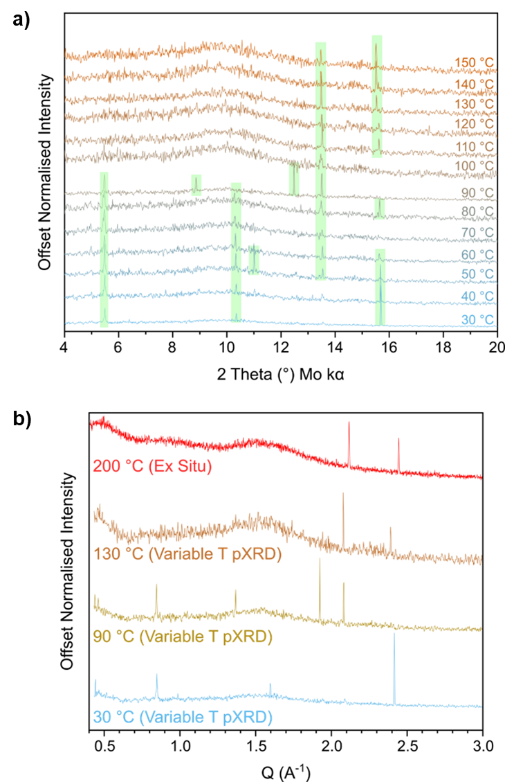
Figure S42: Degradation of 8 under nitrogen atmosphere. (a) Variable-temperature PXRD of wax sealed capillary sample heated in 10°C increments between scans, data normalised and offset for clarity. Green shaded backgrounds used to highlight emerging/lost peaks as temperature increases. (b) Sample of 8 heated to 200°C under nitrogen and cooled to room temperature (measured by Cu PXRD), in comparison to data from variable temperate experiment (Mo PXRD), plotted versus Q to provide a common x-scale.

5. X-Ray Photoelectron Spectroscopy (XPS)
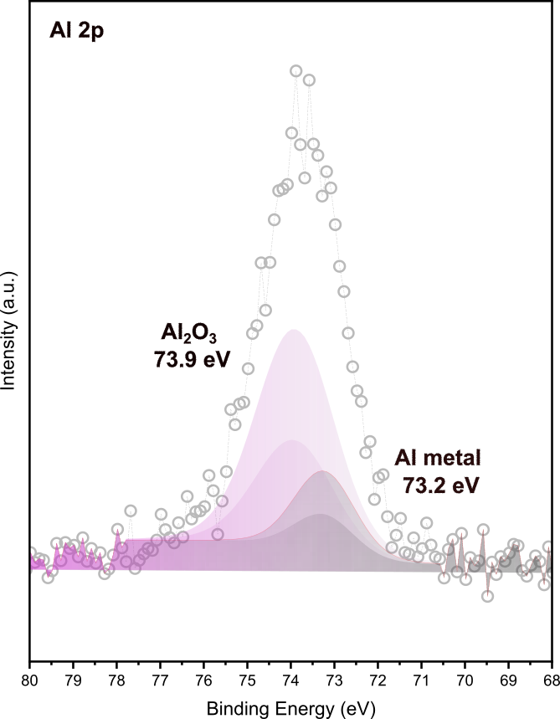
Figure S43: Al 2p XPS of the grey solid obtained from 8: aluminium metal (Al) at 73.2 eV and aluminium oxide (Al₂O₃) at 73.9 eV.

6. Air- and moisture stability test of cluster 8 and dimethyl amine alane (DMEAA)
To probe the superior user-friendly character of cluster 8 compared to alanes, dimethylamine alane (DMEAA) was chosen as a model alane compound since it is more stable than AlH₃ alone. Both compounds were exposed to air and dropped onto a tissue and their stability was evaluated.
When a hexane solution of DMEAA was used, signs of pyrophoricity could already be identified as soon as the port of the glove box was opened to air as the solution started fuming. Subsequent dropping of the solution onto a tissue paper in air, lead to immediate ignition of the paper. (VIDEO LINK). A comparable test with a toluene suspension of 8 leads to no visible effects. (VIDEO LINK)

7. Transmission electron microscopy (TEM)
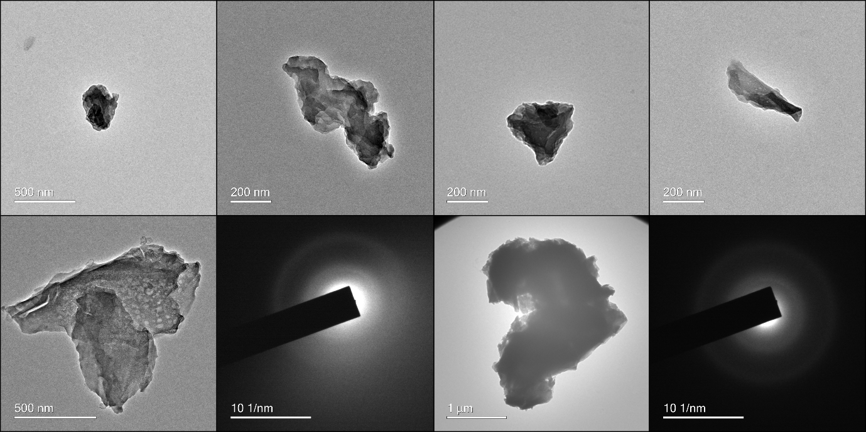
Figure S44: TEM micrographs of the cluster precursor 8.

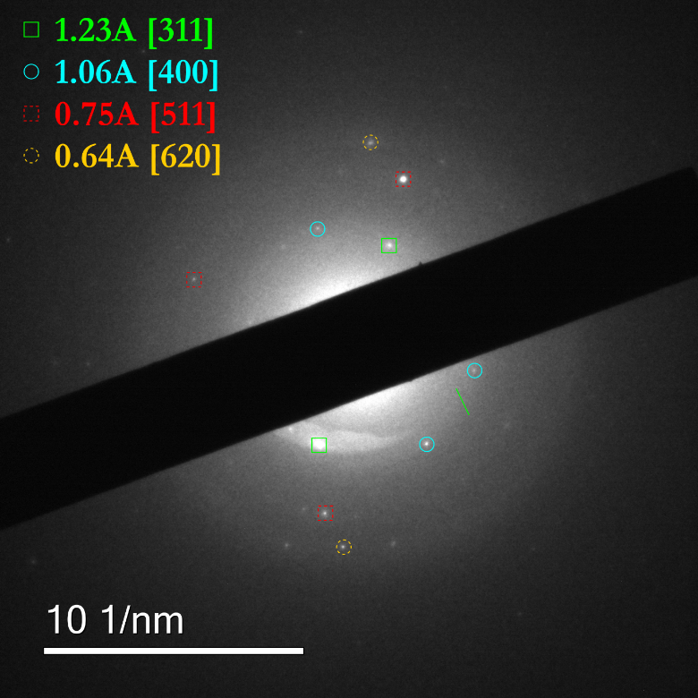
Figure S45: SAED assignment of the aluminium powder.
8. References
1. Pauling, L. The nature of the chemical bond. IV. The energy of single bonds and the relative electronegativity of atoms. J Am Chem Soc 54, 3570–3582 (1932).
2. Yu, R. C., Hung, C. H., Huang, J. H., Lee, H. Y. & Chen, J. T. Four- and five-coordinate aluminum ketiminate complexes: Synthesis, characterization, and ring-opening polymerization. Inorg Chem 41, 6450–6455 (2002).
3. Shukla, P., Gordon, J. C., Cowley, A. H. & Jones, J. N. Fluoroaryl-substituted ketiminate complexes of aluminum. J Organomet Chem 690, 1366–1371 (2005).
4. Mears, K. L., Bhide, M. A., Knapp, C. E. & Carmalt, C. J. Investigations into the structure, reactivity, and AACVD of aluminium and gallium amidoenoate complexes. Dalton Transactions 51, 156–167 (2021).
5. Pangborn, A. B., Giardello, M. A., Grubbs, R. H., Rosen, R. K. & Timmers, F. J. Safe and convenient procedure for solvent purification. Organometallics 15, 1518–1520 (1996).
6. Douglas, S. P. et al. Tris(β-ketoiminate) Aluminium(III) Compounds as Aluminium Oxide Precursors. Chempluschem 88, e202200411 (2023).
7. W. E. Garner, F. R. S. A. & Haycock, E. W. The thermal decomposition of lithium aluminium hydride. Proc R Soc Lond A Math Phys Sci 211, 335–351 (1952).
8. Dolomanov, O. V., Bourhis, L. J., Gildea, R. J., Howard, J. A. K. & Puschmann, H. OLEX2: a complete structure solution, refinement and analysis program. J. Appl. Cryst. 42, 339–341 (2009).
9. Bourhis, L. J., Dolomanov, O. V., Gildea, R. J., Howard, J. A. K. & Puschmann, H. The anatomy of a comprehensive constrained, restrained refinement program for the modern computing environment – Olex2 dissected. Acta Cryst. A 71, 59–75 (2015).
10. Sheldrick, G. M. & IUCr. Crystal structure refinement with SHELXL. Acta Cryst. C 71, 3–8 (2015).
11. Sheldrick, G. M. & IUCr. SHELXT – Integrated space-group and crystal-structure determination. Acta Cryst. A 71, 3–8 (2015).

