Supplementary Materials
This file contains Extended Data Figures 1-3 and Supplementary Tables S1-S2.

Extended Data Figures
Extended Data Fig. 1
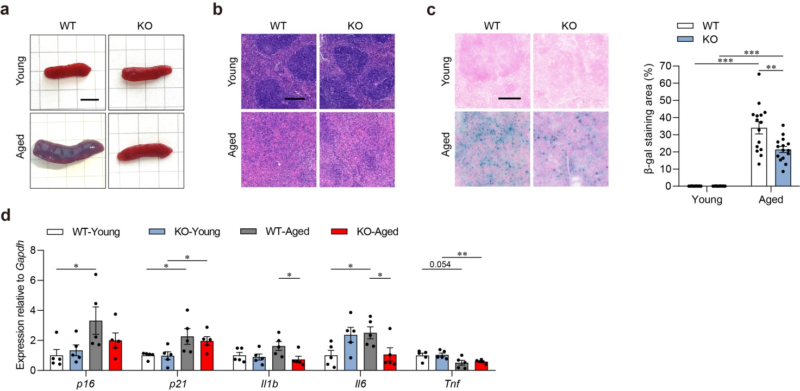
Extended Data Fig. 1| Armh4 deficiency decelerates splenic aging.
a, Representative images of spleens from wild-type (WT) and Armh4-knockout (KO) mice at 8-week (young) or 25-month (aged) old.
b, Representative hematoxylin and eosin (H&E) staining images of spleens from above-mentioned groups. Scaler bar, 200μm. n = 3.
c, Representative images (left) and quantitative data (right) showing the β-galactosidase (β-Gal) activity in spleens from above-mentioned groups. Scaler bar, 200μm. n = 15.
d, Quantitative reverse transcription polymerase chain reaction (qRT-PCR) assays showing the senescence-associated secretory phenotype (SASP) factors, including p16, p21, Il1b, Il6, and Tnf. n = 5.
*P < 0.05, **P < 0.01, ***P < 0.001.

Extended Data Fig. 2
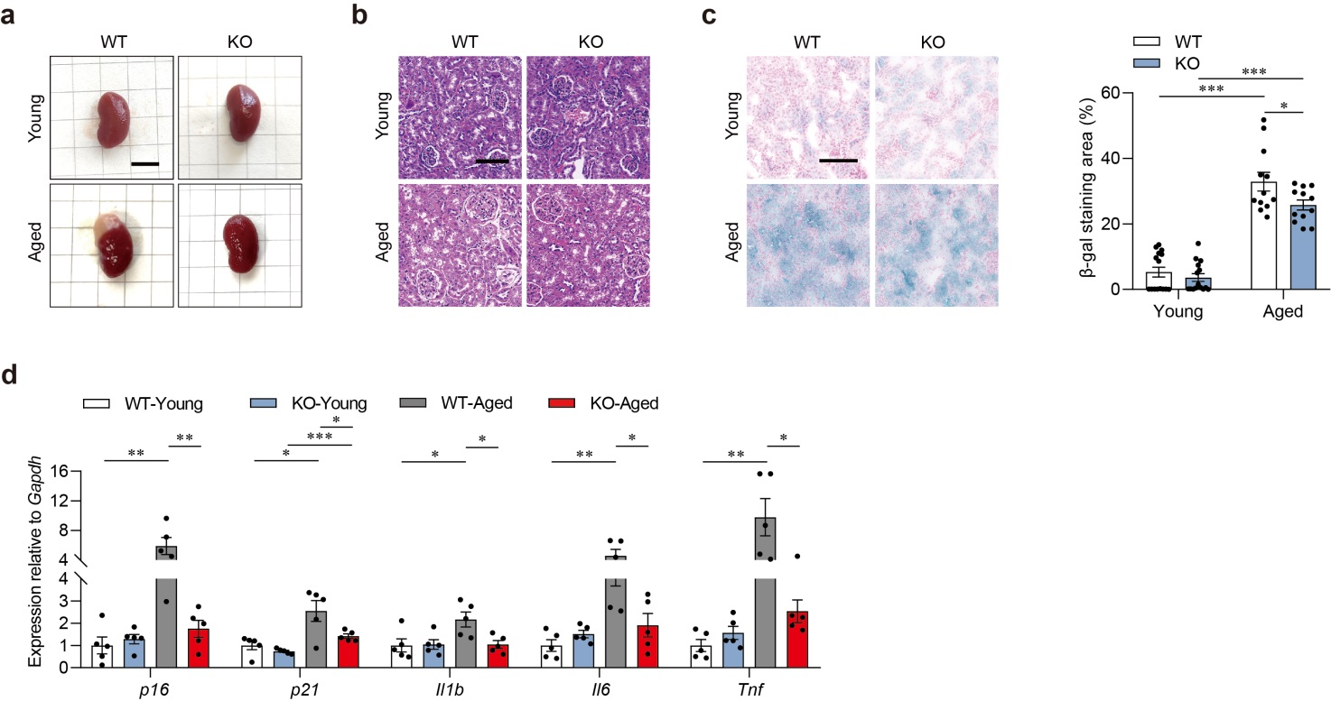
Extended Data Fig. 2| Armh4 deficiency decelerates renal aging.
a, Representative images of kidneys from WT and Armh4-KO mice at 8-week (young) or 25-month (aged) old.
b, Representative H&E staining images of kidneys from above-mentioned groups. Scaler bar, 100μm. n = 3.
c, Representative images and quantitative results showing the β-Gal activity in kidneys from above-mentioned groups. Scaler bar, 200μm. n = 15.
d, qRT-PCR assays showing the SASP factors, including p16, p21, Il1b, Il6, and Tnf. n = 5.
*P < 0.05, **P < 0.01, ***P < 0.001.

Extended Data Fig. 3
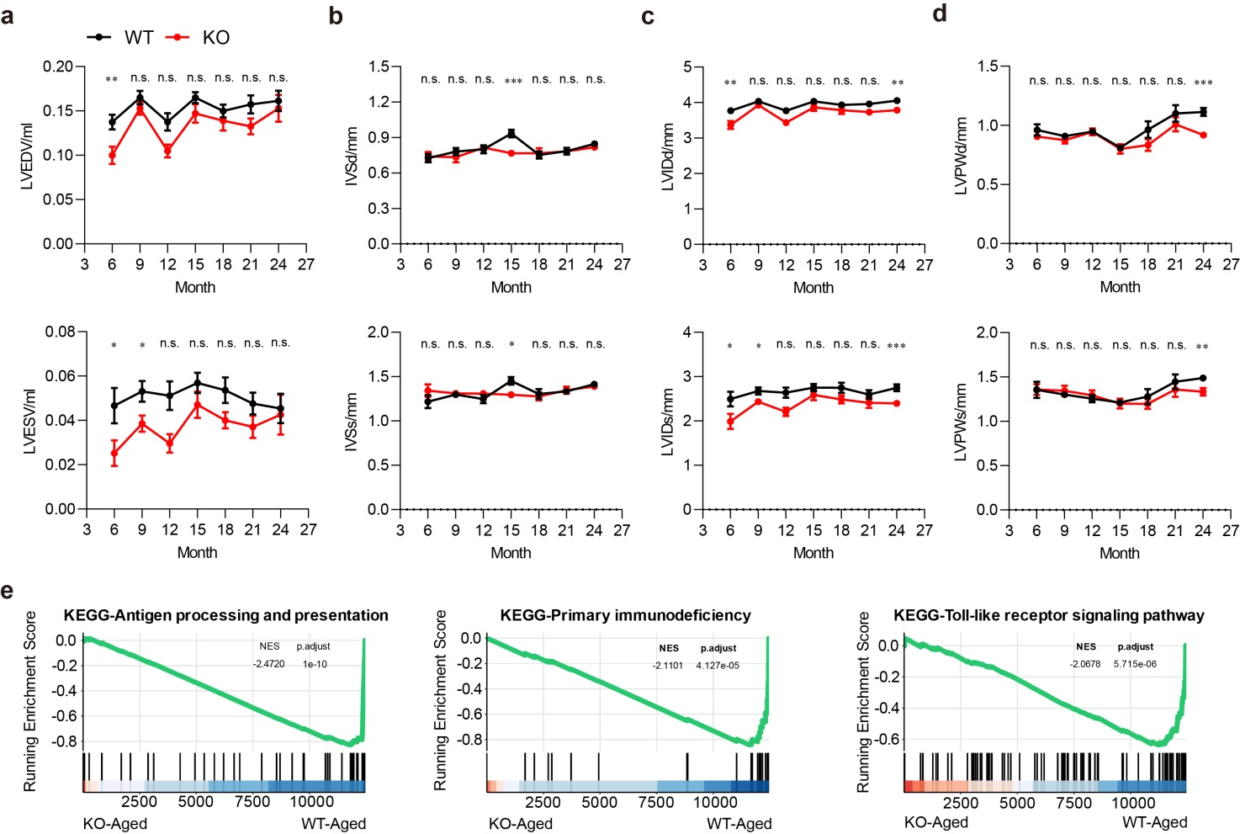
Extended Data Fig. 3| Armh4 deficiency decelerates cardiac aging.
a-d, Echocardiographic results showing the impacts of Armh4 deficiency on left ventricular volume at end-diastolic (LVEDV; a, upper) or end-systolic (LVESV; a, lower) phases, inter-ventricle septum width at diastolic (IVSd; b, upper) or systolic (IVSs; b, lower) phases, left ventricular inner diameter at diastolic (LVIDd; c, upper) or systolic (LVIDs; c, lower) phases, and left ventricular postal wall thickness at diastolic (LVPWd; d, upper) or systolic (LVPW; d, lower) phases during aging. n = 9~12.
e, Gene set enrichment analysis (GSEA) of the RNA-seq data showing the inflammation-related KEGG pathways altered by Armh4 deficiency in the heart.
*P < 0.05, **P < 0.01, ***P < 0.001.

Supplementary Tables
Table S1. Sequences of siRNAs used in this study.
siRNAs | Gene | Species | Sequence(sense/forward) | Sequence(antisense/reverse)
siArmh4-rat | Armh4 | Rat | CCUGACCCAUCAGAUUUCCUUCACU | AGUGAAGGAAAUCUGAUGGGUCAGG
siArmh4-hum | ARMH4 | Human | CUGAAGUAUAUGGAUAAUCAAUCAU | AUGAUUGAUUAUCCAUAUACUUCAGAA
siMyc-rat | Myc | Rat | GAAGAGAAUUUCUAUCACCAGCAAC | GUUGCUGGUGAUAGAAAUUCUCUUCCU

Table S2. Primers used for qRT-PCR assays in this study.
Primers | Gene | Species | Sequence(sense/forward) | Sequence(antisense/reverse)
m_Armh4 | Armh4 | Mouse | AGCAGAATCAAGGTCTGGTGAG | AGGCTCCAGCTATCCCTACC
m_p16 | Cdkn2a | Mouse | TCGCACGATGTCTTGATGTC | TCAACTACGGTGCAGATTCG
m_p21 | Cdkn1a | Mouse | TATCCAGACATTCAGAGCCACA | ACTTTGCTCCTGTGCGGAA
m_p53 | Trp53 | Mouse | CTCCGAAGACTGGATGACTG | ACAGATCGTCCATGCAGTGAG
m_Il1b | Il-1b | Mouse | CCGTGGACCTTCCAGGATGA | GGGAACGTCACACACCAGCA
m_Il6 | Il-6 | Mouse | AGTTGCCTTCTTGGGACTGA | TCCACGATTTCCCAGAGAAC
m_Tnf | Tnf-a | Mouse | CATCTTCTCAAAATTCGAGTGACAA | TGGGAGTAGACAAGGTACAACCC
m_Acta2 | Acta2 | Mouse | CTTCGTGACTACTGCCGAGC | AGGTGGTTTCGTGGATGCC
m_Col1a1 | Col1a1 | Mouse | ACCTTCCTGCGCCTAATGTC | AGTTCCGGTGTGACTCGTG
m_Ki67 | Ki67 | Mouse | CATTGACCGCTCCTTTAGGTATG | CCATCTGAGGCAGGGCTATC
m_Gapdh | Gapdh | Mouse | TCCTGCACCACCAACTGCTTAG | GATGACCTTGCCCACAGCCTTG
m_Nppa | Nppa | Mouse | TTTCAAGAACCTGCTAGACCACC | GATCTATCGGAGGGGTCCCA
m_Nppb | Nppb | Mouse | CGCTGGGAGGTCACTCCTAT | CTTCAGTGCGTTACAGCCCAA
m_Myh6 | Myh6 | Mouse | AGCTCACCTACCAGACAGAGG | TTCCTCGTCGTGCATCTTCTT
m_Myh7 | Myh7 | Mouse | GGCCTGGGCTTACCTCTCTA | ACAGTCACCGTCTTGCCATT
m_Acta1 | Acta1 | Mouse | GCTGTGTTCCCATCCATCGT | GCAGGCACGTTGAAGGTCTC
h_GAPDH | GAPDH | Human | CTAGGCGCTCACTGTTCTCT | GCCCAATACGACCAAATCCGT
h_ Il1b | IL-1β | Human | ATGATGGCTTATTACAGTGGCAA | GTCGGAGATTCGTAGCTGGA
h_ Il6 | IL-6 | Human | ACTCACCTCTTCAGAACGAATTG | CCATCTTTGGAAGGTTCAGGTTG
h_ Tnf | TNF-α | Human | CCCATGTTGTAGCAAACCCT | TATCTCTCAGCTCCACGCCA
m_Hmgcr | Hmgcr | Mouse | ATCATGTGCTGCTTCGGCTGCAT | AAATTGGACGACCCTCACGGCT
m_Srebp1c | Srebp1c | Mouse | CACTTCTGGAGACATCGCAAAC | ATGGTAGACAACAGCCGCATC
m_Abcg1 | Abcg1 | Mouse | GGTTGCGACATTTGTGGGTC | TTCTCGGTCCAAGCCGTAGA
m_Cyp7a1 | Cyp7a1 | Mouse | CTGGGCTGTGCTCTGAAGTT | TGCCTTCGCAGAAGTAGTGT
m_Ldlr | Ldlr | Mouse | CACACAGCCTAGAGAAGTCG | GATCCTCACTGTGCTTCGGT
m_Srebp2 | Srebp2 | Mouse | GGGGCTGTCGGGTGTC | GGAACTCTCCCACTTGATTGC
m_Fatp1 | Fatp1 | Mouse | TGCACAGCAGGTACTACCGCAT | TGCGCAGTACCACCGTCAAC
m_Cd36 | Cd36 | Mouse | GACTGGGACCATTGGTGATGA | AAGGCCATCTCTACCATGCC
m_Cpt1a | Cpt1a | Mouse | AGGACCCTGAGGCATCTATT | ATGACCTCCTGGCATTCTCC
m_Fasn | Fasn | Mouse | CTGCGGAAACTTCAGGAAATG | GGTTCGGAATGCTATCCAGG
m_Pparg | Pparg | Mouse | ATTCTGGCCCACCAACTTCGG | TGGAAGCCTGATGCTTTATCCCCA
m_Acaca | Acaca | Mouse | GCCGCCAGCCTGAGTTCTT | GGGAGCCCTCCTTCTCTTCT
m_Pten | Pten | Mouse | GTGGTCTGCCAGCTAAAGGTGA | TCAGACTTTTGTAATTTGTGAATGCT
m_Glut2 | Glut2 | Mouse | TTCACGGCTGTCTCTGTGCT | TGCCAATCATCCCGGTTAGG
m_Pdk4 | Pdk4 | Mouse | TTCACACCTTCACCACATGC | AAAGGGCGGTTTTCTTGATG
m_Pepck | Pepck | Mouse | TGCCCCAGGCAGTGAGGAAGTT | GTCAGTGAGAGCCAGCCAACAGT
m_G6pase | G6pase | Mouse | CGACTCGCTATCTCCAAGTGA | GGGCGTTGTCCAAACAGAAT
m_Irs1 | Irs1 | Mouse | AATGAGGGCAACTCCCCAAG | AGGTCTTCATTCTGCTGTGATGT

