Supplementary material

Material and methods
Caves and sampling sites description
Gruta do Padre Cave is 17 km long in the Santana municipality in southwestern Bahia state, Brazil. The cave is part of the Bambuí Group, the largest carbonate region in Brazil, and is home to the longest subterranean hydrologic system in the country. The cave has two entrances, and the area has a dry climate with safe access only possible during dry periods (March to October). The cave can be divided into three distinct levels, with the lower level housing the Santo Antônio River and reaching a depth of 40 meters. The cave is under a vegetation transition zone between the Caatinga and Seasonal Dry Forests (Dinerstein et al., 2017). The climate in the area is the Aw (Köppen, 1936), with dry winters and rainy summers.
Brega (1208 meters) and Santuário (1085 meters) are closely situated caves (20º24’59.7”S - 45º46’20.6”W), both found in the municipality of Pains, Minas Gerais. These caves are located in limestone formations, have two opposing entrances, and contain water bodies that experience fluctuations in water levels. They also receive aboveground water from dripping, temporary ponds, and runoff during the rainy season. The Brega and Santuário caves are in the Patos Creek sub-basin (530 km²). The macroclimate of the Pains region is described as mild temperate, with hot, humid summers and dry winters. The average annual temperature is 20.7ºC, with July being the coldest month, averaging 16.3ºC, and January being the hottest month, averaging 23.3ºC. The local annual average precipitation is 1344 mm3 (Menegasse et al., 2002). The local climate is responsible for the seasonal variation in the water dynamics of Patos Creek, significantly altering the surrounding landscapes with periodic floods during the rainy season (October to March), which accounts for 81% of the annual precipitation (Menegasse et al., 2002). The existing vegetation in the vicinity of the caves consists of forested areas and pastures for extensive cattle farming (Souza-Silva et al., 2012).
The cave PEA-445 (580 meters long) is in southeastern Bahia state, Brazil (13º 05' 4.18''S; 44º 41' 58.88''W). It is formed in sandstones from the Urucuia formation at an altitude of 625 meters. The cave entrance is at the bottom of a sinkhole, around 10 meters in diameter. The chamber slopes steeply until it intercepts a “lake” about 15 meters deep. The "lake" comprises the phreatic level of the area. Inside the water, roots matts and decaying organic matter are abundant. The cave is relatively well preserved, but the surrounding area is deforested, affecting organic resource input (Senna et al., 2014).
The cave known as Lapa D’Água do Zezé (Zeze) (15°01'07.45'' S 44°12'10.86'' W) in the municipality of Itacarambi, state of Minas Gerais, Brazil, is inserted in a large limestone formation belonging to the Bambuí group. A well-preserved deciduous forest surrounds it and serves as a transition between the Cerrado (Brazilian savannah) and the Caatinga regions (Velloso et al., 2002). Local farmers have placed an electric pump inside the cave near the main entrance to extract water for household use and watering crops. The cave consists of two interconnected yet distinct areas of water presence. The first area allows access to the water table through a narrow passage at the base of a diaclasis, near a vertical entrance of the cave, and is situated within a photic/disphotic zone (Bastos-Pereira & Ferreira, 2017).
Muierilor Cave (Muieri) (45◦11′31.78′′N and 23◦45′14.07′′E), developed in limestone and located in south-western Romania, is one of the most-visited show caves in the country (Figure 1). The cave is situated at 650 m.a.s.l and is developed on four distinct levels. The second one has been a tourist and scientific attraction since the late 19th century. Only water samples from 6 pools provided enough material for sequencing (Table 1, Fig. 1, map modified after Mirea et al., 2021).
Apă din Valea Leșului Cave (Lesu) in north-western Romania, located at an altitude of 700 m.a.s.l., is horizontal and has a main gallery with water and a few small lateral passages (Table 1 and Fig. 1, map modified after Rusu, 1988). Station L1A is a pool fed by percolating water without substrate, about 500 m from the entrance in a lateral passage. Stations L2 and L4 are represented by a small pool and silt and percolating water flowing on rocks, respectively; these stations are about 10 m upstream from L1A on the left side of the main gallery, in a small side passage. Not far from these is Station 3, represented by a larger pool of sandy sediments that originated from a source under the rocks, which is not accessible.
Ferice Cave (Ferice) in north-western Romania is developed in Triassic limestones and is located at 400 m a.s.l. It is an active resurgent sinuous cave, ~1380 m long, with ~7-8 m wide passages (Table 1 and Fig. 1, map modified after Bleahu et al., 1976). The samples were collected before the stream (Station 4) from pools with thick, fine sediments fed by percolating water.
Izvorul Tăușoarelor Cave (Tausoare) is a northern Romanian cave developed in Upper Lutetian-Priabonian (Eocene) limestones, interbedded with layers of bituminous shales (Onac et al., 2019; Table 1 and Fig. 1, map modified after Onac et al., 2019). Only water samples were taken from pools formed on limestone with no substrate, fed by percolating water.
Topolnița Cave (Topolnita) in southwestern Romanian consists of a network of about 20 km of passages, with one of the entrances at 429 m.a.s.l. The sampling and monitoring station was in a side passage, a pool of calcite without substrate; it contained water only in spring (Table 1 and Fig. 1, map modified after Goran and Povară, 2019).
Cloşani Cave (Closani), located at an absolute altitude of 433 meters, is a dry cave, 1100 m long, developed on two passages in southwestern Romania. The two collecting and monitoring stations were located on the cave floor on the left side gallery, about 150 and 250 m from the entrance (Table 1 and Fig. 1, map modified after Diaconu, 1990); one with fine sediments and the other with a thin layer.
Movile Cave (Movile) is a small, closed chemoautotrophic system driven by in-house sulfur and methane oxidation and CO₂ fixation as primary production processes (Sarbu et al., 1996). The cave, located in south-eastern Romania (Dobrogea region), developed in oolitic and fossil-rich limestone of the Sarmatian age (Late Miocene) and was sealed off during the Quaternary by a thick and impermeable layer of clays and loess. It has two levels that converge in the so-called Lake Room (Table 1 and Fig. 1, map modified after Sarbu et al., 2019) from where the sample was taken.

Physicochemical analysis
The pH and electrical conductivity (EC) were measured using a Seven Excellence multiparameter (Mettler Toledo). Dissolved carbon (DC), dissolved inorganic carbon (DIC) and dissolved nitrogen concentrations were measured in water samples filtered through 0.45 µm PTFE filters using a Multi N/C 2100S analyser (Analytic Jena). Dissolved organic carbon (DOC) was calculated as the difference between TC and DIC. Nitrate, sulphate and chloride were measured in the filtered water samples using a 761 Compact ion chromatograph (Metrohm), whereas the alkalinity by acid-base titration with HCl in the presence of methyl orange. For major and trace elements analyses, the water samples were filtered through 0.45 µm cellulose acetate filters and acidulated to pH<2 with HNO₃ (65%). Na, Mg, K, Ca and Fe concentrations were measured by inductively coupled plasma optical emission spectrometry (ICP-OES) using a 5300 Optima DV (Perkin Elmer) spectrometer equipped with a pneumatic nebuliser. The concentration of Al, Ni, Zn, Sr and Ba were measured by inductively coupled plasma mass spectrometer (ICP-MS) using an Elan DRC II (Perkin Elmer) spectrometer in standard operation (Dynamic Reaction Cell in rf only mode).

Results
Pool water chemistry
The pool water pH was neutral to alkaline (7.0-8.5), with low spatial and temporal variability in the same cave, except Muieri, where the pH of pool water in both sampling sites (WC2 and WC3) was 6.6 in November, whereas in the other months ranged between 7.3-8.2. The EC was low in all caves and months (115-550 µS/cm), except for Movile where the EC was much higher (1250 µS/cm). The dissolved organic carbon (DOC) was lower than 6 mg/l in all samples except WL4aug, where a much higher DOC concentration (48 mg/L) was measured. Dissolved nitrogen was lower than 3 mg/l in all caves except Muieri, where the nitrogen content was ten-fold higher in some of the samples. Based on the concentrations of major anions and cations in the water (Fig. S1), all waters are of Ca²⁺-Mg²⁺-HCO₃⁻ type, except Movile, which is of Na⁺-Cl⁻ type. Ca was the predominant element, followed by Mg, K and Na (0.2-10 mg/l) in all caves pool water except Movile, where Na was much higher than in the other caves. The Ca content ranged between 20-80 mg/L in the pool waters from Muieri, Lesu and Closani caves, 10-40 mg/L in Ferice and Tausoare and 160 mg/L in Movile. In the pool water of Movile the concentration of Ca was about 3-fold higher, that of Mg about 7-fold higher, of K 28-fold higher and Na 40-fold higher than in the other caves. The concentration of Fe was low (<0.3 mg/l in all samples in all seasons). Among the main anions, the Cl⁻ was the lowest (0.6-4.2 mg/l), except for Movile where the concentration was about 50-fold higher (250 mg/l) than in the other caves. The NO₃⁻ and SO₄²⁻ contents were generally below 12 mg/L except for the samples in Muierilor caves. Al, Ni, Zn, Sr and Ba concentrations were low in all samples from all caves.

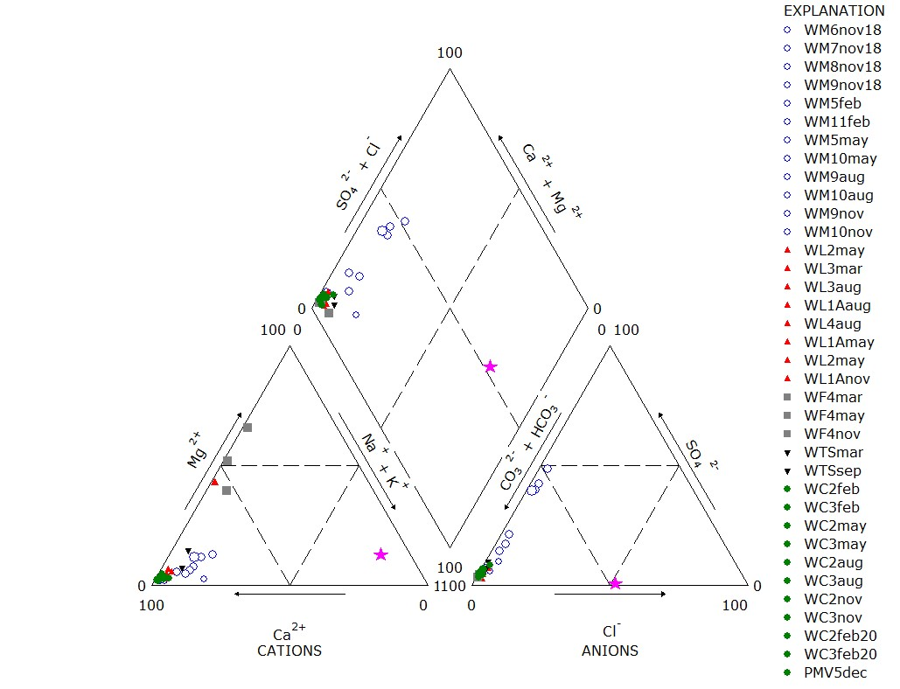
Fig. S1. Piper trilinear diagram showing the chemical characteristics of the pool water samples.

Fig. S2. The most abundant phyla (A), families (B) and genera (C) in the studied cave water pools. See Table 1 for abbreviations.

Fig. S3. The most abundant phyla (A), families (B) and genera (C) in the studied cave pools substrate. See Table 1 for abbreviations.

Fig. S4. MDS on the bacteria phyla in the analysed pools: A. water samples showing the differentiation of Movile sample along Dim1 from Ferice samples in August and November, Muierilor station 5 in May and Closani February samples ((Kruskal's stress (1) = 0.147)); B. substrate samples from Padre, Zeze, Ferice and Closani have large distribution in space, compared to Lesu that are more clustered ((Kruskal's stress (1) = 0.182)).

Fig. S5. MDS of the first 100 most abundant bacteria genera shows different patterns for both water (A) ((Kruskal's stress (1) = 0.147)) and substrate (B) samples ((Kruskal's stress (1) = 0.077)) than that of the phyla distribution. Movile is well separated from the other water samples, and, at lower significance, a group was formed by Muieri 5 in May, Ferice in November, and Closani 3 in February. The substrate samples from Lesu 4 in August and Zeze 3 are significantly separated from all the other samples.

Supplemental references
Bastos-Pereira, R., Ferreira, R.L. 2017. Spelaeogammarus uai (Bogidielloidea: Artesiidae): a new troglobitic amphipod from Brazil. Zootaxa, 4231(1), 38-50.
Bleahu M.D., Decu V., Negrea Ş., Pleşa C., Povară I., Viehmann I. 1976 – Caves of Romania. Editura Ştiinţifică şi Enciclopedică, Bucureşti, 415 pp.
Diaconu G. 1990. Cloșani Cave. Mineralogical and genetic study of carbonates and clays. Misc Speol Rom 2, 190.
Dinerstein, E., et al. 2017. An ecoregion-based approach to protecting half the terrestrial realm. BioScience, 67(6), 534-545.
Goran C. and Povară I. 2019. Mehedinti Plateau: Epuran-Topolnita Karst System. In: Ponta GML, Onac BP, editors. Cave and Karst Systems of Romania. Cham: Springer International Publishing; p. 183–201.
Koppen, W. 1936. Das geographische System de Klimate. Handbuch der klimatologie.
Menegasse, L.N., Gonçalves, J.M., L. Fantinel M. 2002. Disponibilidades hídricas na Província cárstica de Arcos-Pains-Doresópolis, Alto São Francisco, Minas Gerais, Brasil. Rev. Águas Subterrâneas, [S.l.], 16.
Mirea I.-C., et al. 2021. Last deglaciation flooding events in the South Carpathians as revealed by the study of cave deposits from Muierilor Cave, Romania. Palaeogeography, Palaeoclimatology, Palaeoecology, 110084. https://doi.org/10.1016/j.palaeo.2020.110084
Onac, B.P., Drăgușin, V., Papiu, F., Theodorescu, CT. 2019. Rodna Mountains: Izvorul Tăusoarelor Cave (Pestera de la Izvorul Tăusoarelor). In: Ponta, G., Onac, B. (eds) Cave and Karst Systems of Romania. Cave and Karst Systems of the World. Springer, Cham. https://doi.org/10.1007/978-3-319-90747-5_7.
Rusu T. 1988. Carstul din Munţii Pădurea Craiului. Ed Dacia, Cluj-Napoca, p 253.
Sarbu S, Kane T, Kinkle B. 1996. A chemoautotrophically based cave ecosystem. Science, 272, 1953–1955.
Sarbu S.M., Lascu C., Brad T. 2019. Dobrogea: Movile Cave. In: Ponta GML, Onac BP, editors. Cave and Karst Systems of Romania. Cham: Springer International Publishing; p. 429–436.
Senna, A.R., Andrade, L.F., Castelo-Branco, L.P., Ferreira, R.L. 2014. Spelaeogammarus titan, a new troglobitic amphipod from Brazil (Amphipoda: Bogidielloidea: Artesiidae). Zootaxa, 3887 (1), 55–67.
Souza-Silva, M. S., Liria, C. C. S., Sampaio, F.A.C., Ferreira, R.L. 2012. Transitory aquatic taxocenosis in two neotropical limestone caves. Revista Brasileira de Espeleologia, 1(2), 29-41.
Velloso, A.L., Sampaio, E.V.S.B., Pareyn, F.G.C. 2002. Ecorregiões propostas para o bioma caatinga. Associação Plantas do Nordeste; The Nature Conservancy do Brasil.

