Precise modulation of electron spin states in metal-organic framework towards exceptional oxygen evolution reaction
Xianbiao Hou ª, Tengjia Ni ª, Zhaozheng Zhang ª, Jian Zhou ª, Shucong Zhang ª, Shuixing Dai ª, Lei Chu ª, Huanlei Wang ª, Bolong Huang ^{b,} *, Minghua Huang ^{a,} *
ª School of Materials Science and Engineering, Ocean University of China, Qingdao 266100, China
^{b} Department of Applied Biology and Chemical Technology, The Hong Kong Polytechnic University, Hung Hom, Kowloon, Hong Kong SAR, China
Corresponding author. E-mail: bhuang@polyu.edu.hk, huangminghua@ouc.edu.cn

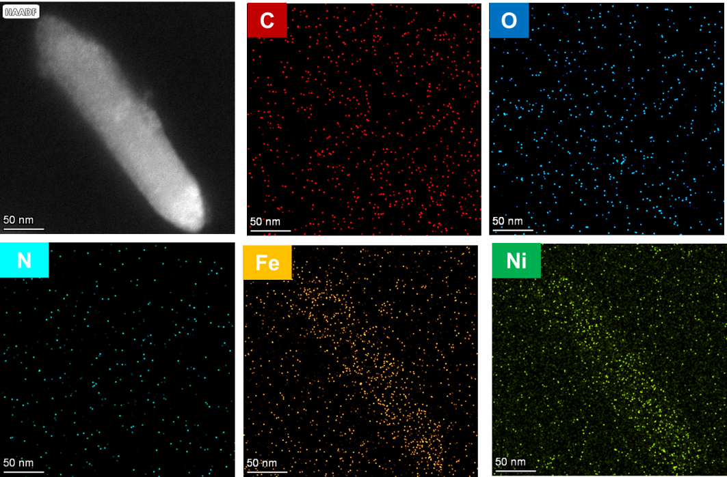
Figure S1. HAADF-STEM and corresponding elemental mapping images of NiFe-MOF-D₃
Figure S2. The XPS survey spectra of NiFe-MOF-D₀ and NiFe-MOF-D₃.

Figure S3. The XPS valence bands of these obtained catalysts.

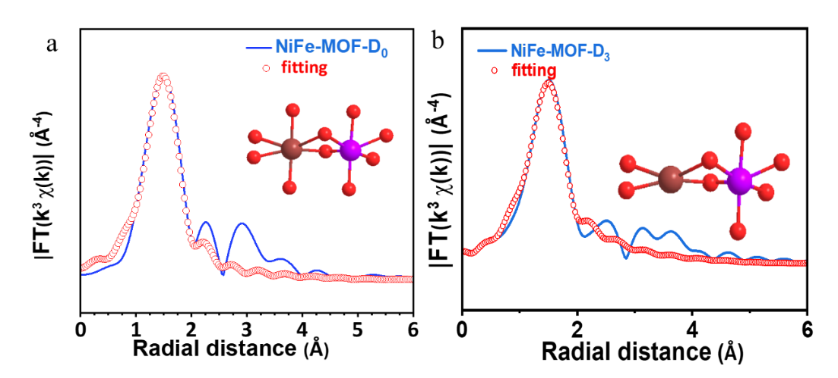
Figure S4. The k³-weighted EXAFS fitting curves of Fe at R space. (a) NiFe-MOF-D₀ and (b) NiFe-MOF-D₃.

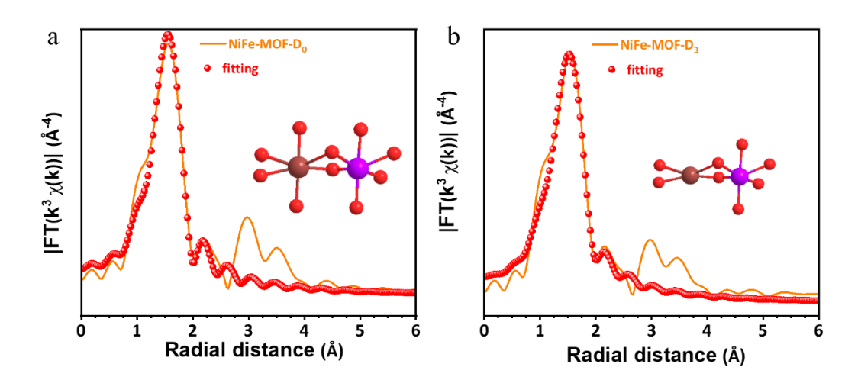
Figure S5. The k³-weighted EXAFS fitting curves of Ni at R space. (a) NiFe-MOF-D₀ and (b) NiFe-MOF-D₃.

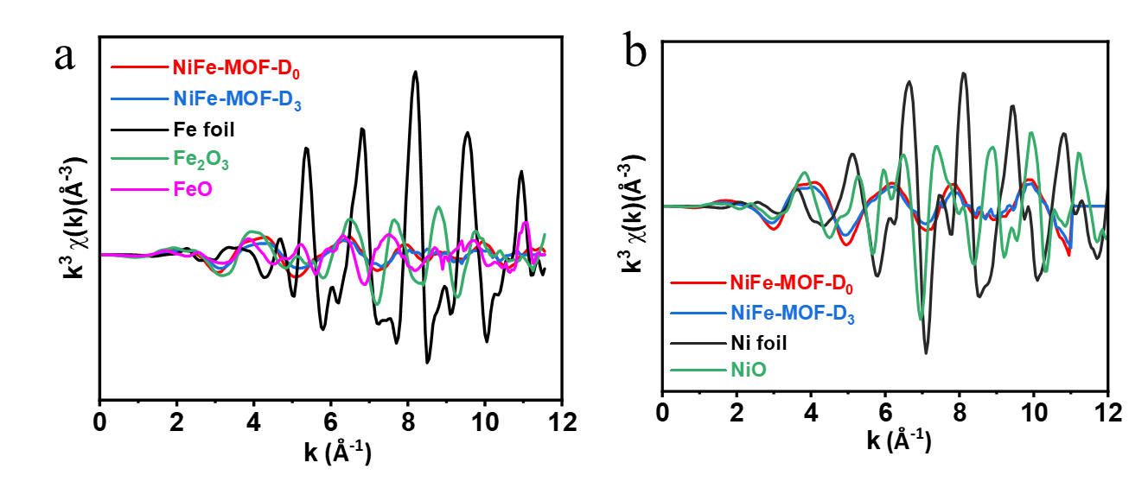
Figure S6. The k³-weighted EXAFS fitting curves at k space. (a) Fe, (b) Ni.

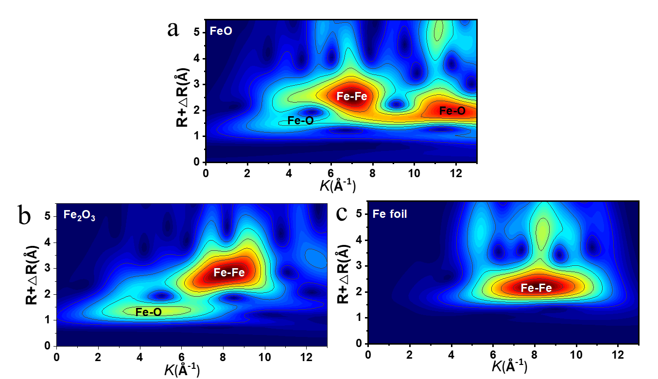
Figure S7. Wavelet transform of Fe K-edge EXAFS spectra. (a) FeO, (b) Fe₂O₃, and (c) Fe foil.

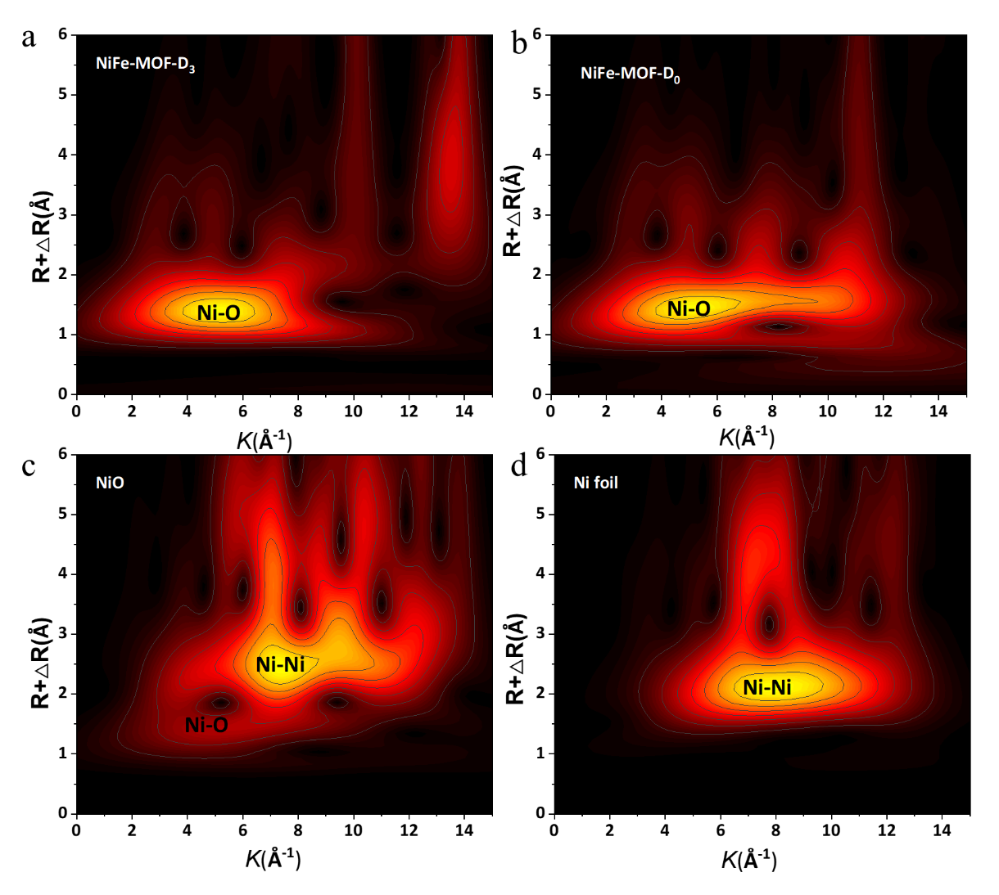
Figure S8. Wavelet transform of Ni K-edge EXAFS spectra. (a) NiFe-MOF-D₃, (b) NiFe-MOF-D₀, (c) NiO, and (d) Ni foil.
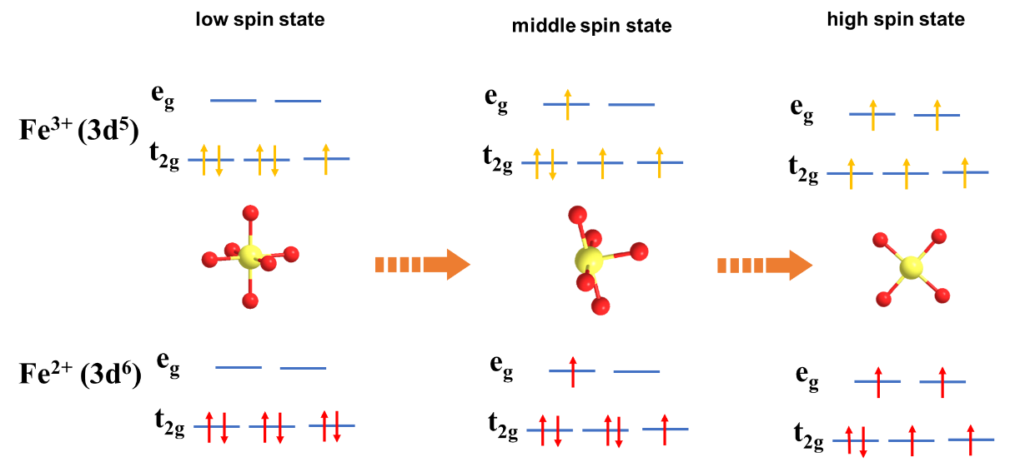
Figure S9. The transitions of Fe 3d electron configuration in different spin states on the catalysts.

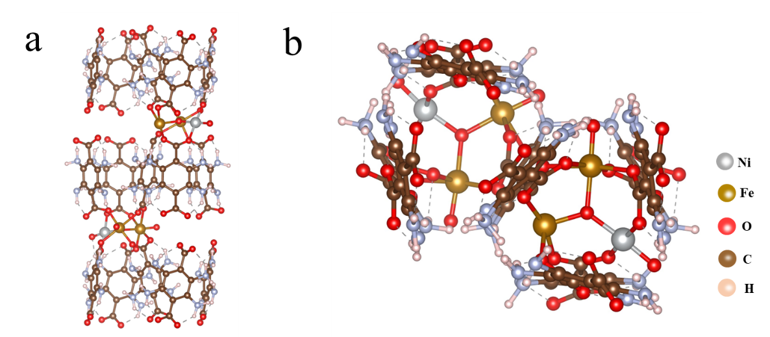
Figure S10. The NiO₆-FeO₄ model structure within NiFe-MOF, (a) side view, (b) top view.
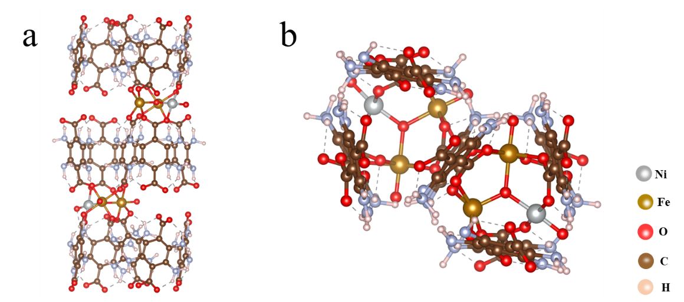
Figure S11. The NiO₆-FeO₅ model structure within NiFe-MOF, (a) side view, (b) top view.

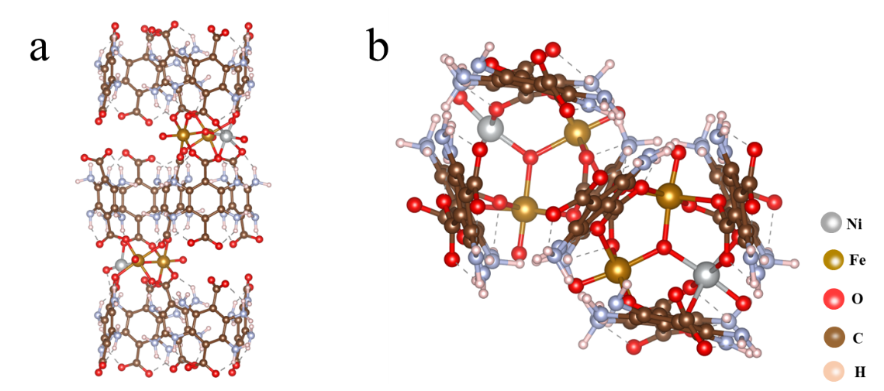
Figure S12. The NiO₆-FeO₆ model structure within NiFe-MOF, (a) side view, (b) top view.

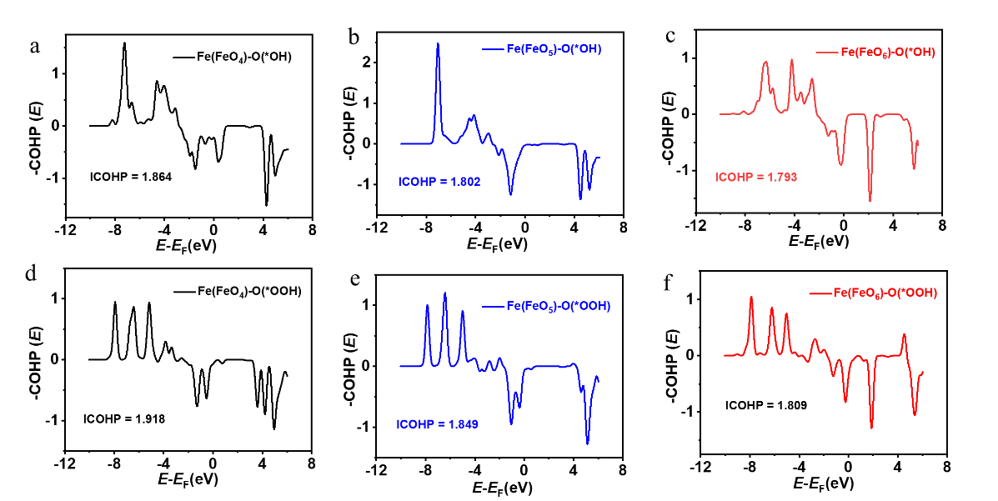
Figure S13. The COHP analysis of (a, d) NiO₆-FeO₆, (b, e) NiO₆-FeO₅, and (c, f) NiO₆-FeO₄ models after the adsorption of OH* and OOH*.
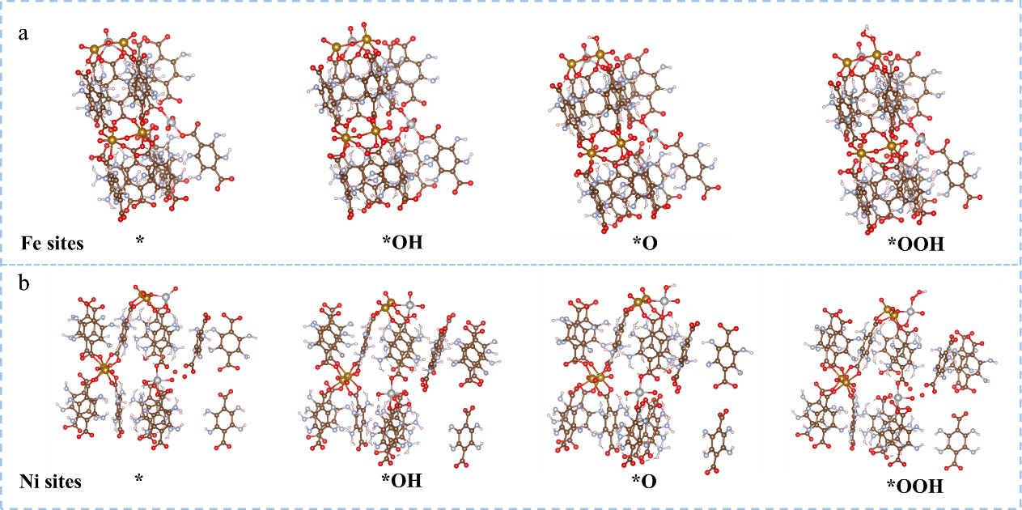
Figure S14. The OER pathway for the NiO₆-FeO₆ model of NiFe-MOF at (a) Fe sites, and (b) Ni Sites.

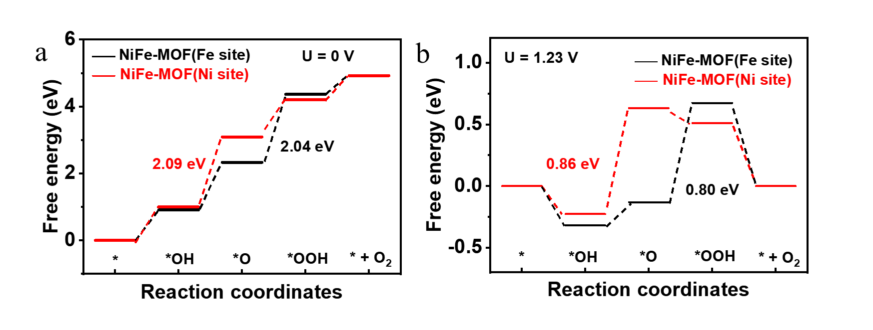
Figure S15. The free energy diagrams at different metal sites within NiO₆-FeO₆ model of NiFe-MOF during the OER process: (a) U = 0V, (b) U=1.23 V.
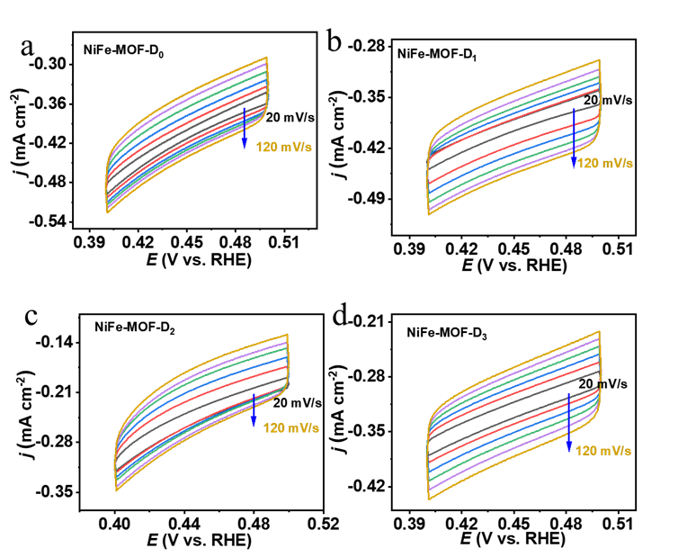
Figure S16. The cyclic voltammetry curves of (a) NiFe-MOF-D₀, (b) NiFe-MOF-D₁, (c) NiFe-MOF-D₂, and (d) NiFe-MOF-D₃ with different scan rates from 20 to 120 mVs⁻¹.
Figure S17. The LSV curves normalized by ECSA for these obtained catalysts.

Figure S18. Cyclic voltammetry curves of these obtained catalysts in PBS solution at a scan rate of 50 mV s⁻¹.
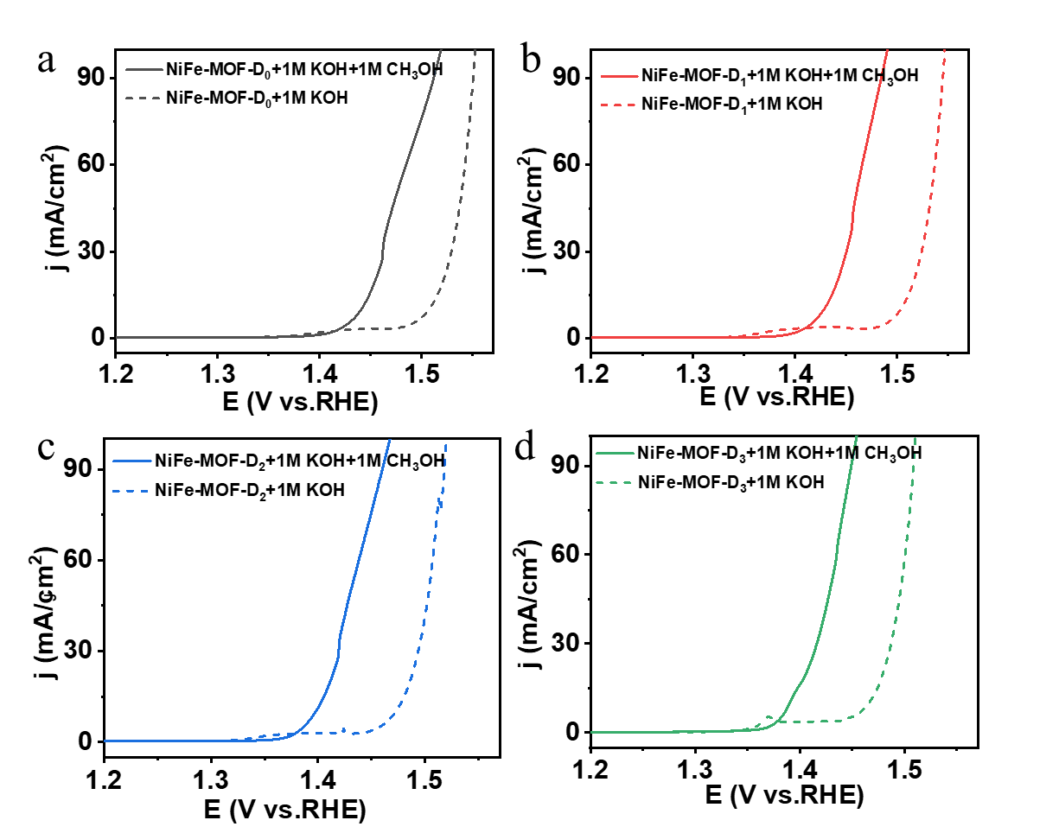
Figure S19. Polarization curves of (a)NiFe-MOF-D₀, (b) NiFe-MOF-D₁, (c) NiFe-MOF-D₂, and (d) NiFe-MOF-D₃ in 1.0 M KOH solution with or without adding 1.0 M CH₃OH.
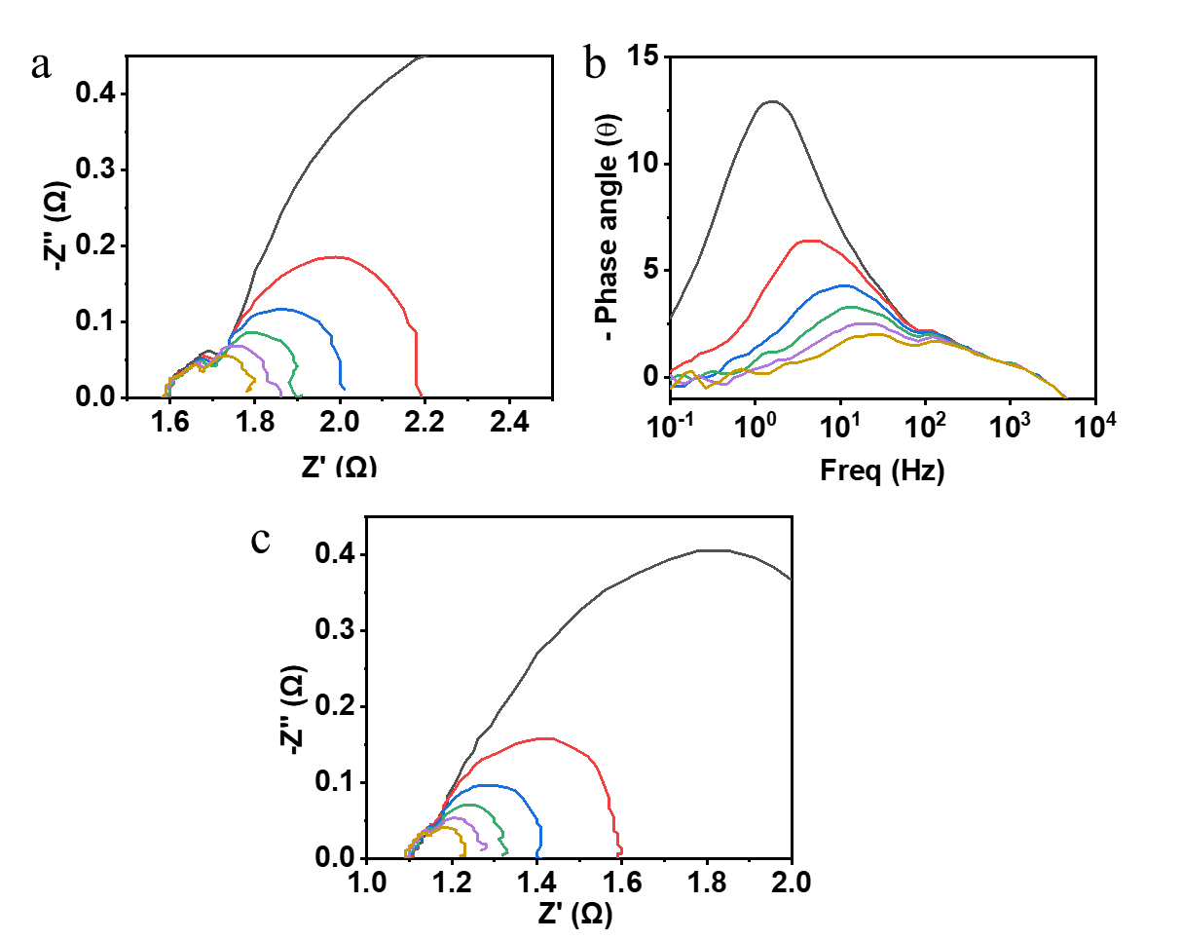
Figure S20. (a) Nyquist plots and (b) Bode phase plots for NiFe-MOF-D₀. (c) Nyquist plots for NiFe-MOF-D₃. The voltage range tested is from 1.25 V to 1.50V.
Figure S21. The corresponded R_{ct} values at different potentials for NiFe-MOF-D₀ and NiFe-MOF-D₃.

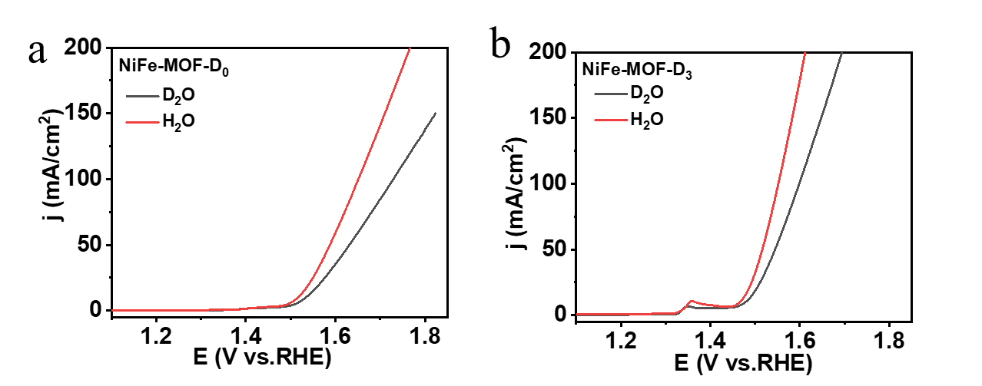
Figure S22. Polarization curves of (a)NiFe-MOF-D₀, (b) NiFe-MOF-D₃ in 1.0 M KOH dissolved in H₂O and D₂O.

Table S1. EXAFS fitting parameters at the Ni K-edge for the Ni foil, NiO, NiFe-MOF-D₀, and NiFe-MOF-D₃.
Sample | Shell | CNª | R(Å)^{b} | σ²(Å²)^{c} | ΔE₀(eV)^{d} | R factor
Ni foil | Ni-Ni | 12.0* | 2.48 | 0.0061 | 7.33 | 0.0018
NiO | Ni-O | 6.0* | 2.09 | 0.0067 | -1.13 | 0.0043
NiO | Ni-Ni | 12* | 2.95 | 0.0064 | -3.46 | 0.0043
NiFe-MOF-D₀ | Ni- O | 6.3 | 2.04 | 0.0041 | -1.44 | 0.0094
NiFe-MOF-D₃ | Ni- O | 6.1 | 2.03 | 0.0077 | -3.86 | 0.0087

Table S2. EXAFS fitting parameters at the Fe K-edge for the Fe foil, Fe₂O₃, FeO, NiFe-MOF-D₀, and NiFe-MOF-D₃.
Sample | Shell | CNª | R(Å)^{b} | σ²(Å²)^{c} | ΔE₀(eV)^{d} | R factor
Fe foil | Fe- Fe | 8* | 2.46 | 0.0048 | 4.09 | 0.0037
Fe foil | Fe- Fe | 6* | 2.86 | 0.0038 | 5.33 | 0.0037
Fe₂O₃ | Fe-O1 | 6.7 | 1.96 | 0.0081 | -5.78 | 0.0066
Fe₂O₃ | Fe-O2 | 1.5 | 2.14 | 0.0029 | -5.34 | 0.0066
Fe₂O₃ | Fe-Fe1 | 7.9 | 2.98 | 0.0077 | -0.33 | 0.0066
Fe₂O₃ | Fe-Fe2 | 4.0 | 3.45 | 0.0037 | 14.71 | 0.0066
FeO | Fe-O1 | 3.8 | 2.17 | 0.0025 | 12.82 | 0.0049
FeO | Fe-O2 | 5.8 | 2.36 | 0.0108 | 1.10 | 0.0049
FeO | Fe-Fe1 | 6.0 | 3.03 | 0.0108 | -1.57 | 0.0049
NiFe-MOF-D₀ | Fe-O | 5.8 | 2.01 | 0.0096 | 0.24 | 0.0055
NiFe-MOF-D₃ | Fe-O | 4.4 | 1.99 | 0.0101 | -0.53 | 0.0040

Table S3. Comparisons of overpotential and Tafel slope for the as-synthesized NiFe-MOF-D₃ in this work and related electrocatalysts in the literatures.
Catalysts | j (A cm⁻²) |  | η (mV) | Stability | Reference
NiFe-MOF-D₃ |  | 0.5  1.0 | 285  328 | 170 h @500 mA cm⁻² | This work
 |  | 1.5 | 365 | 170 h @500 mA cm⁻² | This work
NiMOF-Ni₂P/IF |  | 1.0 | 330 | 100 h @500 mA cm⁻² | Chem. Eng. J. 2024, 497, 154483
Ru@Cr-FeMOF |  | 1.0 | 348 | 80000 s @20 mA cm⁻² | Adv. Funct. Mater. 2024, 34, 2307917
Fe-MOFs-SO₃ |  | 1.0 | 330 | 100 h @1000 mA cm⁻² | Adv. Energy Mater. 2020, 10, 2000184
Er_{0.4}Fe-MOF/NF |  | 1.0 | 326 | 25 h @500 mA cm⁻² | Nanomaterials. 2021, 11, 1847
NiCo(OH)x@Co-MOF/NF |  | 1.0 | 531 | 24 h @500 mA cm⁻² | Int J Hydrogen Energy.  2022, 47, 31587-31595
NiFe-MOF-74/NiFe-LDH |  | 1.0 | 284 | 10 h @1000 mA cm⁻² | Adv. Funct. Mater. 2023, 33, 2211260
CoFeP TPAs/Ni |  | 0.7 | 335 | 100 h @20 mA cm⁻² | J. Mater. Chem. A. 2019, 7, 17529-17535
NFN-MOF/NF |  | 0.5 | 360 | 30 h @500 mA cm⁻² | Adv. Energy Mater. 2018, 8, 1801065
FeOOH-NiBDC-NF |  | 0.5 | 316 | 100 h @500 mA cm⁻² | Chem. Eng. J. 2022, 431, 134040
Fe-doped-(Ni-MOFs)/FeOOH |  | 0.4 | 314 | 120 h @10 mA cm⁻² | Angew. Chem. Int. Ed. 2022, 61, e202116934
CoCe-MOF/CP |  | 0.2 | 539 | 70 h @100 mA cm⁻² | Small 2024, 20, 2307685
Er_{0.5}Ni-BDC MOF |  | 0.1 | 420 | 14 h @20 mA cm⁻² | Energy & Fuels, 2024, 38, 5397-5406.

Table S4. Comparisons of cell voltages of AEMWE for the NiFe-MOF-D₃ // Pt/C in this work and related electrocatalysts in the literatures.
Catalysts | j (mA cm⁻²) | potential (V) | Reference
NiFe-MOF-D₃ | 500 | 1.77 | This work
Ni-Co-Fe-P NBs | 800 | 1.98 | Appl. Catal. B Environ. 2022, 310, 121353
CeO2-NiCoPx/NCF | 300 | 1.78 | Appl. Catal. B Environ. 2022, 316, 121678
F-CDs/CoP/NF | 240 | 1.81 | Adv. Energy Mater. 2022, 12, 2102573
FeO_{x}@Co_{0.75}Fe_{0.25}P | 100 | 1.67 | Adv. Sci. 2024, 11, 2403206
Pd-NiFeB/NF | 500 | 1.81 | Appl. Catal. B Environ. 2024, 342, 123343
NiCo₂O₄-B-CC | 400 | 2.0 | Adv. Funct. Mater. 2024, 2410439
NiCoP | 500 | 1.815 | Adv. Energy Mater. 2023, 13, 2300499
Ru SAs-MoO_{3−x}/NF | 100 | 1.759 | Adv. Sci. 2023, 10, 2300342
Ni_{SA}Fe_{SA}-Ni_{x}Fe/CNT | 382 | 1.8 | ACS Catal. 2022, 12, 1167-1179
6%LS-CMMOFs | 500 | 1.85 | Appl. Catal. B Environ. 2022, 307, 121151
Sn₄P₃/Co₂P SCNAs | 80 | 1.72 | Appl. Catal. B Environ. 2022, 304, 120923

Calculations of AEM electrolyzer efficiency and H₂ cost
H₂ production rate @ 0.5 A cm⁻²
= (j A cm⁻²)(1 e⁻/1.602 ×10⁻¹⁹ C)(1 H₂/2 e⁻)
= 0.5 A cm⁻² / (1.602 × 10⁻¹⁹ C x 2)
= 2.59 × 10⁻⁶ mol H₂ cm⁻² s⁻¹
LHV of H₂
= 120 kJ g⁻¹ H₂ = 2.42 × 10⁵ J mol⁻¹ H₂
H₂ power out
= (2.59 × 10⁻⁶ mol cm⁻² s⁻¹) × (2.42 × 10⁵ J mol⁻¹)
= 0.627 W cm⁻²
Electrolyzer Power of NiFe-MOF-D₃ // Pt/C @ 0.5 A cm⁻²
= (0.5 A cm⁻²) (1.61 V)
= 0.885 W cm⁻²
Efficiency of NiFe-MOF-D₃ // Pt/C
= (H₂ Power Out) / (Electrolyzer Power)
= 0.627 W cm⁻²/0.885 W cm⁻²
= 70.8 %
Efficiency of RuO₂//Pt/C
= (H₂ Power Out) / (Electrolyzer Power)
= 0.627 W cm⁻²/1.097 W cm⁻²
= 57.15%
Price per gasoline-gallon equivalent (GGE) H₂
= 1GGE H₂ / H₂ production rate × Electrolyzer power × Electricity bill
= 0.997 kg / (2.59 × 10⁻⁶ mol H₂.cm⁻² s⁻¹ × 2 kg/mol) × 0.885 W cm⁻² × $ 0.02 / kW h
= $ 0.94 /GGE H₂
<< $ 2 /GGE H₂ of U.S. Department of Energy (DOE) by 2026

