Electronic Supporting Information
Negative correlations between cultivable pyrene-degrading Sphingomonas and active soil pyrene degraders explain bioaugmentation postpone or failure
Bo Jiang^{1,2,6}, Yating Chen^{1,2}, Yi Xing^{1,2}, Luning Lian^{1,2}, Yaoxin Shen^{1,2}, Baogang Zhang³, Han Zhang³, Guangdong Sun⁴, Junyi Li⁵, Xinzi Wang⁴, Dayi Zhang^{4,6,*}
¹ School of Energy and Environmental Engineering, University of Science & Technology Beijing, Beijing 100083, PR China
² Beijing Key Laboratory of Resource-oriented Treatment of Industrial Pollutants, University of Science & Technology Beijing, Beijing 100083, PR China
³ School of Water Resources and Environment, MOE Key Lab Groundwater Circulation and Environment Evolution, China University of Geosciences, Beijing 100083, PR China
⁴ School of Environment, Tsinghua University, Beijing 100084, PR China
⁵ Department of Research and Development, Yiqing (Suzhou) Environmental Technology Co. Ltd, Suzhou 215163, PR China
⁶ National Engineering Laboratory for Site Remediation Technologies, Beijing 100015, PR China

*Corresponding author
Dr Dayi Zhang, School of Environment, Tsinghua University, Beijing 100084, PR China, email: zhangdayi@tsinghua.edu.cn
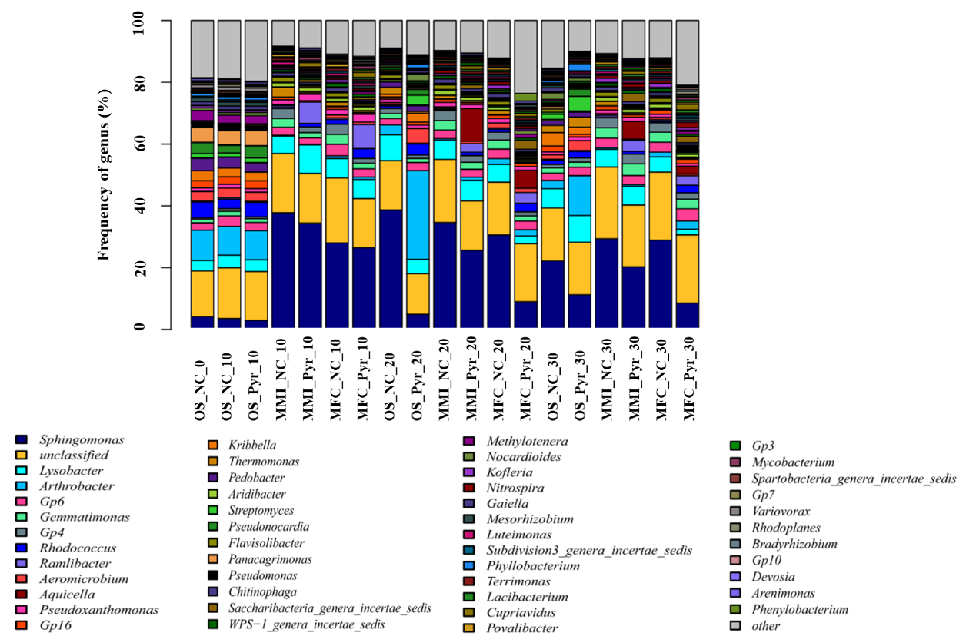
Figure S1. Bacterial community composition in different treatments on genus level.

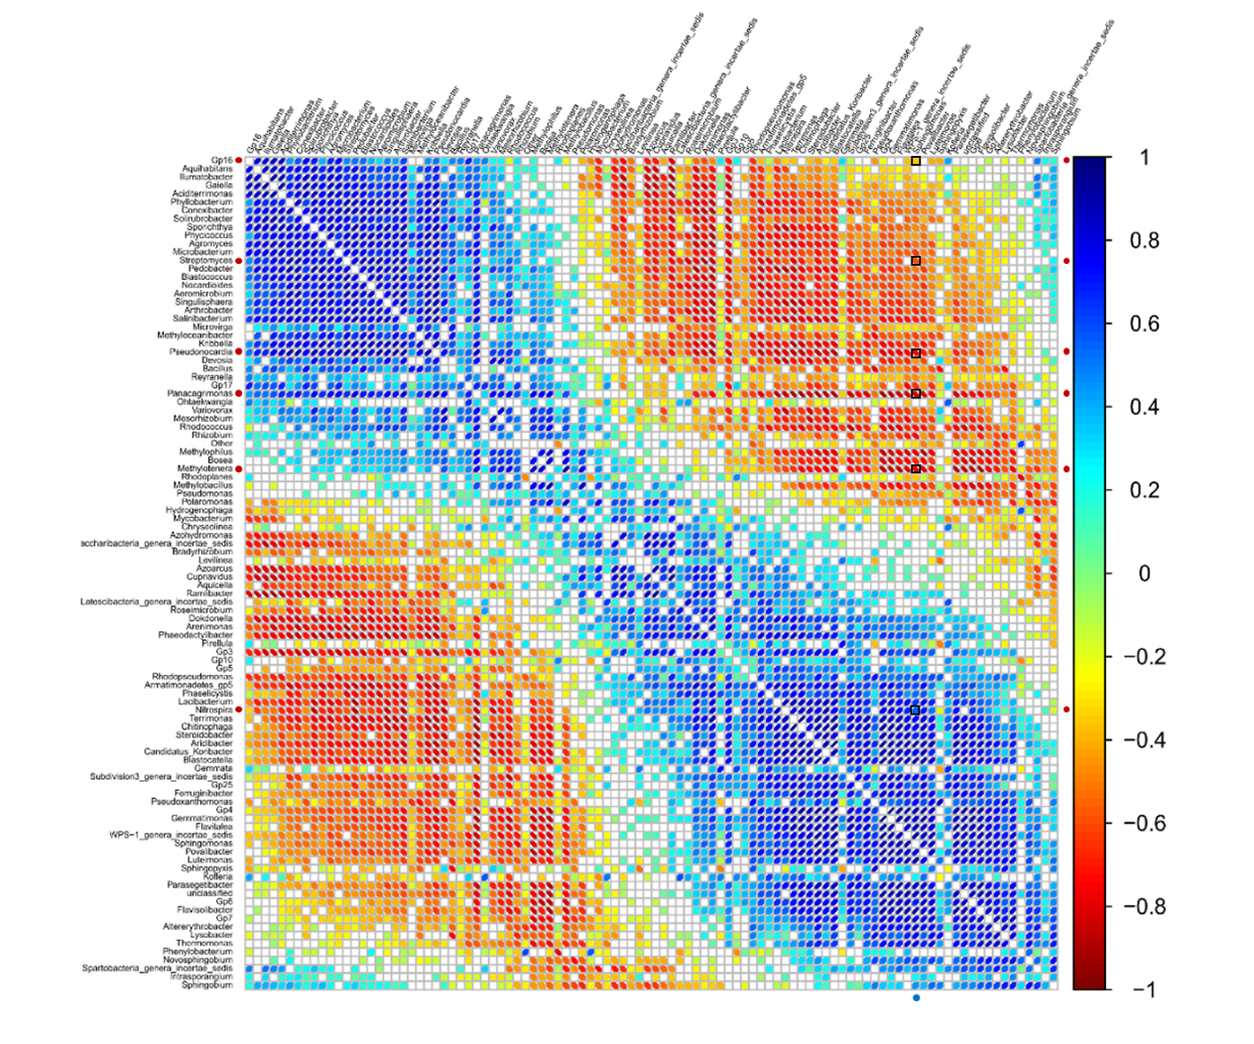
Figure S2. Correlation network of bacterial lineages on genus level (p<0.05). The size of ellipse represented the absolute value of the correlation coefficients, in which smaller ellipse indicated larger value of correlation, and vice versa. Negative correlation was shown in redder color, and positive correlation was shown in bluer color. Boxed blocks highlight the correlations between cultivable Sphingomonas sp. YT1005 and the active pyrene degraders including Nitrospira (OTU23472), Gp16 (OTU33542), Streptomyces (OTU29458), Pseudonocardia (OTU29851), Panacagrimonas (OTU4395) and Methylotenera (OTU583)..
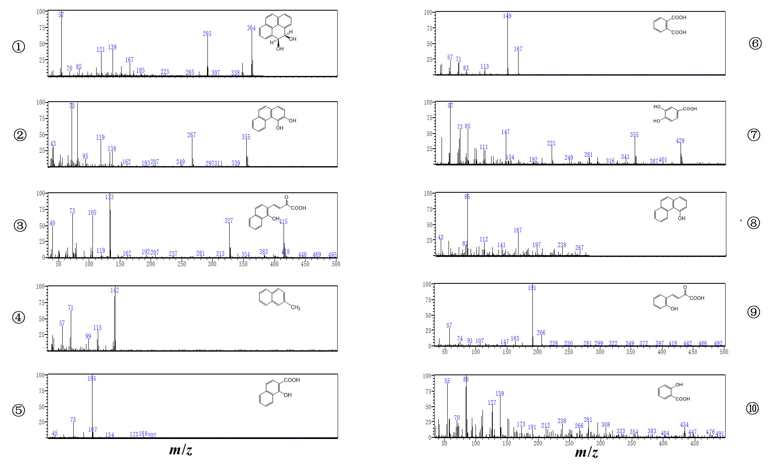
Figure S3. Mass spectra of metabolites during pyrene degradation process. Metabolite ①: cis-4,5-pyrene dihydrodiol; metabolite ②: dihydroxyphenanthrene; metabolite ③: 2-hydroxy-2-H-benzo[h]chromene-2-carboxylic acid; metabolite ④: 2-methylnaphthalene; metabolite ⑤: 1-hydroxy-2-naphthoic acid; metabolite ⑥: phthalic acid; metabolite ⑦: protocatechuic acid; metabolite ⑧: 4-phenanthrenol; metabolite ⑨: trans-2'-carboxybenzalpyruvate; metabolite ⑩: salicylic acid.

Table S1. Soil geochemical properties and analytical methods
Geochemical property | Data | Analytical methods (Chinese standard)
pH | 7.5 | Glass electrode method (NY/T 1121.2-2006)
Moisture (%) | 15.9 | Gravimetric analysis (NY/T 52-1987)
Humus (g/kg) | 10.2 | Volumetric method (LY/T 1238-1999)
Organic matter (g/kg) | 17.5 | Volumetric method (LY/T 1237-1999)
Organic carbon (g/kg) | 10.3 | Volumetric method (LY/T 1237-1999)
Total nitrogen (g/kg) | 1.12 | Volumetric method (LY/T 1228-2015)
Hydrolyzable nitrogen (mg/kg) | 79.3 | Volumetric method (LY/T 1228-2015)
Total phosphorus (g/kg) | 1.10 | UV-VIS (LY/T 1232-2015)
Available phosphorus (mg/kg) | 52.5 | UV-VIS (LY/T 1232-2015)
Available potassium (mg/kg) | 124 | ICP-AES (LY/T 1234-2015)

Table S2. Primers used in this study.
Genes | Primers | Sequence (5’-3’) | Length (bp) | Annealing  temperature (ºC) | Reference
16S rRNA | 338F | ACTCCTACGGGAGGCAGCAG | 236 | 55 | [1]
16S rRNA | 517R | ATTACCGCGGCTGCTGG | 236 | 55 | [1]
PAH-RHDα-GP | GP-F | CGGCGCCGACAAYTTYGTNGG | 292 | 54 | [2]
PAH-RHDα-GP | GP-R | GGGGAACACGGTGCCRTGDATRAA | 292 | 54 | [2]
PAH-RHDα-GN | GN-F | GAGATGCATACCACGTKGGTTGGA | 306 | 56 | [2]
PAH-RHDα-GN | GN-R | AGCTGTTGTTCGGGAAGAYWGTGCMGTT | 306 | 56 | [2]
nidA | NidA-F | TTCCCGAGTACGAGGGATAC | 121 | 56 | [3]
nidA | NidA-R | TCACGTTGATGAACGACAAA | 121 | 56 | [3]
nidA3 | NidA3-F | CCTGATGCGACGACAATG | 421 | 55 | [4]
nidA3 | NidA3-R | GCAACCCTAGCCGACTCTT | 421 | 55 | [4]

Table S3. Sequencing reads, OTU numbers, coverage and bacterial alpha-diversity indices (Chao1, Shannon and Simpson) of soil samples in different treatments.
Sample | Reads | OTU number | Coverage | Shannon | Chao1 | Simpson
OS_CK_0 | 45,488 | 4,530 | 94.99% | 5.78 | 7,824 | 0.0208
OS_CK_10 | 46,385 | 4,805 | 95.07% | 6.02 | 7,746 | 0.0172
OS_CK_20 | 50,589 | 3,855 | 96.15% | 4.96 | 6,690 | 0.0680
OS_CK_30 | 52,944 | 4,761 | 95.52% | 5.86 | 8,424 | 0.0179
OS_Pyr_10 | 44,487 | 4,532 | 94.94% | 5.90 | 7,769 | 0.0184
OS_Pyr_20 | 56,196 | 4,216 | 96.23% | 4.83 | 7,398 | 0.0921
OS_Pyr_30 | 40,833 | 3,629 | 95.31% | 5.32 | 6,712 | 0.0298
MMI_NC_10 | 45,636 | 3,690 | 95.91% | 5.21 | 6,512 | 0.0478
MMI_NC_20 | 56,174 | 4,275 | 96.22% | 5.43 | 7,726 | 0.0416
MMI_NC_30 | 53,421 | 4,468 | 95.90% | 5.68 | 7,776 | 0.0340
MMI_Pyr_10 | 60,220 | 4,054 | 96.68% | 5.04 | 6,950 | 0.0514
MMI_Pyr_20 | 62,756 | 4,372 | 96.56% | 5.28 | 7,633 | 0.0416
MMI_Pyr_30 | 40,873 | 3,859 | 95.35% | 5.78 | 6,736 | 0.0231
MFC_NC_10 | 54,659 | 4,657 | 95.86% | 5.72 | 7,903 | 0.0272
MFC_NC_20 | 63,481 | 4,824 | 96.50% | 5.54 | 7,851 | 0.0552
MFC_NC_30 | 53,947 | 4,778 | 95.77% | 5.84 | 8,084 | 0.0319
MFC_Pyr_10 | 57,597 | 4,144 | 96.44% | 5.46 | 7,530 | 0.0291
MFC_Pyr_20 | 41,841 | 2,129 | 99.28% | 6.02 | 2,341 | 0.0102
MFC_Pyr_30 | 44,273 | 4,516 | 95.54% | 6.53 | 7,156 | 0.0069
Table S4. Topological properties of the molecular ecological network of bacterial community.
Network Indexes | Value
Total nodes | 360
Total links | 784
R square of power-law | 0.874
Average degree (avgK) | 4.356
Average clustering coefficient (avgCC) | 0.205
Average path distance (GD) | 5.646
Geodesic efficiency (E) | 0.237
Harmonic geodesic distance (HD) | 4.228
Maximal degree | 32
Nodes with max degree | 26451
Centralization of degree (CD) | 0.077
Maximal betweenness | 9272.77
Nodes with max betweenness | 29850
Centralization of betweenness (CB) | 0.137
Maximal stress centrality | 131457
Nodes with max stress centrality | 29850
Centralization of stress centrality (CS) | 1.964
Maximal eigenvector centrality | 0.253
Nodes with max eigenvector centrality | 26451
Centralization of eigenvector centrality (CE) | 0.234
Density (D) | 0.012
Reciprocity | 1
Transitivity (Trans) | 0.389
Connectedness (Con) | 0.56
Efficiency | 0.983
Hierarchy | 0
Lubness | 1

Table S5. Identification of metabolites produced during the biodegradation of pyrene based on GC-MS.
Metabolites | r_{T} (min) | m/z of fragments ions [% relative abundance] | Molecule | Reference
① | 19.82 | 364[M⁺,70], 293[62], 167[20], 139[43], 121[40], 57[100] | cis-4,5-pyrene dihydrodiol | [5]
② | 5.31 | 355[M⁺,45], 339[4], 267[50], 73[100] | dihydroxyphenanthrene | [6]
③ | 6.28 | 415[M⁺,55], 327[61], 133[100], 105[69], 73[72] | 2-hydroxy-2-H-benzo[h]chromene-2-carboxylic acid | [7]
④ | 6.86 | 142[M⁺,100], 115[23], 99[18], 71[12] | 2-methylnaphthalene | [8]
⑤ | 5.58 | 202[M⁺,3], 188[7], 173[5], 105[100] | 1-hydroxy-2-naphthoic acid | [9]
⑥ | 21.73 | 167[M⁺,42], 149[100], 71[20], 57[25] | phthalic acid | NIST
⑦ | 22.43 | 429[M⁺,42], 355[60], 281[35], 221[50], 147[56], 73[79], 57[100] | protocatechuic acid | [10]
⑧ | 21.93 | 267[M⁺,10], 238[14], 197[15], 167[38], 141[15], 112[23], 85[100] | 4-phenanthrenol | [6, 8]
⑨ | 8.47 | 206[M⁺,18], 191[100], 147[5], 57[27] | trans-2'-carboxybenzalpyruvate | [7]
⑩ | 20.87 | 308[M⁺,19], 281[25], 266[17], 191[13], 139[68], 85[100], 55[88] | salicylic acid | [7, 11]

Reference
[1] Ovreas L, Forney L, Daae FL, Torsvik V (1997). Distribution of bacterioplankton in meromictic Lake Saelenvannet, as determined by denaturing gradient gel electrophoresis of PCR-amplified gene fragments coding for 16S rRNA. Applied and Environmental Microbiology 63: 3367-3373.
[2] Cebron A, Norini M-P, Beguiristain T, Leyval C (2008). Real-Time PCR quantification of PAH-ring hydroxylating dioxygenase (PAH-RHD alpha) genes from Gram positive and Gram negative bacteria in soil and sediment samples. Journal of Microbiological Methods 73: 148-159.
[3] DeBruyn JM, Chewning CS, Sayler GS (2007). Comparative quantitative prevalence of Mycobacteria and functionally abundant nidA, nahAc, and nagAc dioxygenase genes in coal tar contaminated sediments. Environmental Science & Technology 41: 5426-5432.
[4] Chen S, Peng J, Duan G (2016). Enrichment of functional microbes and genes during pyrene degradation in two different soils. Journal of Soils and Sediments 16: 417-426.
[5] Luan TG, Yu KSH, Zhong Y, Zhou HW, Lan CY, Tam NFY (2006). Study of metabolites from the degradation of polycyclic aromatic hydrocarbons (PAHs) by bacterial consortium enriched from mangrove sediments. Chemosphere 65: 2289-2296.
[6] Zhong Y, Luan T, Zhou H, Lan C, Tam NFY (2006). Metabolite production in degradation of pyrene alone or in a mixture with another polycyclic aromatic hydrocarbon by Mycobacterium sp. Environmental Toxicology and Chemistry 25: 2853-2859.
[7] Zhou H, Wang H, Huang Y, Fang T (2016). Characterization of pyrene degradation by halophilic Thalassospira sp strain TSL5-1 isolated from the coastal soil of Yellow Sea, China. International Biodeterioration & Biodegradation 107: 62-69.
[8] Wu F, Guo C, Liu S, Liang X, Lu G, Dang Z (2019). Pyrene degradation by Mycobacterium gilvum: Metabolites and proteins involved. Water Air And Soil Pollution 230.
[9] Seo J-S, Keum Y-S, Kim K, Li QX (2010). Degradation of Pyrene by Mycobacterium aromativorans Strain JS19b1. Journal of the Korean Society for Applied Biological Chemistry 53: 323-329.
[10] Teh ZC, Hadibarata T (2014). Enhanced Degradation of Pyrene and Metabolite Identification by Pleurotus eryngii F032. Water Air and Soil Pollution 225.
[11] Zhong J, Luo L, Chen B, Sha S, Qing Q, Tam NFY et al (2017). Degradation pathways of 1-methylphenanthrene in bacterial Sphingobium sp MP9-4 isolated from petroleum-contaminated soil. Marine Pollution Bulletin 114: 926-933.

