Supplementary Information for
Design of robust networks via reinforcement learning prompt the emergence of multilayer backbones
Bingyu Zhu¹, Tianchen Zhu¹, Jianxi Gao², Shlomo Havlin³, Daqing Li^{1,4*}
1 School of Reliability and Systems Engineering, Beihang University, Beijing 100191, China
2 Department of Computer Science, Rensselaer Polytechnic Institute, Troy, NY 12180, USA
3 Department of Physics, Bar-Ilan University, Ramat Gan 52900, Israel.
4 Hangzhou International Innovation Institute, Beihang University, Hangzhou 311115, China
Email: daqingl@buaa.edu.cn
Content
Supplementary Note 1: Features of the designed robust BA network 1
Supplementary Note 2: Features of the backbone structure 1
Supplementary Note 3: Comparison between DCBO and RL design results under different attacks 1

Supplementary Figure 1 The robustness design process of the BA network under HDA attack. 3
Supplementary Figure 2 Features of the backbone structure under HDA attack. 4
Supplementary Figure 3 The first peak moment distribution of networks designed by different methods under HDA attack. 5
Supplementary Figure 4 The result of the randomly generated network under HDA attack. 6
Supplementary Figure 5 Comparison between DCBO and RL design results under HBA attack.. 7
Supplementary Figure 6 Comparison between DCBO and RL design results under CI(2) attack. 8
Supplementary Figure 7 Comparison between DCBO and RL design results under MS attack. 9
Supplementary Figure 8 Comparison between DCBO and RL design results under GND attack. 10
Supplementary Figure 9 Comparison between DCBO and RL design results under GNDR attack. 11
Supplementary Figure 10 Case of network structures designed by RL and DCBO under different attacks. 12
Supplementary Figure 11 Robustness design of Germany grid. 13
Supplementary Figure 12 Performance of different design strategies on SF networks. 14

Supplementary Note 1: Features of the designed robust BA network
During the RL design process of the BA network (Fig.2 in the main text), multilayer backbone structures are gradually established among non-hub nodes within the network, instead of merely enhancing hub nodes, establishing connections between low-degree nodes or prioritizing long-distance connections. The backbone structures, the change of degree distribution and the distance between nodes to be connected are shown in Supplementary Figure 1. During the RL design process, the degree of hub nodes (nodes with degree greater than 5) is constant, and the number of low-degree nodes (nodes with degree of 1) does not decrease rapidly (Supplementary Figure 1a), while the number of nodes with degree between 2 and 5 increases. The shortest path lengths of the nodes (s-t distance) to which an edge is to be added are less than the diameter of the network during the design process. From design step 50 to 101, one red backbone structure and two backbone structures (red and blue) appeared, respectively. This gradual design of multilayer backbone structures may be the essence of intelligent network robustness design.

Supplementary Note 2: Features of the backbone structure
1、The non-critical nature of nodes in backbones
Nodes in backbones are non-critical, meaning they are difficult to be directly identified by attack strategies. For the network designed against HDA attack, the degree distribution of nodes in different backbones is shown in Supplementary Figure 2a, d. The degrees of nodes in the backbones are mostly in the middle range of the distribution. This indicates that many nodes of the network have larger degrees than those in the backbones. Therefore, nodes in backbones are difficult to be identified by HDA attack.
2、The parallel relationship between backbones
During the dismantling process, different backbones alternately assume the role of bridges. This phenomenon suggests the parallel relationship between backbones. Therefore, we sequentially conducted HDA attack on each backbone to verify the parallelism between them and their crucial role in maintaining network connectivity during dismantling. As shown in Supplementary Figure 2b and e, we conducted HDA attack on each backbone sequentially, and there is no sudden disassembly in the network until all backbones were removed. It indicates that the removal of one backbone hardly affects the ability of another one to maintain network connectivity. Additionally, we attacked the network while preserving all the backbones. Unlike the dismantling processes shown in Fig.3b and e of the main text, attacking nodes except backbones resulted in almost no sudden disassembly phenomena (as shown in Supplementary Figure 2c, f). This confirms that the multilayer backbones are the key structure for high network robustness.

Supplementary Note 3: Comparison between the DCBO and RL design results under different attacks
We provide the results of the randomly designed network in Supplementary Figure 4 compared with Fig.3 of the main text, the comparison results of synthetic networks under different attacks designed by RL and DCBO (Supplementary Figure 5-9).
Notably, under different attacks, the characteristics of backbones that maintain high robustness vary, apart from the first peak moment backbones. For attacks based on centrality, such as HBA, series-parallel relationship of backbones may be the key factor for high robustness. Under HBA attack, the RL-designed network contains backbones with separate peaks, while the backbones of the DCBO-designed network have near peaks (Supplementary Figure 5). From the average rate of change in betweenness centrality during the dismantling process, it can be seen that the backbone of the RL-designed network exhibits two peaks farther from each other (Backbone 2 and Backbone 3 in Supplementary Figure 5e) than the DCBO-designed network. This means that in the RL-designed network, after one backbone is compromised, another gradually takes on the bridge role in the network. For CI attack based on influence maximization, the topological combination of the backbones in RL allows for a tighter functional transition process (Supplementary Figure 6). That is, as Backbone 1 fails, Backbone 3 takes over the connectivity role immediately (Supplementary Figure 6e). In contrast, in the DCBO-designed network, after Backbone 2 fails, although Backbone 3 takes over the connectivity role in the next moment, the network robustness has already declined (Supplementary Figure 6b).
On the other hand, for overall network attacks like MS, GND, and GNDR, the backbone structures may enhance robustness of the entire networks through their topological combinations, with almost no obvious collapse (Supplementary Figure 7-9). Under MS attack, there is a deep backbone in the network designed by RL, whose bridging role almost spans the entire dismantling process. Under GND attack, whenever a backbone structure is compromised and the network trends toward collapse, a hidden backbone emerges to take on the main connectivity. This stepwise parallel relationship may be derived from the topological combination of the backbones. Under GNDR attack, similar to MS, there are two deep backbones that play a key role in bridging during almost the whole dismantling. Meanwhile, when one backbone structure is attacked, another further improves its bridging function. In contrast, in the DCBO-designed networks under these attacks, although there are multiple backbones, most are successively compromised early on, making it difficult to maintain high network connectivity. In summary, facing different attacks may require designing backbone structures with different characteristics, where the first peak moment of backbones and their topological combination in parallel relationships and depth may be key factors in designing robust networks.
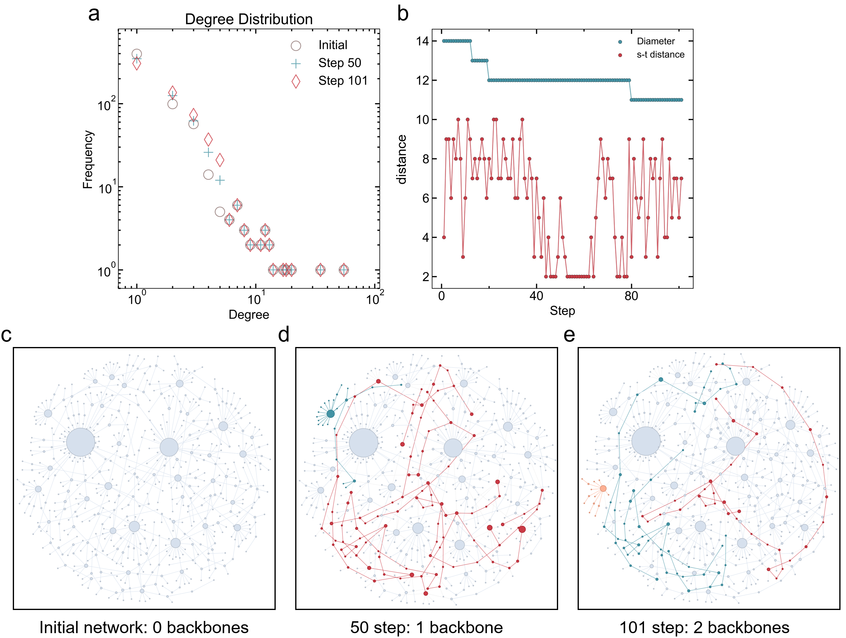
Supplementary Figure 1 The robustness design process of the BA network under HDA attack. a. Degree distribution of networks during the design process. b. The diameter of the network and the shortest path length of the nodes (s-t distance) to which an edge is to be added during the design process. c. No backbones in the initial network. d. One backbone in the network at design step 50. e. Two backbones in the network at design step 101.
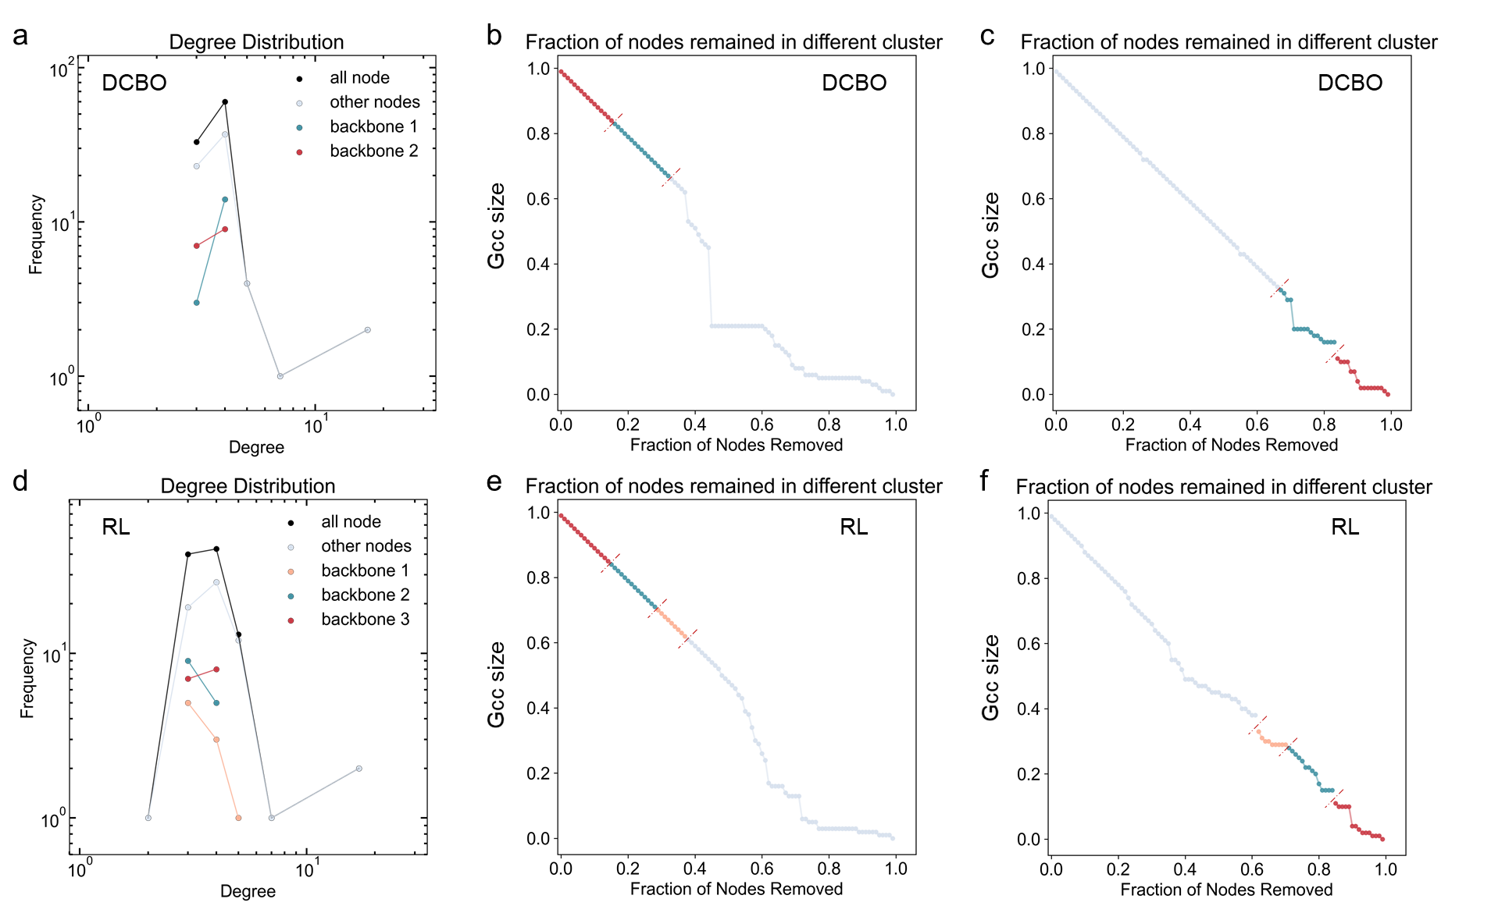
Supplementary Figure 2 Features of the backbone structure under HDA attack. a. The degree distributions of nodes in backbones in the network designed by DCBO. b. The dismantling process curve for the sequential removal of nodes from backbones in the network designed by DCBO c. The dismantling curves of the network designed by DCBO when nodes outside of the backbones are removed first, followed by the removal of the backbones themselves. d, e, f. Same analysis for the RL-designed network.
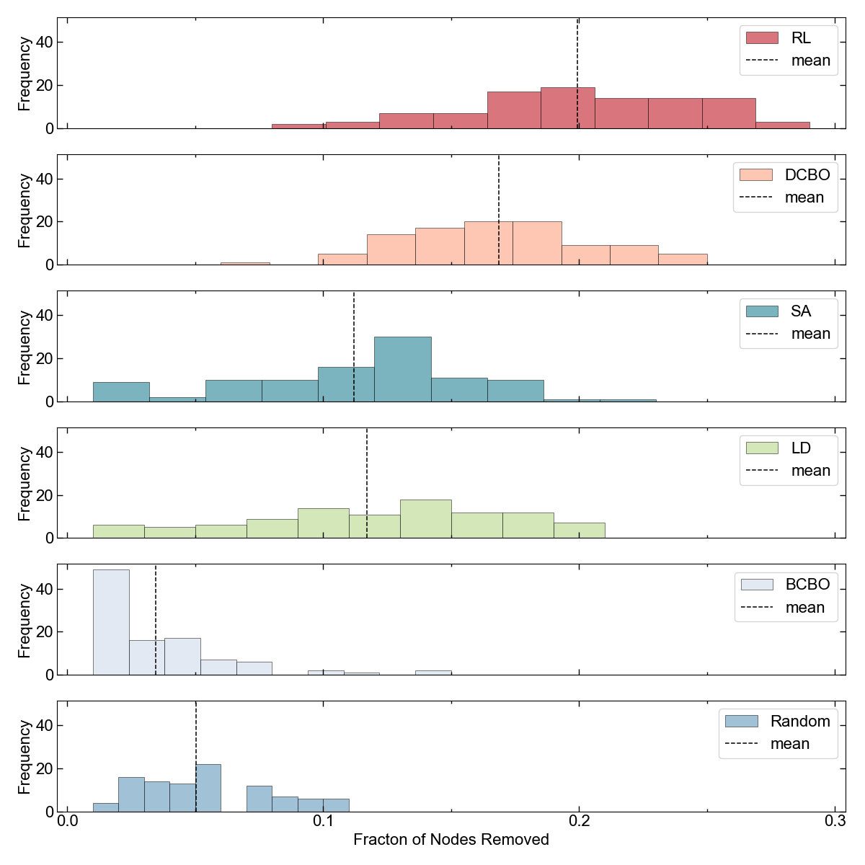
Supplementary Figure 3 The first peak moment distribution of networks designed by different methods under HDA attack.
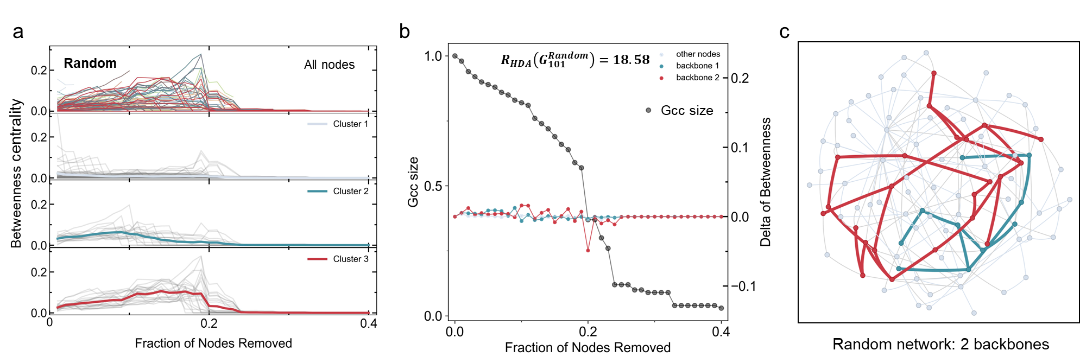
Supplementary Figure 4 The result of the randomly generated network under HDA attack. a. The betweenness centrality sequence of nodes in the randomly generated network during the dismantling process and the cluster result. b. The average change rate of the betweenness centrality of nodes in backbones (right y-axis) and the dismantling curve of the randomly generated network (left y-axis). c. Schematic of backbones in the randomly generated network. Backbones with the same color in b and c are corresponding.
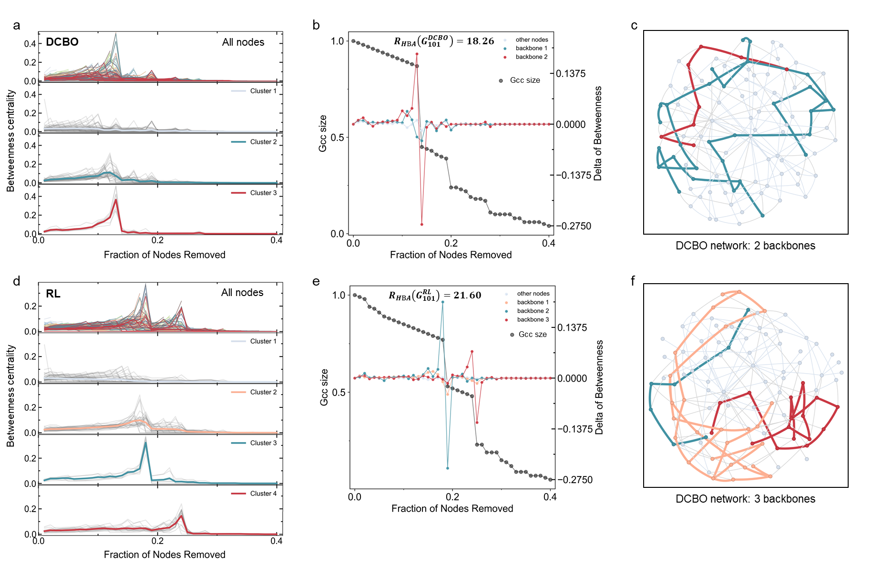
Supplementary Figure 5 Comparison between DCBO and RL design results under HBA attack. a. The betweenness centrality sequence of nodes in the DCBO-designed network during the dismantling process and the cluster result. b. The average change rate of the betweenness centrality of nodes in backbones and the dismantling curve of the DCBO-designed network c. Schematic of backbones generated in the DCBO-designed network. Backbones with the same color in b and c are corresponding. d-f. Same analysis for the RL-designed network.
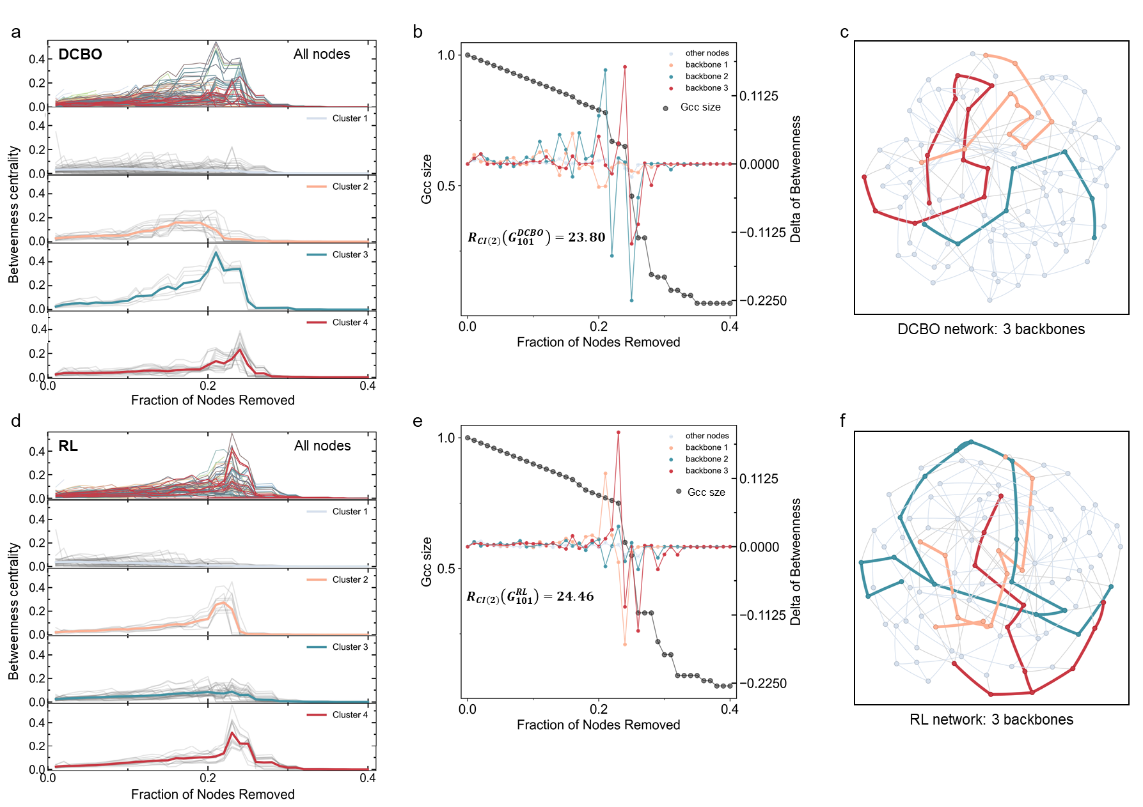
Supplementary Figure 6 Comparison between DCBO and RL design results under CI(2) attack. a. The betweenness centrality sequence of nodes in the DCBO-designed network during the dismantling process and the cluster result. b. The average change rate of the betweenness centrality of nodes in backbones and the dismantling curve of the DCBO-designed network c. Schematic of backbones generated in the DCBO-designed network. Backbones with the same color in b and c are corresponding. d-f. Same analysis for the RL-designed network.
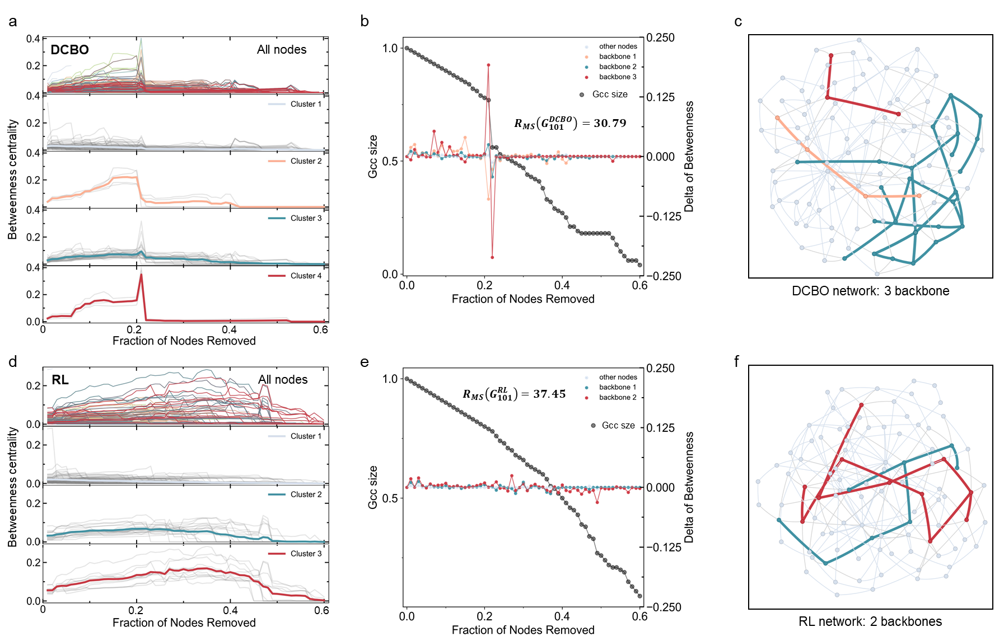
Supplementary Figure 7 Comparison between DCBO and RL design results under MS attack. a. The betweenness centrality sequence of nodes in the DCBO-designed network during the dismantling process and the cluster result. b. The average change rate of the betweenness centrality of nodes in backbones and the dismantling curve of the DCBO-designed network c. Schematic of backbones generated in the DCBO-designed network. Backbones with the same color in b and c are corresponding. d-f. Same analysis for the RL-designed network.
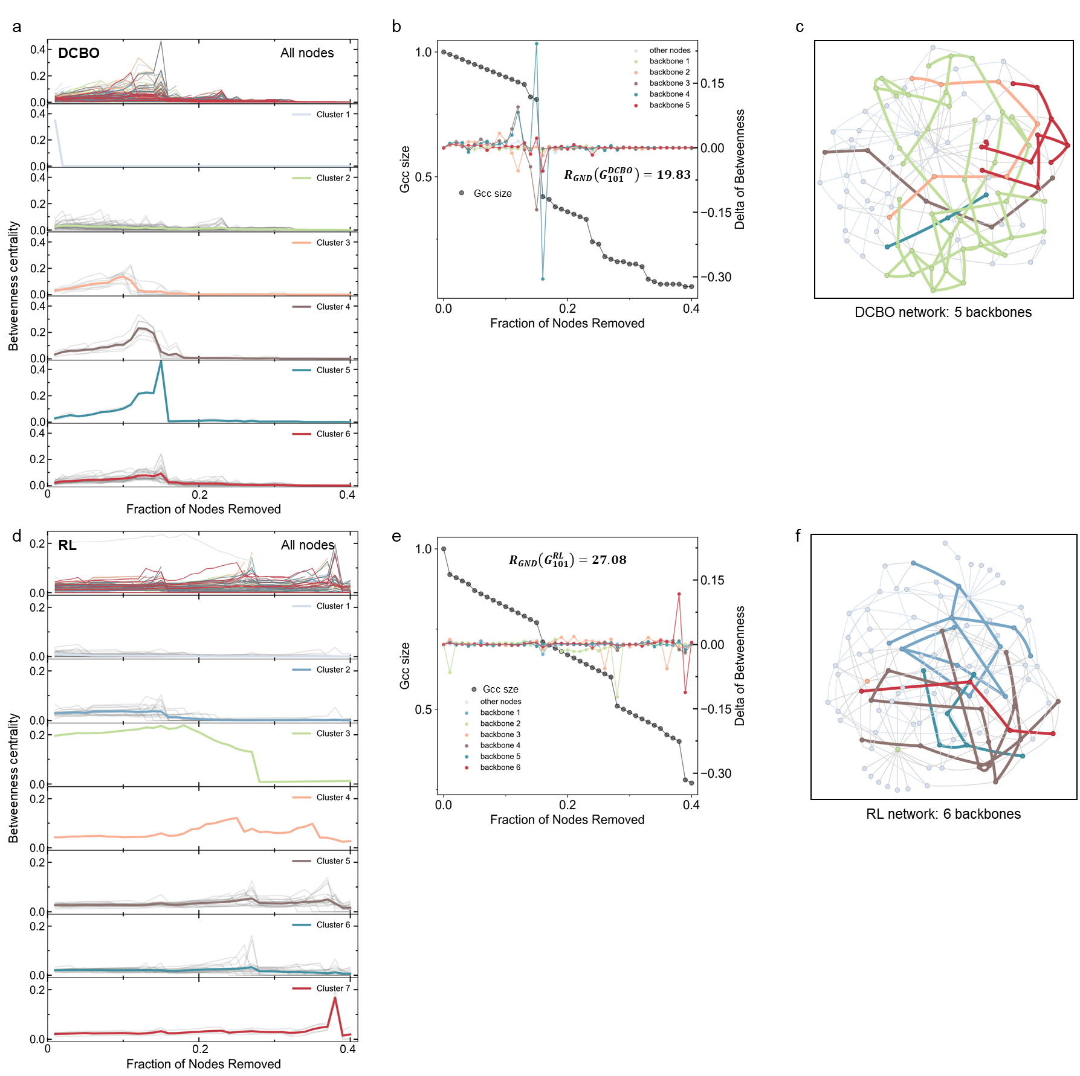
Supplementary Figure 8 Comparison between DCBO and RL design results under GND attack. a. The betweenness centrality sequence of nodes in the DCBO-designed network during the dismantling process and the cluster result. b. The average change rate of the betweenness centrality of nodes in backbones and the dismantling curve of the DCBO-designed network c. Schematic of backbones generated in the DCBO-designed network. Backbones with the same color in b and c are corresponding. d-f. Same analysis for the RL-designed network.
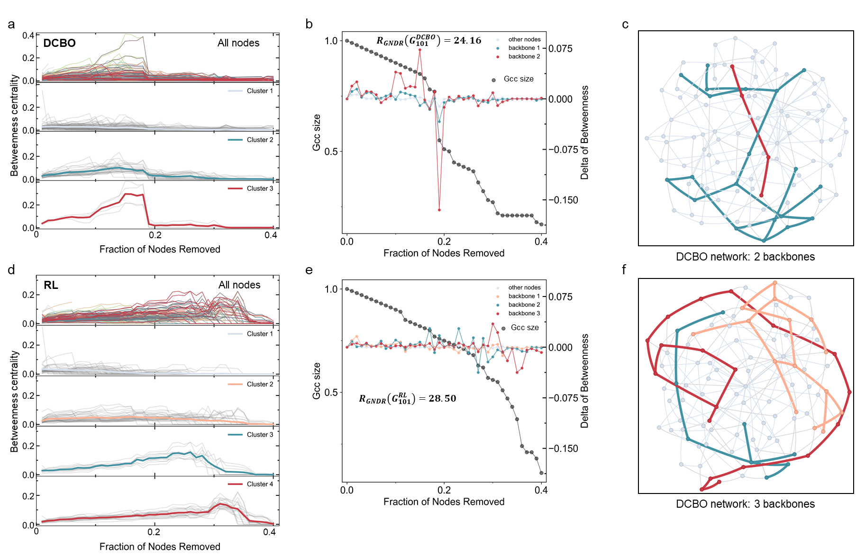
Supplementary Figure 9 Comparison between DCBO and RL design results under GNDR attack. a. The betweenness centrality sequence of nodes in the DCBO-designed network during the dismantling process and the cluster result. b. The average change rate of the betweenness centrality of nodes in backbones and the dismantling curve of the DCBO-designed network c. Schematic of backbones generated in the DCBO-designed network. Backbones with the same color in b and c are corresponding. d-f. Same analysis for the RL-designed network.
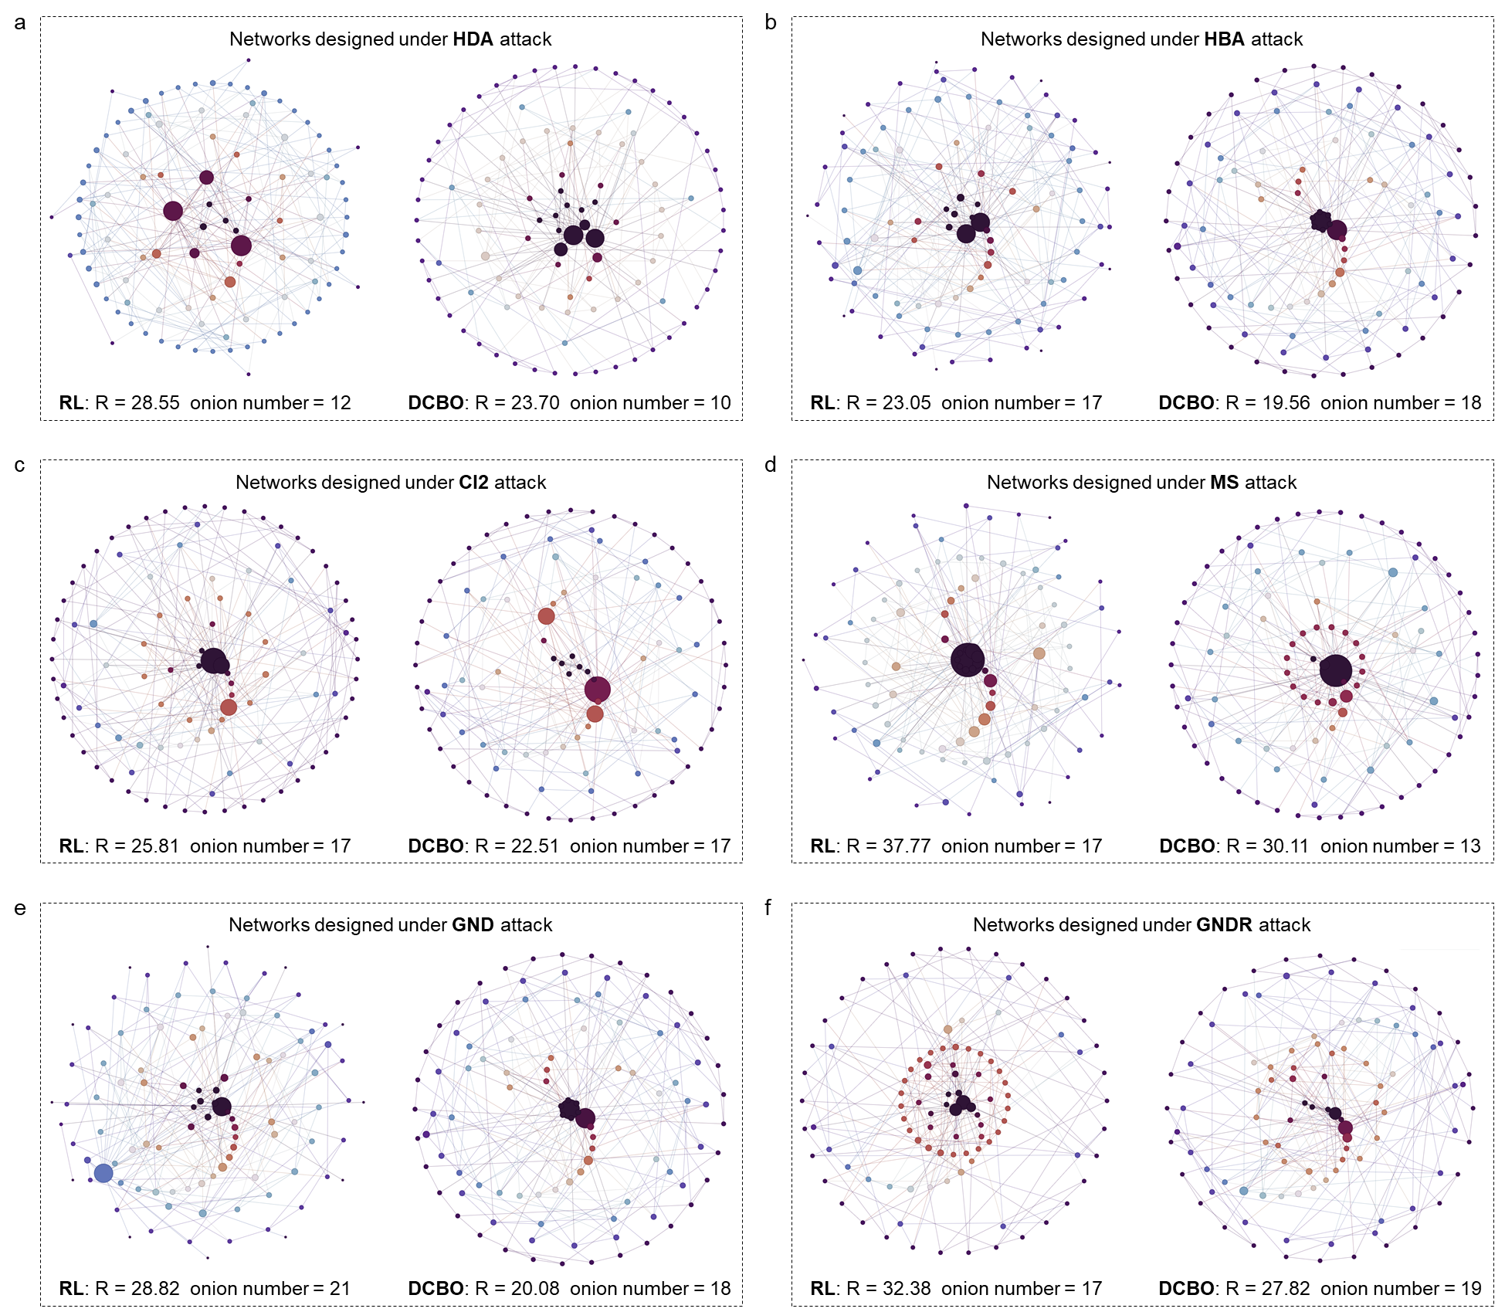
Supplementary Figure 10 Case of network structures designed by RL and DCBO under different attacks. The network is laid out from the outside to the inside based on the order of onion decomposition. Each color of nodes represents a layer of onion decomposition The size of the nodes is proportional to their degree. R represents network robustness. Onion number represents the number of layers in onion decomposition.
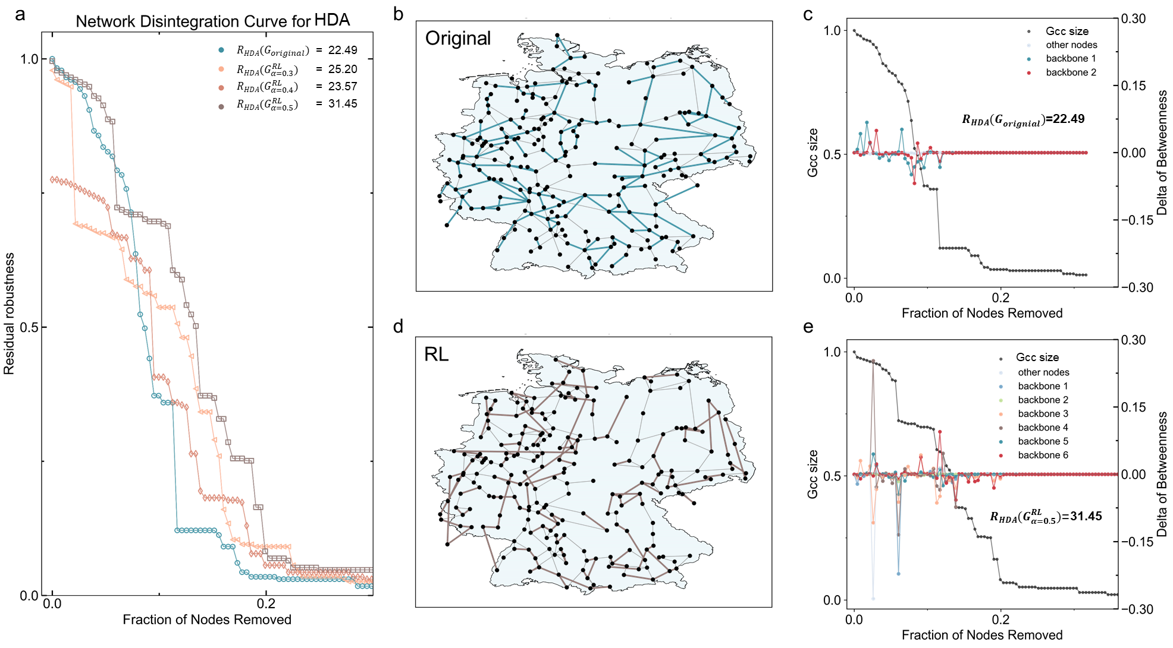
Supplementary Figure 11 Robustness design of Germany grid. a. Dismantling curves under HDA attack with different reconnection fractions, and the original network. b. The initial topology of Germany grid (ForceAtlas2 layout). c. The dismantling curve and the average change rate of betweenness centrality of different clusters in the original network. d. The network topology with a reconnection fraction of 0.5 (nodes maintaining the same layout as b). e. The dismantling curve and the average change rate of betweenness centrality of different clusters in the network with a reconnection fraction of 0.5.
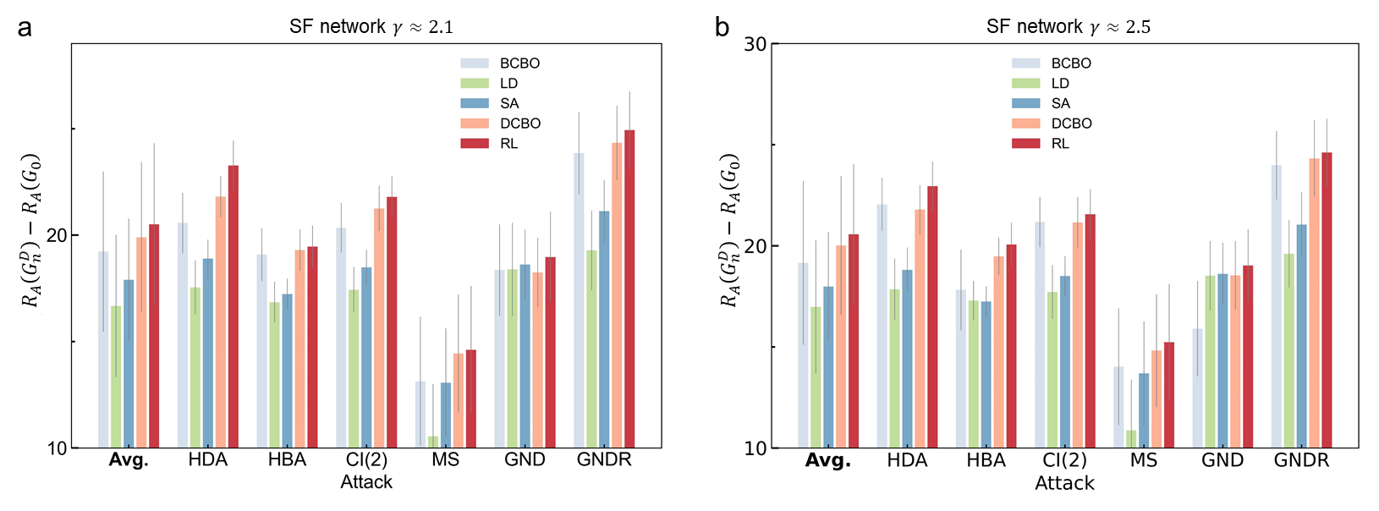
Supplementary Figure 12 Performance of different design strategies on SF networks. a. Results of robustness design for SF networks with $γ≈2.1$ under different attacks. b. Results of robustness design for SF networks with $γ≈2.5$ under different attacks. Each bar represents the average robustness improvement value of 100 networks with 100 nodes adding 100edges.

