Clinical Characteristics and Short-Term Outcomes of Pediatric Lymphoma: A Retrospective Cohort Study from a Large Tertiary Hospital in a Low- and Middle-Income Country

Dania Abuhalima ^{1*}
Email: dabuhalima@gmail.com
Dima Malhis ¹
Email: malhiss.dima@gmail.com
Zeina Qadi ¹
Email: zeinaraedqadi@gmail.com
Adham Abu Taha ^{2,3}
Email: aabutaha@najah.edu
Sultan Mosleh ^{1,4*}
Email: sultan.mosleh@najah.edu
Sa’ed H. Zyoud ^{5,6,7}
Email: saedzyoud@najah.edu
¹ Department of Medicine, College of Medicine and Health Sciences, An-Najah National University, Nablus 44839, Palestine
² Department of Biomedical Sciences, Faculty of Medicine and Health Sciences, An-Najah National University, Nablus 44839, Palestine
³ Department of Pathology, An-Najah National University Hospital, Nablus 44839, Palestine
⁴ Department of Pediatric Oncology, An-Najah National University Hospital, Nablus 44839, Palestine
⁵ Department of Clinical and Community Pharmacy, College of Medicine and Health Sciences, An-Najah National University, Nablus 44839, Palestine
⁶ Poison Control and Drug Information Center (PCDIC), College of Medicine and Health Sciences, An-Najah National University, Nablus 44839, Palestine
⁷ Clinical Research Center, An-Najah National University Hospital, Nablus 44839, Palestine

*Corresponding authors: sultan.mosleh@najah.edu; dabuhalima@gmail.com

Supplementary Table S1. Survival rates in association with demographic and clinical characteristics
 | N of patients N =75 | N died (% | N survived (%) | P value
Total lymphoma | 75 | 3 (4) | 72 (96)
Lymphoma type |  |  |  | 0.246*
NH | 41 | 3 (4) | 38 (50.7)
H | 34 | 0 (0) | 34 (45.3)
Gender |  |  |  | 0.999*
Male | 46 | 2 (2.7) | 44 (58.7)
Female | 29 | 1 (1.3) | 28 (37.3)
Residence |  |  |  | 0.999*
West Bank | 42 | 2 (2.7) | 40 (53.3)
Gaza | 33 | 1 (1.3) | 32 (42.7)
Presentation |  |  |  | 0.492*
Neck mass | 36 | 1 (1.3) | 35 (46.7)
Respiratory symptoms | 10 | 0 (0) | 10 (13.3)
GI manifestations | 16 | 1 (1.3) | 15 (20.0)
B symptoms | 5 | 0 (0) | 5 (6.7)
Others** | 7 | 1 (1.3) | 7 (9.3)
Pathological diagnosis |  |  |  | 0 .636*
DLBCL | 5 | 0 (0) | 5 (6.7)
BL | 23 | 2 (2.7) | 21 (28.0)
Classical nodular sclerosing | 25 | 0 (0) | 25 (33.3)
Classical lymphocyte rich | 4 | 0 (0) | 4 (5.3)
Classical mixed cellularity | 4 | 0 (0) | 4 (5.3)
Nodular nonclassical | 1 | 0 (0) | 1(1.3)
Stage early/advanced |  |  |  | 0.999*
Early < 3 | 36 | 1 (1.3) | 35 (46.7)
Advanced ≥ 3 | 39 | 2 (2.7) | 37 (49.3)
B symptoms |  |  |  | 0.246*
No | 41 | 3 (4.0) | 38 (50.7)
yes | 34 | 0 (0) | 34 (45.3)
BM involvement |  |  |  | 0.999*
no | 70 | 3 (4.0) | 67 (89.3)
yes | 5 | 0 (0) | 5 (6.7)
LDH |  |  |  | 0.802*
Less than 320 | 38 | 1 (1.3) | 37 (49.3)
More than 320 | 18 | 1 (1.3) | 17 (22.7)
Not done | 19 | 1 (1.3) | 18 (24)
Site |  |  |  | 0.999*
Head/neck | 28 | 1 (1.3) | 27 (36.0)
mediastinal | 15 | 0 (0) | 15 (20.0)
abdomen/pelvis | 15 | 1 (1.3) | 14 (18.7)
Generalized | 17 | 1 (1.3) | 16 (21.3)
Stage |  |  |  | 0.613*
I | 6 | 0 (0) | 6 (8)
II | 30 | 1 (1.3) | 29 (38.7)
III | 30 | 1(1.3) | 29 (38.7)
IV | 9 | 1 (1.3) | 8 (10.7)
* Fisher’s exact test
**Others: encompassed diverse presentations, such as generalized edema, facial puffiness, back pain, headache, migratory arthralgia & erythema, scrotal swelling, periorbital swelling, tooth pain, jaw mass, snoring, hoarseness, and double vision.

Supplementary Table S2. Event rate in association with demographic and clinical data
 | N of patients N =75 | N event (death or relapse) (%) | N no events (%) | P value
Total lymphoma | 75 | 12 (16) | 63 (84)
Lymphoma type |  |  |  | 0.999*
NH | 41 | 7 (9.3) | 34 (45.3)
H | 34 | 5 (6.7) | 29 (38.7)
Gender |  |  |  | 0.195*
Male | 46 | 5 (6.7) | 41 (54.7)
Female | 29 | 7 (9.3) | 22 (29.3)
Residence |  |  |  | 0.999*
West Bank | 42 | 7 (9.3) | 35 (46.7)
Gaza | 33 | 5 (6.7) | 28 (37.3)
Presentation |  |  |  | 0.360*
Neck mass | 36 | 4 (5.3) | 32 (42.7)
Respiratory symptoms | 10 | 2 (2.7) | 8 (10.7)
GI manifestations | 16 | 2 (2.7) | 14 (18.7)
B symptoms | 5 | 2 (2.7) | 3 (4.0)
Others** | 7 | 2 (2.7) | 6 (8)
Pathological diagnosis |  |  |  | 0.277*
LL | 13 | 4 (5.3) | 9 (12.0)
DLBCL | 5 | 0 (0) | 5 (6.7)
BL | 23 | 3 (4.0) | 20 (26.7)
Classical nodular sclerosing | 25 | 4 (5.3) | 21 (28.0)
Classical lymphocyte rich | 4 | 0 (0) | 4 (5.3)
Classical mixed cellularity | 4 | 0 (0) | 4 (5.3)
Nodular nonclassical | 1 | 1 (1.3) | 0
Stage early/advanced |  |  |  | 0.351*
Early < 3 | 36 | 4 (5.3) | 32 (42.7)
Advanced ≥ 3 | 39 | 8 (10.7) | 31 (41.3)
B symptoms |  |  |  | 0.999*
No | 41 | 7 (9.3) | 34 (45.3)
yes | 34 | 5 (6.7) | 29 (38.7)
BM involvement |  |  |  | 0.999*
no | 70 | 11 (14.7) | 59 (78.7)
yes | 5 | 1 (1.3) | 4 (5.3)
LDH |  |  |  | 0.999*
Less than 320 | 38 | 6 (8) | 32 (42.7)
More than 320 | 18 | 3 (4) | 15 (20)
Not done | 19 | 3 (4) | 16 (21.3)
Site |  |  |  | 0.251*
Head/neck | 28 | 2 (2.7) | 26 (34.7)
mediastinal | 15 | 3 (4.0) | 12 (16.0)
abdomen/pelvis | 15 | 2 (2.7) | 13 (17.3)
Generalized | 17 | 5 (6.7) | 12 (16.0)
Stage |  |  |  | 0.434*
I | 6 | 0 (0) | 6 (8)
II | 30 | 4 (5.3) | 26 (34.7)
III | 30 | 5 (6.7) | 25 (33.3)
IV | 9 | 3 (4.0) | 6 (8.0)
* Fisher’s exact test
* * Others: encompassed diverse presentations, such as generalized edema, facial puffiness, back pain, headache, migratory arthralgia & erythema, scrotal swelling, periorbital swelling, tooth pain, jaw mass, snoring, hoarseness, and double vision.

Supplementary Figure 1. Kaplan-Meier curve for Event-Free Survival (EFS) in Pediatric Lymphoma
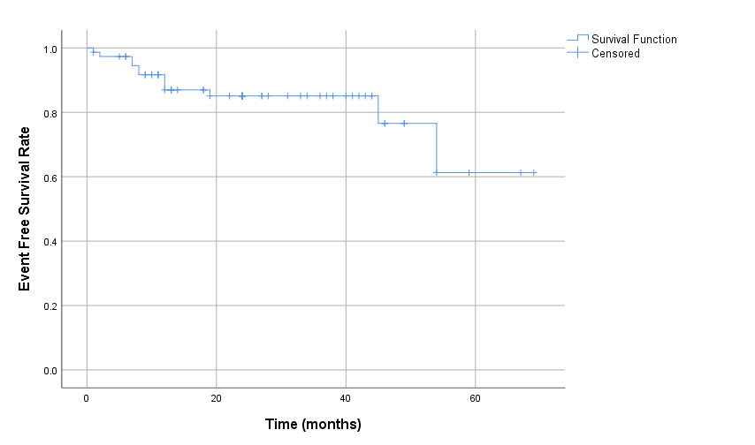

Supplementary Figure 2. Kaplan-Meier curve for Overall Survival (OAS) in Pediatric Lymphoma
