Extended Data
1. Different transcription factors affect CHST11 and CHST15 expression.
2. Impact of rhARSB and ARSB siRNA on MMP2 and MMP9 expression in melanomas and A375 cells.
3. Effectiveness of COP1 and CHST15 siRNAs.
4. Untrimmed Western blot of phospho(Ser473)-AKT1following silencing of ARSB and CHST15.
5. Untrimmed Western blot of phospho(Ser473)-AKT1 following phospho-ROR1 inhibition.
6. Immunoblot of FOXO3A antibody binding to the COP1 promoter in ChIP assay in A375 cells.
7. Effects of ARSB overexpression by plasmid compared with exogenous ARSB on expression of MMP2
and MMP9.
8. Lack of effect of GALNS (N-acetylgalactosamine-6-sulfate sulfatase) on COP-1 expression.
9. Graphical representation of disaccharide data from Table 4, expressed in µg/mg protein.

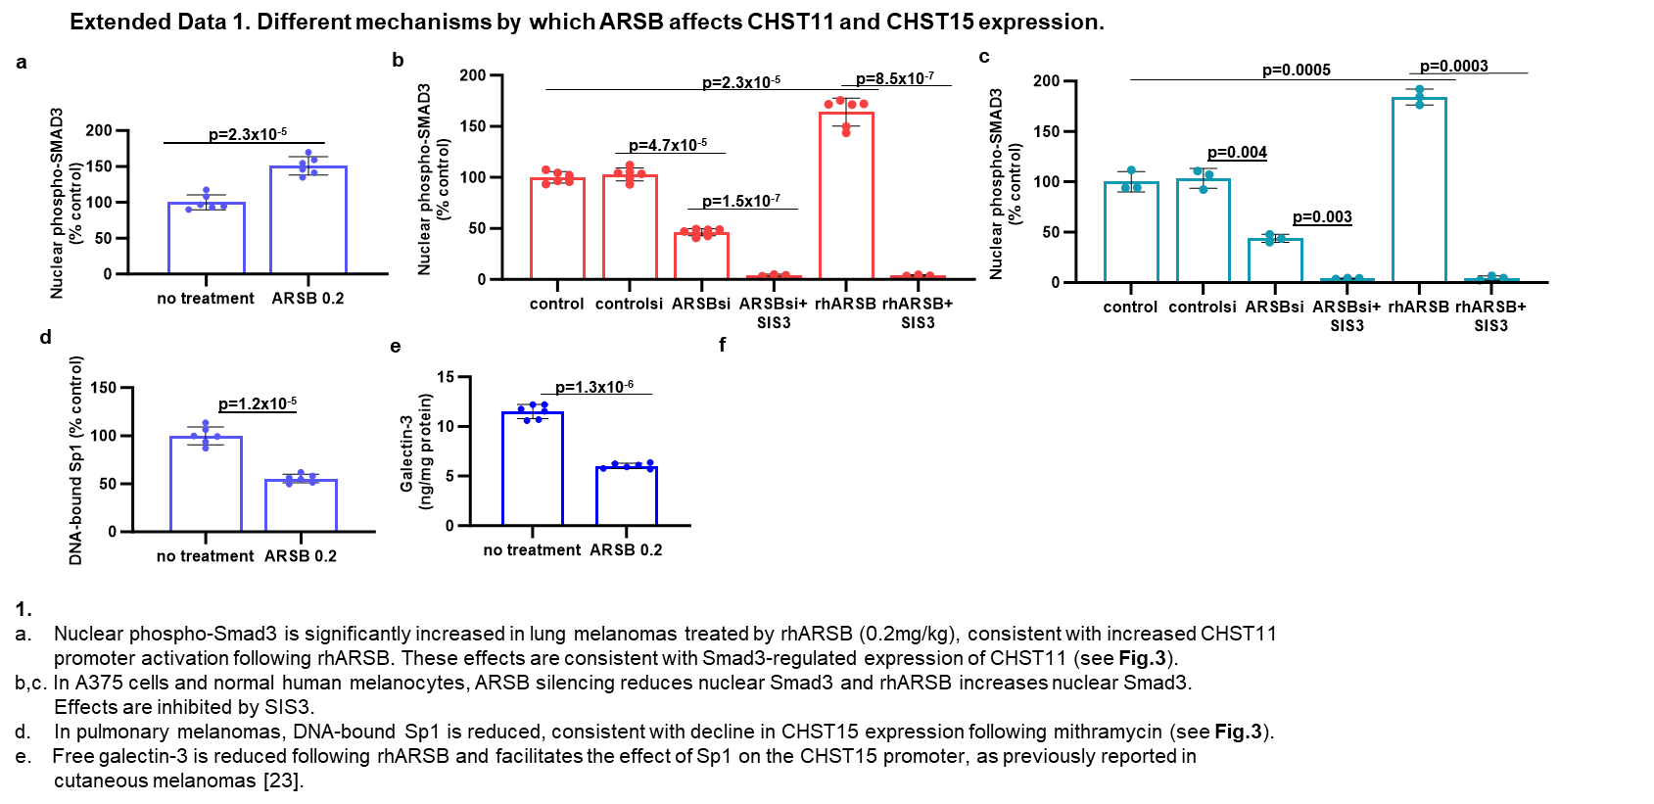

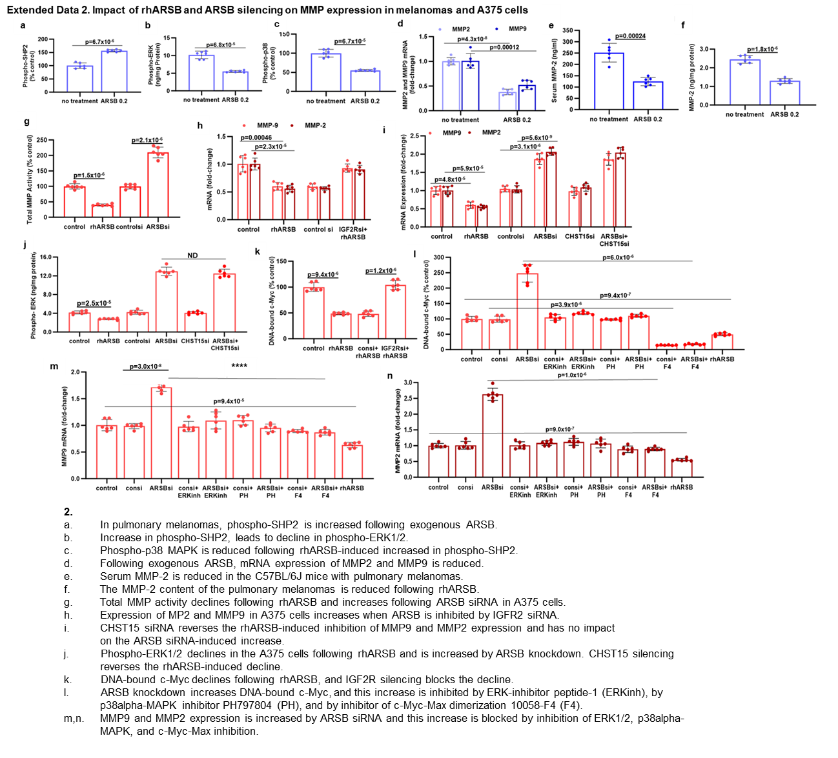

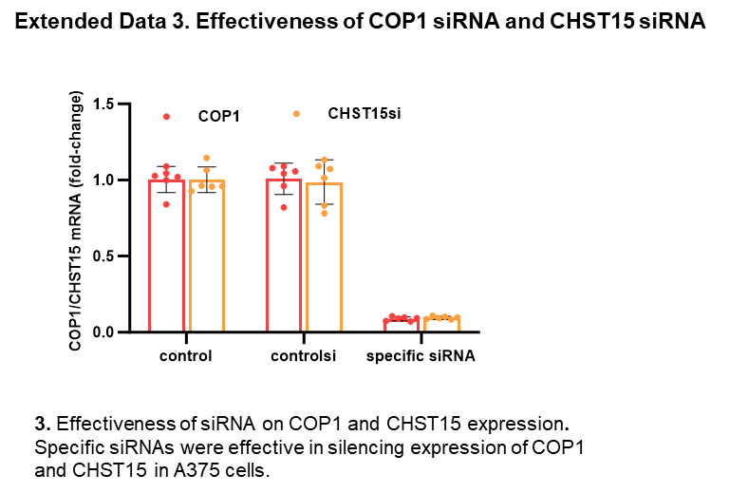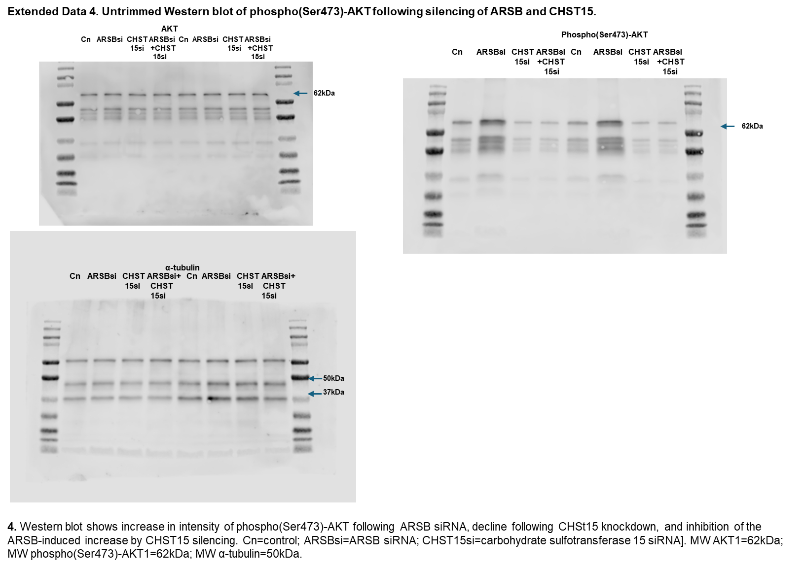

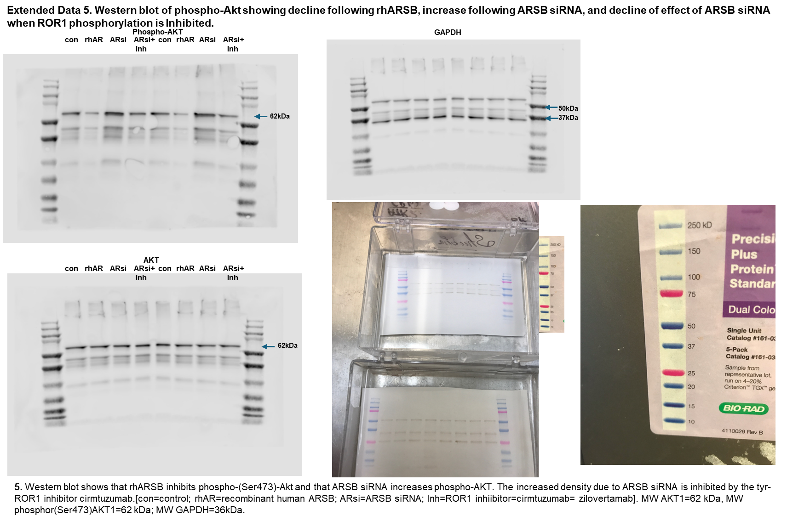

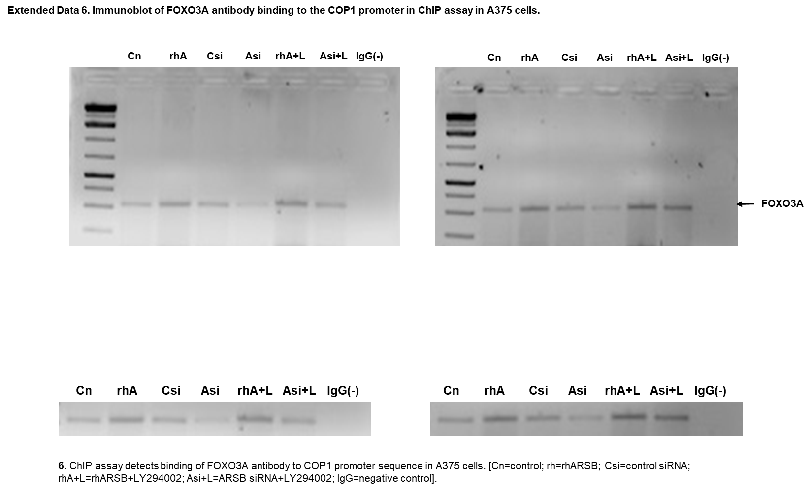

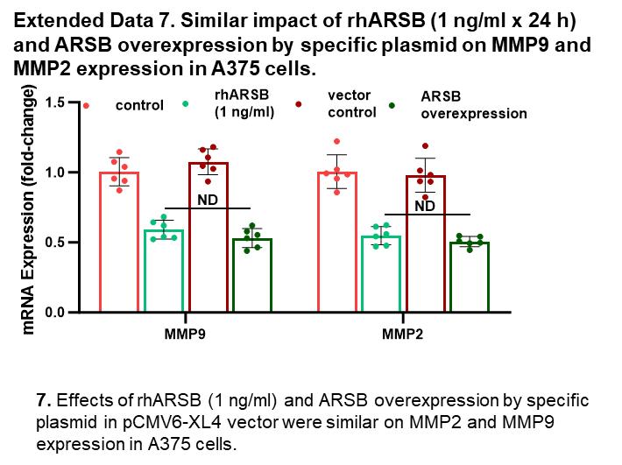
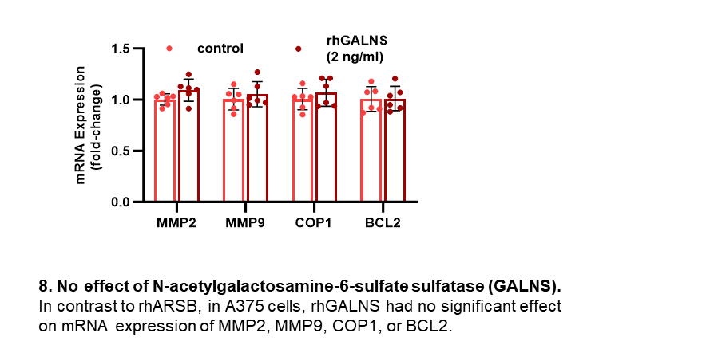
Extended Data 8. No significant effect of rhGALNS (N-acetylgalactosamine-6-sulfate sulfatase) on COP1,BCL2, MMP9, or MMP2 expression.

Extended Data 9. Graphical representation of disaccharide analysis in µg/mg protein, as presented in Table 4.
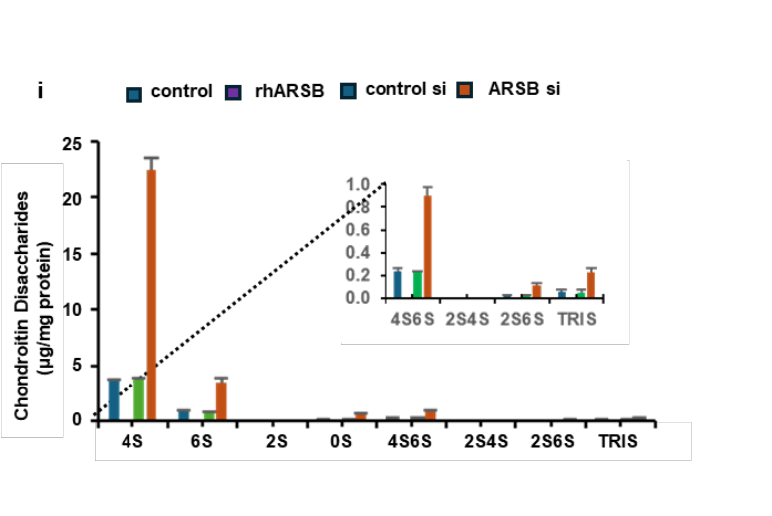

9. Graphical representation of the findings of disaccharide analysis, expressed as µg disaccharide/mg protein, shows increases in C4S, C6S, C0S, C4,6S, C2,6S, and TRIS (C2,4,6S) when ARSB is silenced and declines when A375 cells were treated with exogenous ARSB. The insert shows the lower levels of the di-sulfated (4S6S, 2S4S. 2S6S) and tri-sulfated disaccharides. Results are shown in Table 4.

