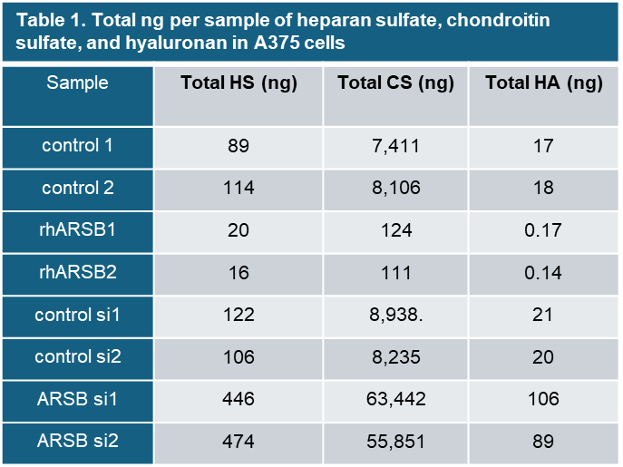
Table 1 confirms the marked decline in total CS, as well as increases in heparan sulfate and hyaluronan following rhARSB treatment of the A375 cells. Conversely, marked increases are evident following ARSB knockdown, most notable in the marked increase in total chondroitin sulfates. Values from duplicate samples are presented.

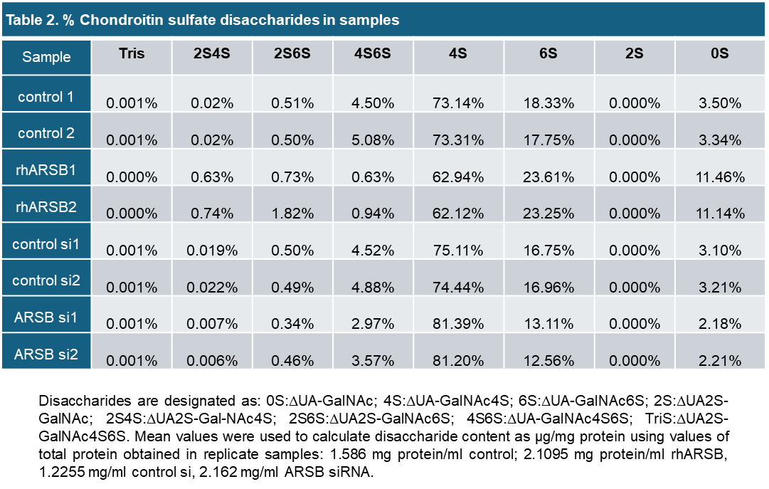
Table 2 indicates the change in the % of each disaccharide following rhARSB or ARSB siRNA, compared to the control value. Disaccharides are designated as: 0S:ΔUA-GalNAc; 4S:ΔUA-GalNAc4S; 6S:ΔUA-GalNAc6S; 2S:ΔUA2S-GalNAc; 2S4S:ΔUA2S-Gal-NAc4S; 2S6S:ΔUA2S-GalNAc6S; 4S6S:ΔUA-GalNAc4S6S; TriS:ΔUA2S-GalNAc4S6S.

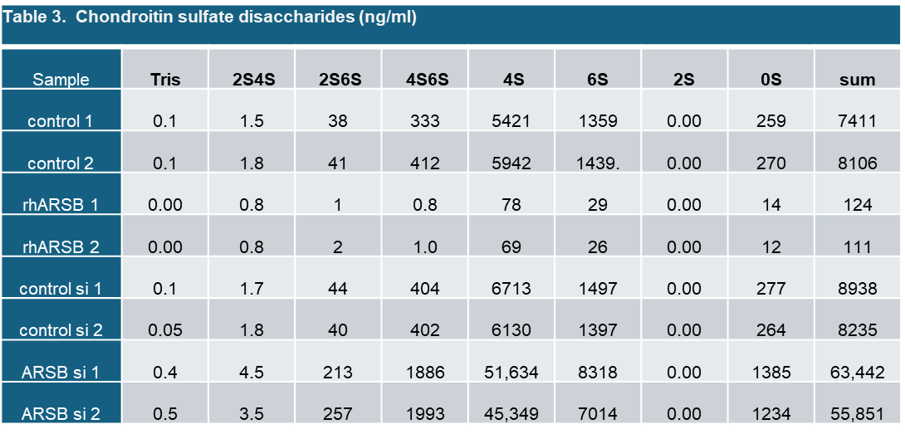
Table 3 expresses the quantity of each disaccharide (ng) per ml of sample.

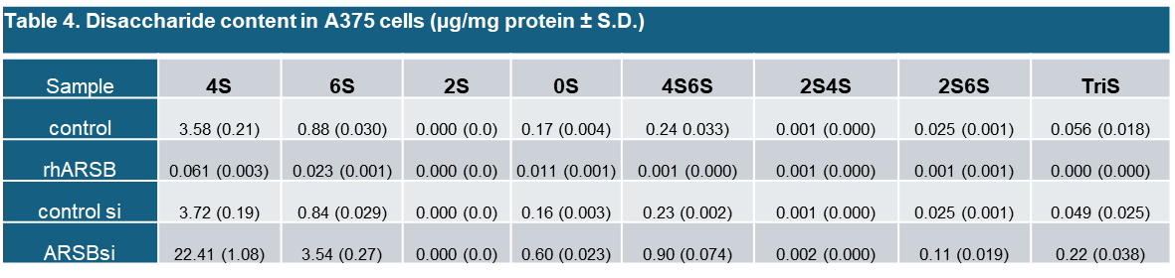

Table 4 indicates the total ng per mg of protein in samples, using the mg protein / ml of replicate samples to calculate the disaccharides (µg) / mg protein in the samples. Mean values were used to calculate disaccharide content as µg/mg protein using values of total protein obtained in replicate samples: 1.586 mg protein/ml control; 2.1095 mg protein/ml rhARSB; 1.2255 mg/ml control si; 2.162 mg/ml ARSB siRNA.

