Supplementary Note 1. SEM image of etched Nb_{0.3}W_{0.7}Se₂ contact bars
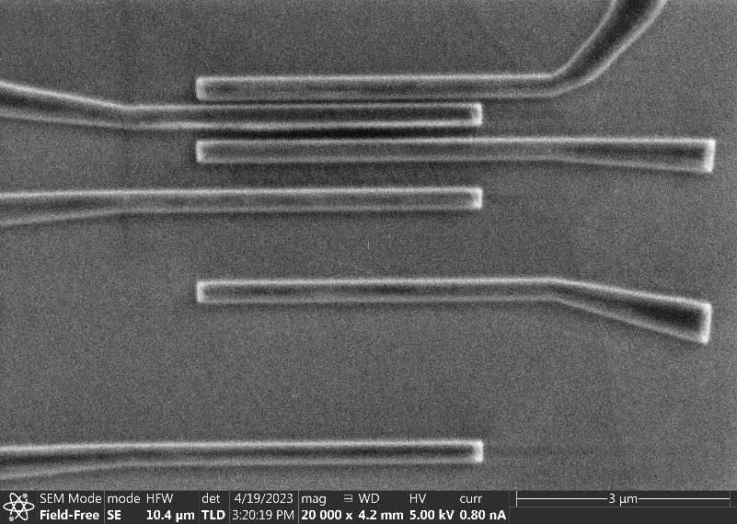
Figure S1 A SEM image of etched Nb_{0.3}W_{0.7}Se₂ contact bars on 90nm SiO₂

Supplementary Note 2. Detailed fabrication process for 2D/2D contacts on different substrates
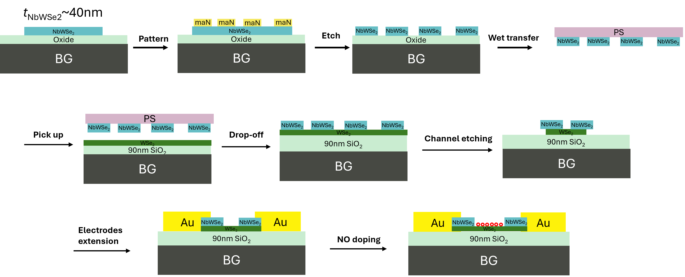
Figure S2 Fabrication process for 2D/2D contacts on 90nm SiO₂/Si substrates.

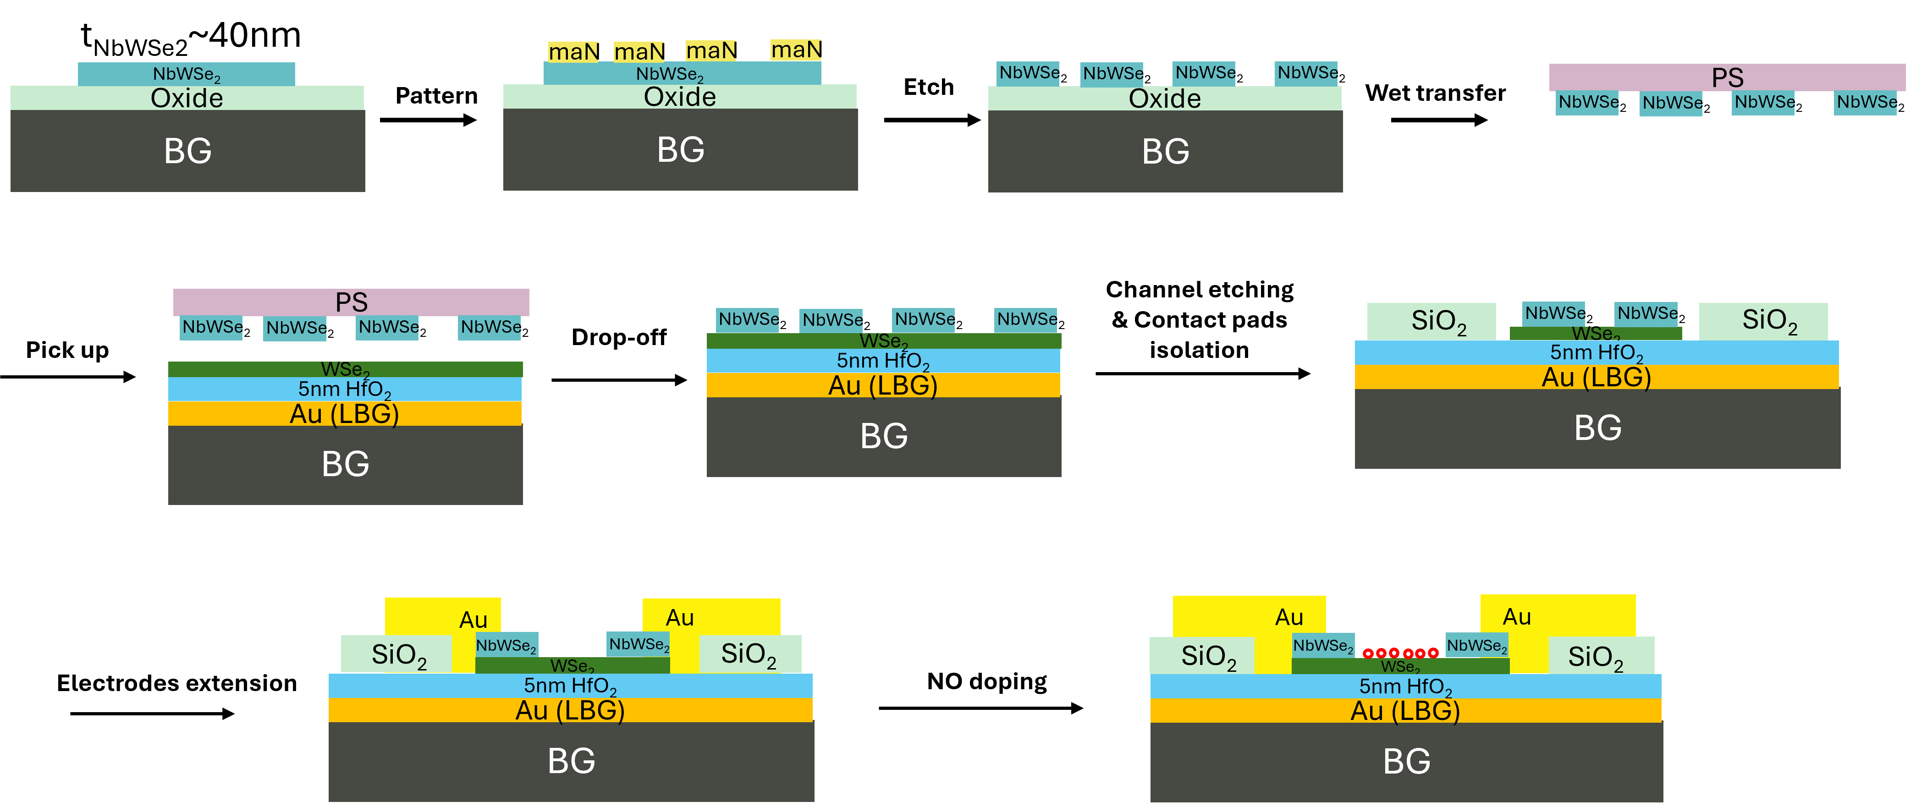
Figure S3 Fabrication process for 2D/2D contacts on 5nm HfO₂ substrates.

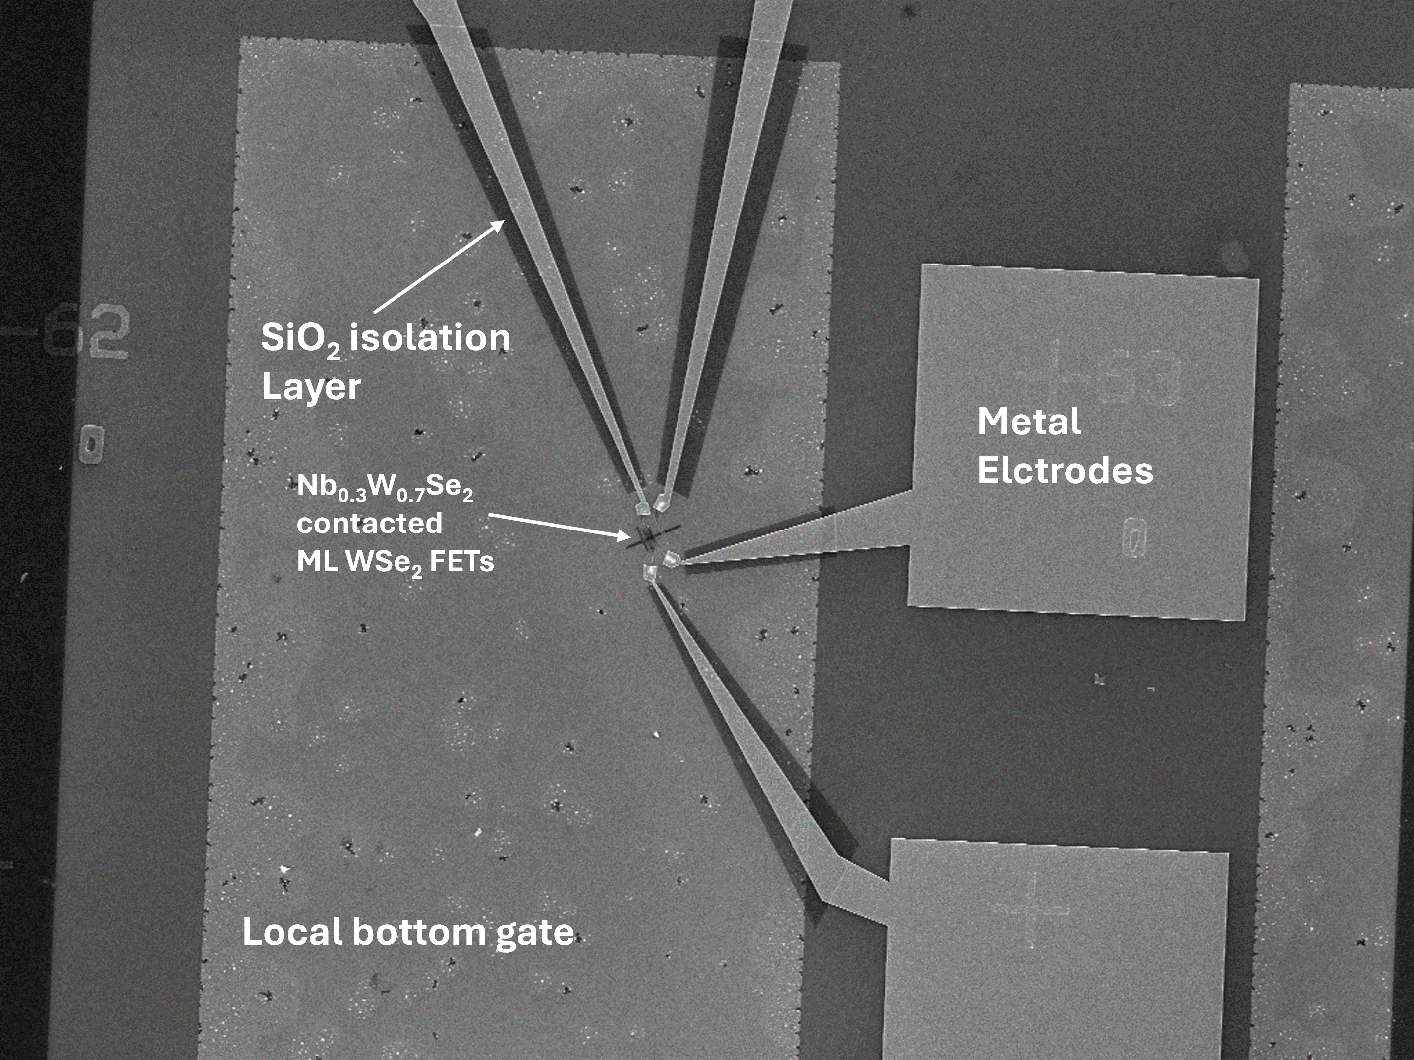
Figure S4 An SEM image of Nb_{0.3}W_{0.7}Se₂ contacted ML WSe₂ on local bottom gate (5nm HfO₂/Au/p++ Si)

Supplementary Note 3. Electrical characterization of Nb_{x}W_{1-x}Se₂ with different thicknesses
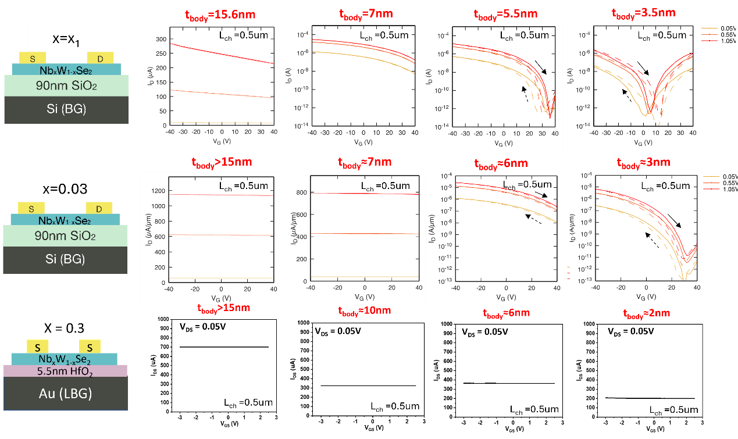
Figure S5 Transfer curves of mechanically exfoliated Nb_{x}W_{1-x}Se₂ flakes of varied composition from x=x1 to x=0.03 and x=0.3 with different thicknesses,. The sample labeled Nb_{x1}W_{1-x1} Se₂ had a near-zero Nb concentration, undetectable by EDX as described in the materials growth part of the Method section.
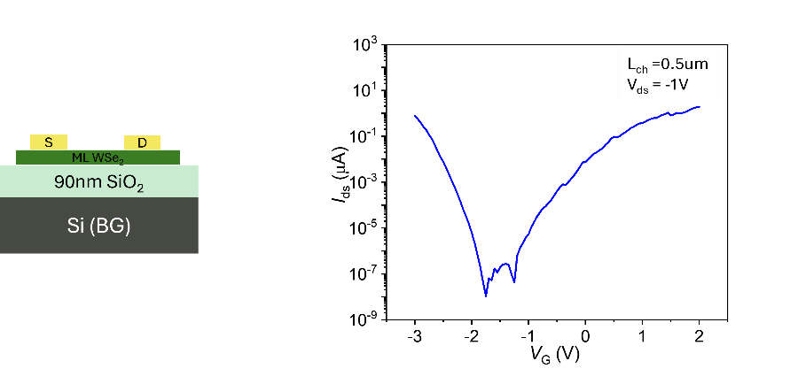
Figure S6 Exemplary transfer curve of a ML WSe₂ FET.
Supplementary Note 4. Device variability for 2D/2D contacted ML FETs on 90nm SiO₂ substrates
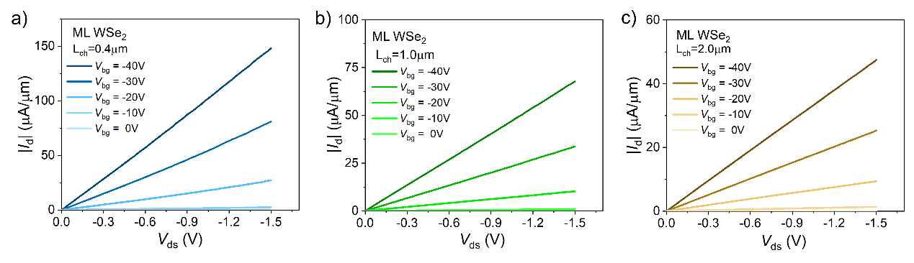Figure S7 Transfer curves of three different sets of 2D/2D contacted ML FETs on 90nm SiO₂ substrates. a), b), and c) each include characteristics for different channel length FETs.

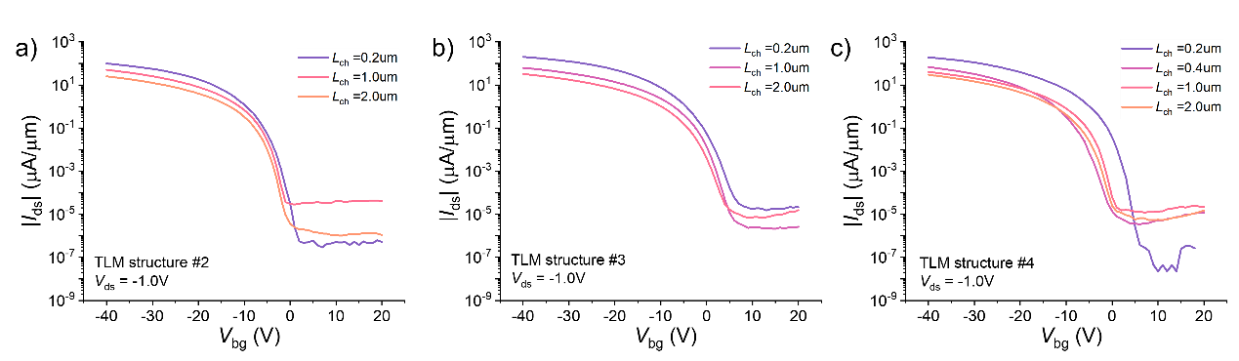Figure S8 Transfer curves of three different sets of 2D/2D contacted ML FETs on 90nm SiO₂ substrates. a), b), and c) each include characteristics for different channel length FETs.
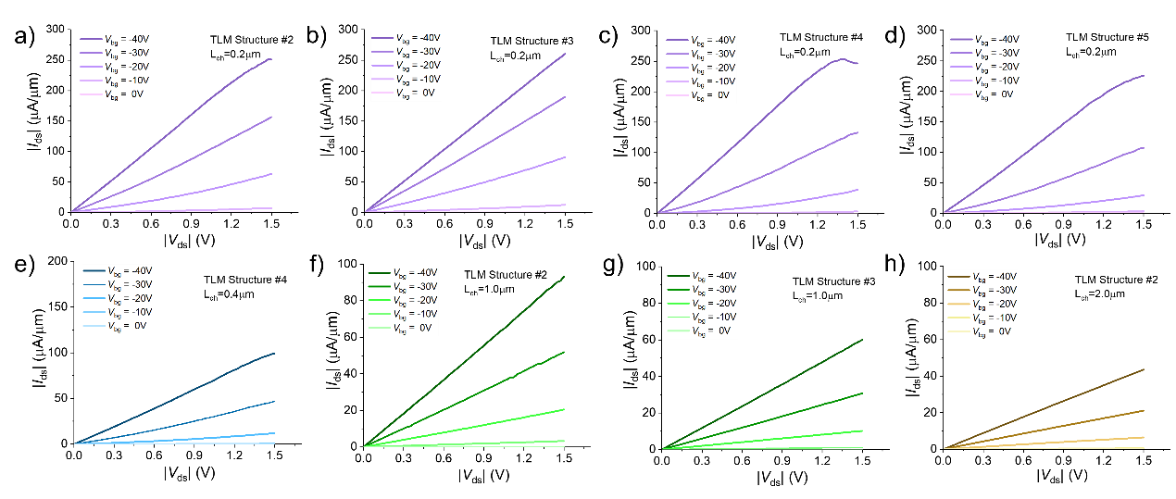Figure S9 Output characteristics for 2D/2D contacted ML FETs on 90nm SiO₂ substrates with different channel lengths beyond those presented in the main text.
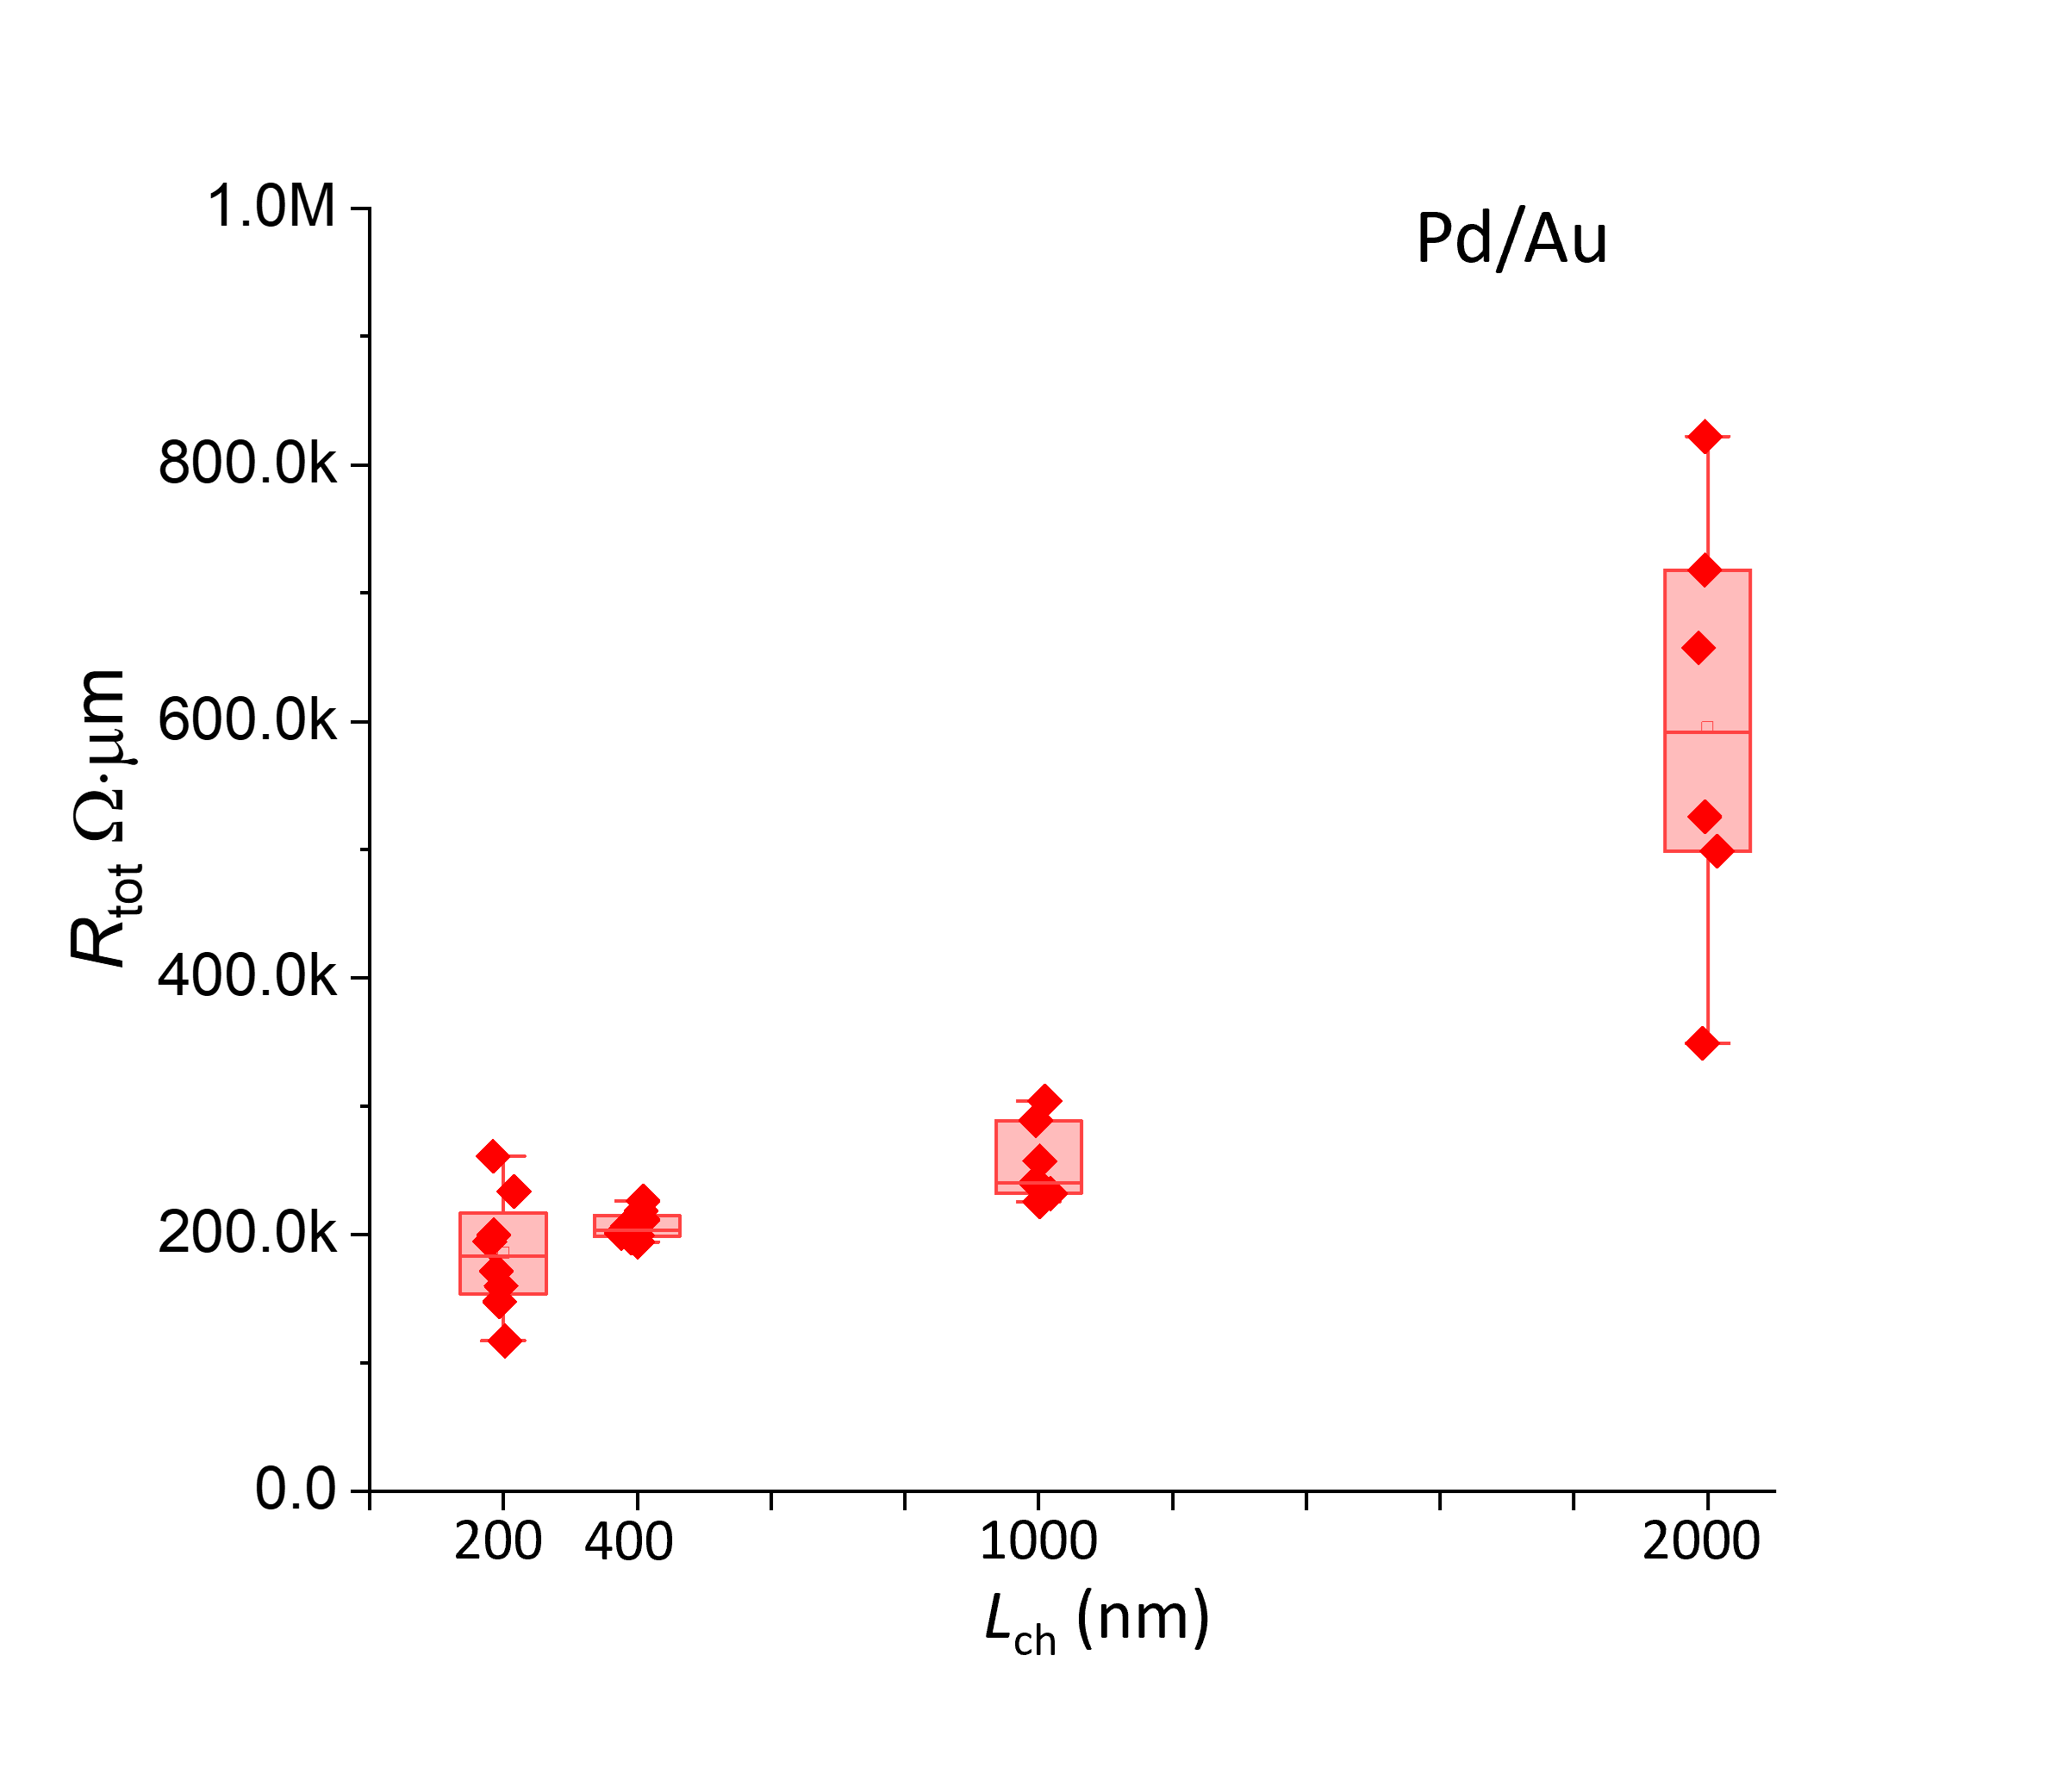
Figure S10 Total resistance versus channel length at V_{bg} = -60V for Pd/Au contacted devices with different channel lengths.

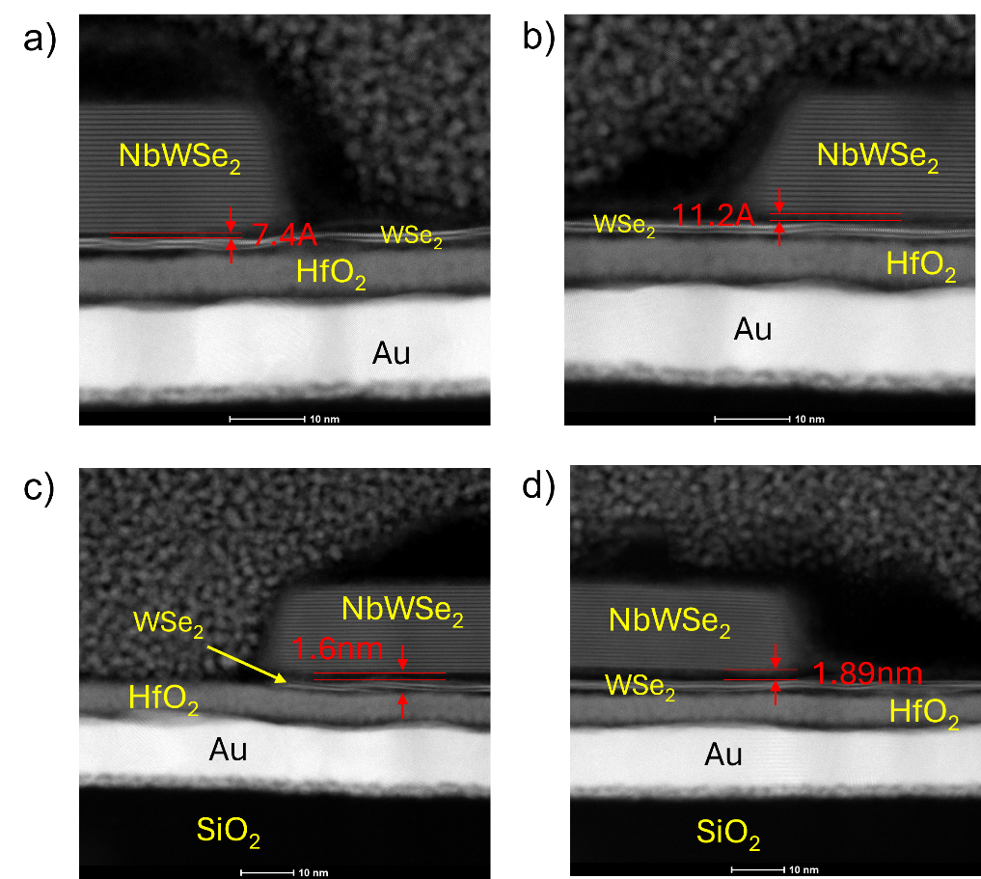
Figure S11 Cross-sectional STEM image of Nb_{0.3}W_{0.7}Se₂ contacted WSe₂ FETs on 5nm HfO₂/Au substrate
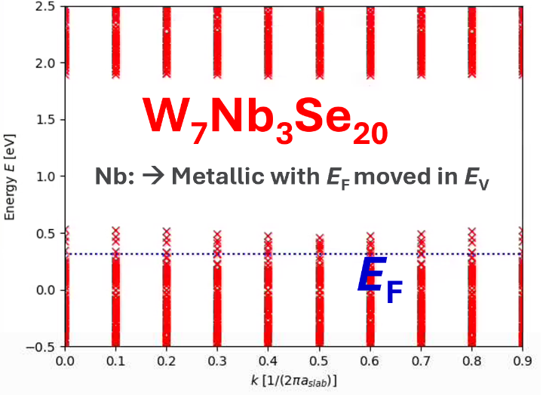
Figure S12 The DFT result of Nb_{0.3}W_{0.7}Se₂. The fermi level of Nb_{0.3}W_{0.7}Se₂ moves in to valence band, indicating a metallic property.

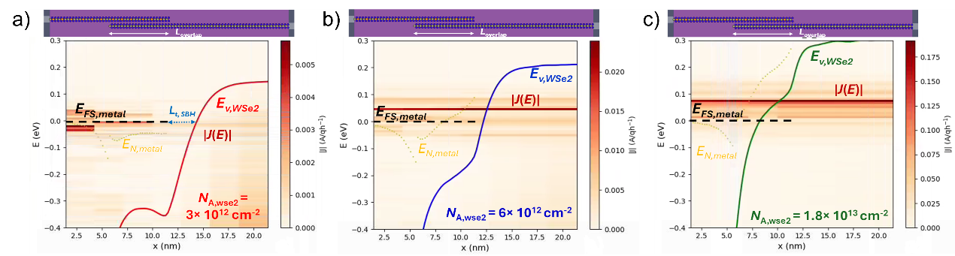

Figure S13 DFT-NEGF-simulated spectral current (in absolute units), |J(E)|, along the transport direction (x) in the NbWSe₂/WSe₂ heterostructure of Figure 4c for different N_{A},_{WSe2} doping concentrations in the WSe₂ bottom layer a) N_{A},_{WSe2} = 3×10¹² cm⁻², b) N_{A},_{WSe2} = 6×10¹² cm⁻², and c) N_{A},_{WSe2} = 1.8×10¹³ cm⁻². The valence band in the WSe₂ layer, E_{V,WSe2}, as well as, the source Fermi level in the NbWSe₂ metalic region (black dotted line), E_{FS,metal}, are also indicated. The x-distance between the end of the E_{FS,metal} line and the E_{V,WSe2} line in the vicinity of the source Fermi level L_{t},_{SBH} is indicated with a blue arrow in Figure S12a. L_{t},_{SBH} represents an estimate of the carrier tunneling distance through the Schottky barrier. As N_{A},_{Wse2} is increased, this distance is strongly reduced (Figure S12b), or vanishes (Figure S12c), i.e., the carriers feel an increasingly transparent Schottky barrier when crossing from the edge of the metal layer to the WSe₂ layer. Finally, the position of the neutrality level, E_{N,metal}, i.e., the equilibrium DFT- Fermi-level moved by the self-consistent potential in the metal layer is also shown, as well as a schematic view of the device, with the top metal and bottom WSe₂ positions in the x-direction matching those of the spectral plot. V_{DS} = -0.15V.

Figure S14 Contact resistance versus carrier density of WSe₂/Nb_{0.3}W_{0.7}Se₂ heterostructures with different layers of WSe₂ or NbWSe₂ in AA and AA’ stacking. The number of layers is indicated in the figure with the first (second) number being the number of WSe₂ (respectively Nb_{0.3}W_{0.7}Se₂) layers. An additional ’ is added for a AA’ stacking. The Schottky barrier heighs of the corresponding heterostructures are shown in Figure 4h.

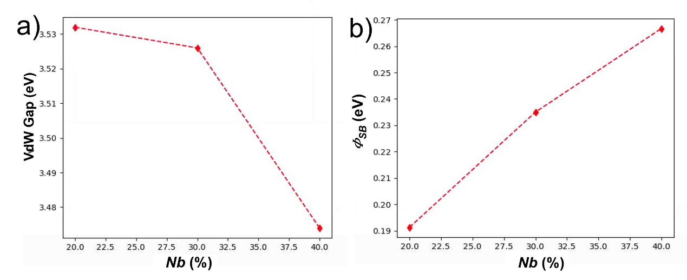
Figure S15 a. vdW gap for varying Nb-content for the AA stacking. b. Schottky barrier height of the heterostructure of Nb_{x}W_{1-x}Se₂/WSe₂ for different Nb concentrations, x=0.2, 0.3, 0.4 or the AA stacking.
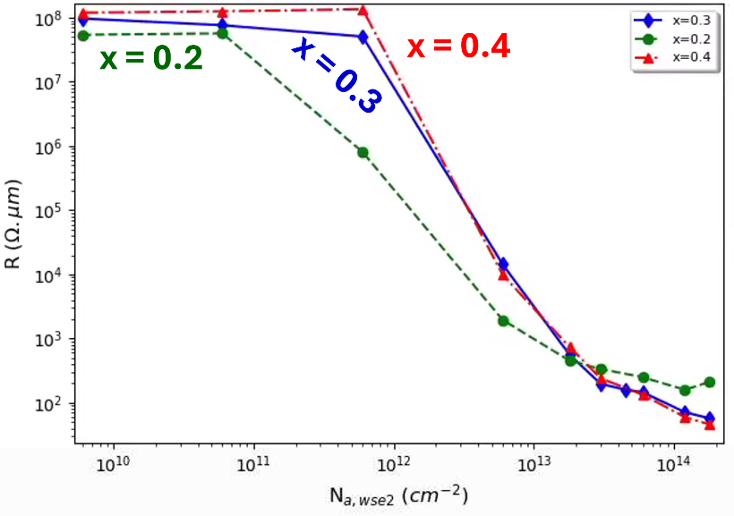
Figure S16 Contact resistance versus carrier density for different Nb concentrations x in of Nb_{x}W_{1-x}Se₂ alloys.

