Suppl. Table 1: Pathway analysis obtained through Metaboanalyst tool, indicating pathways with p<0.05 as significant
Sl. No. | Pathway | Raw p | FDR | Impact
1 | Purine metabolism | 0.011 | 0.991 | 0.007
2 | Glycerophospholipid metabolism | 0.029 | 1 | 0.121
3 | Thiamine metabolism | 0.053 | 1 | 0
4 | Sulfur metabolism | 0.060 | 1 | 0
5 | Glycosylphosphatidylinositol (GPI)-  anchor biosynthesis | 0.104 | 1 | 0
6 | Pyrimidine metabolism | 0.264 | 1 | 0.06
7 | Tyrosine metabolism | 0.282 | 1 | 0.01
8 | Primary bile acid biosynthesis | 0.304 | 1 | 0.01

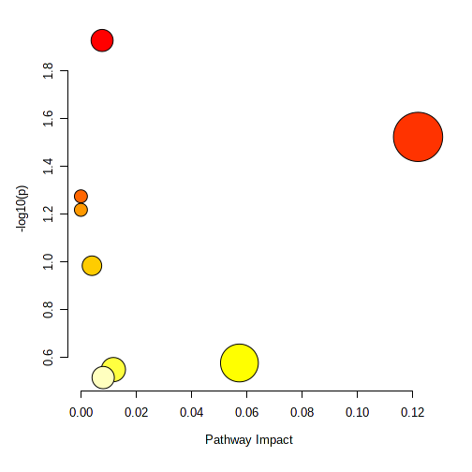
Purine metabolism
Glycerophospholipid
metabolism
Thiamine metabolism

Suppl. Fig 1: Pathway analysis image obtained from Metaboanalyst
Suppl. Table 2: Partial Least Squares Discrimination analysis (PLS-DA) class prediction model

Sl. No. | VIP Scores | Mass | Retention Time | Identified Compound
 | 1.2495 | 507.3653 | 17.04 | Phosphoadenosine phosphosulfate
 | 1.2441 | 596.438 | 17.79 | DG(5-iso PGF2VI/0:0/a-13:0)
 | 1.0873 | 437.2876 | 16.69 | -
 | 1.0780 | 686.3473 | 13.16 | PA(18:3(9,11,15)-OH(13)/i-16:0)
 | 1.0234 | 465.3193 | 17.20 | Glycocholic acid
 | 1.0189 | 298.2842 | 17.34 | -
 | 1.0183 | 345.322 | 16.23 | Cyclic GMP
 | 1.0111 | 292.236 | 18.89 | -
 | 1.0014 | 505.3506 | 16.90 | Thiamine triphosphate
 | 0.9945 | 228.1452 | 0.78 | Deoxyuridine
 | 0.9944 | 183.0641 | 16.8 | Epinephrine
 | 0.9924 | 144.0591 | 11.73 | -
 | 0.9878 | 495.3657 | 17.12 | LysoPC(16:0/0:0)
 | 0.9857 | 673.3806 | 16.10 | -
 | 0.9844 | 507.3654 | 16.93 | Adenosine triphosphate
 | 0.9833 | 496.2681 | 17.86 | Polypodine B
 | 0.9762 | 1083.523 | 16.73 | -
 | 0.9761 | 1413.749 | 16.62 | -
 | 0.9760 | 605.3231 | 16.70 | -
 | 0.9754 | 1122.592 | 16.65 | -
 | 0.9748 | 528.3112 | 14.88 | -
 | 0.9743 | 424.2129 | 13.44 | -
 | 0.9728 | 740.3797 | 16.58 | -
 | 0.9716 | 538.1841 | 17.35 | 9'-cis-neurosporene
 | 0.9680 | 465.3181 | 16.53 | 3a,7b,12a-Trihydroxyoxocholanyl-Glycine
 | 0.9667 | 634.2462 | 17.79 | -
 | 0.9664 | 753.3586 | 17.37 | PE(P-16:0/PGJ2)
 | 0.9655 | 978.4435 | 17.23 | -
 | 0.9635 | 876.4851 | 13.50 | -
 | 0.9583 | 1501.803 | 16.56 | -
 | 0.9491 | 556.4442 | 17.67 | DG(PGF1alpha/0:0/8:0)
 | 0.9465 | 493.3498 | 17.01 | Glyburide
 | 0.9302 | 479.3345 | 16.77 | Nicardipine
 | 0.9281 | 451.3035 | 16.93 | 4-Methylsulfonyl-3-butenyl glucosinolate
 | 0.9176 | 549.3141 | 12.55 | Apigeninidin 5-(5''-caffeylarabinoside)

Suppl. Table 3: Entities without any missing signals

Sl. No. | Mass | Retention Time | Identified Compound
 | 479.3345 | 16.77 | Nicardipine
 | 507.3654 | 16.93 | Adenosine triphosphate
 | 686.3473 | 13.16 | PA(18:3(9,11,15)-OH(13)/i-16:0)
 | 437.2876 | 16.69 | -
 | 505.3506 | 16.90 | Thiamine triphosphate
 | 465.3193 | 17.20 | Glycocholic acid
 | 495.3657 | 17.12 | LysoPC(16:0/0:0)
 | 451.3035 | 16.93 | 4-Methylsulfonyl-3-butenyl glucosinolate
 | 465.3181 | 16.53 | 3a,7b,12a-Trihydroxyoxocholanyl-Glycine

