Supplementary information
Table S1. Loadings of the principal components of seven climatic variables.
 | PC1 | PC2 | PC3 | PC4 | PC5 | PC6 | PC7
Mean temperature | -0.05 | 0.73 | -0.13 | -0.04 | 0.01 | 0.48 | 0.46
Diurnal temperature range | 0.42 | -0.04 | 0.73 | 0.16 | 0.05 | 0.48 | -0.17
Near-surface relative humidity | -0.48 | -0.03 | -0.19 | -0.20 | -0.02 | 0.54 | -0.64
Solar radiation* | 0.44 | 0.05 | -0.17 | -0.62 | 0.61 | -0.02 | -0.12
Vapor pressure deficit | 0.24 | 0.63 | -0.05 | 0.25 | -0.11 | -0.37 | -0.58
Precipitation | -0.44 | 0.09 | 0.20 | 0.40 | 0.76 | -0.12 | 0.01
Near-surface wind speed | 0.39 | -0.24 | -0.58 | 0.57 | 0.16 | 0.31 | -0.03
Variance explained (%) | 59.58 | 25.80 | 6.67 | 3.74 | 2.87 | 0.96 | 0.38
Accumulated (%) | 59.58 | 85.39 | 92.06 | 95.80 | 98.66 | 99.62 | 100.00
* refers to surface downwelling shortwave radiation in CHELSA dataset.

Table S2. Pairwise Pearson correlation coefficients between species traits.
 | enclosed nest | ground nest | cooperative breeding | log egg mass | log clutch size
enclosed nest | 1.00
ground nest | -0.13 | 1.00
cooperative breeding | 0.06 | -0.09 | 1.00
log egg mass | -0.15 | 0.26 | -0.02 | 1.00
log clutch size | 0.18 | 0.24 | 0.04 | 0.05 | 1.00

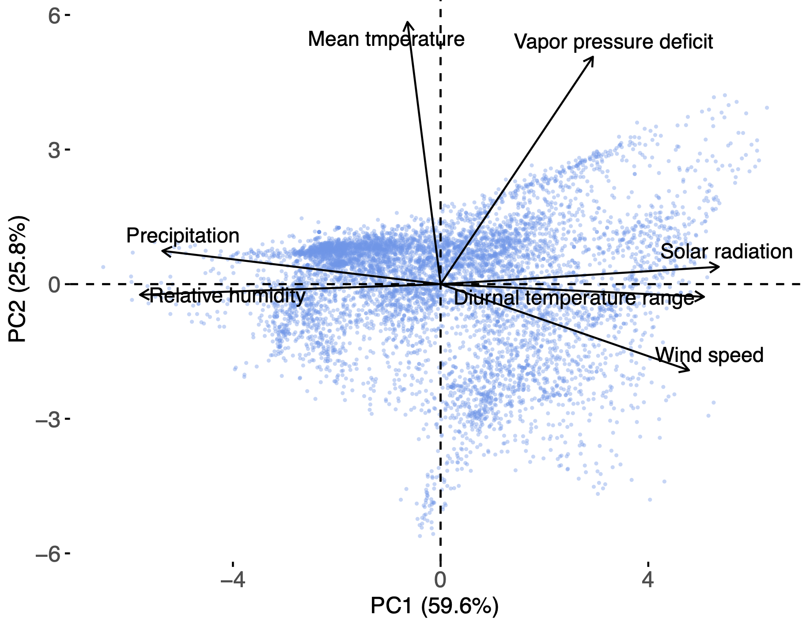
Figure S1. PCA biplot of the climatic variables.
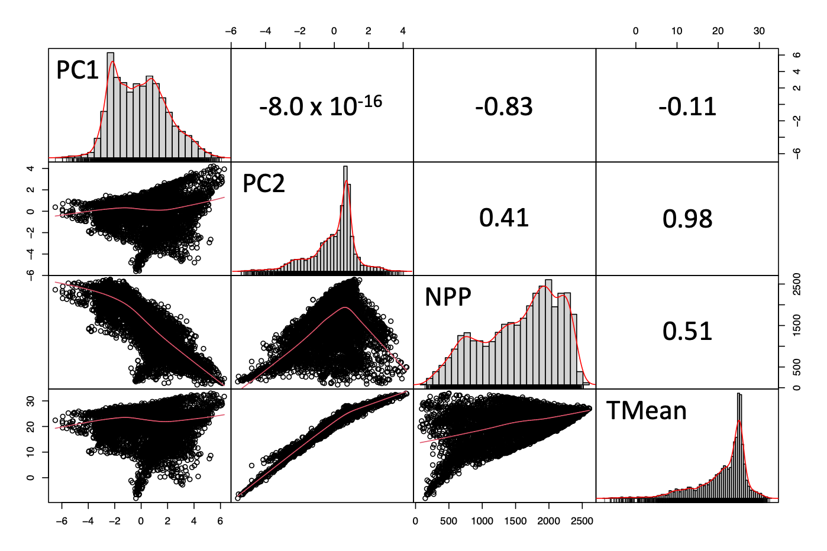
Figure S2. Pairwise correlations between PC1, PC2, net primary productivity (NPP), and mean temperature (TMean). The numbers shown are the Pearson correlation coefficients.
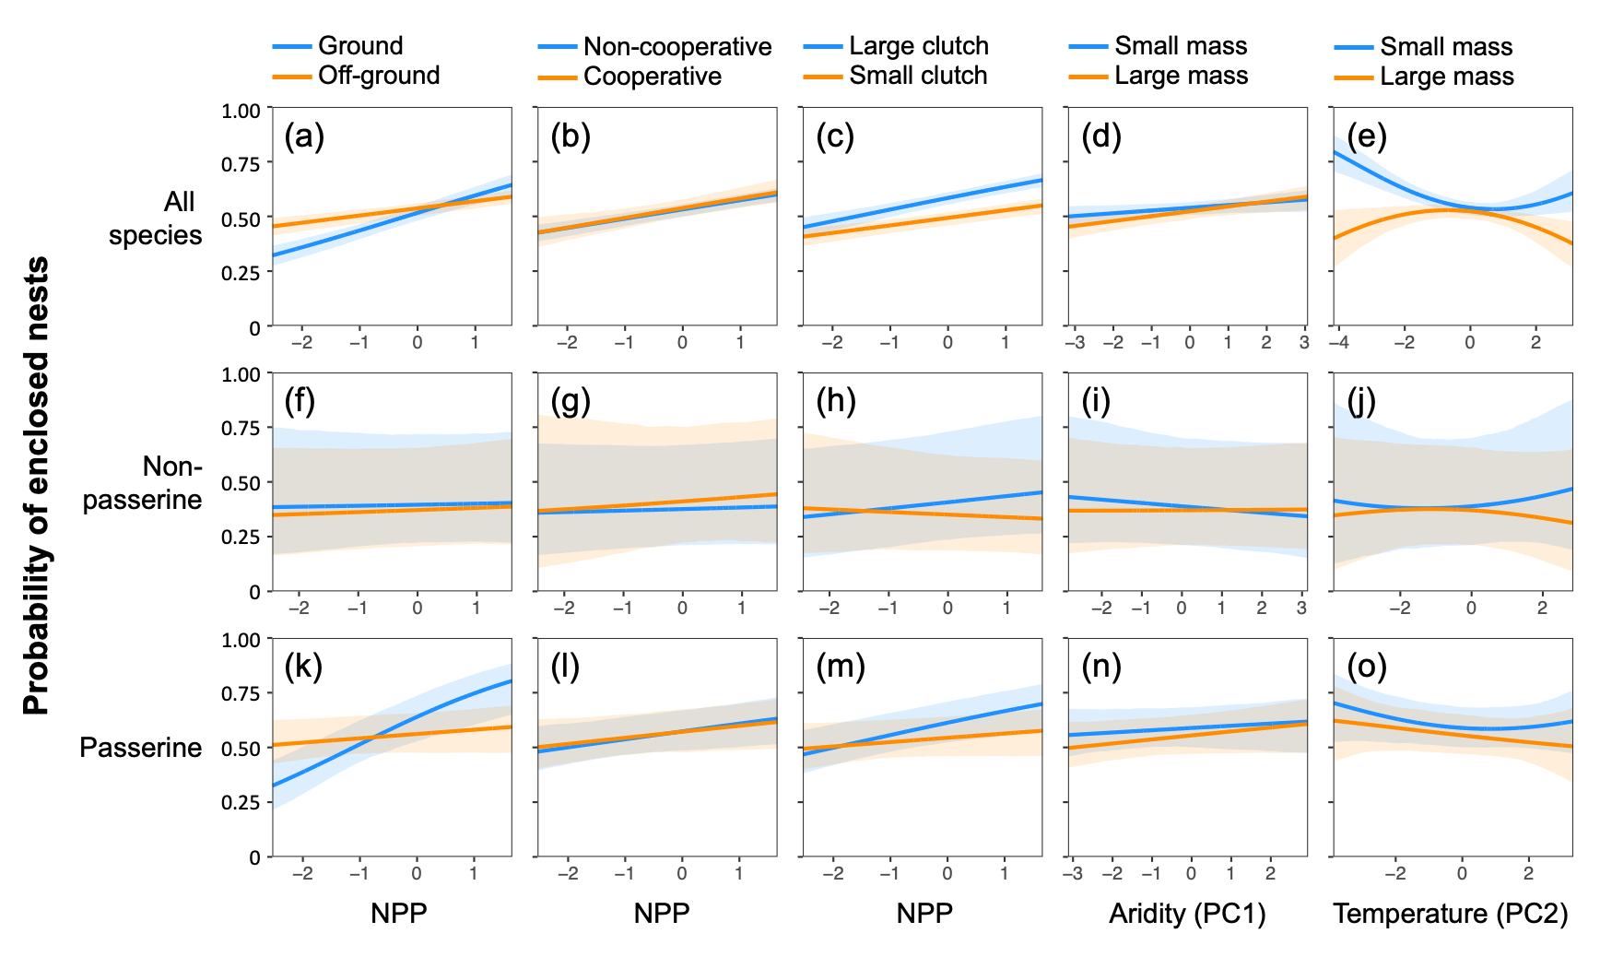
Figure S3. Partial effect plots of the three Enclosed models. Blue lines indicate traits expected to be more sensitive to predation risk or climatic conditions, whereas orange lines represent less sensitive traits. The expected results are depicted in Fig. 1.
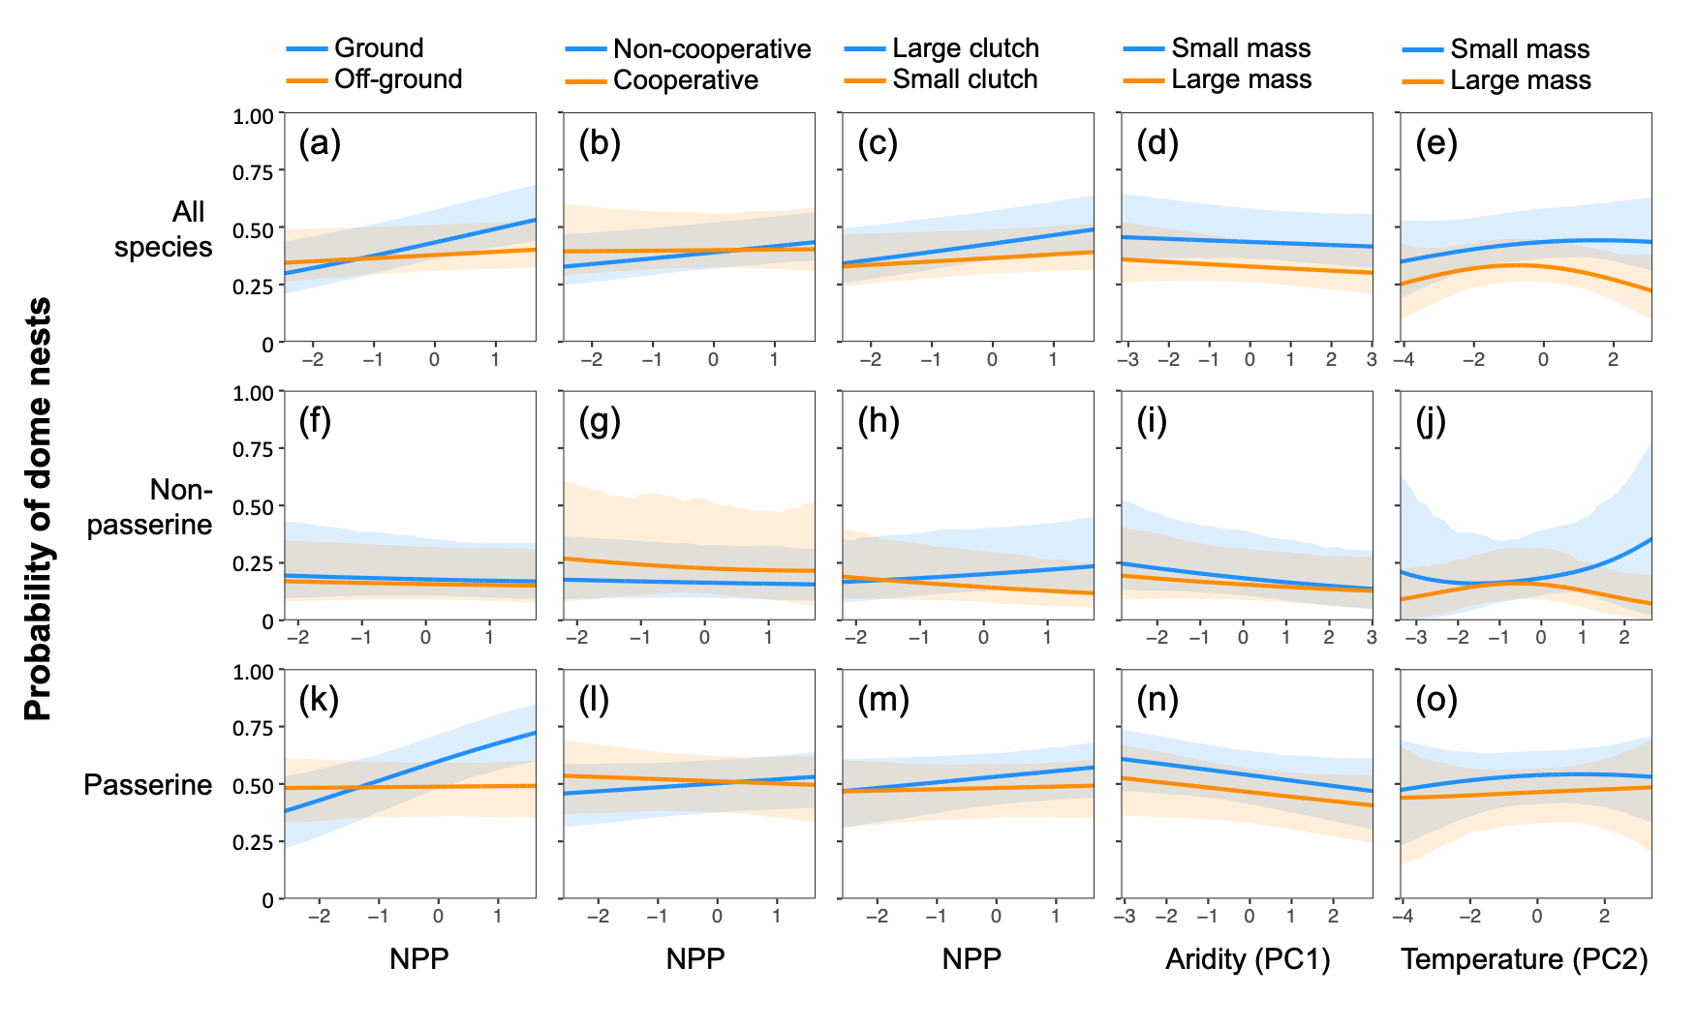
Figure S4. Partial effect plots of the three Dome models.
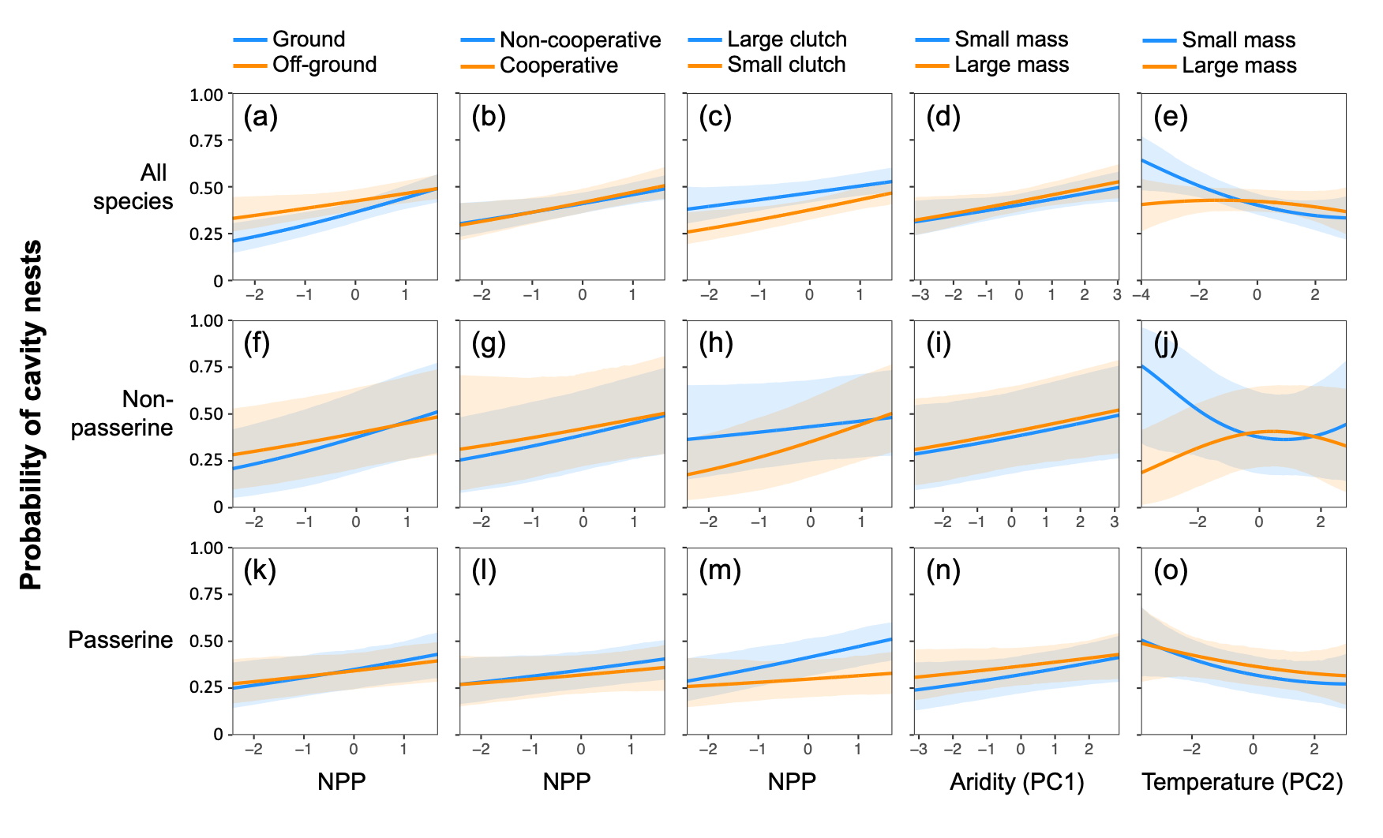
Figure S5. Partial effect plots of the three Cavity models.

Figure S6. Coefficient estimates for the predictor variables in the nine models built for the use of enclosed, dome, and cavity nests by all bird species, non-passerines, and passerines. Each model was built with 1,000 individual phylogenetic trees. All predictors were standardised, so the coefficients represent effect sizes. The mean estimate of effect sizes with significant effects (95% confidence intervals not crossing zero) are marked in white, whereas nonsignificant effects are marked in black. Yellow shades indicate expected outcomes. The three alternative expectations for Prediction M2 are presented as blue right-leaning stripes, red left-leaning stripes, and yellow shades, indicating that enclosed nests are used for resisting cold, heat, or both, respectively.

Figure S7. Summary of results in relation to the predictions based on separate models built with 1,000 individual phylogenetic trees. A significant relationship is identified when the 95% confidence interval (CI) does not cross zero, whereas a nonsignificant relationship is identified when the 50% CI does not cross zero. Significant effects with a mean absolute effect size (coefficient) larger than 0.10 are marked with asterisks. An alternative prediction of M2, i.e. positive effect of temperature, is not listed as it is the inverse of another alternative prediction, which is marked with a dagger (†).

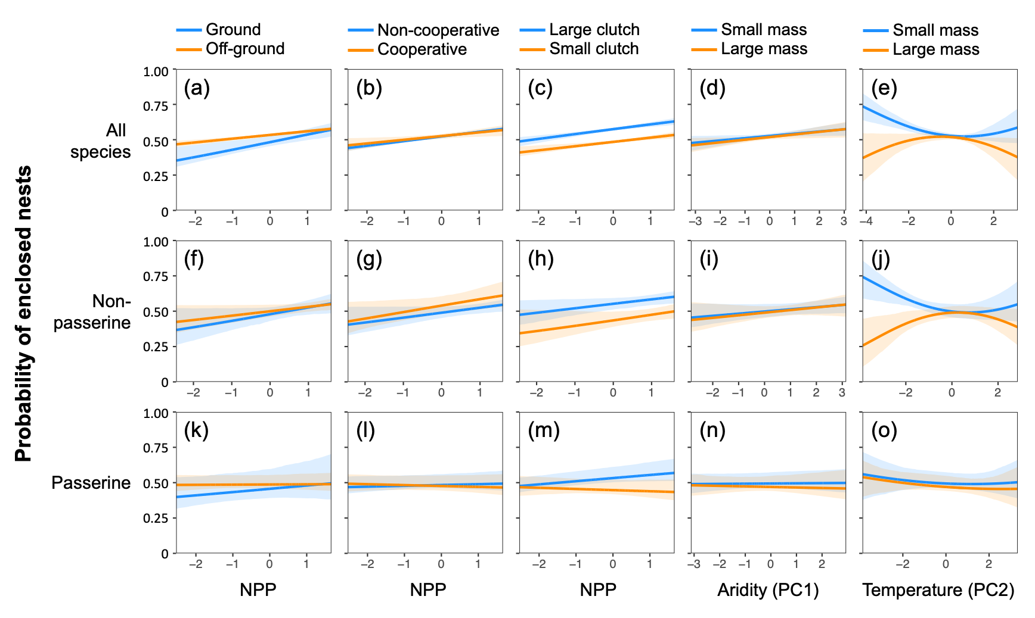
Figure S8. Partial effect plots of the three Enclosed models, each built with 1,000 individual phylogenetic trees.
Figure S9. Partial effect plots of the three Dome models, each built with 1,000 individual phylogenetic trees.
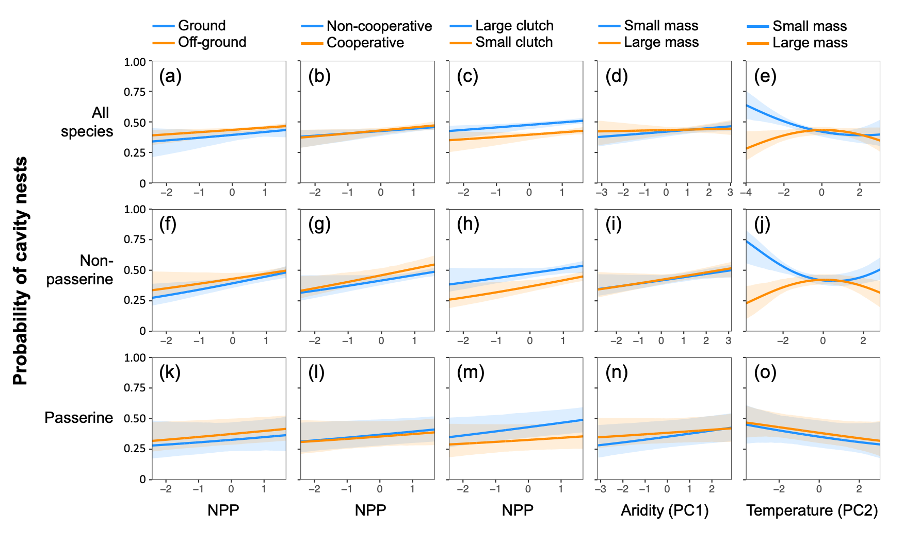
Figure S10. Partial effect plots of the three Cavity models, each built with 1,000 individual phylogenetic trees.

