Supplementary Information

Title
A Unified Platform for At-Home Post-Stroke Rehabilitation Enabled by Wearable Technologies and Artificial Intelligence

Authors
Chenyu Tang^{†1,2}, Ruizhi Zhang^{†3}, Shuo Gao^{†*1,3}, Zihe Zhao³, Zibo Zhang², Jiaqi Wang³, Cong Li³, Junliang Chen³, Yanning Dai⁴, Shengbo Wang³, Ruoyu Juan⁵, Qiaoying Li⁶, Ruimou Xie⁷, Xuhang Chen⁸, Xinkai Zhou⁹, Yunjia Xia⁹, Jianan Chen⁹, Fanghao Lu¹, Xin Li⁷, Ninglli Wang¹⁰, Peter Smielewski⁸, Yu Pan⁷, Hubin Zhao^{*9}, and Luigi G. Occhipinti^{*2}

Affiliations
¹Hangzhou International Innovation Institute, Beihang University, Hangzhou, China
²Department of Engineering, University of Cambridge, Cambridge, UK
³School of Instrumentation and Optoelectronic Engineering, Beihang University, Beijing, China
⁴AI Initiative, KAUST, Thuwal, Saudi Arabia
⁵Beijing New Guoxin Software Evaluation Technology Co ltd, Beijing, China
⁶Stomatology Department, Shijiazhuang People's Hospital, Shijiazhuang, China
⁷Department of Rehabilitation Medicine, Beijing Tsinghua Changgung Hospital, Tsinghua University, Beijing, China
⁸Department of Clinical Neurosciences, University of Cambridge, Cambridge, UK
⁹HUB of Intelligent Neuro-engineering (HUBIN), CREATe, Division of Surgery and Interventional Science, UCL, Stanmore, UK
¹⁰Beijing Tongren Hospital, Capital Medical University, Beijing, China

†These authors contributed equally: Chenyu Tang, Ruizhi Zhang, Shuo Gao
*Correspondence to: Shuo Gao (shuo_gao@buaa.edu.cn), Hubin Zhao (hubin.zhao@ucl.ac.uk), and Luigi G. Occhipinti (lgo23@cam.ac.uk)

Supplementary Figure 1-11
Supplementary Table 1-2

Supplementary Figure 1: Layered structure of the plantar pressure sensing array. This figure illustrates the multilayer design of the 48-channel piezoresistive plantar pressure sensing array. Each layer is engineered to enhance measurement precision while minimizing crosstalk. The sensing mechanism uses a flexible substrate and resistive elements arranged in a grid format, enabling high-resolution plantar pressure distribution measurements. The layered structure facilitates accurate force detection while maintaining device flexibility for wearable applications [1, 2].

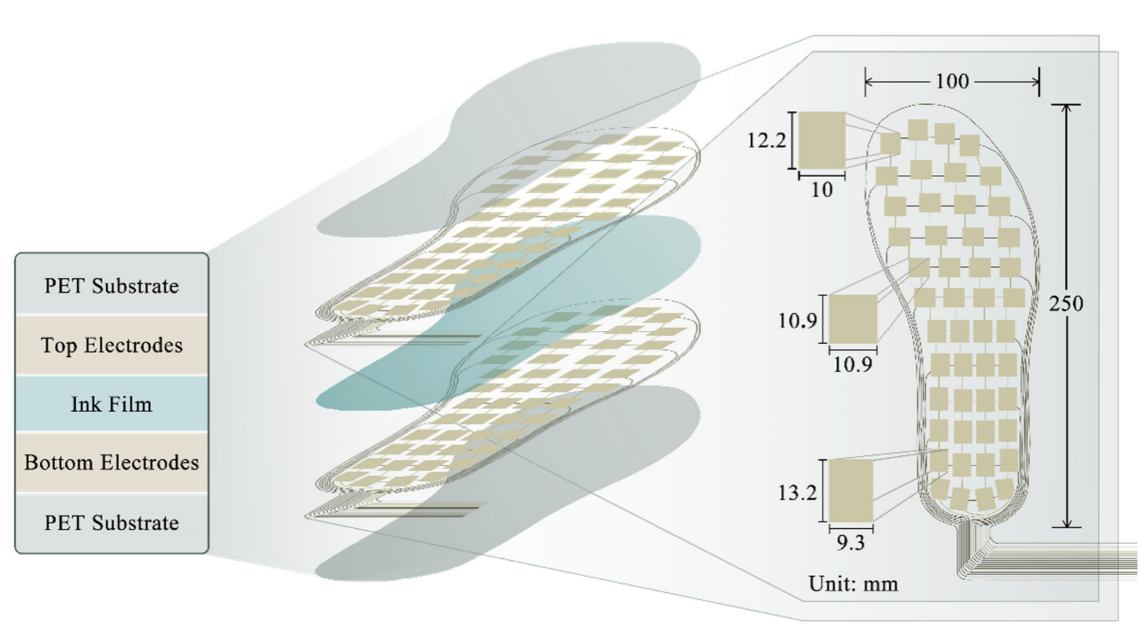
Supplementary Figure 2: Prototype of the plantar pressure sensing device. The compact and lightweight construction allows for seamless integration into wearable systems, suitable for extended use in daily activities. The device has been validated to ensure durability and measurement accuracy under dynamic conditions.

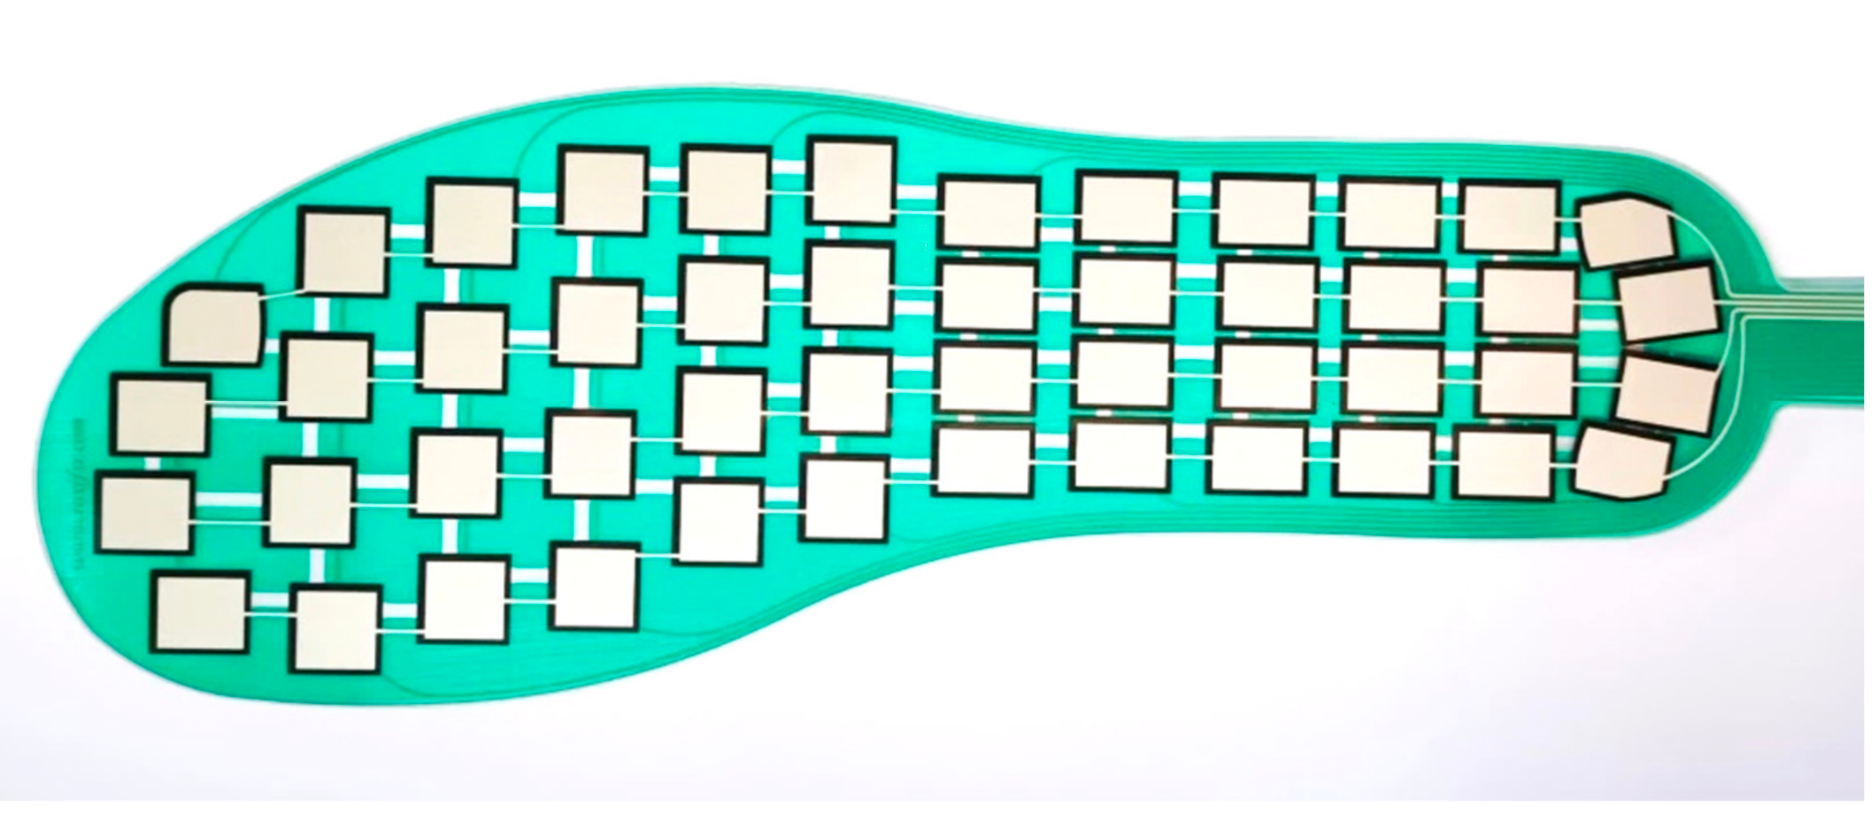

Supplementary Figure 3: Crosstalk suppression circuitry for the piezoresistive array. A schematic representation of the crosstalk suppression circuit employing voltage-negative feedback and high-side current detection. This innovative design addresses challenges in matrix-based sensor arrays, achieving suppression with a detection accuracy of ±0.2%.

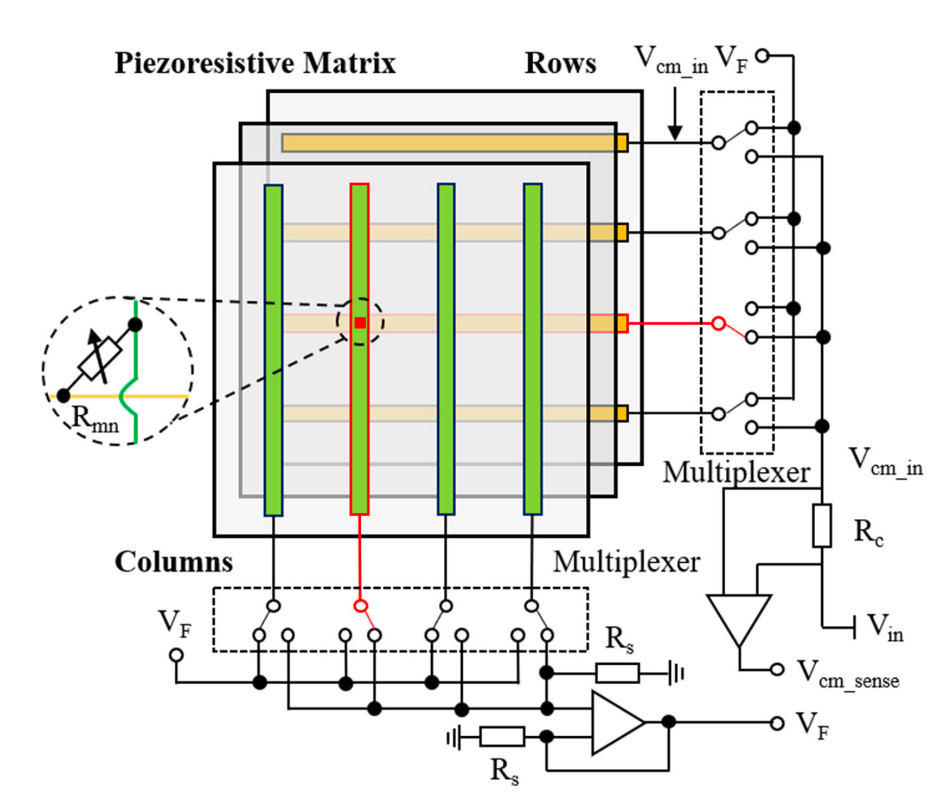
Supplementary Figure 4: Signal chain of the plantar pressure sensing module. The signal chain architecture of the plantar pressure sensing device is depicted, including analog front-end circuitry, ADC (analog-to-digital conversion), and data transmission protocols. This chain ensures real-time, high-fidelity data acquisition and seamless integration with downstream processing modules. The design supports low-latency communication, enabling continuous monitoring of plantar dynamics during walking.

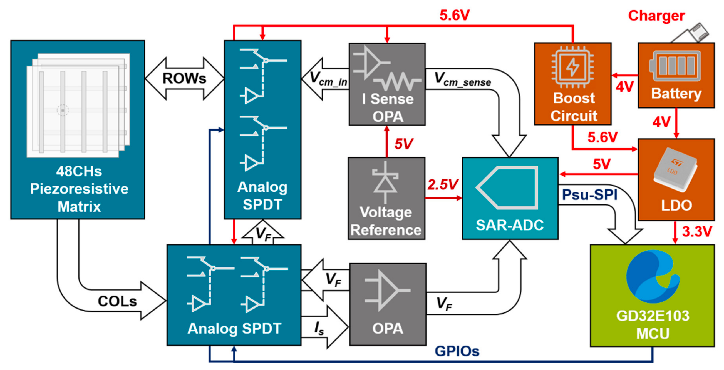

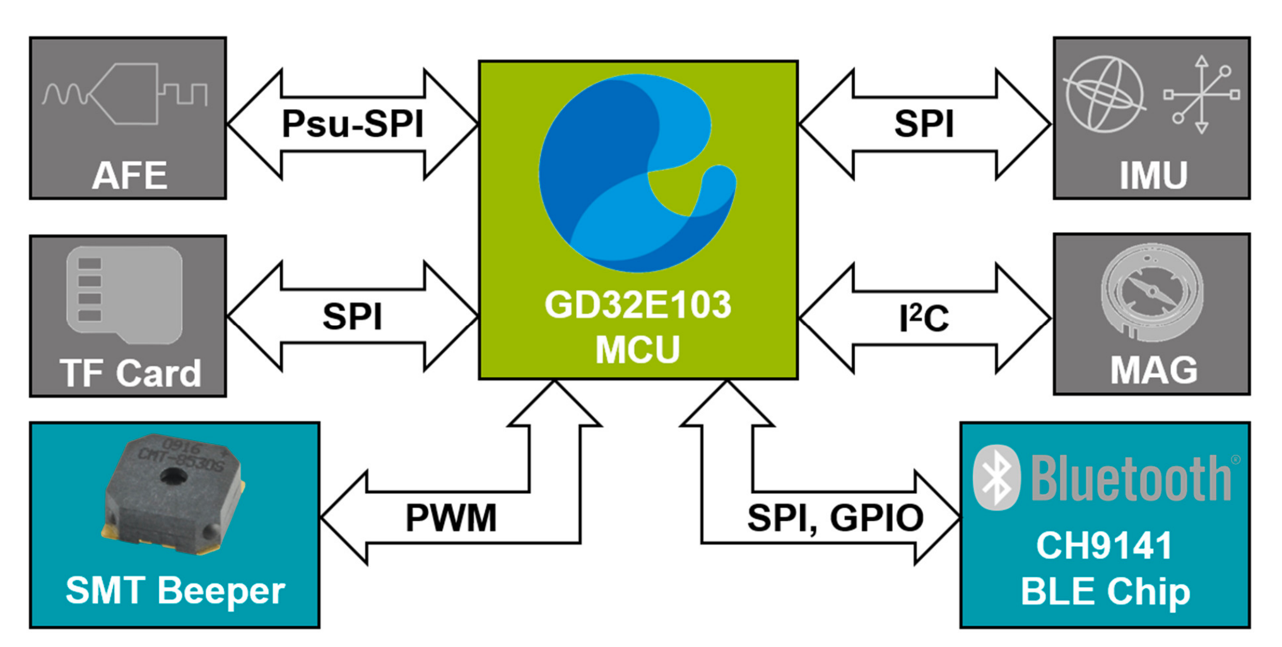

Supplementary Figure 5: Exploded view of the custom-designed wireless wristband for multimodal data acquisition. The wristband integrates six functional modules on a compact six-layer PCB, including the STM32L412 microcontroller for system coordination, CH9141 Bluetooth module for wireless communication, and sensors for PPG (MAX30101), environmental spectrum (AS7341), and temperature (MTS4B). The modular design is enclosed in a lightweight, protective casing, ensuring durability and user comfort during continuous wear. The power management system, featuring a rechargeable lithium battery and integrated charging circuit, supports long-term operation within the IoT system.
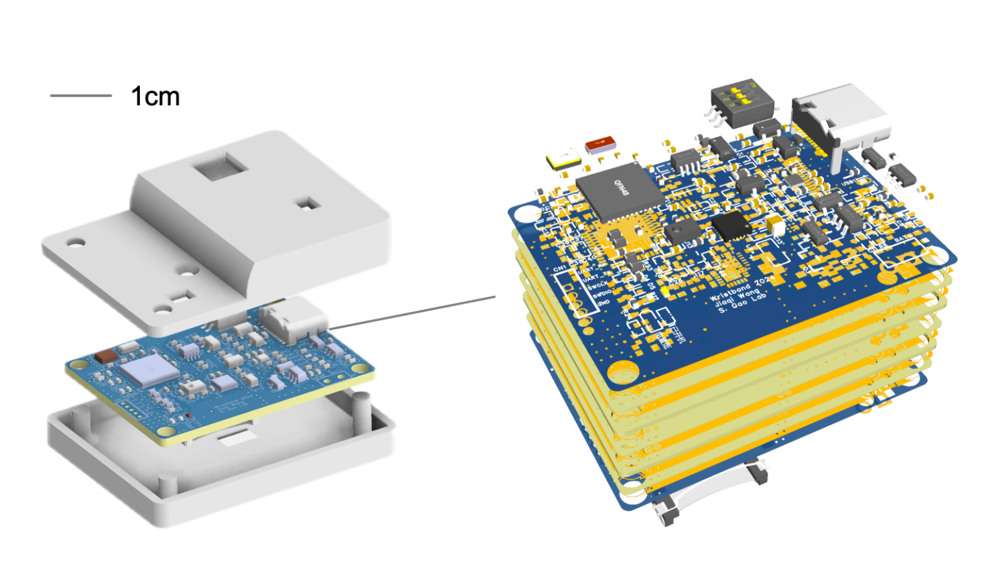
Supplementary Figure 6: Signal chain of the wireless wristband module.

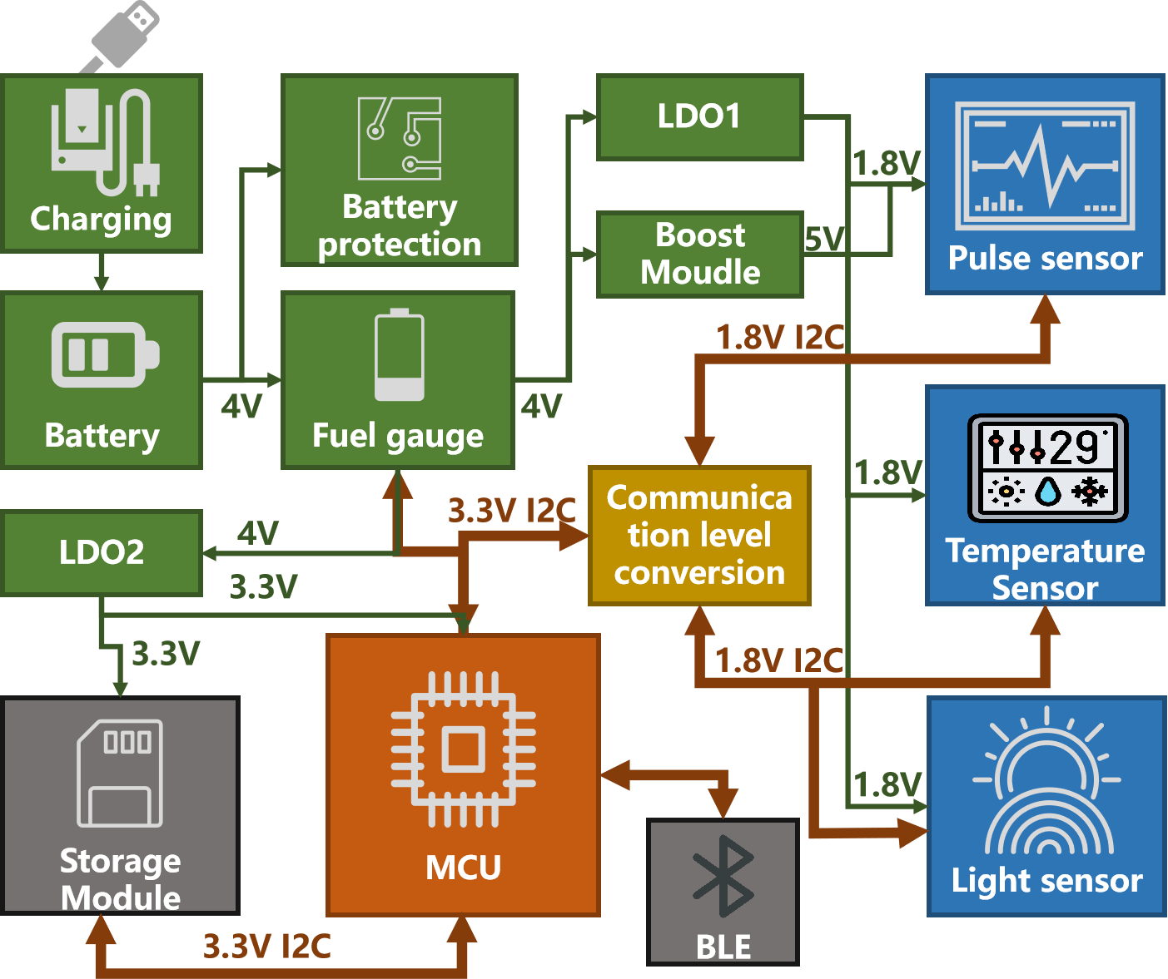
Supplementary Figure 7: Photo of the wearable wireless eye tracker for real-time gaze tracking and environmental scene analysis. The device incorporates two near-infrared cameras with integrated IR LEDs for pupil and eye corner detection, alongside a forward-facing visible-light camera to capture the user's field of view. Built around the IMX258 image sensor, the cameras provide high-resolution imagery (12 MP at 30 FPS) for precise gaze tracking. The OrangePi CM5 module, powered by an RK3588S SoC (2.4 GHz), processes the eye-tracking data in real time, while the CDW-20U5622 WiFi module ensures stable wireless transmission.

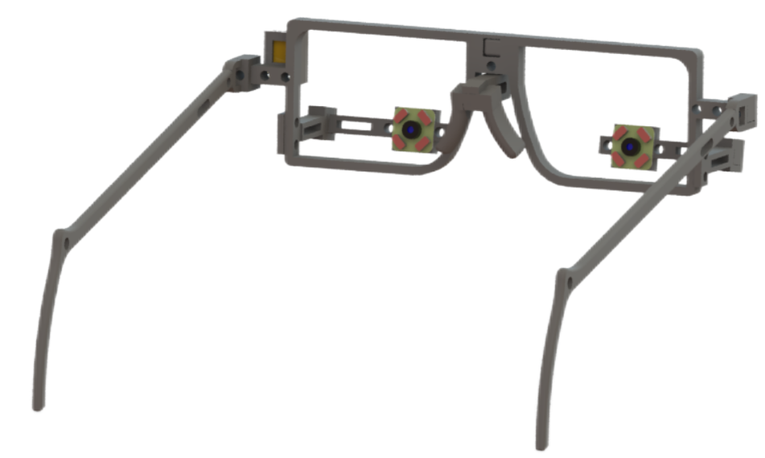
Supplementary Figure 8: Visualization of blink frequency distribution during smart home interactions. Data were collected from 100 interaction trials involving post-stroke patients with and without cognitive impairments, revealing lower blink frequency in the impaired group. The finding highlight the valuable insights into cognitive impairments provided by the wearable eye-tracker module.

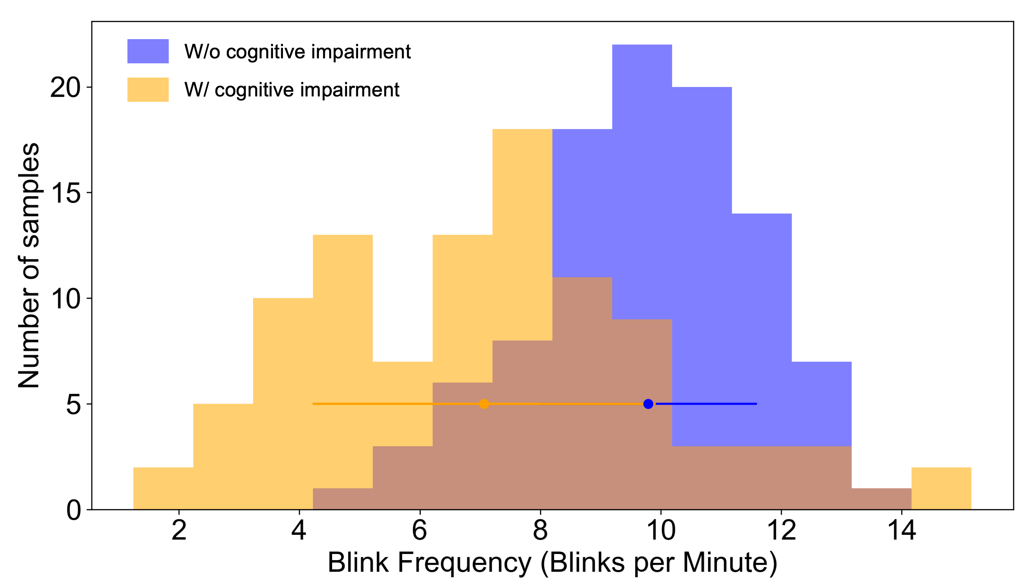

Supplementary Figure 9: Visualization of fixation duration distribution during smart home interactions. Data were collected from 100 interaction trials involving post-stroke patients with and without cognitive impairments, revealing longer fixation duration in the impaired group. The finding highlight the valuable insights into cognitive impairments provided by the wearable eye-tracker module.

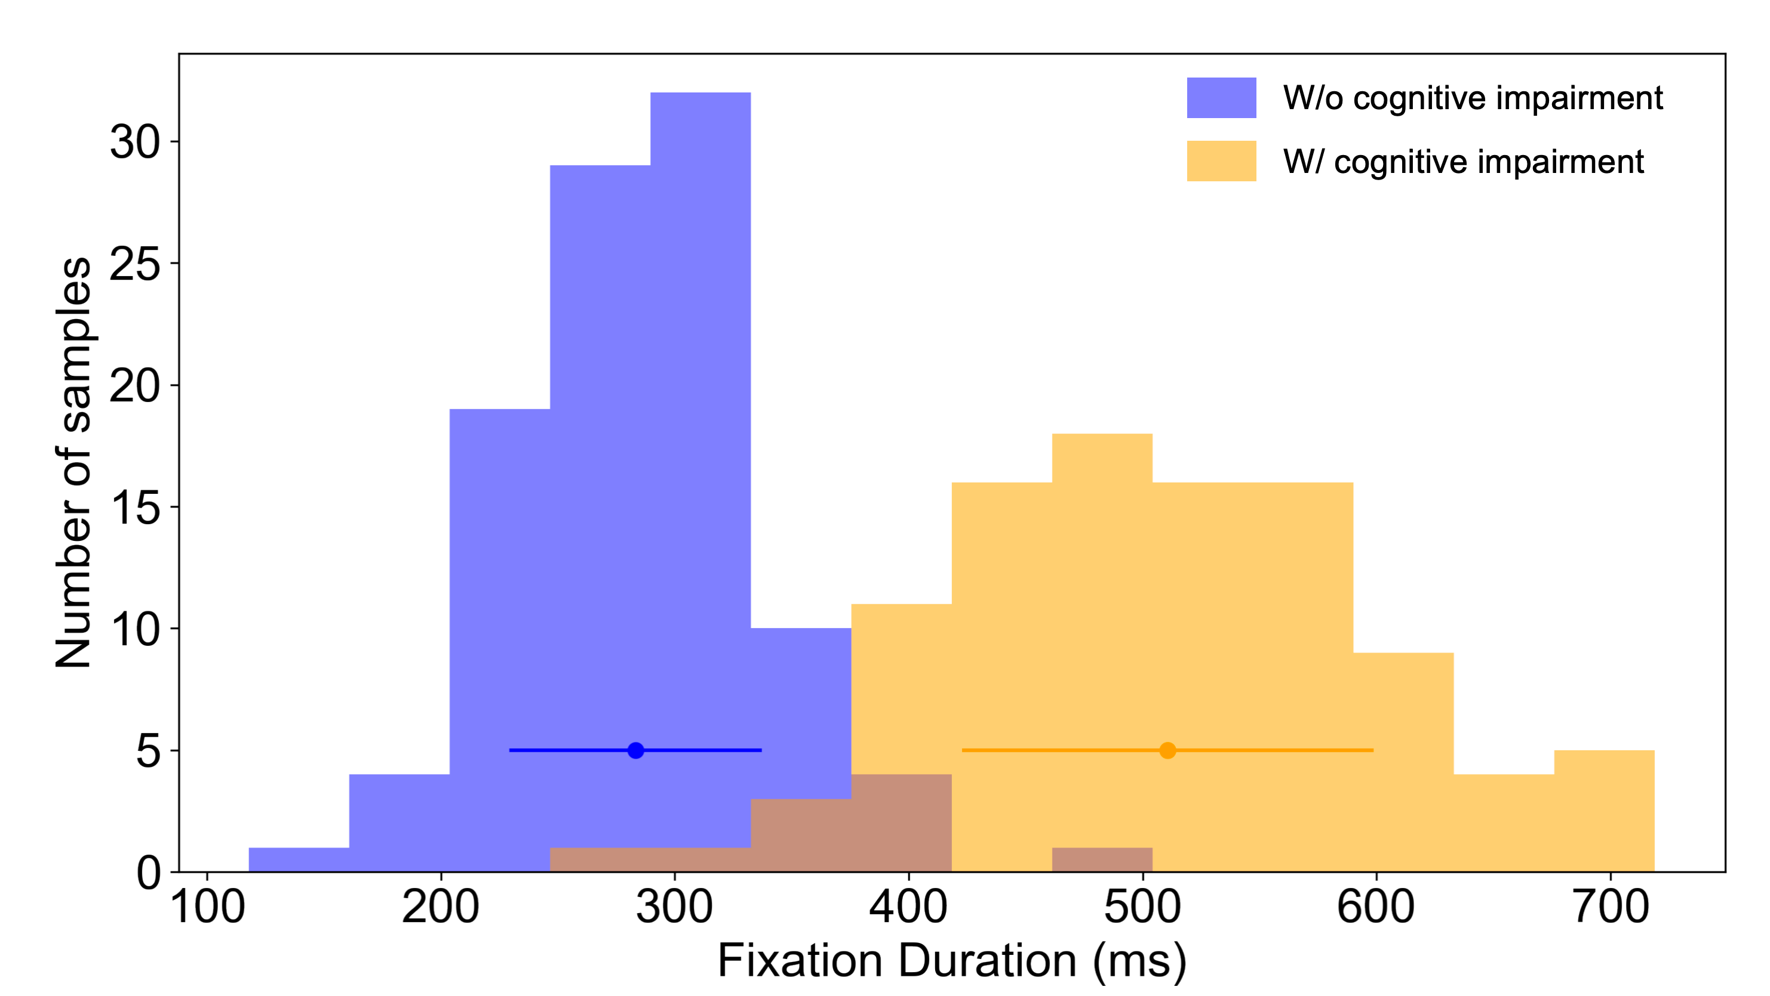

Supplementary Figure 10: Training and validation performance metrics for the YOLOv8n model used in real-time scene analysis and action recognition.

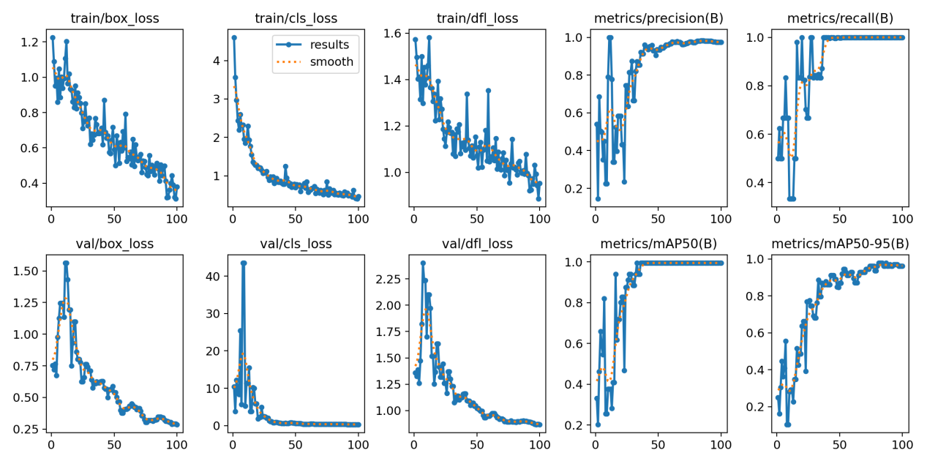

Supplementary Figure 11: Diagram of the hierarchical IoT architecture.
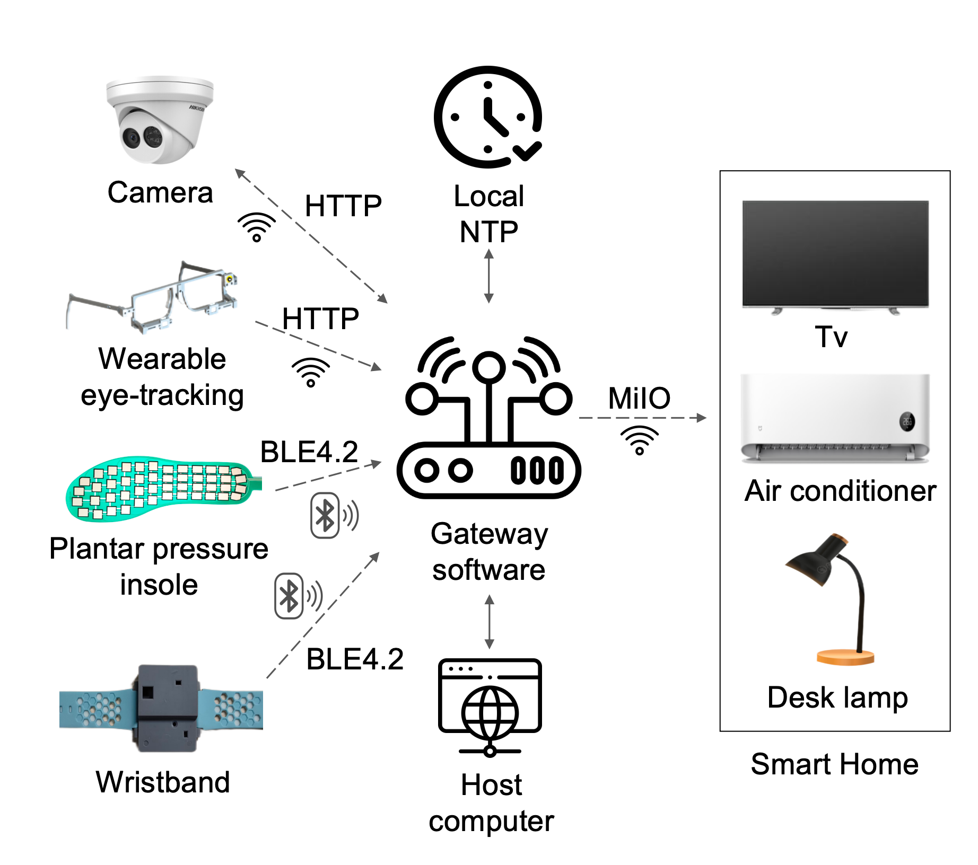
Supplementary Table 1: Optimal hyperparameters for the motor impairment rehabilitation tracking model.
 | Optimal hyperparameters of the baseline model
Optimizer | Ranger
Beta1 | 0.9
Beta2 | 0.99
Weight decay | 1e-5
Epsilon | 1e-8
Learning rate | 0.0001
Epochs | 60
Batch size | 64

Supplementary Table 2: Evaluation criteria for the platform.

Criterion | Question | Scoring guidelines
Cognitive load | How much cognitive effort was required to complete the task? Was it mentally taxing? | 1 (Very low effort) to 10 (Very high effort)
Operational effort | How much physical or mental effort was needed to operate the system? Was it tedious or simple? | 1 (Very easy) to 10 (Very tedious)
Temporal stress | How much time pressure did you feel while completing the task? Was it urgent? | 1 (No pressure) to 10 (Extremely urgent)
Psychological burden | How comfortable or relaxed did you feel during the task? Were you anxious or calm? | 1 (Very anxious) to 10 (Very comfortable)
Overall satisfaction | How satisfied were you with the overall experience? Did the system meet your expectations? | 1 (Very dissatisfied) to 10 (Very satisfied)

Supplementary References
[1] Chen, J., et al. A flexible insole gait monitoring technique for the internet of health things. IEEE Sensors Journal 21, 26397-26405 (2021).
[2] Vidal-Verdú, F., et al. Three realizations and comparison of hardware for piezoresistive tactile sensors. Sensors 11, 3249-326 (2011)

