Supplementary Information

Boundary Complexity of (Sub-) Cortical Areas Predict Deep Brain Stimulation Outcomes in Parkinson’s Disease

Devin Schoen M.S.^{1,2}, Skyler Deutsch B.S.¹, Juhi Mehta B.S.¹, Sarah Wang Ph.D.³, John Kornak, Ph.D.⁴, Philip A. Starr M.D. Ph.D.^{2,5}, Doris D. Wang M.D. Ph.D.^{2,5}, Jill L. Ostrem M.D.³, Ian O. Bledsoe M.D.³, *Melanie A. Morrison Ph.D.^{1,2}
¹Department of Radiology and Biomedical Imaging, University of California San Francisco
²Joint UCSF/UC Berkeley Graduate Group in Bioengineering
³Department of Neurology, University of California San Francisco
⁴Department of Epidemiology and Biostatistics, University of California San Francisco
⁵Department of Neurological Surgery, University of California San Francisco

Normality Testing
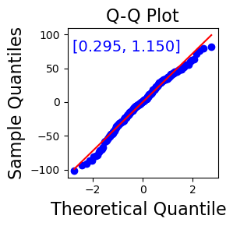
Methods: To ensure that the assumptions of normality were met for the residuals in our regression analyses, quantile-quantile (Q-Q) plots were generated to visually assess the distribution of residuals for all regions which were selected via LASSO regression in the main analysis. We also applied the Anderson-Darling test to quantitatively evaluate normality. A non-significant result from the Anderson-Darling test would indicate that the residuals do not significantly deviate from a normal distribution, thus supporting the assumption of normality for our regression models.
Figure 1: Quantile-quantile (Q-Q) plot of fractal dimension values pooled across brain regions, with Anderson-Darling statistics ranging from 0.295 to 1.150.
Results: All regions yielded non-significant results at the 1% significance level, with Anderson-Darling test statistics ranging from 0.295 to 1.150. These results indicate that we cannot reject the null hypothesis of normality for any region, suggesting that fractal dimension (FD) values in each region are approximately normally distributed.
Given the similarity in normality results across regions, a single Q-Q plot was generated to visually represent the pooled data, confirming a close alignment between the theoretical and sample quantiles (Figure 1). The consistency of these findings across all regions supports the assumption of normality, validating the use of parametric methods in the main analysis.

Deep Brain Stimulation Target Specific Sub-Analysis
Methods: We conducted an interaction analysis to investigate whether the relationship between brain structure, as measured by FD, and post- deep brain stimulation (DBS) medication change differed by DBS target (Subthalamic Nucleus (STN) vs. Globus Pallidus Internus (GPi)). This analysis aimed to identify target-specific effects on outcomes by including interaction terms in our regression models. Specifically, interaction terms were created between FD values for each of the 16 LASSO selected regions of interest (ROIs) and the binary variable indicating the DBS target (STN or GPi).
For each ROI, we fitted an ordinary least squares regression model where the dependent variable was the pre-to-post-DBS change in levodopa equivalent daily dose (ΔLEDD). Predictor variables included the FD of the region, covariates (age, sex, preoperative motor response to PD medications), and an interaction term between FD and the DBS target. The interaction term allowed us to assess whether the effects of FD on DBS outcomes vary depending on the stimulation target.
The statistical significance of the interaction terms was assessed using p-values (p < 0.05) to determine whether the association between FD and ΔLEDD was significantly different between the two target groups. Additionally, we plotted interaction effects to visually represent the relationships between FD, DBS target, and medication reduction. Interaction plots illustrate how the impact of FD on outcomes changes for STN and GPi patients, thus enabling direct comparison of these target-specific effects.
Results: None of the selected regions demonstrated a statistically significant interaction term (all p-values > 0.05), indicating that the relationship between FD and ΔLEDD did not differ by DBS target at a statistically significant level with our current dataset size.
Nevertheless, the interaction plots reveal distinct patterns across regions. In regions such as the left superior frontal gyrus, right inferior opercular frontal gyrus, right olfactory cortex, left and right amygdala, left cuneus, right inferior parietal cortex, and left paracentral lobule, STN and GPi had slopes that were similar in both sign and magnitude, suggesting a comparable relationship between FD and ΔLEDD for these DBS targets. Conversely, in regions including the left inferior orbital frontal gyrus, left Rolandic operculum, left middle cingulum, left superior occipital cortex, right paracentral lobule, left caudate, and right middle temporal pole, STN and GPi exhibited slopes of opposite signs, hinting at a potentially divergent effect of FD on ΔLEDD depending on the DBS target. Additionally, the left middle occipital gyrus had slopes of the same sign but displayed a pronounced difference in magnitude, with a steeper slope observed for STN than GPi.

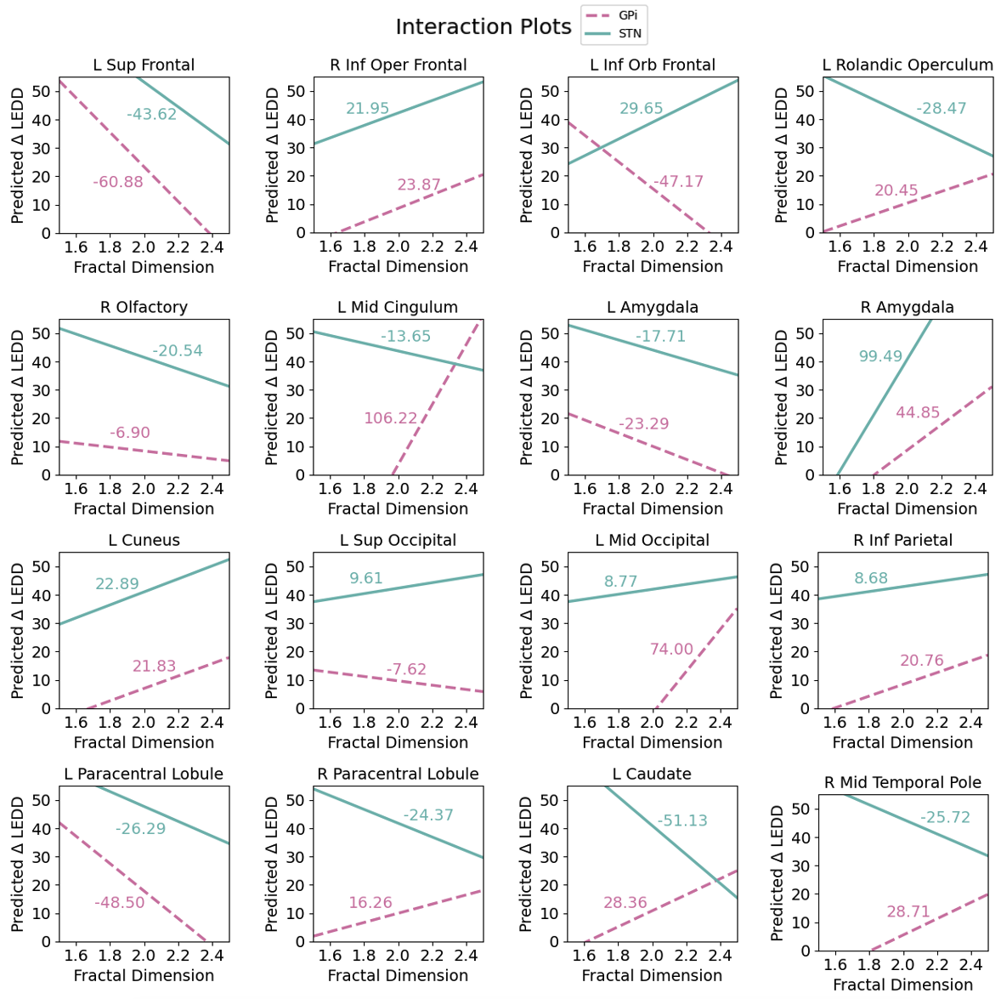
These findings, illustrated in Figure 2, suggest that while these regions were selected for their predictive utility in the main analysis, the effects of FD on ΔLEDD within each DBS target group may follow distinct patterns. However, due to the lack of statistical significance for the interaction terms, these trends should be interpreted cautiously, as they may reflect variability within the data rather than meaningful differences in FD’s relationship with ΔLEDD between STN and GPi. Future work will further explore these trends as new data are added into the analysis and the study is expanded.
Figure 2: Interaction plots for the predicted pre-to-post-DBS change in Parkinson’s medication (ΔLEDD) as a function of fractal dimension across selected brain regions, comparing GPi (dashed lines) and STN (solid lines) targets. Slope values for each target are indicated on each plot.

Cross-Validation Feature Selection
In the main analysis, the dataset was split into training, validation, and testing sets at the very beginning of processing to ensure that feature selection was conducted independently of the test set. This separation was critical to avoid introducing biases into the final model evaluation, ensuring that selected features and model performance could be assessed on truly unseen data. This approach reflects a practical application where predictive models are applied to entirely new datasets. However, to further evaluate the robustness of selected features, here we conducted a complementary analysis using cross-validation. While cross-validation introduces overlap between feature selection and evaluation, making it unsuitable for the main analysis, it serves as an exploratory tool to assess feature importance across the full dataset and verify that the trends observed in the main analysis are consistent and stable. Features included in the selection process were the FD of 90 brain ROIs from the AAL atlas, preoperative medication responsiveness quantified as the percent improvement in MDS-UPDRS III motor scores from the OFF- to ON-medication state (%Δ MDS-UPDRS III), age, sex, DBS target, and DBS hemisphere (lead configuration).
Methods: Preprocessing involved standardizing all features using z-scores to ensure comparability. We implemented a 10-fold cross-validation framework, with the outer loop splitting the data into training and test sets. The stratified outer loop ensured that ΔLEDD remained balanced across folds. Within each outer fold, LASSO was applied with a fixed LASSO shrinkage factor (0.03 as selected in the main analysis) to perform feature selection on the training set, reducing dimensionality and isolating the most important predictors. Features with non-zero coefficients were considered selected for that fold.
To evaluate the consistency of feature selection, how often each feature was selected across the 10 outer folds was tracked. Cross-validation complements the main analysis by assessing trends in feature importance when the full dataset is used for both selection and evaluation. This approach allows us to validate the robustness of key features identified in the main analysis, ensuring that they are stable and biologically plausible. Although cross-validation does not replace the independent train-validation-test splitting method used in the main pipeline, it provides an additional exploratory lens to ensure the reliability of feature selection trends.
Results: This analysis identified the most frequently selected features across all folds (Figure 3). The cross-validation analysis and the main analysis revealed overlapping as well as distinct sets of features relevant to predicting ΔLEDD. Several features were consistently identified as important across both analyses. Notably, the left cingulate gyrus, posterior division, left parahippocampal gyrus, and right superior parietal gyrus appeared in both the cross-validation and original feature selection lists, emphasizing their robust contributions to the model. Additionally, clinical features such as DBS target, age, and preoperative motor response to PD medications were repeatedly highlighted, underscoring the relevance of both anatomical and clinical predictors in explaining variability in the outcome.
However, there were also differences between the two approaches. The cross-validation analysis selected features such as the right calcarine cortex, right thalamus, and right angular gyrus, which were not identified in the original analysis. These regions may represent features that are sensitive to the inclusion of the entire dataset in feature selection, reflecting broader trends across all data splits. Conversely, the original analysis identified features like the left superior frontal gyrus and the left caudate nucleus, which were absent in the cross-validation results. These differences likely reflect the stricter separation of training, validation, and testing sets in the original analysis.
Despite these differences, the overlap between the two analyses supports the robustness of key anatomical and clinical predictors. The left posterior cingulate gyrus, identified in both analyses, is a region linked to motor control and cognitive processes, which are directly relevant to PD. The cross-validation analysis complements the main analysis by confirming trends in feature importance while highlighting additional features that might warrant further investigation in future studies.
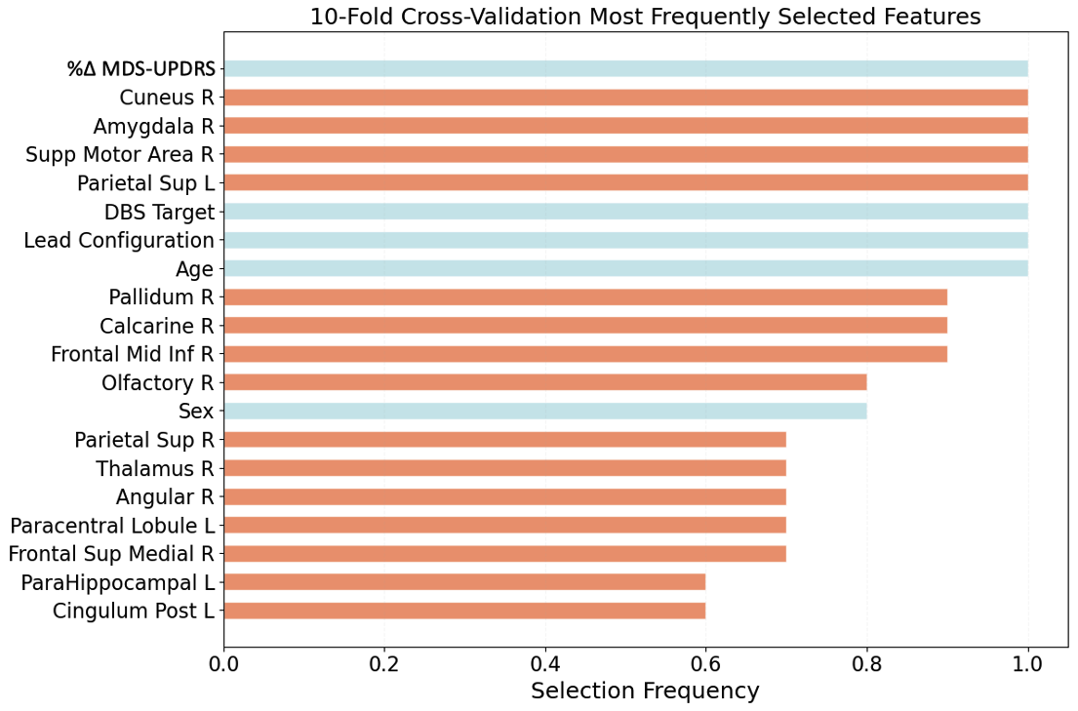
Figure 3: Features most frequently selected in the cross-validation analysis using LASSO regression, aggregated across 10 folds. Fractal dimension features are shown in orange, while clinical variables are shown in blue.

