Online resource Table 1 Search strategy

Database: Pubmed
Nº | Terms | Results
1 | ((((heme iron*[TIAB] OR heme-iron*[TIAB] OR haeme-iron*[TIAB] OR "Iron/administration and dosage"[Mesh] ) OR "Heme") AND (((fortif*[TIAB] OR supplem*[TIAB] OR Food, Fortified [Mesh] OR "Sprinkles"[TIAB])) OR ((bovine[TIAB] OR chicken[TIAB] OR porcine[TIAB])))) AND (("Iron Deficiencies"[Mesh] OR "Hemoglobins"[Mesh] AND "Anemia"[Mesh]) OR ("Anemia"[Mesh] OR anemi*[TIAB] OR ANAEMIA[TIAB] or iron deficiency*[TIAB] OR "Hemoglobins"[Mesh] OR Hemoglobin* [TIAB] OR Haemoglobin [TIAB] OR Serum Ferritin [TIAB] OR Ferritin* [TIAB] OR Serum Iron [TIAB] OR Total Iron Binding Capacity [TIAB] OR Transferrin Saturation [TIAB] OR Erythrocyte Protoporphyrin [TIAB] OR Zinc Protoporphyrin [TIAB]))) AND (("Randomized Controlled Trial" [Publication Type] OR (randomizedcontrolledtrial[Filter])) OR (Randomized Controlled Trial [TIAB] OR RCT [TIAB] OR Randomized Clinical Trial [TIAB] OR Controlled Clinical Trial [TIAB] OR Randomized Controlled Clinical Trial [TIAB] OR Randomized Clinical Study [TIAB] OR Randomized Intervention Study [TIAB] OR Controlled Randomized Study [TIAB] OR Controlled Randomized Clinical Trial [TIAB] OR Randomized Assignment Trial [TIAB] OR placebo[TIAB] OR randomly [TIAB] OR trial [TIAB] OR groups [TIAB])) | 832

Database: Scopus
Nº | Terms | Results
1 | ( TITLE-ABS-KEY ( "heme iron*" OR "heme-iron*" OR "haeme-iron*" OR "iron administration*" ) OR ALL ( "Heme" ) AND TITLE-ABS-KEY ( "fortif*" OR "supplem*" OR "Food Fortified" OR "Sprinkles" ) OR TITLE-ABS-KEY ( "bovine" OR "chicken" OR "porcine" ) AND TITLE-ABS-KEY ( "Anemia" OR "anemi" OR "ANAEMIA" OR "iron deficienc*" OR "Hemoglobins" OR "Hemoglobin*" OR “Haemoglobin” OR "Serum Ferritin" OR "Ferritin*" OR "Serum Iron" OR "Total Iron Binding Capacity" OR "Transferrin Saturation" OR "Erythrocyte Protoporphyrin" OR "Zinc Protoporphyrin" ) AND TITLE-ABS-KEY ( "Randomized Controlled Trial" OR "RCT" OR "Randomized Clinical Trial" OR "Controlled Clinical Trial" OR "Randomized Controlled Clinical Trial" OR "Randomized Clinical Study" OR "Randomized Intervention Study" OR "Controlled Randomized Study" OR "Controlled Randomized Clinical Trial" OR "Randomized Assignment Trial" OR “placebo” OR "randomly" OR “trial” OR “groups”) ) | 1385

Database: Web of Science
Nº | Terms | Results
1 | TS=(heme iron* OR heme-iron* OR haeme-iron* ) OR ALL=(Heme) AND TS=("fortif*" OR "supplem*" OR "Food Fortified" OR “Sprinkles”) OR TS=(bovine OR chicken OR porcine ) AND TS=("Anemia" OR "anemi" OR "ANAEMIA" OR "iron deficienc*" OR "Hemoglobins" OR “Haemoglobin” OR "Hemoglobin*" OR "Serum Ferritin" OR "Ferritin*" OR "Serum Iron" OR "Total Iron Binding Capacity" OR "Transferrin Saturation" OR "Erythrocyte Protoporphyrin" OR "Zinc Protoporphyrin" ) AND TS=( "Randomized Controlled Trial" OR "RCT" OR "Randomized Clinical Trial" OR "Controlled Clinical Trial" OR "Randomized Controlled Clinical Trial" OR "Randomized Clinical Study" OR "Randomized Intervention Study" OR "Controlled Randomized Study" OR "Controlled Randomized Clinical Trial" OR "Randomized Assignment Trial" OR “placebo” OR “randomly” OR “trial” OR “groups”) | 222

Database: LILACS
Nº | Terms | Results
1 | (((mh: iron OR (heme iron) OR (heme-iron) OR (haeme iron) OR (hem)) AND (((fortified ) OR (supplementation ) OR (Food Fortified) OR (Sprinkles)) OR ((bovine ) OR (chicken ) OR (porcine)))) AND (mh: Anemia OR mh: Iron Deficiencies OR (Anemia) OR (ANAEMIA) OR (Iron deficiency) OR (Hemoglobin*) OR (Serum Ferritin) OR (Ferritin) OR (Haemoglobin) OR (Serum Iron) OR (Total Iron Binding Capacity) OR (Transferrin Saturation) OR (Erythrocyte Protoporphyrin) OR (Zinc Protoporphyrin))) AND (mh:"Randomized Controlled Trial" OR (Randomized Controlled Trial ) OR (RCT) OR (Randomized Clinical Trial ) OR (Controlled Clinical Trial ) OR (Randomized Controlled Clinical Trial) OR (Randomized Clinical Study ) OR (Randomized Intervention Study ) OR (Controlled Randomized Study ) OR (Controlled Randomized Clinical Trial ) OR (Randomized Assignment Trial) OR (placebo) OR (randomly) OR (trial) OR (groups)) | 47

Database: Cochrane Central
Nº | Terms | Results
#3 | MeSH descriptor: [Iron] this term only and with qualifier(s): [administration & dosage  - AD] OR ('heme iron' OR 'heme-iron' OR haeme-iron*):ti,ab,kw AND ((food* AND fortif*) OR supplem* OR sprinkles):ti,ab,kw OR (bovine OR chicken OR porcine):ti,ab,kw AND MeSH descriptor: [Anemia] explode all trees OR (anemi* OR 'iron deficien*' OR hemoglobin* OR ferritin OR 'serum iron' OR 'total iron binding capacity' OR transferrin OR 'erythrocite protoporphyrin' OR 'zinc protoporphyrin'):ti,ab,kw in Trials | 611

Online resource Table 2 List of excluded studies with reasons

N° | Title | Reason of exclusion
1 | Allen LH, Peerson JM, Olney DK (2009) Provision of multiple rather than two or fewer micronutrients more effectively improves growth and other outcomes in micronutrient-deficient children and adults. J Nutr 139:1022–1030 | Review
2 | Reizenstein P (1979) Hemoglobin fortification of food and prevention of iron deficiency with heme iron. Acta Med Scand Suppl 629:1–47 | Non-randomized
3 | Anwar F, Mudjajanto ES, Martianto D, Hakimi H (2003) High protein and iron-folate crackers supplementation on the iron status of pregnant women. Med J Indones 243 | Wrong intervention, fish-based crackers with protein as the main component
4 | JPRN-UMIN000048585 (2022) Effect of combined intake of iron supplement and protein on anemia-related indices. https://trialsearch.who.int/Trial2.aspx?TrialID=JPRN-  UMIN000048585. | Protocol
5 | Fuerth JH (1972) Iron supplementation of the diet in full-term infants: a controlled study. J Pediatr 80:974–979 | Non-randomized
6 | Suzuki, S., Ito, H. and Kiyokawa, H. (1990) The Effect of BioIron-150 on Pregnant Women and Women with Females Associated Bleeding Disorders. The World of Obstetrics and Gynecology, 42, 33-42. | Not retrieved and abstract suggest hospitalized patients
7 | Ahmed P, Mahmood A, Aziz S, Azim W (2003) Comparison of response between food supplemented with powdered iron and iron in syrup form for iron deficiency anemia. J Coll Physicians Surg Pak 13:402–404 | Non-randomized
8 | Young MF, Griffin I, Pressman E, McIntyre AW, Cooper E, McNanley T, Harris ZL, Westerman M, O’Brien KO (2010) Utilization of Iron from an Animal-Based Iron Source Is Greater Than That of Ferrous Sulfate in Pregnant and Nonpregnant Women123. J Nutr 140:2162–2166 | Wrong study design, only bioavailability
9 | Seligman PA, Moore GM, Schleicher RB (2000) Clinical studies of hip: An oral heme-iron product. Nutrition Research 20:1279–1286 | Bioavailability only study
10 | Nam T-S, Shim JY, Kim B-J, et al (2006) Clinical Study on the Iron Absorption from Heme-Iron Polypeptide and Nonheme-Iron. Nutritional Sciences 9:295–300 | Bioavailability only study
11 | Borch-Iohnsen, B., et al. «Bioavailability of Daily Low Dose Iron Supplements in Menstruating Women with Low Iron Stores». European Journal of Clinical Nutrition, vol. 44, n.o 1, enero de 1990, pp. 29-34. | Same study as Borch-Iohnsen 1989

Online resource Table 3 Risk of bias assessment for each study outcome

Study | Bias from randomization process | Bias due to deviations from intended interventions | Bias due to missing outcome data | Bias in measurement of the outcomes | Bias in selection of the reported result | Overall risk of bias
Hemoglobin
Eskeland (1997) | Some concerns | Low | Low | Low | Some concerns | Some concerns
Frykman (1994) | Low | Low | Low | Low | Some concerns | Some concerns
Hoppe (2013) | Some concerns | Some concerns | High | Low | Some concerns | High
Sandstad (2003) | Some concerns | Some concerns | Low | Low | Some concerns | Some concerns
Quintero-Gutiérrez (2016) | Low | Low | High | Low | Some concerns | High
Swain (2007) | Some concerns | Low | Low | Low | High | High
Schuman (2005) | Low | Low | Some concerns | Low | Some concerns | Some concerns
Ulvik RJ (2013) | Low | Low | Low | Low | Some concerns | Some concerns
Borch-Iohnsen B (1989) | Low | Some concerns | Some concerns | Low | Some concerns | Some concerns
Quintero-Gutiérrez (2012) | Low | Low | Low | Low | Some concerns | Some concerns
González-Rosendo (2010) | Low | Low | Low | Low | Some concerns | Some concerns
Palomino Quispe (2024) | Some concerns | Some concerns | Low | Low | Some concerns | Some concerns
Borch-Iohnsen B (1993) | Some concerns | Low | Low | Low | Some concerns | Some concerns
Ferritin
Eskeland (1997) | Some concerns | Low | Low | Low | Some concerns | Some concerns
Frykman (1994) | Low | Low | Low | Low | Some concerns | Some concerns
Hoppe (2013) | Some concerns | Some concerns | High | Low | Some concerns | High
Sandstad (2003) | Some concerns | Some concerns | Low | Low | Some concerns | Some concerns
Quintero-Gutiérrez (2016) | Low | Low | High | Low | Some concerns | High
Swain (2007) | Some concerns | Low | Low | Low | Some concerns | Some concerns
Schuman (2005) | Low | Low | Some concerns | Low | Some concerns | Some concerns
Ulvik RJ (2013) | Low | Low | Low | Low | Some concerns | Some concerns
Borch-Iohnsen B (1989) | Low | Some concerns | Some concerns | Low | Some concerns | Some concerns
Quintero-Gutiérrez (2012) | Low | Low | Low | Low | Some concerns | Some concerns
González-Rosendo (2010) | Low | Low | Low | Low | Some concerns | Some concerns
Borch-Iohnsen B (1993) | Some concerns | Low | Low | Low | Some concerns | Some concerns

Study | Bias from randomization process | Bias due to deviations from intended interventions | Bias due to missing outcome data | Bias in measurement of the outcomes | Bias in selection of the reported result | Overall risk of bias
TIBC
Eskeland (1997) | Some concerns | Low | Some concerns | Low | High | High
Swain (2007) | Some concerns | Low | Low | Low | Some concerns | Some concerns
Ulvik RJ (2013) | Low | Low | Low | Low | Some concerns | Some concerns
Borch-Iohnsen B (1989) | Low | Some concerns | Some concerns | Low | Some concerns | Some concerns
Serum iron
Ulvik RJ (2013) | Low | Low | Low | Low | Some concerns | Some concerns
Quintero-Gutiérrez (2012) | Low | Low | Low | Low | Some concerns | Some concerns
González-Rosendo (2010) | Low | Low | Low | Low | Some concerns | Some concerns
Transferrin receptor
Swain (2007) | Some concerns | Low | Low | Low | Some concerns | Some concerns
Hoppe (2013) | Some concerns | Some concerns | High | Low | Some concerns | High
Erythrocyte indices
Quintero-Gutiérrez (2016) | Low | Low | High | Low | Some concerns | High
Quintero-Gutiérrez (2012) | Low | Low | Low | Low | Some concerns | Some concerns
González-Rosendo (2010) | Low | Low | Low | Low | Some concerns | Some concerns
Eskeland (1997) | Some concerns | Low | Low | Low | Some concerns | Some concerns
Erythrocyte/Zinc protoporphyrin
Eskeland (1997) | Some concerns | Low | Low | Low | Some concerns | Some concerns
Swain (2007) | Some concerns | Low | Low | Low | Some concerns | Some concerns
Transferrin saturation
Eskeland (1997) | Some concerns | Low | Low | Low | High | High
Swain (2007) | Some concerns | Low | Low | Low | High | High
Total side effects
Frykman (1994) | Low | Low | Low | Low | Some concerns | Some concerns
Hoppe (2013) | Some concerns | Some concerns | High | Some concerns | Some concerns | High
Ulvik RJ (2013) | Low | Low | Low | Low | Some concerns | Some concerns
Palomino Quispe (2024) | Some concerns | Some concerns | Low | Some concerns | Some concerns | Some concerns

Online resource Table 5 Summary of other iron status indicators in different types of population

 | Children |  |  | Women of reproductive age
Iron status indicators | n | Estimate MD (95% CI) | I² | n | Estimate MD (95% CI) | I²
Total iron binding capacity (µmol/L) | - | - | - | 3 | 2.72 (-0.46; 5.90) | 0%
Serum iron (µg/dL) | - | - | - | 1 | 7.60 (-13.68; 28.88) | -
Transferrin receptor (nmol/L) | - | - | - | 2 | -0.59 (-5.88; 4.70) | 74%
Mean corpuscular hemoglobin (pg/cell) | 1 | 0.50 (-1.18; 2.18) | - | - | - | -
Mean corpuscular volume (fL) | 1 | -0.30 (-1.21; 0.61) | - | - | - | -
Hematocrit (%) | 1 | -1.30 (-2.83; 0.23) | - | - | - | -
Body iron (mg/kg) | - | - | - | 2 | -0.66 (-1.79; 0.48) | 0%
Zinc protoporphyrin (µg/L) | - | - | - | 1 | 29 (0.73; 57.27) | -

 | Pregnant women |  |  | Female adolescents
Iron status indicators | n | Estimate MD (95% CI) | I² | n | Estimate MD (95% CI) | I²
Total iron binding capacity (µmol/L) | - | - | - | - | - | -
Serum iron (µg/dL) | - | - | - | 2 | 0.36 (-7.24; 7.96) | 0%
Transferrin receptor (nmol/L) | - | - | - | - | - | -
Mean corpuscular hemoglobin (pg/cell) | - | - | - | 2 | 0.65 (-0.23; 1.53) | 65%
Mean corpuscular volume (fL) | 1 | 0.60 (-1.55; 2.75) | - | 2 | 1.38 (-0.43; 3.19) | 25%
Hematocrit (%) | - | - | - | 2 | -0.33 (-0.97; 0.30) | 0%
Body iron (mg/kg) | - | - | - | - | - | -
Erythrocyte protoporphyrin (µmol/L) | 1 | 0.08 (-0.17; 0.32) | - | - | - | -

Online resource Table 6 Reported side effects in heme and non-heme iron interventions

Study | Population | Reported side effects
Study | Population | Heme iron | Non-heme iron
Eskeland (1997) | Pregnant women | Similar side effects in both groups, no data available
Frykman (1994) | Adults blood donors | Diarrhea (26%)  Constipation (14%)  Gastric pain (6%)  Nausea (8%)  Total: 14% | Diarrhea (37%)  Constipation (35%)  Gastric pain (19%)  Nausea (6%)  Total: 25%
Hoppe (2013) | Woman of reproductive age | Constipation (11%)  Nausea and gastric pain (2.9%)  Flatulence (2.9%) | Low dose:  Constipation (8%)  High dose:  Nausea (13.3%)  Loose stools (13.3%)  Constipation and dark stools (7%)
Quintero-Gutiérrez (2016) | Children (previously dewormed) from 3 to 6 years | No reported side effects in any group
Ulvik RJ (2013) | Healthy adults (mostly women) registering as blood donors for first time, with poor iron status | Gastrointestinal side effects (35%) | Gastrointestinal side effects (58%)
Palomino Quispe (2024) | Children with moderate or mild anemia (previously dewormed) | Diarrhea (16.7%)  Constipation (4.2%) | Constipation (12%)  Allergy (8%)  Diarrhea (4%)  Emesis (4%)

Abbreviation: %: Percentage

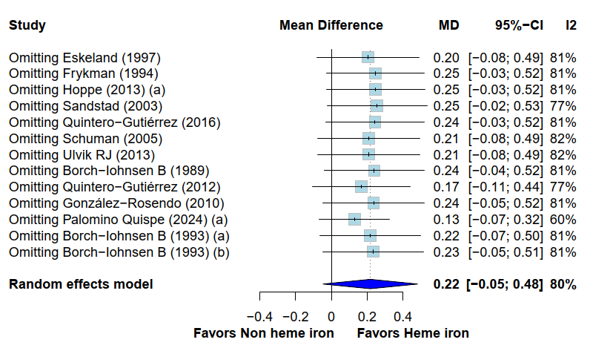
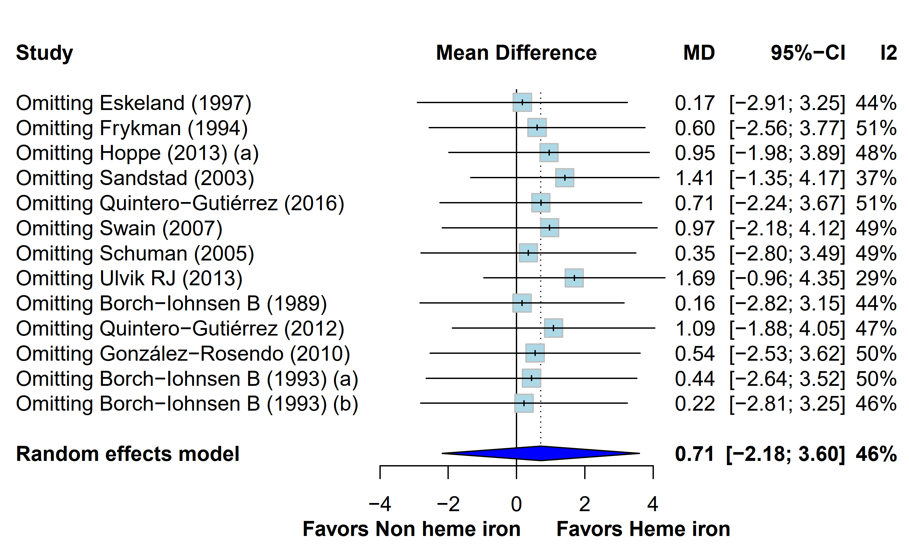
A
B

Online resource Figure 2 Leave-one-out analysis for hemoglobin (A), ferritin (B)

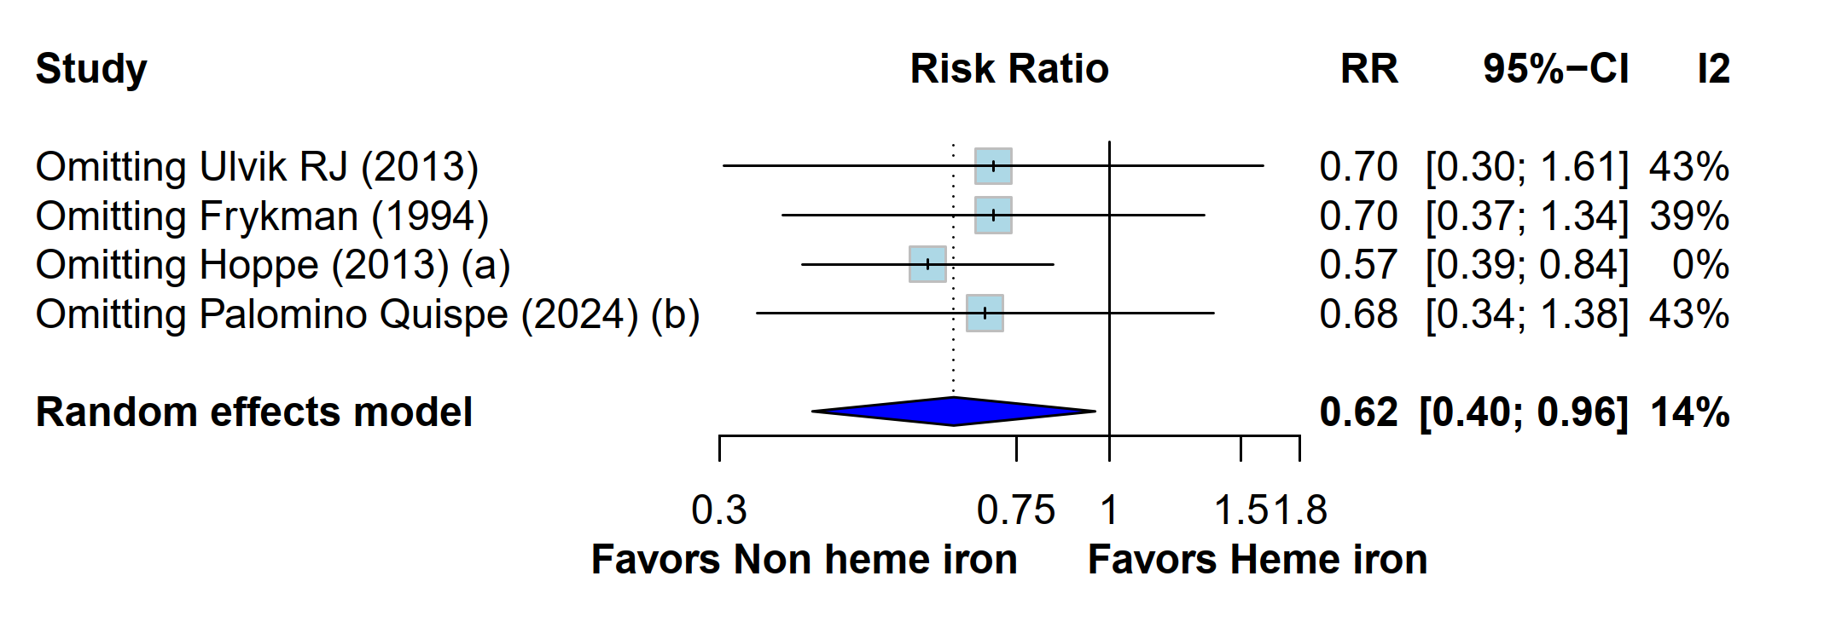

Online resource Figure 3 Leave-one-out analysis for side effects

Online resource Table 6 Sensitivity analysis

Overall outcome  Sensitivity analysis | Hemoglobin (g/dL) |  | Ferritin (µg/L)
Overall outcome  Sensitivity analysis | Estimate (95% CI) | I² | Estimate (95% CI) | I²
Excluding skewed studies | MD 0.26 (-0.09; 0.62) | 85% | MD 1.32 (-2.10;4.74) | 37%
Excluding studies with high  risk of bias | MD 0.28 (-0.01; 0.56) | 82% | MD 0.96 (-2.03; 3.96) | 53%
Excluding studies with  active blood donors | MD 0.28 (-0.04; 0.59) | 84% | MD -0.29 (-4.34; 3.77) | 56%
Meta-analysis of medians | EMD 0.23 (-0.04; 0.49) | 77% | EMD 0.61 (-2.25; 3.47) | 45%

Abbreviations: EMD: Estimated median difference; MD: Mean difference; CI: Confidence interval; I²: Statistic assessment of heterogeneity; g: Gram; µg: Micrograms; L: Liter; dL: Deciliter

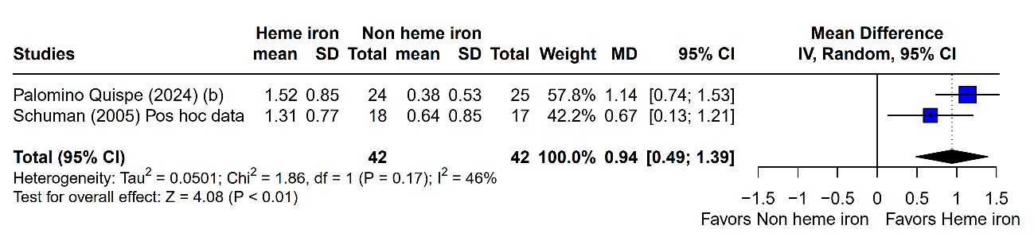
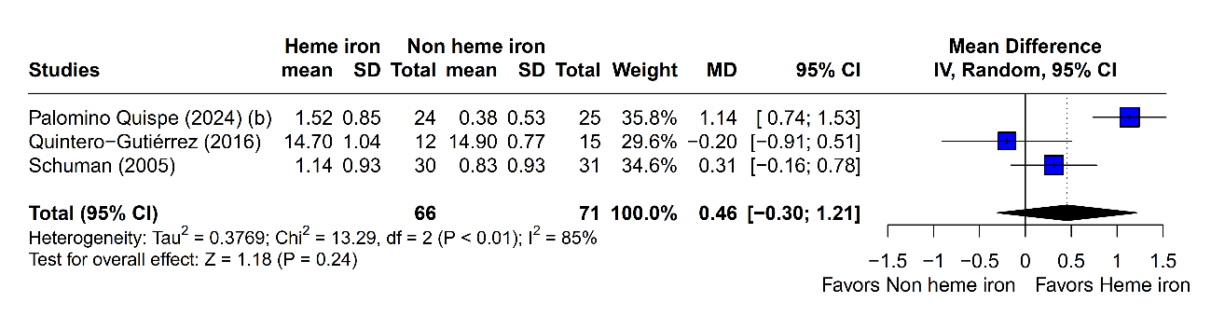
B
A

Online resource Figure 4 Forest plot of hemoglobin levels in the overall children population (A) and in children with iron deficiency (B), using as comparator Palomino Quispe (2024) (b) ferrous fumarate in the form of sprinkles
A

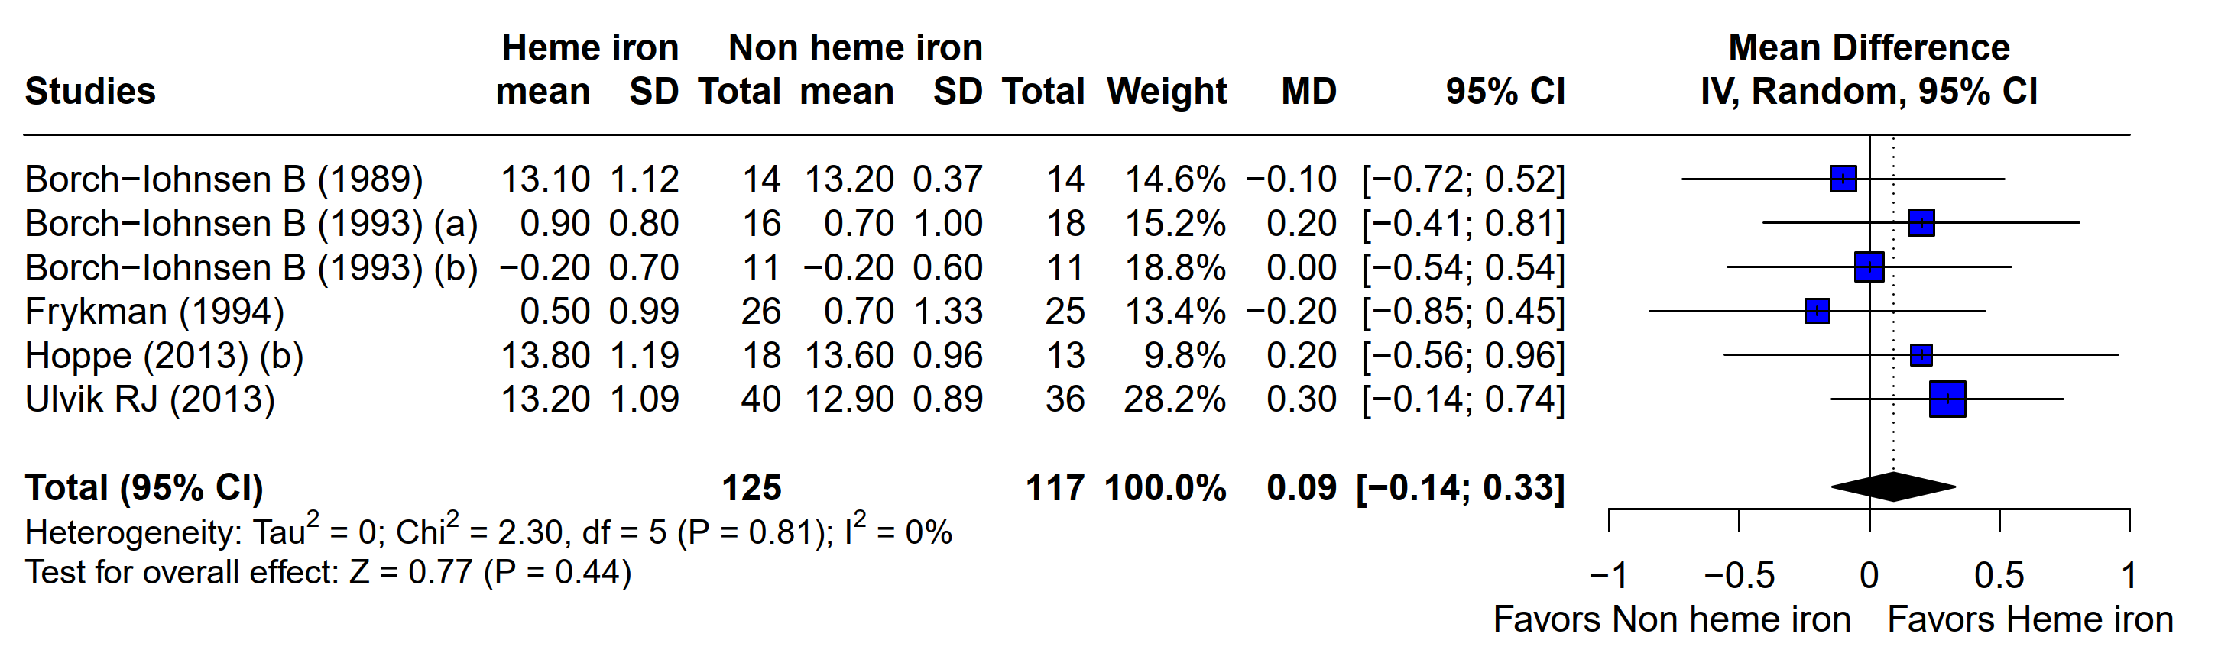
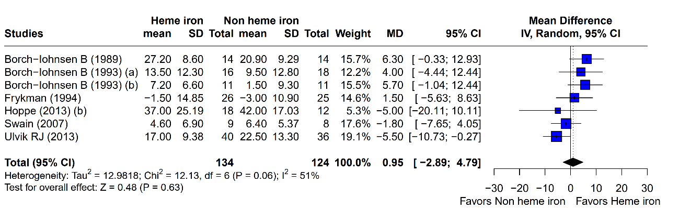
B
Online resource Figure 5 Forest plot of hemoglobin (A) and ferritin (B) levels in the overall women of reproductive age population using as comparator Hoppe (2013) (b) 60 mg of ferrous sulphate

A2
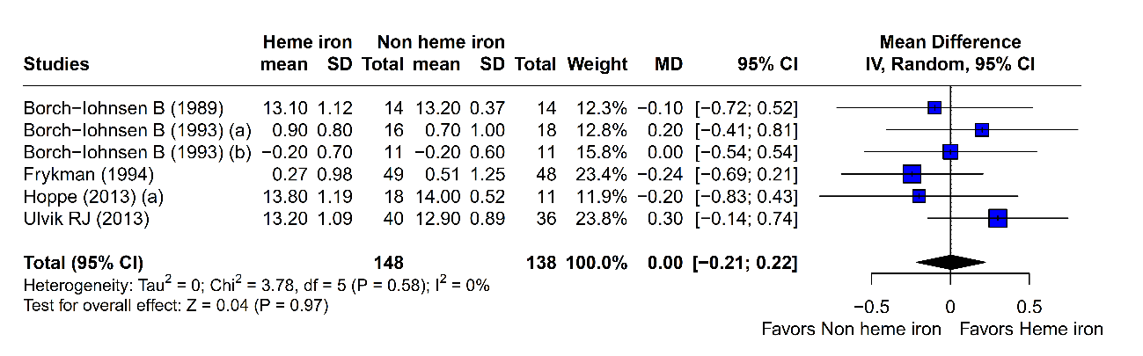
B

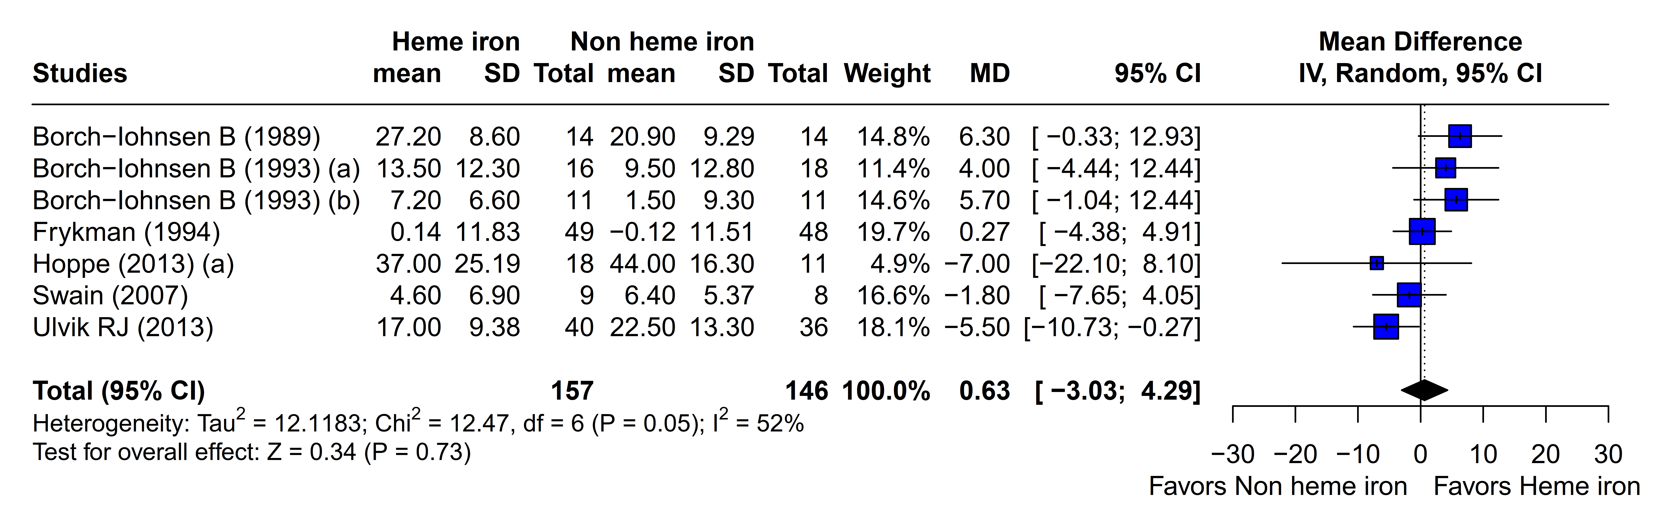

Online resource Figure 6 Forest plot of hemoglobin (A) and ferritin (B) levels in the adult population using men data from Frykman study

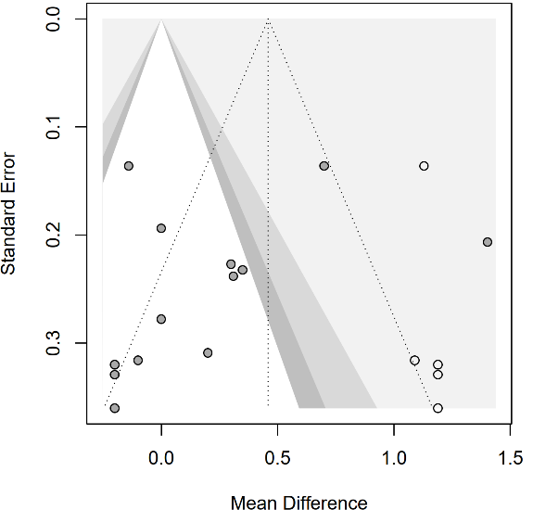
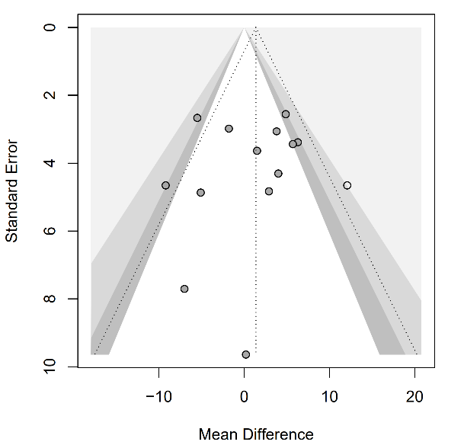
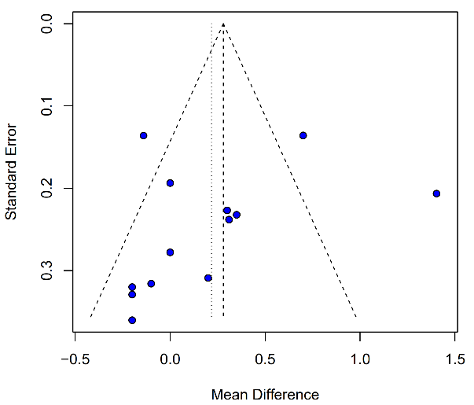
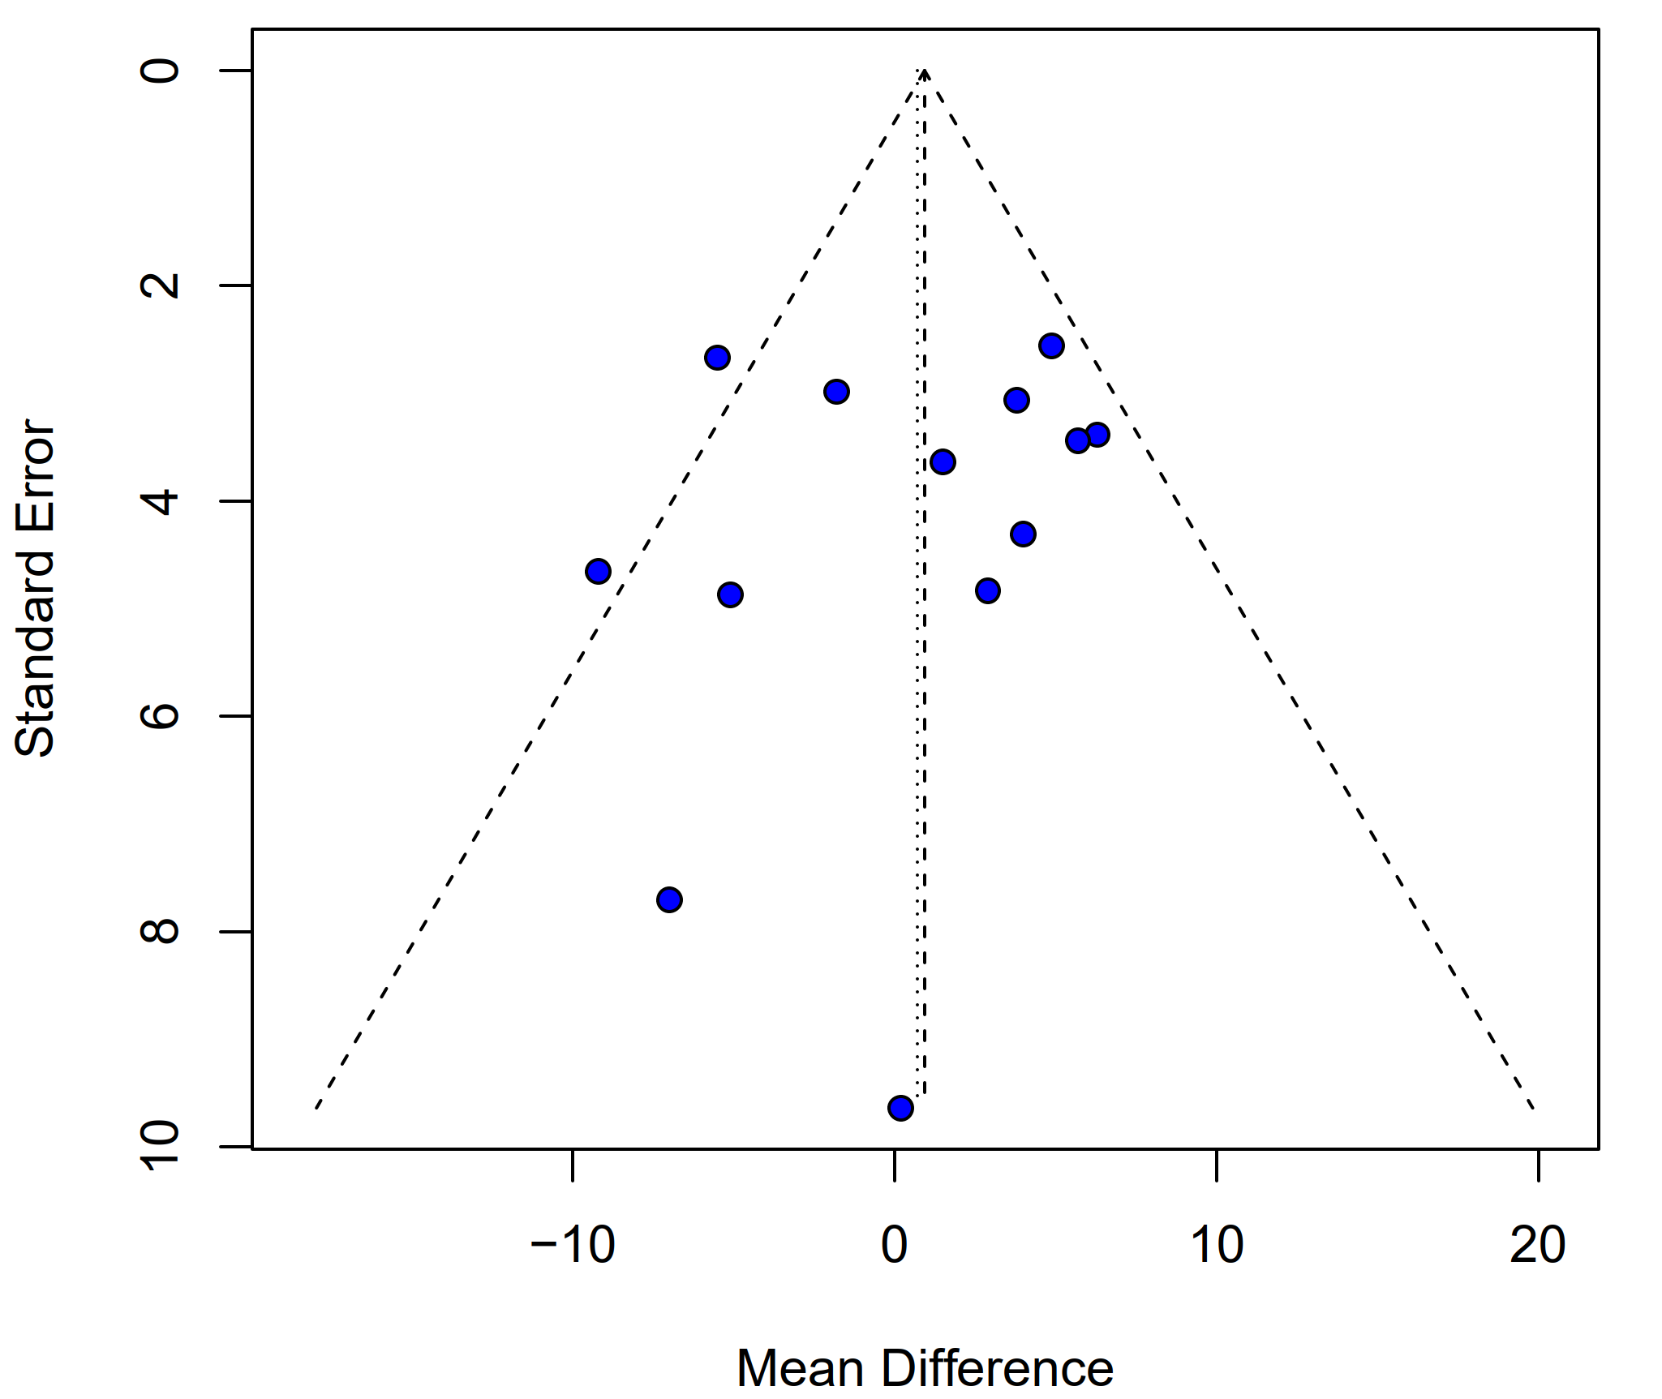
C
D
A
B

Online resource Figure 7 Funnel plots for (A) hemoglobin and (B) ferritin and Trim and fill (below) for (C) hemoglobin and (D) ferritin

Online resource Table 7 Summary of findings (SoF) for children studies
Certainty assessment |  |  |  |  |  |  | № of patients |  | Effect |  | Certainty | Importance
№ of studies | Study design | Risk of bias | Inconsistency | Indirectness | Imprecision | Other considerations | Heme iron | Non heme iron | Relative  (95% CI) | Absolute  (95% CI) | Certainty | Importance
Hemoglobin (follow-up: range 10 weeks to 12 weeks)
3 | randomised trials | seriousª | not serious^{b} | not serious | very serious^{c} | none | 66 | 69 | - | MD 0.53 g/dL higher  (0.4 lower to 1.47 higher) | ⨁◯◯◯  Very low^{a,b,c} | CRITICAL
Ferritin (follow-up: mean 10 weeks)
2 | randomised trials | serious^{d} | not serious | not serious | very serious^{e} | none | 42 | 46 | - | MD 3.47 µg/L higher  (2.25 lower to 9.19 higher) | ⨁◯◯◯  Very low^{d,e} | IMPORTANT
Mean corpuscular hemoglobin (follow-up: mean 10 weeks)
1 | randomised trials | serious^{f} | not serious | not serious | very serious^{g} | none | 12 | 15 | - | MD 0.53 pg/cell higher  (0.13 lower to 1.2 higher) | ⨁◯◯◯  Very low^{f,g} | IMPORTANT
Mean corpuscular volume (follow-up: mean 10 weeks)
1 | randomised trials | very serious^{f} | not serious | not serious | very serious^{h} | none | 12 | 15 | - | MD 0.3 fL lower  (1.21 lower to 0.61 higher) | ⨁◯◯◯  Very low^{f,h} | IMPORTANT
Hematocrit (follow-up: mean 10 weeks)
1 | randomised trials | serious^{f} | not serious | not serious | very serious^{i} | none | 12 | 15 | - | MD 1.3 % lower  (2.83 lower to 0.23 higher) | ⨁◯◯◯  Very low^{f,i} | IMPORTANT
CI: confidence interval; MD: mean difference

Explanations
a. Risk of bias: High risk of bias due to missing outcome data domain in ≥25% studies. Downgraded one level.
b. Inconsistency: The heterogeneity was explained after considering only children with iron deficiency. Not downgraded
c. Imprecision: Number of participants <30% of the Diversity-adjusted required information size of 867 participants. Downgraded two levels.
d. Risk of bias: High risk of bias due to missing outcome data domain in ≥25% studies. Downgraded one level.
e. Imprecision: Number of participants <30% of the Diversity-adjusted required information size of 489 participants. Downgraded two levels
f. Risk of bias: High risk of bias in missing outcome data domain (one study). Downgraded one level.
g. Number of participants <30% of the Diversity-adjusted required information size of 625 participants. Downgraded two levels.
h. Number of participants <30% of the Diversity-adjusted required information size of 512 participants. Downgraded two levels.
i. Number of participants <50% of the Diversity-adjusted required information size of 77 participants. Downgraded two levels.

Online resource Table 8 Summary of findings (SoF) for female adolescent studies

Certainty assessment |  |  |  |  |  |  | № of patients |  | Effect |  | Certainty | Importance
№ of studies | Study design | Risk of bias | Inconsistency | Indirectness | Imprecision | Other considerations | Heme iron | non-heme iron | Relative  (95% CI) | Absolute  (95% CI) | Certainty | Importance
Hemoglobin (follow-up: range 7 weeks to 13 weeks)
2 | randomised trials | not serious | seriousª | serious^{b} | very serious^{c} | none | 99 | 101 | - | MD 0.36 g/dL higher  (0.32 lower to 1.05 higher) | ⨁◯◯◯  Very low^{a,b,c}
Ferritin (follow-up: range 7 weeks to 13 weeks)
2 | randomised trials | not serious | not serious | serious^{d} | very serious^{e} | none | 99 | 101 | - | MD 1.08 µg/L lower  (8.92 lower to 6.76 higher) | ⨁◯◯◯  Very low^{d,e}
Serum iron (follow-up: range 7 weeks to 13 weeks)
2 | randomised trials | not serious | not serious | serious^{b} | very serious^{f} | none | 99 | 101 | - | MD 0.36 µg/dL higher  (7.24 lower to 7.96 higher) | ⨁◯◯◯  Very low^{b,f}
Mean corpuscular hemoglobin (follow-up: range 7 weeks to 13 weeks)
2 | randomised trials | not serious | serious^{g} | serious^{b} | very serious^{h} | none | 99 | 101 | - | MD 0.65 pg/cell higher  (0.23 lower to 1.53 higher) | ⨁◯◯◯  Very low^{b,g,h}
Mean corpuscular volume (follow-up: range 7 weeks to 13 weeks)
2 | randomised trials | not serious | serious^{g} | serious^{b} | very serious^{i} | none | 99 | 101 | - | MD 1.38 fL higher  (0.43 lower to 3.19 higher) | ⨁◯◯◯  Very low^{b,g,i}
Hematocrit (follow-up: range 7 weeks to 13 weeks)
2 | randomised trials | not serious | not serious | serious^{b} | very serious^{j} | none | 99 | 101 | - | MD 0.33 % lower  (0.97 lower to 0.3 higher) | ⨁◯◯◯  Very low^{b,j}
CI: confidence interval; MD: mean difference

Explanations
a. Heterogeneity in the point estimates of the forest plot could not be explained by subgroup analysis of iron status due to low number of studies. Downgraded one level.
b. Indirectness: Population with chronic inflammation. Low generalisability of the findings.
c. Imprecision: Number of participants <30% of the Diversity-adjusted required information size of 1490 participants. Downgraded two levels
d. Indirectness: Ferritin biomarker altered at baseline in the population, low generalisability of the findings. Downgraded one level.
e. Imprecision: Number of participants <30% of the Diversity-adjusted required information size of 21946 participants. Downgraded two levels.
f. Imprecision: Number of participants <30% of the Diversity-adjusted required information size of 177806 participants. Downgraded two levels.
g. Inconsistency: Heterogeneity in the point estimates of the forest plot.
h. Imprecision: Number of participants <30% of the Diversity-adjusted required information size of 541 participants. Downgraded two levels.
i. Imprecision: Number of participants <30% of the Diversity-adjusted required information size of 629 participants. Downgraded two levels.
j. Imprecision: Number of participants <30% of the Diversity-adjusted required information size of 1504 participants. Downgraded two levels.

Online resource Table 9 Summary of findings (SoF) for pregnant women studies

Certainty assessment |  |  |  |  |  |  | № of patients |  | Effect |  | Certainty | Importance
№ of studies | Study design | Risk of bias | Inconsistency | Indirectness | Imprecision | Other considerations | Heme iron | non-heme iron | Relative  (95% CI) | Absolute  (95% CI) | Certainty | Importance
Hemoglobin (follow-up: range 18 weeks to 36 weeks)
2 | randomised trials | not serious | not seriousª | serious^{b} | very serious^{c} | none | 122 | 103 | - | MD 0.07 g/dL higher  (0.41 lower to 0.54 higher) | ⨁◯◯◯  Very low^{a,b,c} | IMPORTANT
Ferritin (follow-up: range 18 weeks to 36 weeks)
2 | randomised trials | not serious | serious^{d} | serious^{b} | very serious^{e} | none | 121 | 106 | - | MD 1.62 µg/L lower  (15.38 lower to 12.14 higher) | ⨁◯◯◯  Very low^{b,d,e} | IMPORTANT
Erythrocyte protoporphyrin (follow-up: mean 36 weeks)
1 | randomised trials | not serious | not serious | serious^{b} | very serious^{f} | none | 31 | 30 | - | MD 0.08 µmol/L higher  (0.17 lower to 0.32 higher) | ⨁◯◯◯  Very low^{b,f} | IMPORTANT
Transferrin saturation (follow-up: mean 36 weeks)
1 | randomised trials | very serious^{g} | not serious | serious^{b} | very serious^{h} | none | Transferrin saturation was higher in the heme group than in the non-heme group in the last trimester of gestation (p<0.01 at 28 and 38 weeks), it fell below 15% in the non-heme group at the end of gestation. |  |  |  | ⨁◯◯◯  Very low^{b,g,h} | IMPORTANT
Serum iron (follow-up: mean 36 weeks)
1 | randomised trials | very serious^{g} | not serious | serious^{b} | very serious^{h} | none | During gestation, serum iron was significantly higher in the heme group than in the non-heme group from week 28 to week 8 postpartum. |  |  |  | ⨁◯◯◯  Very low^{b,g,h} | IMPORTANT
Mean corpuscular volume (follow-up: mean 36 weeks)
1 | randomised trials | not serious | not serious | serious^{b} | very serious^{f} | none | 31 | 30 | - | MD 0.6 fL higher  (1.55 lower to 2.75 higher) | ⨁◯◯◯  Very low^{b,f} | IMPORTANT
CI: confidence interval; MD: mean difference

Explanations
a. Inconsistency: While I2 was 70%, there was no inconsistency on point estimates from the forest plot.
b. Indirectness: Heme iron mixed with ferrous salts.
c. Imprecision: Number of participants <30% of the Diversity-adjusted required information size of 6620 participants. Downgraded two levels.
d. Inconsistency: Heterogeneity in point estimates of the forest plot. Downgraded one level.
e. Imprecision: Number of participants <30% of the Diversity-adjusted required information size of 10756 participants. Downgraded two levels.
f. Imprecision: Preliminary outcome of a single study, low statistical power to infer non-inferiority. Downgraded two levels.
g. Risk of bias: Decreased two levels due to high risk of bias due to selection of the reported results.
h. Statistical summary of data not provided by authors

Online resource Table 10 Summary of findings (SoF) for women of reproductive age studies

Certainty assessment |  |  |  |  |  |  | № of patients |  | Effect |  | Certainty | Importance
№ of studies | Study design | Risk of bias | Inconsistency | Indirectness | Imprecision | Other considerations | Heme iron | Non-heme iron | Relative  (95% CI) | Absolute  (95% CI) | Certainty | Importance
Hemoglobin (follow-up: range 12 weeks to 24 weeks)
4 | randomised trials | seriousª | not serious | serious^{b} | very serious^{c} | none | 98 | 86 | - | MD 0.01 g/dL higher  (0.28 lower to 0.31 higher) | ⨁◯◯◯  Very low^{a,b,c} | CRITICAL
Ferritin (follow-up: range 12 weeks to 24 weeks)
5 | randomised trials | not serious | serious^{d} | serious^{e} | very serious^{f} | none | 107 | 94 | - | MD 0.73 ug/L lower  (5.38 lower to 0.27 lower) | ⨁◯◯◯  Very low^{d,e,f} | IMPORTANT
Total iron binding capacity (follow-up: range 12 weeks to 24 weeks)
3 | randomised trials | not serious | not serious | serious^{b} | very serious^{g} | none | 63 | 58 | - | MD 2.72 µmol/L higher  (0.46 lower to 5.9 higher) | ⨁◯◯◯  Very low^{b,g} | IMPORTANT
Serum iron (follow-up: mean 12 weeks)
1 | randomised trials | not serious | not serious | serious^{b} | very serious^{h} | none | 40 | 36 | - | MD 7.6 higher  (13.68 lower to 28.88 higher) | ⨁◯◯◯  Very low^{b,h} | IMPORTANT
Transferrin receptor (follow-up: mean 12 weeks)
2 | randomised trials | serious^{i} | serious^{j} | not serious | very serious^{k} | none | 27 | 19 | - | MD 0.59 nmol/L lower  (5.88 lower to 4.7 higher) | ⨁◯◯◯  Very low^{i,j,k} | IMPORTANT
Body iron (follow-up: mean 12 weeks)
2 | randomised trials | serious^{i} | not serious | not serious | very serious^{l} | none | 27 | 19 | - | MD 0.66 mg/kg lower  (1.79 lower to 0.48 higher) | ⨁◯◯◯  Very low^{i,l} | IMPORTANT
Zinc protoporphyrin (follow-up: mean 12 weeks)
1 | randomised trials | not serious | not serious^{m} | serious^{n} | very seriousº | none | 8 | 9 | - | MD 29 µg/L higher  (0.73 higher to 57.27 higher) | ⨁◯◯◯  Very low^{m,n,o} | IMPORTANT
Transferrin saturation (follow-up: mean 12 weeks)
1 | randomised trials | serious^{p} | not serious^{m} | serious^{n} | very serious^{q} | none | Authors reported that transferrin saturation indices did not differed between groups at baseline or changed relative to the placebo group after iron treatment |  |  |  | ⨁◯◯◯  Very low^{m,n,p,q} | IMPORTANT
CI: confidence interval; MD: mean difference

Explanations
a. Risk of bias: Decreased one level due to high risk of bias in selection of the reported result and missing outcome data in ≥25% of studies.
b. Indirectness: HI used in low proportion and mixed with ferrous salts. Downgraded one level.
c. Imprecision: Number of participants <30% of the Diversity-adjusted required information size of 12069 participants. Downgraded two levels.
d. Inconsistency: Heterogeneity in the point estimates was not resolved after only considering data from women with iron deficiency. Downgraded one level.
e. Indirectness: HI used in low proportion and mixed with ferrous salts.
f. Imprecision: Number of participants <30% of the Diversity-adjusted required information size of 4682 participants. Downgraded two levels.
g. Imprecision: Decreased two levels due to low sample size (<50% Optimal information size of 339 participants)
h. Imprecision: Number of participants <30% of the Diversity-adjusted required information size of 1261 participants. Downgraded two levels.
i. Risk of bias: High risk of bias in missing outcome data domain in ≥50% of the studies. Downgraded one level.
j. Inconsistency: Different direction in point estimates.
k. Imprecision: Number of participants <30% of the Diversity-adjusted required information size of 2274 participants. Downgraded two levels.
l. Imprecision: Number of participants <30% of the Diversity-adjusted required information size of 281 participants. Downgraded two levels.
m. Only one study reported the outcome, inconsistency is not measurable
n. Heme iron dose of elemental iron was 1/10 of the dose given for non-heme iron group. Downgraded one level.
o. Imprecision: Decreased two levels, only one study analyzed, authors reported low statistical power due to low sample size.
p. Risk of bias: High risk of bias in the domain of selection of reported results. Downgraded one level.
q. Imprecision: Decreased two levels, only one study analyzed, authors reported low statistical power due to low sample size, statistical summary not provided by authors.

Online resource Table 11 Summary of findings (SoF) for total side effects in adults and children population

Certainty assessment |  |  |  |  |  |  | № of patients |  | Effect |  | Certainty | Importance
№ of studies | Study design | Risk of bias | Inconsistency | Indirectness | Imprecision | Other considerations | Heme iron | non-heme iron | Relative  (95% CI) | Absolute  (95% CI) | Certainty | Importance
Total side effects (follow-up: mean 12 weeks)
4 | randomised trials | seriousª | not serious | serious^{b} | serious^{c} | none | 32/131 (24.4%) | 45/120 (37.5%) | RR 0.62  (0.40 to 0.96) | 14 fewer per 100  (from 22 fewer to 2 fewer) | ⨁◯◯◯  Very low^{m,n,p,q} | IMPORTANT
CI: confidence interval; RR: risk ratio

Explanations
a. Risk of bias: High risk of bias due to missing outcome data domain in ≥25% studies. Downgraded one level.
b. Heme iron mixed with ferrous salts.
c. Imprecision: Number of participants <30% of the Diversity-adjusted required information size of 517 participants. Downgraded two levels.

