Appendices

Appendix A
Table A1. Logistic analysis of in-hospital mortality
Variables | OR¹ (95% CI²) | P value
Age-year | 1.102(1.043-1.164) | <0.001
Sex
Male (reference group)
Female | 0.849(0.585-1.240) | 0.393
Medical insurance
UEBMI³ (reference group)
URBMI⁴ | 0.679(0.235-1.549) | 0.411
Other | 1.096(0.523-2.063) | 0.792
Admission source
Outpatient medical services (reference group)
Emergency medical services | 0.294(0.193-0.451) | <0.001
Transferred from other hospitals | 1.000(0.054-5.416) | 1.000
CCI⁵ | 0.761(0.427-1.359) | 0.353
Hospital
Hospital A (reference group)
Hospital B | 1.599(0.829-3.162) | 0.167
Hospital C | 0.818(0.340-1.892) | 0.643
Year
2014 (reference group)
2015 | 2.818(1.603-5.098) | <0.001
2016 | 2.638(1.485-4.811) | <0.01
2017 | 2.197(1.153-4.229) | <0.05
¹OR indicates odds-ratios; ²CI indicates confidence interval; ³UEBMI, Urban Employment Basic Medical Insurance; ⁴URBMI, Urban Residents Basic Medical Insurance; ⁵CCI, Charlson Comorbidity Index.

Appendix B
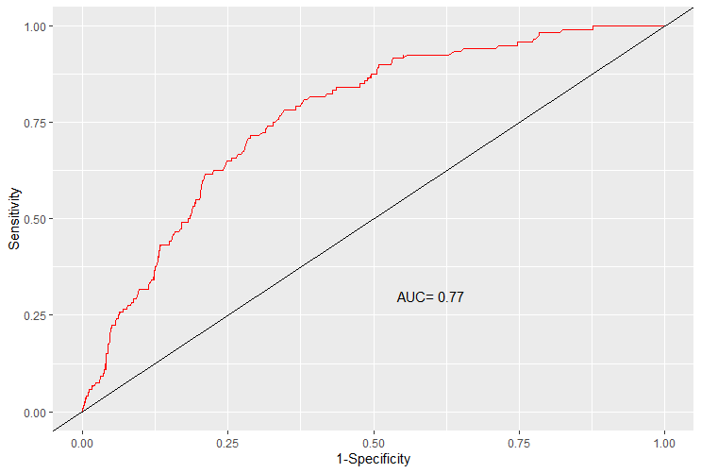
Figure B1. Area under the ROC curve

Appendix C
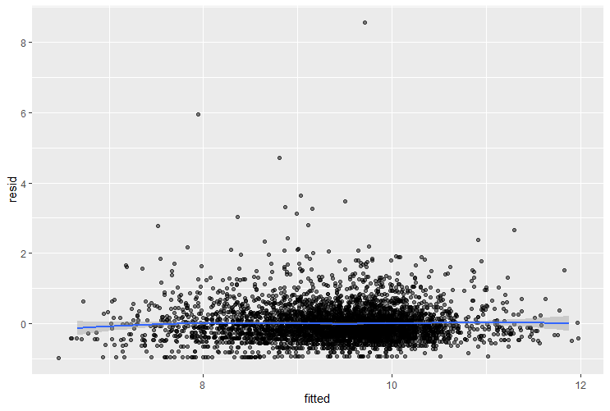
Figure C1. Fitting effect of regression model

Appendix D
Table D1. Occupation of interviewees
Rank | Sample size | Institution/ Individual | Interviewee
1-2 | 2 | Administrative staffs of Wuhan Municipal Health Commission | Directors of the Medical Reform Office of the Health Commission; the person in charge of the medical insurance policy
3-34 | 32 | Directors of the sample hospital | Deans of the sample hospital, deputy deans in charge of medical care, directors of the medical department, directors of the performance office, directors of the quality control office, directors of the medical insurance office, and directors of the financial department
35-51 | 17 | Directors and physicians of clinical department | The Directors and Clinicians of Cardiovascular Medicine; The Directors and Clinicians of Respiratory Medicine; The Directors and Clinicians of Bone Surgery or General Surgery
52-58 | 7 | Experts and scholars in the field of medical insurance or hospital management | Professors working in School of Medicine and Health Management, Huazhong University of Science and Technology

Appendix E
Table E1. Coding reliability testers by the content analysis on the demographic information
Coder number | Sex | Age | Occupation
Coder A | Female | 25 | Graduate student (hospital management)
Coder B | Female | 26 | Graduate student (hospital management)
Coder C | male | 28 | PhD candidate (hospital management)

Appendix F
Table F1. The results of coding reliability test by content analysis
Sample number | 1 | 2 | 3 | 4 | 5 | 6 | 7 | 8 | 9 | 10 | Total
Coder A | 8 | 10 | 4 | 3 | 10 | 12 | 8 | 2 | 7 | 1 | 65
Coder B | 7 | 10 | 4 | 5 | 9 | 11 | 7 | 2 | 6 | 1 | 62
Coder C | 5 | 12 | 4 | 4 | 6 | 11 | 6 | 2 | 6 | 1 | 57
Number of consistent codes
A and B | 6 | 7 | 4 | 2 | 7 | 10 | 5 | 2 | 5 | 1 | 49
A and C | 5 | 9 | 4 | 2 | 6 | 10 | 5 | 1 | 5 | 1 | 47
B and C | 5 | 9 | 4 | 4 | 5 | 11 | 6 | 1 | 5 | 1 | 50

Appendix G
Table G1. Categories and indicators of influencing factors on hospital quality under GBP
Primary classification | Secondary classification | Serial number | Tertiary  classification | Encoding quantification (whether it is the main factor)
Healthcare purchasers and regulators | GBP implementation plan | 1 | Accounting and allocation of quotas | 1 Yes； 2 No
 |  | 2 | Payment and settlement of quotas | 1 Yes； 2 No
 | Medical insurance management | 3 | Regulatory standards for medical insurance | 1 Yes； 2 No
 |  | 4 | Feedback on assessment results | 1 Yes； 2 No
 |  | 5 | The professionalism of medical insurance management personnel | 1 Yes； 2 No
Healthcare Provider | Hospital strategic decision | 6 | Hospital development strategy | 1 Yes； 2 No
 |  | 7 | Actual development of the hospital | 1 Yes； 2 No
 |  | 8 | Hospital leaders’ attitudes and decisions to GBP | 1 Yes； 2 No
 |  | 9 | Hospital performance programs | 1 Yes； 2 No
 | Quality Control | 10 | Supervision of quality of healthcare | 1 Yes； 2 No
 |  | 11 | Implementation of the core system in healthcare quality system | 1 Yes； 2 No
 |  | 12 | Medical technology normative | 1 Yes； 2 No
 |  | 13 | Implementation of clinical pathway or single disease quality management | 1 Yes； 2 No
 | Medical Cost Control | 14 | Cost structure adjustment (medicine ratio, consumable ratio, etc.) | 1 Yes； 2 No
 |  | 15 | Medical cost control requirements for departments or physicians | 1 Yes； 2 No
 | Other internal factors of hospital | 16 | Diagnosis and treatment technology level | 1 Yes； 2 No
 |  | 17 | Resource allocation of personnel, equipment, drugs, etc. | 1 Yes； 2 No
 |  | 18 | Management ability of department director | 1 Yes； 2 No
 |  | 19 | Hospital culture | 1 Yes； 2 No
 |  | 20 | Information system | 1 Yes； 2 No
Recipient of Medical Services | Characteristic factors of the insured | 21 | Condition of Patients | 1 Yes； 2 No
 |  | 22 | Patient financial status | 1 Yes； 2 No
 |  | 23 | Patient compliance | 1 Yes； 2 No
other | Inspection of quality of healthcare | 24 | Health administrative department's inspection | 1 Yes； 2 No

Appendix H
Table H1. The results of the mutual agreement of coding reliability test mutual agreement by content analysis
Mutual agreement | Coder A | Coder B
Coder C | 0.77 | 0.84
Coder B | 0.77

