APPENDIX 2.

ANALYSIS OF TIMELINESS OF CARE IN ED AND IN-HOSPITAL MORTALITY WITH TREND GRAPHS WITH REGRESSION AND ESTIMATED MODELS.
TABLE OF CONTENTS

APPENDIX 2. 1
ANALYSIS OF TIMELINESS OF CARE IN ED AND IN-HOSPITAL MORTALITY WITH TREND GRAPHS WITH REGRESSION AND ESTIMATED MODELS. 1
Figure 1S. Characteristics of hospital triage before and after the implementation of the Ministry of Health policy 5
Figure 2S. Timeliness of care in the ED, in general, in patients with ischemic stroke 5
Figure 3S. In-hospital mortality of patients with ischemic stroke 8
Figure 4S: Proportion of patients attended at different levels of triage per month 10
Figure 5S. Proportion of patients with ischemic strokes thrombolized with rTPA per month 10
Figure 6S. Timeliness of care in the ED in stroke patients classified as Triage I and II 12
Figure 7S. Timeliness of care in the ED in patients with contributory insurance 14
Figure 9S. Timeliness of care in ED for patients over 65 years of age 16
Figure 10S. Timeliness of care in ED for patients younger than 65 years of age 17
Figure 11S. Timeliness of care in ED for female patients with ischemic stroke 18
Figure 12S. Timeliness of care in ED for male patients with ischemic stroke 19
Figure 13S. Timeliness of care in ED for stroke patients seen in the day shift 20
Figure 14S. Timeliness of care in ED for stroke patients seen on the night shift 21
Figure 15S. In-hospital mortality in patients with ischemic stroke and subsidized insurance 22
Figure 16S. Proportion of in-hospital deaths in stroke patients with contributory insurance 24
Figure 17S. In-hospital mortality in female patients with ischemic stroke 25
Figure 18S. In-hospital mortality in male patients with ischemic stroke 26
Figure 19S. In-hospital mortality in patients with ischemic stroke in the day shift 27
Figure 20S. In-hospital mortality in patients with ischemic stroke on the night shift 29
Figure 21S. In-hospital mortality in patients with ischemic stroke, Triage I-II 30
Figure 22S. In-hospital mortality in patients with ischemic stroke, Triage III, IV and V 31
Figure 23S. In-hospital mortality in patients with ischemic stroke older than 65 years of age 32
Figure 24S. In-hospital mortality in patients with ischemic stroke, younger than 65 years of age 34
CORRELOGRAMS FOR ANALYSIS 35
Figure 3.1S. Timeliness of care in ED for patients with stroke 35
Figure 3.2S. Timeliness of care in ED for patients evaluated in less than 30 minutes 37
37
Figure 3.3S. In-hospital mortality in patients with ischemic stroke 38
Figure 3.4S. Timeliness of care in ED for patient with ischemic stroke with contributory insurance 39
Figure 3.5S. Timeliness of care in ED for patients with subsidized insurance 40
Figure 3.6S. Timeliness of care in ED for patients over 65 years of age 41
Figure 3.7S. Timeliness of care in ED for patients younger than 65 years of age 42
Figure 3.8S. Timeliness of care in ED for female patients with ischemic stroke 43
Figure 3.9S. Timeliness of care in ED for male patients with ischemic stroke 44
Figure 3.10S. Timeliness of care in ED for stroke patients seen in the day shift 45
Figure 3.11S. Timeliness of care in ED for stroke patients seen on the night shift 46
Figure 3.12S. Timeliness of care in ED for patients with stroke, Triage I and II 47
Figure 3.13S. In-hospital mortality in patients with ischemic stroke and subsidized insurance 48
Figure 3.14S. Proportion of in-hospital deaths in stroke patients with contributory insurance 49
Figure 3.15S. In-hospital mortality in female patients with ischemic stroke 50
Figure 3.16S. In-hospital mortality in male patients with ischemic stroke 51
Figure 3.17S. In-hospital mortality in patients with ischemic stroke in the day shift 52
Figure 3.18S. In-hospital mortality in patients with ischemic stroke on the night shift 53
Figure 3.19S. In-hospital mortality in patients with ischemic stroke, Triage I-II 54
Figure 3.20S. In-hospital mortality in patients with ischemic stroke, Triage III, IV and V 55
Figure 3.21S. In-hospital mortality in patients with ischemic stroke older than 65 years of age 56
Figure 3.22S. In-hospital mortality in patients with ischemic stroke younger than 65 years of age 57
INTERACTION AND CONFUSION 58
Timeliness 58
Death 59

Figure 1S. Characteristics of hospital triage before and after the implementation of the Ministry of Health policy
2017
2016
2011

Figure 2S. Timeliness of care in the ED, in general, in patients with ischemic stroke
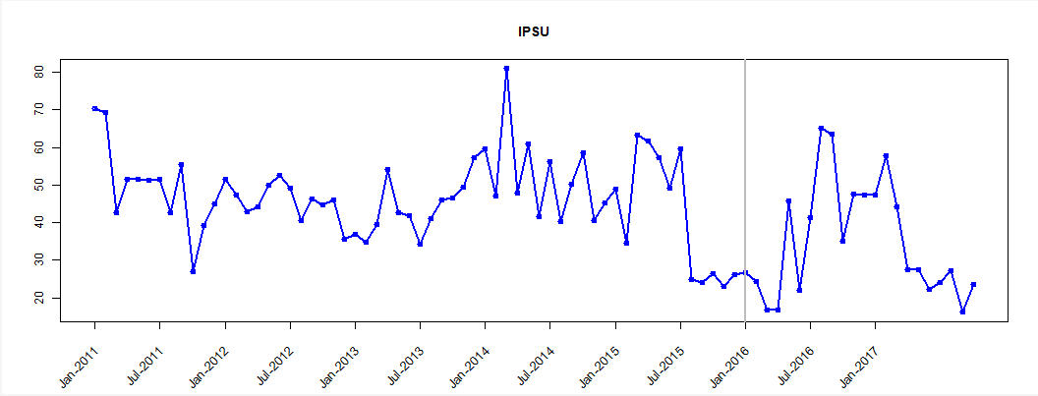

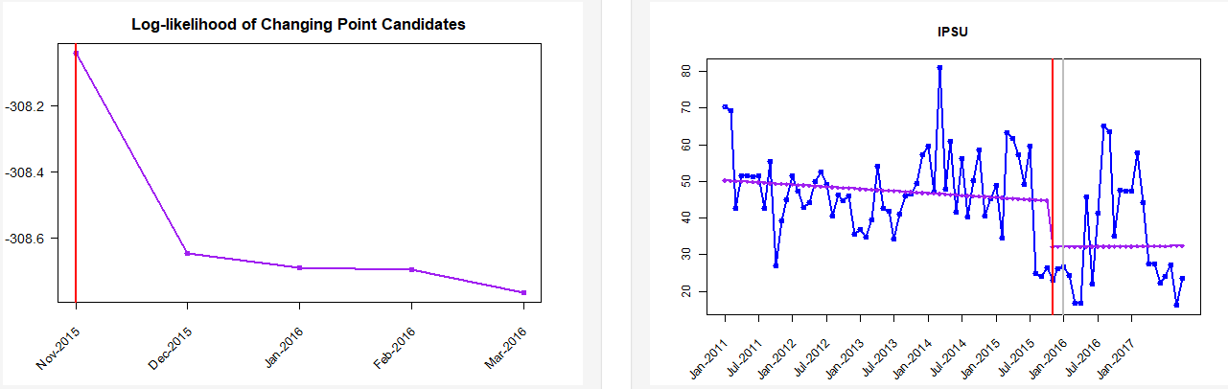
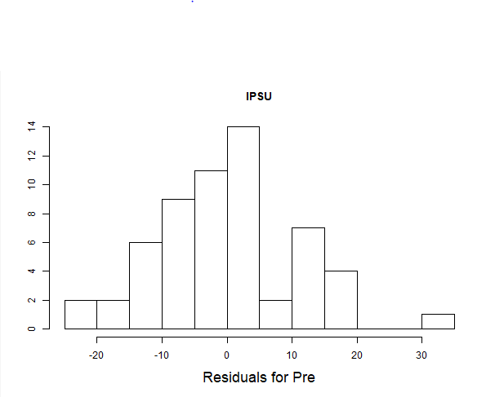
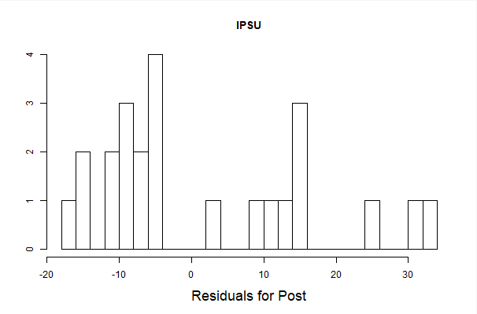
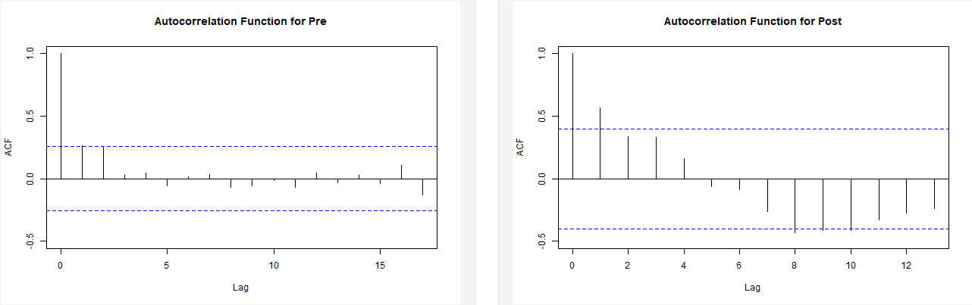
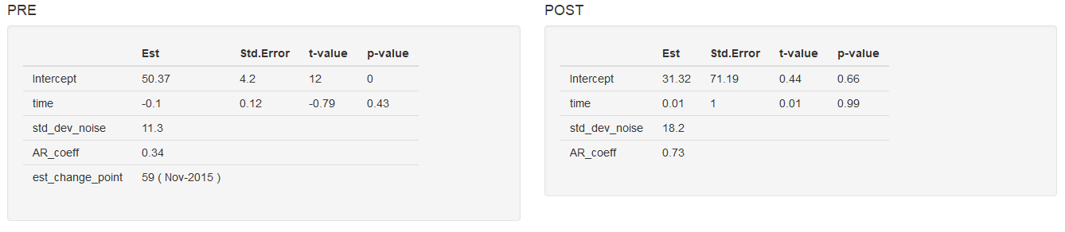
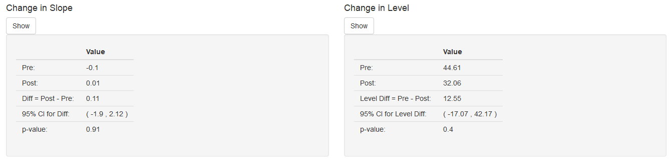
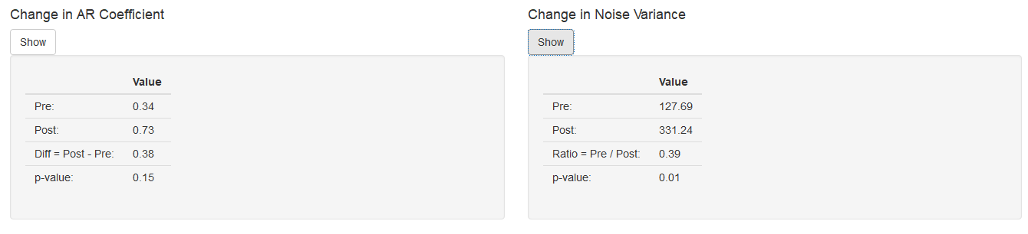
Figure 3S. In-hospital mortality of patients with ischemic stroke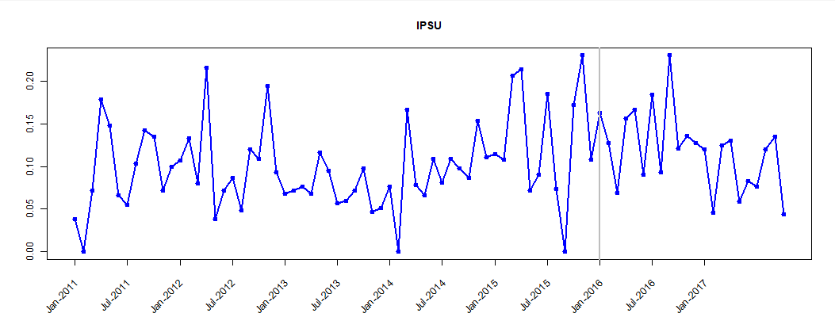
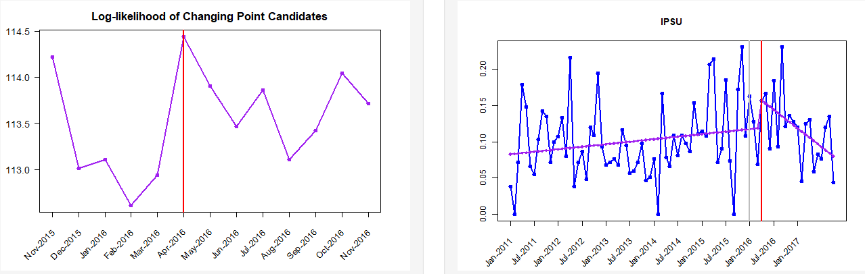
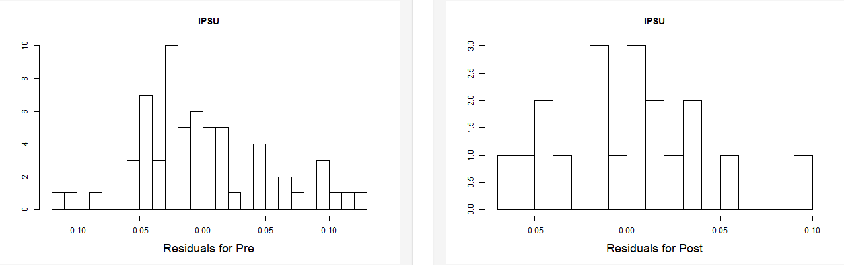
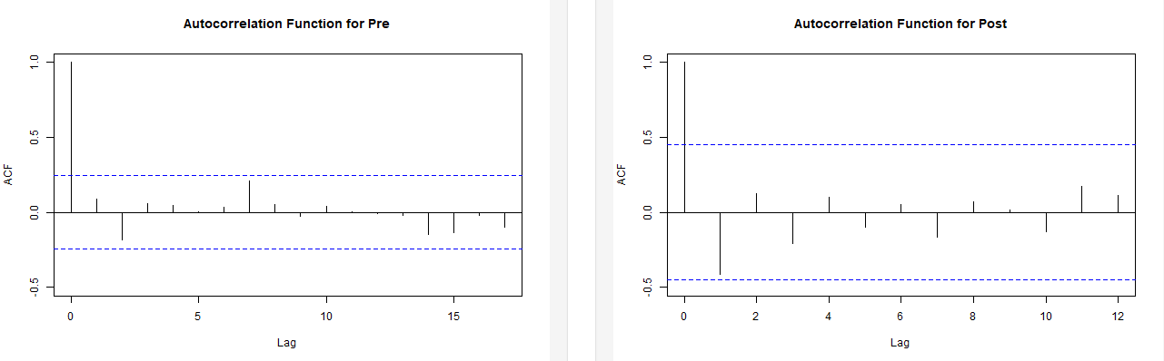
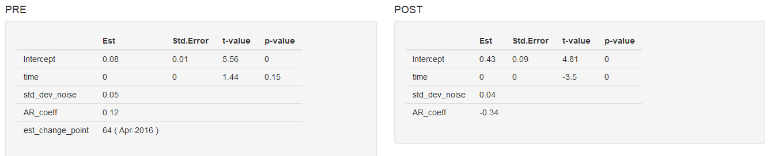
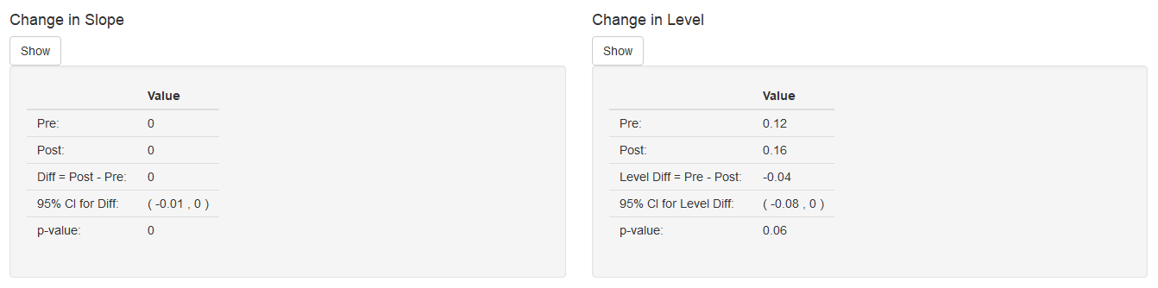
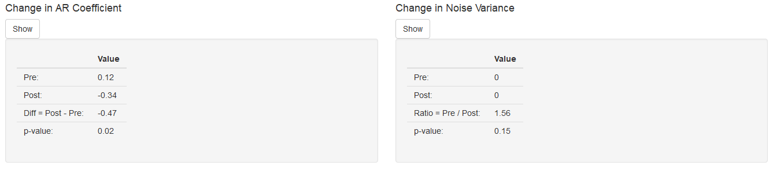

Figure 4S: Proportion of patients attended at different levels of triage per month
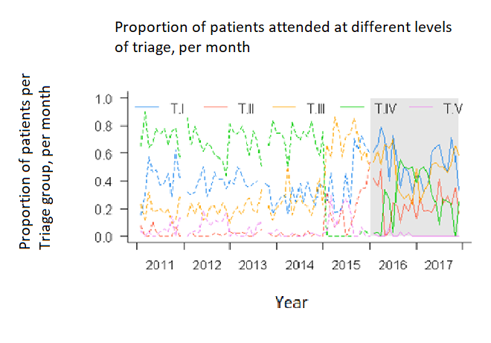
T = Triage categories

Figure 5S. Proportion of patients with ischemic strokes thrombolized with rTPA per month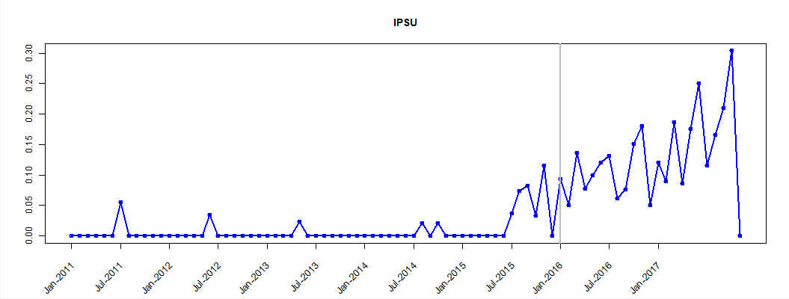
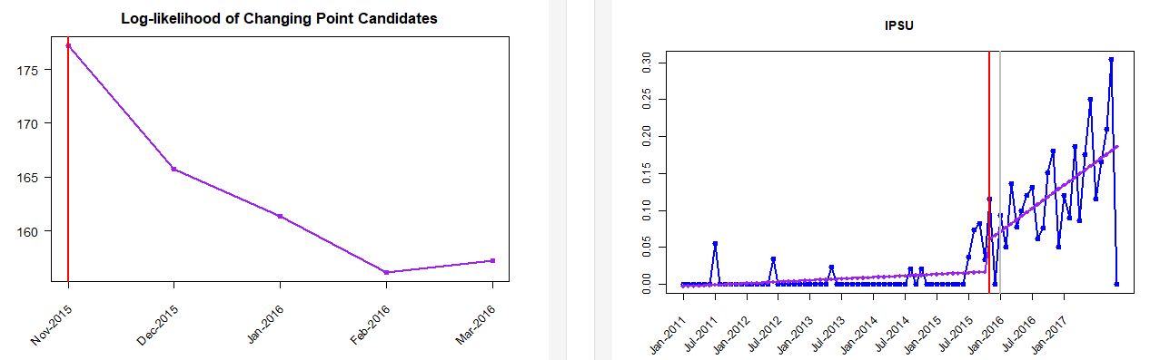
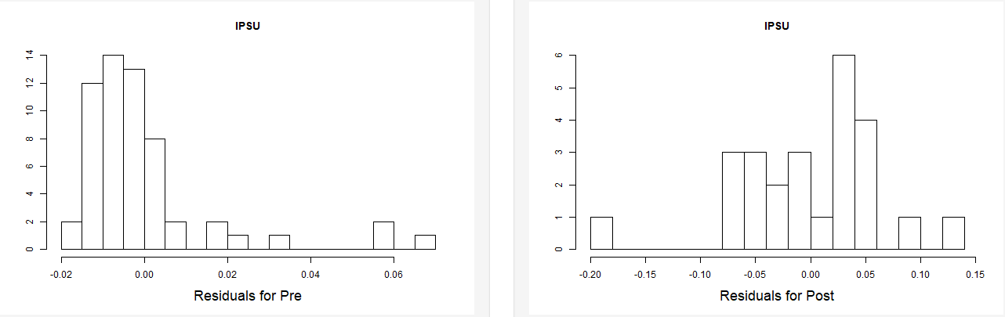
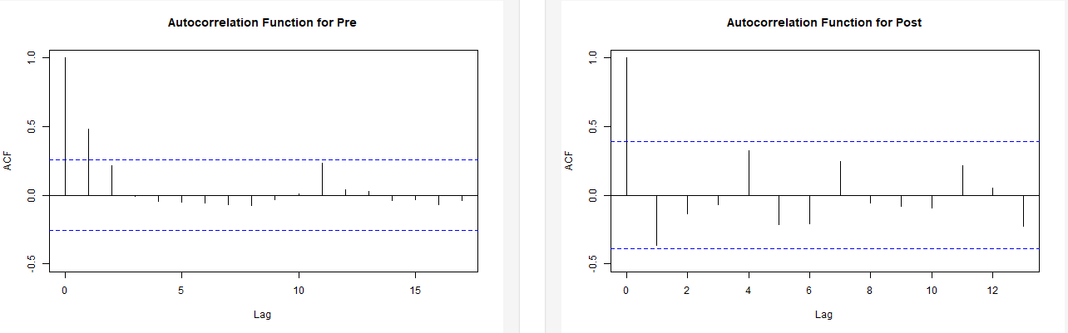
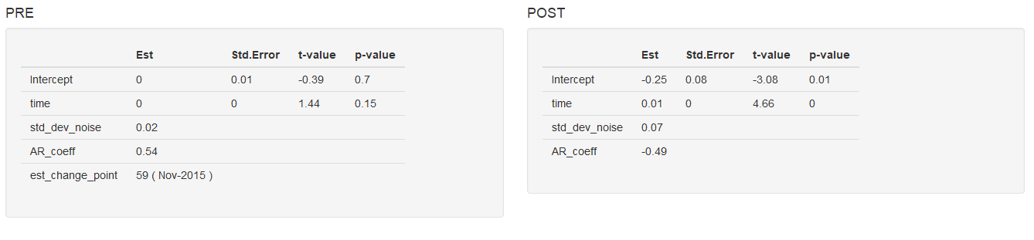
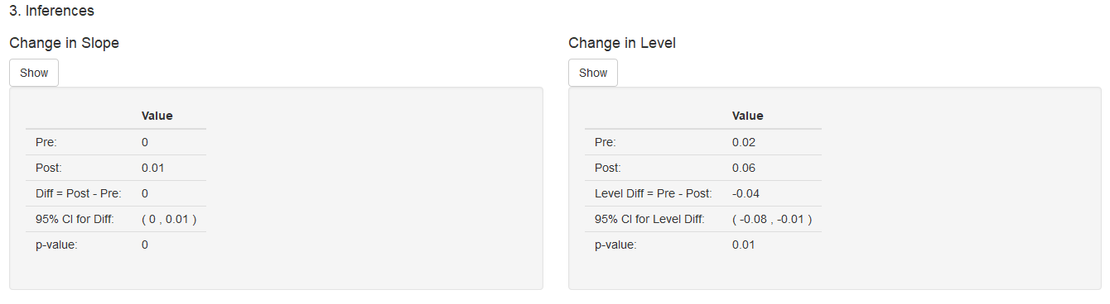
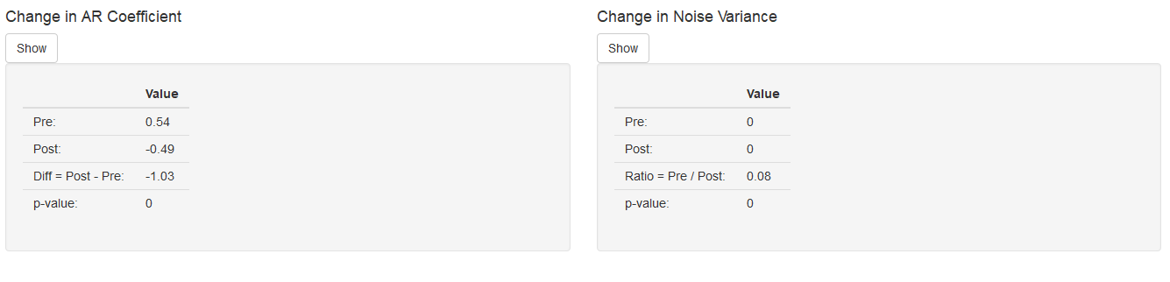

Figure 6S. Timeliness of care in the ED in stroke patients classified as Triage I and II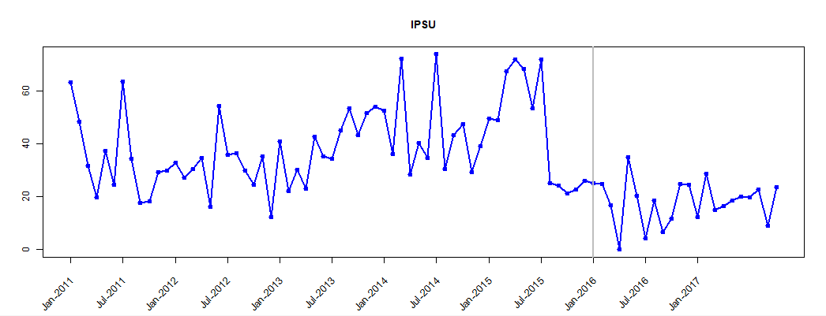
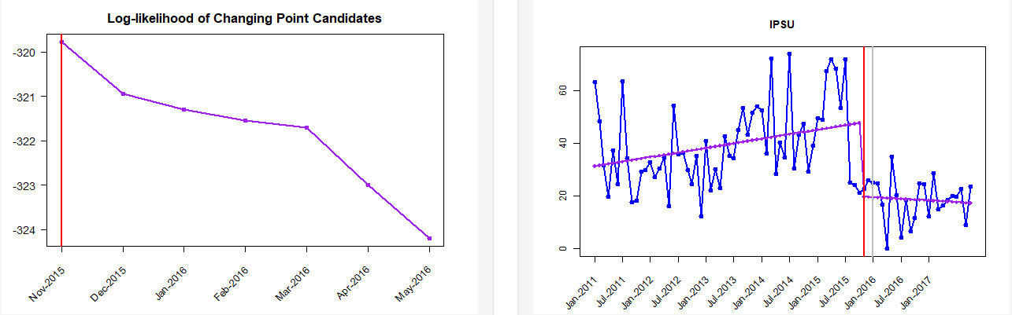

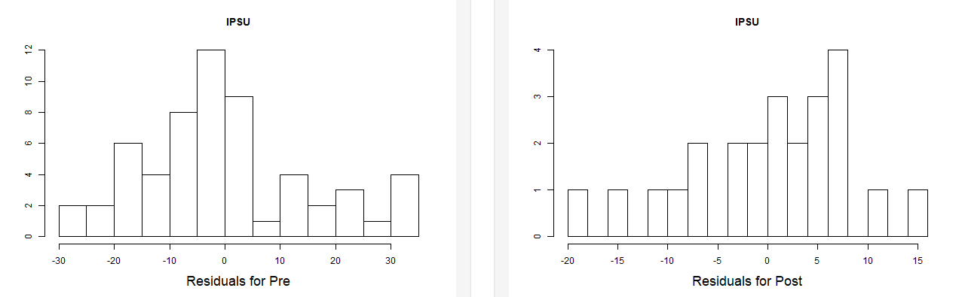
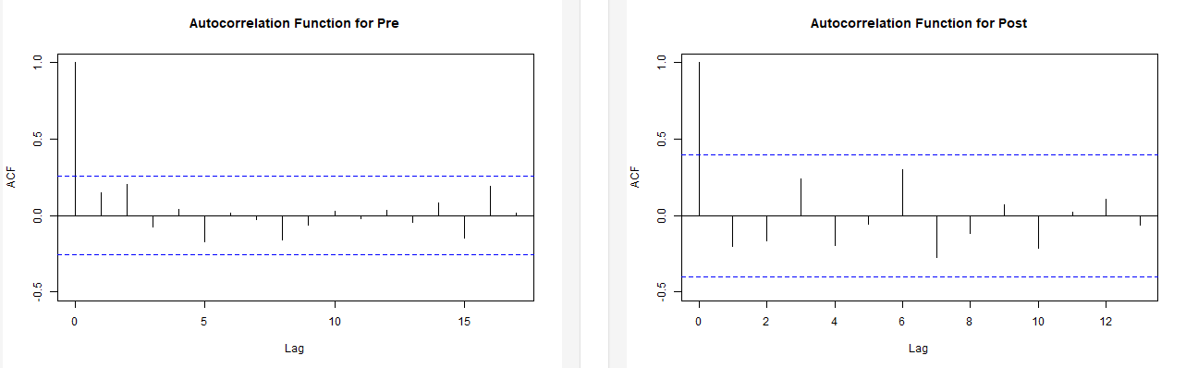
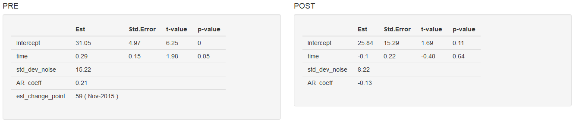
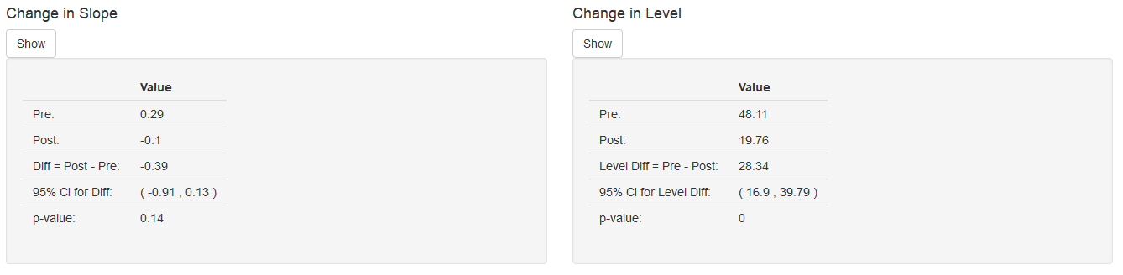
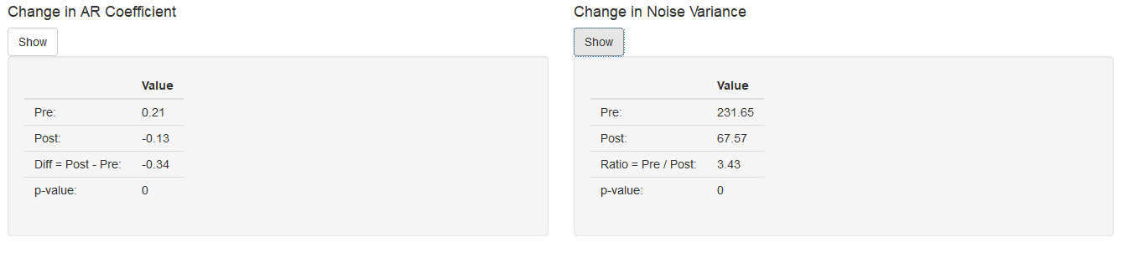

Figure 7S. Timeliness of care in the ED in patients with contributory insurance
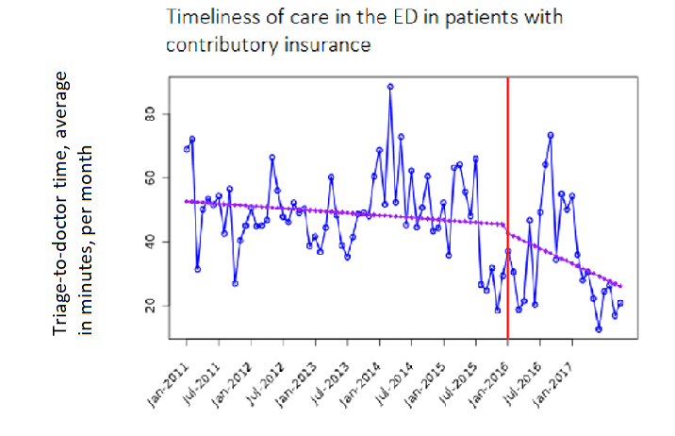
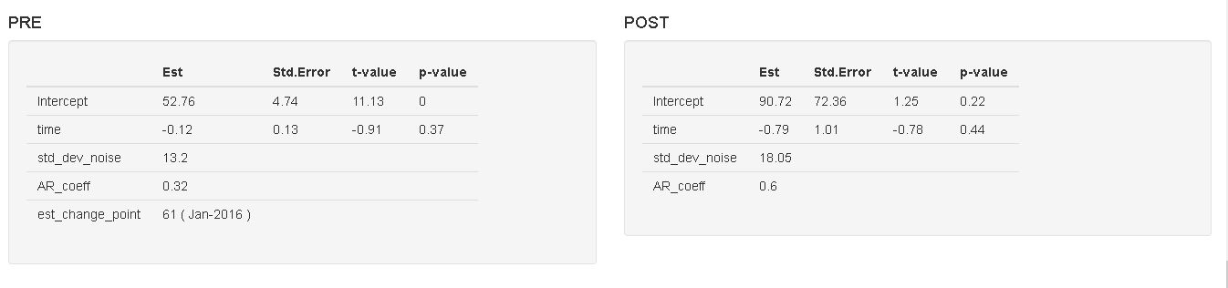
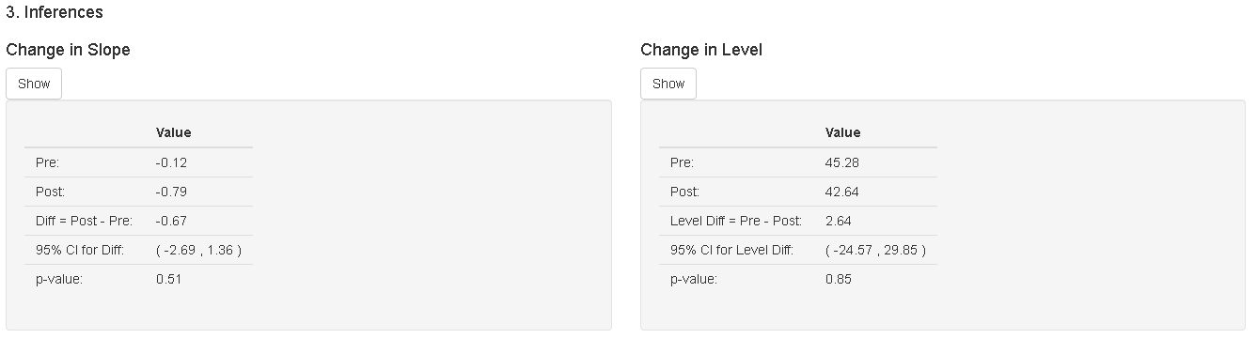
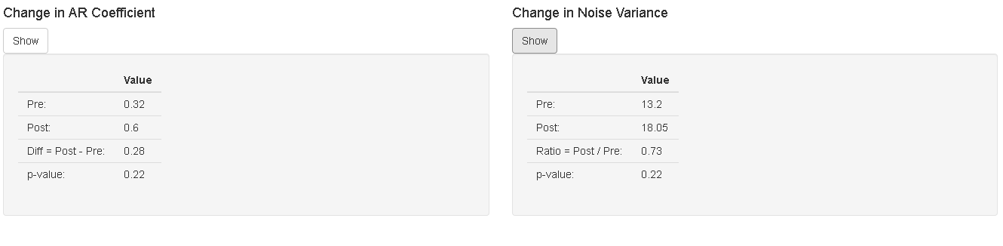Figure 8S. Timeliness of care in ED in patients with subsidized insurance

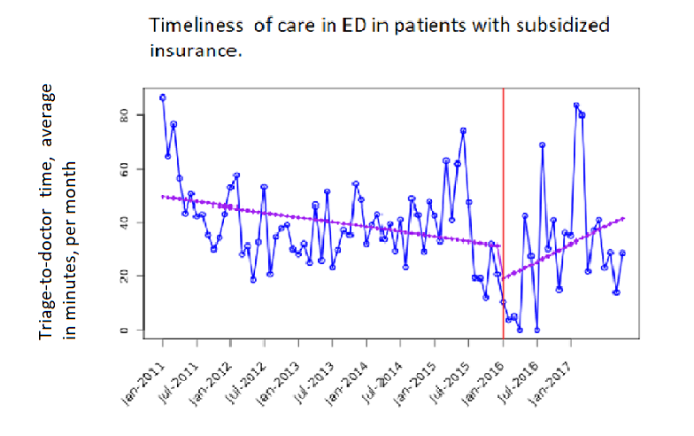
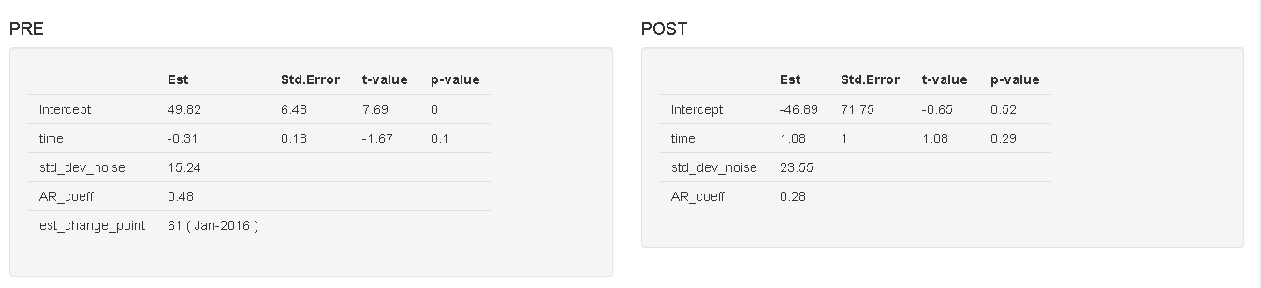
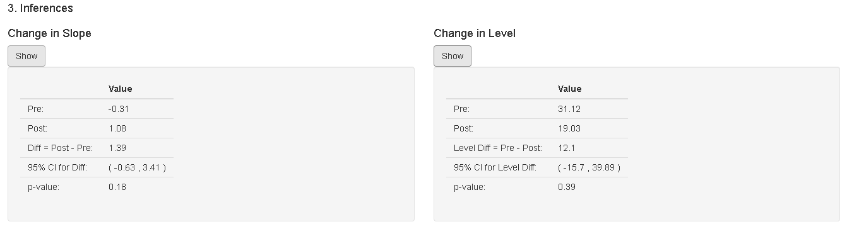
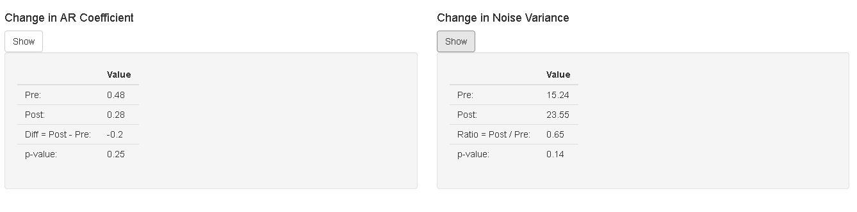

Figure 9S. Timeliness of care in ED for patients over 65 years of age

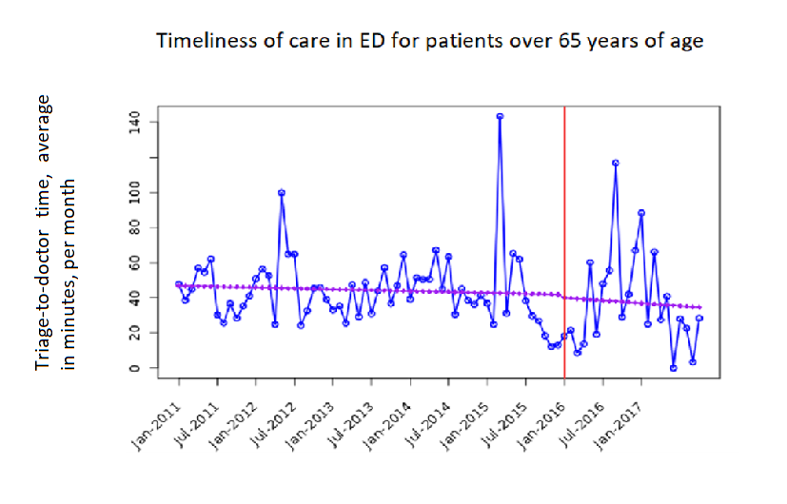
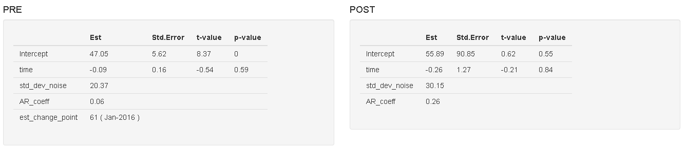
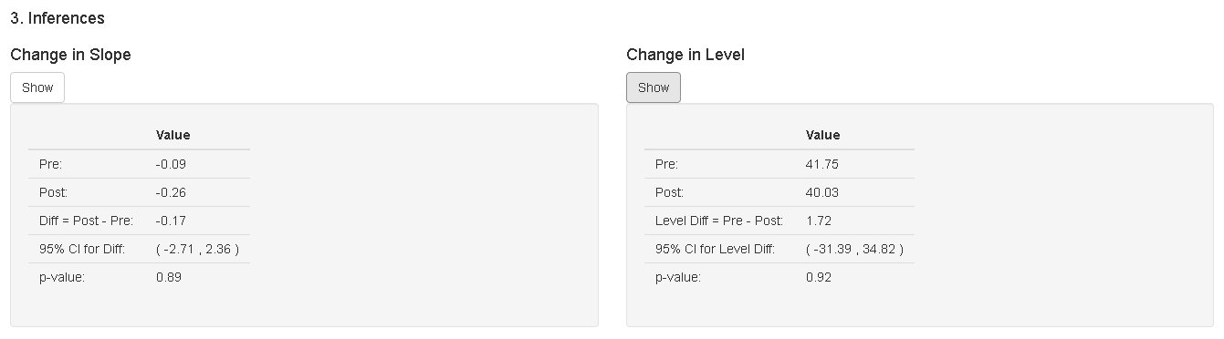
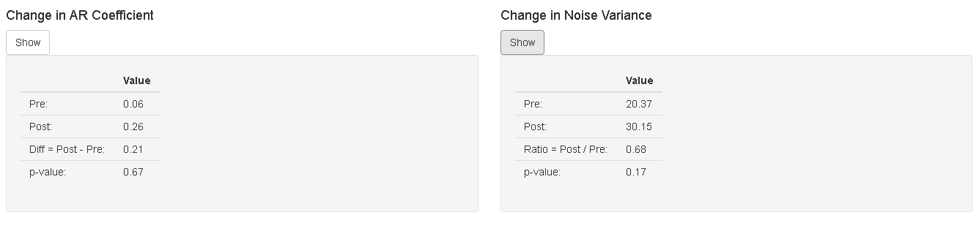

Figure 10S. Timeliness of care in ED for patients younger than 65 years of age
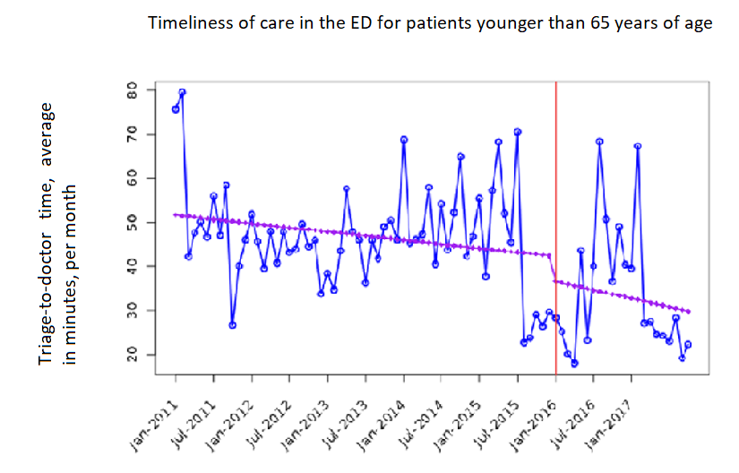
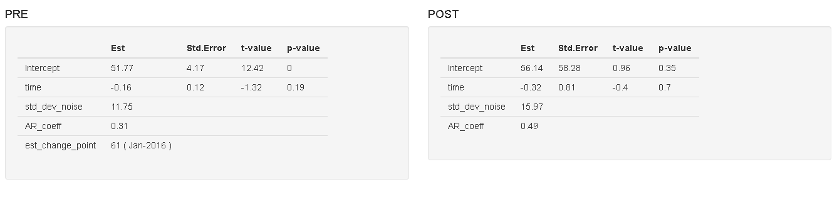
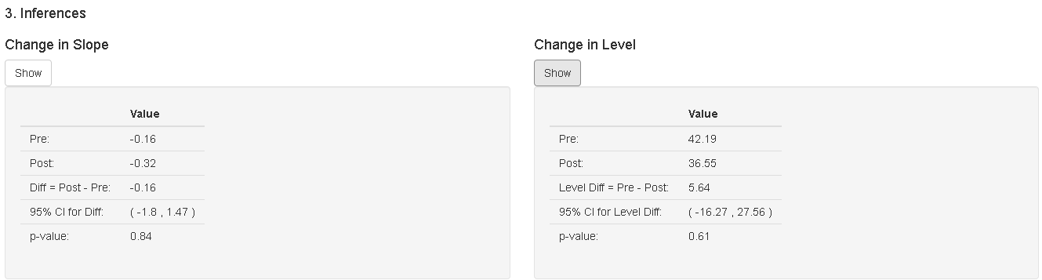
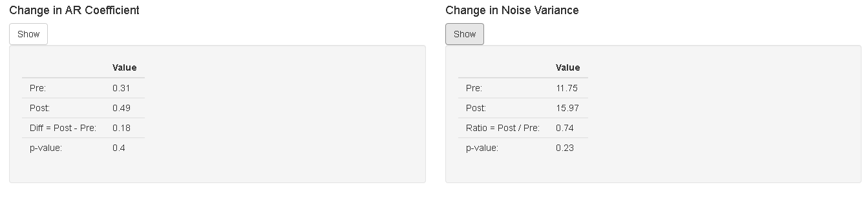

Figure 11S. Timeliness of care in ED for female patients with ischemic stroke

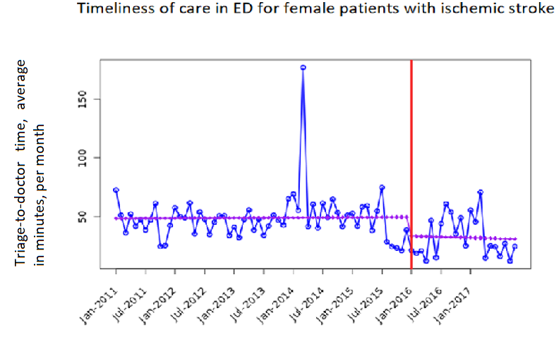
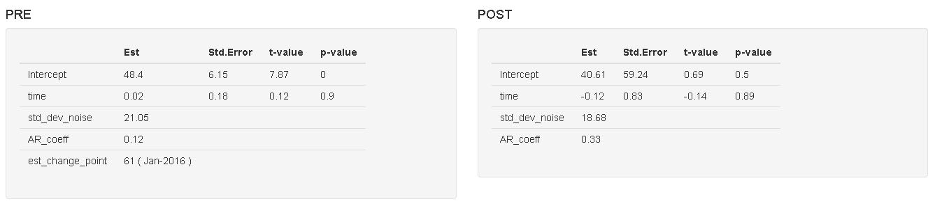
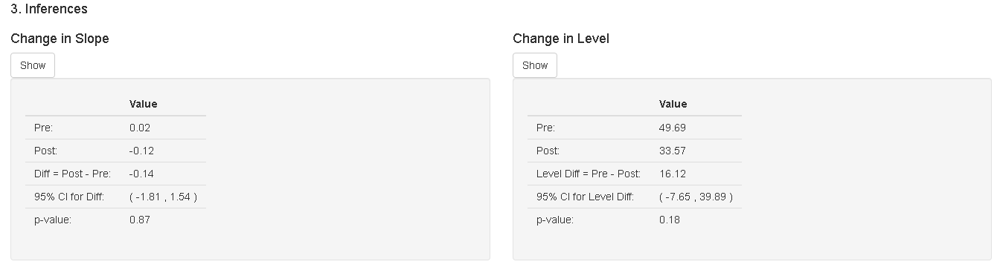
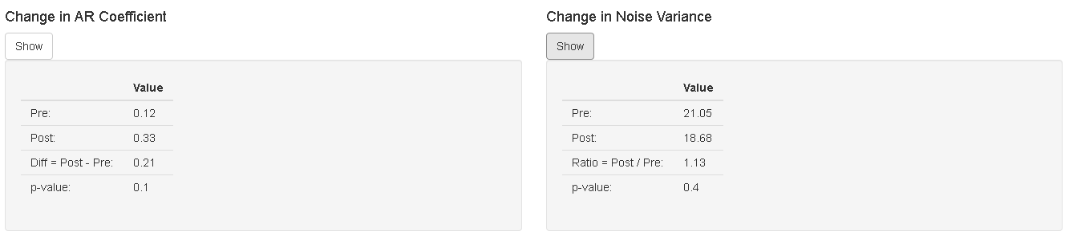

Figure 12S. Timeliness of care in ED for male patients with ischemic stroke

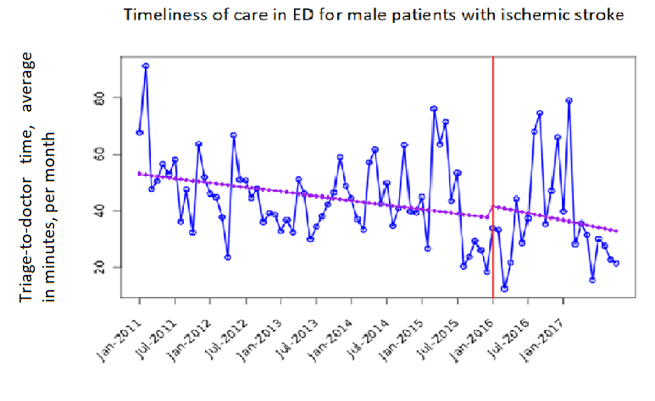
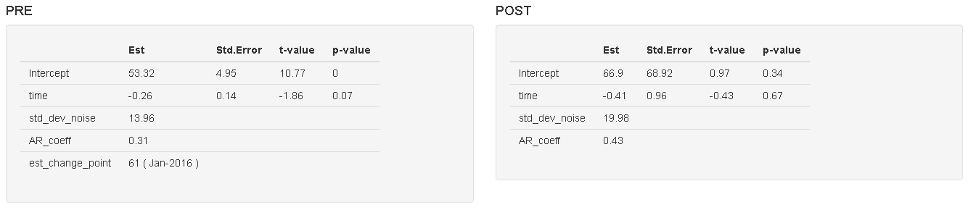
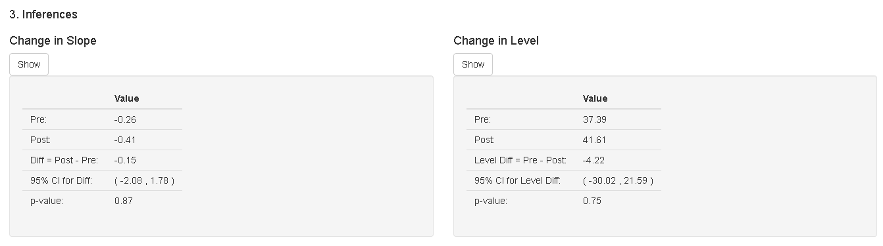
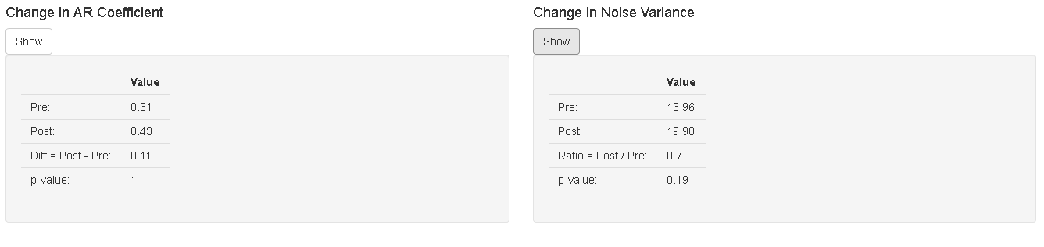

Figure 13S. Timeliness of care in ED for stroke patients seen in the day shift

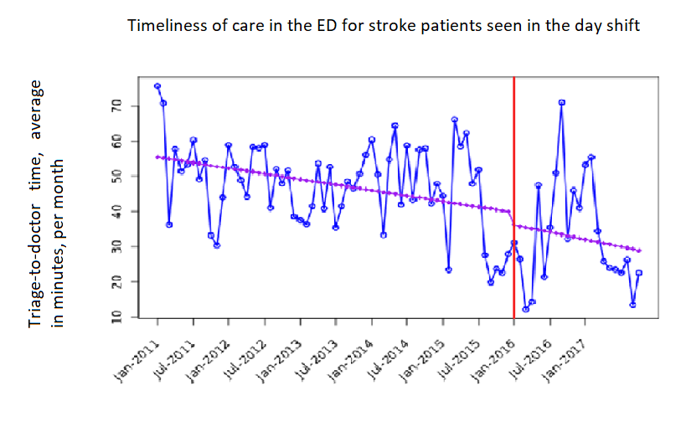
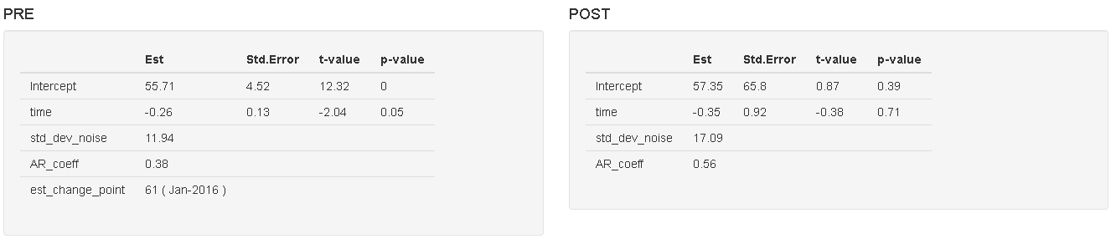
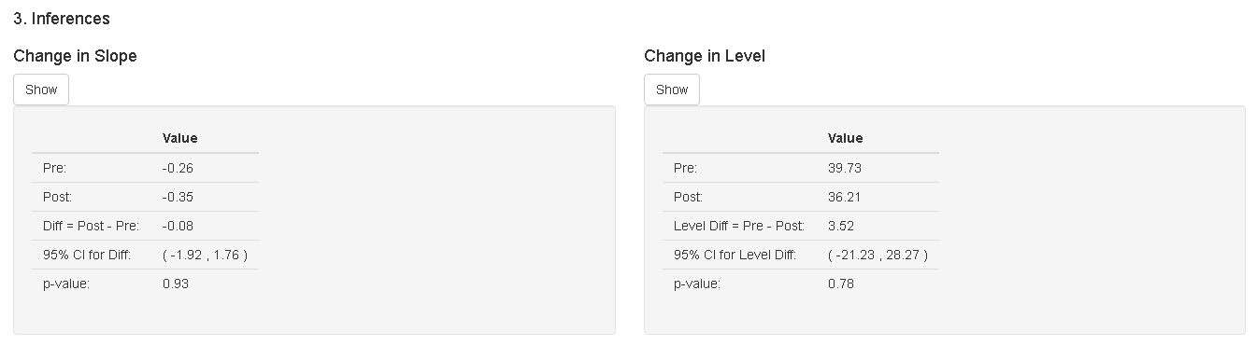
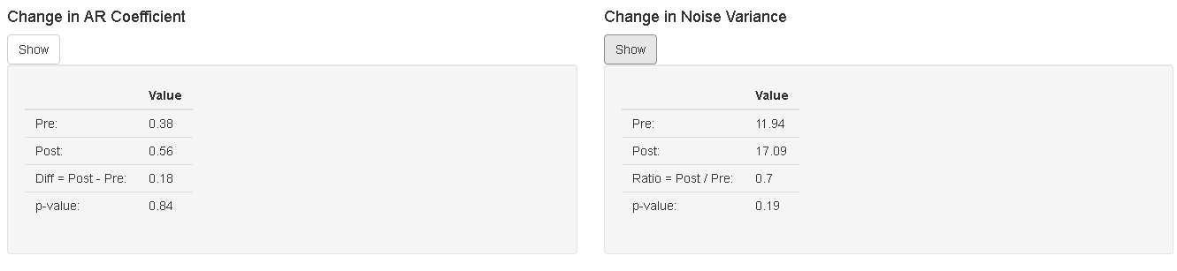

Figure 14S. Timeliness of care in ED for stroke patients seen on the night shift

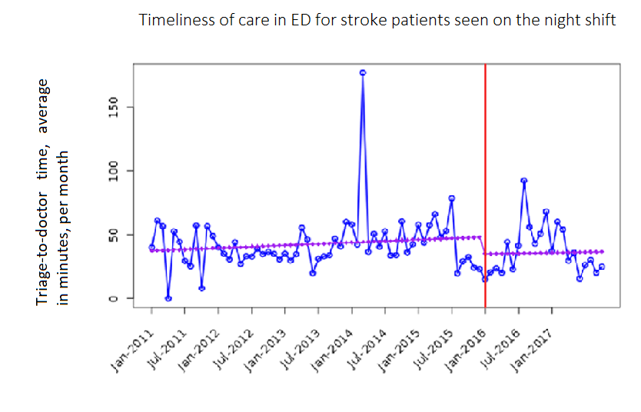
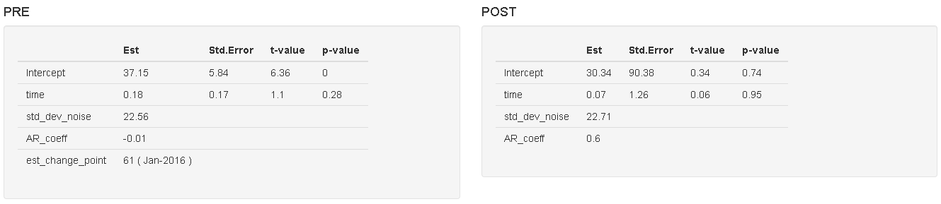
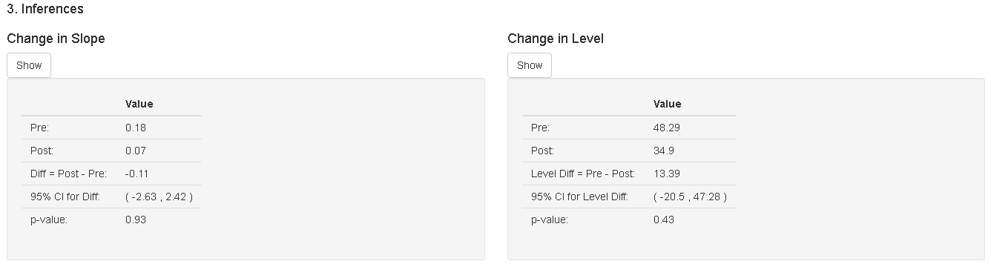
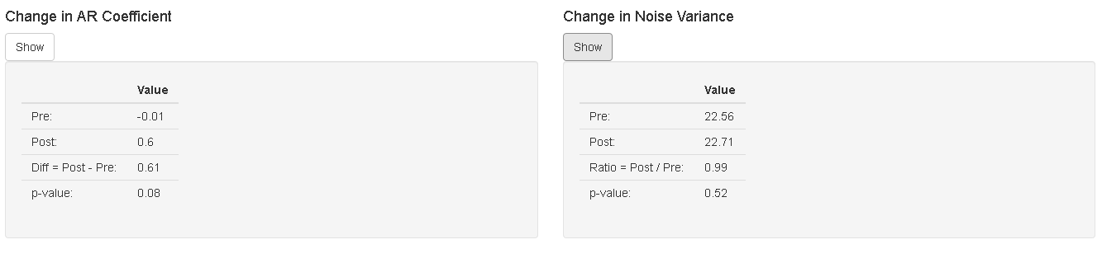

Figure 15S. In-hospital mortality in patients with ischemic stroke and subsidized insurance

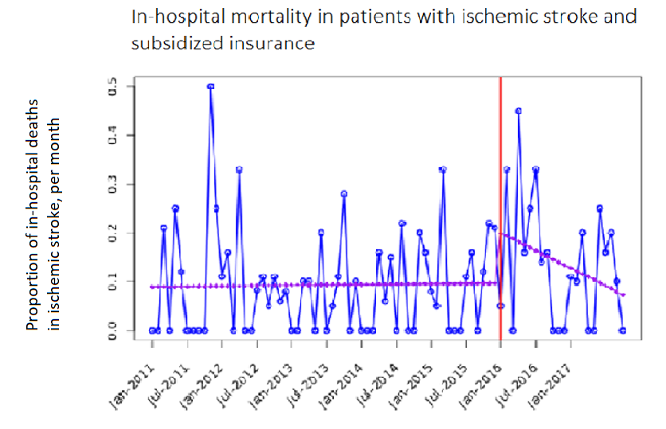
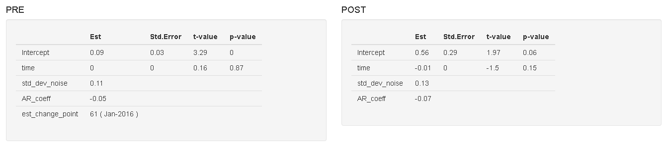
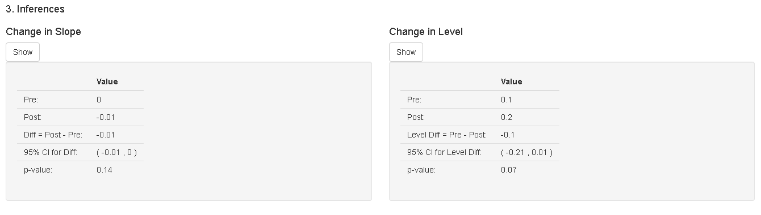
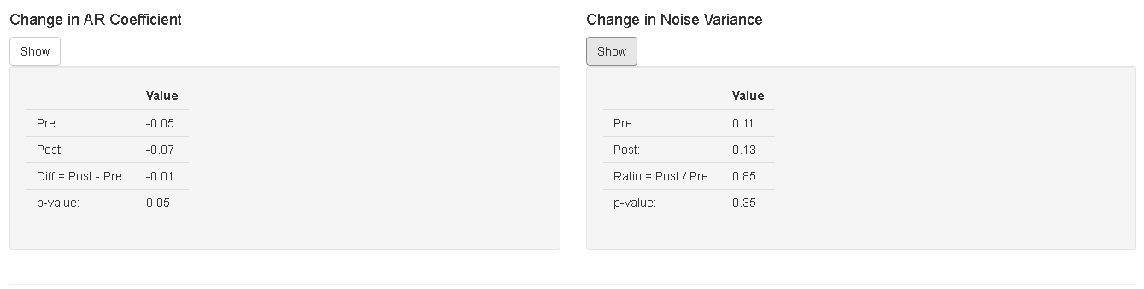

Figure 16S. Proportion of in-hospital deaths in stroke patients with contributory insurance

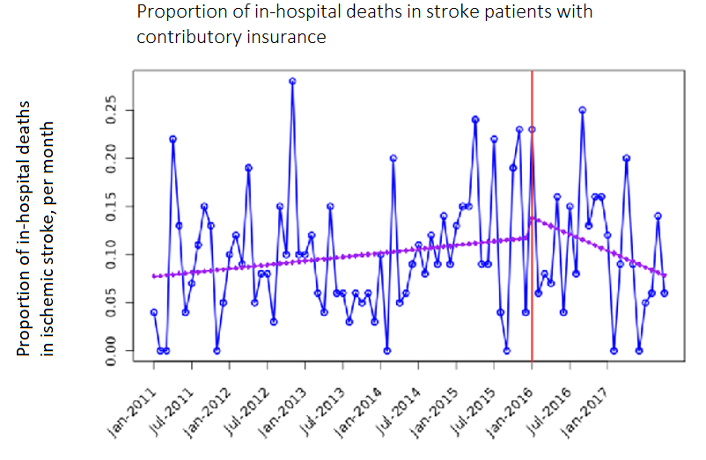
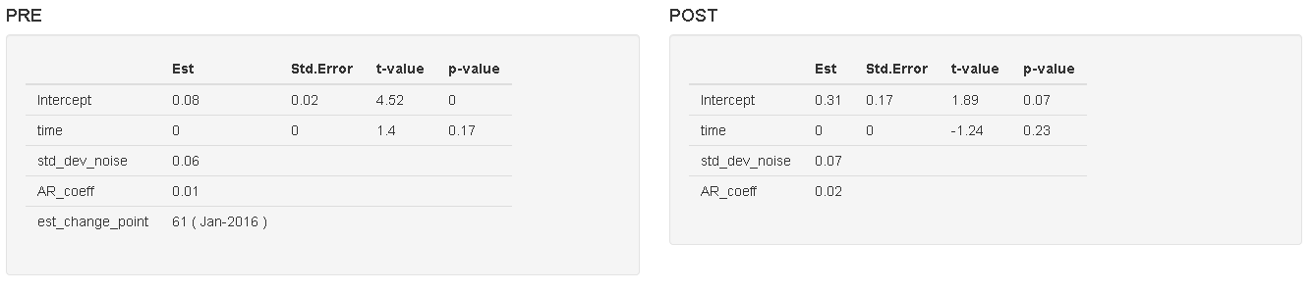
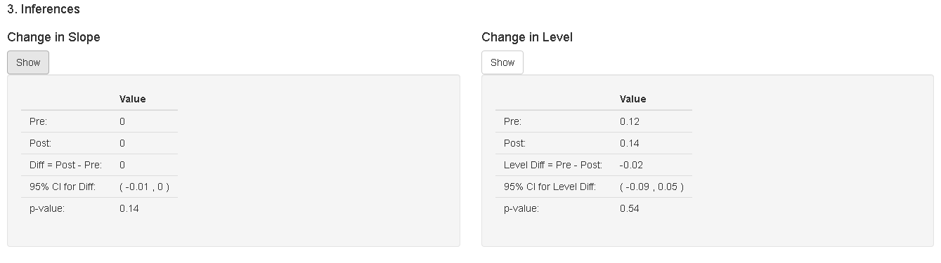
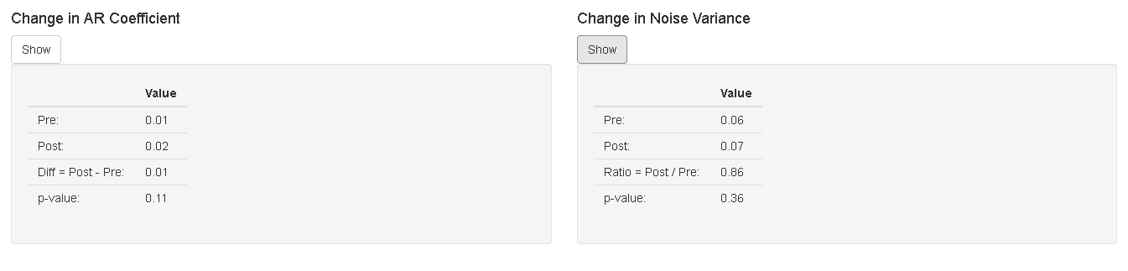

Figure 17S. In-hospital mortality in female patients with ischemic stroke

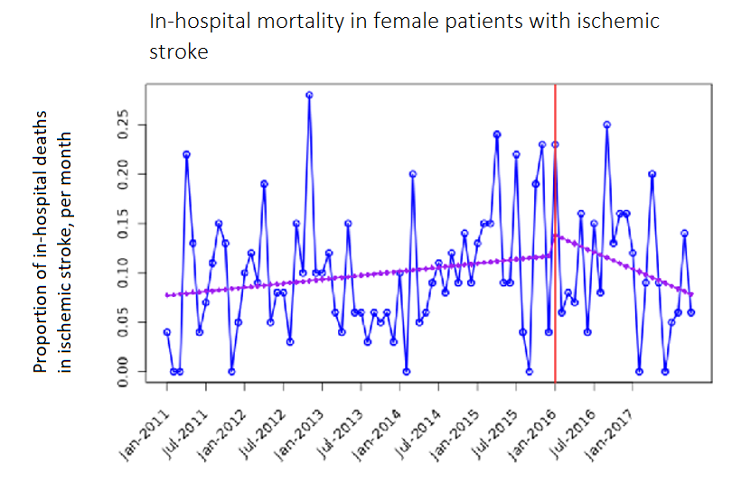
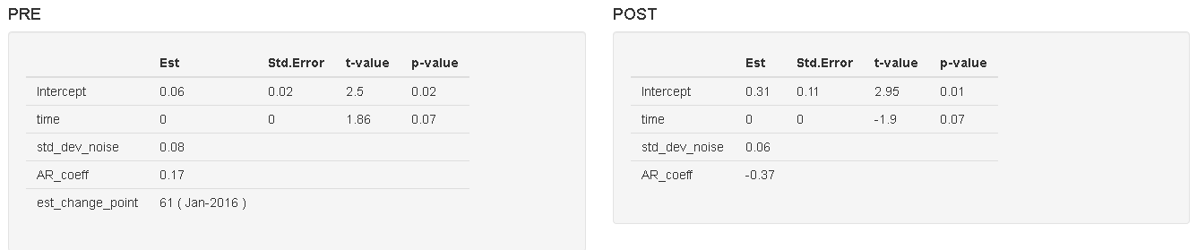
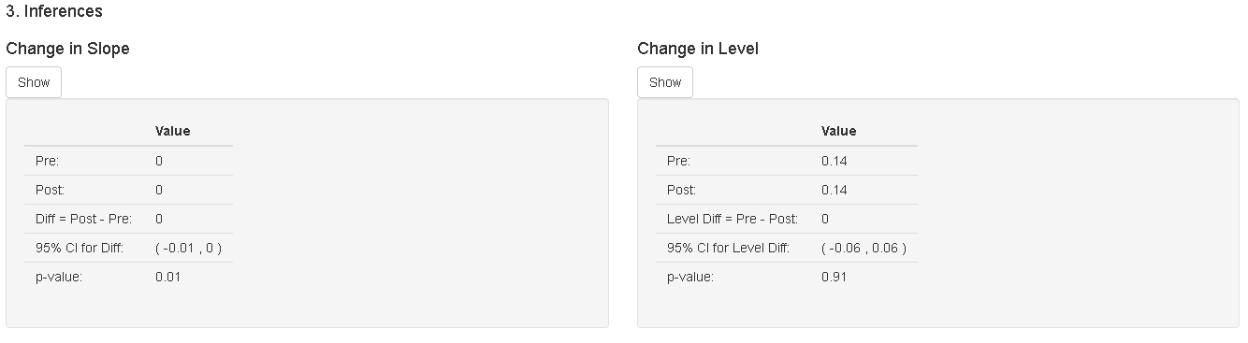
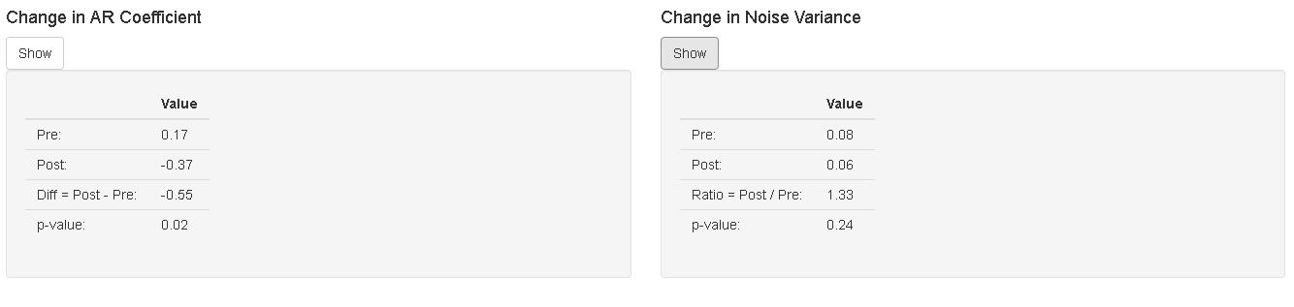

Figure 18S. In-hospital mortality in male patients with ischemic stroke

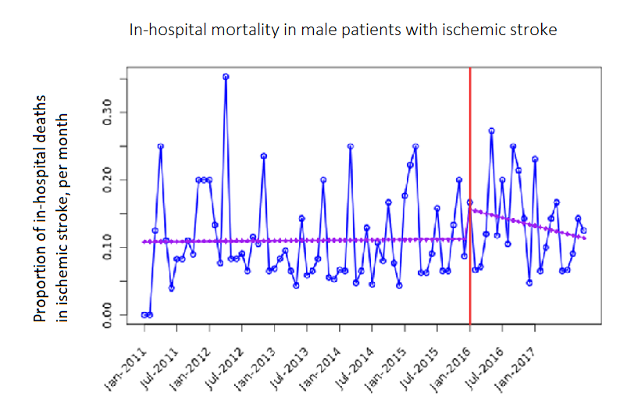
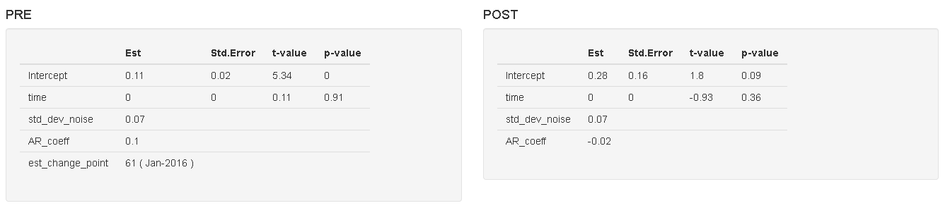
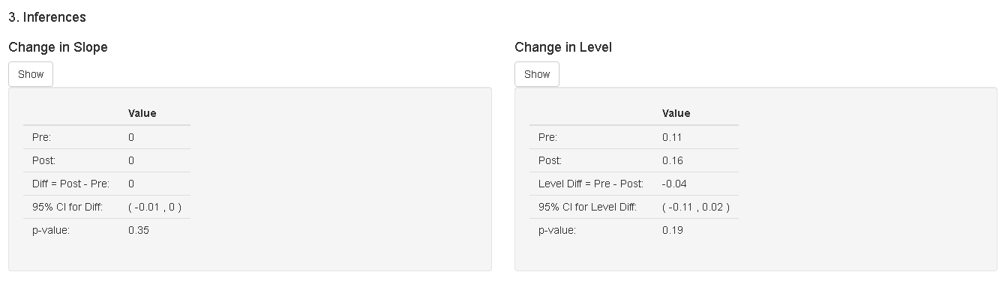
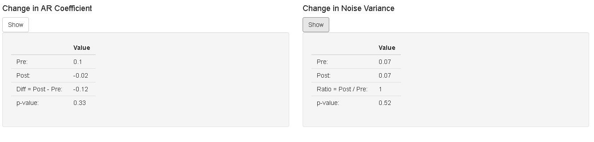

Figure 19S. In-hospital mortality in patients with ischemic stroke in the day shift

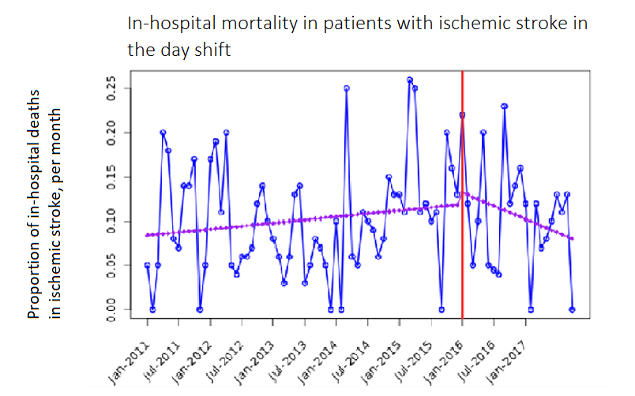
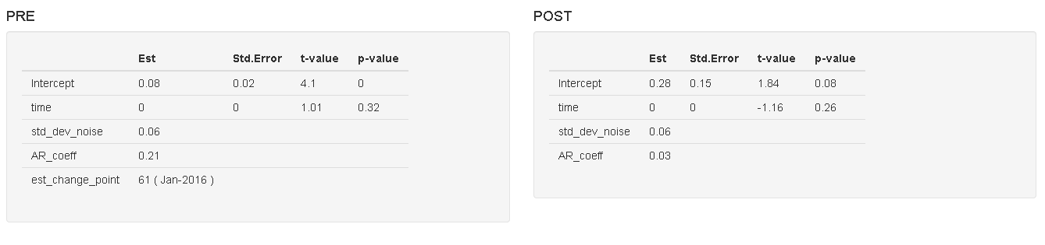
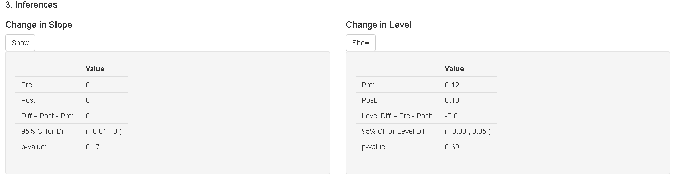
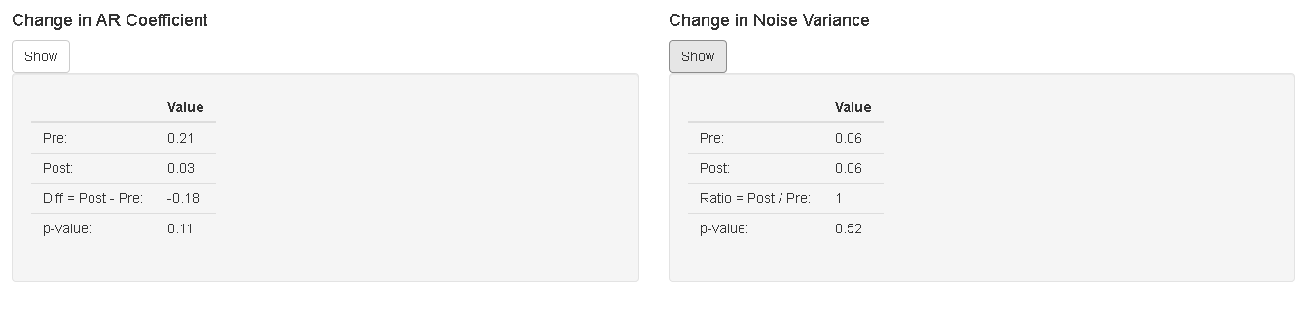

Figure 20S. In-hospital mortality in patients with ischemic stroke on the night shift

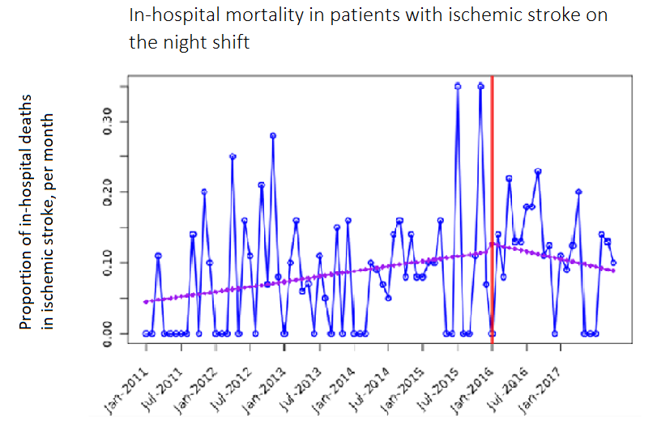
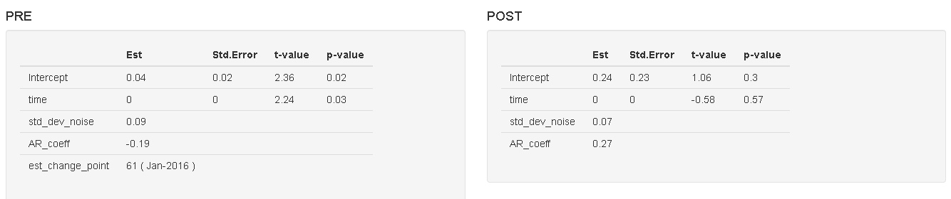
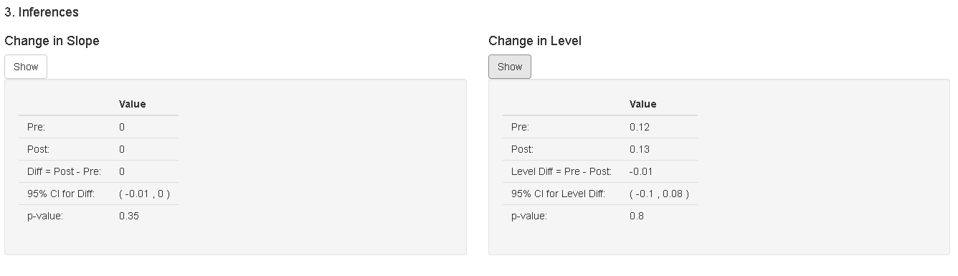
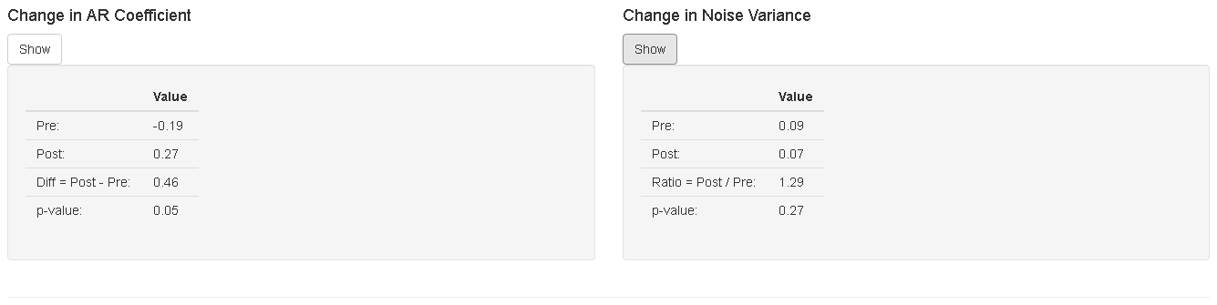

Figure 21S. In-hospital mortality in patients with ischemic stroke, Triage I-II

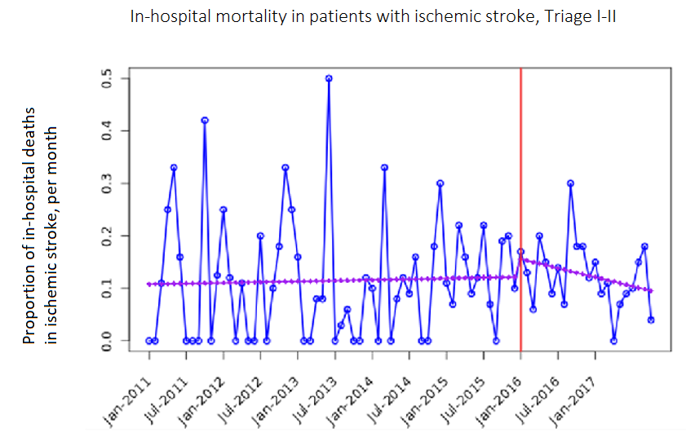
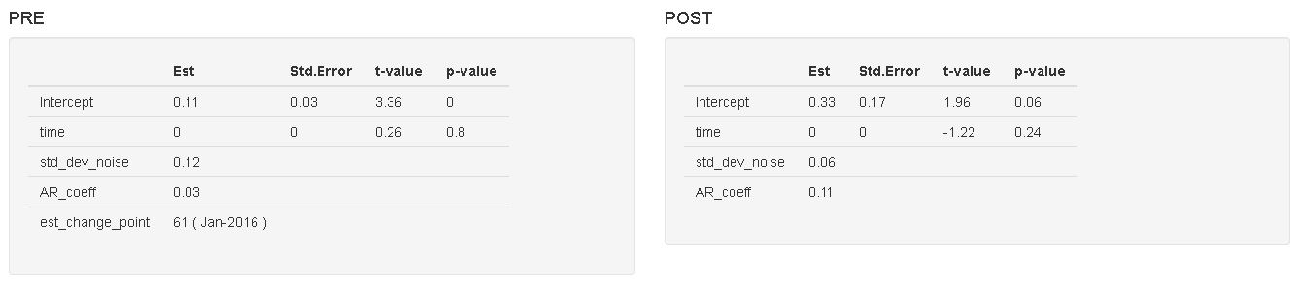
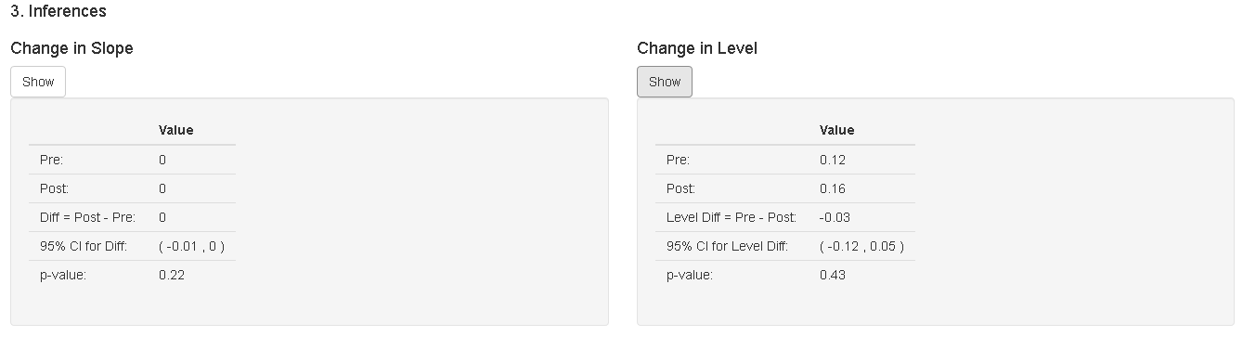
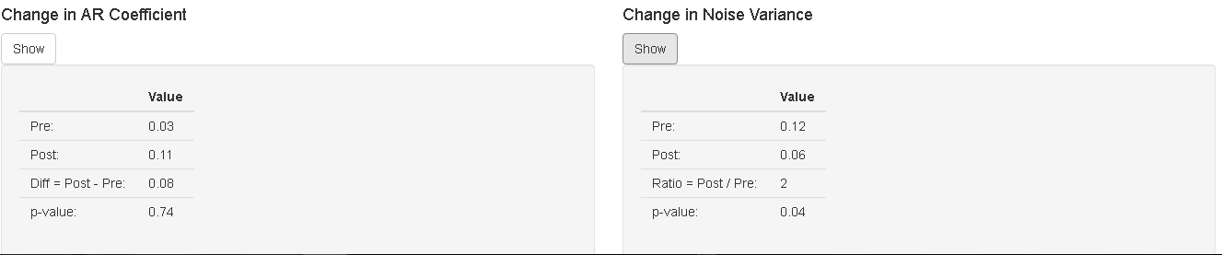

Figure 22S. In-hospital mortality in patients with ischemic stroke, Triage III, IV and V

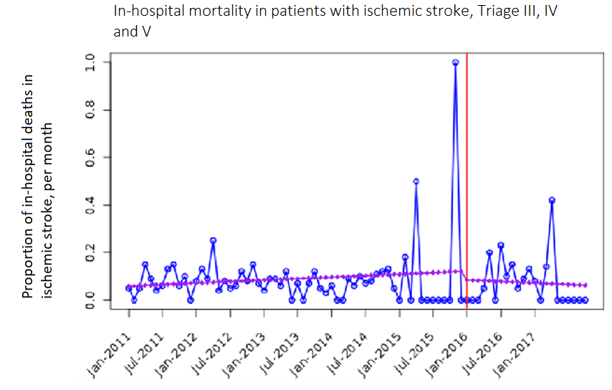
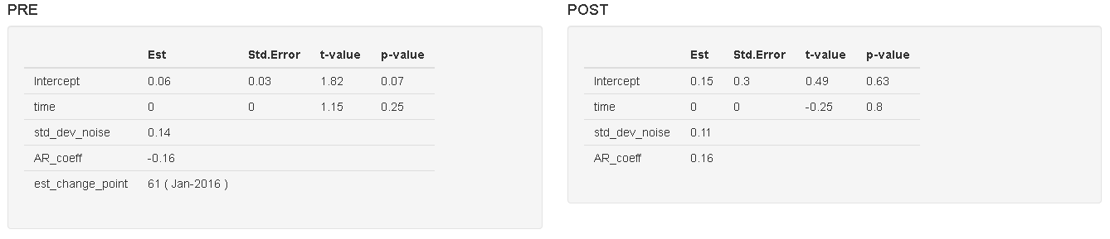
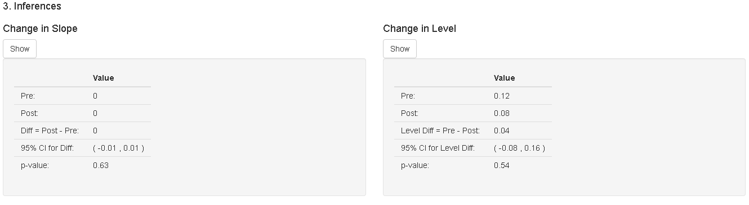
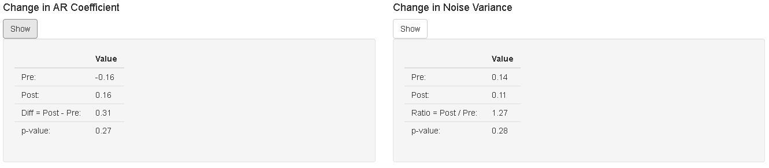

Figure 23S. In-hospital mortality in patients with ischemic stroke older than 65 years of age

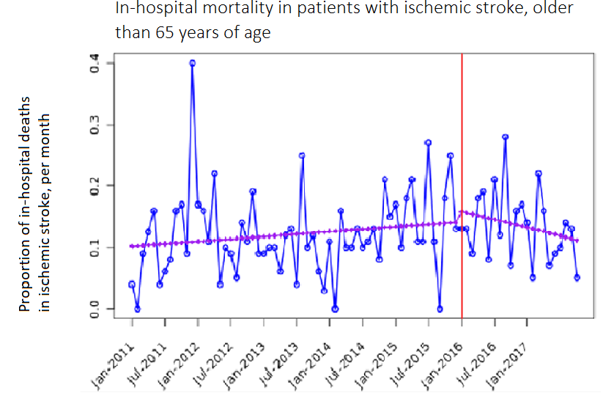
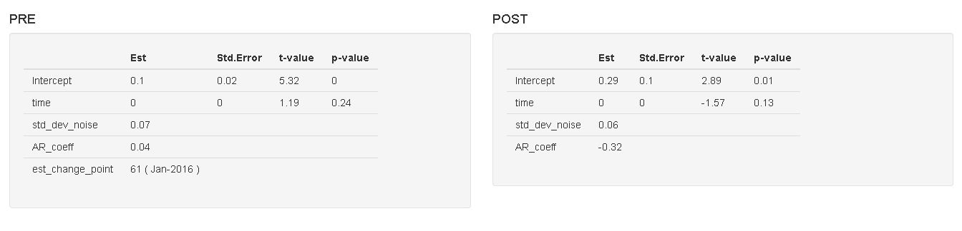
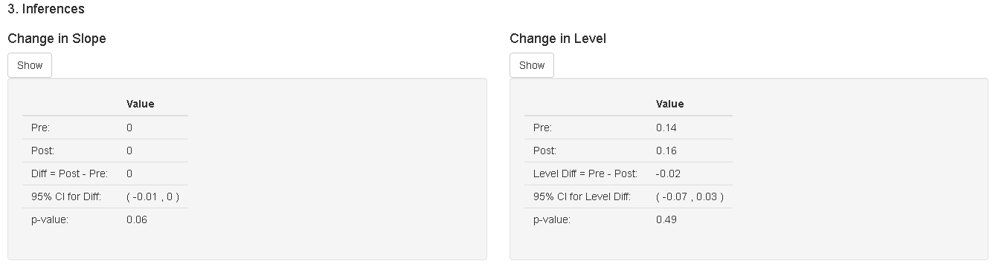
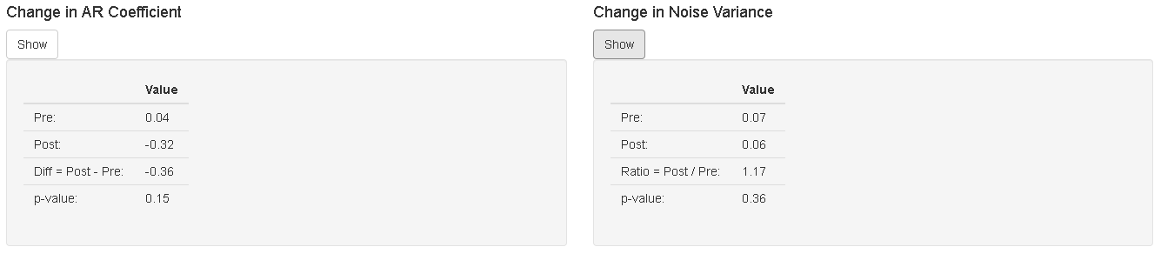

Figure 24S. In-hospital mortality in patients with ischemic stroke, younger than 65 years of age

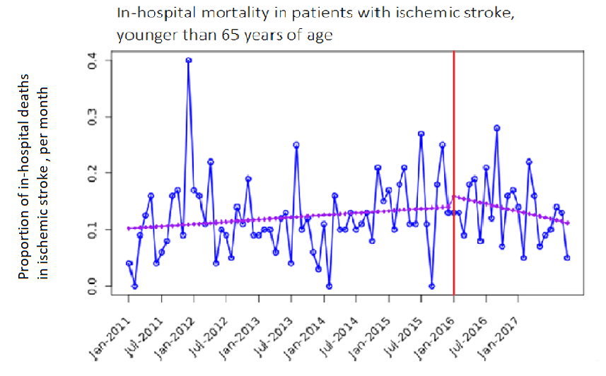

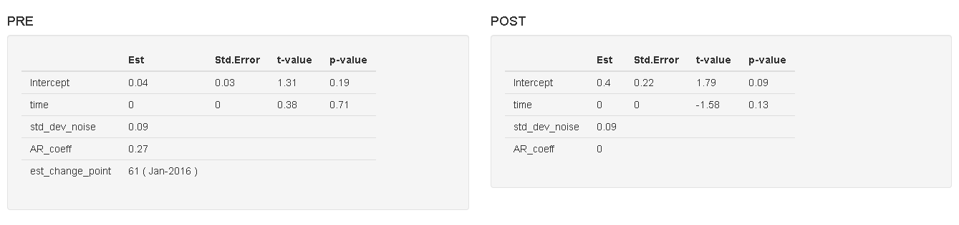
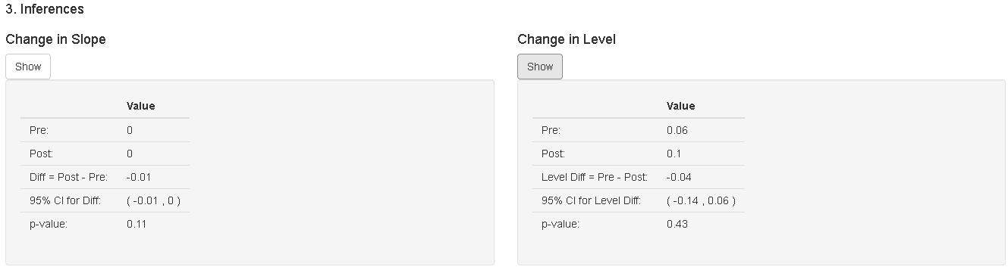
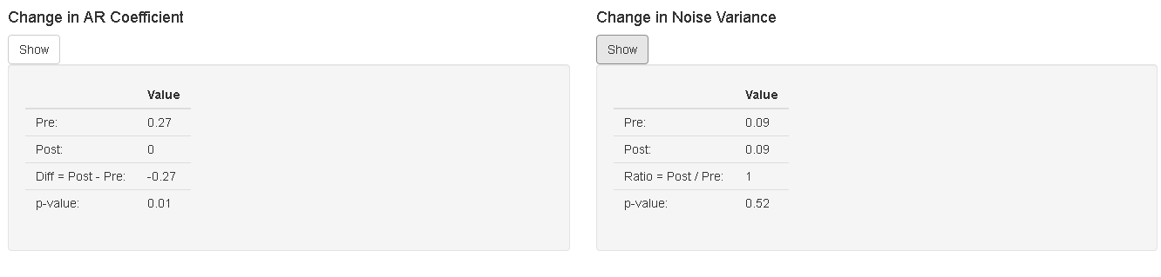

CORRELOGRAMS FOR ANALYSIS

Figure 3.1S. Timeliness of care in ED for patients with stroke

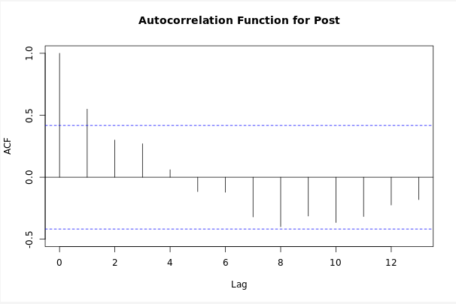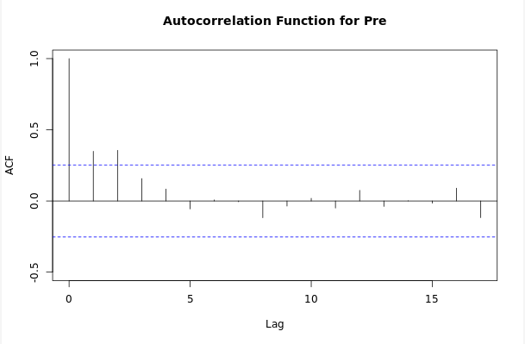

Figure 3.2S. Timeliness of care in ED for patients evaluated in less than 30 minutes

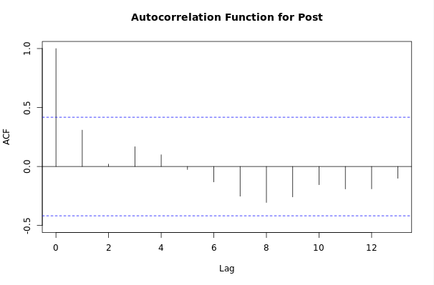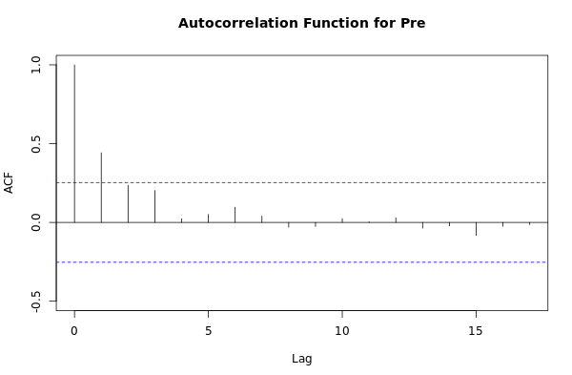

Figure 3.3S. In-hospital mortality in patients with ischemic stroke

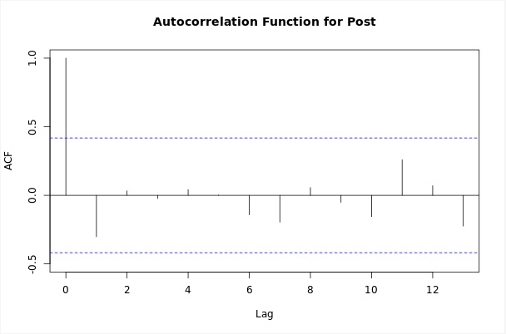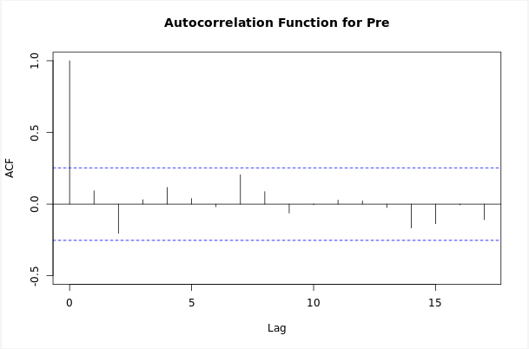

Figure 3.4S. Timeliness of care in ED for patient with ischemic stroke with contributory insurance

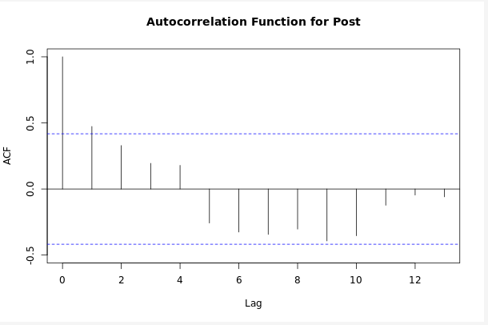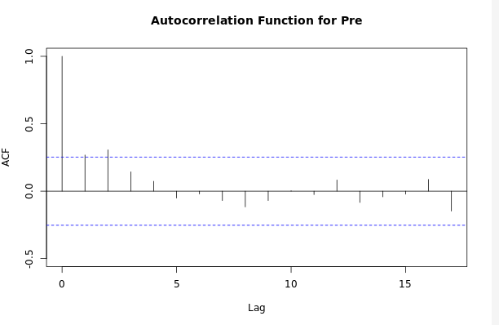

Figure 3.5S. Timeliness of care in ED for patients with subsidized insurance
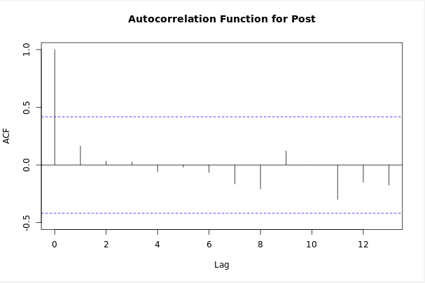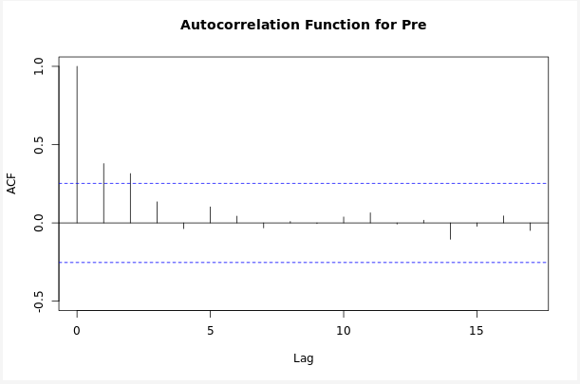

Figure 3.6S. Timeliness of care in ED for patients over 65 years of age
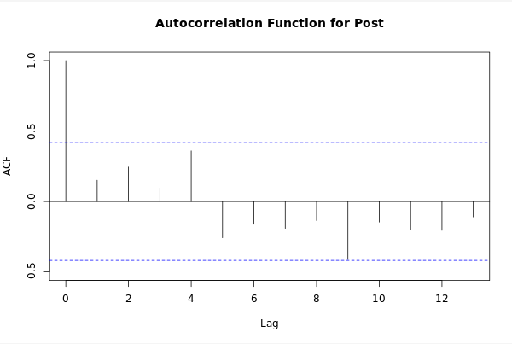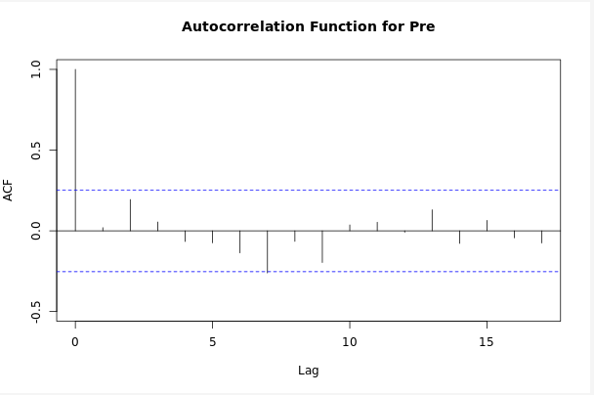

Figure 3.7S. Timeliness of care in ED for patients younger than 65 years of age
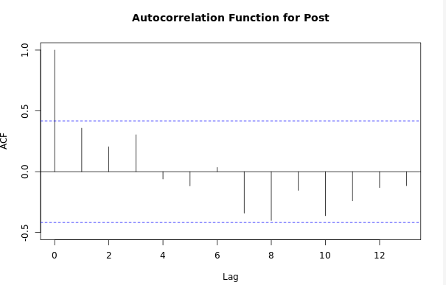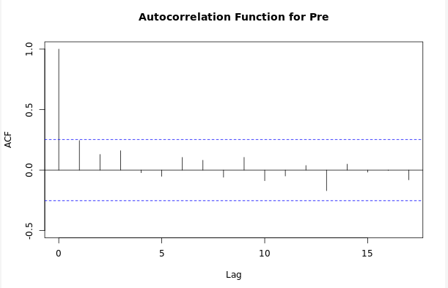

Figure 3.8S. Timeliness of care in ED for female patients with ischemic stroke
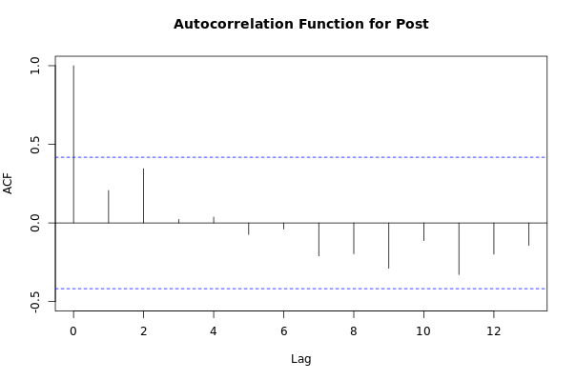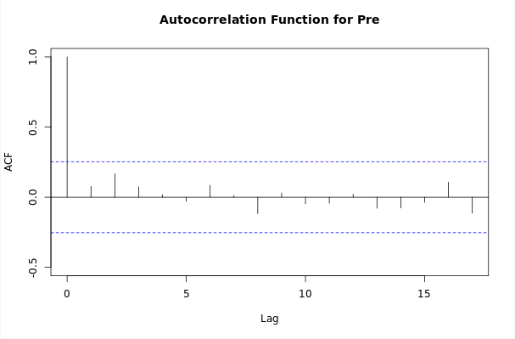

Figure 3.9S. Timeliness of care in ED for male patients with ischemic stroke
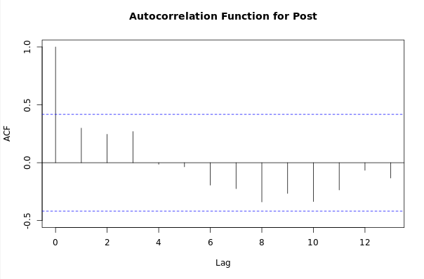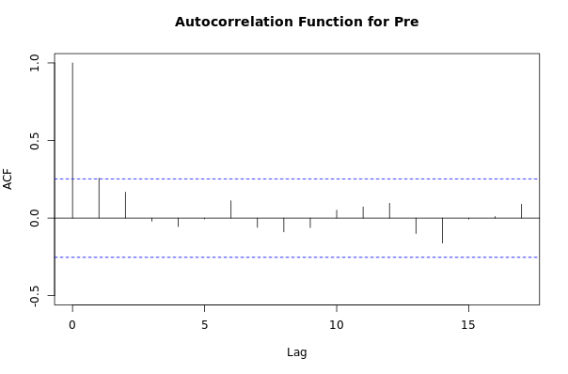

Figure 3.10S. Timeliness of care in ED for stroke patients seen in the day shift
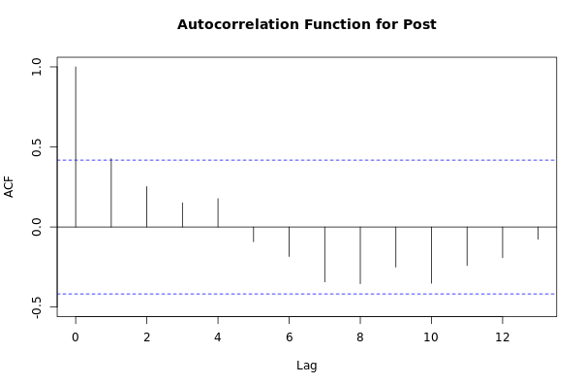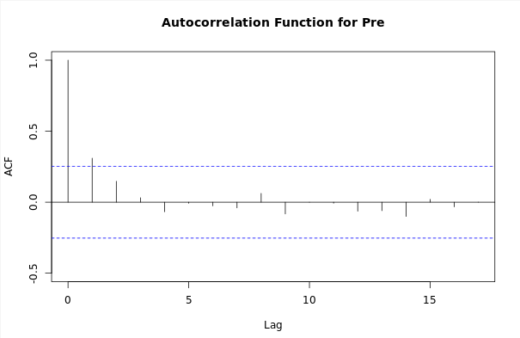

Figure 3.11S. Timeliness of care in ED for stroke patients seen on the night shift
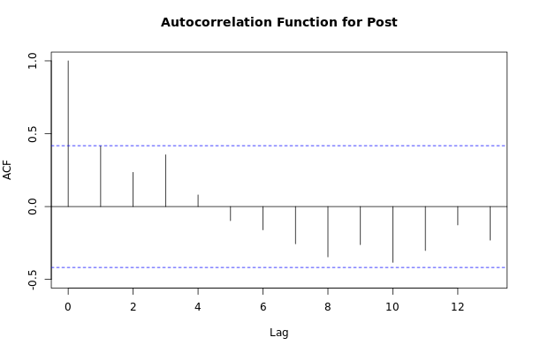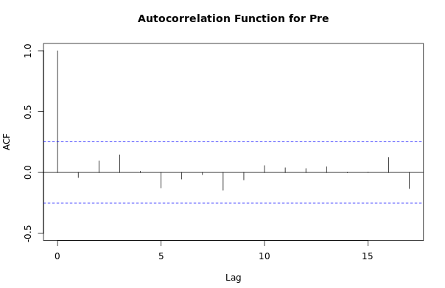

Figure 3.12S. Timeliness of care in ED for patients with stroke, Triage I and II
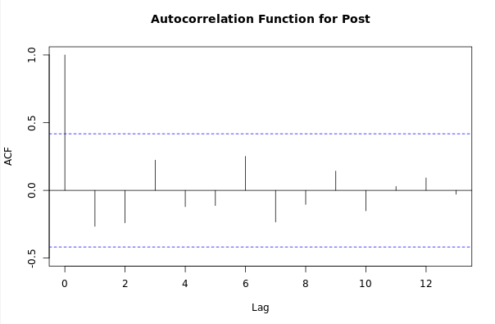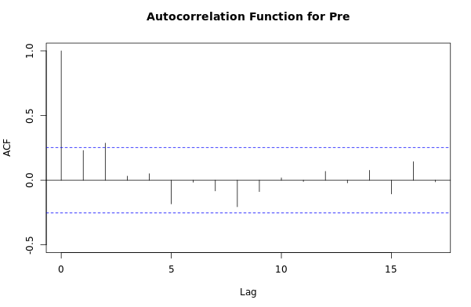

Figure 3.13S. In-hospital mortality in patients with ischemic stroke and subsidized insurance
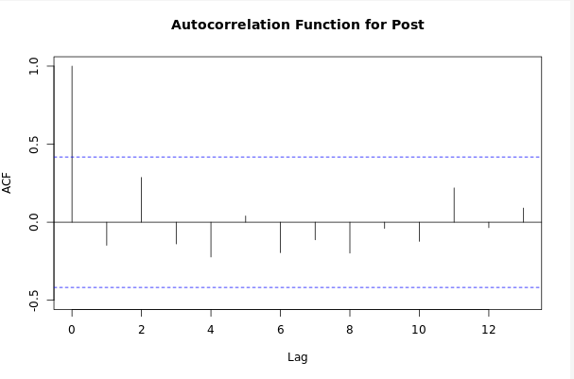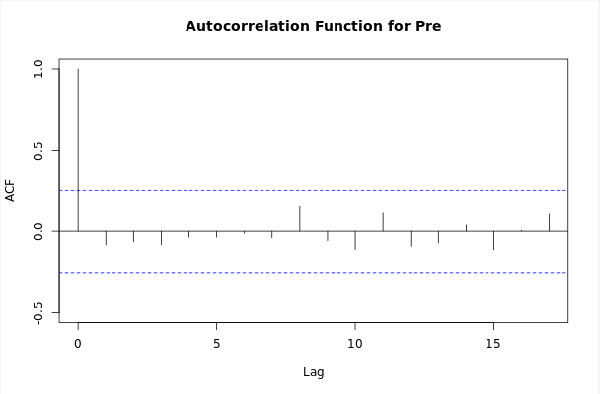

Figure 3.14S. Proportion of in-hospital deaths in stroke patients with contributory insurance
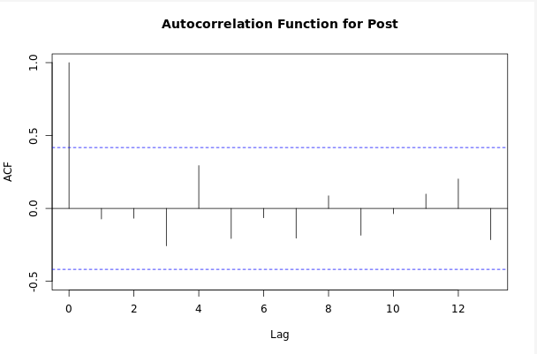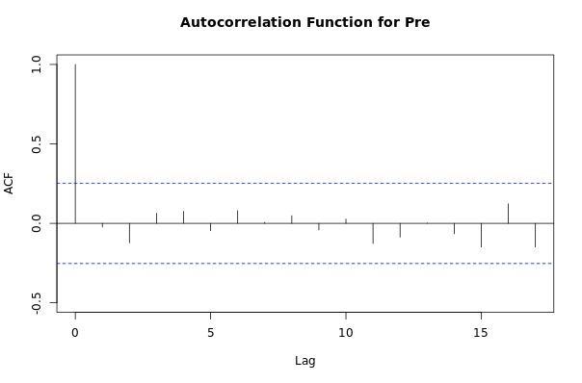

Figure 3.15S. In-hospital mortality in female patients with ischemic stroke
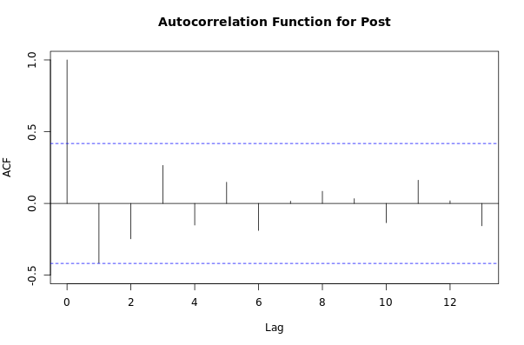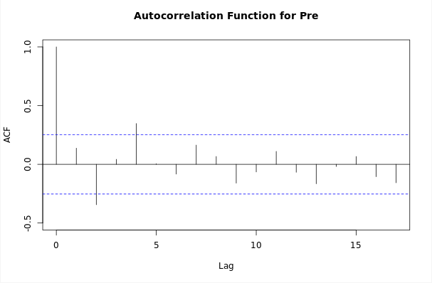

Figure 3.16S. In-hospital mortality in male patients with ischemic stroke
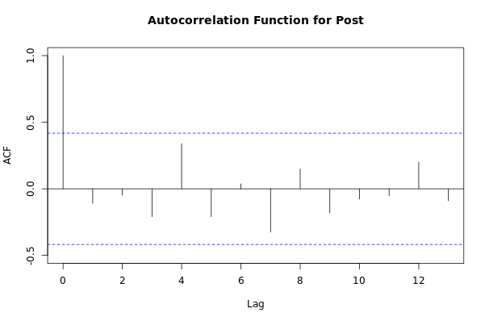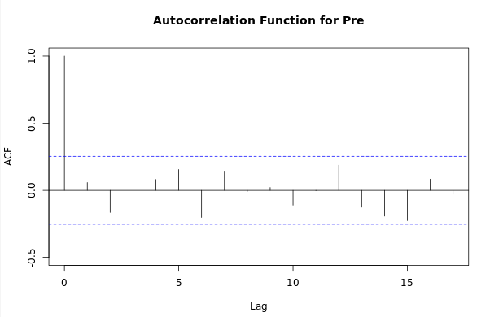

Figure 3.17S. In-hospital mortality in patients with ischemic stroke in the day shift
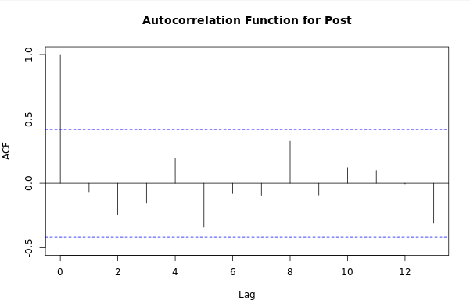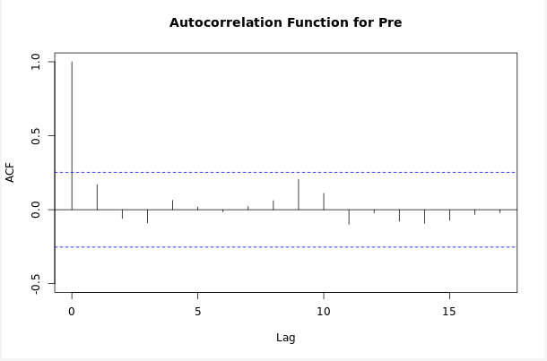

Figure 3.18S. In-hospital mortality in patients with ischemic stroke on the night shift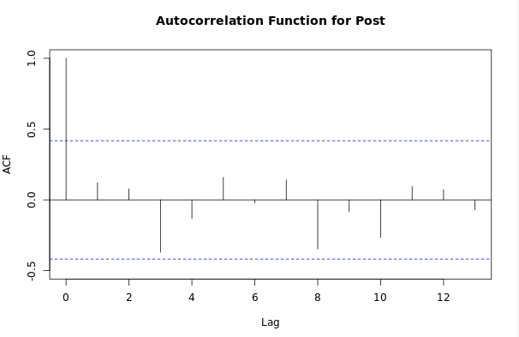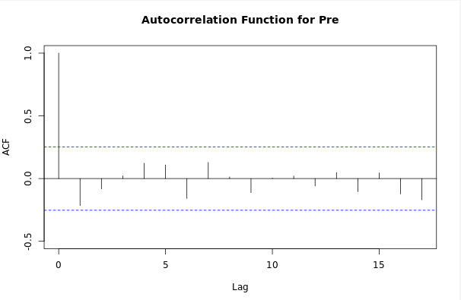

Figure 3.19S. In-hospital mortality in patients with ischemic stroke, Triage I-II
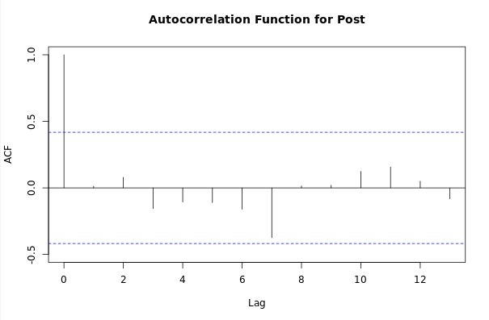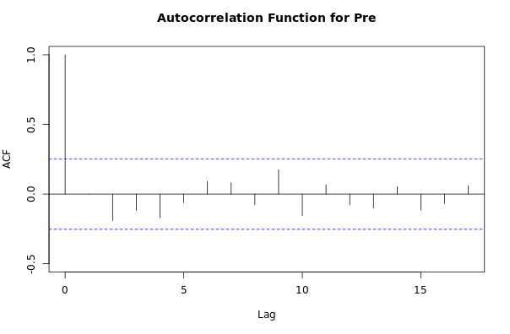

Figure 3.20S. In-hospital mortality in patients with ischemic stroke, Triage III, IV and V
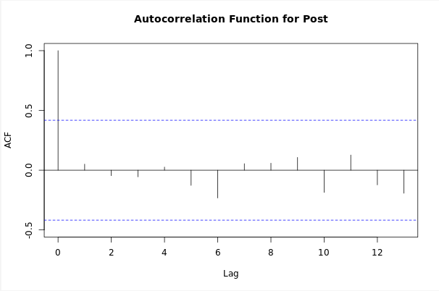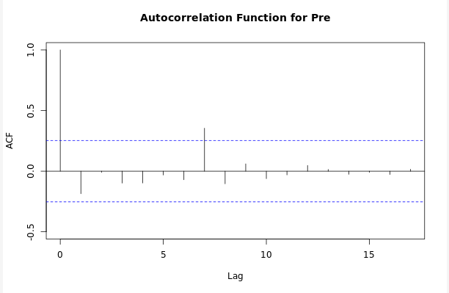

Figure 3.21S. In-hospital mortality in patients with ischemic stroke older than 65 years of age
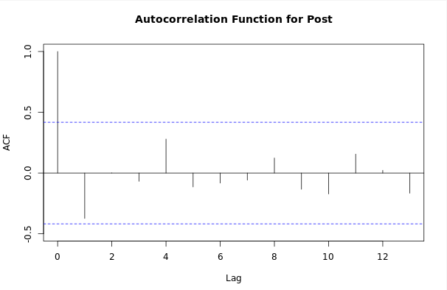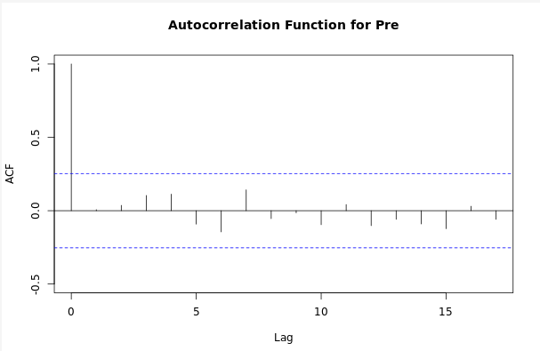

Figure 3.22S. In-hospital mortality in patients with ischemic stroke younger than 65 years of age
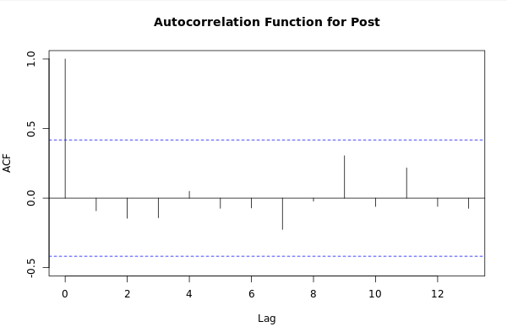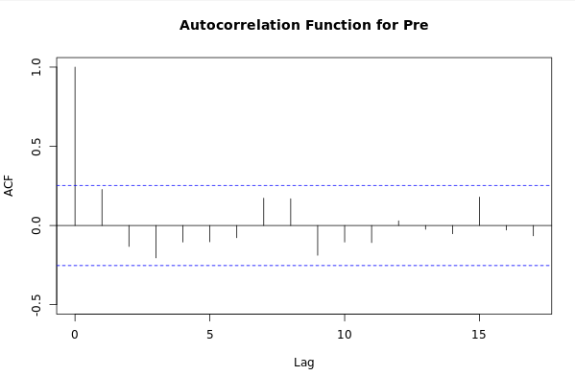

INTERACTION AND CONFUSION

Timeliness

Simple linear regression
Coefficients:
Call:
lm(formula = Minutos ~ INTERVENCION, data = data_modelacion_16_11_2018)

Residuals:
Min 1Q Median 3Q Max
-46.577 -33.527 -7.577 18.423 285.235

Coefficients:
Estimate Std. Error t value Pr(>|t|)
(Intercept) 46.5766 0.9216 50.536 < 2e-16 ***
INTERVENCION -12.8117 1.8103 -7.077 1.87e-12 ***
---
Signif. codes: 0 ‘***’ 0.001 ‘**’ 0.01 ‘*’ 0.05 ‘.’ 0.1 ‘ ’ 1

Residual standard error: 40.93 on 2660 degrees of freedom
Multiple R-squared: 0.01848, Adjusted R-squared: 0.01811
F-statistic: 50.09 on 1 and 2660 DF, p-value: 1.873e-12

*Multiple linear regression
** Multivariate model
lm(formula = Minutos ~ INTERVENCION + Aseguramiento + Sexo +
Edad_gr + Turno, data = data_modelacion_16_11_2018)

Residuals:
Min 1Q Median 3Q Max
-49.993 -28.599 -7.906 18.154 285.432

Coefficients:
Estimate Std. Error t value Pr(>|t|)
(Intercept) 49.9933 1.4129 35.383 < 2e-16 ***
INTERVENCION -12.4755 1.8132 -6.880 7.42e-12 ***
AseguramientoSUBSIDIADO -8.7510 1.8357 -4.767 1.97e-06 ***
SexoMasculino -0.3677 1.5847 -0.232 0.817
Edad_grme65 -1.0267 1.8636 -0.551 0.582
TurnoNOCHE -2.5551 1.6929 -1.509 0.131
---
Signif. codes: 0 ‘***’ 0.001 ‘**’ 0.01 ‘*’ 0.05 ‘.’ 0.1 ‘ ’ 1

Residual standard error: 40.74 on 2656 degrees of freedom
Multiple R-squared: 0.02876, Adjusted R-squared: 0.02693
F-statistic: 15.73 on 5 and 2656 DF, p-value: 2.721e-15

** Models with significant variables:

Call:
lm(formula = Minutos ~ INTERVENCION + Aseguramiento, data = data_modelacion_16_11_2018)

Residuals:
Min 1Q Median 3Q Max
-48.877 -28.731 -7.877 18.123 282.823

Coefficients:
Estimate Std. Error t value Pr(>|t|)
(Intercept) 48.877 1.024 47.710 < 2e-16 ***
INTERVENCION -12.700 1.802 -7.047 2.32e-12 ***
AseguramientoSUBSIDIADO -9.146 1.813 -5.046 4.82e-07 ***
---
Signif. codes: 0 ‘***’ 0.001 ‘**’ 0.01 ‘*’ 0.05 ‘.’ 0.1 ‘ ’ 1

Residual standard error: 40.74 on 2659 degrees of freedom
Multiple R-squared: 0.02779, Adjusted R-squared: 0.02706
F-statistic: 38.01 on 2 and 2659 DF, p-value: < 2.2e-16

Death

*Simple linear regression
Call:
glm(formula = ESTADO ~ INTERVENCION, data = data_modelacion_16_11_2018_numericos)

Deviance Residuals:
Min 1Q Median 3Q Max
-0.12754 -0.09838 -0.09838 -0.09838 0.90162

Coefficients:
Estimate Std. Error t value Pr(>|t|)
(Intercept) 0.098377 0.006927 14.202 <2e-16 ***
INTERVENCION 0.029159 0.013606 2.143 0.0322 *
---
Signif. codes: 0 ‘***’ 0.001 ‘**’ 0.01 ‘*’ 0.05 ‘.’ 0.1 ‘ ’ 1

(Dispersion parameter for gaussian family taken to be 0.09462091)

Null deviance: 252.13 on 2661 degrees of freedom
Residual deviance: 251.69 on 2660 degrees of freedom
AIC: 1281.8

Number of Fisher Scoring iterations: 2

Multiple linear regression
** Multivariate model
Call:
glm(formula = ESTADO ~ INTERVENCION + Aseguramiento + Sexo +
Edad_gr + Turno, data = data_modelacion_16_11_2018_numericos)

Deviance Residuals:
Min 1Q Median 3Q Max
-0.1534 -0.1218 -0.1158 -0.0474 0.9657

Coefficients:
Estimate Std. Error t value Pr(>|t|)
(Intercept) 0.050476 0.017004 2.969 0.00302 **
INTERVENCION 0.026485 0.013623 1.944 0.05199 .
Aseguramiento -0.008054 0.013792 -0.584 0.55928
Sexo -0.003072 0.011906 -0.258 0.79640
Edad_gr 0.076399 0.014002 5.456 5.31e-08 ***
Turno -0.005070 0.012719 -0.399 0.69022
---
Signif. codes: 0 ‘***’ 0.001 ‘**’ 0.01 ‘*’ 0.05 ‘.’ 0.1 ‘ ’ 1

(Dispersion parameter for gaussian family taken to be 0.09370463)

Null deviance: 252.13 on 2661 degrees of freedom
Residual deviance: 248.88 on 2656 degrees of freedom
AIC: 1259.9

Number of Fisher Scoring iterations: 2

Call:
glm(formula = ESTADO ~ INTERVENCION + Edad_gr, data = data_modelacion_16_11_2018_numericos)

Deviance Residuals:
Min 1Q Median 3Q Max
-0.14346 -0.11742 -0.11742 -0.04217 0.95783

Coefficients:
Estimate Std. Error t value Pr(>|t|)
(Intercept) 0.04217 0.01243 3.392 0.000704 ***
INTERVENCION 0.02604 0.01355 1.922 0.054662 .
Edad_gr 0.07525 0.01385 5.432 6.07e-08 ***
---
Signif. codes: 0 ‘***’ 0.001 ‘**’ 0.01 ‘*’ 0.05 ‘.’ 0.1 ‘ ’ 1

(Dispersion parameter for gaussian family taken to be 0.09361756)

Null deviance: 252.13 on 2661 degrees of freedom
Residual deviance: 248.93 on 2659 degrees of freedom
AIC: 1254.4

Number of Fisher Scoring iterations: 2

** Models with significant variables:
Call:
glm(formula = ESTADO ~ INTERVENCION + Edad_gr, data = data_modelacion_16_11_2018_numericos)

Deviance Residuals:
Min 1Q Median 3Q Max
-0.14346 -0.11742 -0.11742 -0.04217 0.95783

Coefficients:
Estimate Std. Error t value Pr(>|t|)
(Intercept) 0.04217 0.01243 3.392 0.000704 ***
INTERVENCION 0.02604 0.01355 1.922 0.054662 .
Edad_gr 0.07525 0.01385 5.432 6.07e-08 ***
---
Signif. codes: 0 ‘***’ 0.001 ‘**’ 0.01 ‘*’ 0.05 ‘.’ 0.1 ‘ ’ 1

(Dispersion parameter for gaussian family taken to be 0.09361756)

Null deviance: 252.13 on 2661 degrees of freedom
Residual deviance: 248.93 on 2659 degrees of freedom
AIC: 1254.4

Number of Fisher Scoring iterations: 2

