A highly effective self-supplying photosensitizer drug for deep-tissue metastatic tumours treatment
‡Zhengze Yu^{∗,1}, ‡Hanxiang Li¹, Mingchao Xia¹, Yuhang Wang¹, Hao Zhang¹, Yue Tang^{∗,2}, Hongyu Wang^{∗,3}, Bo Tang^{∗,4}
¹College of Chemistry and Chemical Engineering, Qingdao University, Qingdao 266071, P. R. China. E-mail: qduyuzz@qdu.edu.cn
²Department of Emergency Medicine, Shandong Provincial Clinical Research Center for Emergency and Critical Care Medicine, Qilu Hospital of Shandong University, Jinan, 250014, P. R. China. E-mail: yuetang0531@hotmail.com.
³Key laboratory of marine drugs, ministry of education; Molecular synthesis center, and School of medicine and pharmacy, Ocean university of china, Qingdao, 266003 P. R. China. E-mail: why@ouc.edu.cn.
⁴Laoshan Laboratory, Qingdao, 266237, P. R. China. E-mail: btang@qnlm.ac.
‡These authors contributed equally to this work.

Instruments
TEM images were taken by a HT7700 electron microscope. Zeta potentials were measured by a Malvern Zeta Sizer Nano (Malvern Instruments). The absorbance of the 96-well plate was recorded with a microplate reader (Synergy 2, Biotek, USA). Flow cytometry was taken by CytoFLEX S. A confocal laser scanning microscope (CLSM, Nikon AIR HD25) was used to take the fluorescence images. ¹H NMR and ¹³C NMR spectra were recorded on Bruker Avance 300, 400 or 600 MHz spectrometers. Fluorescence spectra were recorded on F-4700 Portable Hitachi F-4700 Fluorescence Spectrophotometer, while the UV-Vis spectra were obtained by a pharmaspec UV-1700 UV-visible spectrophotometer (Shimadzu, Japan). High-resolution mass spectra (HR-MS) were obtained on a Bruker ultrafleXtreme™ mass spectrometer system operated in matrix-assisted laser desorption and ionization–time-of-flight (MALDI-TOF) mode. All chemiluminescent images were performed by the PerkinElmer IVIS Lumina III.

Supplementary Fig. 1 ¹H-NMR spectrum of Cy7 in CDCl₃.

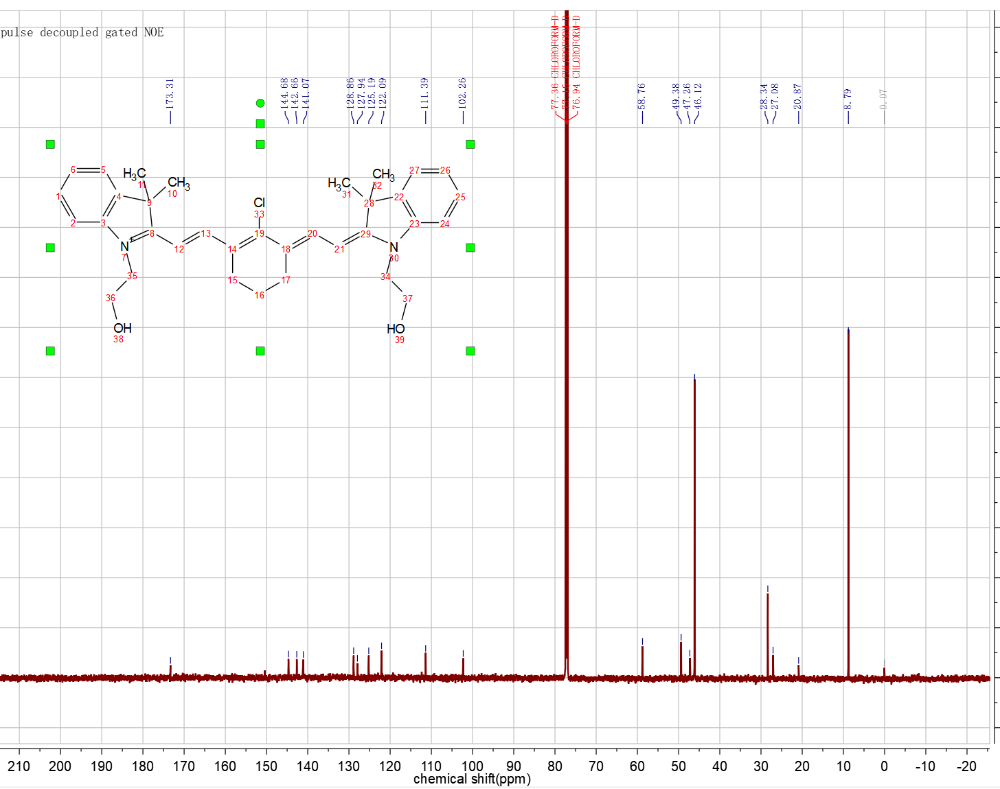
Supplementary Fig. 2 ¹³C-NMR spectrum of Cy7 in CDCl₃.

Supplementary Fig. 3 HR-MS of Cy7.

Supplementary Fig. 4 ¹H-NMR spectrum of Cy7-EOM in d₆-DMSO.

Supplementary Fig. 5 ¹³C-NMR spectrum of Cy7-EOM in CDCl₃.

Supplementary Fig. 6 HR-MS of Cy7-EOM.

a b

Supplementary Fig. 7 TEM images of Cy7-EOM NMs before (a) and after (b) treated with GSH (10 mM) for 3h. Scale bars are 400 nm.

a b

Supplementary Fig. 8 Size distribution of Cy7-EOM SS NMs (a) and Cy7-EOM NMs (b) by DLS measurement.

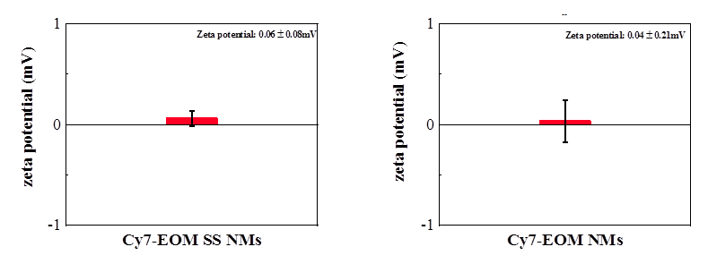
Supplementary Fig. 9 Zeta potentials of Cy7-EOM SS NMs and Cy7-EOM NMs.

Supplementary Fig. 10 ESR spectra of Cy7-EOM and Cy7-EOM SS NMs with the incubation of H₂O₂ for the detection of ¹O₂ generation by using TEMP.

Supplementary Fig. 11 CLSM images of 4T1 cells were incubated with Cy7-EOM SS NMs (50 µg/mL) for 2, 4, 6 and 8h, respectively, and the corresponding statistical analysis of fluorescence intensity. The cell nucleus was stained with Hoechst. Scale bars are 200 μm. Data are reported as the means ± S.D. and analyzed by two-tailed Student’s t-test.

Supplementary Fig. 12 CLSM images of FA pre-treated 4T1 cells or 4T1 cell without pre-treatment after incubation with Cy7-EOM SS NMs for 6h, and the corresponding statistical analysis of fluorescence intensity. Scale bars are 200 μm. Data are reported as the means ± S.D. and analyzed by two-tailed Student’s t-test.

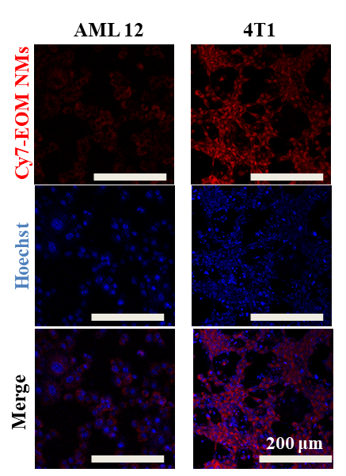

Supplementary Fig. 13 CLSM images of AML 12 cells and 4T1 cells incubated with Cy7-EOM NMs (50 µg / mL) for 6h and the corresponding statistical analysis of fluorescence intensity. Scale bars are 200 μm. Data are reported as the means ± S.D. and analyzed by two-tailed Student’s t-test.

Supplementary Fig. 14 CLSM images of 4T1 cells stained with NDA for the detection of GSH consumption and the corresponding statistical analysis of fluorescence intensity after different treatments. Scale bars are 200 μm. Data are reported as the means ± S.D. and analyzed by two-tailed Student’s t-test.

Supplementary Fig. 15 Statistical analysis of the fluorescence intensity in CLSM images of 4T1 cells stained with SOSG after different treatments. Data are reported as the means ± S.D. and analyzed by two-tailed Student’s t-test.

Supplementary Fig. 16 Statistical analysis of the fluorescence intensity in CLSM images of 4T1 cells stained with JC-1 after different treatments. *p<0.05, ***p<0.001, ****p<0.0001. Data are reported as the means ± S.D. and analyzed by two-tailed Student’s t-test.

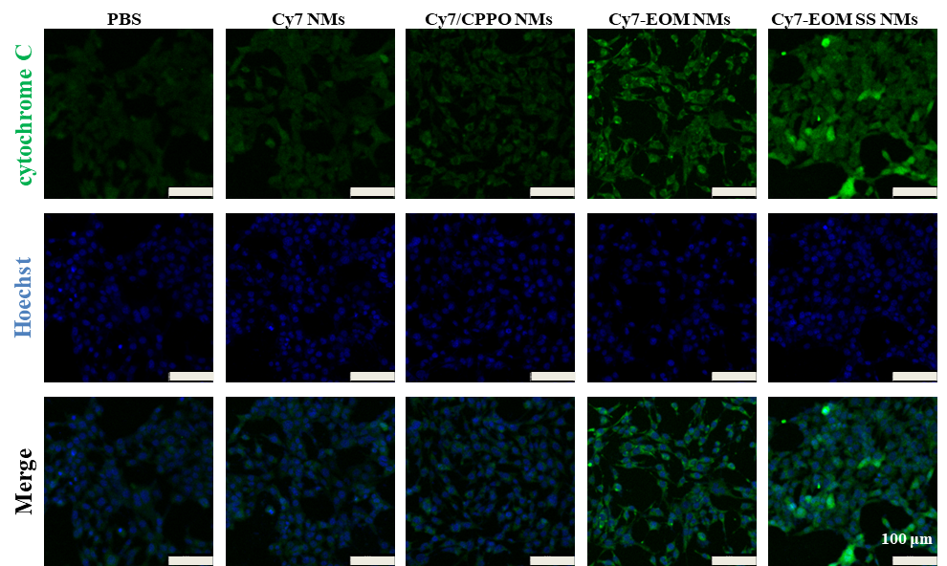

Supplementary Fig. 17 Immunofluorescent staining images and the corresponding fluorescence intensity analysis of cytochrome C in 4T1 cells after different treatments. Data are reported as the means ± S.D. and analyzed by two-tailed Student’s t-test.

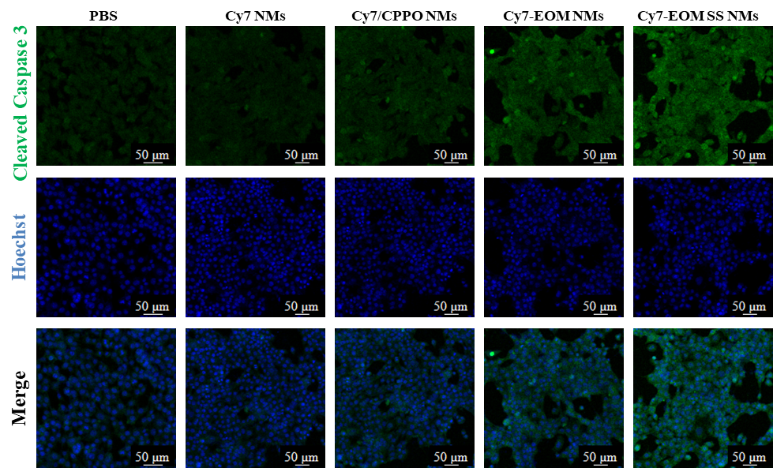
Supplementary Fig. 18 Immunofluorescent staining images and the corresponding fluorescence intensity analysis of cleaved caspase-3 in 4T1 cells after different treatments. Data are reported as the means ± S.D. and analyzed by two-tailed Student’s t-test.

Supplementary Fig. 19 Statistical analysis of the fluorescence intensity in 4T1 cells stained with DCFH-DA after different treatments. Data are reported as the means ± S.D. and analyzed by two-tailed Student’s t-test.
Supplementary Fig. 20 Quantitative analysis of the chemiluminescence intensity signals in mice.

