Supplementary Material

Supplementary Table 1. Clinical information of three sets
Covariates |  | TCGA set | Train set | Test set | P-value
Age | <=65 | 181(46.53%) | 89(45.64%) | 92(47.42%)
 | >65 | 205(52.7%) | 105(53.85%) | 100(51.55%) | 0.764
 | unknown | 3(0.77%) | 1(0.51%) | 2(1.03%)
Gender | Female | 133(34.19%) | 65(33.33%) | 68(35.05%) | 0.802
 | Male | 256(65.81%) | 130(66.67%) | 126(64.95%)
Grade | G1-G2 | 145(37.28%) | 65(33.33%) | 80(41.24%)
 | G3 | 235(60.41%) | 126(64.62%) | 109(56.19%) | 0.120
 | unknown | 9(2.31%) | 4(2.05%) | 5(2.58%)
Stage | Stage I-II | 172(44.22%) | 90(46.15%) | 82(42.27%)
 | Stage III-IV | 201(51.67%) | 94(48.21%) | 107(55.15%) | 0.334
 | unknown | 16(4.11%) | 11(5.64%) | 5(2.58%)
T | T1-2 | 103(26.48%) | 50(25.64%) | 53(27.32%)
 | T3-4 | 281(72.24%) | 142(72.82%) | 139(71.65%) | 0.818
 | unknown | 5(1.29%) | 3(1.54%) | 2(1.03%)
M | M0 | 350(89.97%) | 179(91.79%) | 171(88.14%)
 | M1 | 25(6.43%) | 8(4.1%) | 17(8.76%) | 0.101
 | unknown | 14(3.6%) | 8(4.1%) | 6(3.09%)
N | N0 | 115(29.56%) | 63(32.31%) | 52(26.8%)
 | N1-3 | 263(67.61%) | 126(64.62%) | 137(70.62%) | 0.264
 | unknown | 11(2.83%) | 6(3.08%) | 5(2.58%)

Supplementary Table 2 Correlation analysis between the GIMiSig and immune cells
Cell subtypes | Cor | P-value
B cell_TIMER | 0.143 | p < 0.01
T cell CD4+_TIMER | 0.227 | p < 0.001
T cell CD8+_TIMER | 0.156 | p < 0.01
Neutrophil_TIMER | 0.265 | p < 0.001
Macrophage_TIMER | 0.405 | p < 0.001
Myeloid dendritic cell_TIMER | 0.253 | p < 0.001
B cell memory_CIBERSORT | 0.160 | p < 0.01
T cell CD4+ memory activated_CIBERSORT | -0.141 | p < 0.01
T cell follicular helper_CIBERSORT | -0.199 | p < 0.001
T cell regulatory (Tregs)_CIBERSORT | -0.131 | p < 0.05
Macrophage M0_CIBERSORT | -0.109 | p < 0.05
Macrophage M2_CIBERSORT | 0.141 | p < 0.01
Mast cell activated_CIBERSORT | 0.202 | p < 0.001
Mast cell resting_CIBERSORT | -0.168 | p < 0.01
Eosinophil_CIBERSORT | 0.114 | p < 0.05
B cell naive_CIBERSORT-ABS | 0.178 | p < 0.001
B cell memory_CIBERSORT-ABS | 0.170 | p < 0.01
T cell CD8+_CIBERSORT-ABS | 0.140 | p < 0.01
T cell CD4+ memory resting_CIBERSORT-ABS  T cell CD4+ memory activated_CIBERSORT-ABS  NK cell activated_CIBERSORT-ABS | 0.260  -0.123  0.109 | p < 0.001  p < 0.05  p < 0.05
Monocyte_CIBERSORT-ABS | 0.183 | p < 0.001
Macrophage M1_CIBERSORT-ABS | 0.160 | p < 0.01
Macrophage M2_CIBERSORT-ABS | 0.319 | p < 0.001
Mast cell activated_CIBERSORT-ABS | 0.231 | p < 0.001
Eosinophil_CIBERSORT-ABS | 0.115 | p < 0.05
B cell_QUANTISEQ | 0.252 | p < 0.001
Macrophage M2_QUANTISEQ | 0.283 | p < 0.001
Monocyte_QUANTISEQ | 0.114 | p < 0.05
T cell CD4+ (non-regulatory)_QUANTISEQ | 0.144 | p < 0.01
Myeloid dendritic cell_QUANTISEQ | 0.143 | p < 0.01
uncharacterized cell_QUANTISEQ | -0.260 | p < 0.001
T cell CD8+_MCPCOUNTER | 0.110 | p < 0.05
NK cell_MCPCOUNTER | 0.156 | p < 0.01
B cell_MCPCOUNTER | 0.255 | p < 0.001
Monocyte_MCPCOUNTER | 0.265 | p < 0.001
Macrophage/Monocyte_MCPCOUNTER | 0.265 | p < 0.001
Myeloid dendritic cell_MCPCOUNTER | 0.346 | p < 0.001
Endothelial cell_MCPCOUNTER | 0.330 | p < 0.001
Cancer associated fibroblast_MCPCOUNTER | 0.363 | p < 0.001
Myeloid dendritic cell activated_XCELL  B cell_XCELL | 0.227  0.137 | p < 0.001  p < 0.01
T cell CD4+ naive_XCELL | 0.140 | p < 0.01
T cell CD4+ central memory_XCELL | -0.145 | p < 0.01
T cell CD8+_XCELL | 0.159 | p < 0.01
T cell CD8+ central memory_XCELL | 0.113 | p < 0.05
Common lymphoid progenitor_XCELL | -0.113 | p < 0.05
Common myeloid progenitor_XCELL | 0.127 | p < 0.05
Myeloid dendritic cell_XCELL | 0.182 | p < 0.001
Endothelial cell_XCELL | 0.317 | p < 0.001
Eosinophil_XCELL | 0.107 | p < 0.05
Cancer associated fibroblast_XCELL | 0.372 | p < 0.001
Granulocyte-monocyte progenitor_XCELL | 0.182 | p < 0.001
Hematopoietic stem cell_XCELL | 0.408 | p < 0.001
Macrophage_XCELL | 0.136 | p < 0.01
Macrophage M1_XCELL | 0.141 | p < 0.01
Macrophage M2_XCELL | 0.126 | p < 0.05
B cell memory_XCELL | 0.119 | p < 0.05
Monocyte_XCELL | 0.241 | p < 0.001
T cell gamma delta_XCELL | -0.160 | p < 0.01
T cell CD4+ Th1_XCELL | -0.318 | p < 0.001
T cell CD4+ Th2_XCELL | -0.111 | p < 0.05
immune score_XCELL | 0.213 | p < 0.001
stroma score_XCELL | 0.381 | p < 0.001
microenvironment score_XCELL | 0.352 | p < 0.001
B cell_EPIC | 0.216 | p < 0.001
Cancer associated fibroblast_EPIC | 0.268 | p < 0.001
Endothelial cell_EPIC | 0.342 | p < 0.001
Macrophage_EPIC | 0.205 | p < 0.001
uncharacterized cell_EPIC | -0.372 | p < 0.001

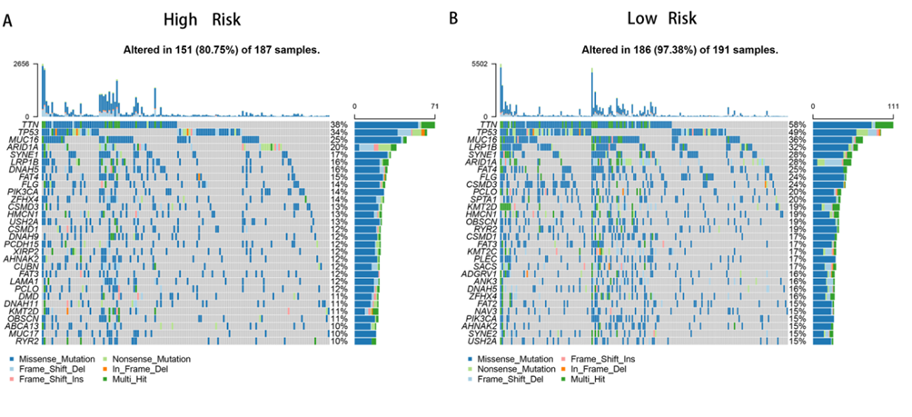
Supplementary Figure 1. Gene mutation landscapes of high-risk (A) and low-risk (B) groups.

Supplementary Figure 2. Venn diagrams showing overlapping target genes according to TargetScan, MiRanda, and miRTarBase.

