Figure legends
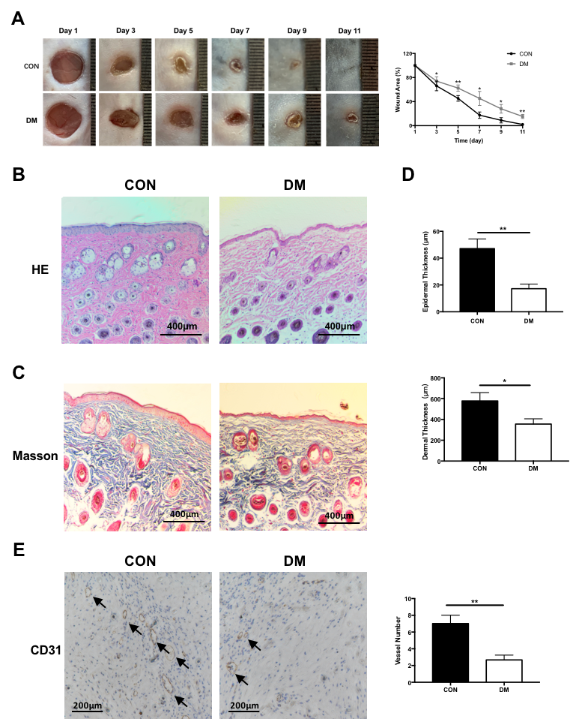
Figure 1. Skin recovery and evaluation of CON and DM after injury. (A) Image of representative wound and area of wound on different days. (B) HE staining of representative wound of CON and DM. (C) Masson staining of representative wound of CON and DM. (D) evaluation of the thickness of epidermis, demis in CON and DM. (E) immunohistochemical staining of CD31 showed the number of endothelium blood vessels of the normal wound and DM wound at 7-days after healing. All data were expressed as the mean ± SEM. n = 3, * P < 0.05; **P < 0.01. DM, diabetic mice; CON, control mice; HE, hematoxylin eosin.
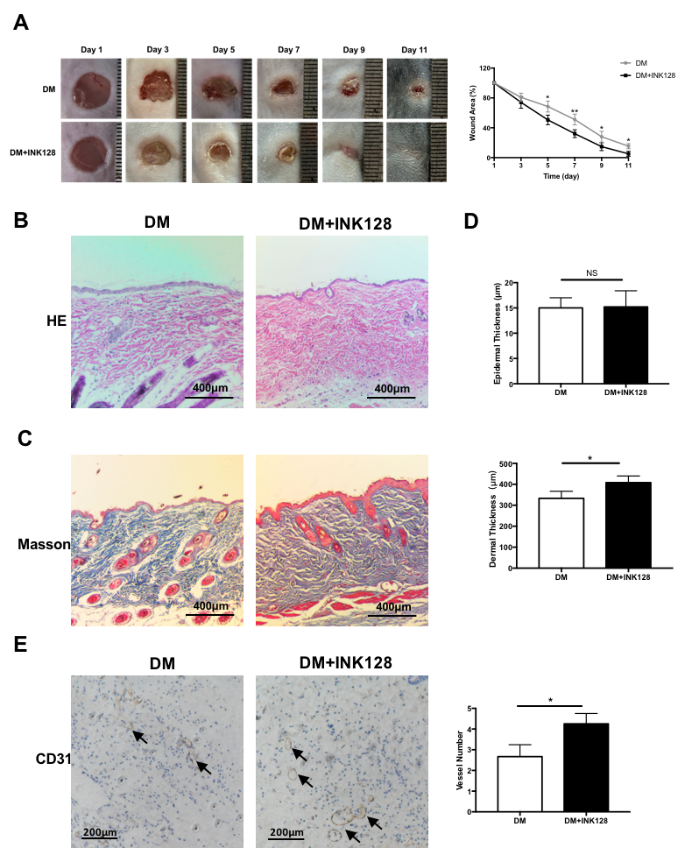
Figure 2. mTOR inhibitor INK128 promotes skin recovery of DM after injury. (A) INK128 decreased the area of wound on different days. (B-D) HE staining and Masson staining showed the effect of INK128 on the thickness of epidermis and dermis in DM. (E) Immunohistochemical staining of CD31 showed that INK128 promoted the number of endothelium blood vessels of DM wound at day 7 after injury. All data were expressed as the mean ± SEM. n = 3, * P < 0.05; **P < 0.01. DM, diabetic mice; DM+INK128, the diabetic mice treated with INK128.

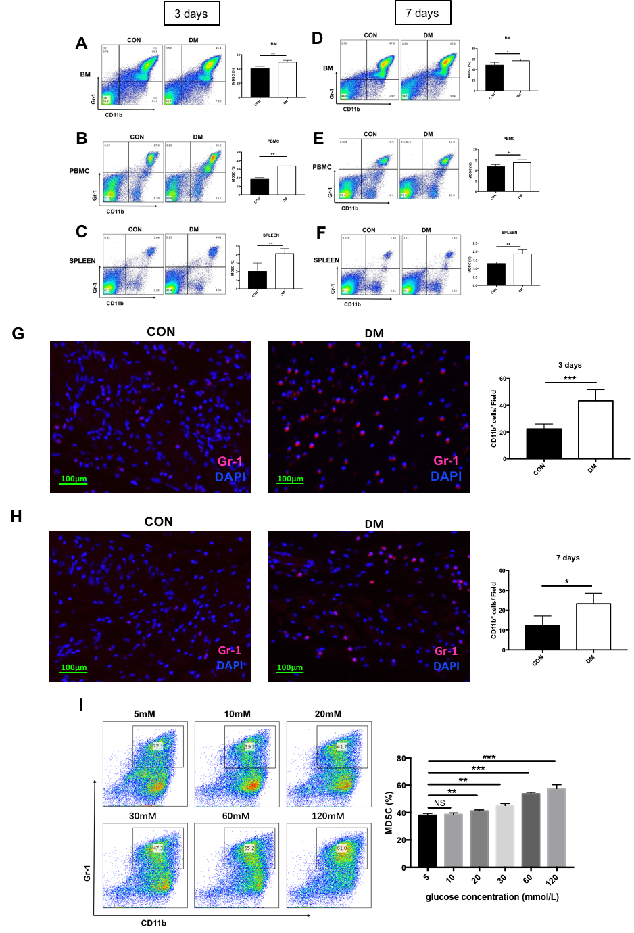
Figure 3. Accumulation of MDSCs in DM and promotion of high glucose on MDSCs. (A-C) The accumulation of MDSCs was showed by flow cytometry in bone marrow, PBMC and spleen of DM and CON at day 3 after injury. (D-F) The accumulation of MDSCs in bone marrow, PBMC and spleen at day 7 after injury was showed by flow cytometry. (G, H) MDSCs of skin tissue around the wound at day 3 and day 7 after injury were investigated by immunofluorescence staining. (I) The percentage of MDSCs was analyzed by flow cytometry in bone marrow cells from CM treated with the graded concentration of glucose in vitro. MDSCs, myeloid-derived suppressor cells; BM, bone marrow; CON, control mice; DM, diabetic mice; PBMC, peripheral blood mononuclear cell.

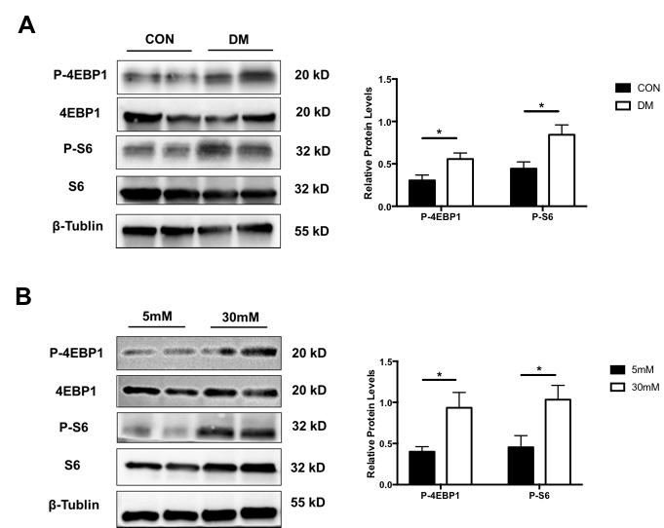
Figure 4. The expressions of the 4EBP1 and S6 along with p-4EBP1 and p-S6 proteins in MDSCs. (A) The expression of 4EBP1, S6, P-4EBP1 and P-S6 was analyzed by Western blot in MDSCs from spleen of CON and DM. (B) The expression of 4EBP1, S6, P-4EBP1 and P-S6 was analyzed by Western blot in MDSCs from bone marrow under presence of 5mM and 30Mm glucoses, respectively. MDSCs, myeloid-derived suppressor cells; CON, control mice; DM, diabetic mice; P-4EBP1, phosphorylated mammalian target of rapamycin; P-S6, phosphorylated ribosomal protein S6. The experiments were tripled. β-Tublin was used as the reference.

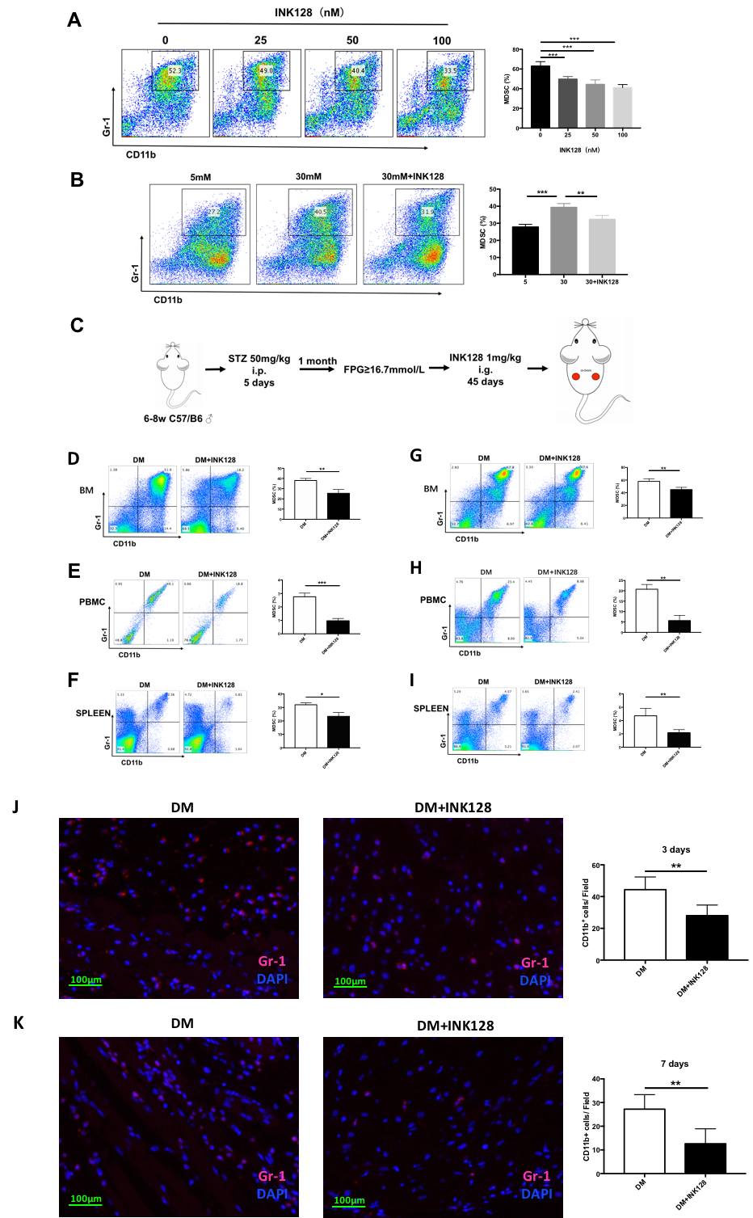
Figure 5. mTOR inhibitor INK128 inhibits accumulation of MDSCs. (A) INK128 inhibited the proliferation of MDSCs in vitro. (B) INK128 decreased the accumulation of glucoses-induced MDSCs in vitro. (C) The construction process of DM and DM+INK128 models. (D-F) INK128 inhibited the accumulation of MDSCs in marrow, PBMC and spleen of DM at day 3 after injury. (G-I) INK128 inhibited the accumulation of MDSCs in marrow, PBMC and spleen of DM at day 7 after injury. (J, K) Immunofluorescence staining showed that INK128 decreased the accumulation of Gr-1+ cells in skin tissue around the wound of DM at day 3 and day 7 after injury. MDSCs, myeloid-derived suppressor cells; PBMC, peripheral blood mononuclear cell; DM, diabetic mice.
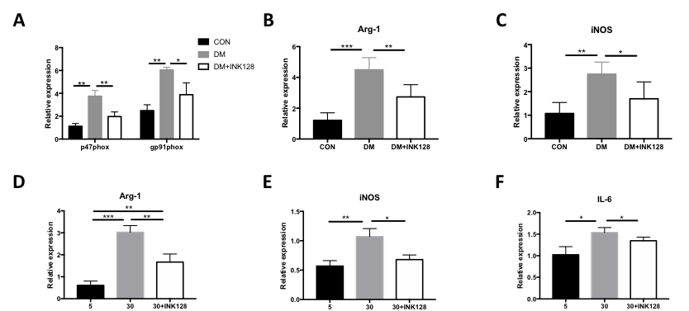
Figure 6. mTOR inhibitor INK128 suppresses the expression of genes related to MDSC functions. (A-C) The expressions of p47phox, gp91phox, Arg-1, iNOS, mRNA in MDSCs purified from the spleen of CON, DM and DM treated with INK128 by qRT-PCR analysis. (D-F) INK128 decreased the expression of Arg-1, iNOS, and IL-6 in glucose-induced MDSCs in vitro. * P < 0.05; **P < 0.01. CON, control mice; DM, diabetic mice.

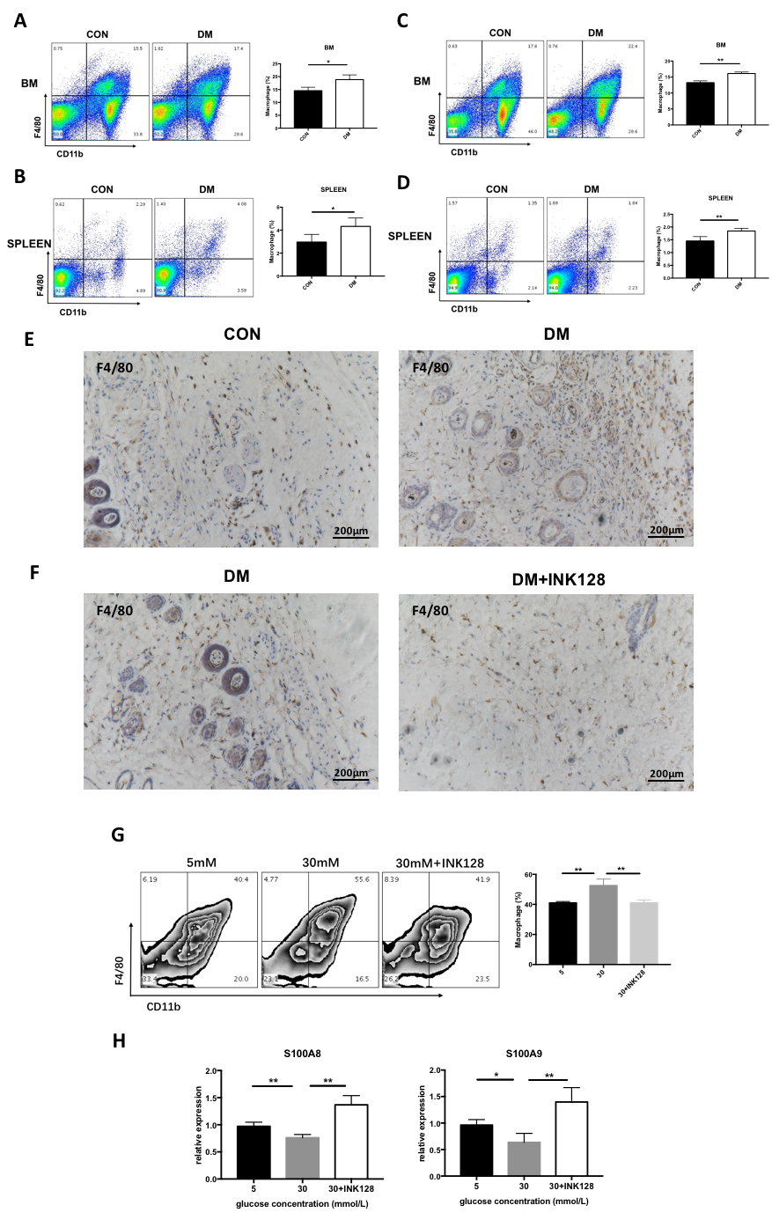
Figure 7. INK128 inhibits differentiation of MDSCs into macrophage in bone marrow and spleen of DM as well as high glucose environment. (A-B) The percentage of macrophage was increased in bone marrow and spleen of DM. (C-D) INK128 decreased the percentage of macrophage in bone marrow and spleen of DM. (E) Immunohistochemistry staining showed that macrophage was increased in skin of DM. (F) INK128 decreased macrophage in skin of DM. (G) the percentage of macrophage under glucose treatments of 5mM, 30mM, and 30mM+INK128 in vitro. (H) INK128 promoted the gene expression of S100A8 and S100A9 with glucose treatments. * P < 0.05; **P < 0.01. CON, control mice; DM, diabetic mice; DM+INK128, the diabetic mice treated with INK128.
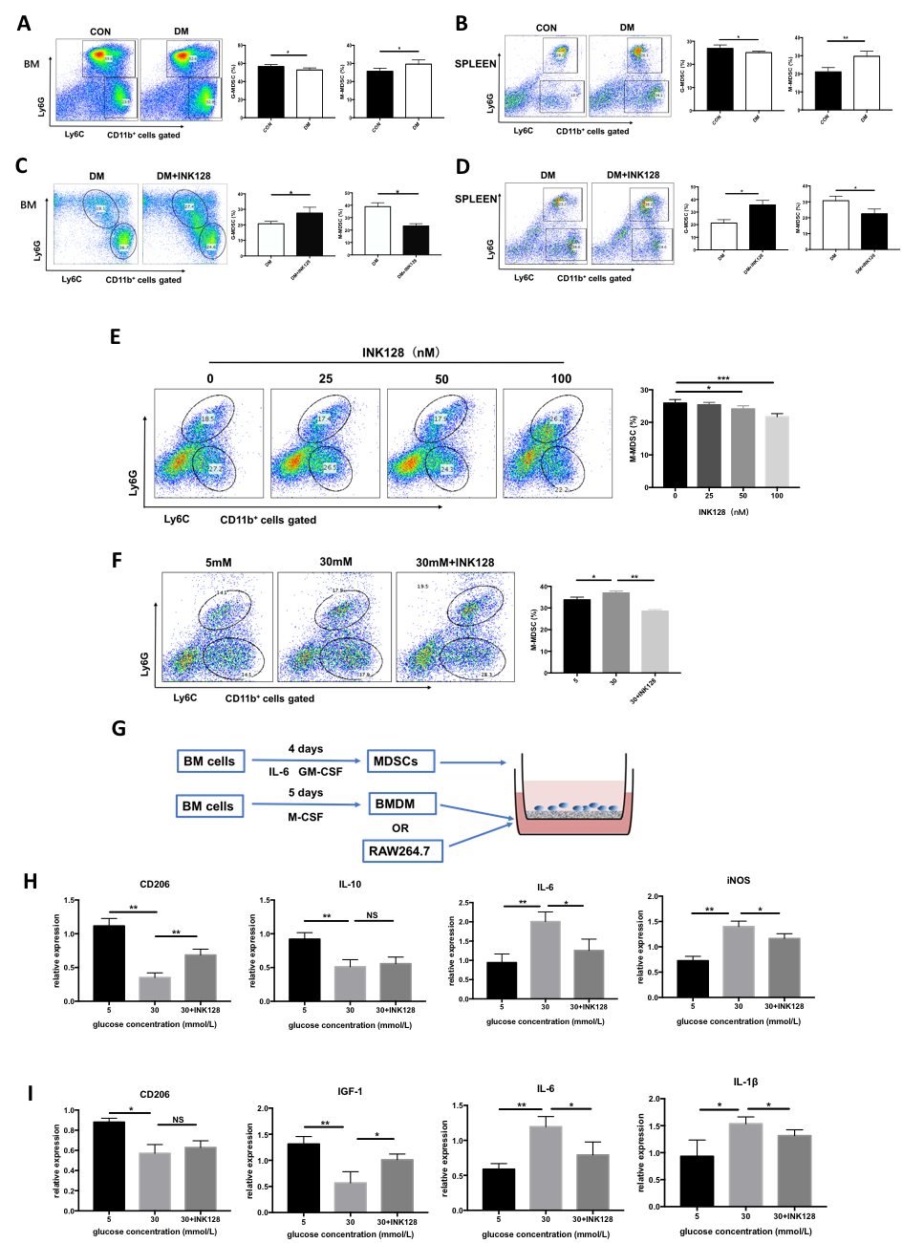
Figure 8. INK128 inhibits the differentiation of M-MDSCs into M1 macrophages in MD. (A-B) The MDSCs differentiated into M-MDSCs in bone marrow and spleen of MD. (C-D) INK128 decreased the MDSCs to differentiate into M-MDSCs in bone marrow and spleen of MD. (E-F) INK128 inhibited the differentiation of glucose-induced MDSCs into M-MDSCs in vitro. (G) The construction process in differentiation of MDSCs/M-MDSCs into macrophage models. (H-I) INK128 inhibited mainly the differentiation of glucose-induced M-MDSCs into M1 macrophage. * P < 0.05; **P < 0.01. M-MDSCs, M-myeloid-derived suppressor cells; CON, control mice; DM, diabetic mice; DM+INK128, the diabetic mice treated with INK128.

