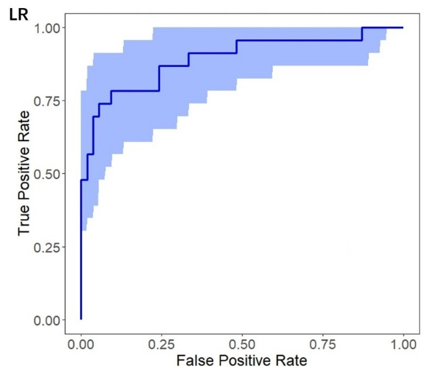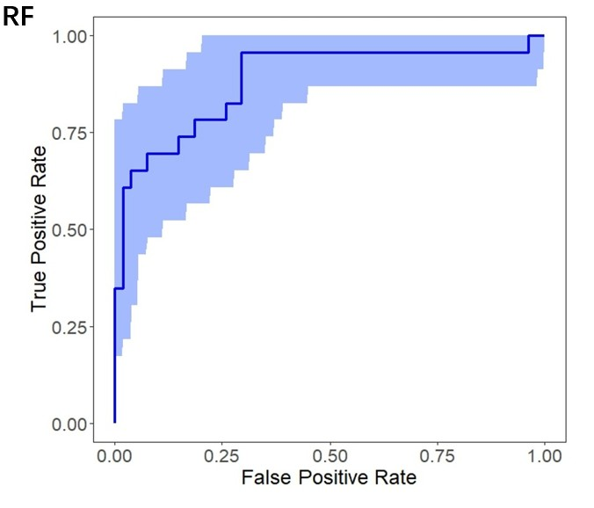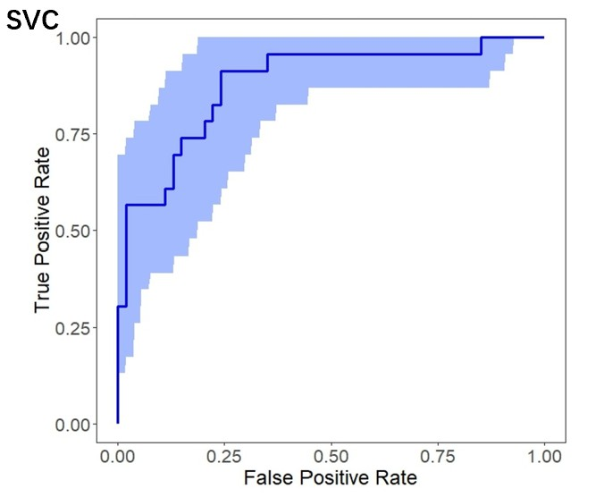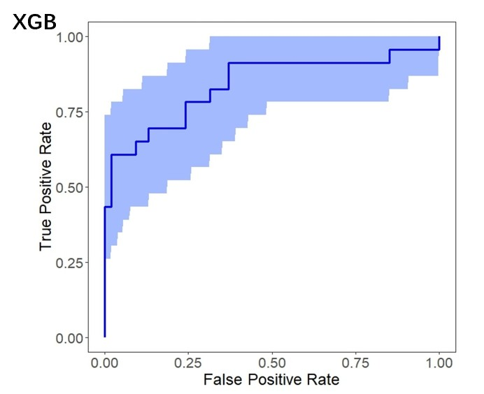
 | AUC
LR | 0.895(0.795,0.970)
RF | 0.865(0.764,0.945)
SVC | 0.862(0.762,0.943)
XGBoost | 0.828(0.718,0.935)

