Supplementary

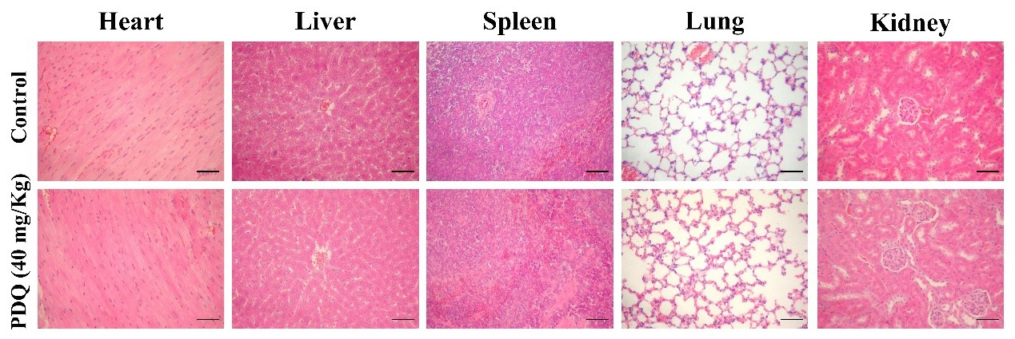

Figure S1. H&E staining of major organs from PDQ and control groups, including the heart, liver, spleen, lung and kidney. Scale bars = 20 μm.

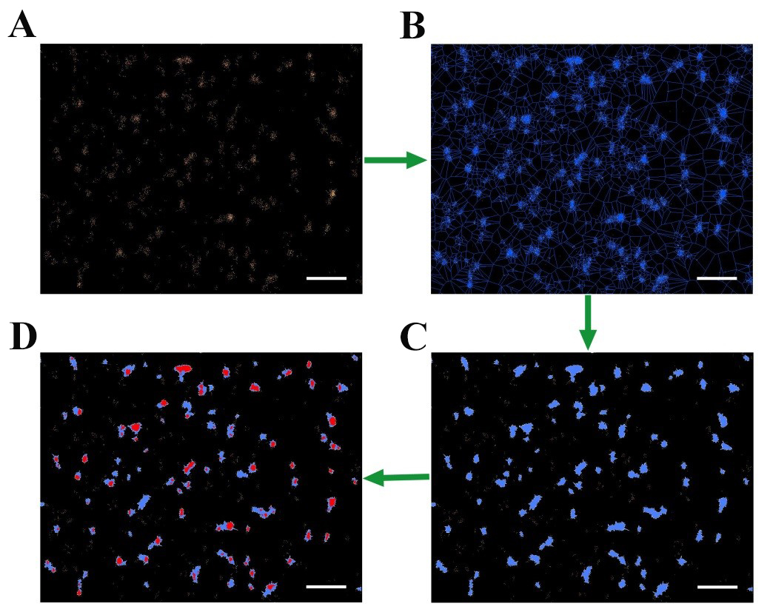

Figure S2. The illustration of SR-Tesseler analysis. An original reconstructed localization map of GLUT1 was imported (A). Bisectors between the nearest localizations segmented the map into many polygons (B). By thresholding the localization density of every polygon, objects (blue) were identified (C), and clusters (red) were extracted through the second thresholding (D). Scale bars are 1 μm.

Table S1. Hematological and biochemical parameters
Group | Control(mean±SD) |  | PDQ（40 mg/Kg）(mean±SD)
WBC (K/μl) | 9.00±0.61 |  | 9.54±0.84
RBC (M/μl) | 10.13±0.48 |  | 10.96±0.32
LY (K/μl) | 7.31±0.42 |  | 7.43±0.85
MONO (K/μl) | 0.72±0.02 |  | 0.83±0.04
ALT (U/L) | 79.30±9.28 |  | 82.54±7.54
AST (U/L) | 177.18±14.76 |  | 168.50±23.53
BUN (mmol/L) | 11.09±1.86 |  | 10.52±1.08
CRE (umol/L) | 34.26±9.22 |  | 30.82±4.75
WBC, white blood cell; RBC, red blood cell; LY, lymphocyte; MONO, monocyte,; ALT, alanine aminotransferase; AST, aspartate aminotransferase; BUN, blood urea nitrogen; CRE, creatinine.

