Supplementary Information
for paper
Using k-mer embeddings learned from Skip-gram based neural network as effective feature representation for building a cross-species prediction model to identify DNA N6-Methyladenine sites in plant genomes
Trinh Trung Duong Nguyen ¹, Quang Thai Ho 1, Van Ngu Trinh ², Le Nguyen Quoc Khanh ³⁴, Yu-Yen Ou ¹
¹ Department of Computer Science and Engineering, Yuan Ze University, Taoyuan,
32003, Taiwan
²SoonChunHyang Institute of Medi-Bio Science, SoonChunHyang University
³Professional Master Program in Artificial Intelligence in Medicine, College of
Medicine, Taipei Medical University, Taipei City 106, Taiwan
⁴Research Center for Artificial Intelligence in Medicine, Taipei Medical University,
Taipei City 106, Taiwan
yienou@gmail.com

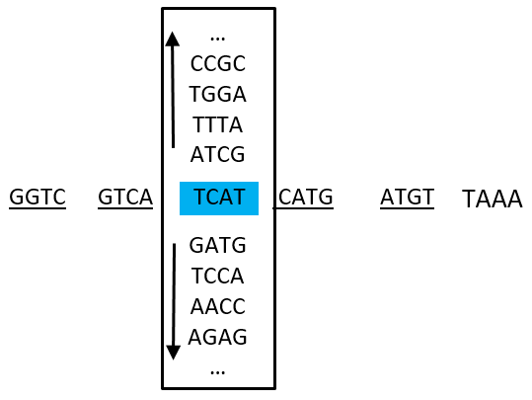
w(t)
w(t-2)
w(t-1)
w(t+1)
w(t+2)
Input
Projection
Output
a)
b)

Figure S1: Example of a Skip-gram neural network learning from a “DNA sentence”.
- An architecture of the Skip-gram neural network
- A “DNA sentence” consisting of 6 “words”. If the context window is 2 and the target word is “TCAT”, then the Skip-gram model will learn to predict “GGTC”, “GTCA”, “CATG”, and “TAAA”

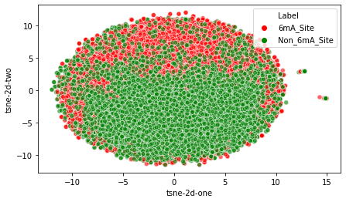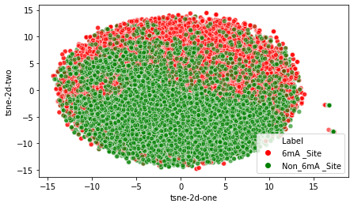
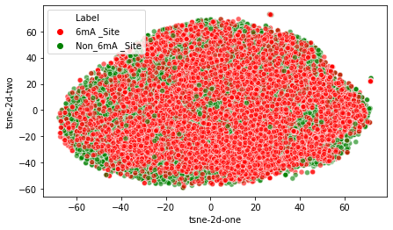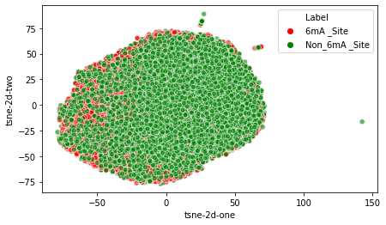
Figure S2: Visualization of representations bases on k-mer embedding using t-SNE. From let to right: First row: (1-mer,2-mer) and (1-mer,2-mer,3-mer) combinations; Second row: (1-mer,2-mer,3-mer,4-mer) and (1-mer,2-mer,3-mer,4-mer,5-mer) combinations. For each figure, samples from different different classes are distinguished using different colors.

