Table 1. Information on sensors used in the Bowen ratio system.
Parameters | Sensors | Height(m) | Accuracy
Relative humidity  Air temperature | 225-050YA, NOVALYNX, Grass Valley, CA, USA | 2.0, 1.5 | ±3%, ± 0.6 ◦C
Wind speed and  wind direction | 200-WS-02, NOVALYNX,  Grass Valley, CA, USA | 2 | ±0.2 m s⁻¹, ±3◦
Solar radiation | PYP-PA, APOGEE, Santa  Monica, CA, USA | 2 | 10~40 µV W⁻¹ m⁻²
Net radiation | 240-100, NOVALYNX, Grass  Valley, CA, USA | 2 | <4%
Soil heat flux | HFP01, HUKSEFLUX, Center  Moriches, NY, USA | -0.05, -0.02 | 50 µV W⁻¹ m⁻²

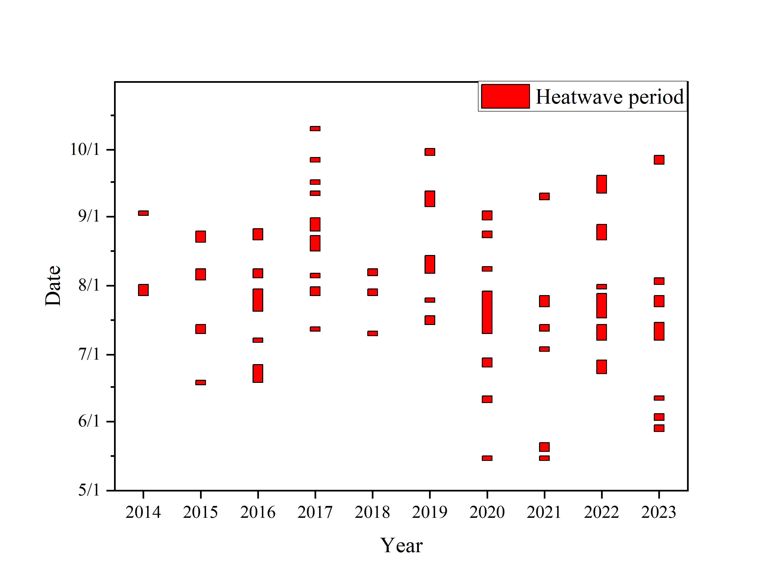
Figure 1. Identified heatwave periods in Shenzhen University Town based on 10 years (2014-2023) of Bowen ratio System, using air temperature recorded at a height of 1.5 m.

Table 2. Identified heatwave periods in Shenzhen University Town.
Number | Year | Start Date |  | End Date |  | Number | Year | Start Date | End Date
#1 | 2014 |  | 28-Jul | 2-Aug |  | #28 | 2019 | 29-Sep | 2-Oct
#2 | 2014 |  | 2-Sep | 4-Sep |  | #29 | 2020 | 15-May | 17-May
#3 | 2015 |  | 18-Jun | 20-Jun |  | #30 | 2020 | 10-Jun | 13-Jun
#4 | 2015 |  | 11-Jul | 15-Jul |  | #31 | 2020 | 26-Jun | 30-Jun
#5 | 2015 |  | 4-Aug | 9-Aug |  | #32 | 2020 | 11-Jul | 30-Jul
#6 | 2015 |  | 21-Aug | 26-Aug |  | #33 | 2020 | 8-Aug | 10-Aug
#7 | 2016 |  | 19-Jun | 27-Jun |  | #34 | 2020 | 23-Aug | 26-Aug
#8 | 2016 |  | 7-Jul | 9-Jul |  | #35 | 2020 | 31-Aug | 4-Sep
#9 | 2016 |  | 21-Jul | 31-Jul |  | #36 | 2021 | 15-May | 17-May
#10 | 2016 |  | 5-Aug | 9-Aug |  | #37 | 2021 | 19-May | 23-May
#11 | 2016 |  | 22-Aug | 27-Aug |  | #38 | 2021 | 3-Jul | 5-Jul
#12 | 2017 |  | 12-Jul | 14-Jul |  | #39 | 2021 | 12-Jul | 15-Jul
#13 | 2017 |  | 28-Jul | 1-Aug |  | #40 | 2021 | 23-Jul | 28-Jul
#14 | 2017 |  | 5-Aug | 7-Aug |  | #41 | 2021 | 9-Sep | 12-Sep
#15 | 2017 |  | 17-Aug | 24-Aug |  | #42 | 2022 | 23-Jun | 29-Jun
#16 | 2017 |  | 26-Aug | 1-Sep |  | #43 | 2022 | 8-Jul | 15-Jul
#17 | 2017 |  | 11-Sep | 13-Sep |  | #44 | 2022 | 18-Jul | 29-Jul
#18 | 2017 |  | 16-Sep | 18-Sep |  | #45 | 2022 | 31-Jul | 2-Aug
#19 | 2017 |  | 26-Sep | 28-Sep |  | #46 | 2022 | 22-Aug | 29-Aug
#20 | 2017 |  | 10-Oct | 12-Oct |  | #47 | 2022 | 12-Sep | 20-Sep
#21 | 2018 |  | 10-Jul | 12-Jul |  | #48 | 2023 | 28-May | 31-May
#22 | 2018 |  | 28-Jul | 31-Jul |  | #49 | 2023 | 2-Jun | 5-Jun
#23 | 2018 |  | 6-Aug | 9-Aug |  | #50 | 2023 | 11-Jun | 13-Jun
#24 | 2019 |  | 15-Jul | 19-Jul |  | #51 | 2023 | 8-Jul | 16-Jul
#25 | 2019 |  | 25-Jul | 27-Jul |  | #52 | 2023 | 23-Jul | 28-Jul
#26 | 2019 |  | 7-Aug | 15-Aug |  | #53 | 2023 | 2-Aug | 5-Aug
#27 | 2019 |  | 6-Sep | 13-Sep |  | #54 | 2023 | 25-Sep | 29-Sep

