Supplementary Material
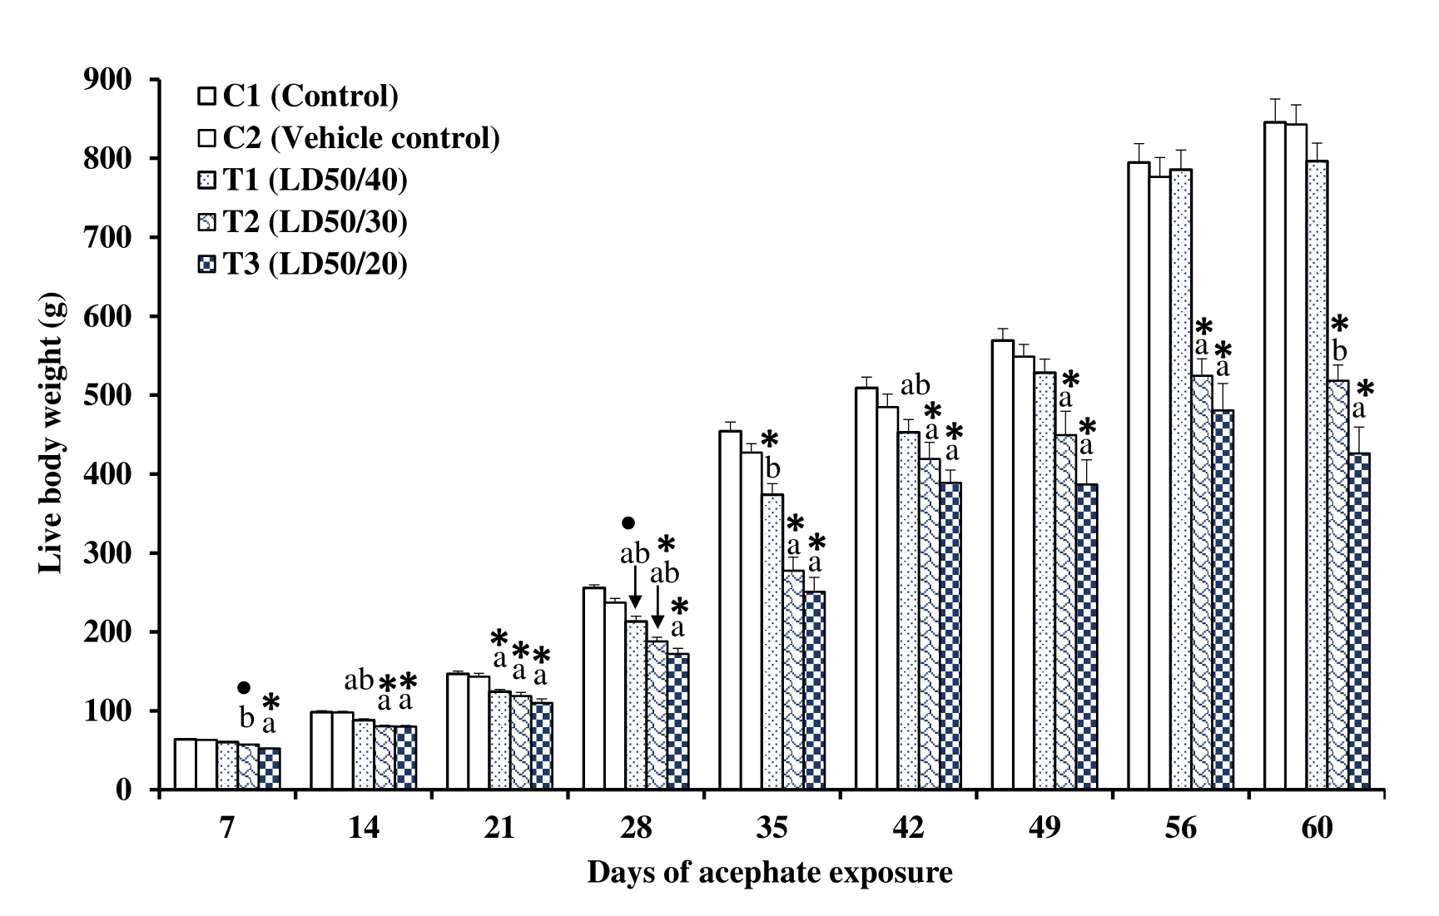
Supplementary FIGURE 1: Effect on live body weight (g) of white leghorn cockerels in control and different treatment groups following daily oral exposure to acephate suspended in groundnut oil for 60 days. Each bar represents mean ± SEM (n= 10). Bars bearing different alphabet shows the mean difference is significant at the level 0.05 while bars bearing bullet point (•) and asterisk (*) vary significantly (p < 0.05) and highly significantly (p < 0.01) respectively in Duncan’s multiple comparison post hoc tests.
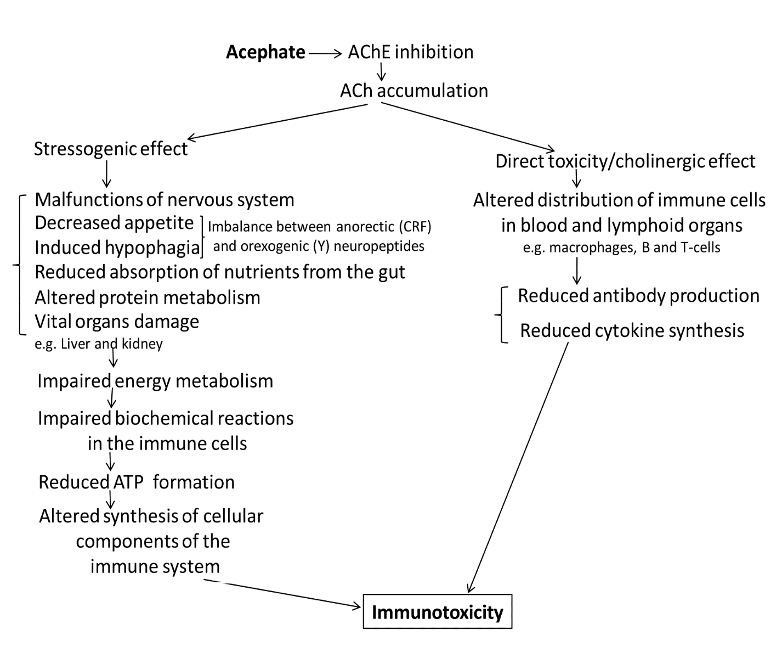
Supplementary FIGURE 2: Proposed schematic representation of acephate induced immunotoxicity by inhibition of acetylcholinesterase (AChE).

