GenomeFISH: genome-based fluorescence in situ hybridisation for strain-level visualisation of microbial communities

Supplementary Information
Supplementary Note 1
To generate GenomeFISH polynucleotide probes, DNA of isolates, SAGs, and calf thymus (negative control) was sheared to ~130bp, a length consistent with the optimal fragment size suggested for nucleic acid hybridisations¹. Fragments were fluorescently labelled, and probe labelling efficiency was measured in nucleotide base to dye ratio (BDR, Table S2). For isolates, the average labelling efficiencies per 130 nucleotides were 1.6 (for Alexa546), 2.3 (Alexa594), and 2.0 fluorophores (Alexa647). Average labelling efficiencies were 1.9 (Alexa546), 2.2 (Alexa594), and 1.3 fluorophores (Alexa647) for SAGs, and 2.4, 1.8, and 2.2, respectively, for calf thymus DNA.

Supplementary Note 2
Two Agathobacter rectalis single amplified genomes (SAGs) were obtained from a single donor from samples collected 11 months apart (Nov 2022 and Oct 2023, Table S4). The SAG from each sample was near identical to the MAG recovered from the respective metagenome (99.78% ANI sample 1, 99.88% ANI sample 2), but the genomes differed between samples (94.8% ANI between SAGs, 98.08% ANI between MAGs), suggesting that each faecal sample contained a distinct A. rectalis strain.
To investigate if the two strains were unique to each sample, reads from the bulk metagenomes were aligned to each MAG (see details below). In the first metagenome, 99.4% of MAG 1-specific single nucleotide variants (SNVs) had >0 coverage (median coverage 250), while only 1.7% of MAG 2-specific SNVs had >0 coverage. This shows that the strain of the second faecal sample (Strain 2) was either absent or present only at very small abundance in the first faecal sample. The converse analysis (i.e. mapping reads from the second metagenome) yielded analogous results, showing that the strain found in the first faecal sample (Strain 1) was absent from the second faecal sample.

Methodological details
To find variants in the metagenomic reads, Lorikeet v0.8.2² 'call' was used to call variants against the Strain 1 genome as a reference. To account for genome incompleteness in the MAGs, only variant positions in regions that aligned between the two genomes were considered. Specifically, only the coverage of those variants which could be converted between the MAGs using transanno v0.4.5 (https://github.com/informationsea/transanno) ‘liftover’ from the Strain 1 genome to the Strain 2 genome were considered. To generate the chain file required for ‘liftover’³, minimap2 v2.28-r1209⁴ ‘-cx asm5 --cs’ was used to align the genome, with the resulting PAF file converted to chain format using transanno ‘minimap2chain’.
After applying bcftools v1.20⁵ ‘norm -m +any’ and ‘annotate -x FORMAT/PL’ to the variant call format (VCF) file⁶ produced by Lorikeet, transanno ‘liftover’ was applied. Of the 36,854 variants, 27,807 biallelic SNVs were lifted over from the genome of Strain 2 to the genome of Strain 1.
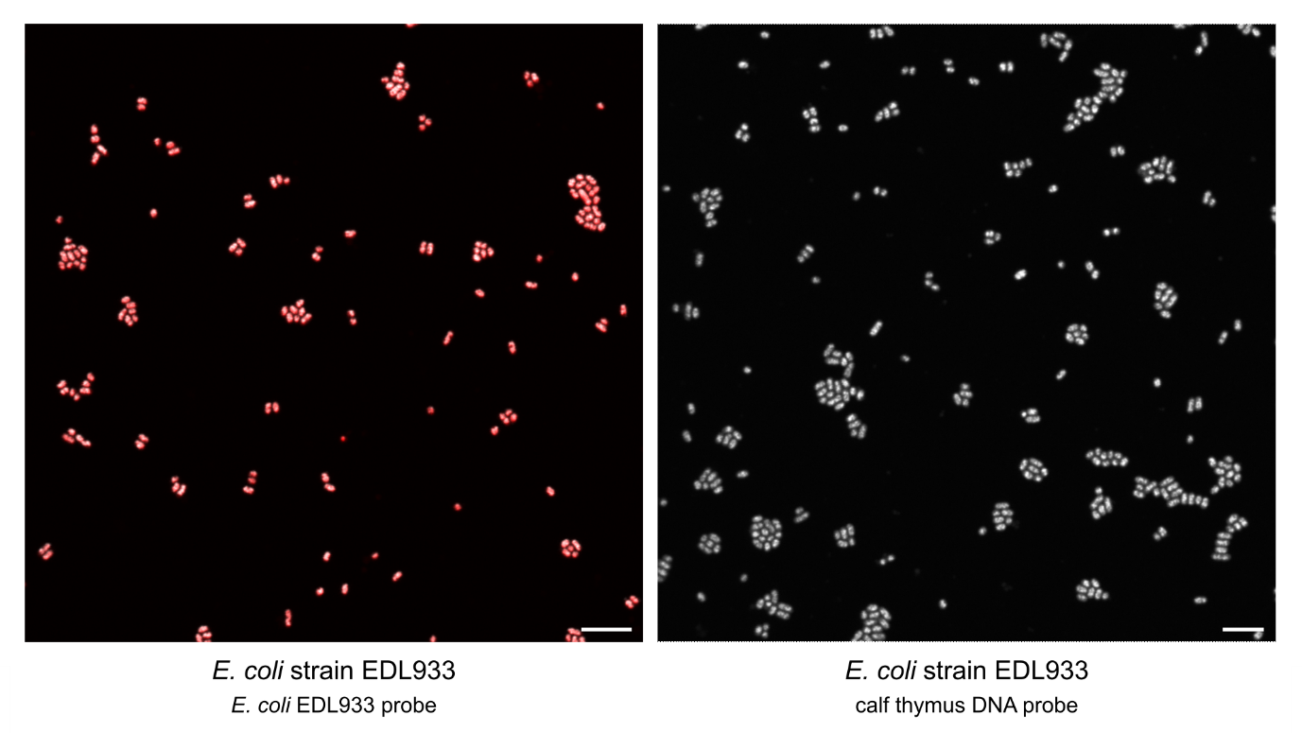
Figure S1. Representative GenomeFISH micrographs of E. coli strain EDL933 hybridised with GenomeFISH probes generated from E. coli strain EDL933 (left) or calf thymus DNA (right). GenomeFISH signal appears red and DAPI signal grey. Scale bars are 5 µm.

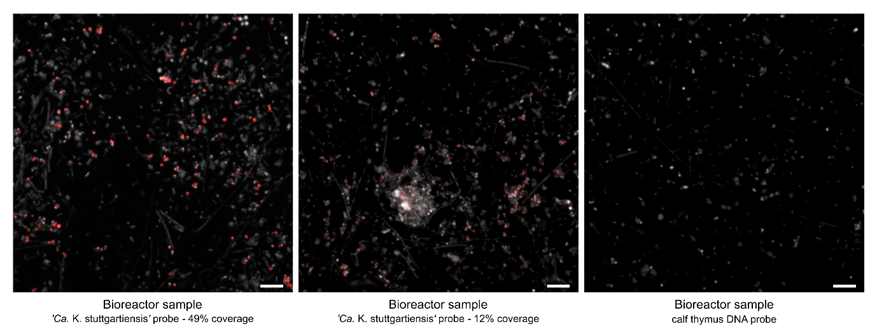
Figure S2. Representative GenomeFISH micrographs of a bioreactor community hybridised with GenomeFISH probes generated from ‘Ca. Kuenenia stuttgartiensis’ (49% complete SAG, left), ‘Ca. Kuenenia stuttgartiensis’ (12% complete SAG, middle), and calf thymus DNA (right). GenomeFISH signal appears red and DAPI signal grey. Scale bars are 5 µm.

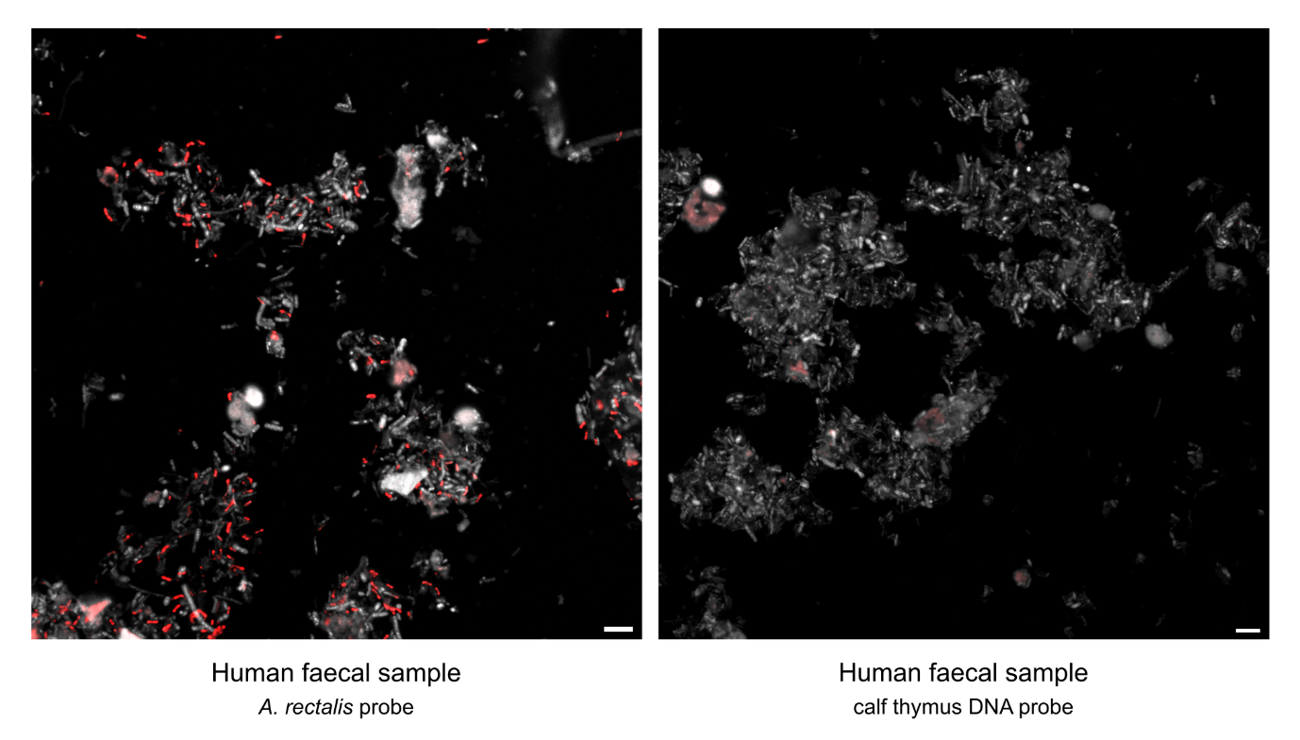
Figure S3. Representative GenomeFISH micrographs of a human faecal sample hybridised with GenomeFISH probes generated from Agathobacter rectalis (left) or calf thymus DNA (right). GenomeFISH signal appears red and DAPI signal grey. Scale bars are 5 µm.

Supplementary Table legends

Table S1. Details of the in-house cultured isolates and single amplified genomes (SAGs) used to optimise the GenomeFISH protocol. SAGs highlighted in green were used to test the effect of SAG coverage on signal specificity and sensitivity.

Table S2. Labelling efficiency of isolate and single cell DNA for the respective fluorophore the DNA was labelled with. BDR: base to dye ratio.

Table S3. Overview of the metagenome assembled genomes (MAGs), and single amplified genomes (SAGs) retrieved from the bioreactor sample, including MAG abundance and taxonomy, and fraction of the corresponding MAGs covered by the SAGs. MAGs for which SAGs were recovered are highlighted in grey. SAGs that were used to generate GenomeFISH probes are highlighted in green.

Table S4. Overview of the metagenome assembled genomes (MAGs), and single amplified genomes (SAGs) retrieved from two human faecal samples, including MAG abundance and taxonomy, and fraction of the corresponding MAGs covered by the SAGs. MAGs for which SAGs were recovered are highlighted in grey. SAGs that were used to generate GenomeFISH probes are highlighted in green.

References

1 Lichter, P. & Cremer, T. in Human Cytogenetics: A Practical Approach (ed D.E. Rooney and B.H. Czepulkowski) 157–192 (IRL Press, 1992).
2 Newell, R. J. P., McMaster, E. S., Craig, P., Boden, M., Tyson, G. W., Woodcroft, B. J. Lorikeet: strain-resolved metagenome analysis using local reassembly (v0.8.2). Zenodo (2023). https://doi.org:https://doi.org/10.5281/zenodo.10275469
3 Genovese, G. et al. BCFtools/liftover: an accurate and comprehensive tool to convert genetic variants across genome assemblies. Bioinform 40 (2024). https://doi.org:10.1093/bioinformatics/btae038
4 Li, H. Minimap2: pairwise alignment for nucleotide sequences. Bioinform 34, 3094-3100 (2018). https://doi.org:10.1093/bioinformatics/bty191
5 Danecek, P. et al. Twelve years of SAMtools and BCFtools. Gigascience 10, giab008 (2021).
6 Danecek, P. et al. The variant call format and VCFtools. Bioinform 27, 2156-2158 (2011). https://doi.org:10.1093/bioinformatics/btr330

