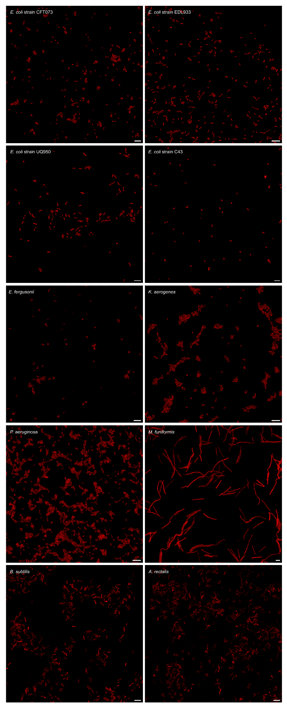
Extended Data Figure 1. Representative GenomeFISH micrographs for in-house cultured isolates. GenomeFISH micrographs show Escherichia coli strains (CFT073, EDL933, UQ950, and C43), Escherichia fergusonii, Klebsiella aerogenes, Pseudomonas aeruginosa, Megamonas funiformis, Bacillus subtilis, and Agathobacter rectalis hybridised with their respective GenomeFISH probes. Scale bars are 5 µm.

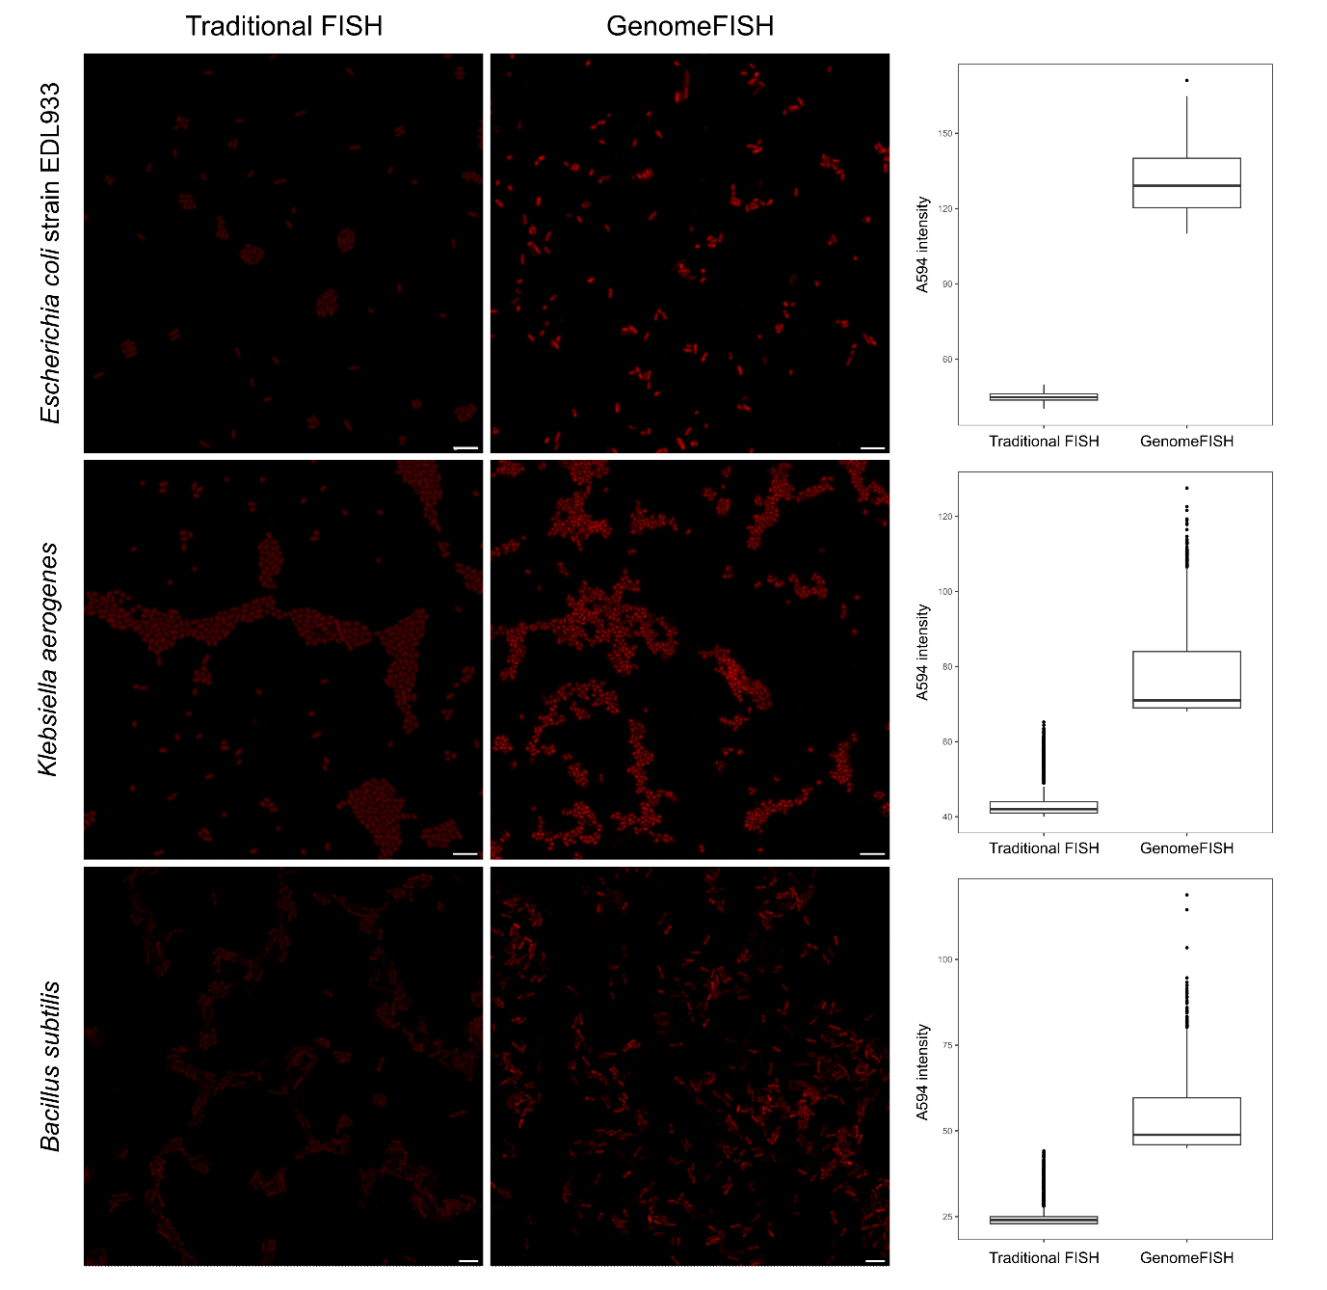
Extended Data Figure 2. Comparison of signal intensities of traditional FISH and GenomeFISH performed on isolates. Representative micrographs show signal intensities for Escherichia coli strain EDL933 (top panels), Klebsiella aerogenes (middle panels), and Bacillus subtilis (bottom panels). Traditional FISH probes (left panels) and GenomeFISH probes (right panels) were applied to targeted cells under respective optimal conditions and images for comparison were acquired using the same settings on the microscope for each species. Scale bars are 5 µm.

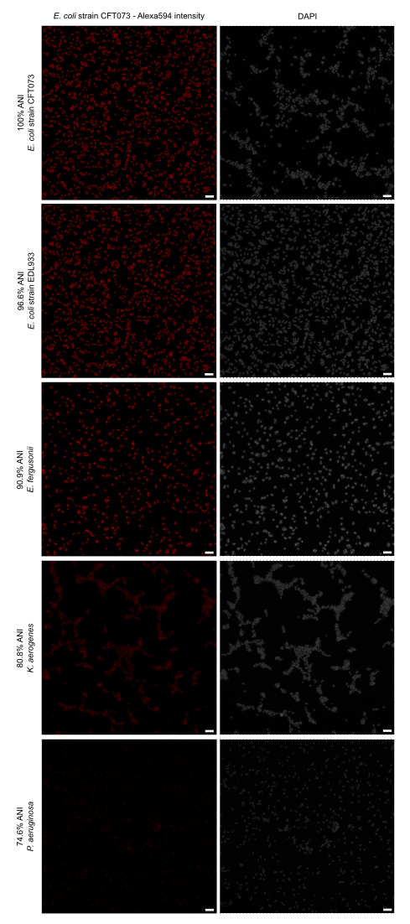
Extended Data Figure 3. Representative GenomeFISH micrographs for Figure 3A. GenomeFISH micrographs show the DAPI signal and signal intensity of probes generated from E. coli strain CFT073 when hybridised to four bacteria with ANI values between 74.6% and 96.6%. Scale bar is 5 um.
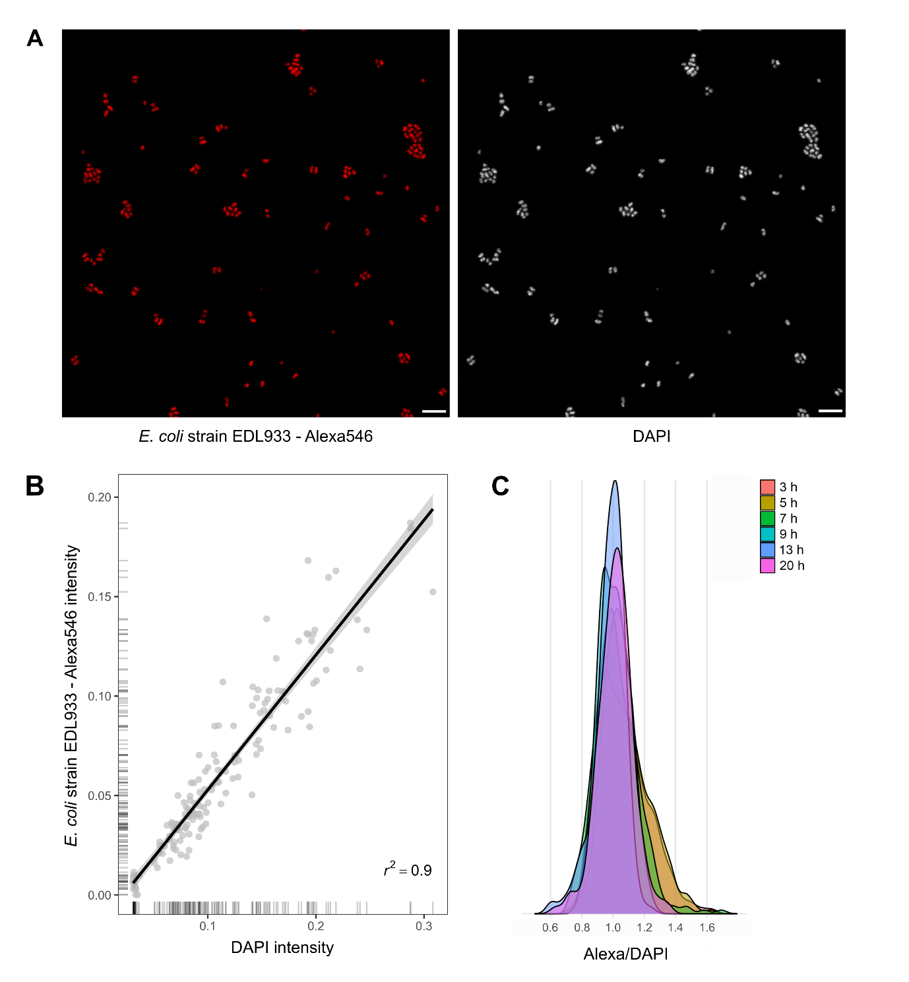
Extended Data Figure 4. Relationship between the GenomeFISH and DAPI signal in a target population A) GenomeFISH micrographs showing the signal variation within a single Escherichia coli strain EDL933 population. The left micrograph shows the GenomeFISH signal, the right micrograph shows the DAPI signal. Scale bar is 5 µm. B) Correlation between GenomeFISH and DAPI signal intensity. Each grey dot represents a single E. coli EDL933 cell as seen in Panel A. C) Relationship between the GenomeFISH and DAPI signal across growth phases of E. coli.

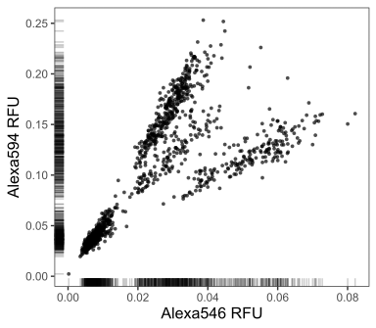
Extended Data Figure 5. Image segmentation results of Figure 3C. Signal intensity (RFU, relative fluorescence unit) of Alexa546 versus Alexa594 for each cell in a mock community consisting of Escherichia coli strains CFT073 and EDL933, Escherichia fergusonii, and Pseudomonas aeruginosa. Cells were hybridised with GenomeFISH probes generated from E. coli CFT073 in Alexa546 and from E. coli EDL933 in Alexa594.

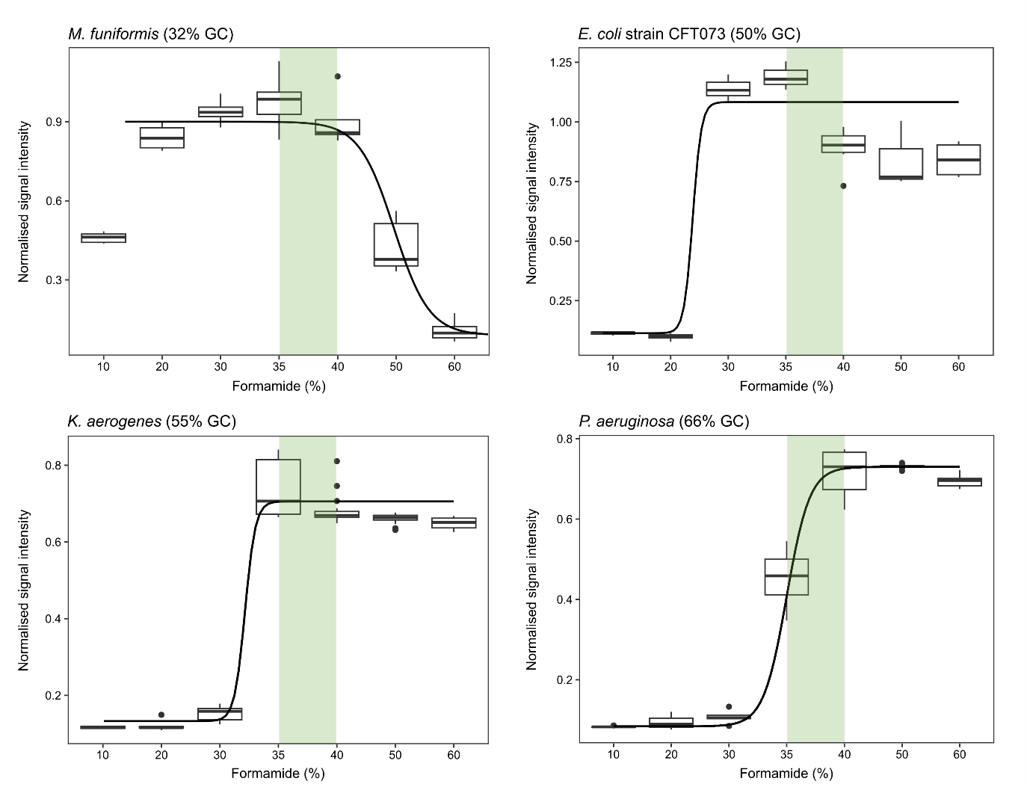
Extended Data Figure 6. The effect of GC content on the hybridisation efficiency of GenomeFISH probes. Formamide dissociation curves for four microbial species with varying GC content, including Megamonas funiformis (top left, 32% GC content), Escherichia coli strain CFT073 (top right, 50% GC), Klebsiella aerogenes (bottom left, 55% GC), and Pseudomonas aeruginosa (bottom right, 66% GC). Each microorganism was hybridised with their respective GenomeFISH probes. Normalised signal intensities are shown (GenomeFISH/DAPI signal intensities). Optimal formamide concentrations for the application of GenomeFISH on mixed microbial communities are highlighted in green.

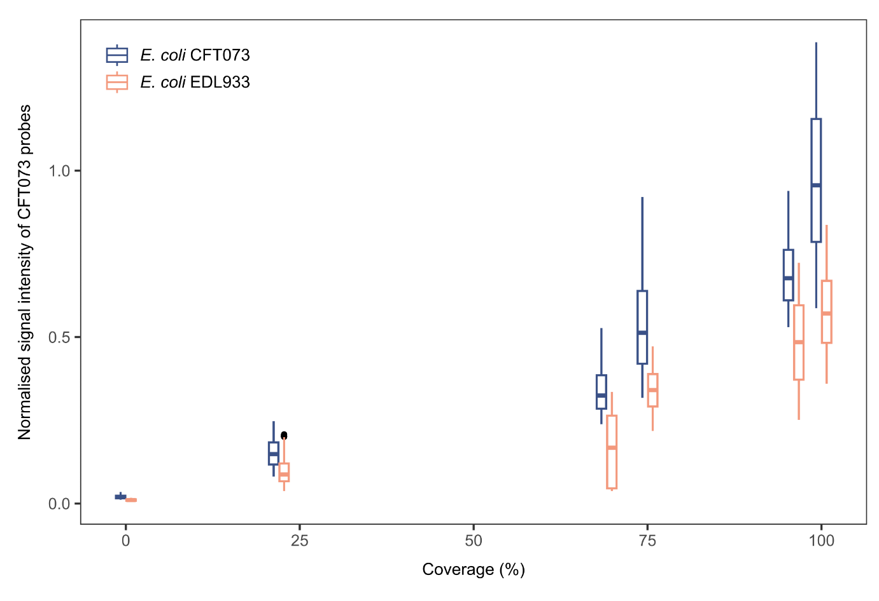
Extended Data Figure 7. The effect of SAG coverage on the specificity and sensitivity of GenomeFISH. Relationship between normalised GenomeFISH signal intensity (GenomeFISH/DAPI signal intensity) and single amplified genome (SAG) coverage when GenomeFISH probes generated from Escherichia coli strain CFT073 SAGs were hybridised to E. coli strains CFT073 and EDL933. A coverage of 0% represents the normalised signal intensity of cells when no probes are added to the hybridisation.

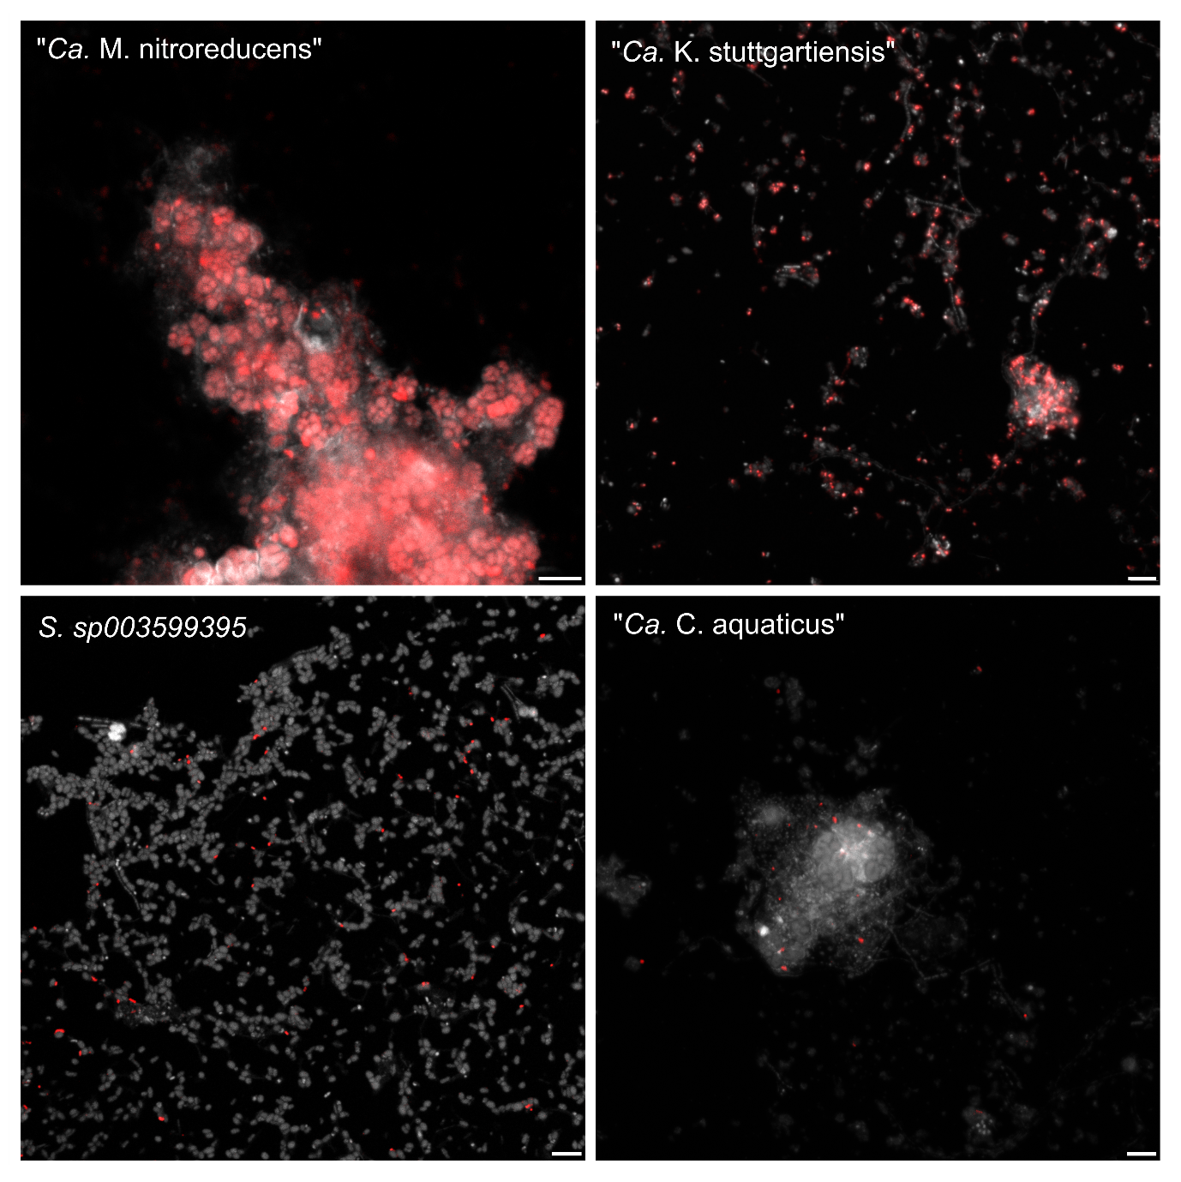
Extended Data Figure 8. GenomeFISH micrographs of microbial populations in a bioreactor sample. GenomeFISH micrographs show biomass of a bioreactor sample hybridised with GenomeFISH probes generated from ‘Ca. Methanoperedens nitroreducens’ (top left), ‘Ca. Kuenenia stuttgartiensis’ (top right), SURF-28 sp003599395 (bottom left), and ‘Ca. Chazhemtobacterium aquaticus’ (bottom right). GenomeFISH signal appears red and DAPI signal grey. Scale bars are 5 μm.

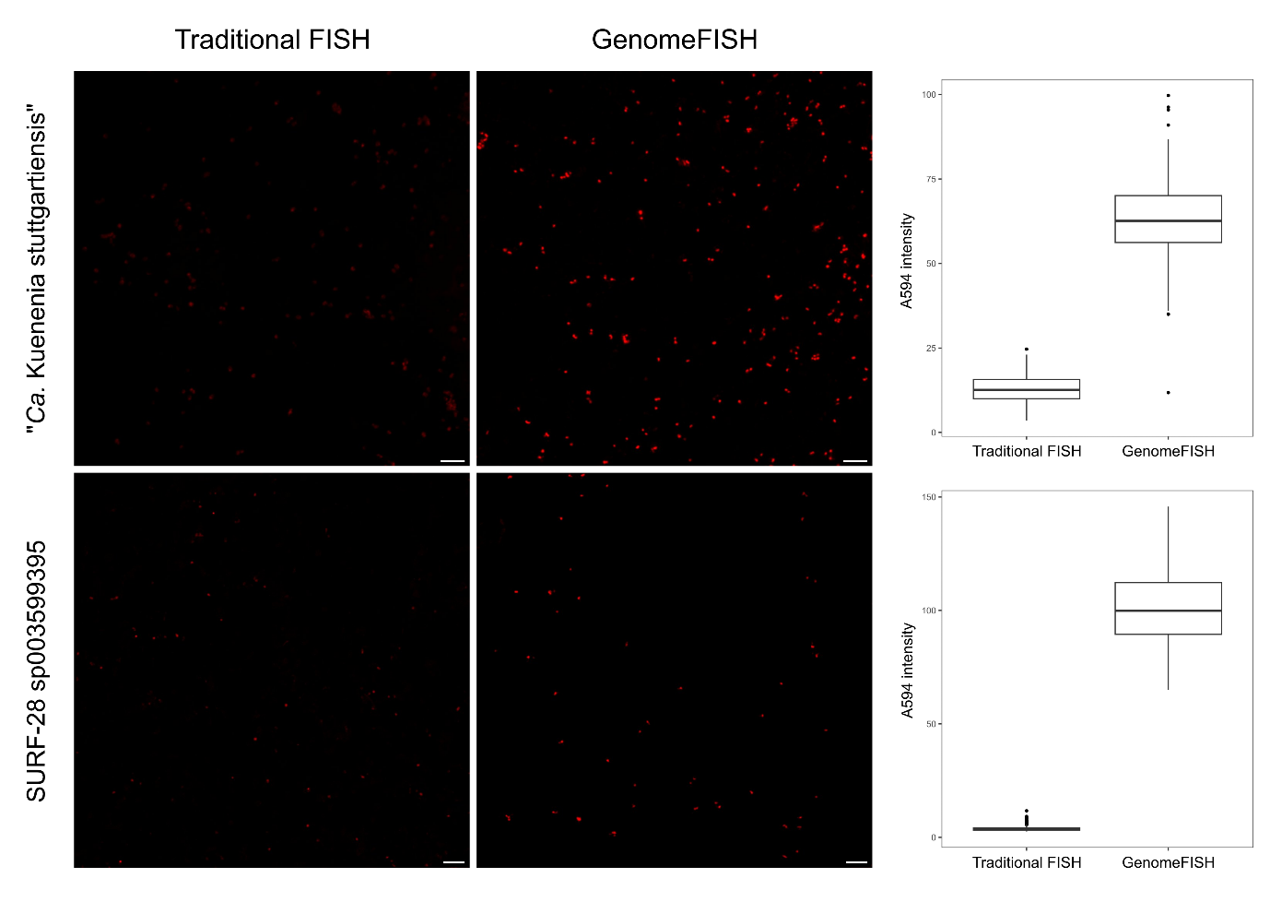
Extended Data Figure 9. Comparison of signal intensities of traditional FISH and GenomeFISH performed on a bioreactor community. Representative micrographs show signal intensities for ‘Ca. Kuenenia stuttgartiensis’ (top panels) and SURF sp003599395 (bottom panels). Traditional FISH probes (left panels) and GenomeFISH probes (right panels) were applied to targeted cells under respective optimal conditions and images for comparison were acquired using the same settings on the microscope for each species. Scale bars are 5 µm.

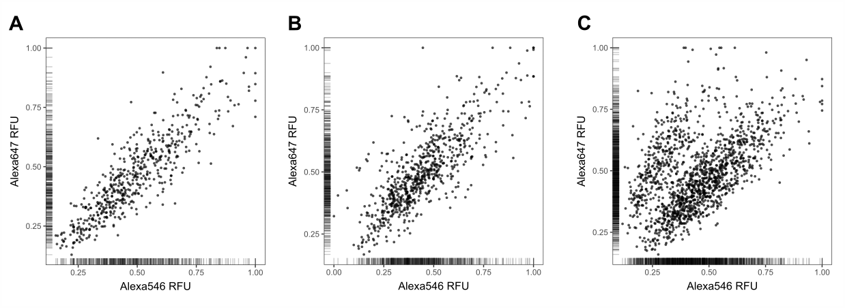
Extended Data Figure 10. Image segmentation of GenomeFISH micrographs of A. rectalis strains in human faecal samples. Signal intensity (RFU, relative fluorescence unit) of cells labelled with Alexa546 versus Alexa647 for human faecal samples hybridised with GenomeFISH probes from Agathobacter rectalis Strain 1 (in Alexa546) and A. rectalis Strain 2 (in Alexa647). A and B) Signal intensities for two individual faecal samples, each containing one strain of A. rectalis. Plot A shows the first faecal sample that was collected and Plot B shows the second faecal sample that was collected from the same donor 11 months later. C) Signal intensities of cells in a mixture of two human faecal samples containing two A. rectalis strains. All samples (Plot A-C) were hybridised with GenomeFISH probes generated from both Strain 1 and 2. For each plot, signal intensities were measured for five fields of view.

