Supplementary Information

3d(Fe)-5d(W) diatomic hybrid oxygen electrocatalysts enables ultra-stable operation of rechargeable zinc-air batteries for over 10,000 h

Yifan Li¹, Hanlin Wang¹, Chang Chen², Xuesong Xie¹, Yang Yang¹, Xuehai Tan¹, Keren Jiang¹, Ning Chen³, Hao Zhang¹*, Zhi Li¹*
¹Department of Chemical and Materials Engineering, University of Alberta, Edmonton, Alberta T6G 1H9, Canada
²Engineering Research Center of Advanced Rare Earth Materials, Department of Chemistry, Tsinghua University, Beijing, 100000, China
³Hard X-Ray Micro Analysis BL, Canadian Light Source Saskatoon, Saskatchewan, S7N 2V3 Canada

Contents:
Supplementary Figure 1-29
Supplementary Table 1-7
Supplementary Reference 1-32

Supplementary Figures

Supplementary Fig. 1. Morphological characterizations of WC-C catalyst. a, Scanning electron microscopy (SEM) image. b, Transmission electron microscopy (TEM) image. c, X-ray diffraction (XRD) pattern. d, High-angle annular dark-field scanning transmission electron microscopy (HAADF-STEM) image and corresponding energy-dispersive X-ray spectroscopy (EDX) mapping images for C (red) and W (yellow).

Supplementary Fig. 2. X-ray photoelectron spectroscopy (XPS) analysis of WC-C catalyst. a, High-resolution XPS spectrum of C 1s. b, High-resolution XPS spectrum of W 4f.

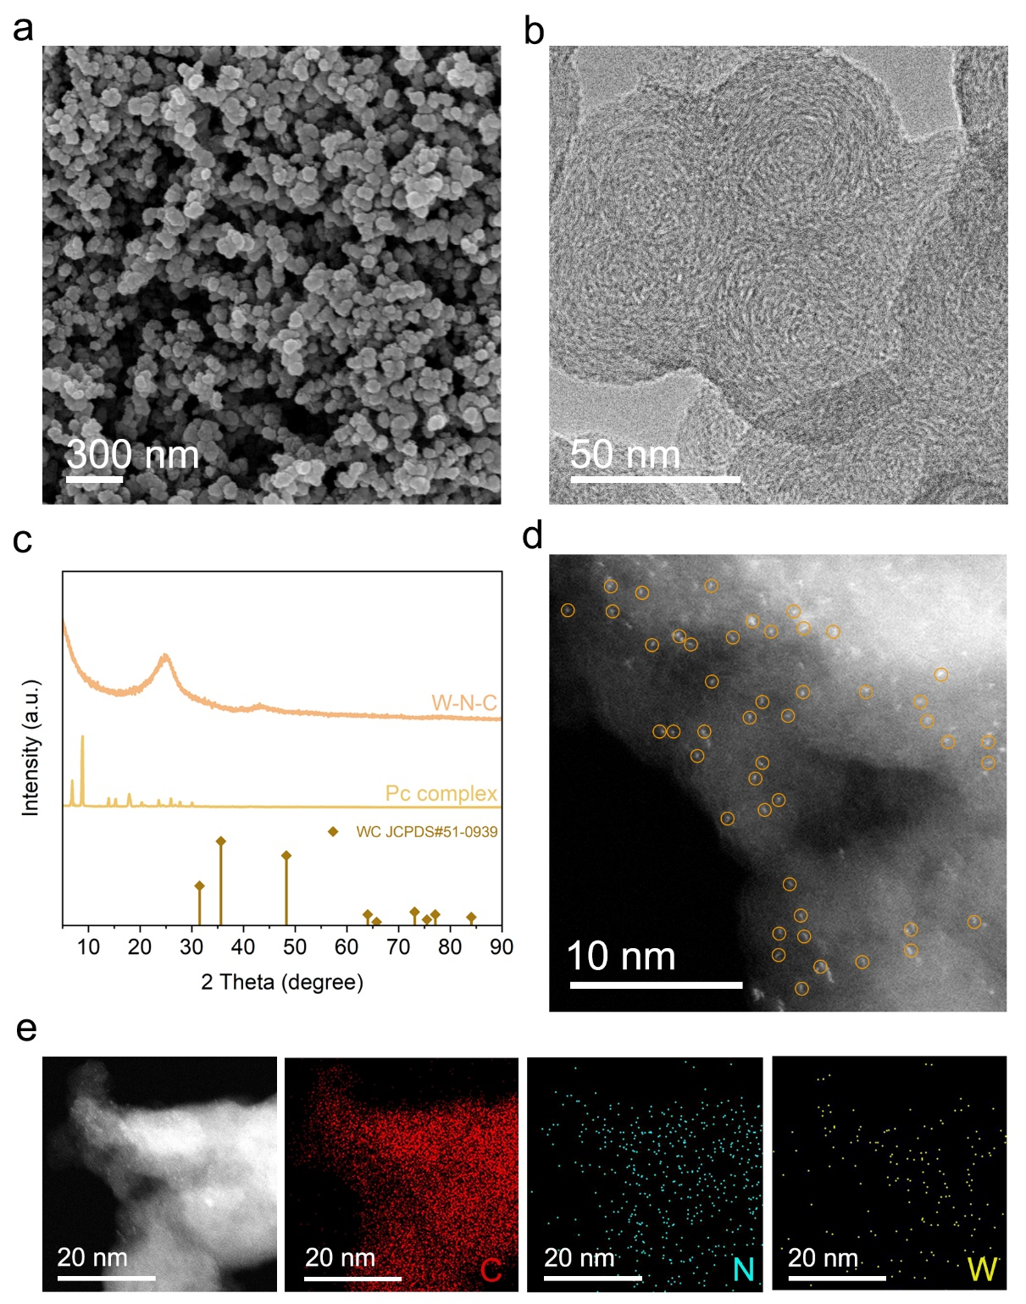

Supplementary Fig. 3. Morphological characterizations of W-N-C catalyst. a, SEM image. b, TEM image. c, XRD patterns of W-N-C catalyst and phthalocyanine crystalline complex (Pc complex). d, Aberration-corrected HAADF-STEM image. e, HAADF-STEM image and corresponding EDX mapping images for C (red), N (blue) and W (yellow).

Supplementary Fig. 4. XPS analysis of W-N-C catalyst. a, High-resolution XPS spectrum of C 1s. b, High-resolution XPS spectrum of N 1s. c, High-resolution XPS spectrum of W 4f.

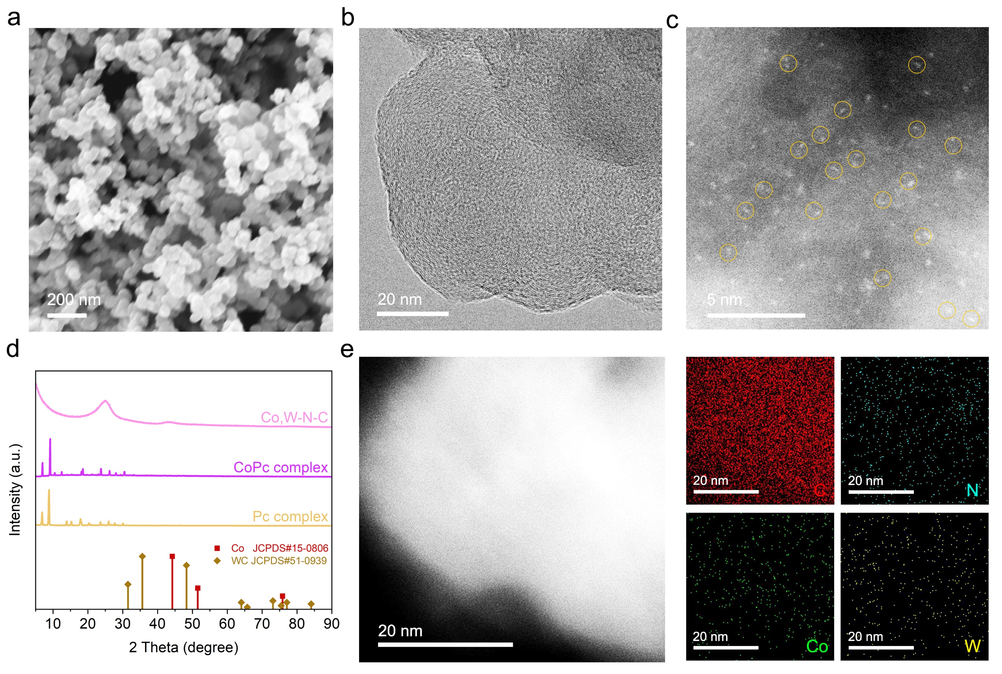

Supplementary Fig. 5. Morphological characterizations of Co,W-N-C catalyst. a, SEM image. b, TEM image. c, Aberration-corrected HAADF-STEM image. d, XRD patterns of Co,W-N-C catalyst, cobalt (Ⅱ) phthalocyanine complex (CoPc complex) and Pc complex. e, HAADF-STEM image and corresponding EDX mapping images for C (red), N (blue), Co (green) and W (yellow).

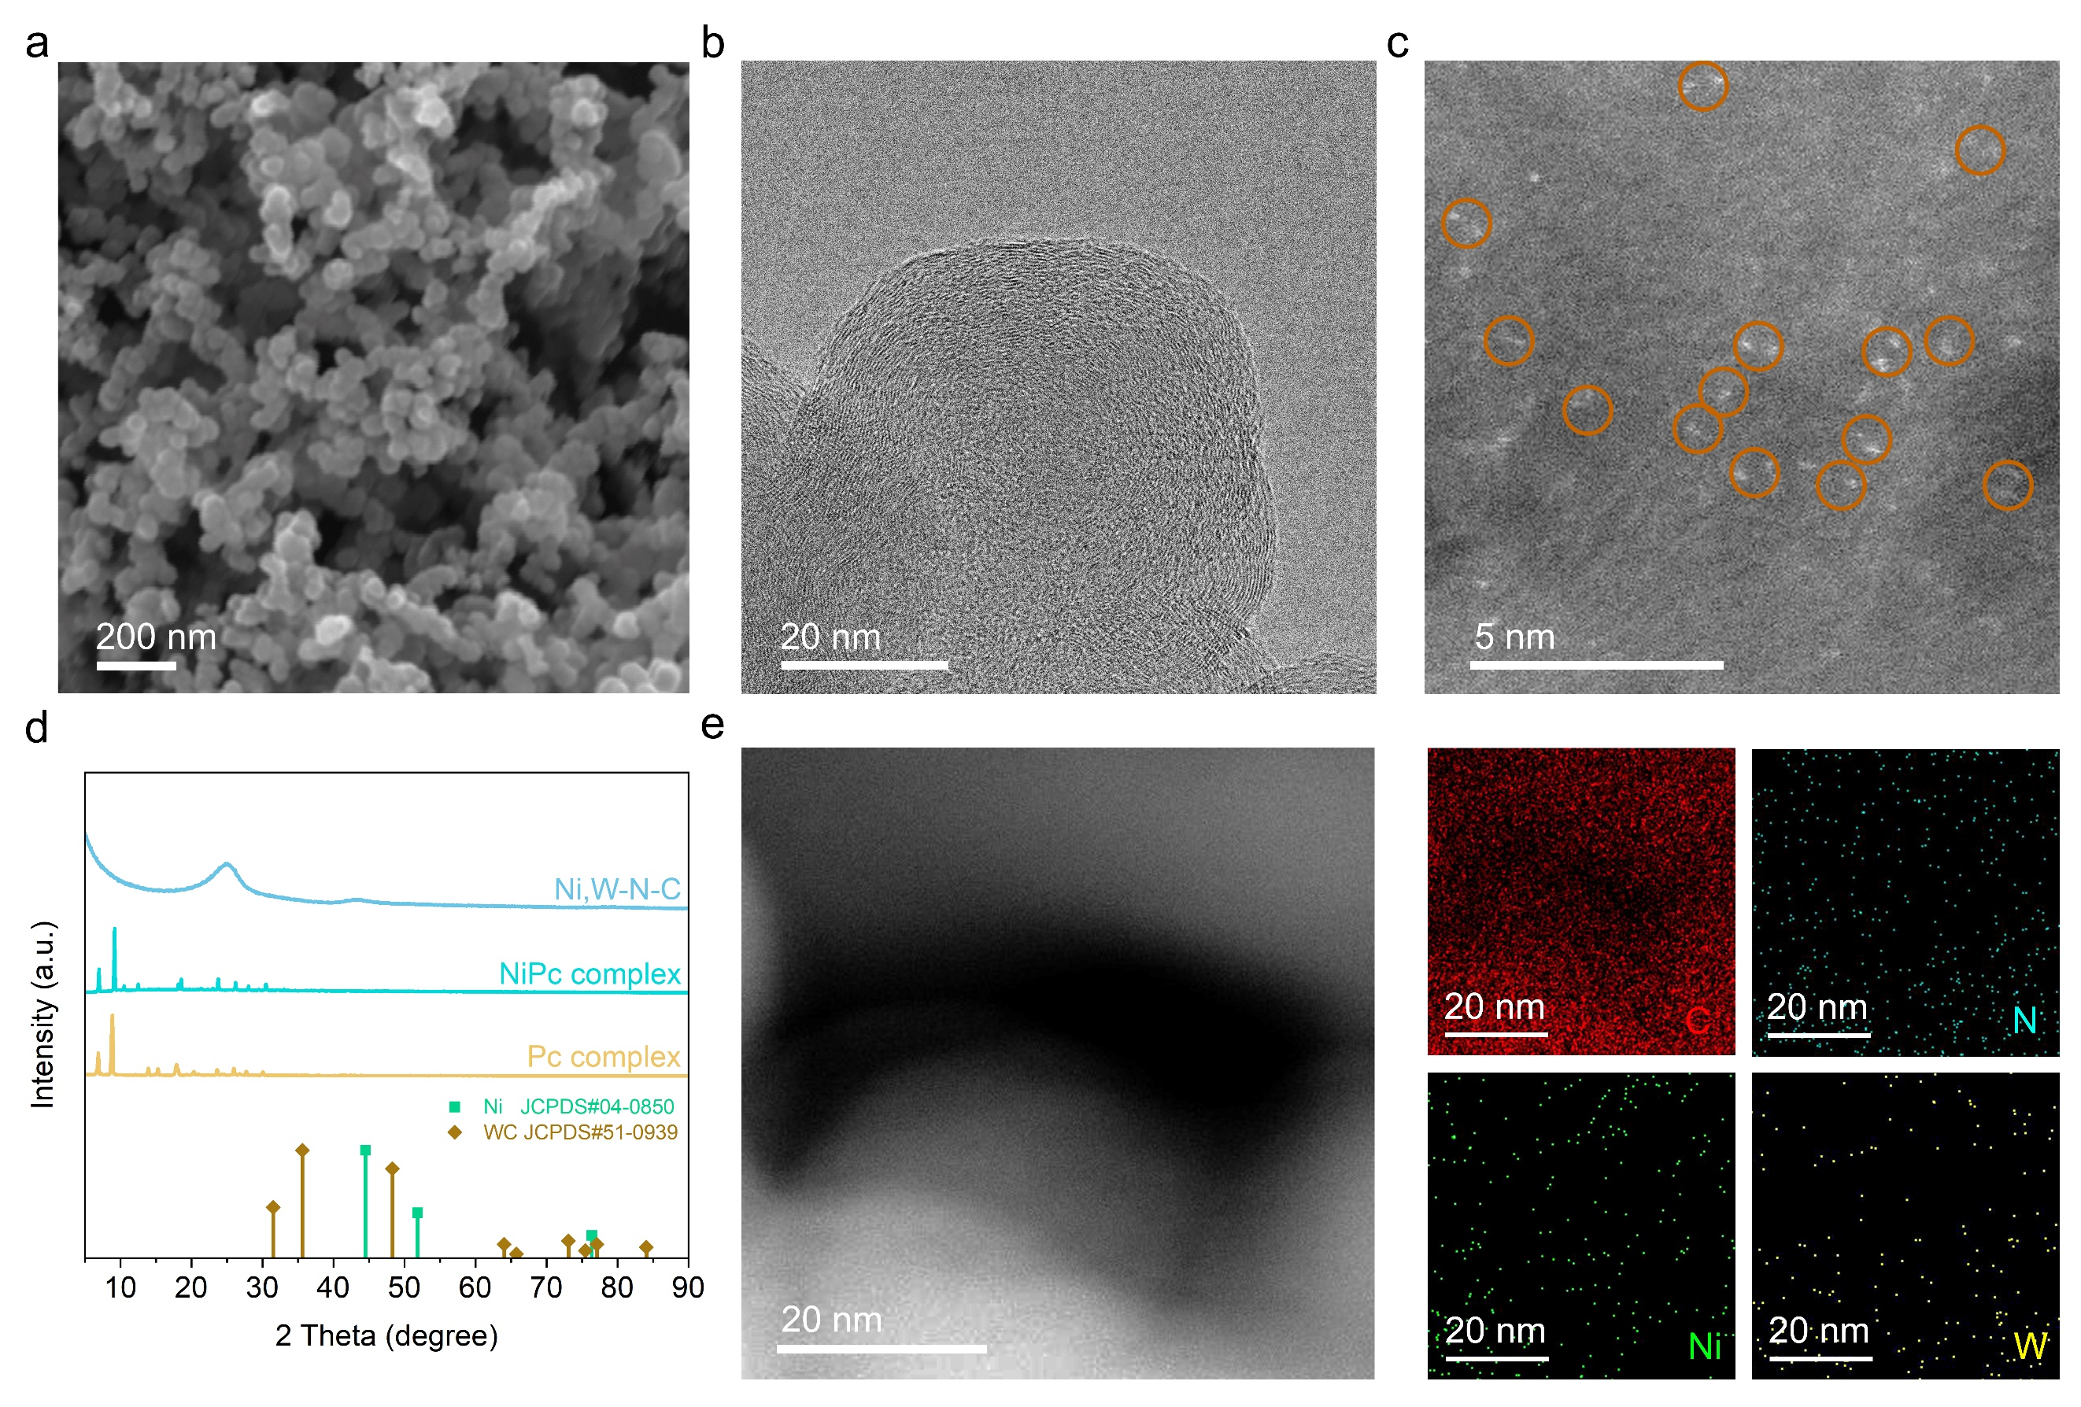

Supplementary Fig. 6. Morphological characterizations of Ni,W-N-C catalyst. a, SEM image. b, TEM image. c, Aberration-corrected HAADF-STEM image. d, XRD patterns of Ni,W-N-C catalyst, nickel phthalocyanine complex (NiPc complex) and Pc complex. e, HAADF-STEM image and corresponding EDX mapping images for C (red), N (blue), Ni (green) and W (yellow).

Supplementary Fig. 7. Distance between two adjacent metal atoms in site 1 (a) and site 2 (b).

Supplementary Fig. 8. XPS analysis of Fe,W-N-C catalyst. a, High-resolution XPS spectrum of C 1s. b, High-resolution XPS spectrum of N 1s. c, High-resolution XPS spectrum of Fe 2p. d, High-resolution XPS spectrum of W 4f.
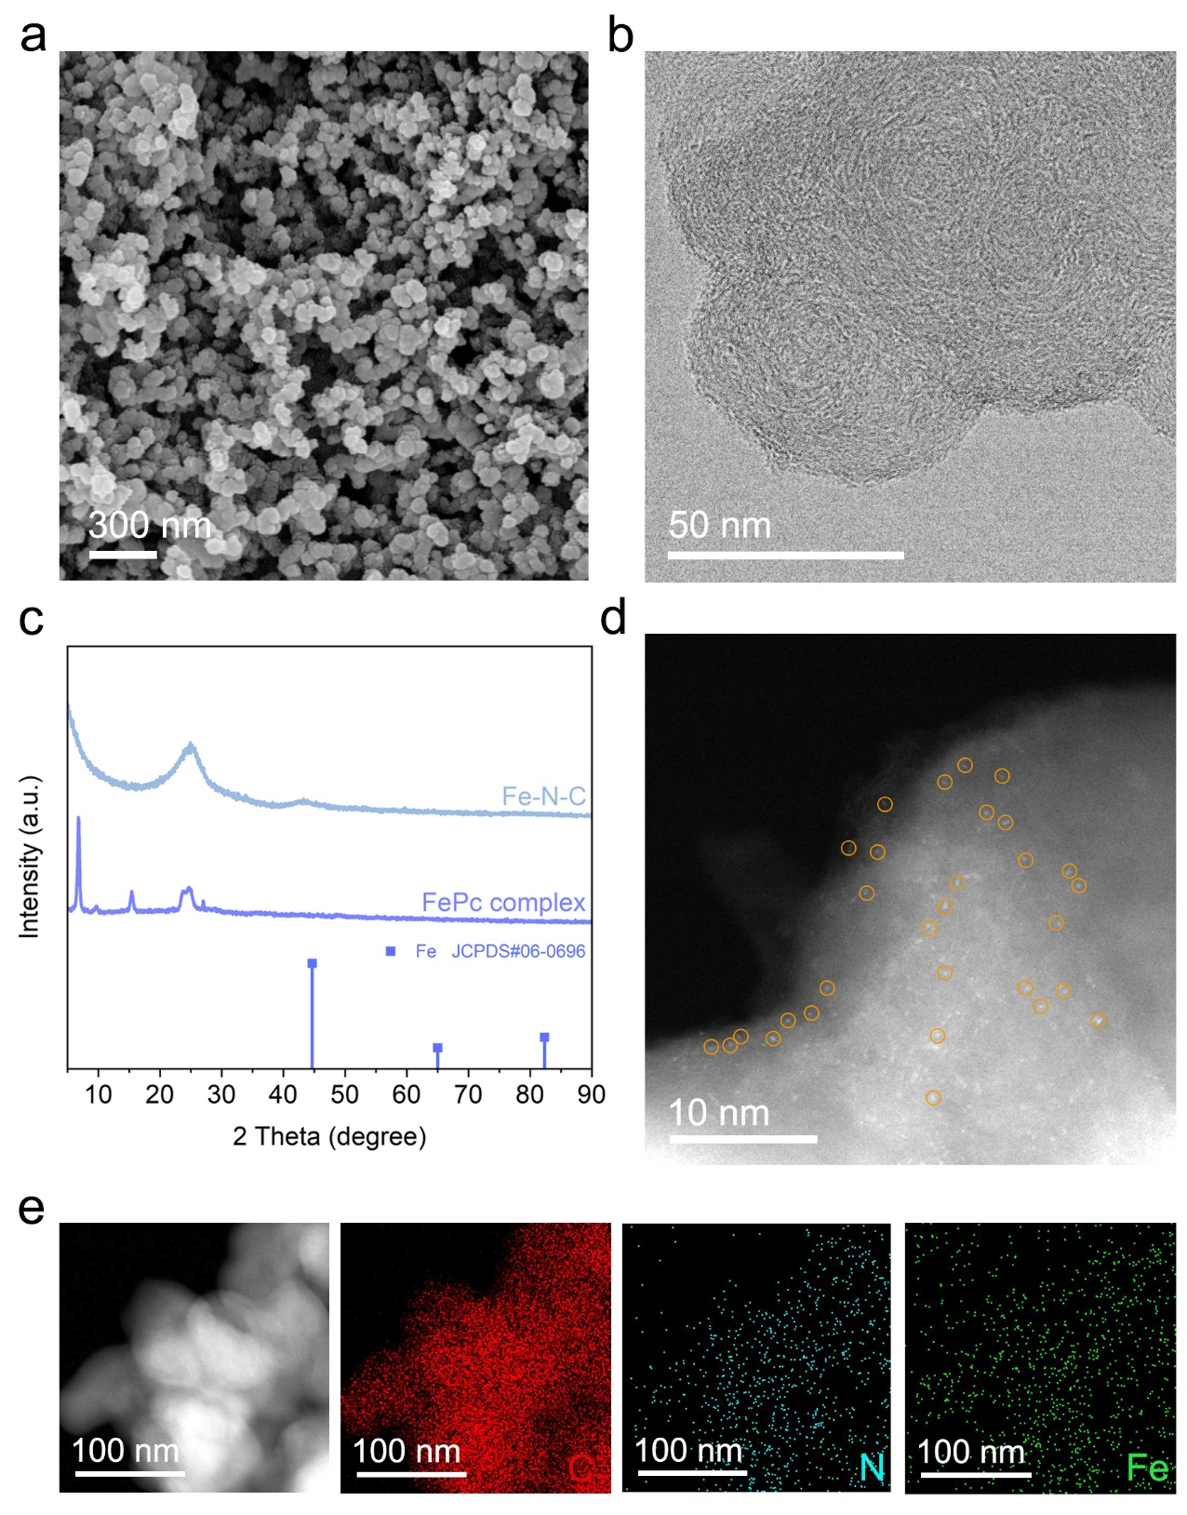

Supplementary Fig. 9. Morphological characterizations of Fe-N-C catalyst. a, SEM image. b, TEM image. c, XRD patterns of Fe-N-C catalyst and iron (Ⅱ) phthalocyanine complex (FePc complex). d, Aberration-corrected HAADF-STEM image. e, HAADF-STEM image and corresponding EDX mapping images for C (red), N (blue) and Fe (green).

Supplementary Fig. 10. XPS analysis of Fe-N-C catalyst. a, High-resolution XPS spectrum of C 1s. b, High-resolution XPS spectrum of N 1s. c, High-resolution XPS spectrum of Fe 2p.

Supplementary Fig. 11. a, Normalized Fe K-edge X-ray absorption near-edge structure (XANES) spectra of Fe foil, FeO, Fe₂O₃, Fe,W-N-C and Fe-N-C. b, Expanded pre-edge region of Fe K-edge XANES spectra.

Supplementary Fig. 12. 3D contour wavelet transformed extended X-ray absorption fine structure (EXAFS) maps of Fe foil (a), FeO (b) and Fe₂O₃ (c).

Supplementary Fig. 13. 3D contour Wavelet transformed EXAFS maps of W powder (a) and WO₃ (b).

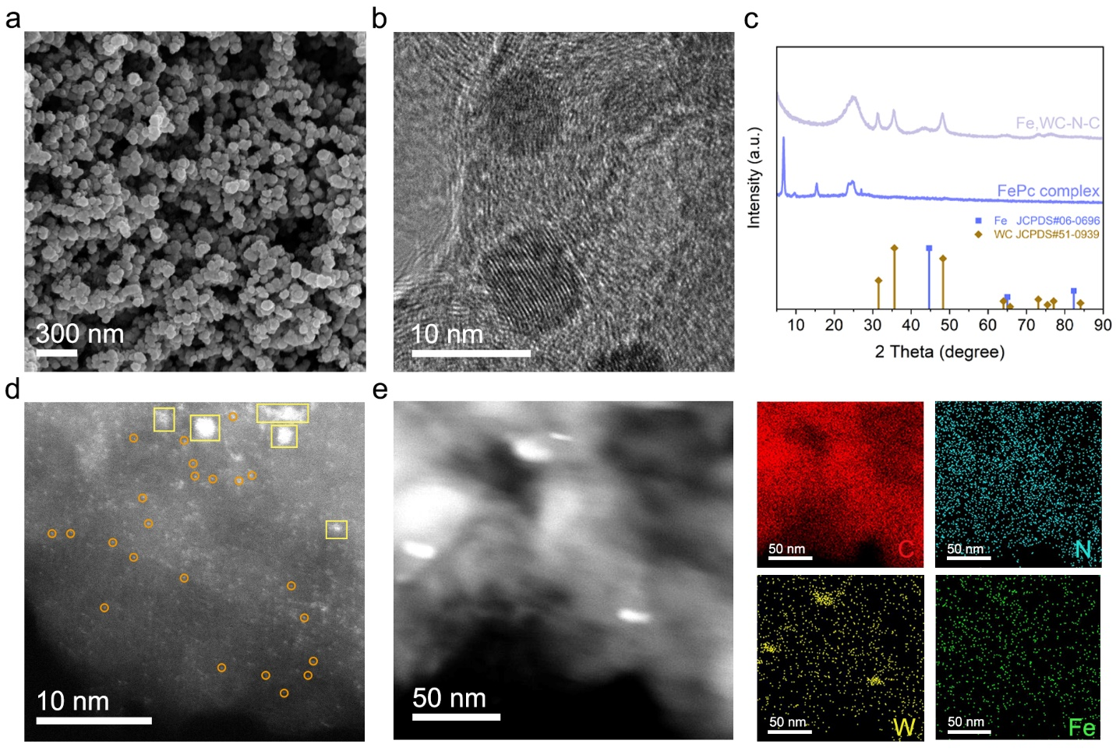

Supplementary Fig. 14. Morphological characterizations of Fe,WC-N-C catalyst. a, SEM image. b, TEM image. c, XRD patterns of Fe,WC-N-C catalyst and FePc complex. d, Aberration-corrected HAADF-STEM image. e, HAADF-STEM image and corresponding EDX mapping images for C (red), N (blue), W (yellow) and Fe (green).

Supplementary Fig. 15. XPS analysis of Fe,WC-N-C. a, High-resolution XPS spectrum of C 1s. b, High-resolution XPS spectrum of N 1s. c, High-resolution XPS spectrum of Fe 2p. d, High-resolution XPS spectrum of W 4f.

Supplementary Fig. 16. Tafel slope for oxygen reduction reaction (ORR) of Fe,W-N-C, Fe,WC-N-C, Fe-N-C, W-N-C, WC-C and commercial 20 wt% Pt/C catalysts.

Supplementary Fig. 17. Methanol tolerance tests of Fe,W-N-C and commercial Pt/C catalysts at 0.67 V (V versus RHE). The chronoamperometric responses of the two catalysts before and after adding CH₃OH to the electrolyte.

Supplementary Fig. 18. Oxygen evolution reaction (OER) polarization curves of Fe,W-N-C, Fe,WC-N-C, Fe-N-C, W-N-C, WC-C and commercial IrO₂ catalysts in 1.0 M KOH solution.

Supplementary Fig. 19. OER Tafel slopes of Fe,W-N-C, Fe,WC-N-C, Fe-N-C, W-N-C, WC-C and commercial IrO₂ catalysts.

Supplementary Fig. 20. Long-term electrochemical OER stability tests of Fe,W-N-C and commercial IrO₂ catalysts.

Supplementary Fig. 21. Specific capacity of zinc-air batteries (ZABs) with Fe,W-N-C catalyst and commercial Pt/C-IrO₂ catalyst as the air cathode.

Supplementary Fig. 22. Energy density plots of ZABs with Fe,W-N-C catalyst and commercial Pt/C-IrO₂ catalyst as the air cathode.

Supplementary Fig. 23. Repeated galvanostatic discharge/charge cycle stability test for liquid-state ZAB with Fe,W-N-C air cathode at a current density of 5 mA cm⁻².

Supplementary Fig. 24. Galvanostatic discharge/charge cycle stabilities for liquid-state ZABs with Fe,W-N-C and Pt/C-IrO₂ air cathodes at a current density of 50 mA cm⁻².

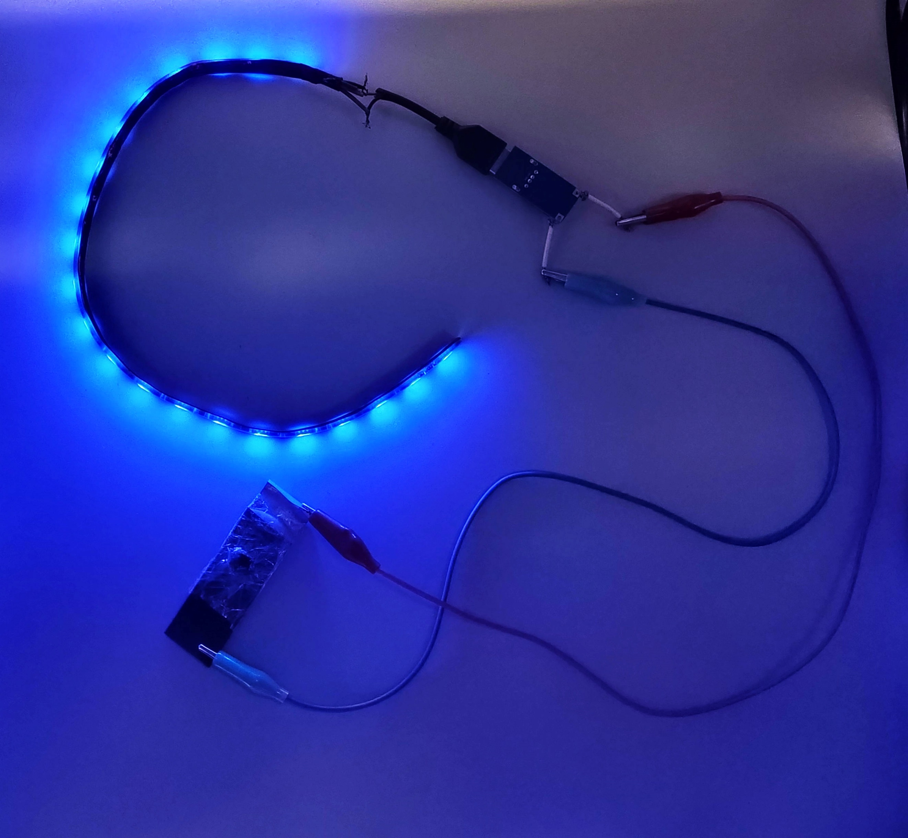

Supplementary Fig. 25. Photograph of a wristband with LED lights powered by the flexible solid-state ZAB with Fe,W-N-C catalyst as the air cathode.

Supplementary Fig. 26. In situ XAS characterizations. a, Fe K-edge XANES spectra of Fe,W-N-C based ZAB during charge and discharge processes at different current densities. b, Enlarged view of the adsorption edge of XANES spectra.

Supplementary Fig. 27. The atomistic structure and free energy of the initial, transition, and final states of the adsorption and dissociation reactions of O₂ on the W-N₄ site in Fe,W-N-C catalyst.

Supplementary Fig. 28. Projected density of state analysis of (a) Fe-3dxy, (b) Fe-3dyz, (c) Fe-3dxz and (d) Fe-3dx²-y² orbitals with O 2px/2py/2pz orbitals in *OH intermediate on Fe-N₄/W-N₄ site.

Supplementary Fig. 29. Projected density of state analysis of (a) Fe-3dxy, (b) Fe-3dyz, (c) Fe-3dxz and (d) Fe-3dx²-y² orbitals with O 2px/2py/2pz orbitals in *OH intermediate on Fe-N₄ site.

Supplementary Tables

Supplementary Table 1. Inductively coupled plasma-optical emission spectroscopy (ICP-OES) analysis results of the as-prepared catalysts.

Catalyst | M (M=Fe/Co/Ni, wt%) | W (wt%)
Fe,W-N-C | 1.25 | 4.02
Fe,WC-N-C | 1.56 | 5.49
Fe-N-C | 1.34 | N/A
W-N-C | N/A | 4.76
WC-N-C | N/A | 6.23
Co,W-N-C | 1.18 | 4.06
Ni,W-N-C | 1.30 | 4.04

Supplementary Table 2. Extended X-ray absorption fine structure (EXAFS) fitting parameters for Fe foil, WO₃ and Fe,W-N-C catalyst.

Sample | Bond Type | Coordination Number | Bond Length  R (Å) | Bond disorder  σ² (Å²) | R factor
Fe foil | Fe-Fe | 8 | 2.47±0.02 | 0.0049 | 0.0023
Fe foil | Fe-Fe | 6 | 2.85±0.01 | 0.0062 | 0.0023
Fe,W-N-C | Fe-N | 4 | 1.90±0.06 | 0.0027 | 0.0107
Fe,W-N-C | Fe-C | 4 | 2.69±0.08 | 0.0057 | 0.0107
Fe,W-N-C | Fe-C | 4 | 3.01±0.09 | 0.0025 | 0.0107
Fe,W-N-C | Fe-N (bond with W) | 1 | 3.33±0.04 | 0.0023 | 0.0107
WO₃ | W-O | 4 | 1.80±0.01 | 0.0054 | 0.0072
WO₃ | W-O | 2 | 2.15±0.03 | 0.0052 | 0.0072
Fe,W-N-C | W-N | 4 | 2.08±0.09 | 0.0014 | 0.0164
Fe,W-N-C | W-C | 4 | 2.88±0.04 | 0.0025 | 0.0164
Fe,W-N-C | W-C | 4 | 3.21±0.06 | 0.0054 | 0.0164
Fe,W-N-C | W-C | 4 | 3.65±0.06 | 0.0007 | 0.0164
Fe,W-N-C | W-N (bond with Fe) | 1 | 4.29±0.05 | 0.0055 | 0.0164

Supplementary Table 3. Summary of the onset potential (E_{onset}), half-wave potential (E_{1/2}), and J_{k} at 0.82 V of different catalysts.

Sample | E_{onset} Potential  (V, V versus RHE) | E_{1/2} Potential  (V, V versus RHE) | J_{k}  (mA cm⁻²)
Fe,W-N-C | 1.03 | 0.90 | 17.14
Fe,WC-N-C | 1.00 | 0.87 | 13.96
Fe-N-C | 0.99 | 0.84 | 7.26
W-N-C | 0.90 | 0.79 | 1.59
WC-N-C | 0.88 | 0.77 | 1.10
Pt/C | 1.01 | 0.85 | 9.64

Supplementary Table 4. Summary of Tafel slopes for ORR of the as-prepared catalysts.

 | Fe,W-N-C | Fe,WC-N-C | Fe-N-C | W-N-C | WC-N-C | Pt/C
Tafel Slope  (mV/dec) | 91 | 99 | 101 | 63 | 64 | 98

Supplementary Table 5. ORR electrocatalytic performance comparison of Fe,W-N-C with other state-of-the-art catalysts in 0.1 M KOH.

Catalyst | Loading Amount  (mg cm⁻²) | E_{onset} | E_{1/2} | Stability | Ref.
Fe,W-N-C | 0.2 | 1.03 | 0.90 | 97.94% after 36000 s | This Work
Co(CN)₃-Cub | 2.04 | 0.99 | 0.90 | E_{1/2} −20 mV after 10000 cycles | [1]  Nat. Catal. 6, 1164-1173 (2023)
HESA | 0.127 | 0.96 | 0.87 | 97% after 43200 s | [2]  Nat. Sustain. 6, 816-826 (2023)
(101) copper phosphosulfide | 0.1 | - | 0.90 | E_{1/2} −11 mV after 30000 cycles | [3]  Nat. Energy 6, 592-604 (2021)
ZrN NPs | 0.125 | 0.89 | 0.80 | 95.6% after 36 h | [4]  Nat. Mater. 19, 282-286 (2020)
4.3% NiFe-MOF | 2.0 | 0.92 | 0.83 | 97% after 200 h | [5]  Nat. Energy 4, 115-122 (2019)
NFLGDY-900c | 0.6 | - | 0.87 | 92% after 10000 s | [6]  Nat. Chem. 10, 924-931 (2018)
FeCo-NCH | 0.33 | - | 0.889 | E_{1/2} −8 mV after 10000 cycles | [7]  Nat. Commun. 14, 1822 (2023)
HESACs (FeCoNiCuMn) | 0.18 | 0.999 | 0.887 | 93.33% after 25000 s | [8]  Nat. Commun. 13, 5071 (2022)
Co SA-NDGs | 0.3 | 1.02 | - | E_{1/2} −11 mV after 5000 cycles | [9]  Nat. Commun. 13, 3689 (2022)
P/Fe-N-C | 0.6 | 1.01 | 0.90 | E_{1/2} −2 mV after 36000 s | [10]  J. Am. Chem. Soc. 145, 3647-3655 (2023)
MNCSs | 0.126 | - | 0.82 | E_{1/2} −6mV after 5000 cycles | [11]  J. Am. Chem. Soc. 144, 11767-11777 (2022)
Co-Fe ZIF (S-CFZ) | 0.3 | - | 0.85 | 91% after 100 h | [12]  J. Am. Chem. Soc. 144, 4783-4791 (2022)
Fe-Co-Ni MOF | 0.28 | 0.82 | 0.75 | - | [13]  J. Am. Chem. Soc. 144, 3411-3428 (2022)
Ru-SAS/SNC | 0.4 | 0.998 | 0.861 | E_{1/2} −24 mV after 30000 cycles | [14]  J. Am. Chem. Soc. 144, 2197–2207 (2022)
Mn-RuO₂ | 0.2 | - | 0.86 | 95.5% after 50 h | [15]  J. Am. Chem. Soc. 144, 2694−2704 (2022)
FeCo-NPC | 0.51 | 0.96 | 0.83 | no obvious change after 30000 s | [16]  Adv. Mater. 36, 2306047 (2024)
YN₄-Cl | 0.41 | 0.93 | 0.85 | 95% after 43200 s | [17]  Adv. Mater. 35, 2300381 (2023)
Fe_{H}-N-C | 0.6 | - | 0.91 | E_{1/2} −29 mV after 100000 cycles | [18]  Adv. Mater. 35, 2210714 (2023)
H-3DOM-Co/ONC | 0.2 | 0.94 | 0.84 | 94% after 30000 s | [19]  Adv. Mater. 35, 2301894 (2023)
V-CMO/5rGO | 0.255 | - | 0.86 | 90% after 36000 s | [20]  Adv. Mater. 35, 2303109 (2023)
DAF-COF | 0.167 | 0.89 | 0.74 | 94.3% after 36000 s | [21]  Adv. Mater. 35, 2209129 (2023)
Fe-Zn@SNC | 0.51 | 0.99 | 0.86 | E_{1/2} −25 mV after 2000 cycles | [22]  Angew. Chem. Int. Ed. 135, e202301833 (2023)
Pd-Gd₂O₃/C | 0.255 | 0.986 | 0.877 | 90.1 % after 39600 s | [23]  Angew. Chem. Int. Ed. 62, e202314565 (2023)
Mn-SAS | - | 0.99 | 0.85 | 98.5% after 22000 s | [24]  Angew. Chem. Int. Ed. 62, e202314933 (2023)

Supplementary Table 6. Summary of the potential at a constant current density of 10 mA cm⁻² (E_{J=10}) and Tafel slopes for OER of the as-prepared catalysts.

 | Fe,W-N-C | Fe,WC-N-C | Fe-N-C | W-N-C | WC-N-C | IrO₂
E_{J=10} (V) | 1.56 | 1.68 | 1.81 | 1.64 | 1.72 | 1.59
Tafel Slope (mV/dec) | 63 | 157 | 220 | 129 | 132 | 92

Supplementary Table 7. The zinc-air batteries performance comparison of Fe,W-N-C with other state-of-the-art catalysts.

Catalyst | Loading Amount  (mg cm⁻²) | Cycling Stability  (h/cycles) | Current Density  (mA cm⁻²) | Ref.
Fe,W-N-C | 0.5 | Over 10,000 h  (20,000 cycles) | 5 | This work
Fe,W-N-C | 1.0 | Over 2,000 h  12,000 cycles | 50 | This work
HESA (FeMnCoNiCu) | 1.0 | 200 h | 2 | [2]  Nat. Sustain. 6, 816-826 (2023)
(101)-copper phosphosulfide | 15.0 | 800 h | 25 | [3]  Nat. Energy 6, 592-604 (2021)
ZrN nanoparticles | 1.0 | 100 h | 10 | [4]  Nat. Mater. 19, 282-286 (2020)
PdMo bimetallene/C | 1.0 | 500 h | 10 | [25]  Nature 574, 81-85 (2019)
CuNa-CF | 0.2 | 5000 h | 1 | [26]  Nat. Commun. 15, 8365 (2024).
FeCo-NCH | 1.0 | 100 h | 5 | [7]  Nat. Commun. 14, 1822 (2023)
P/Fe-N-C | 1.0 | 192 h | 10 | [10]  J. Am. Chem. Soc.145, 3647-3655 (2023)
Ru SAS/SNC | 1.0 | 270 h | 5 | [14]  J. Am. Chem. Soc. 144, 2197-2207 ( 2022)
Fe-Co-Ni MOF | 1.0 | 120 h | 5 | [13]  J. Am. Chem. Soc. 144, 3411-3428 ( 2022)
FeCo-NPC | 10 | 60 h | 10 | [16]  Adv. Mater. 36, 2306047 (2024)
Fe_{H}-N-C | 1.0 | 1200 h | 5 | [18]  Adv. Mater. 35, 2210714 (2023)
VMoON@NC | 2.0 | 630 h | 10 | [27]  Adv. Mater. 35, 2302625 (2023)
CuCo₂O_{4-x}S_{x}/NC-2 | 6.0 | 300 h | 10 | [28]  Adv. Mater. 35, 2370257 (2023)
Cu-Co/NC | 1.0 | 510 h | 10 | [29]  Adv. Mater. 35, 2300905 (2023)
T-Fe SAC | 4.0 | 350 h | 20 | [30]  Angew. Chem. Int. Ed. 136, e202319370 (2024)
Fe-SA/N-HCS | 1.0 | 400 h | 5 | [31]  Angew. Chem. Int. Ed. 135, e202309784 (2023)
ZnCo₂O_{4−x}F_{x}/CNTs | 6.0 | 300 h | 5 | [32]  Angew. Chem. Int. Ed. 62, e202301408 (2023)
Pd-Gd₂O₃/C+RuO₂ | - | 580 h | 5 | [23]  Angew. Chem. Int. Ed. 62, e202314565 (2023)

Reference
[1] Sun, K. et al. Co(CN)₃ catalysts with well-defined coordination structure for the oxygen reduction reaction. Nat. Catal. 6, 1164-1173 (2023).
[2] Lei, X. et al. High-entropy single-atom activated carbon catalysts for sustainable oxygen electrocatalysis. Nat. Sustain. 6, 816-826 (2023).
[3] Shinde, S. S. et al. Ampere-hour-scale zinc–air pouch cells. Nat. Energy 6, 592-604 (2021).
[4] Yuan, Y. et al. Zirconium nitride catalysts surpass platinum for oxygen reduction. Nat. Mater. 19, 282-286 (2020).
[5] Cheng, W. et al. Lattice-strained metal–organic-framework arrays for bifunctional oxygen electrocatalysis. Nat. Energy 4, 115-122 (2019).
[6] Zhao, Y. et al. Few-layer graphdiyne doped with sp-hybridized nitrogen atoms at acetylenic sites for oxygen reduction electrocatalysis. Nat. Chem. 10, 924-931 (2018).
[7] Jiang, Z. et al. Interfacial assembly of binary atomic metal-Nx sites for high-performance energy devices. Nat. Commun. 14, 1822 (2023).
[8] Rao, P. et al. Movable type printing method to synthesize high-entropy single-atom catalysts. Nat. Commun. 13, 5071 (2022).
[9] Wang, Q. et al. Quasi-solid-state Zn-air batteries with an atomically dispersed cobalt electrocatalyst and organohydrogel electrolyte. Nat. Commun. 13, 3689 (2022).
[10] Zhou, Y. et al. Boosting oxygen electrocatalytic activity of Fe–N–C catalysts by phosphorus incorporation. J. Am. Chem. Soc. 145, 3647-3655 (2023).
[11] Zhao, Z. et al. Constructing unique mesoporous carbon superstructures via monomicelle interface confined assembly. J. Am. Chem. Soc. 144, 11767-11777 (2022).
[12] Jiang, Y. et al. Linker-compensated metal-organic framework with electron delocalized metal sites for bifunctional oxygen electrocatalysis. J. Am. Chem. Soc. 144, 4783-4791 (2022).
[13] Shahbazi Farahani, F. et al. Trilayer metal-organic frameworks as multifunctional electrocatalysts for energy conversion and storage applications. J. Am. Chem. Soc. 144, 3411-3428 (2022).
[14] Qin, J. et al. Altering ligand fields in single-atom sites through second-shell anion modulation boosts the oxygen reduction reaction. J. Am. Chem. Soc. 144, 2197–2207 (2022).
[15] Zhou, C. et al. Superdurable bifunctional oxygen electrocatalyst for high-performance zinc–air batteries. J. Am. Chem. Soc. 144, 2694−2704 (2022).
[16] Pei, Z. et al. Atomically dispersed Fe sites regulated by adjacent single Co atoms anchored on N‐P Co‐doped carbon structures for highly efficient oxygen reduction reaction. Adv. Mater. 36, 2306047 (2024).
[17] Ji, B. et al. Coordination chemistry of large‐sized yttrium single‐atom catalysts for oxygen reduction reaction. Adv. Mater. 35, 2300381 (2023).
[18] Tian, H. et al. High durability of Fe–N–C single‐atom catalysts with carbon vacancies toward the oxygen reduction reaction in alkaline media. Adv. Mater. 35, 2210714 (2023).
[19] Yao, W. et al. Hierarchically ordered macro–mesoporous electrocatalyst with hydrophilic surface for efficient oxygen reduction reaction. Adv. Mater. 35, 2301894 (2023).
[20] Huang, H. et al. Tailoring oxygen reduction reaction kinetics on perovskite oxides via oxygen vacancies for low‐temperature and knittable zinc–air batteries. Adv. Mater. 35, 2303109 (2023).
[21] You, Z. et al. Metal‐free carbon‐based covalent organic frameworks with heteroatom‐free units boost efficient oxygen reduction. Adv. Mater. 35, 2209129 (2023).
[22] Xie, Y. et al. Direct oxygen‐oxygen cleavage through optimizing interatomic distances in dual single‐atom electrocatalysts for efficient oxygen reduction reaction. Angew. Chem. Int. Ed. 135, e202301833 (2023).
[23] Ning, S. et al. Importing antibonding‐orbital occupancy through Pd−O−Gd bridge promotes electrocatalytic oxygen reduction. Angew. Chem. Int. Ed. 62, e202314565 (2023).
[24] Tong, M. et al. Potential dominates structural recombination of single atom Mn sites for promoting oxygen reduction reaction. Angew. Chem. Int. Ed. 62, e202314933 (2023).
[25] Luo, M. et al. PdMo bimetallene for oxygen reduction catalysis. Nature 574, 81-85 (2019).
[26] Li, Y. et al. Main-group element-boosted oxygen electrocatalysis of Cu-N-C sites for zinc-air battery with cycling over 5000 h. Nat. Commun. 15, 8365 (2024).
[27] Balamurugan, J. et al. Electrocatalysts for zinc–air batteries featuring single molybdenum atoms in a nitrogen‐doped carbon framework. Adv. Mater. 35, 2302625 (2023).
[28] Cai, J. et al. Hetero‐anionic structure activated Co-S bonds promote oxygen electrocatalytic activity for high‐efficiency zinc-air batteries. Adv. Mater. 35, 2303488 (2023).
[29] Li, Z. et al. Geometric and electronic engineering of atomically dispersed copper‐cobalt diatomic sites for synergistic promotion of bifunctional oxygen electrocatalysis in zinc–air batteries. Adv. Mater. 35, 2300905 (2023).
[30] Zhu, Y. et al. Tip‐like Fe-N₄ sites induced surface microenvironments regulation boosts the oxygen reduction reaction. Angew. Chem. Int. Ed. 136, e202319370 (2024).
[31] Zong, L. et al. Constructing Fe‐N₄ sites through anion exchange‐mediated transformation of Fe coordination environments in hierarchical carbon support for efficient oxygen reduction. Angew. Chem. Int. Ed. 135, e202309784 (2023).
[32] Xiao, K., Wang, Y., Wu, P., Hou, L., & Liu, Z. Q. Activating lattice oxygen in spinel ZnCo₂O₄ through filling oxygen vacancies with fluorine for electrocatalytic oxygen evolution. Angew. Chem. Int. Ed. 62, e202301408 (2023).

