Supplemental material

Suppl. Fig. 1. Reported eating windows. Reported eating windows for the control (gray) and time-restricted eating (TRE; black) groups at baseline, week 6, and week 12. Circles represent data from individuals and diamonds represent averages +/- standard deviation. There are no statistically significant differences between the six group/time points (ANOVA, Tukey’s posthoc comparisons, all p’s>0.25). We suspect under-reporting based on reported eating windows at enrollment (had to be >10 hours at least 6/7 days per week to be eligible) and discussions of eating patterns at intervention delivery appointments.

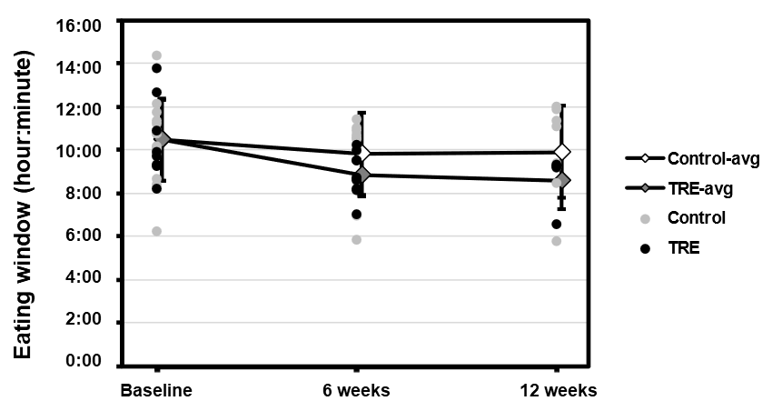

Suppl. Fig. 2. Example continuous glucose data. Participants were asked to wear a continuous glucose monitor for seven days at baseline, week 6, and week 12.
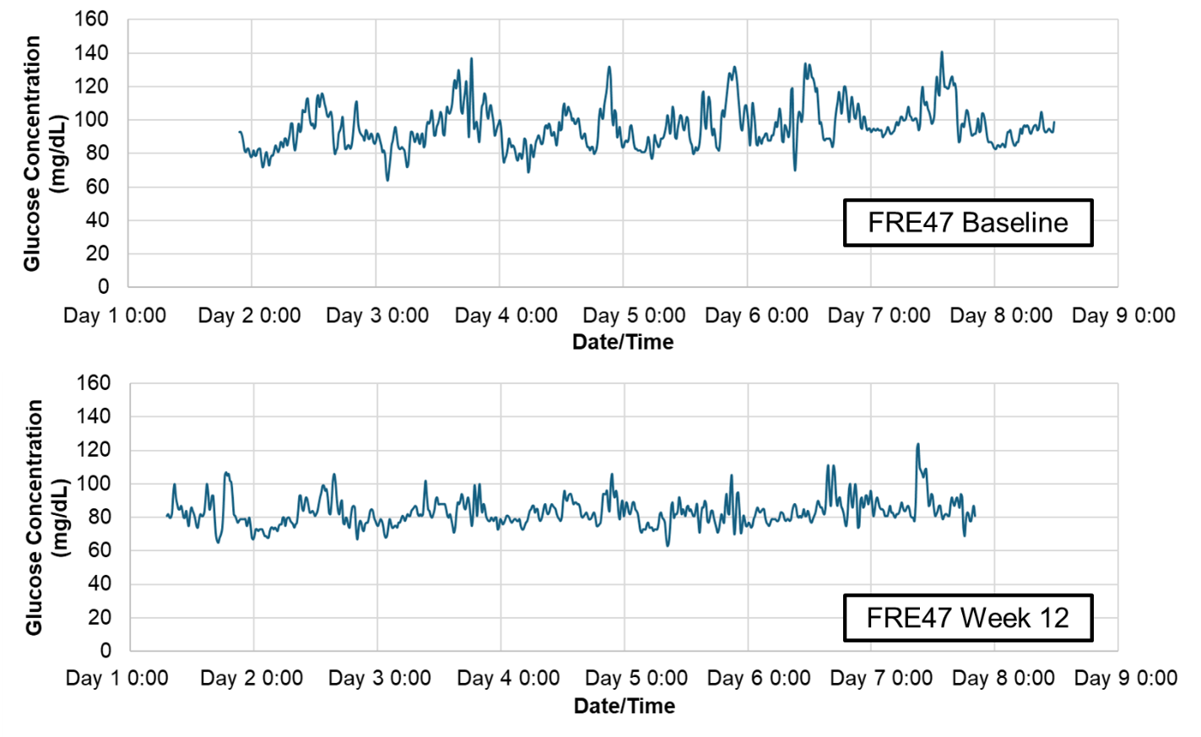

Suppl. Fig. 3. The effect of time-restricted eating vs. control on A) average blood glucose and B) average fasting interstitial glucose over approximately 7 days at baseline, week 6, and week 12 (n=47 observations). See Suppl. Table 2 for numerical values. Error bars depict standard deviation.
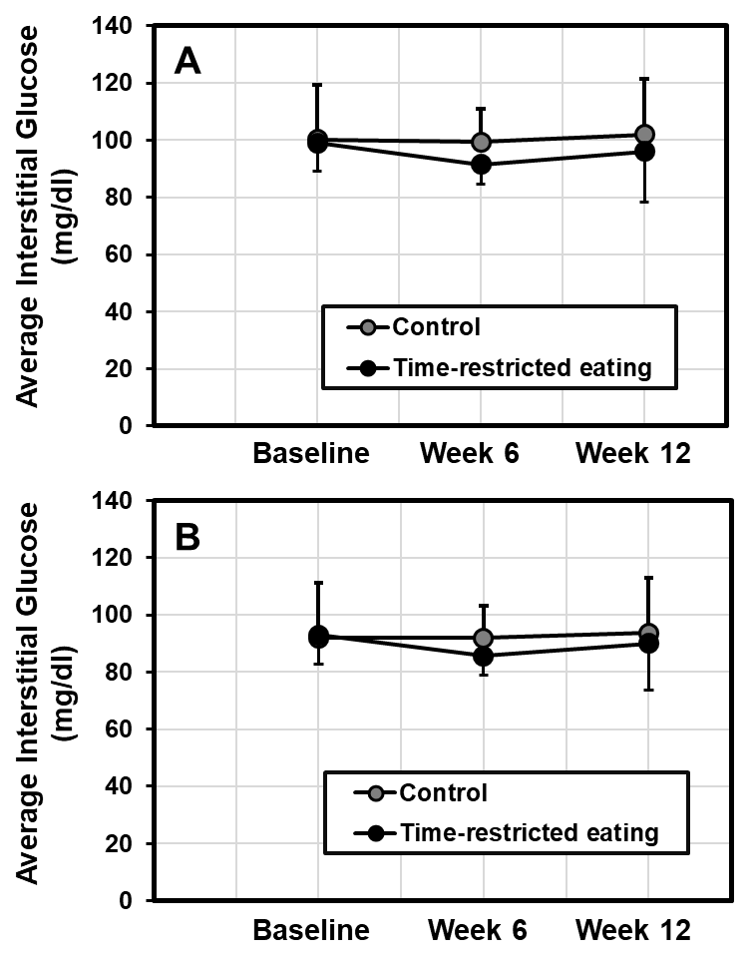

Suppl. Fig. 4. Example of raw actigrams collected from the MotionWatch8 (MotionWare software, v.1.4.25, CamNTech). A) Example of a “strong” rest-activity rhythm, non-parametric relative amplitude = 0.94, B) example of a “strong” rest-activity rhythm, non-parametric relative amplitude = 0.92, C) example of a “weak” rest-activity rhythm, non-parametric relative amplitude = 0.69, D) example of a “weak” rest-activity rhythm, non-parametric relative amplitude = 0.66. The yellow represents light exposure in lux. The vertical blue bars towards the top indicate that the participant pushed the “event marker” button, though we did not ask participants to push this at all during the study.
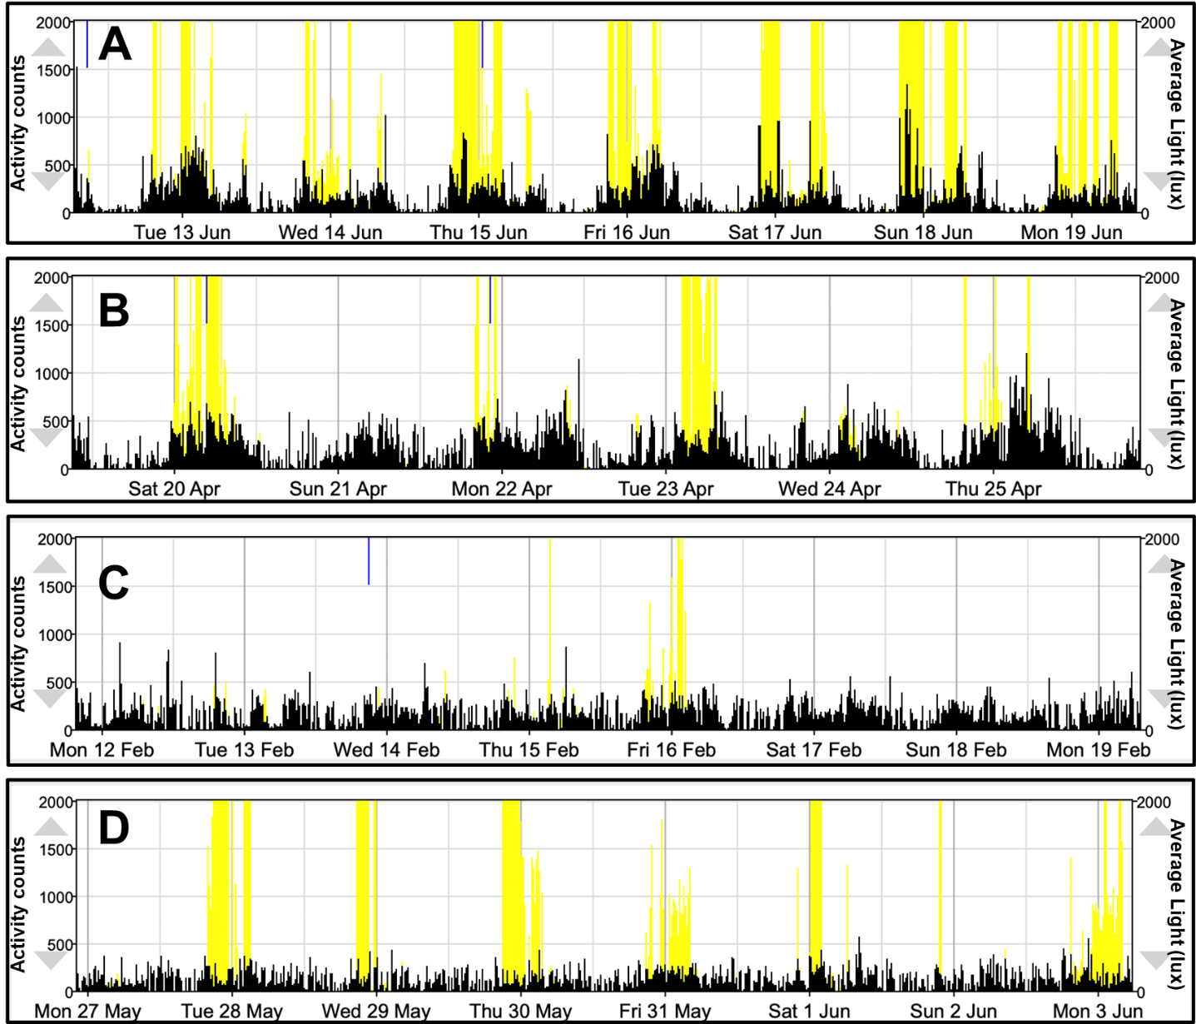

Suppl. Fig. 5. Parametric and non-parametric rest-activity rhythm analyses over time by group—control or time-restricted eating (TRE). A) Non-parametric relative amplitude, B) interdaily stability, C) intradaily variability, D) average of the 5 consecutive hours with the least activity (L5), E) starting hour of the 5 consecutive hours with the least activity, F) average of the 10 consecutive hours with the most activity (M10), G) starting hour of the 10 consecutive hours with the most activity, H) parametric fitted cosine peak, I) fitted cosine amplitude, J) fitted cosine midline estimating statistic of rhythm (MESOR).
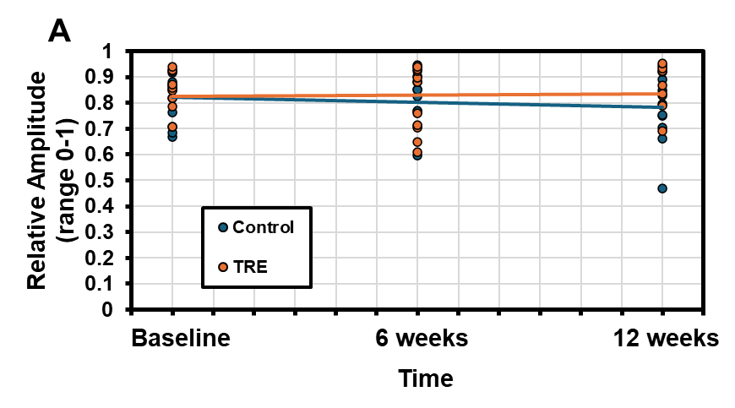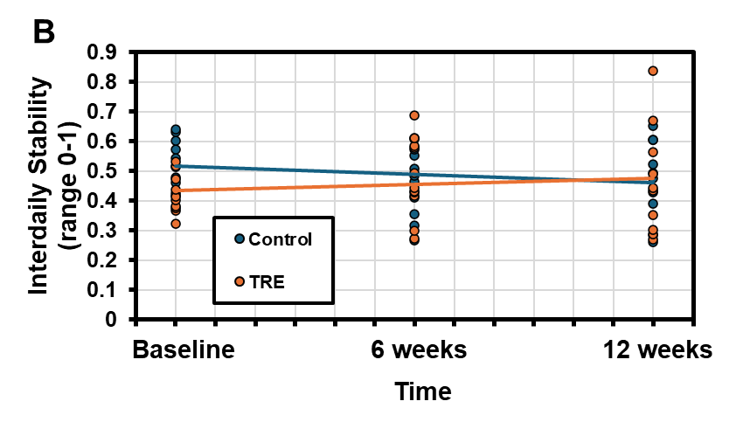
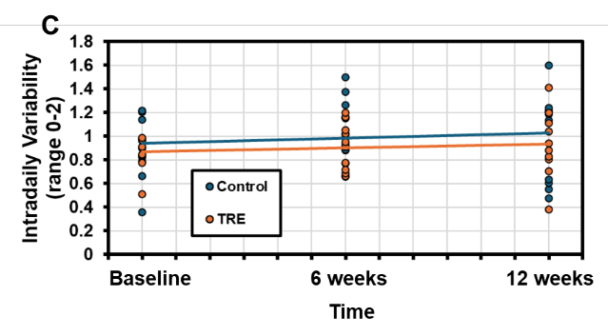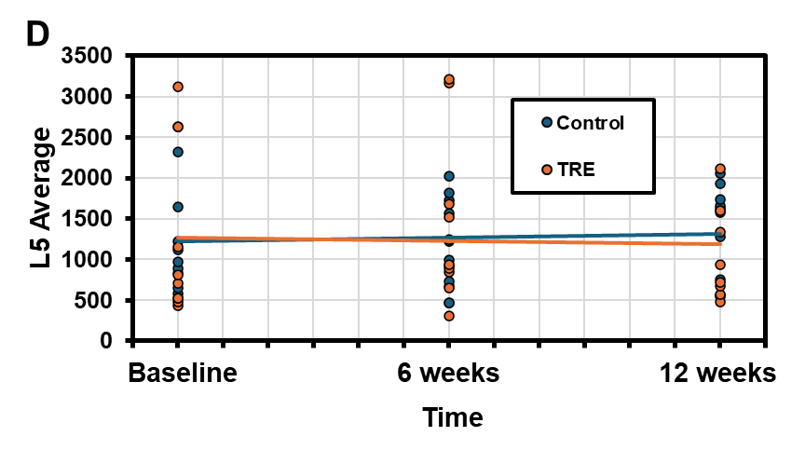
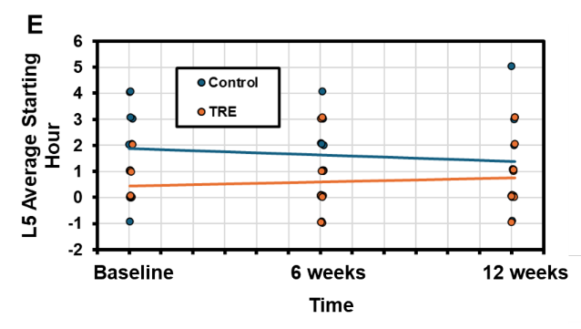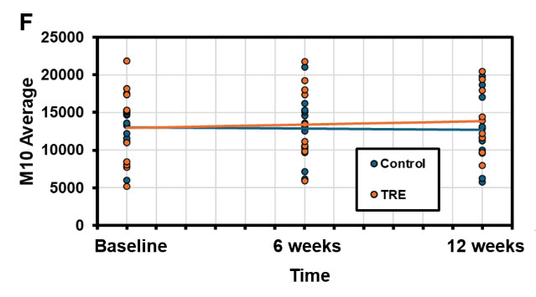
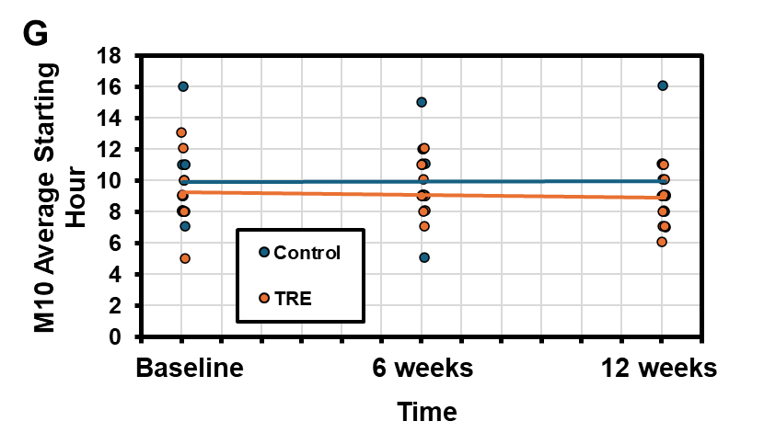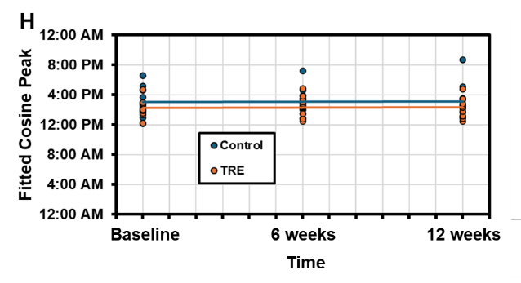
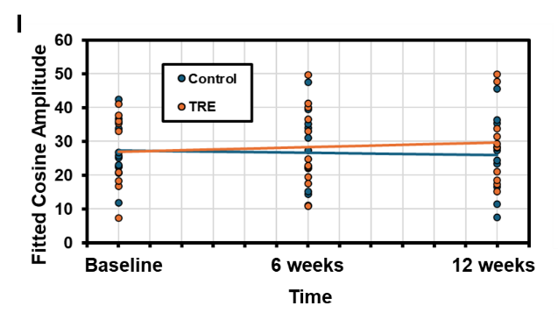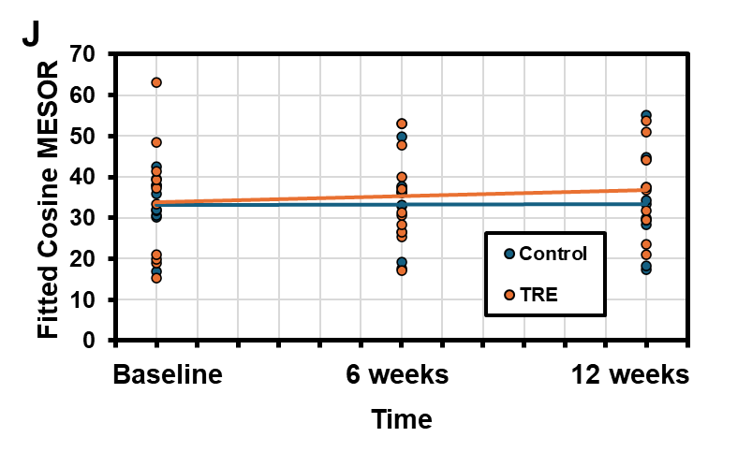

Suppl. Table 1. Reported eating windows. The eating windows are reported in hours. There were no statistically significant differences between groups (p>0.50, ANOVA, Tukey’s posthoc comparisons). TRE=time-restricted eating; time point in weeks.
Group-Time | n | Mean (hours) | Std Error
Control-0 | 15 | 10.46 | 0.46
Control-6 | 9 | 9.79 | 0.58
Control-12 | 8 | 9.91 | 0.62
TRE-0 | 8 | 10.46 | 0.62
TRE-6 | 10 | 8.86 | 0.55
TRE-12 | 4 | 8.59 | 0.89

Suppl. Table 2. Blood glucose parameters over time, as measured using the continuous glucose monitor. (There were no statistically significant parameters in linear mixed models for time or group×time, p>0.25).
 | Week 0 |  | Week 6 |  | Week 12
 | Control | TRE | Control | TRE | Control | TRE
n | 9 | 10 | 7 | 7 | 7 | 7
Average glucose | 100.2 ± 19.1 | 98.9 ± 9.9 | 99.4 ± 11.4 | 91.5 ± 7.1 | 102.0 ± 19.4 | 96.1 ± 17.7
Absolute maximum | 177.6 ± 38.9 | 162.7 ± 26.5 | 177.1 ± 34.4 | 157.7 ± 29.1 | 180.4 ± 47.8 | 159.7 ± 29.4
Average daily maximum | 152.3 ± 39.8 | 142.4 ± 18.9 | 145.7 ± 24.7 | 133.7 ± 17.3 | 153.9 ± 44.2 | 139.4 ± 25.8
Absolute minimum | 58.6 ± 13.8 | 61.2 ± 11.1 | 61.1 ± 16.0 | 45.6 ± 10.7 | 55.7 ± 15.9 | 56.9 ± 19.3
Average daily minimum | 69.6 ± 13.2 | 75.5 ± 8.2 | 73.9 ± 9.0 | 62.5 ± 8.2 | 70.3 ± 11.8 | 69.2 ± 16.1
Coefficient of variance | 21.2 ± 6.3 | 16.3 ± 4.1 | 18.0 ± 4.1 | 18.0 ± 4.8 | 20.0 ± 9.3 | 17.7 ± 1.7
Average fasting glucose | 91.9 ± 16.6 | 93.0 ± 10.3 | 91.8 ± 9.1 | 85.7 ± 6.8 | 93.7 ± 16.8 | 89.9 ± 16.3

