Supplementary Information
Metabolomic and lipidomic profiling for pre-transplant risk assessment of delayed graft function using chemical biopsy with microextraction probes
Natalia Warmuzińska¹, Kamil Łuczykowski¹, Iga Stryjak¹, Emilia Wojtal², Aleksandra Woderska-Jasińska², Marek Masztalerz², Zbigniew Włodarczyk², Barbara Bojko¹

¹Department of Pharmacodynamics and Molecular Pharmacology, Faculty of Pharmacy, Collegium Medicum in Bydgoszcz, Nicolaus Copernicus University in Torun, Bydgoszcz, Poland
²Department of Transplantology and General Surgery, Collegium Medicum in Bydgoszcz, Antoni Jurasz University Hospital No. 1 in Bydgoszcz, Nicolaus Copernicus University in Torun, Bydgoszcz, Poland

Table S1. Donors laboratory test results whose kidneys were associated with delayed graft function (DGF) in recipients.
Characteristic | Total (n=32) | non DGF (n=22 ) | DGF (n=10) | p-value
Ischemia time | 17h26min (7h09min) | 16h03min (7h06min) | 20h27min (6h35min) | >0.05
Creatinine, mg/dL | 1.27 [0.98-2.13] | 1.35 [1.05-2.13] | 1.15 [0.90-1.50] | >0.05
Urea, mg/dL | 45.00 [37.20-62.00] | 47.00 [37.20-90.00] | 39.30 [24.70-48.00] | >0.05
CRP, mg/L | 256.09 (127.38) | 242.85 (134.01) | 285.21 (112.29) | >0.05
Procalcitonin, ng/mL | 1.37 [0.57-9.12] | 5.35 [0.57-9.12] | 1.07 [0.44-2.05] | >0.05
WBC, 10³/uL | 12.98 [11.75-18.40] | 12.96 [11.70-16.70] | 13.52 [11.78-20.10] | >0.05
HGB, g/dL | 10.50 [8.80-13.75] | 9.90 [8.50-14.00] | 11.40 [10.20-12.60] | >0.05
PLT, 10³/uL | 145.50 [92.00-169.50] | 146.00 [92.00-171.00] | 139.00 [127.00-168.00] | >0.05
AST, IU/L | 68.00 [31.00-98.00] | 54.00 [29.00-95.00] | 68.00 [52.00-132.00] | >0.05
ALT, IU/L | 51.00 [26.00-103.00] | 62.00 [26.00-109.00] | 46.00 [45.00-60.00] | >0.05
K, mmol/L | 4.21 (0.74) | 4.22 (0.63) | 4.20 (0.99) | >0.05
Na, mmol/L | 156.59 (11.82) | 154.24 (9.89) | 161.77 (14.47) | >0.05
Cl, mmol/L | 117.62 (11.63) | 115.62 (10.06) | 121.43 (13.93) | >0.05

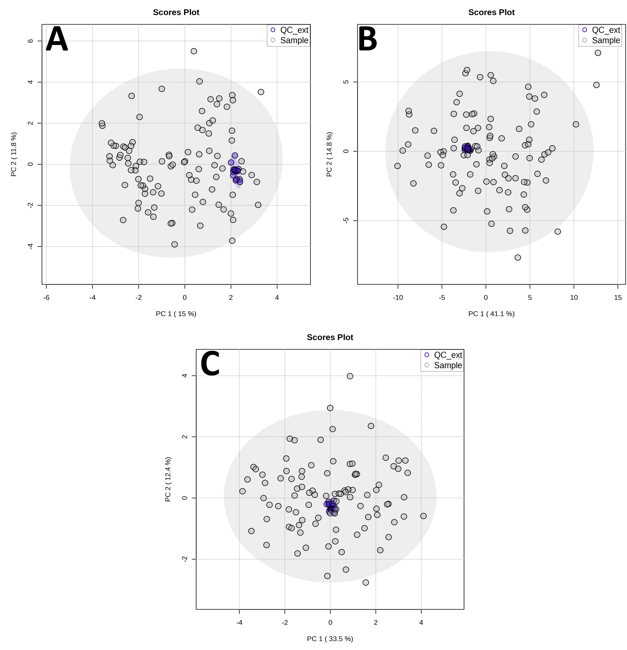
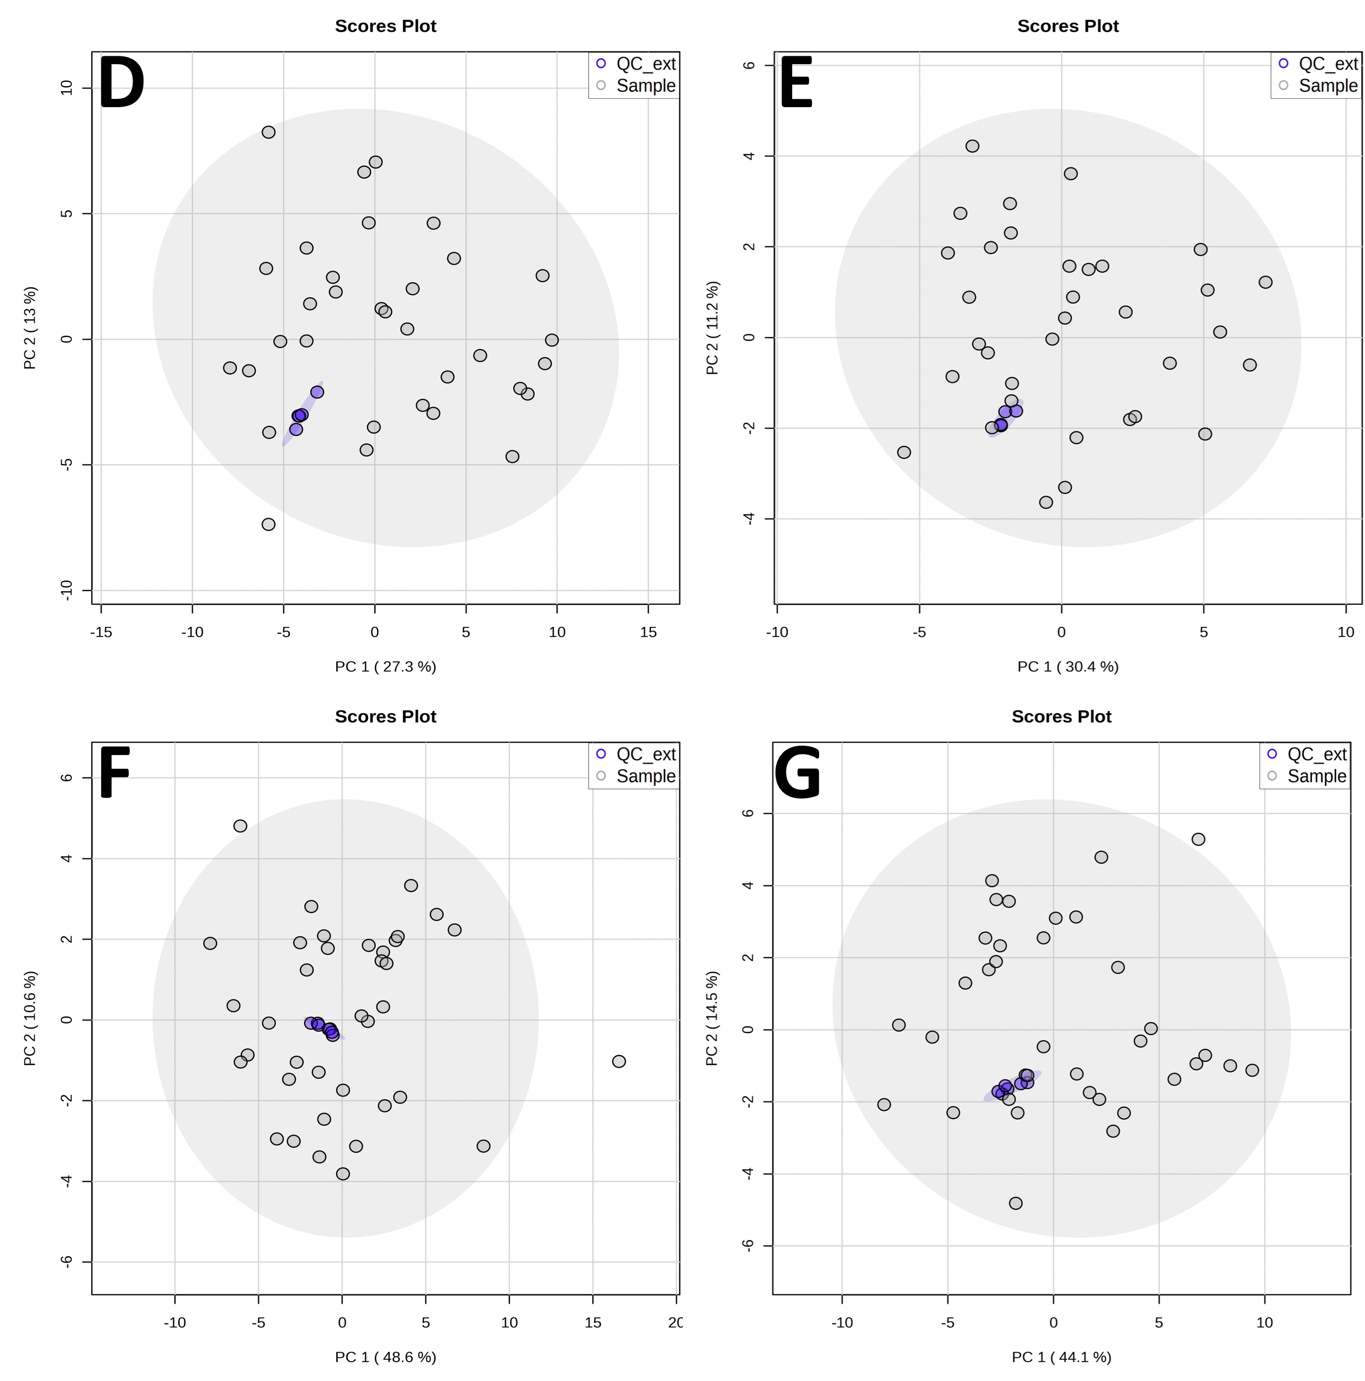

Figure S1. Principal component analysis (PCA) plots of all analyzed samples and extraction quality control (QC) samples for chemical biopsy analysis: (A) metabolomics, (B) Lipidomics RP, (C) Lipidomics HILIC, and plasma samples analysis: (D) Metabolomics – RP Positive ionization mode, (E) Metabolomics – RP Negative ionization mode, (F) Lipidomics - RP Positive ionization mode, (G) Lipidomics - HILIC Positive ionization mode.

Table S2. Metabolites with the highest MDA and MDG values for each analytical block.
Name | MW | RT | Mean Decrease Accuracy | Mean Decrease Gini
Metabolomics
Time point 1
Pyroglutamic acid | 129.04 | 1.75 | 8.752 | 1.551
4-oxo-2-nonenal | 154.10 | 10.09 | 6.484 | 0.917
N-Butyryl-L-homoserine lactone | 171.09 | 1.74 | 5.937 | 0.859
Ornithine | 132.09 | 1.88 | 5.731 | 0.889
Glutaric acid | 132.04 | 1.32 | 4.705 | 0.474
Tetramethylpyrazine | 136.10 | 8.95 | 3.819 | 0.601
Heptylic acid | 130.10 | 1.69 | 3.305 | 0.506
Glyceraldehyde 3-phosphate | 169.99 | 2.11 | 3.870 | 0.433
Carnitine | 161.11 | 3.35 | 3.570 | 0.226
Dopamine | 153.08 | 9.93 | 3.371 | 0.452
4-Nitroaniline | 138.04 | 6.84 | 2.658 | 0.602
Leucine | 131.09 | 9.14 | 1.558 | 0.533
Nicotine glucuronide | 338.15 | 16.46 | 0.056 | 0.456
Time point 2
Phosphoethanolamine | 141.01 | 11.70 | 5.746 | 0.613
Glutamic acid | 147.05 | 1.53 | 5.577 | 0.683
Glyceraldehyde 3-phosphate | 169.99 | 2.11 | 5.243 | 0.913
Histidine | 155.07 | 1.90 | 5.065 | 0.644
1-Nitronaphthalene-5,6-oxide | 189.04 | 24.76 | 4.992 | 0.581
Adenosine | 267.10 | 7.28 | 4.805 | 0.643
Carnitine | 161.11 | 3.35 | 4.369 | 0.852
Homocycloleucine | 143.09 | 1.75 | 5.215 | 0.553
3,5-Dihydroxypentanoic acid | 134.06 | 1.73 | 4.545 | 0.296
7-Methyl-2,6,9,12-tetraoxahexadecane | 248.20 | 14.09 | 4.523 | 0.358
NA-Val 18:0 | 383.34 | 22.19 | 4.090 | 0.607
5-Aminopentanoic acid | 117.08 | 1.70 | 3.851 | 0.601
Tetramethylpyrazine | 136.10 | 8.95 | 4.251 | 0.564
Time point 3
Phosphoethanolamine | 141.01 | 11.70 | 9.547 | 1.966
3-Indolebutyric acid | 203.10 | 13.52 | 6.979 | 1.343
NA-Val 18:0 | 383.34 | 22.19 | 6.040 | 0.896
4-Hydroxynonenal | 156.12 | 11.86 | 5.431 | 0.606
Creatine | 131.07 | 1.98 | 4.971 | 0.735
Adenosine | 267.10 | 7.28 | 4.912 | 0.806
Arginine | 174.11 | 2.01 | 4.456 | 0.636
Dopamine | 153.08 | 9.93 | 3.553 | 0.383
Taurine | 125.01 | 1.26 | 3.092 | 0.261
3,5-Dihydroxypentanoic acid | 134.06 | 1.73 | 3.006 | 0.251
Glyceraldehyde 3-phosphate | 169.99 | 2.11 | 1.335 | 0.510
Heptylic acid | 130.10 | 1.69 | 2.699 | 0.438
Pyroglutamic acid | 129.04 | 1.75 | 2.747 | 0.389
Lipidomics HILIC
Time point 1
SM 42:1;O2 | 814.69 | 7.78 | 6.180 | 1.053
PC 38:5 | 807.58 | 6.48 | 5.532 | 0.638
PC 34:1 | 759.58 | 6.53 | 5.511 | 0.813
SM 40:2;O2 | 784.65 | 7.94 | 5.046 | 0.536
PC 38:6 | 805.56 | 6.49 | 4.820 | 0.459
LPC 18:0 | 523.36 | 8.84 | 4.474 | 0.467
SM 34:1;O2 | 702.57 | 8.16 | 4.317 | 0.483
PE 38:5 | 765.53 | 7.42 | 4.289 | 0.549
PE O-38:5 | 751.55 | 7.26 | 4.591 | 0.408
PE 34:1 | 717.53 | 7.46 | 4.248 | 0.399
PC O-34:2 | 743.58 | 6.59 | 2.375 | 0.547
PC 38:4 | 809.59 | 6.46 | 3.967 | 0.422
Time point 2
PE 38:5 | 765.53 | 7.56 | 7.547 | 0.981
PC 34:1 | 759.58 | 6.62 | 6.284 | 0.636
PC P-34:2 | 741.57 | 6.58 | 4.900 | 0.514
PE 38:6 | 763.52 | 7.45 | 4.734 | 0.673
SM 40:1;O2 | 786.66 | 7.91 | 4.687 | 0.567
PE 36:3 | 741.53 | 7.45 | 4.670 | 0.495
PC 38:5 | 807.58 | 6.48 | 4.280 | 0.468
LPE 18:0 | 481.32 | 10.34 | 4.040 | 0.519
LPC P-16:0 | 479.34 | 8.58 | 4.035 | 0.363
PC 36:3 | 783.58 | 6.49 | 3.274 | 0.554
Time point 3
PE 38:6 | 763.52 | 7.45 | 6.126 | 0.854
PE 36:3 | 741.53 | 7.45 | 5.718 | 0.716
PC 36:4 | 781.56 | 6.52 | 5.468 | 0.756
PE 36:2 | 743.55 | 7.56 | 5.324 | 0.660
PE 36:4 | 739.52 | 7.46 | 4.985 | 0.655
PC 36:3 | 783.58 | 6.49 | 4.715 | 0.589
PC 34:2 | 757.56 | 6.69 | 4.289 | 0.493
SM 40:2;O2 | 784.65 | 7.94 | 4.819 | 0.356
SM 36:1;O2 | 730.6 | 8.03 | 4.441 | 0.350
SM 40:1;O2 | 786.66 | 7.91 | 4.368 | 0.400
PE 40:7 | 789.53 | 7.42 | 3.929 | 0.841
PE P-36:1 | 729.57 | 7.38 | 4.188 | 0.528
PC 33:4 | 739.52 | 7.47 | 3.712 | 0.520
Lipidomics RP
Time point 1
TG 56:0 | 918.86 | 14.63 | 4.684 | 0.500
TG 48:5 | 796.66 | 12.52 | 4.027 | 0.456
TG P-52:1 | 846.80 | 14.11 | 3.750 | 0.295
Cer 34:0;O2 | 539.53 | 10.70 | 3.701 | 0.249
TG 50:1 | 832.75 | 13.77 | 3.282 | 0.247
Cer 32:0;O2 | 511.50 | 9.99 | 3.247 | 0.293
DG 36:3 | 618.52 | 10.46 | 3.361 | 0.186
TG 54:1 | 888.81 | 14.27 | 3.225 | 0.178
TG 53:3 | 870.77 | 13.75 | 3.085 | 0.157
TG 50:0 | 834.77 | 13.99 | 3.052 | 0.146
DG 36:2 | 620.54 | 10.88 | 3.029 | 0.375
TG 34:0 | 610.52 | 11.14 | 2.175 | 0.275
TG 46:5 | 768.63 | 12.63 | 2.497 | 0.244
DG 35:1 | 608.54 | 11.02 | 2.953 | 0.235
Time point 2
TG 56:0 | 918.86 | 14.63 | 5.891 | 0.650
DG 36:4 | 616.51 | 10.03 | 5.395 | 0.654
DG 36:3 | 618.52 | 10.46 | 4.257 | 0.376
TG O-52:1 | 846.80 | 14.35 | 4.099 | 0.274
TG 44:3 | 744.63 | 12.81 | 3.955 | 0.252
TG 42:0 | 722.64 | 12.81 | 3.807 | 0.269
TG 50:0 | 834.77 | 13.99 | 3.676 | 0.266
TG 54:2 | 886.80 | 14.08 | 3.258 | 0.287
TG 54:1 | 888.81 | 14.27 | 3.348 | 0.138
TG 50:4 | 826.71 | 13.13 | 3.237 | 0.144
DG 36:2 | 620.54 | 10.88 | 2.556 | 0.287
DG 32:2 | 564.48 | 9.55 | 2.943 | 0.275
Time point 3
DG 34:1 | 594.52 | 10.73 | 5.148 | 0.642
TG 56:2 | 914.83 | 14.30 | 4.383 | 0.378
TG 54:1 | 888.81 | 14.24 | 4.256 | 0.404
TG 52:0 | 862.80 | 14.23 | 4.221 | 0.388
TG 55:2 | 900.81 | 14.13 | 4.041 | 0.326
TG 54:6 | 878.74 | 13.94 | 3.921 | 0.261
TG 50:2 | 830.74 | 13.57 | 3.615 | 0.236
TG 56:3 | 912.81 | 14.08 | 3.608 | 0.238
TG 56:6 | 906.77 | 13.71 | 4.061 | 0.229
DG 55:2 | 886.84 | 13.61 | 3.700 | 0.191
TG 50:0 | 834.77 | 13.99 | 3.004 | 0.289
TG 55:4 | 896.78 | 14.16 | 3.379 | 0.288

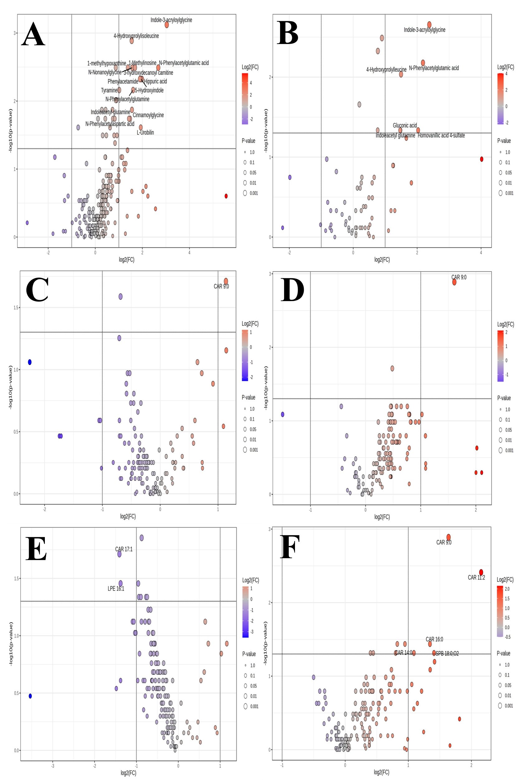
Figure S2. Volcano plots showing differences between DGF and non-DCD DGF groups: (A) metabolomic analysis in positive ionization mode on POD1, (B) metabolomic analysis in negative ionization mode on POD1, (C) lipidomics analysis - RP positive ionization mode on POD1, (D) lipidomics analysis - RP positive ionization mode on POD5, (E) lipidomics analysis - HILIC positive ionization mode on POD1, (F) lipidomics analysis - HILIC positive ionization mode on POD5.

