Supplementary Figures
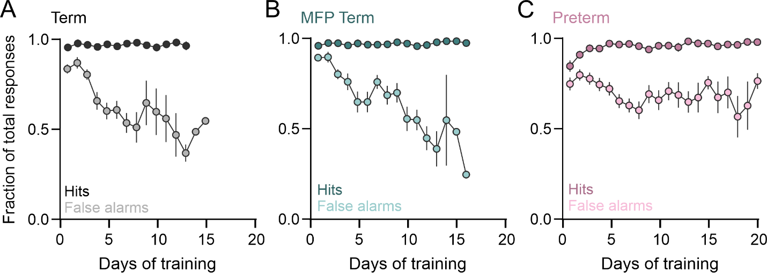 Supplementary Figure 1. The increase in task performance is driven by a reduction in error rate. Hit rates and False Alarm rates for Term (A and B) and preterm mice during training. Data are represented as mean±SEM of mice from Figure 2. Note the steady Hit Rates in both groups of term mice compared to preterm mice, as well as a precipitous decline in False Alarms in both groups of term mice that is absent from preterm mice.

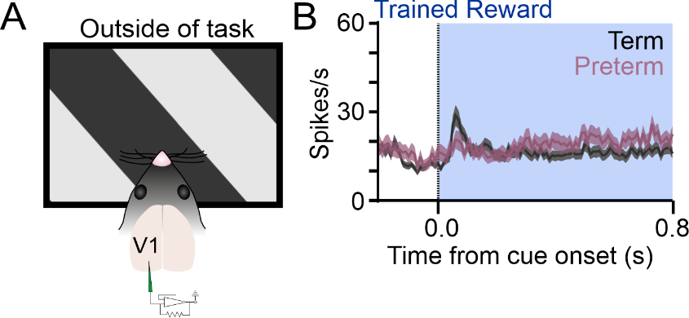

Supplementary Figure 2. Elevated firing rates to the rewarded cue in preterm mice are context-specific. A) V1 activity of trained term and preterm mice was recorded while the mice were not engaged in the task. B) PSTHs of V1 neurons significantly modulated by the rewarded cue revealed no differences between term and preterm mice: Term_{R}=12.65±1.29, N=111 units from 12 mice and Preterm_{R}=13.87±1.26, N=53 units from 10 mice, Welch’s t-test p=0.49, t=0.68, df=143.4). Data are represented as mean±SEM.

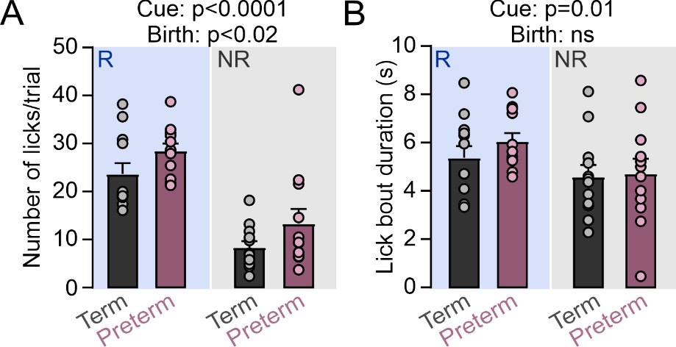
Supplementary Figure 3. Preterm mice have elevated lick rates to both cues. A) Number of licks to the rewarded and non-rewarded cues was significantly elevated in preterm mice (# of licks per bout Term_{R}=23.65±2.23, Preterm_{R}=28.48±1.49, Term_{NR}=8.37±1.28, Preterm_{NR}=13.31±3.056; 2-way ANOVA: birth x cue p=0.97, F_{(1, 22)}=0.00065; birth p=0.024, F=5.85; cue p<0.0001, F=46.26). B) Mice in both groups licked in shorter bouts during the non-rewarded cue presentation (error trials, lick bout duration Term_{R}=5.39±0.48, Preterm_{R}=6.07±0.34, Term_{NR}=4.6±0.49, Preterm_{NR}=4.73±0.62; 2-way ANOVA: birth x cue p=0.47, F_{(1, 22)}=0.52; birth p=0.49, F=0.49; cue p<0.01, F=7.69). N=12 term and 10 preterm mice.

Supplementary Figure 4. Pharmacological inactivation of the ACC impairs performance in trained mice. A) GABA-agonist muscimol was injected into the ACC 1.5-2 hours before the training session begun. B) Behavioral performance of trained mice before (black-filled circles) and after (violet-filled circles) muscimol injection. Pre-d’=3.05±0.28, post-d’=2.25±0.78; paired t-test p=0.02, t=4.42, df=3. N=mice.

