Supporting Materials
In silico studies, synthesis and biological evaluation of 4,5-dehydrospisulosine butyrate ceramides as potential Sphingosine Kinase I Inhibitors
Parleen Kaurª, Sonia Sharma^{b}, Vinay Randhawa^{c}, Navneet Agnihotri^{c}, Ramandeep Kaur^{c}, Vasundhara Singh^{*a}
ªDepartment of Applied Sciences, Punjab Engineering College (Deemed to be University), Chandigarh 160 012, India
^{b}Department cum National Centre for Human Genomics studies and Research, ^{c}Department of Biochemistry, Panjab University, Chandigarh 160014, India.

S.No. | Title | Figure/Table No.
1. | Data of compound 4 (¹H, ¹³C and MS) | Figure S (1-3)
2. | Data of compound 12 (¹H, ¹³C) | Figure S (4-5)
3. | Data of compound 2(¹H, ¹³C and MS) | Figure S (6-8)
4. | Data of compound 1 (¹H, ¹³C and MS) | Figure S (9-11)
5. | Data of compound 5 (¹H, ¹³C and MS) | Figure S (12-14)
6. | Data of compound 5 (¹H, ¹³C and MS) | Figure S (15-16)

Fig. S1: ¹H NMR- Compound 4
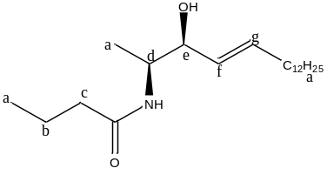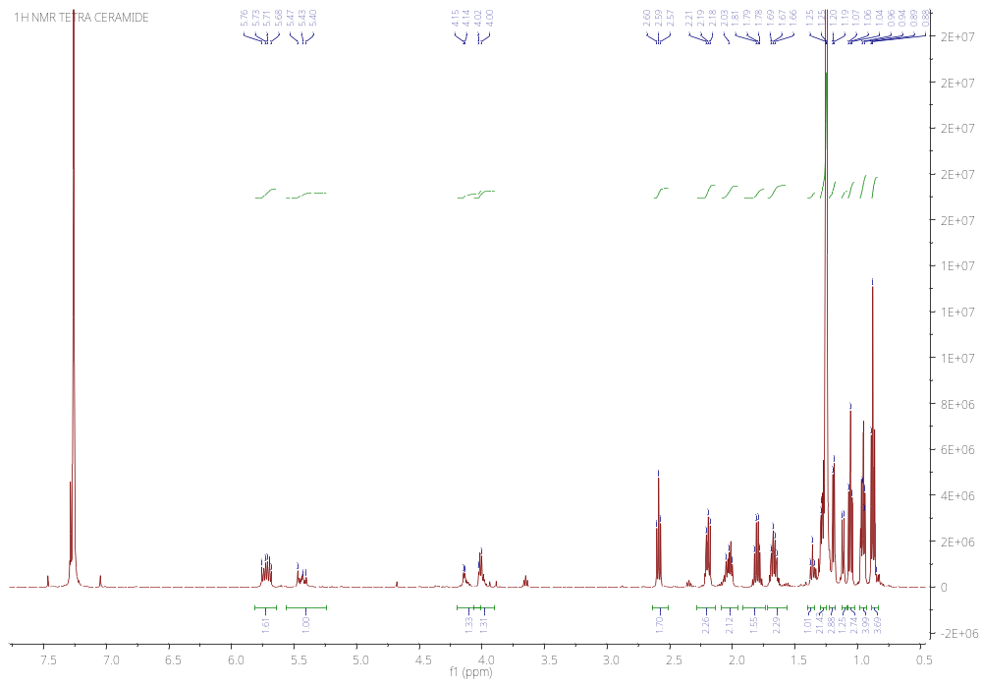
a
a
a
OH/NH/CH₂
b
c
d
e
f
g

Fig. S2: ¹³C NMR- Compound 4

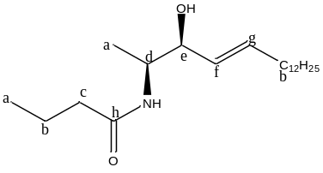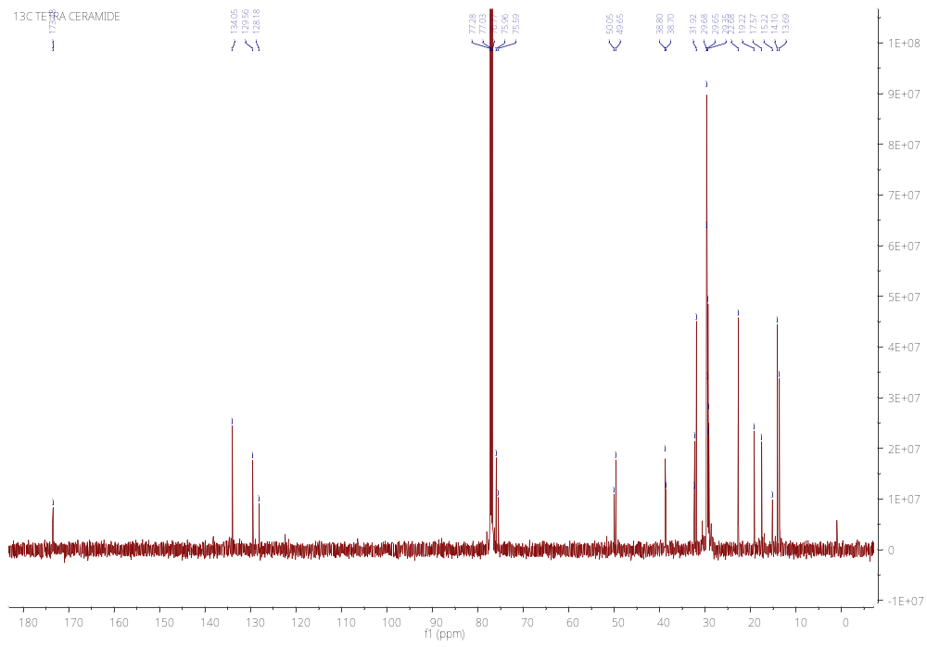
a
b
c
d
e
f
g
h

Fig. S3: LCMS - Compound 4

SAIF/CIL,PANJAB UNIVERSITY,CHANDIGARH
WATERS,Q-TOF MICROMASS (ESI-MS)
m/z
60
80
100
120
140
160
180
200
220
240
260
280
300
320
340
360
380
400
420
440
460
480
500
%
0
100
PARLEEN PK-CER-01 7 (0.153) Cm (6:19-25:76)
TOF MS ES+
1.91e4
322.5281
19068

362.4865
16066
340.5348
15110
363.3854
6730
363.5153
3417
434.4909
902
364.5084
858
[M+H]⁺
[M+Na]⁺
[M-OH]⁺

Fig. S4: ¹H NMR Compound 12
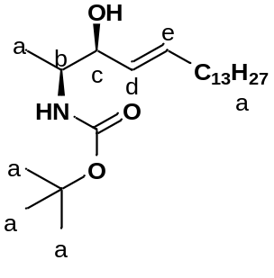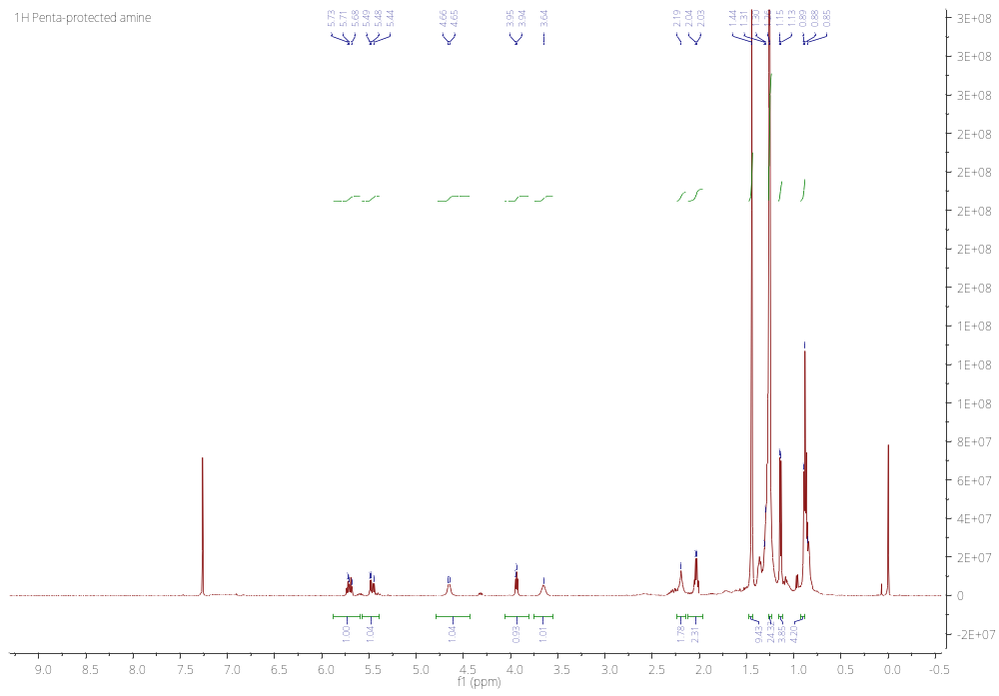
a
a
a
CH₂
OH
NH
b
c
d
e

Fig. S5: ¹³C NMR Compound 12
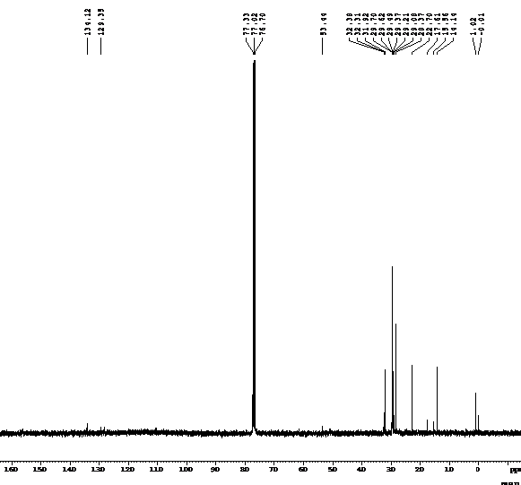
a
a
b
c
d
e

Fig. S5: ¹H NMR Compound 2
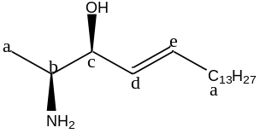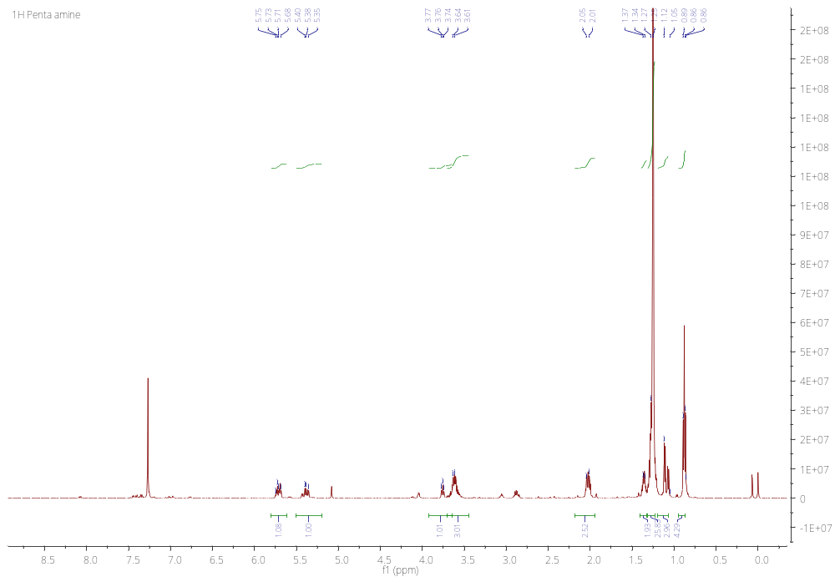
CH₂
e
d
c
b/NH₂
a
a

Fig. S1: ¹³C NMR Compound 2
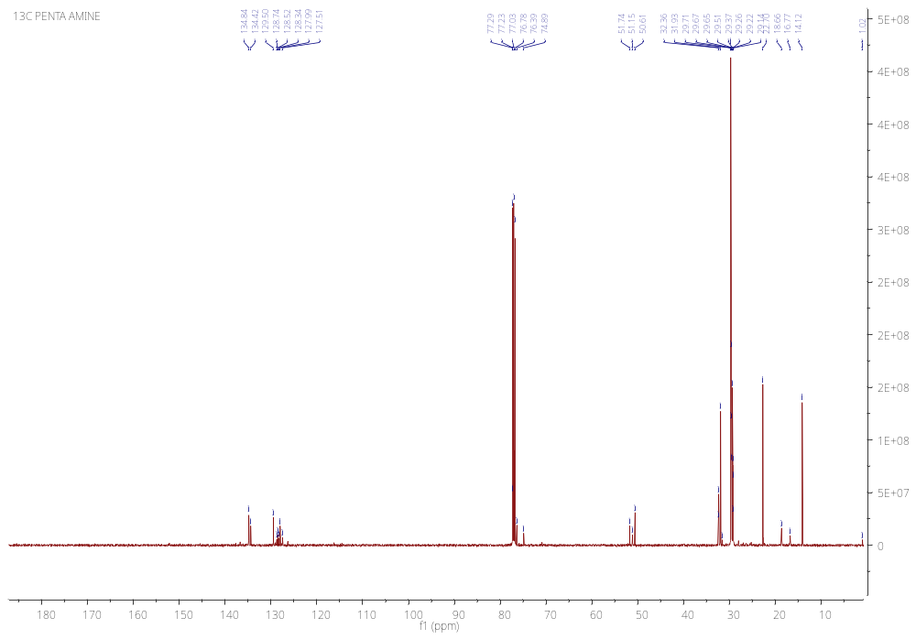
a
a
b
c
CdCl₃
d
e

Fig. S8: LCMS- Compound 2

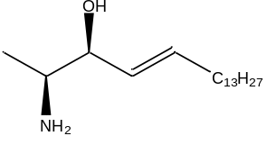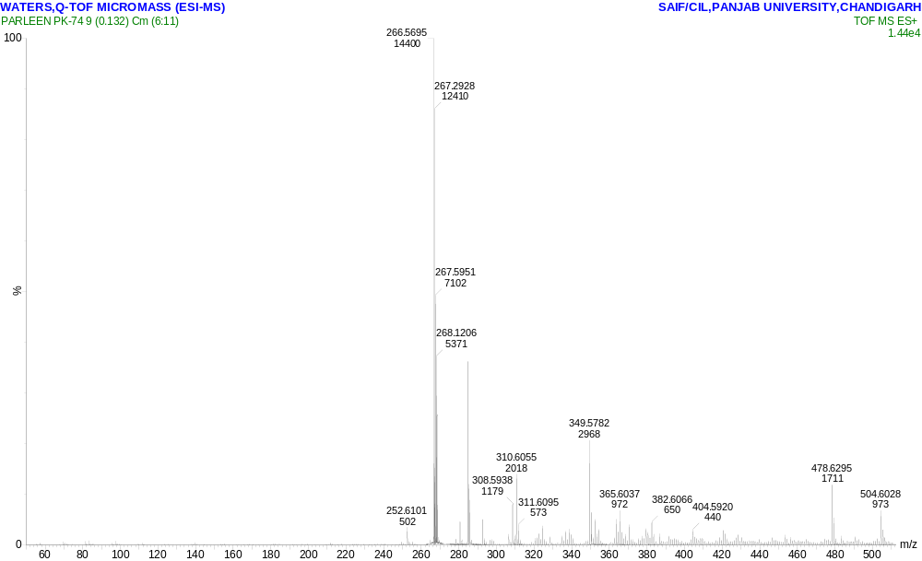
[M+1]⁺
+1
[M-OH]⁺

Fig. S9: ¹H NMR Compound 1
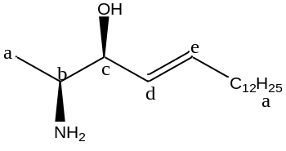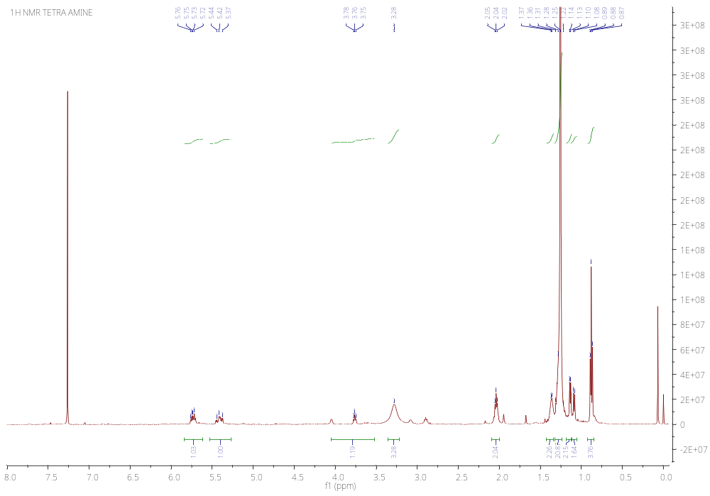
CH₂
a
a
b/NH₂
c
d
e

Fig. S10: ¹³C NMR Compound 1
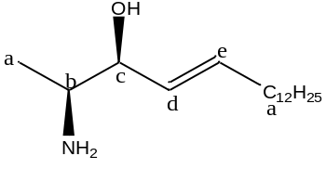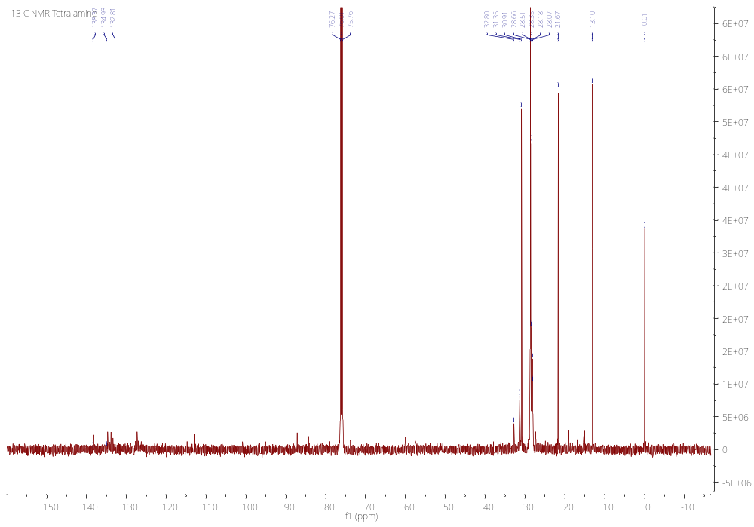
a
a
c/d
d/e

Fig. S11: LCMS- Compound 1
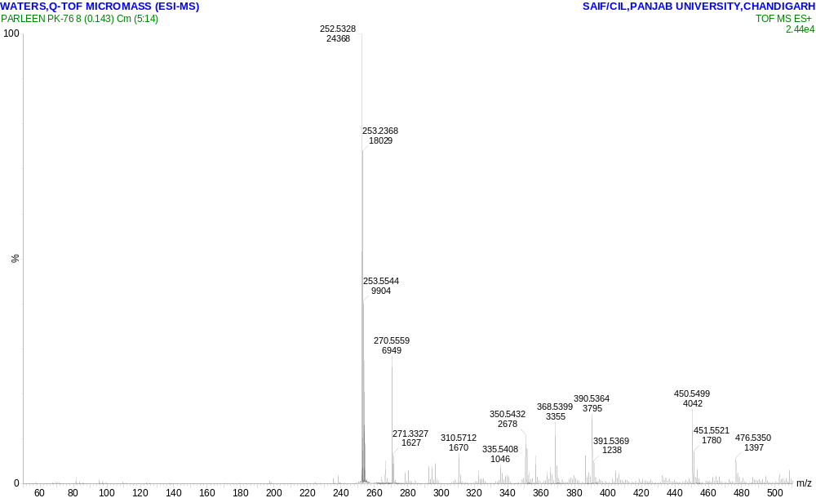
[M+H]⁺
[M-OH]⁺

Fig. S12: ¹H NMR Compound 5

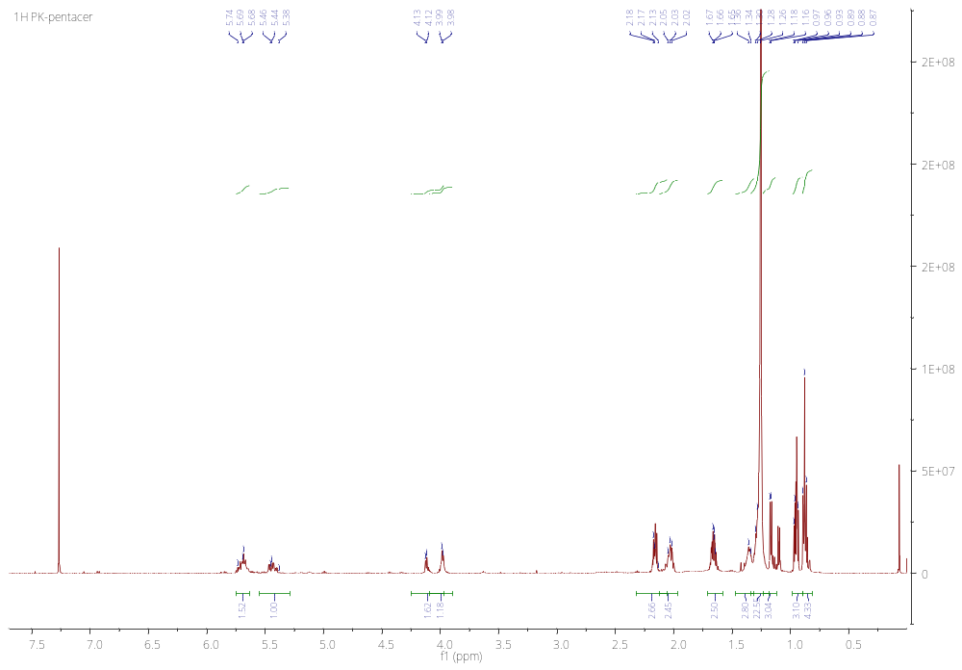
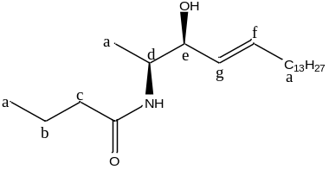

a

a

a

OH/NH
c
b
d
e
f
g

Fig. S13: ¹³C NMR Compound 5

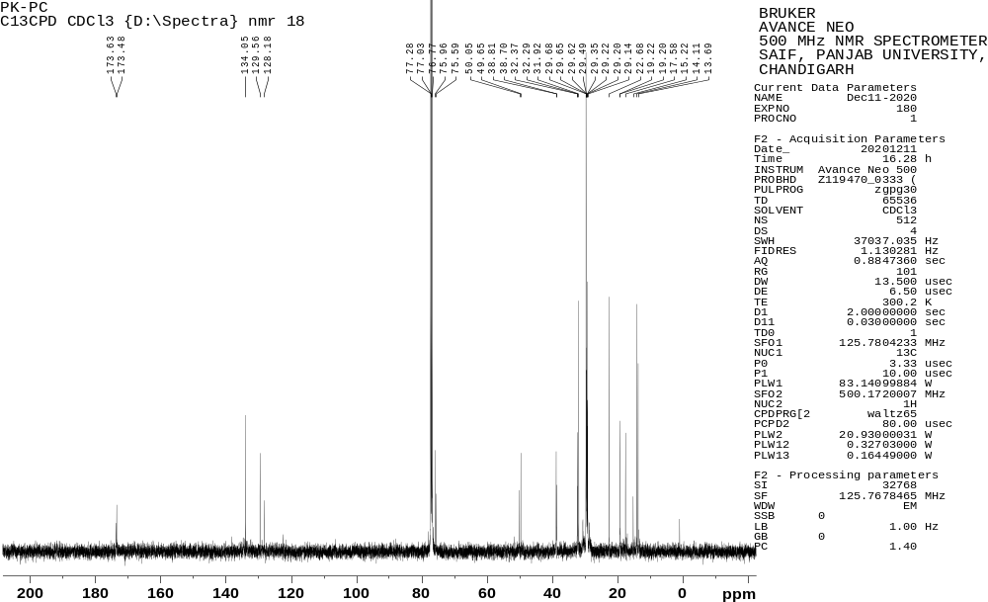

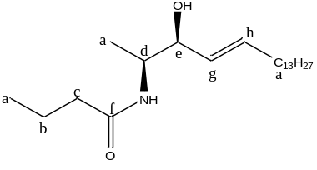
a

b
CdCl₃
c

a

h
d
e

g
f

Fig. S14: LCMS- Compound 5

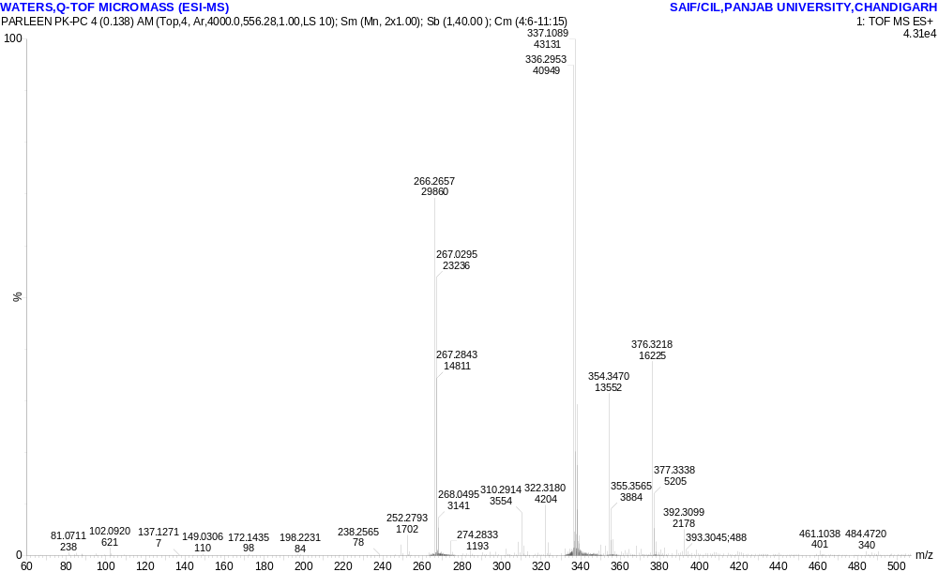
[M+1]⁺
[M+Na]⁺
[M-OH]⁺

Fig. S15: 1H NMR- Compound 6

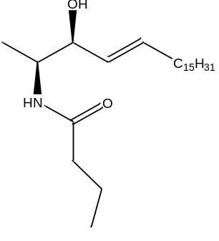
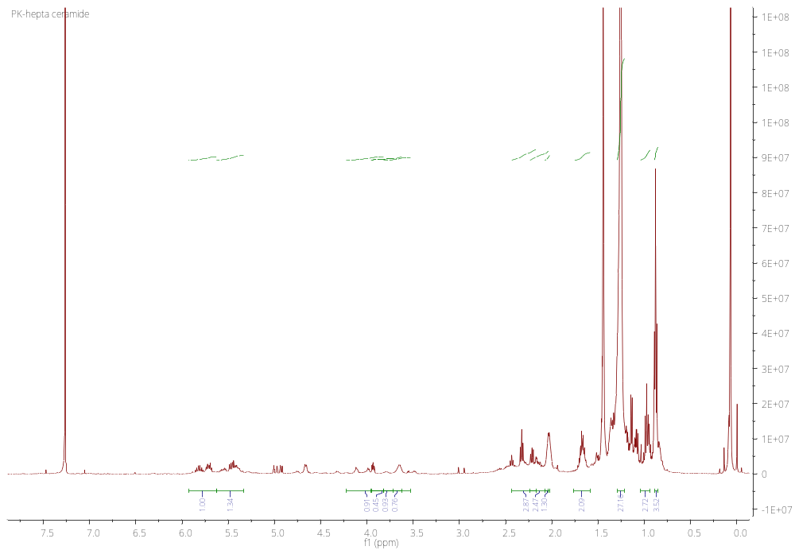

Fig. S16: LCMS- Compound 6

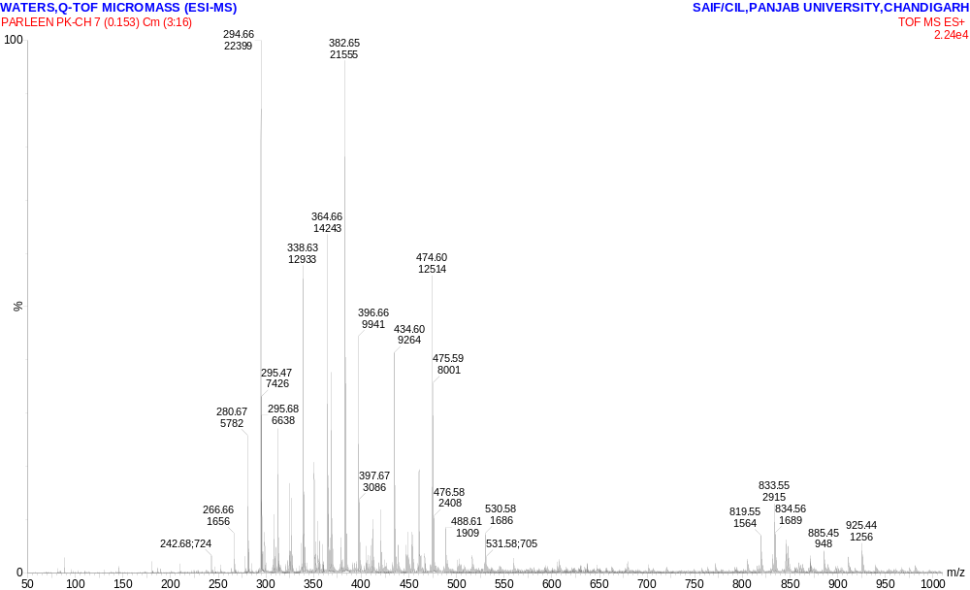
[M+NH₃]⁺
[M+H]⁺

