Supplementary
Correction to: Landscape-level and stand-level factors play diverse roles during different periods of Dendroctonus valens invasion in North China
1 Image preprocessing and classification
GF2, China’s new-generation satellite launched in August 2014, provided high-resolution images for earth observation. According to the calibration parameters given on the official website (China Centre for Resources Satellite Data and Application, 2020), we carried out radiometric calibration and atmospheric correction (FLAASH) for GF2 images (processing level: L1A) to convert the original digital number (DN) values to radiation values or reflectance. The satellite scenes were orthorectified using digital elevation model (DEM) data. Pan-sharpened 1 m resolution GF2 images were created by fusing the 4 m multispectral GF2 images with the 1 m panchromatic GF2 images using the nearest-neighbor diffusion (NNDiffuse) algorithm.
We classified the GF2 images based on object methods and RF (random forest) (Breiman, 2001) algorithm. The multiresolution segmentation was used to segment the GF2 1 m resolution images into objects in eCognition developer software (Benz et al., 2004). The best segmentation parameters were assessed by the scale of tree crowns. We used multiple levels of detail to iteratively optimize segmentation and adjust the shape and compactness parameters. The final scale parameter was 10, and default homogeneity criteria were 0.1 and 0.5 for shape and compactness, respectively.
Table 1 Confusion matrix of GF2 images based on the object method and RF algorithm.
 | China pine | Larch | Broadleaf tree | Grassland | Farmland | Residence community | Total | UA
China pine | 131 | 8 | 16 | 5 | 2 | 0 | 162 | 80.86%
Larch | 6 | 95 | 15 | 4 | 2 | 1 | 123 | 77.24%
Broadleaf tree | 18 | 16 | 109 | 7 | 5 | 0 | 155 | 67.74%
Grassland | 5 | 7 | 7 | 205 | 10 | 2 | 236 | 86.86%
Farmland | 3 | 3 | 7 | 8 | 146 | 9 | 176 | 82.95%
Residence community | 0 | 0 | 1 | 1 | 4 | 74 | 80 | 92.50%
Total | 163 | 129 | 155 | 230 | 169 | 86 | 932
PA | 81.36% | 73.64% | 70.32% | 89.13% | 86.39% | 86.05% | OA | 81.54%
 |  |  |  |  |  |  | KAPPA | 0.78

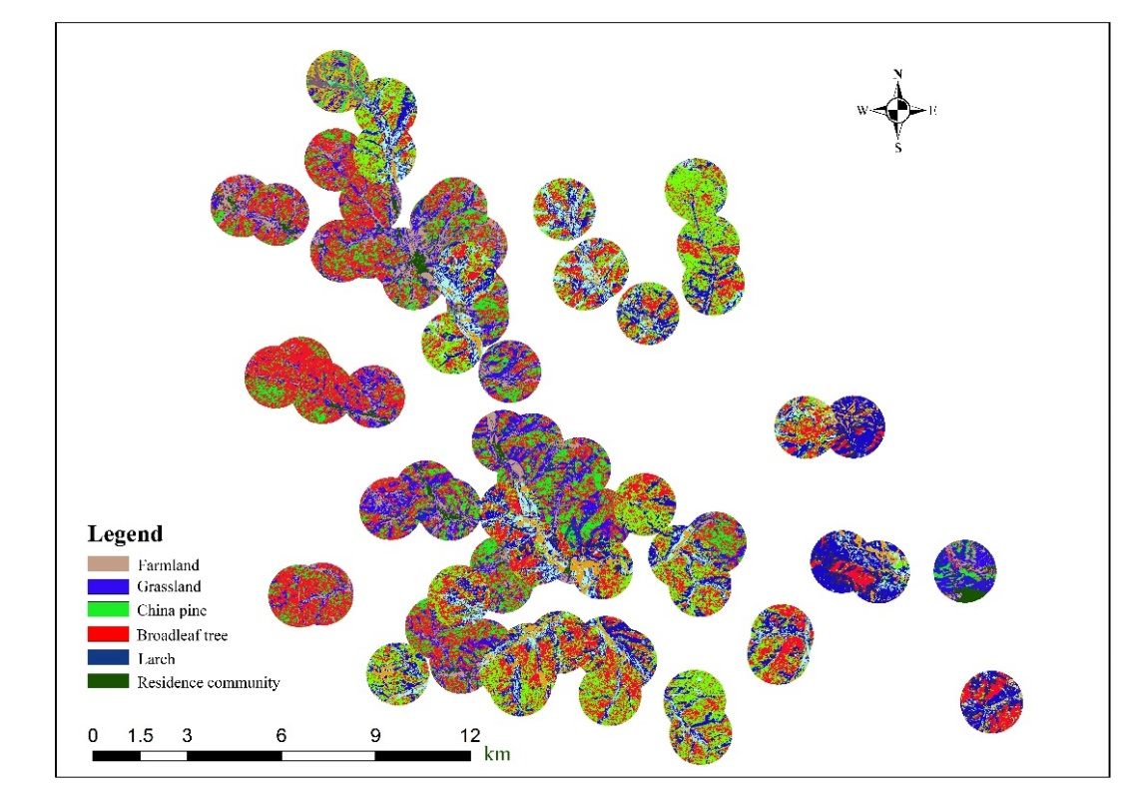
Figure 1 Feature classification map for landscape analysis. Only classification map of Heilihe area is given.
2 Multicollinearity assessment
We separately evaluated the collinearity of the data from the two invasion areas and collinear variables were excluded from model fitting. First, we calculate a correlation matrix (Pearson’s r) for the predictors (Illán et al., 2019). We observed correlations between variables accounting for the (i) ‘PLAND’ and ‘COHESION’ and (ii) ‘soil organic matter’ and ‘soil total nitrogen’ where r was =0.886 (Figure 1 and 2). We removed the PLAND and soil organic matter variable. Then we calculate the variance expansion factor (VIF) between the remaining variables and we found that the VIF values were less than 3, indicating that explanatory variables had a low collinearity (Dormann et al., 2013).
Figure 2 Pearson correlation coefficient for all predictor variables in the early invasion area.
Figure 3 Pearson correlation coefficient for all predictor variables in the middle outbreak area.
3 GLMs Model selection for 500 and 1000 m landscape scale
Because landscape factors did not play a role in the early stage of RTB invasion, we did not exhibit the model fitting results of the early invasion area (Heilihe area) at 500 m and 1000 m landscape scales. The results of the model averaging procedure of the middle invasion area (Dahebei area) at 500 m and 1000 m landscape scales were showed in Table 2 and 3.
Table 2 Summary results of the model averaging procedure assessing effects of stand and landscape level factors on RTB damage (Landscape scale = 500m).
 | Estimate | Std. Error | z-value | P-value | AIC | R²
Middle invasion stage |  |  |  |  | 230.2 | 0.096
Intercept | 11.59 | 10.42 | 1.09 | 0.277
DBH | 0.87 | 2.30 | 0.36 | 0.718
Slope | 1.41 | 1.07 | 1.26 | 0.207
Aspect | 0.23 | 0.26 | 0.82 | 0.412
Canopy density | 0.01 | 5.86 | 0.01 | 0.10
Elevation | -1.67 | 5.69 | 0.28 | 0.777
SHAPE_MN | -11.37 | 11.93 | 0.91 | 0.36
PLAND | 0.45 | 1.34 | 0.326 | 0.745
SHDI | -34.91 | 17.23 | 1.95 | 0.051
R² are presented for best-fit models in the final column.
Table 3 Summary results of the model averaging procedure assessing effects of stand and landscape level factors on RTB damage (Landscape scale = 1000m).
 | Estimate | Std. Error | z-value | P-value | AIC | R²
Middle invasion stage |  |  |  |  | 231.2 | 0.037
Intercept | 1.26 | 5.43 | 0.22 | 0.823
DBH | 1.59 | 2.18 | 0.70 | 0.484
Slope | 0.60 | 1.05 | 0.547 | 0.584
Aspect | 0.07 | 0.25 | 0.27 | 0.786
Canopy density | -1.32 | 5.75 | 0.22 | 0.826
Elevation | 2.39 | 4.71 | 0.49 | 0.626
SHAPE_MN | 5.74 | 14.88 | 0.37 | 0.711
PLAND | 0.51 | 1.48 | 0.328 | 0.743
SHDI | 3.21 | 20.04 | 0.15 | 0.878
R² are presented for best-fit models in the final column.
Reference
Benz UC, Hofmann P, Willhauck G et al (2004). Multi-resolution, object-oriented fuzzy analysis of remote sensing data for GIS-ready information. ISPRS J Photogramm 58:239-258. https://doi.org/10.1016/j.isprsjprs.2003.10.002
Breiman L (2001). Random Forests. Mach Learn 45:5-32. https://doi.org/10.1023/A:1010933404324
China Centre for Resources Satellite Data and Application (2020). http://www.cresda.com/CN/. Accessed 9 June 2020
Dormann C, Elith J, Bacher S, Buchmann, C (2013). Collinearity: A review of methods to deal with it and a simulation study evaluating their performance. Ecography, 36:27-46. https://doi.org/10.1111/j.1600-0587.2012.07348.x
Illán JG, Bloom EH, Wohleb CH (2020). Landscape structure and climate drive population dynamics of an insect vector within intensely managed agroecosystems. Ecol Appl 30. https://doi.org/10.1002/eap.210

