Supplementary Information for
Unveiling air-induced surface transformation on atomic step-engineered sapphire for oriented growth of transition metal dichalcogenides

Wei Fu^{1,2,}*, Jianwei Chai², Hiroyo Kawai³, Thathsara Maddumapatabandi^{1.2}, Ding Huang^{1,2}, Fabio Bussolotti^{1,2}, Siew Lang TEO², Hui Ru Tan², Jingyi Tee², Calvin Pei Yu Wong², Anqi Sng², Yunjie Chen², Mingsheng Zhang², Henry Medina^{2,4}, Ming Lin²，Michel Bosman^{2,5} and Kuan Eng Johnson Goh^{1,2,6,7,}*

- Quantum Innovation Centre (Q.InC), Agency for Science Technology and Research (A*STAR), 2 Fusionopolis Way, Innovis #08-03, Singapore 138634, Republic of Singapore
- Institute of Materials Research and Engineering (IMRE), Agency for Science Technology and Research (A*STAR), 2 Fusionopolis Way, Innovis #08-03, Singapore 138634, Republic of Singapore
- Institute of High-Performance Computing (IHPC), Agency for Science, Technology and Research, 1 Fusionopolis Way, #16-16 Connexis, Singapore 138632, Republic of Singapore
- IMEC, Kapeldreef 75, Leuven 3001, Belgium
- Department of Materials Science and Engineering, National University of Singapore, 9 Engineering Drive 1, 117575, Singapore
- Department of Physics, National University of Singapore, 2 Science Drive 3, Singapore 117551, Singapore
- Division of Physics and Applied Physics, School of Physical and Mathematical Sciences, Nanyang Technological University, 50 Nanyang Avenue 639798, Singapore

Table of Contents
Supplementary section 1: general characterizations 5
Supplementary Fig. 1. Crystal structure of the c-plane sapphire surface 5
Supplementary Fig. 2. The surface profiles of sapphire after annealing 6
Supplementary Fig. 3. AFM images of engineered sapphires 7
Supplementary Fig. 4. Cross-section STEM images of sapphire aging in air for different durations 8
Supplementary Fig. 5. Schematic illustration of sapphire surface morphology evolution during air exposure 9
Supplementary Table. 1. The settings of electron flood gun under various control modes 10
Supplementary Fig. 6. XPS measurement on freshly annealed sapphire under high electron flux mode 10
Supplementary Table. 2. The XPS analysis of freshly annealed and 1-week aged sapphires, assessed under high electron flux mode 11
Supplementary Fig. 7. Schematic illustration of aluminum (oxy)hydroxide structure 11
Supplementary section 2: the comparison of XPS spectra of Al 2p, O 1s, C 1s peaks on freshly annealed sapphire under NEF, LEF and HEF XPS testing modes 12
Supplementary Fig. 8. Angle-resolved XPS spectra of Al 2p and O1s on freshly annealed sapphire, assessed under low electron flux mode (LEF) 12
Supplementary Fig. 9. Angle-resolved XPS spectra of Al 2p and O1s on freshly annealed sapphire, assessed under no electron flux (NEF) mode 13
Supplementary Fig. 10. XPS spectra of Al 2p and O1s on sapphire, freshly annealed with and without electron flood gun 14
Supplementary Table. 3. The XPS analysis of freshly annealed sapphire, measured at different electron flood gun settings 16
Supplementary Fig. 11. Survey scan spectrum of sapphire aged in air for two weeks 17
Supplementary section 3: the comparison of XPS spectra of Al 2p, O 1s, C 1s peaks on 2-week aged sapphire under NEF, LEF and HEF XPS testing modes 18
Supplementary Fig. 12. Angle-resolved XPS spectra of Al 2p and O1s on sapphire aged for two weeks 18
Supplementary Table. 4. The XPS analysis of two-weeks-aged sapphire, measured at various angles 19
Supplementary Fig. 13. The angle-dependent area ratio of Al-OH bonding and Al-O bonding in XPS spectra of O1s on sapphire aged for two weeks 19
Supplementary Fig. 14. Angle-resolved XPS spectra of Al 2p and O1s on sapphire aged for two weeks without electron flood gun 22
Supplementary Fig. 15. Angle-resolved XPS spectra of Al 2p and O1s on sapphire aged for two weeks without electron flood gun 23
Supplementary Table. 5. The XPS analysis of two-weeks-aged sapphire, measured with no electron flux 24
Supplementary Fig. 16. The angle-dependent area ratio of Al-OH bonding and Al-O bonding in XPS spectra of O1s on sapphire aged for two weeks without electron flood gun 24
Supplementary Fig. 17. Angle-resolved XPS spectra of Al 2p and O1s on sapphire aged for two weeks with low electron flood gun 25
Supplementary Fig. 18. Angle-resolved XPS spectra of Al 2p and O1s on sapphire aged for two weeks with low electron flood gun 26
Supplementary Table. 6. The XPS analysis of two-weeks-aged sapphire, measured with low electron flood gun 27
Supplementary Fig. 19. The angle-dependent area ratio of Al-OH bonding and Al-O bonding in XPS spectra of O1s on sapphire aged for two weeks with low electron flood gun. 27
Supplementary Fig. 20. High-resolution XPS spectra of Al 2p, O 1s and C 1s on sapphire aged for two weeks with different electron flux intensities of flood gun 28
Supplementary Table 7. The XPS analysis of two-weeks-aged sapphire, measured with different electron flux intensities of flood gun. 29
Supplementary section 4: The aging duration dependent angle-resolved XPS spectra of Al 2p, O 1s, C 1s peaks under LEF testing mode 30
Supplementary Fig. 21. Angle-resolved XPS spectra of Al 2p and O1s on sapphire, aged for one and two weeks, assessed at low electron flux mode 30
Supplementary Fig. 22. Angle-resolved XPS spectra of Al 2p and O1s on sapphire, aged for four, six and eight weeks, assessed at low electron flux mode. 31
Supplementary Fig. 23. XPS measured surface phase evolution of sapphire during air exposure, assessed at low electron flux mode. 32
Supplementary Table 8. The XPS analysis of two-weeks-aged sapphire, measured with low electron flood gun. 33
Supplementary Fig. 24. The angle-dependent area ratio of Al-OH bonding and Al-O bonding in XPS spectra of O1s on sapphire aged for two weeks with low electron flood gun 33
Supplementary section 5: the XPS spectra and analysis of Al 2p, O 1s, C 1s peaks on sapphires engineered with different atomic step height 34
Supplementary Fig. 26. Atomic step height dependent surface structural changes 34
Supplementary Table 9. The XPS analysis of two-weeks-aged sapphires, engineered with different atomic step heights. 35
Supplementary Fig. 27. The atomic step height dependent ratio of angle-dependent area ratio of AAl-OH/AAl-O 35
Supplementary Fig. 28. The growth recipe without growth precursors 36
Supplementary section 6: the XPS spectra and analysis on structure transformation of aged sapphire in the pre-growth heating process 37
Supplementary Fig. 29. Atomic step height dependent surface structural changes 37
Supplementary Table 10. The XPS analysis of sapphires after annealing, after two-weeks-aging and after growth thermal heating 38
Supplementary Fig. 30. The calculated Al/O changes on sapphire samples in fresh, and after aging for 2 weeks and 4 weeks 38
Supplementary Fig. 31. Photograph of UV cleaner 39
Supplementary section 7: the XPS spectra and analysis on structure transformation of aged sapphire with UV irradiation 40
Supplementary Fig. 32. The high-resolution Al 2p and O 1s spectra of sapphire samples 40
Supplementary Table 11. The XPS analysis of sapphires of annealing, two-weeks-aging, UV exposure and growth heating 41
Supplementary Fig. 33. RHEED patterns of fresh annealed sapphire 42
Supplementary Fig. 34. The illustration of $\sqrt{31}$ x $\sqrt{31}$ reconstructed structure. 42
Supplementary Fig. 35. The schematic illustration of the fabrication of two commonly used c-plane sapphire wafers with atomic step along the a $<1120>$ and m $<1010>$directions 43
Supplementary Fig. 36 Optical image of WS₂ continuous film on 2-inch sapphire wafer 43
Supplementary Fig. 37. Atomic-resolution STEM analysis of grown WS₂ monolayer 44
Supplementary Fig. 38. XPS characterization of WS₂ film transferred on HOPG by PMMA method. 44
Supplementary Fig. 39. ARPES intensity plot showing the valence band dispersion of WS₂ monolayer along GM and GK high symmetry direction at 295 K 45
Reference 46

Supplementary section 1: general characterizations

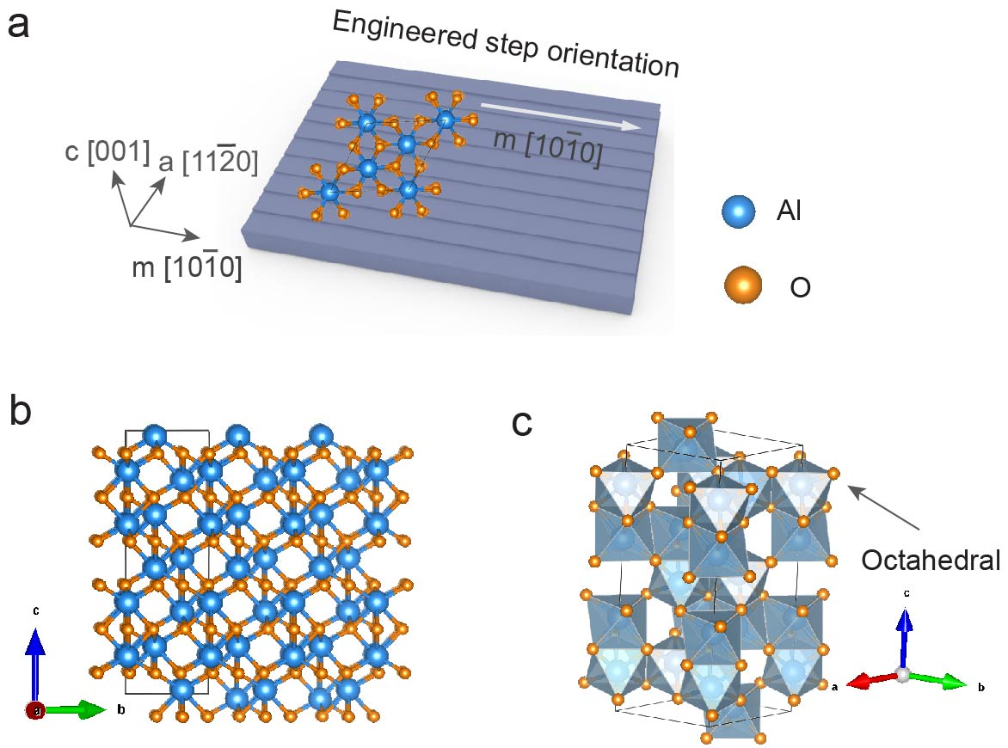

Supplementary Fig. 1. Crystal structure of the c-plane sapphire surface. a, Schematic representation of c-plane sapphire, cutting along the a-axis, and forming the atomic steps towards the m-direction after the thermal annealing process. b, The atomic structure of c-plane sapphire along the a [11-20] plane, showing the half-Al termination. c, The octahedral aluminum coordination in sapphire crystal structure.

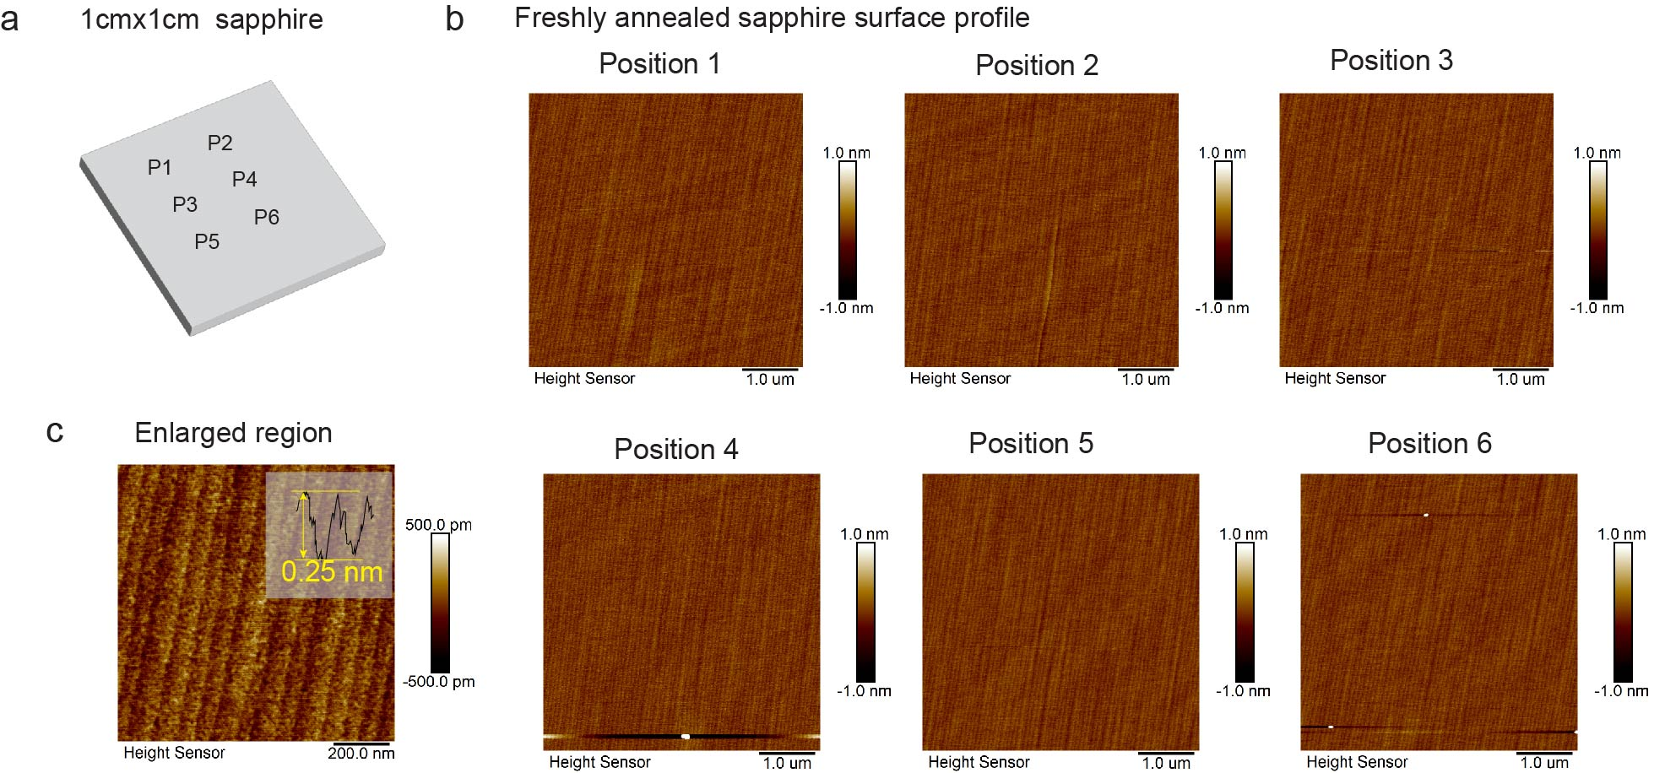
Supplementary Fig. 2. The surface profiles of sapphire after annealing. a, Schematic representation of six AFM testing points marked as P1 to P6. b, AFM images of freshly annealed sapphire at various positions, revealing a clean surface with atomic steps. c, High-resolution AFM image, showing the atomic step height of ~0.25 nm.

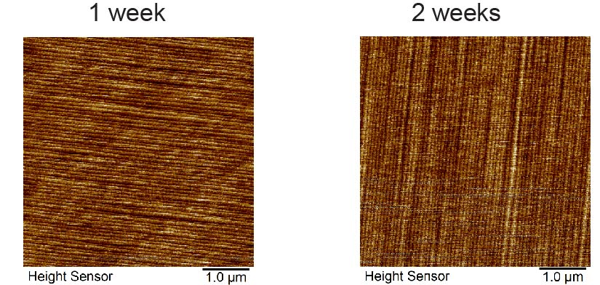
Supplementary Fig. 3. AFM images of engineered sapphires. a, Sapphire upon air exposure for 1 week. b, Sapphire upon air exposure for 2 weeks. It is hard to detect the structure changes during the 2 weeks air-exposure.

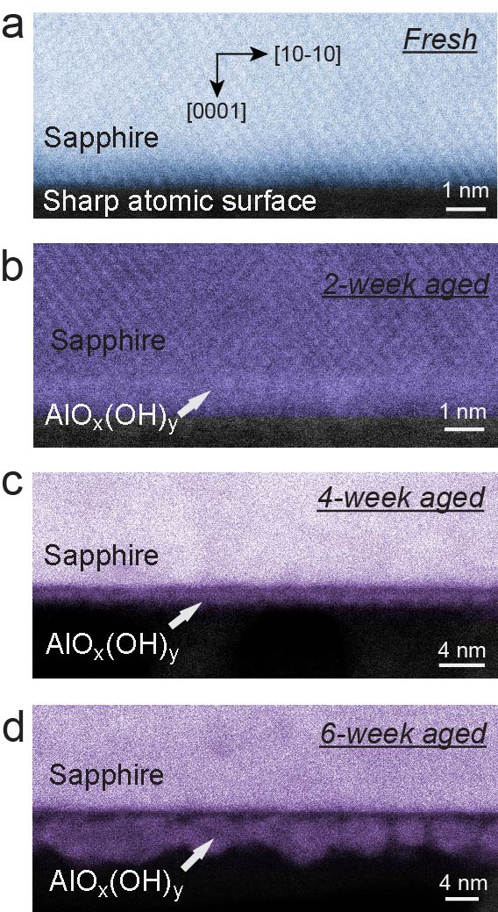
Supplementary Fig. 4. Cross-section STEM images of sapphire aging in air for different durations. a, Freshly annealed sapphire. The clearly atomic b, The sample after air exposure for 2 weeks. c, The sapphire after air exposure for 4 weeks. d, The sample after air exposure for 6 weeks. It shows the amorphous layer with the thickness of ~1 nm on the surface. The clusters are formed on the amorphous layer during the long-term air-exposure.

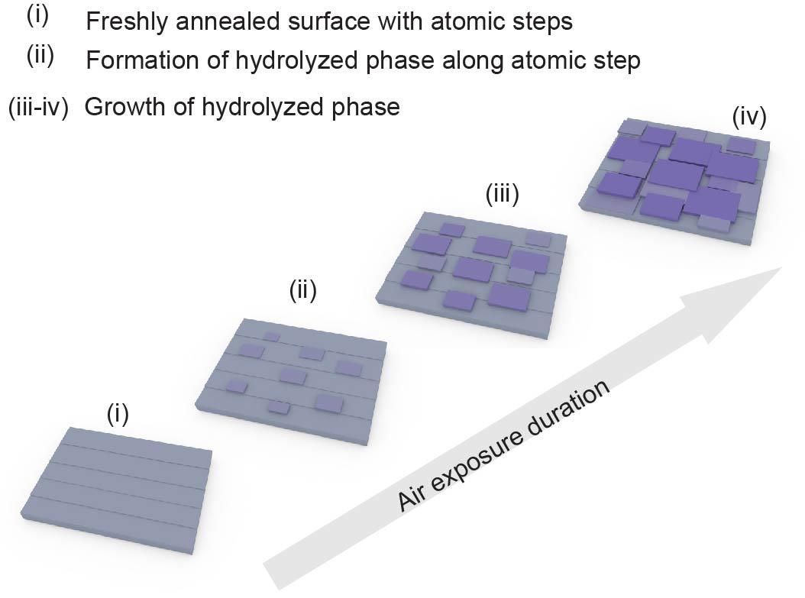
Supplementary Fig. 5. Schematic illustration of sapphire surface morphology evolution during air exposure.

Supplementary Table. 1. The settings of electron flood gun under various control modes
Setting | Filament current  (A) | Extractor V  (V) | Electron energy  (V) | Emission current density  (μA cm⁻²)
No electron flux (NEF) | 0 | 40 | -2 | 0
Low electron flux intensity (LEF) | 2 | 40 | -2 | 20
High electron flux intensity (HEF) | 2.4 | 40 | -2 | 24

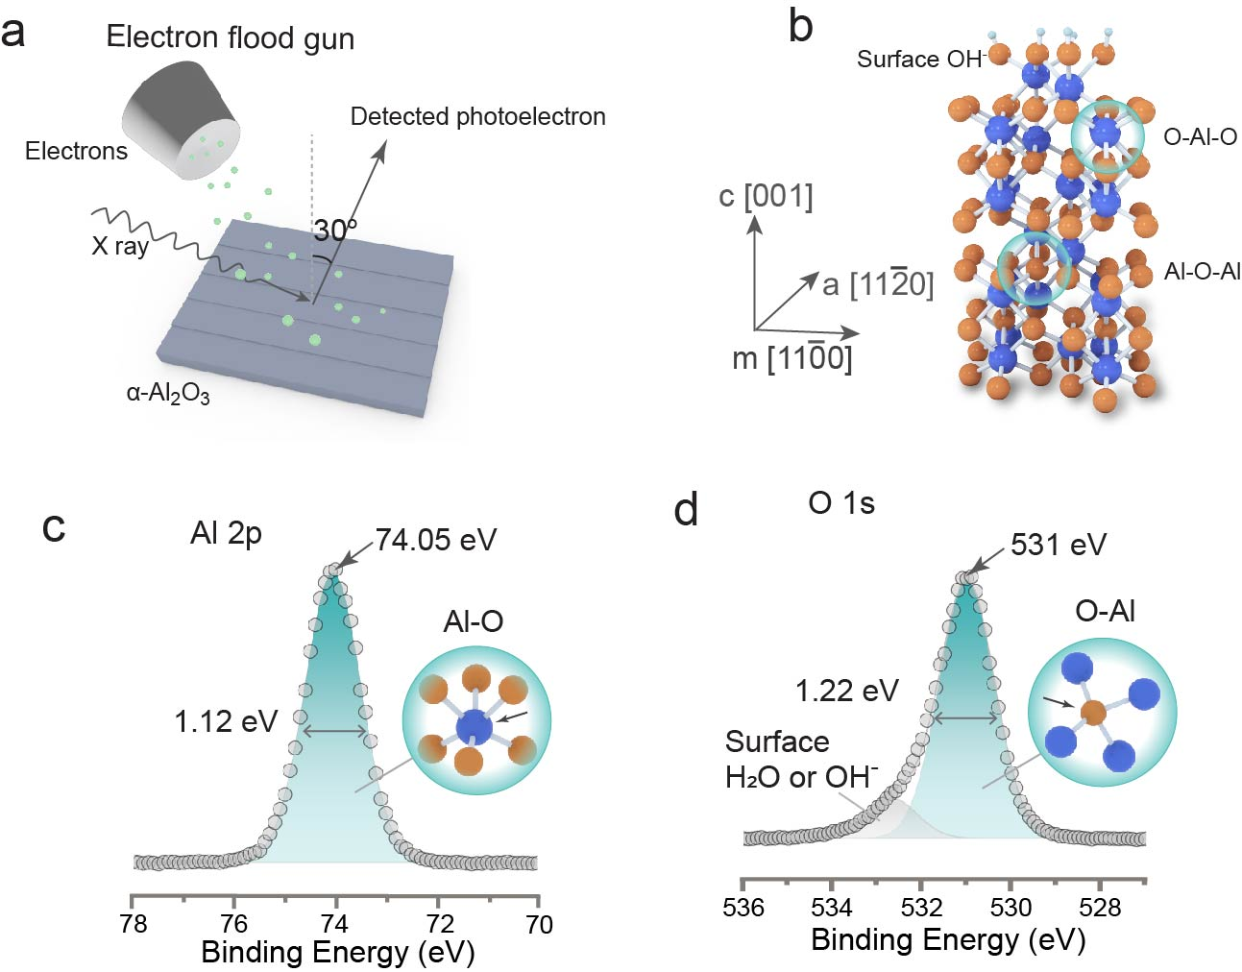
Supplementary Fig. 6. XPS measurement on freshly annealed sapphire under high electron flux mode. a, Schematic of XPS measurement with photoelectron collected at 30º. b, Crystal structure of c-plane sapphire, showing O-Al-O and Al-O-Al bonding. c, High-resolution Al 2p and O1s spectra.

Supplementary Table. 2. The XPS analysis of freshly annealed and 1-week aged sapphires, assessed under high electron flux mode
Samples | O 1s |  |  |  |  |  | Al 2p |  |  |  |  |  | C 1s
Samples | Al-O@ Al₂O₃ |  |  | Al-OH @AlO_{x}(OH)_{y} |  |  | Al-O@ Al₂O₃ |  |  | Al-OH @AlO_{x}(OH)_{y} |  |  | Peak (eV)
Samples | FWHM  (eV) | Peak  (eV) |  | FWHM  (eV) | Peak  (eV) |  | Peak (eV) |  | FWHM  (eV) | Peak  (eV) |  | FWHM  (eV) | Raw | corrected
Samples | FWHM  (eV) | raw | corrected | FWHM  (eV) | Raw | corrected | raw | corrected | FWHM  (eV) | Raw | corrected | FWHM  (eV) | Raw | corrected
Freshly annealed | 1.22 | 529.1 | 531.0 |  |  |  | 72.2 | 74.1 | 1.12 |  |  |  | 283.1 | 285.0
1-week aged | 1.22 | 528.6 | 531.0 | 1.3 | 529.0 | 531.4 | 71.5 | 73.9 | 1.25 | 71.7 | 74.1 | 1.3 | 282.6 | 285.0

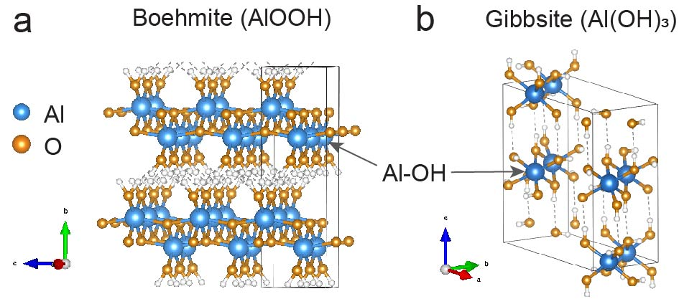
Supplementary Fig. 7. Schematic illustration of aluminum (oxy)hydroxide structure. a, Crystal structure of boehmite, AlOOH. a, Crystal structure of Gibbsite, Al(OH)₃.

Supplementary section 2: the comparison of XPS spectra of Al 2p, O 1s, C 1s peaks on freshly annealed sapphire under NEF, LEF and HEF XPS testing modes

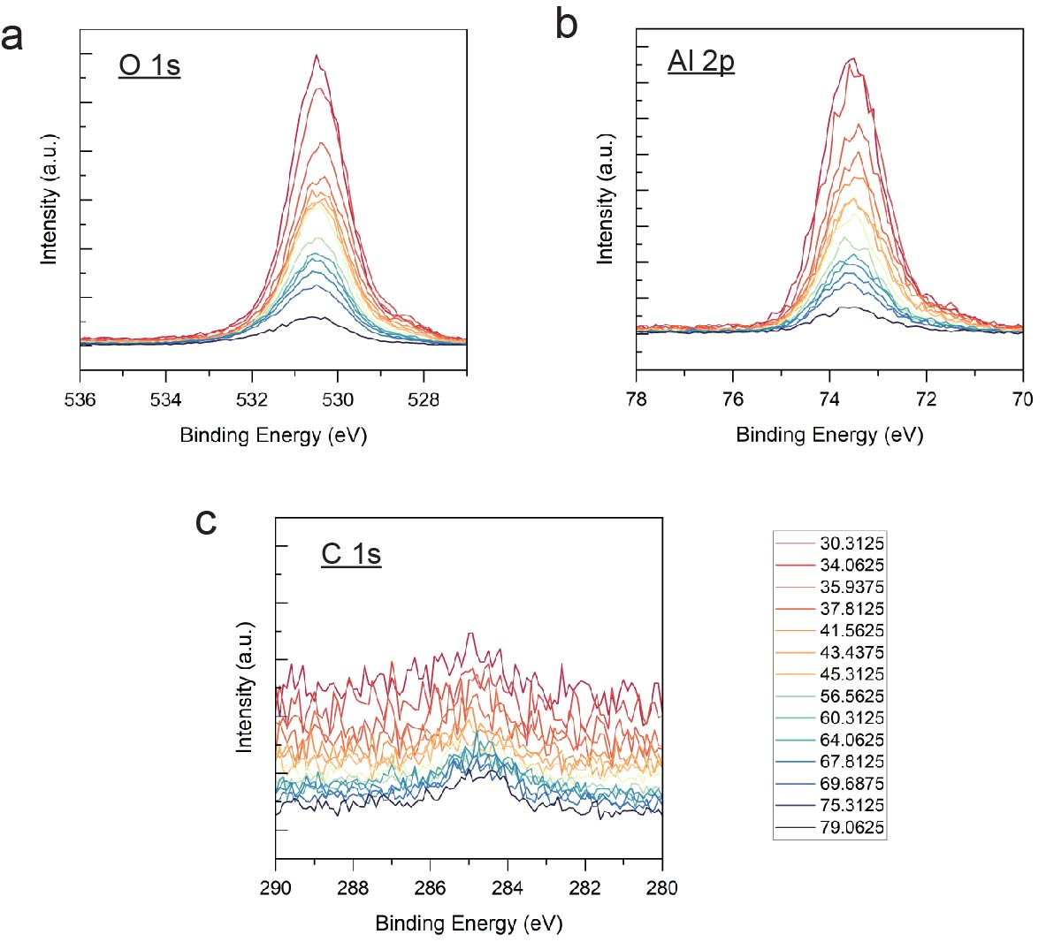
Supplementary Fig. 8. Angle-resolved XPS spectra of Al 2p and O1s on freshly annealed sapphire, assessed under low electron flux mode (LEF).

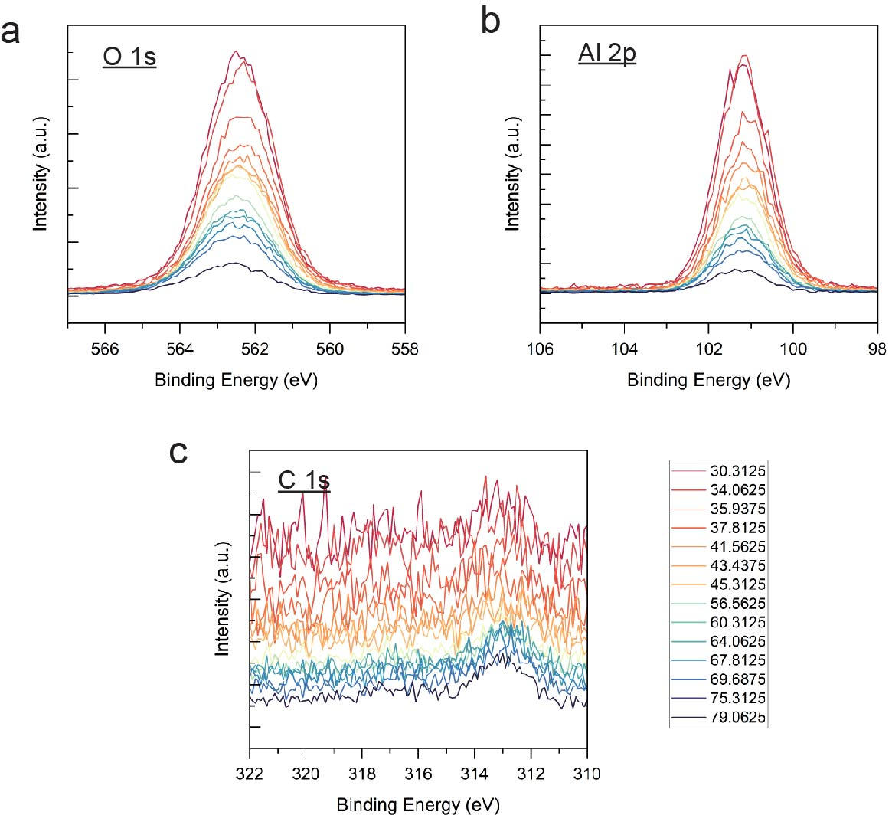
Supplementary Fig. 9. Angle-resolved XPS spectra of Al 2p and O1s on freshly annealed sapphire, assessed under no electron flux (NEF) mode.

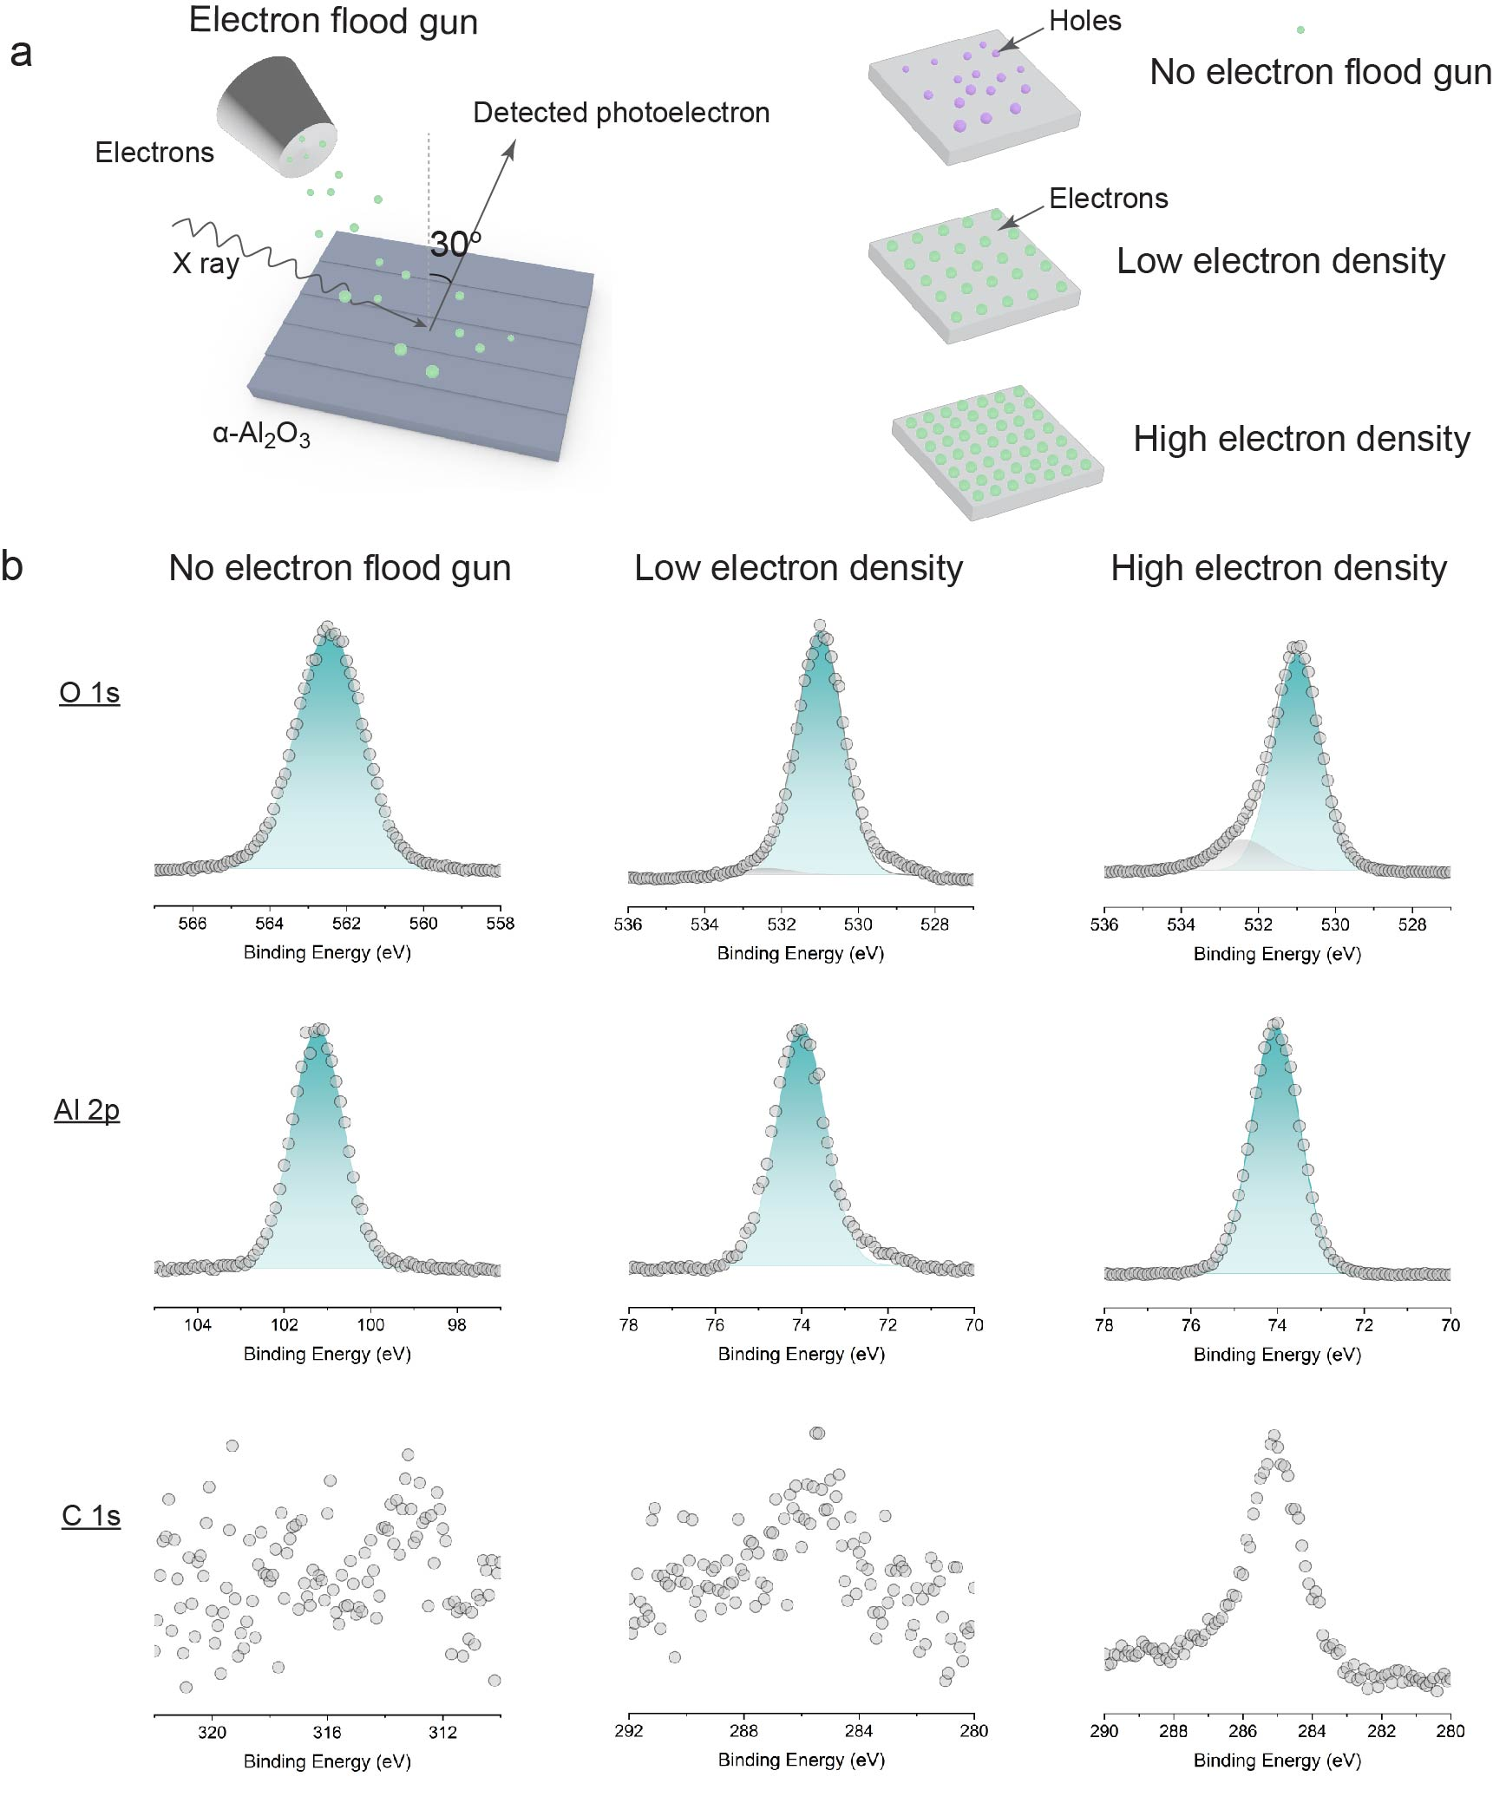
Supplementary Fig. 10. XPS spectra of Al 2p and O1s on sapphire, freshly annealed with and without electron flood gun. a, The illustration of XPS analysis with electron flood gun. b, The Al 2p, O 1s and C 1s peaks under different electron density controlled by electron flood gun.
The freshly annealed sapphire was measured at HEF mode, as detailed in the schematic setup in Figure S6a. After charge correction, the high-resolution Al 2p and O 1s spectra (displayed in Figure 1g and Figure S6) revealed an Al 2p peak at 74.1 eV and a primary O 1s peak at 531 eV, both indicative of O-Al-O bonding in the α-phase Al₂O₃.¹ An additional O 1s peak at 532.4 eV was observed, attributed to physically adsorbed H₂O or dissociated OH⁻ radicals on the surface.² Angle-resolved Al 2p and O 1s spectra measured in LEF and NEF modes are presented in Figures S7 and S8, respectively, with comparative data at a 30° angle shown in Figure S9 and Table S1. In HEF mode, the binding energy of the carbon C-C peak was reduced to 283.1 eV from the standard 284.5-285 eV, indicating a significant negative electric field induced by the high electron flux. Conversely, in NEF mode, the C-C binding energy escalated to 312.8 eV, an increase of 28 eV, alongside similar increases in the O 1s and Al 2p peaks. This rise is attributed to a net positive electric field on the sapphire surface, resulting from the loss of photoelectrons, which leave behind core-holes and valence-holes bearing positive charges. In LEF mode, the C-C binding energy was recorded at 284.3 eV, close to the standard range, suggesting that the emitted electrons adequately compensated for the positive charge induced by photoelectron loss, with a residual small negative electric field remaining on the surface. After charge correction, the Al 2p and O 1s peaks assessed in LEF and HEF modes exhibited similar binding energies and full widths at half maximum, indicating consistent and reliable surface characterization across different electron flux settings.

Supplementary Table. 3. The XPS analysis of freshly annealed sapphire, measured at different electron flood gun settings
XPS spectra (electron flood gun setting) | Al 2p |  |  | O 1s |  |  | C 1s
XPS spectra (electron flood gun setting) | Al-O@ Al₂O₃ |  |  | Al-O@ Al₂O₃ |  |  | Peak (eV)
XPS spectra (electron flood gun setting) | Peak (eV) |  | FWHM  (eV) | Peak (eV) |  | FWHM (eV) | Raw | Corrected
XPS spectra (electron flood gun setting) | Raw | Corrected | FWHM  (eV) | Raw | Corrected | FWHM (eV) | Raw | Corrected
No electron flux (NEF) | 102 | 74.2 | 1.20 | 561 | 533.1 | 1.7 | 312.8 | 285.0
With low electron flux (LEF) | 73.3 | 74 | 1.15 | 530.3 | 531 | 1.22 | 284.3 | 285.0
With high electron flux (HEF) | 72.2 | 74.1 | 1.12 | 529.1 | 531 | 1.22 | 283.1 | 285.0

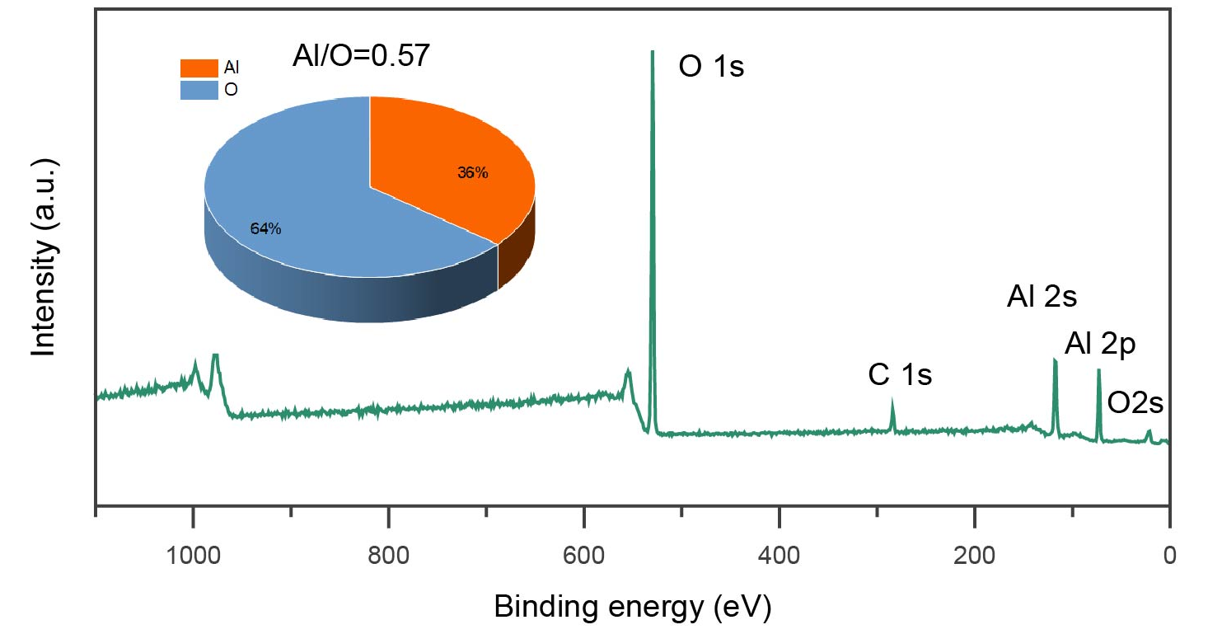
Supplementary Fig. 11. Survey scan spectrum of sapphire aged in air for two weeks. a, Survey scan XPS spectrum, indicating a clean surface with only Al, O and C elements detected. b, Calculated atomic percentage of Al and O in aged sapphire. The Al/O is calculated to be 0.57, which is lower than the stoichiometric value of 0.67 for alfa-Al₂O₃.

Supplementary section 3: the comparison of XPS spectra of Al 2p, O 1s, C 1s peaks on 2-week aged sapphire under NEF, LEF and HEF XPS testing modes
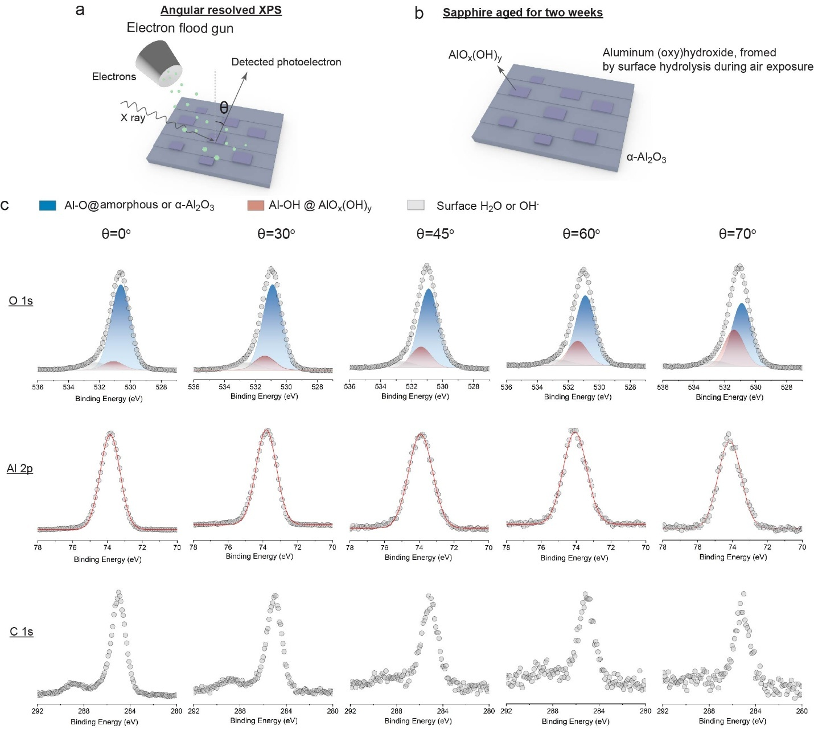
Supplementary Fig. 12. Angle-resolved XPS spectra of Al 2p and O1s on sapphire aged for two weeks. a, The illustration of angle-resolved XPS analysis. b, The schematic of structure phases. c, The angle-resolved Al 2p, O 1s and C 1s peaks.

Supplementary Table. 4. The XPS analysis of two-weeks-aged sapphire, measured at various angles
XPS spectra (testing angle) | O 1s |  |  |  |  |  |  |  |  | Al 2p |  |  | C 1s
XPS spectra (testing angle) | Al-O@ Al₂O₃ |  |  |  | Al-OH @AlO_{x}(OH)_{y} |  |  |  | Ratio of  A_{Al-OH}/A_{Al-O} | Peak  (eV) |  | FWHM  (eV) | Peak  (eV)
XPS spectra (testing angle) | FWHM  (eV) | Peak  (eV) |  | Area  (a.u.) | FWHM  (eV) | Peak  (eV) |  | Area  (a.u.) | Ratio of  A_{Al-OH}/A_{Al-O} | raw | corrected | FWHM  (eV) | raw | corrected
XPS spectra (testing angle) | FWHM  (eV) | raw | corrected | Area  (a.u.) | FWHM  (eV) | Raw | corrected
0º | 1.3 | 528.1 | 530.6 | 90944 | 1.3 | 528.6 | 531.1 | 9386 | 0.103 | 71.4 | 73.9 | 1.14 | 282.5 | 285.0
30º | 1.3 | 528.5 | 530.9 | 22744 | 1.3 | 529.0 | 531.4 | 3771 | 0.166 | 71.5 | 73.9 | 1.17 | 282.6 | 285.0
45º | 1.3 | 528.5 | 530.9 | 8912 | 1.3 | 528.9 | 531.4 | 2384 | 0.268 | 71.4 | 73.9 | 1.28 | 282.5 | 285.0
60º | 1.3 | 528.6 | 530.9 | 5569 | 1.3 | 529.1 | 531.4 | 1960 | 0.352 | 71.7 | 74.0 | 1.35 | 282.7 | 285.0
70º | 1.3 | 528.4 | 530.9 | 3179 | 1.3 | 528.9 | 531.4 | 1850 | 0.582 | 71.6 | 74.1 | 1.38 | 282.5 | 285.0

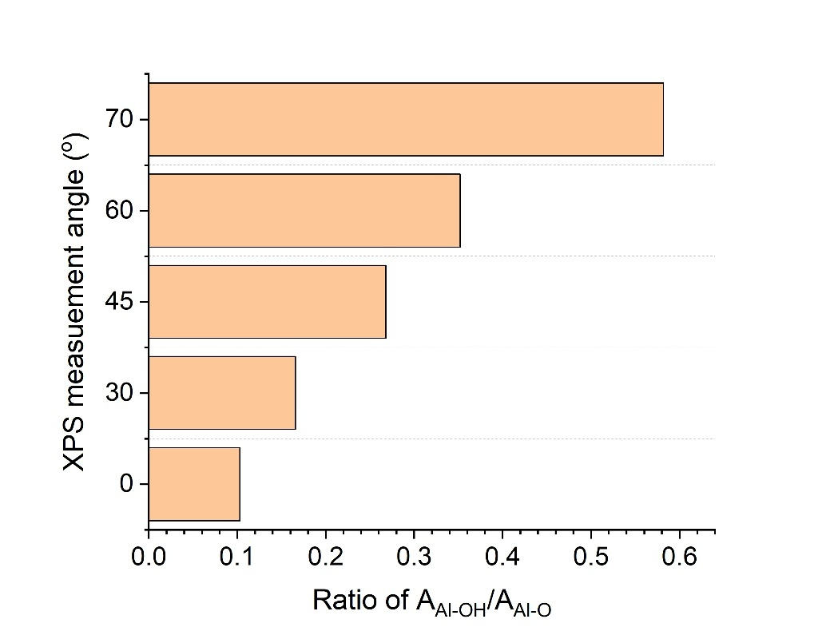
Supplementary Fig. 13. The angle-dependent area ratio of Al-OH bonding and Al-O bonding in XPS spectra of O1s on sapphire aged for two weeks.

In HEF mode, angle-resolved high-resolution scans of Al 2p, O 1s, and C 1s were performed. The C-C binding energy was observed to decrease to 282.5 eV (detailed in Table S2), indicative of a substantial negative electric field during HEF testing. After adjusting the C-C binding energy to the standard 285 eV, the angle-resolved Al 2p and O 1s peaks are depicted in Figure S11. At a θ of 37°, the primary O 1s and Al 2p peaks were recorded at 530.9 eV and 73.9 eV, respectively, with noted broadening of their full width at half maximum (FWHM). This broadening is attributed to the formation of amorphous Al₂O₃ bonded chemically to hydroxyl groups, a consequence of the α-Al₂O₃ surface amorphization driven by vigorous hydroxylation under elevated water vapor pressures.
Additionally, a distinct high-energy shoulder was identified on the primary O 1s peak. Curve fitting revealed an additional O 1s peak at 531.4 eV. The increasing peak area ratio relative to that of bulk sapphire with the angle of testing (shown in Figures S11, S12, and detailed in Table S2) suggests that this additional peak corresponds to a surface phase on sapphire. Referencing the literatures,^{3, 4} we attribute this peak to the characteristic of aluminum (oxy)hydroxide, with binding energies of Al 2p at 74.1 eV for O-Al-OH and O 1s at 531.3 eV for Al-OH, resulting from the surface hydrolysis of sapphire in air. Aluminium (oxy)hydroxide typically manifests in the forms of boehmite and gibbsite, which are characterized by abundant Al-OH bonds, as shown in Figure S13. It is reported that the reaction of water vapor with the clean c-plane surface of α-Al₂O₃ is strongly influenced by water vapor pressure.⁵⁻⁸ Below approximately 1 Torr, dissociative chemisorption of water primarily occurs at defect sites. Above this threshold, extensive hydroxylation and conversion to gibbsite (Al(OH)₃) are observed.⁵ In our experiments, the calculated water vapor pressure in the air was 19 Torr, considerably surpassing this threshold and inducing significant hydroxylation of the surface. The polar surface structure of α-Al₂O₃ is prone to substantial relaxation due to the divergence of the electrostatic potential, leading to instability.^{5, 9, 10} This extensive structural relaxation, coupled with increased hydroxylation and prolonged exposure, likely fosters the transformation of the crystalline Al₂O₃ surface into a hydroxyl-rich aluminum (oxy)hydroxide layer. Distinguishing between the Al 2p peaks at 74.1 eV for O-Al-OH in aluminum (oxy)hydroxide and for O-Al-O in alpha-Al2O3 remains challenging due to their close proximity in binding energies.

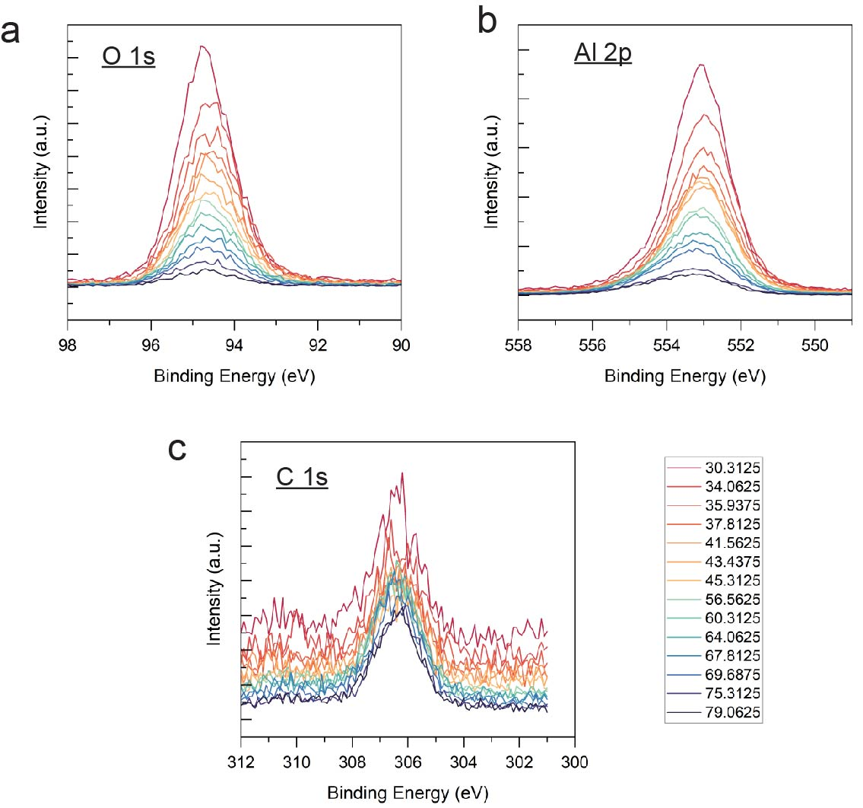
Supplementary Fig. 14. Angle-resolved XPS spectra of Al 2p and O1s on sapphire aged for two weeks without electron flood gun.

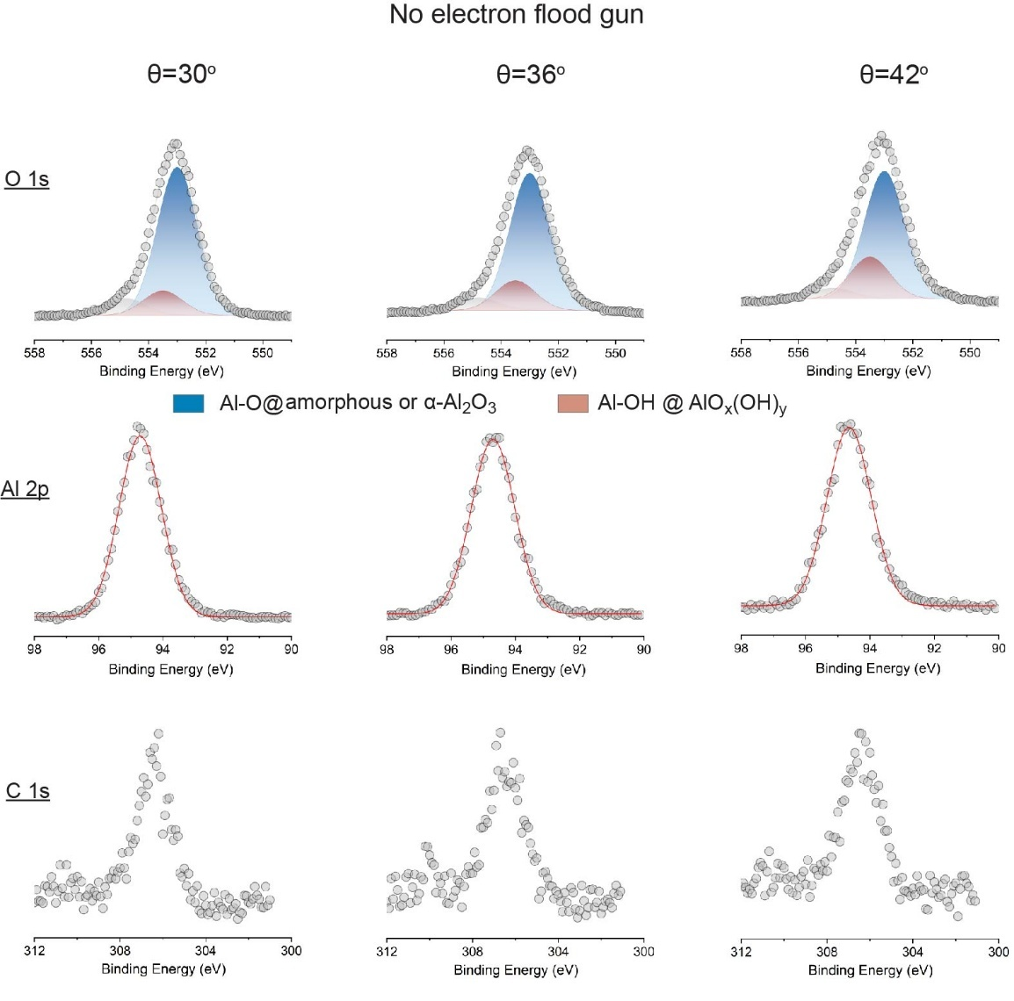
Supplementary Fig. 15. Angle-resolved XPS spectra of Al 2p and O1s on sapphire aged for two weeks without electron flood gun.

Supplementary Table. 5. The XPS analysis of two-weeks-aged sapphire, measured with no electron flux
XPS spectra (testing angle) | O 1s |  |  |  |  |  |  | Al 2p |  | C 1s
XPS spectra (testing angle) | Al-O@ Al₂O₃ |  |  | Al-OH @AlO_{x}(OH)_{y} |  |  | Ratio of  A_{Al-OH}/A_{Al-O} | Peak  (eV) | FWHM  (eV) | Peak  (eV)
XPS spectra (testing angle) | FWHM  (eV) | Peak  (eV) | Area  (a.u.) | FWHM  (eV) | Peak  (eV) | Area  (a.u.)
30º | 1.4 | 553 | 344 | 1.4 | 553.5 | 57 | 0.165 | 94.7 | 1.3 | 306.5
36º | 1.4 | 553 | 259 | 1.4 | 553.5 | 57 | 0.220 | 94.7 | 1.35 | 306.5
42º | 1.4 | 553 | 173 | 1.4 | 553.5 | 56 | 0.323 | 94.7 | 1.38 | 306.5

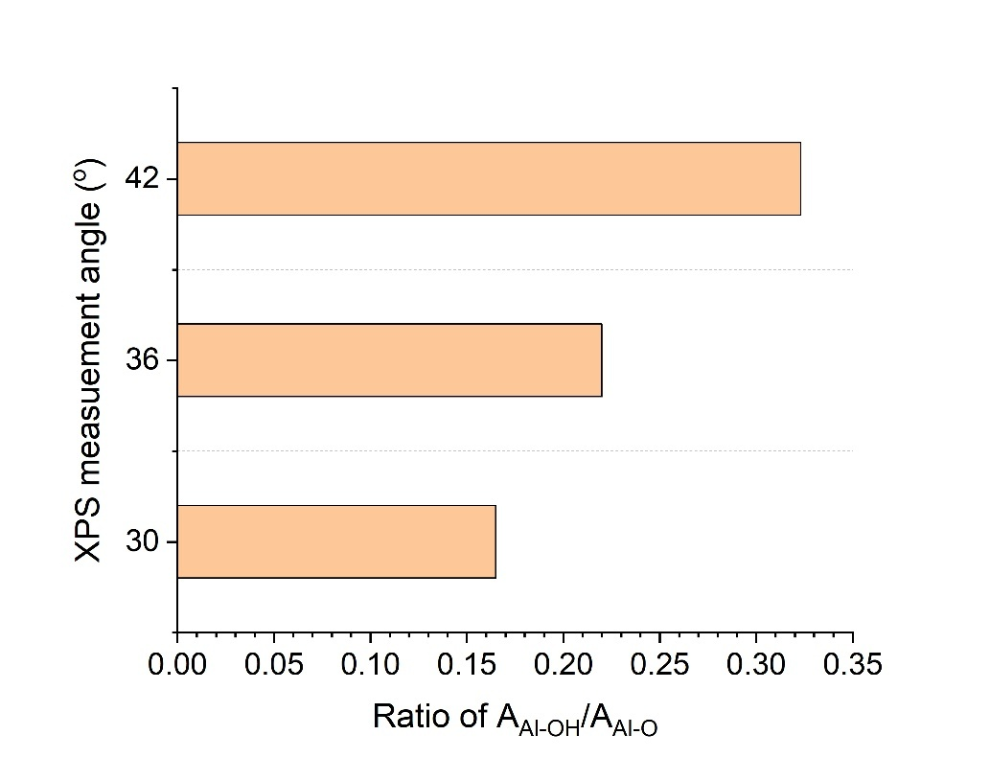
Supplementary Fig. 16. The angle-dependent area ratio of Al-OH bonding and Al-O bonding in XPS spectra of O1s on sapphire aged for two weeks without electron flood gun.

In NEF mode, the angle-resolved Al 2p, O 1s, and C 1s spectra are presented in Figures S14 and S15, with detailed analytical results in Table S3 and Figure S16. Under NEF conditions, the O 1s peaks associated with O-Al-O bonding in alpha-Al₂O₃ and Al-OH bonding in AlO_{x}(OH)_{y} experience an upward shift of 21.5 eV, resulting from the positive electric field present during measurement. These peaks also show an increase in broadness, exhibiting a FWHM of 1.4 eV. Furthermore, the area ratio of the O1s peaks for Al-O bonding to Al-OH bonding is calculated to be 0.165 at θ=30°, matching with the value of 0.166 observed in HEF mode.
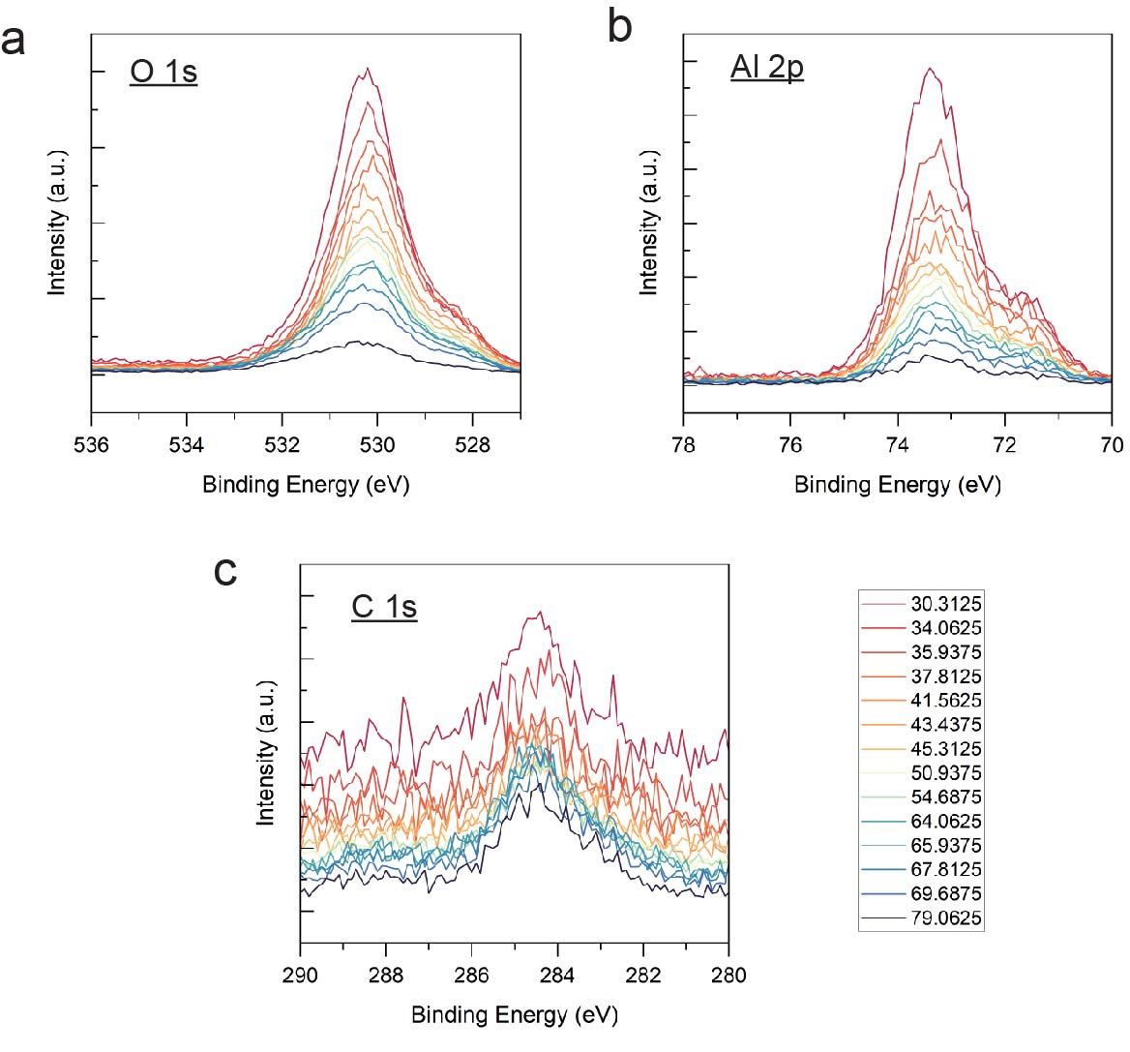
Supplementary Fig. 17. Angle-resolved XPS spectra of Al 2p and O1s on sapphire aged for two weeks with low electron flood gun.

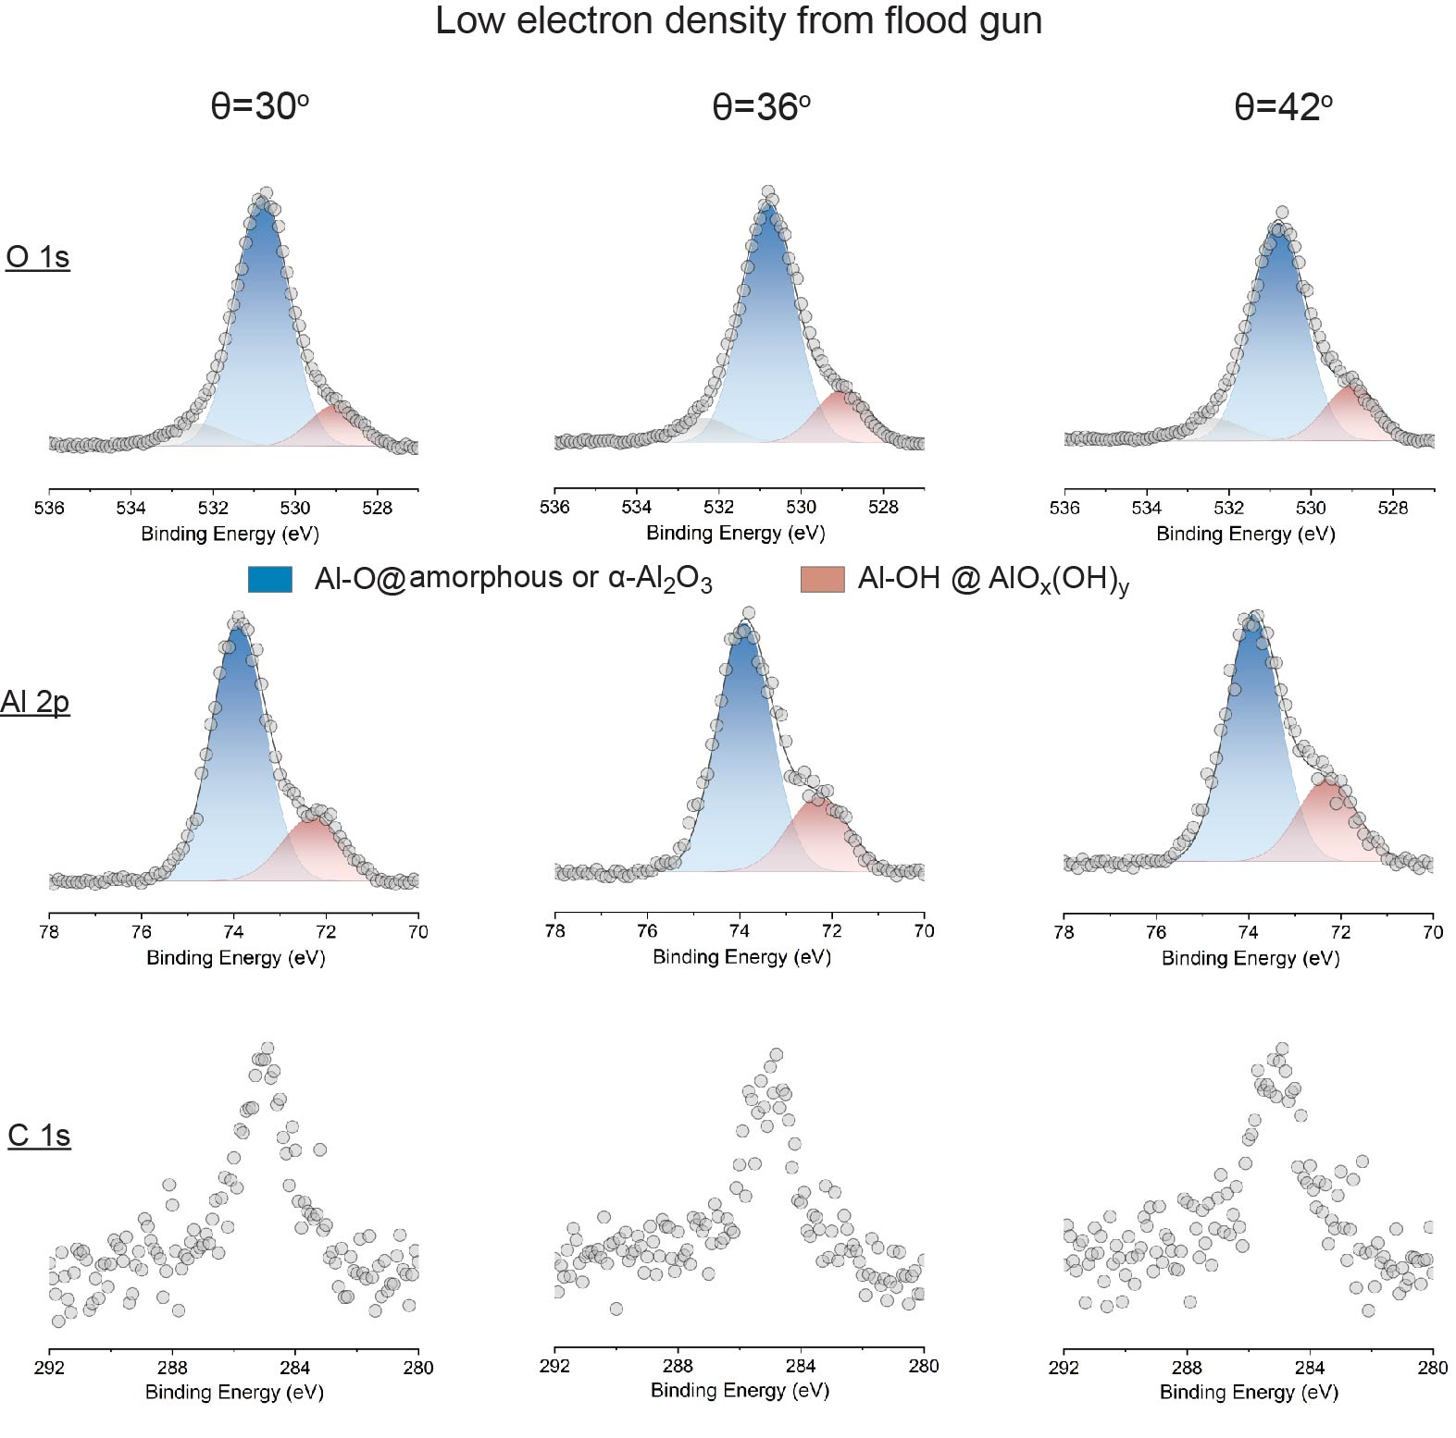
Supplementary Fig. 18. Angle-resolved XPS spectra of Al 2p and O1s on sapphire aged for two weeks with low electron flood gun.

Supplementary Table. 6. The XPS analysis of two-weeks-aged sapphire, measured with low electron flood gun
XPS spectra (testing angle) | O 1s
XPS spectra (testing angle) | Al-O@ Al₂O₃ |  |  |  |  | Al-OH @AlO_{x}(OH)_{y} |  |  |  |  | Ratio of  A_{Al-OH}/A_{Al-O}
XPS spectra (testing angle) | FWHM  (eV) | Peak  (eV) |  | Area  (a.u.) |  | FWHM  (eV) | Peak  (eV) |  | Area  (a.u.) |  | Ratio of  A_{Al-OH}/A_{Al-O}
XPS spectra (testing angle) | FWHM  (eV) | Raw | Corrected |  |  | FWHM  (eV) | Raw | Corrected |  |  | Ratio of  A_{Al-OH}/A_{Al-O}
30º | 1.3 | 530.4 | 530.8 | 311 |  | 1.3 | 528.6 | 529 | 52 |  | 0.167
36º | 1.3 | 530.3 | 530.8 | 270 |  | 1.3 | 528.5 | 529 | 60 |  | 0.222
42º | 1.3 | 530.1 | 530.8 | 215 |  | 1.3 | 528.3 | 529 | 61 |  | 0.284
XPS spectra (testing angle) | Al 2p |  |  |  |  |  |  |  |  | C 1s
XPS spectra (testing angle) | Al-O@ Al₂O₃ |  |  |  | Al-OH @AlO_{x}(OH)_{y} |  |  |  | Ratio of  A_{Al-OH}/A_{Al-O} | Peak  (eV)
XPS spectra (testing angle) | FWHM  (eV) | Peak  (eV) |  | Area  (a.u.) | FWHM  (eV) | Peak  (eV) |  | Area  (a.u.) | Ratio of  A_{Al-OH}/A_{Al-O}
XPS spectra (testing angle) | FWHM  (eV) | Raw | Corrected | Area  (a.u.) | FWHM  (eV) | Raw | Corrected | Area  (a.u.) | Ratio of  A_{Al-OH}/A_{Al-O} | Raw | Corrected
30º | 1.17 | 73.5 | 73.9 | 40 | 1.3 | 71.9 | 72.3 | 11 | 0.275 | 284.6 | 285.0
36º | 1.17 | 73.4 | 73.9 | 31 | 1.3 | 71.8 | 72.3 | 10 | 0.322 | 284.5 | 285.0
42º | 1.17 | 73.2 | 73.9 | 22 | 1.3 | 71.6 | 72.3 | 8 | 0.363 | 284.3 | 285.0

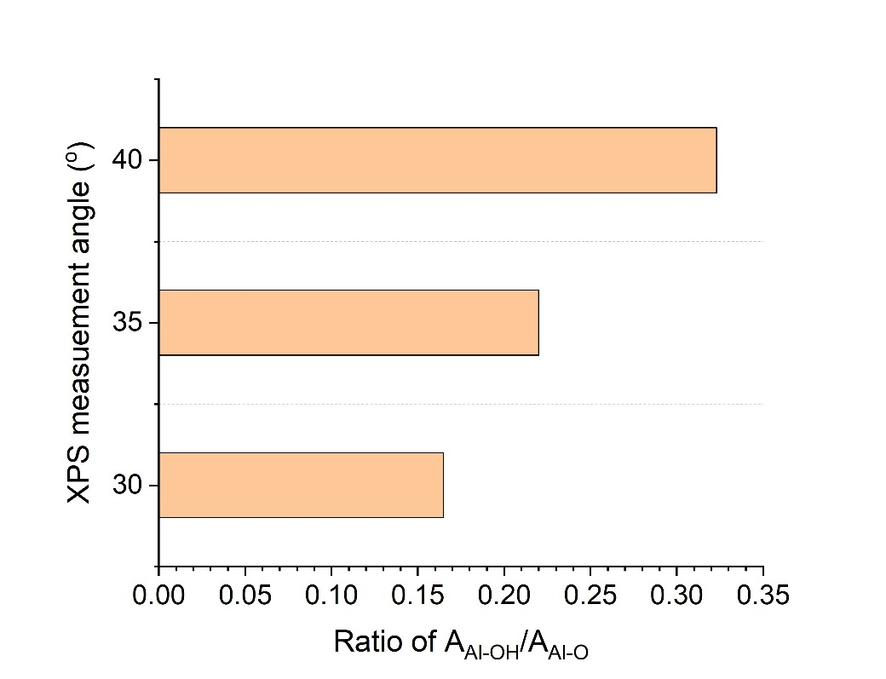

Supplementary Fig. 19. The angle-dependent area ratio of Al-OH bonding and Al-O bonding in XPS spectra of O1s on sapphire aged for two weeks with low electron flood gun.

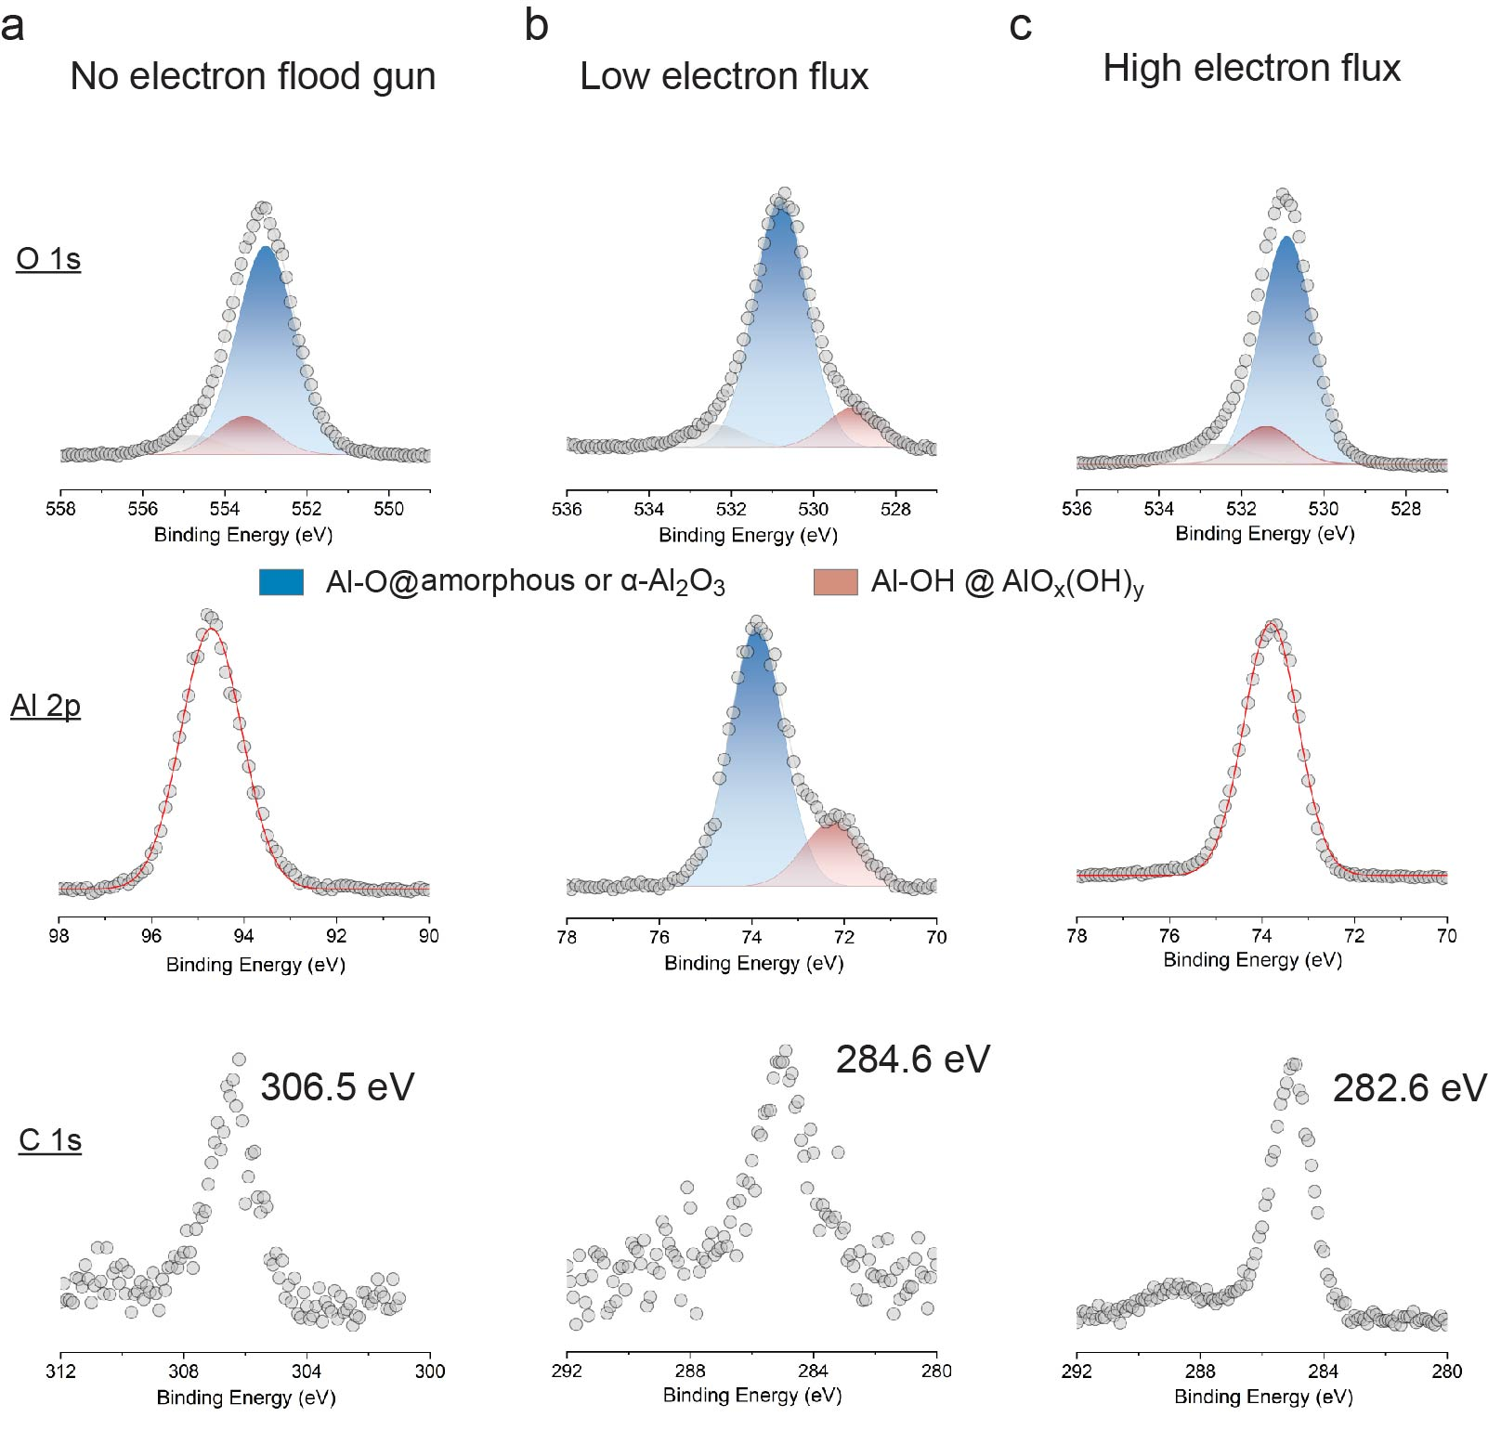
Supplementary Fig. 20. High-resolution XPS spectra of Al 2p, O 1s and C 1s on sapphire aged for two weeks with different electron flux intensities of flood gun.

Supplementary Table 7. The XPS analysis of two-weeks-aged sapphire, measured with different electron flux intensities of flood gun.
XPS spectra (testing angle) | O 1s
XPS spectra (testing angle) | Al-O@ Al₂O₃ |  |  | Al-OH @AlO_{x}(OH)_{y} |  |  |  |  | Ratio of  A_{Al-OH}/A_{Al-O}
XPS spectra (testing angle) | FWHM  (eV) | Peak  (eV) |  | FWHM  (eV) |  | Peak  (eV)
XPS spectra (testing angle) | FWHM  (eV) | Raw | Corrected |  |  | Raw |  | Corrected
No flood gun | 1.4 | 553 | 531.5 | 1.4 |  | 553.5 |  | 532.0 | 0.165
Low electron flux | 1.3 | 530.4 | 530.8 | 1.3 |  | 528.5 |  | 528.9 | 0.167
High electron flux | 1.3 | 528.5 | 530.9 | 1.3 |  | 529.0 |  | 531.4 | 0.166
XPS spectra (testing angle) | Al 2p |  |  |  |  |  |  |  |  | C 1s
XPS spectra (testing angle) | Al-O@ Al₂O₃ |  |  | Al-OH @AlO_{x}(OH)_{y} |  |  |  |  | Ratio of  A_{Al-OH}/A_{Al-O} | Peak  (eV)
XPS spectra (testing angle) | FWHM  (eV) | Peak  (eV) |  | FWHM  (eV) | Peak  (eV)
XPS spectra (testing angle) | FWHM  (eV) | Raw | Corrected | FWHM  (eV) | Raw |  | Corrected |  |  | Raw | Corrected
No flood gun |  |  |  |  |  |  |  |  |  | 306.5 | 285
Low electron flux | 1.17 | 73.5 | 73.9 | 1.3 | 71.9 |  | 72.3 |  | 0.275 | 284.6 | 285
High electron flux |  |  |  |  |  |  |  |  |  | 282.6 | 285

Supplementary section 4: The aging duration dependent angle-resolved XPS spectra of Al 2p, O 1s, C 1s peaks under LEF testing mode

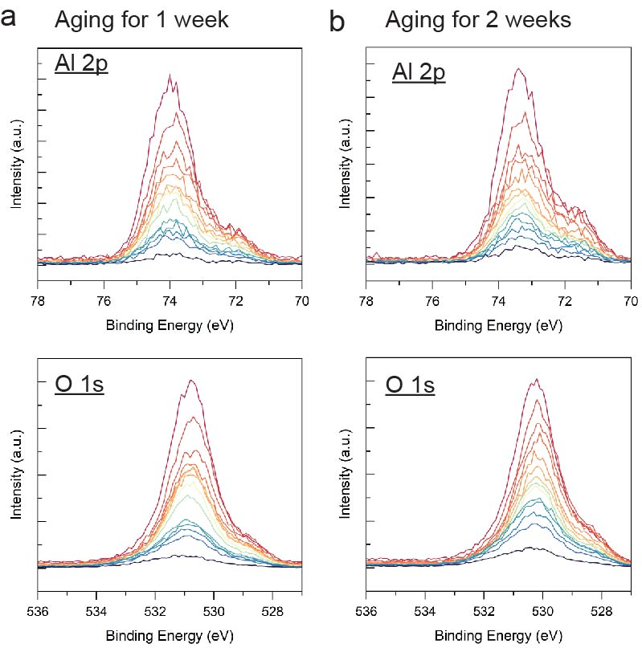
Supplementary Fig. 21. Angle-resolved XPS spectra of Al 2p and O1s on sapphire, aged for one and two weeks, assessed at low electron flux mode.

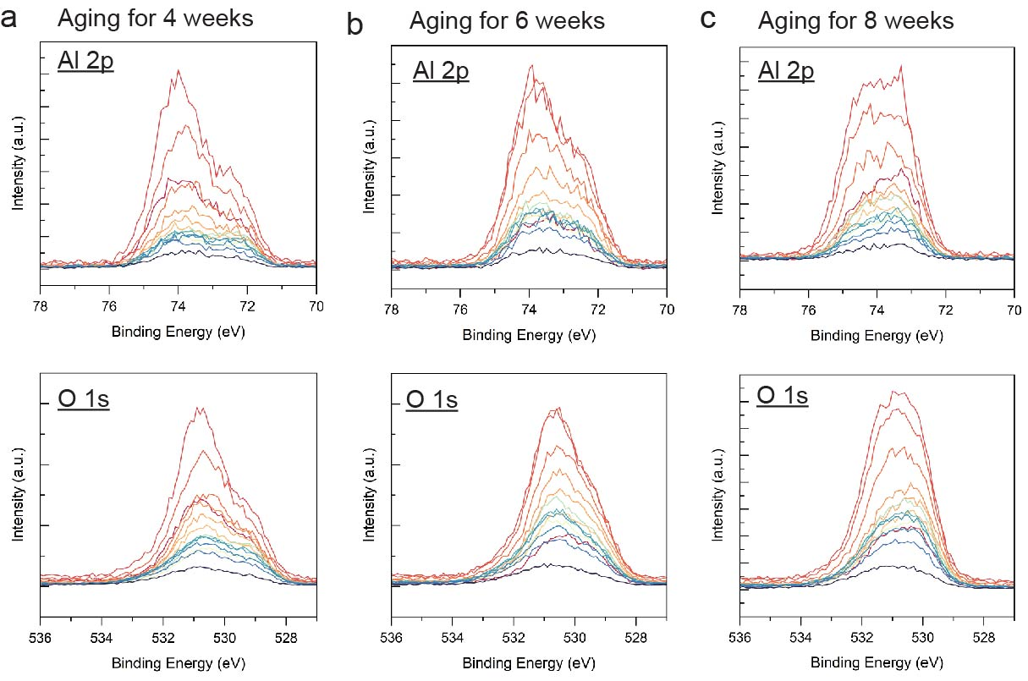

Supplementary Fig. 22. Angle-resolved XPS spectra of Al 2p and O1s on sapphire, aged for four, six and eight weeks, assessed at low electron flux mode.

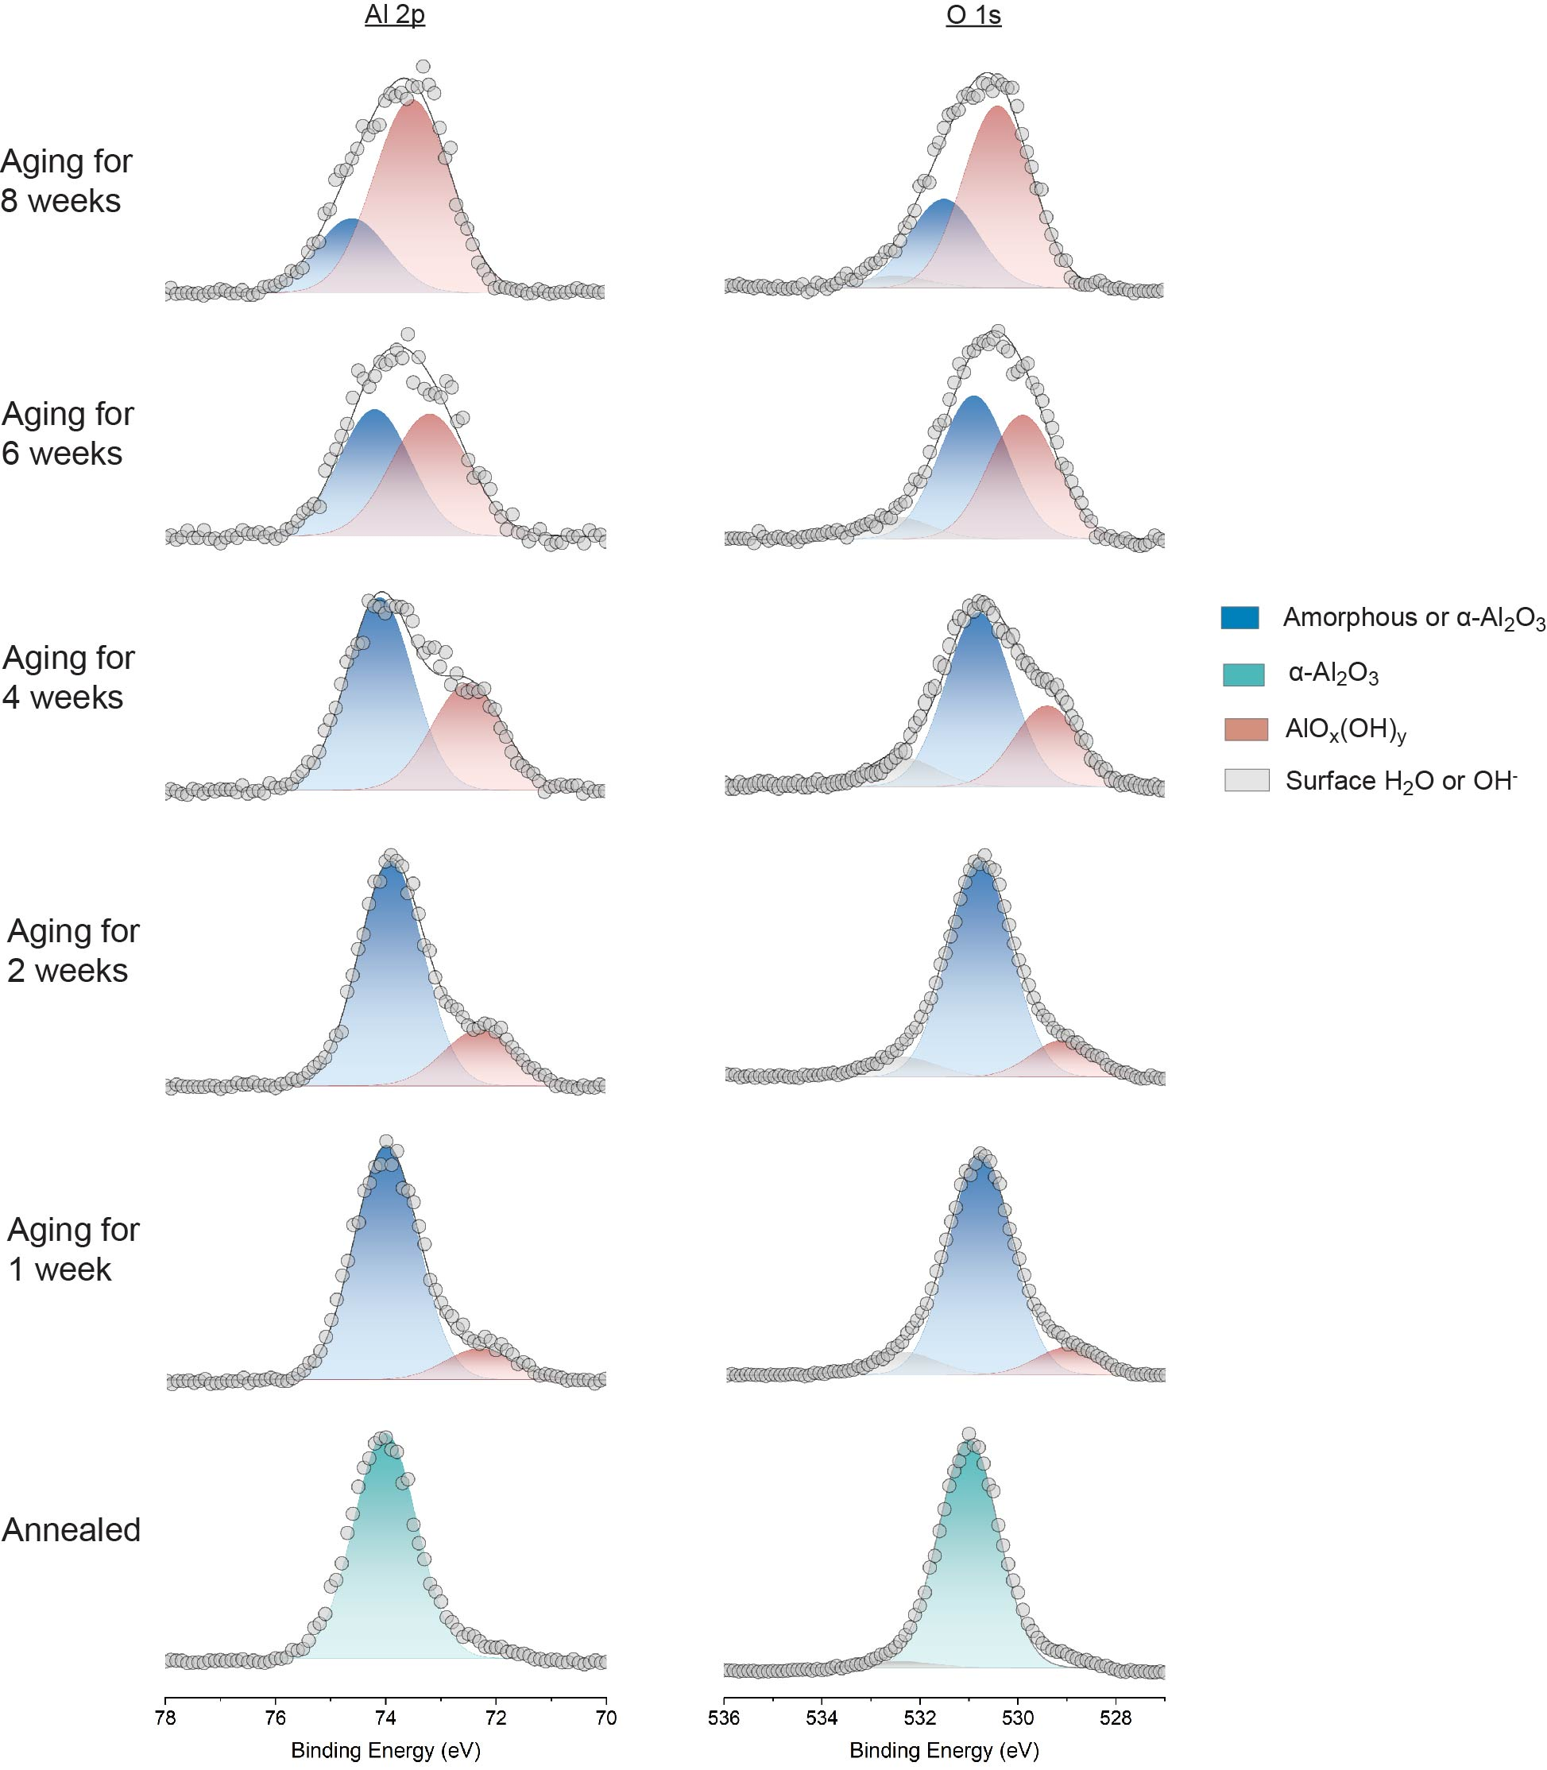

Supplementary Fig. 23. XPS measured surface phase evolution of sapphire during air exposure, assessed at low electron flux mode.

Supplementary Table 8. The XPS analysis of two-weeks-aged sapphire, measured with low electron flood gun.
XPS spectra (aging in air) | O 1s
XPS spectra (aging in air) | Al-O@ Al₂O₃ |  |  |  |  |  | Al-OH @AlO_{x}(OH)_{y} |  |  |  |  |  | Ratio of  A_{Al-OH}/A_{Al-O} |  | AlO_{x}(OH)_{y}%
XPS spectra (aging in air) | FWHM  (eV) |  | Peak  (eV) |  | Area  (a.u.) |  | FWHM  (eV) |  | Peak  (eV) |  | Area  (a.u.) |  |  |  | AlO_{x}(OH)_{y}%
Annealed | 1.22 |  | 531 |  |  |  |  |  |  |  |  |  |  |  | 0
1 week | 1.3 |  | 530.8 |  | 315 |  | 1.3 |  | 529 |  | 40 |  | 0.127 |  | 11%
2 weeks | 1.3 |  | 530.8 |  | 311 |  | 1.3 |  | 529 |  | 52 |  | 0.167 |  | 14%
4 weeks | 1.35 |  | 530.8 |  | 107 |  | 1.35 |  | 529.4 |  | 49 |  | 0.458 |  | 31%
6 weeks | 1.4 |  | 830.9 |  | 49 |  | 1.4 |  | 829.9 |  | 42 |  | 0.857 |  | 46%
8 weeks | 1.42 |  | 531.5 |  | 33 |  | 1.42 |  | 530.4 |  | 68 |  | 2.060 |  | 67%
XPS spectra (testing angle) | Al 2p |  |  |  |  |  |  |  |  |  |  |  |  | C 1s
XPS spectra (testing angle) | Al-O@ Al₂O₃ |  |  |  |  | Al-OH @AlO_{x}(OH)_{y} |  |  |  |  |  | Ratio of  A_{Al-OH}/A_{Al-O} |  | Peak  (eV)
XPS spectra (testing angle) | FWHM  (eV) | Peak  (eV) |  | Area  (a.u.) |  | FWHM  (eV) |  | Peak  (eV) |  | Area  (a.u.) |  |  |  | Peak  (eV)
Annealed | 1.15 | 74 |  |  |  |  |  |  |  |  |  |  |  | 285.0
1 week | 1.17 | 74 |  | 42 |  | 1.3 |  | 72.3 |  | 6 |  | 0.142 |  | 285.0
2 weeks | 1.17 | 73.9 |  | 40 |  | 1.3 |  | 72.3 |  | 11 |  | 0.275 |  | 285.0
4 weeks | 1.2 | 74.1 |  | 20 |  | 1.3 |  | 72.5 |  | 12 |  | 0.600 |  | 285.0
6 weeks | 1.3 | 74.2 |  | 7 |  | 1.4 |  | 73.2 |  | 8 |  | 1.142 |  | 285.0
8 weeks | 1.3 | 74.6 |  | 9 |  | 1.4 |  | 73.5 |  | 24 |  | 2.667 |  | 285.0

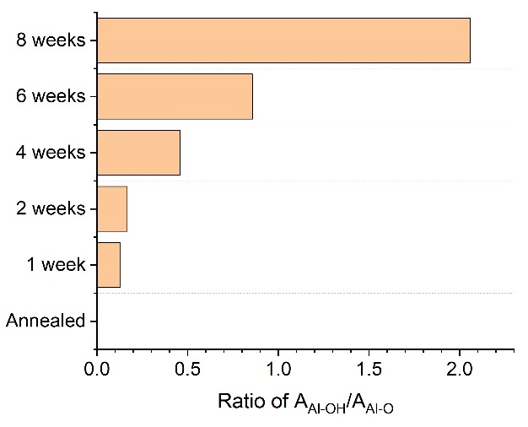
Supplementary Fig. 24. The angle-dependent area ratio of Al-OH bonding and Al-O bonding in XPS spectra of O1s on sapphire aged for two weeks with low electron flood gun.

Supplementary section 5: the XPS spectra and analysis of Al 2p, O 1s, C 1s peaks on sapphires engineered with different atomic step height
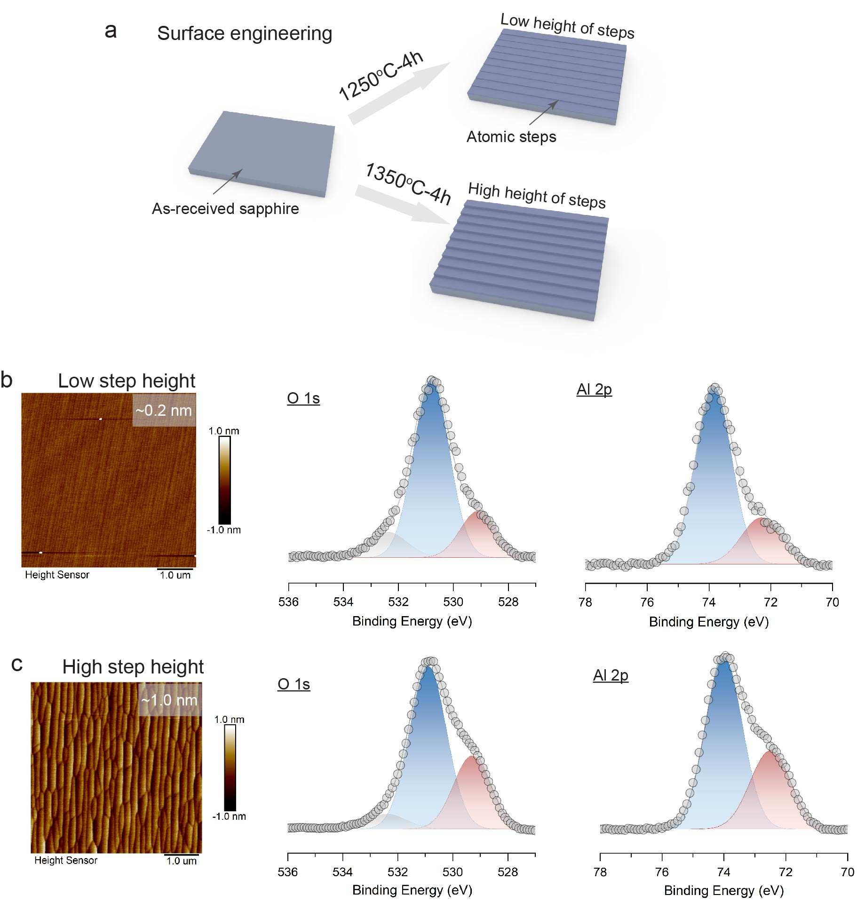

Supplementary Fig. 26. Atomic step height dependent surface structural changes

Supplementary Table 9. The XPS analysis of two-weeks-aged sapphires, engineered with different atomic step heights.
Sapphire of atomic step height | O 1s
Sapphire of atomic step height | Al-O@ Al₂O₃ |  |  |  |  |  | Al-OH @AlO_{x}(OH)_{y} |  |  |  |  |  | Ratio of  A_{Al-OH}/A_{Al-O} |  | AlO_{x}(OH)_{y}%
Sapphire of atomic step height | FWHM  (eV) |  | Peak  (eV) |  | Area  (a.u.) |  | FWHM  (eV) |  | Peak  (eV) |  | Area  (a.u.) |  |  |  | AlO_{x}(OH)_{y}%
0.2 nm | 1.3 |  | 530.8 |  | 253 |  | 1.3 |  | 529.1 |  | 66 |  | 0.261 |  | 21%
1 nm | 1.3 |  | 530.9 |  | 185 |  | 1.3 |  | 529.2 |  | 86 |  | 0.465 |  | 32%
Sapphire of atomic step height | Al 2p |  |  |  |  |  |  |  |  |  |  |  |  | C 1s | The additional AlO_{x}(OH)_{y}% per atomic step height (%/nm)
Sapphire of atomic step height | Al-O@ Al₂O₃ |  |  |  |  | Al-OH @AlO_{x}(OH)_{y} |  |  |  |  |  | Ratio of  A_{Al-OH}/A_{Al-O} |  | Peak  (eV)
Sapphire of atomic step height | FWHM  (eV) | Peak  (eV) |  | Area  (a.u.) |  | FWHM  (eV) |  | Peak  (eV) |  | Area  (a.u.) |  |  |  | Peak  (eV)
0.2 nm | 1.17 | 73.9 |  | 51 |  | 1.3 |  | 72.3 |  | 15 |  | 0.294 |  | 285.0 | 14 %/nm
1 nm | 1.17 | 74 |  | 38 |  | 1.3 |  | 72.4 |  | 19 |  | 0.500 |  | 285.0 | 14 %/nm

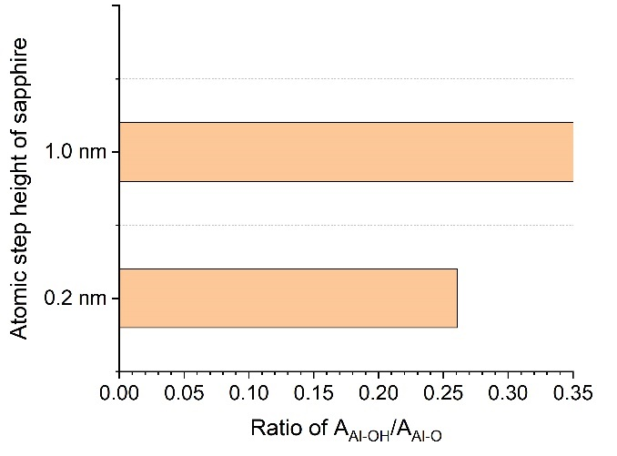
Supplementary Fig. 27. The atomic step height dependent ratio of angle-dependent area ratio of AAl-OH/AAl-O.

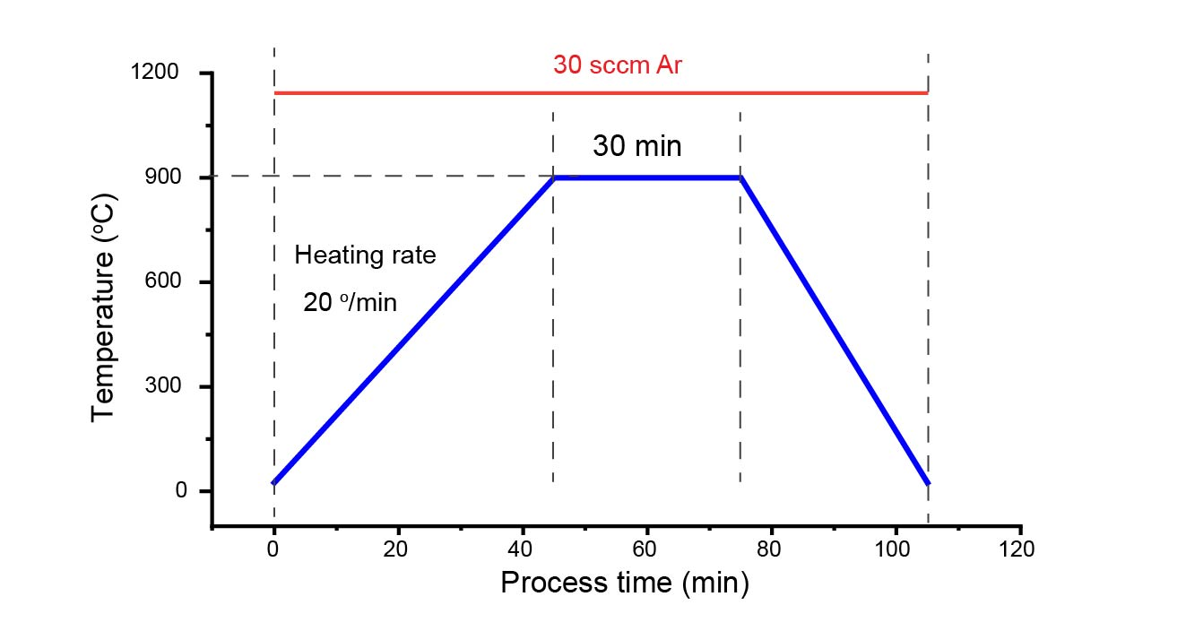
Supplementary Fig. 28. The growth recipe without growth precursors.

Supplementary section 6: the XPS spectra and analysis on structure transformation of aged sapphire in the pre-growth heating process

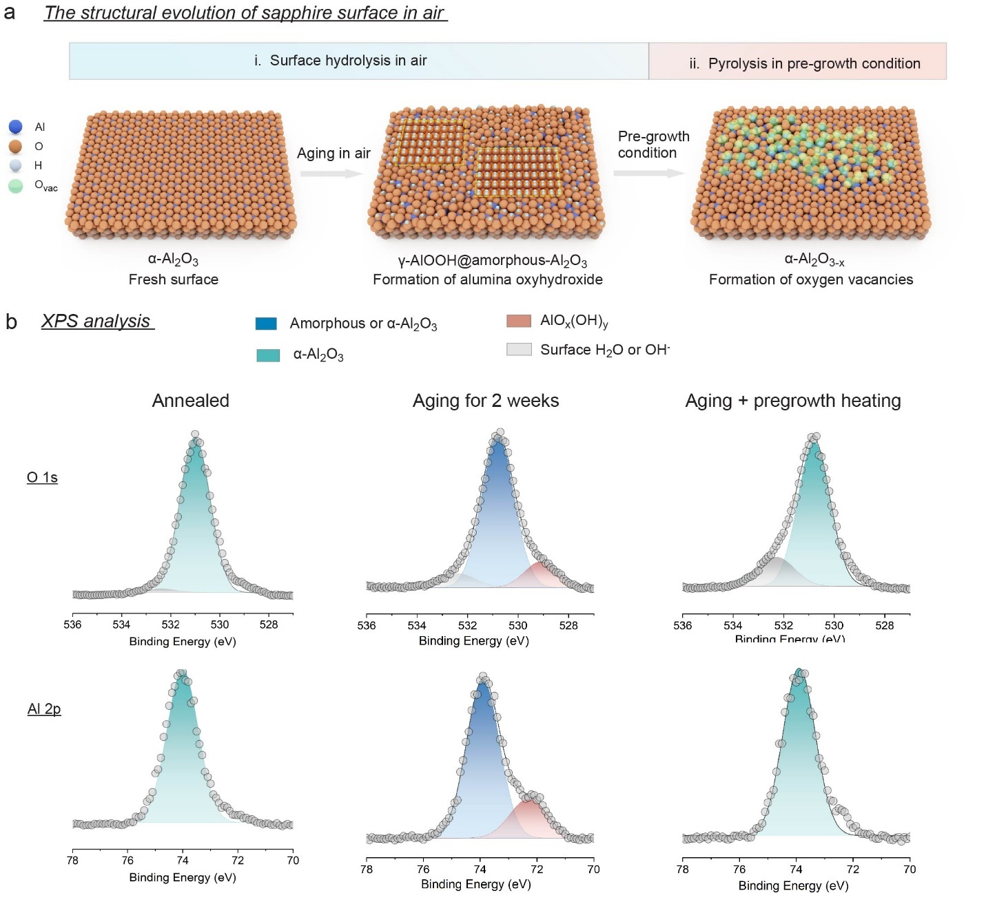
Supplementary Fig. 29. Atomic step height dependent surface structural changes.

Supplementary Table 10. The XPS analysis of sapphires after annealing, after two-weeks-aging and after growth thermal heating
XPS spectra (aging in air) | O 1s
XPS spectra (aging in air) | Al-O@ Al₂O₃ |  |  |  |  | Al-OH @AlO_{x}(OH)_{y} |  |  |  |  |  | Surface OH⁻ or H₂O |  | Surface OH⁻ or H₂O%
XPS spectra (aging in air) | FWHM  (eV) | Peak  (eV) |  | Area  (a.u.) |  | FWHM  (eV) |  | Peak  (eV) |  | Area  (a.u.) |  | FWHM  (eV) | Area  (a.u.) | Surface OH⁻ or H₂O%
Annealed | 1.22 | 531 |  | 427 |  |  |  |  |  |  |  | 1.42 | 14 | 3.2%
2-week air exposure | 1.3 | 530.8 |  | 311 |  | 1.3 |  | 529 |  | 52 |  | 1.42 | 31 | 7.8%
2-week air exposure + growth thermal process | 1.22 | 530.8 |  | 285 |  |  |  |  |  |  |  | 1.42 | 70 | 21.5%
XPS spectra (testing angle) | Al 2p |  |  |  |  |  |  |  |  |  |  |  | C 1s
XPS spectra (testing angle) | Al-O@ Al₂O₃ |  |  |  | Al-OH @AlO_{x}(OH)_{y} |  |  |  |  |  |  |  | Peak  (eV)
XPS spectra (testing angle) | FWHM  (eV) | Peak  (eV) | Area  (a.u.) |  | FWHM  (eV) |  | Peak  (eV) |  | Area  (a.u.) |  |  |  | Peak  (eV)
Annealed | 1.15 | 74 |  |  |  |  |  |  |  |  |  |  | 285.0
2-week air exposure | 1.17 | 73.9 | 40 |  | 1.3 |  | 72.3 |  | 6 |  |  |  | 285.0
2-week air exposure + growth thermal process | 1.15 | 73.9 | 42 |  |  |  |  |  |  |  |  |  | 285.0
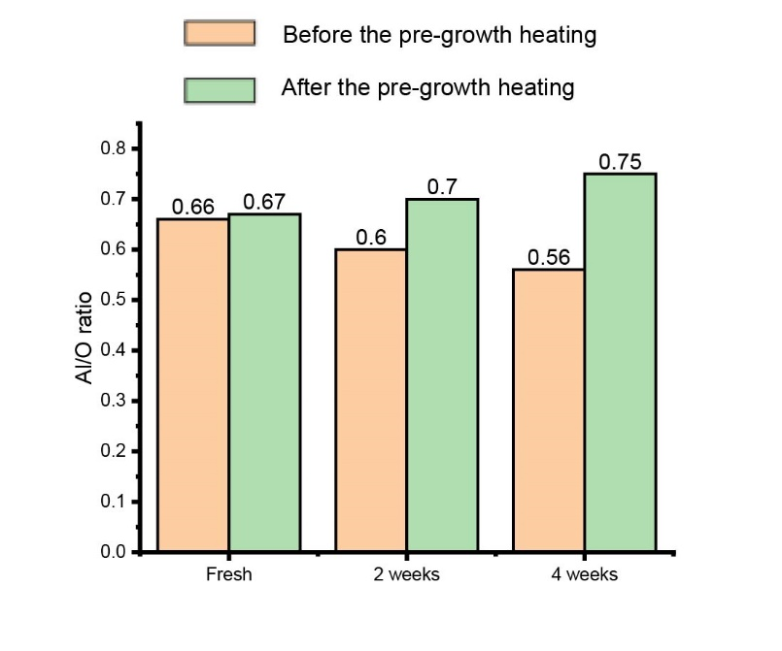

Supplementary Fig. 30. The calculated Al/O changes on sapphire samples in fresh, and after aging for 2 weeks and 4 weeks

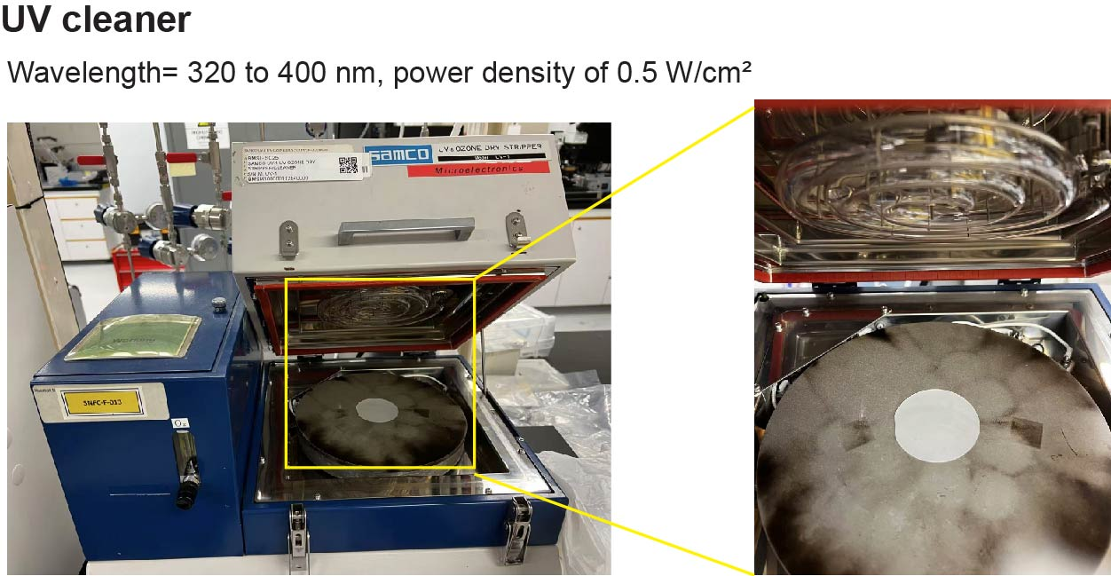
Supplementary Fig. 31. Photograph of UV cleaner.

Supplementary section 7: the XPS spectra and analysis on structure transformation of aged sapphire with UV irradiation

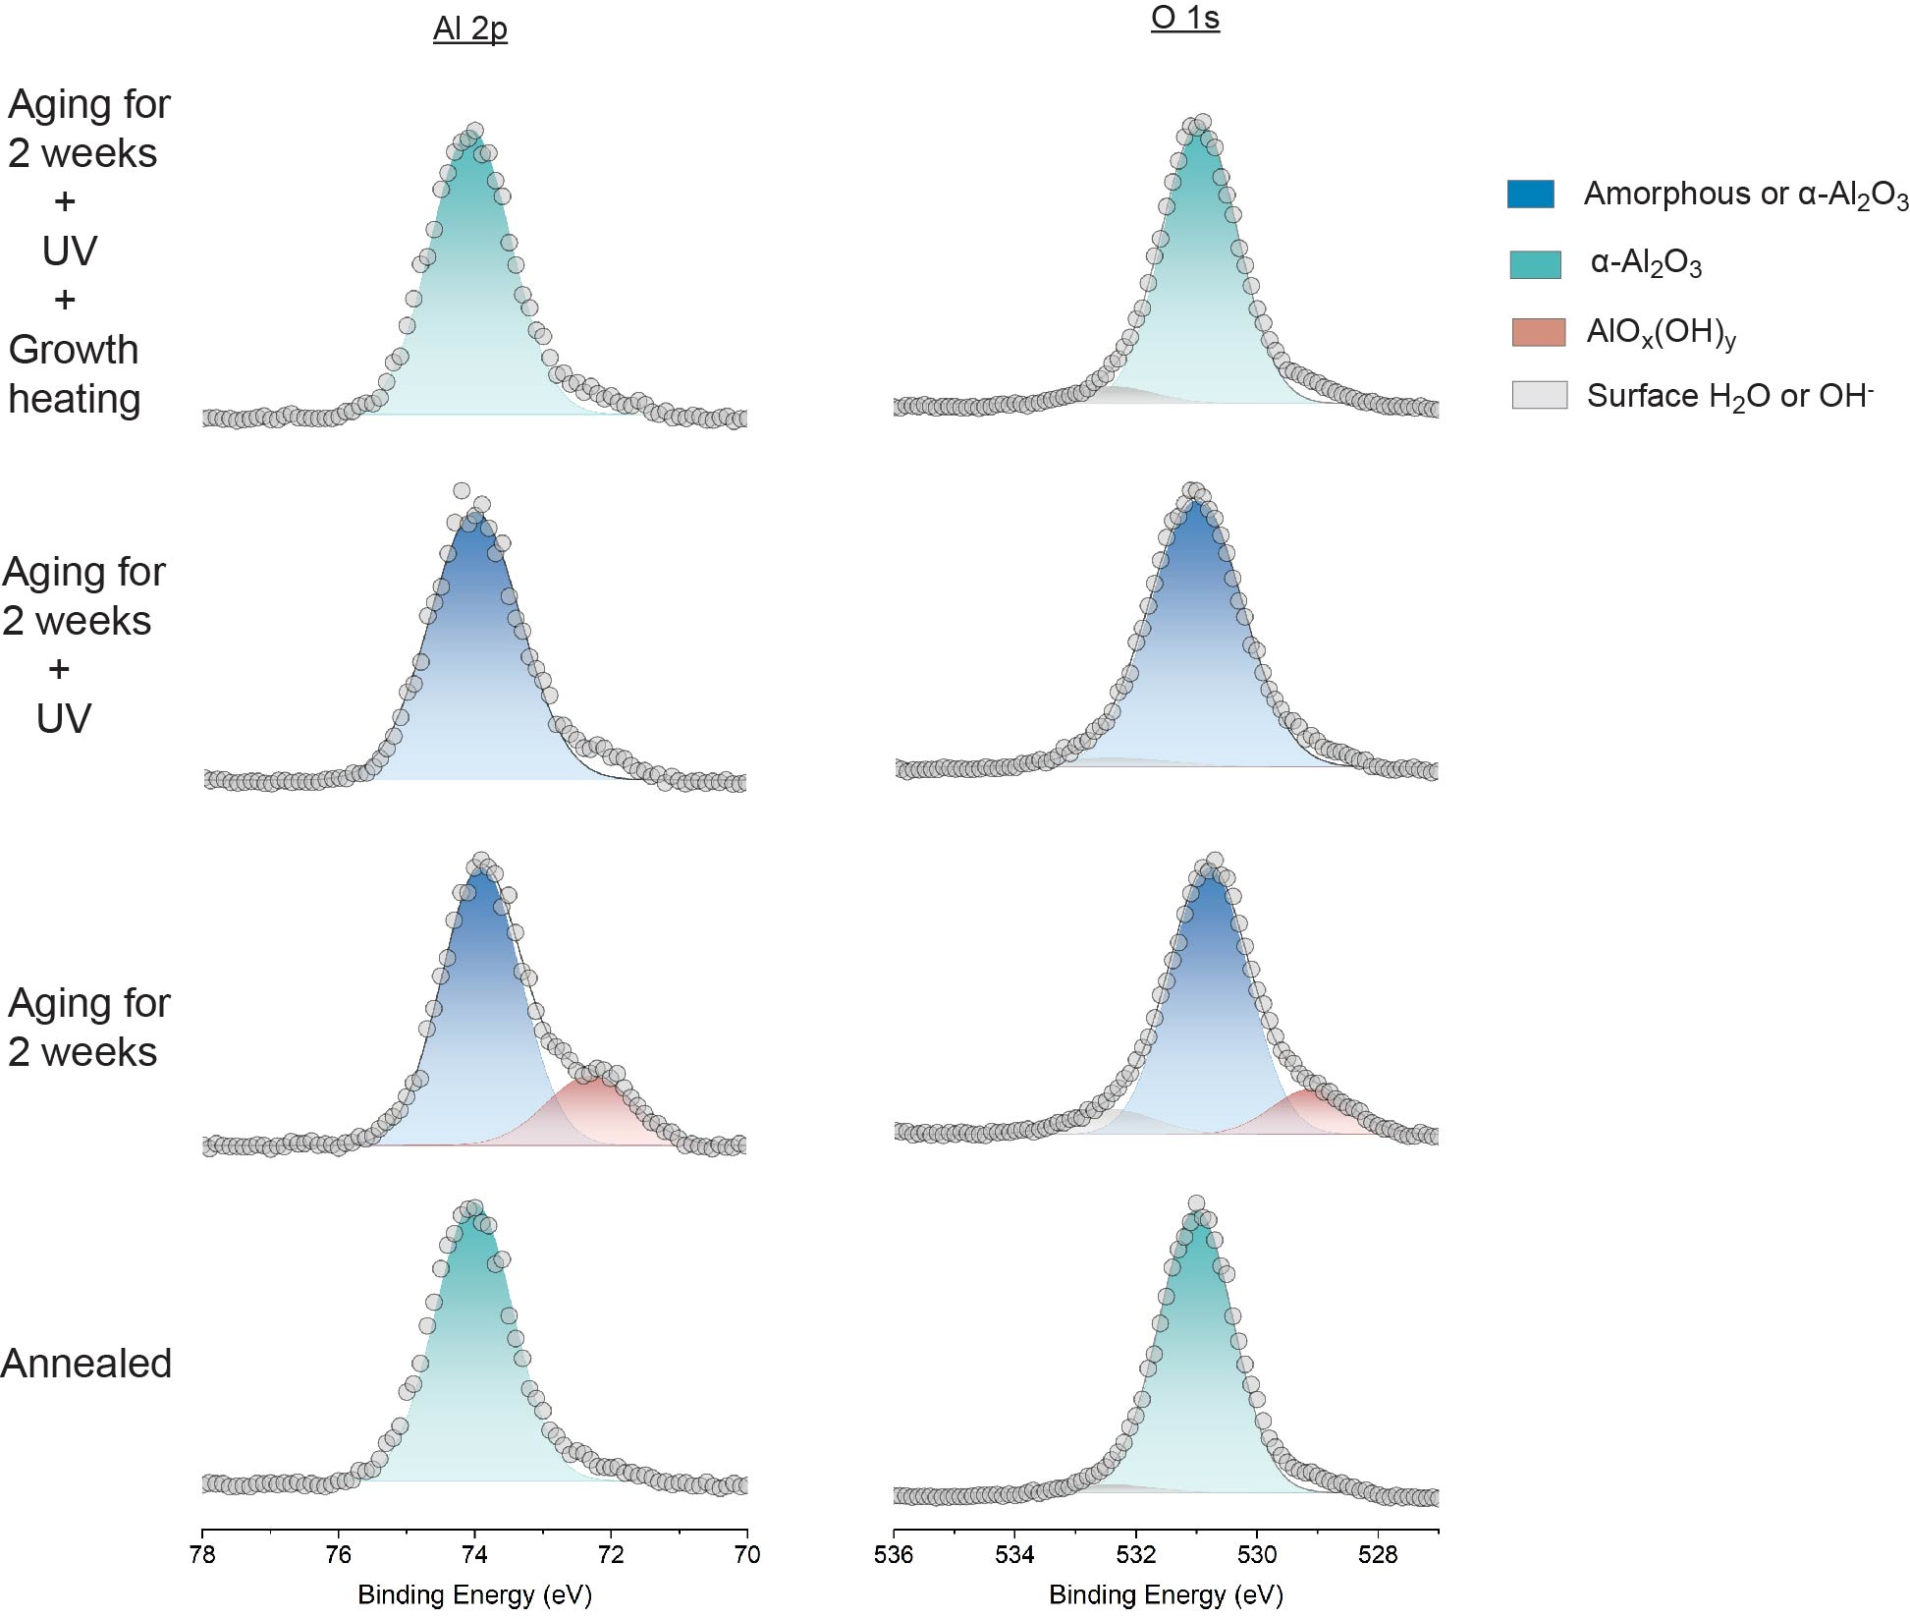
Supplementary Fig. 32. The high-resolution Al 2p and O 1s spectra of sapphire samples.

Supplementary Table 11. The XPS analysis of sapphires of annealing, two-weeks-aging, UV exposure and growth heating
XPS spectra | O 1s |  |  |  | Al 2p |  |  |  | C 1s
XPS spectra | Al-O@ Al₂O₃ |  | Al-OH @AlO_{x}(OH)_{y} |  | Al-O@ Al₂O₃ |  | Al-OH @AlO_{x}(OH)_{y} |  | Peak  (eV)
XPS spectra | FWHM  (eV) | Peak  (eV) | FWHM  (eV) | Peak  (eV) | FWHM  (eV) | Peak  (eV) | FWHM  (eV) | Peak  (eV) | Peak  (eV)
Annealed | 1.22 | 531 |  |  | 1.15 | 74 |  |  | 285
2-week air exposure | 1.3 | 530.8 | 1.3 | 529 | 1.17 | 73.9 | 1.3 | 72.3 | 285
2-week air exposure + UV | 1.5 | 531 |  |  | 1.34 | 74 |  |  | 285
2-week air exposure  + UV + growth heating | 1.25 | 530.9 |  |  | 1.19 | 74 |  |  | 285

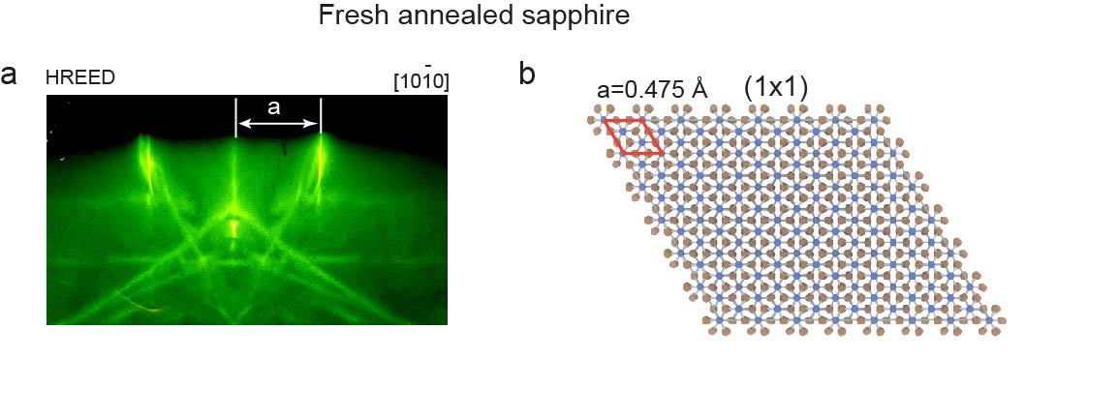

Supplementary Fig. 33. RHEED patterns of fresh annealed sapphire (a) and the corresponding crystal structure (b)

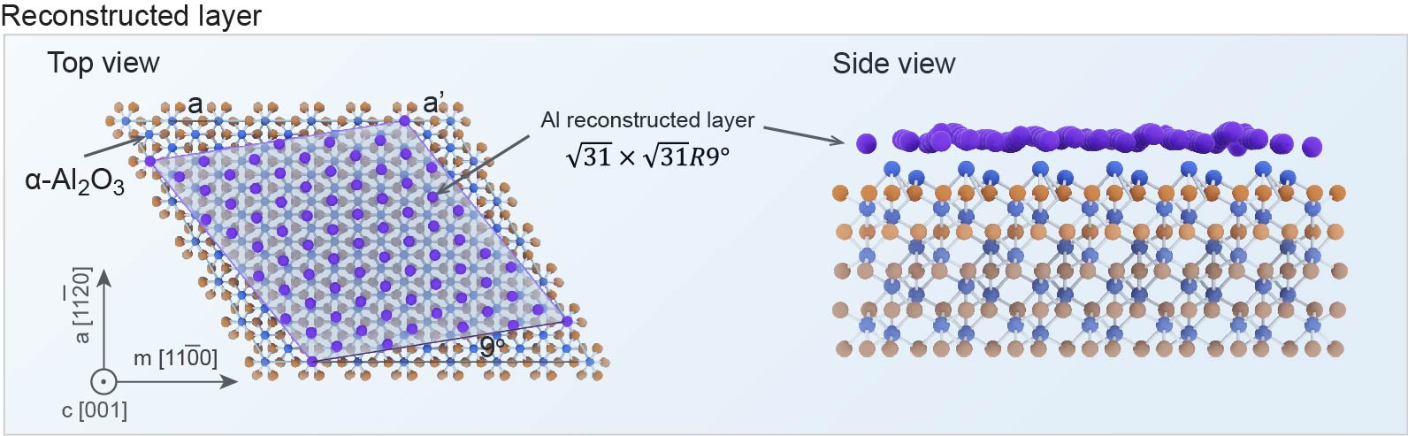

Supplementary Fig. 34. The illustration of $\sqrt{31}$ x $\sqrt{31}$ reconstructed structure.

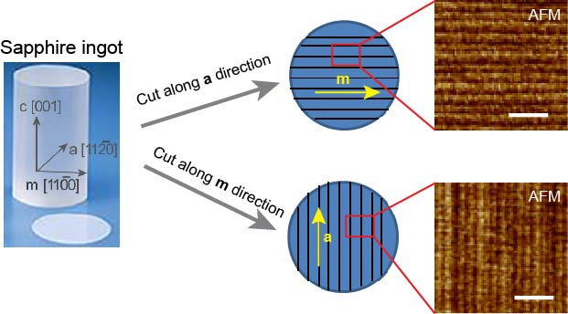
Supplementary Fig. 35. The schematic illustration of the fabrication of two commonly used c-plane sapphire wafers with atomic step along the a $<11\overline{2}0>$ and m $<10\overline{1}0>$directions.

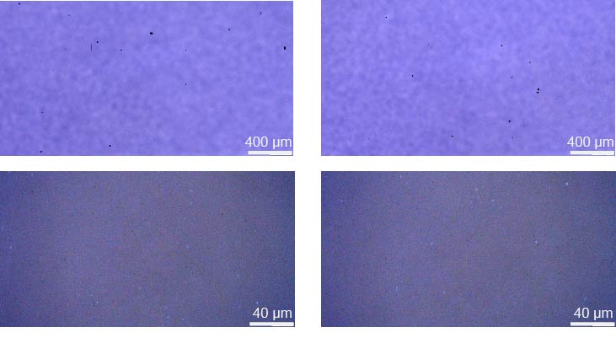
Supplementary Fig. 36 Optical image of WS₂ continuous film on 2-inch sapphire wafer.

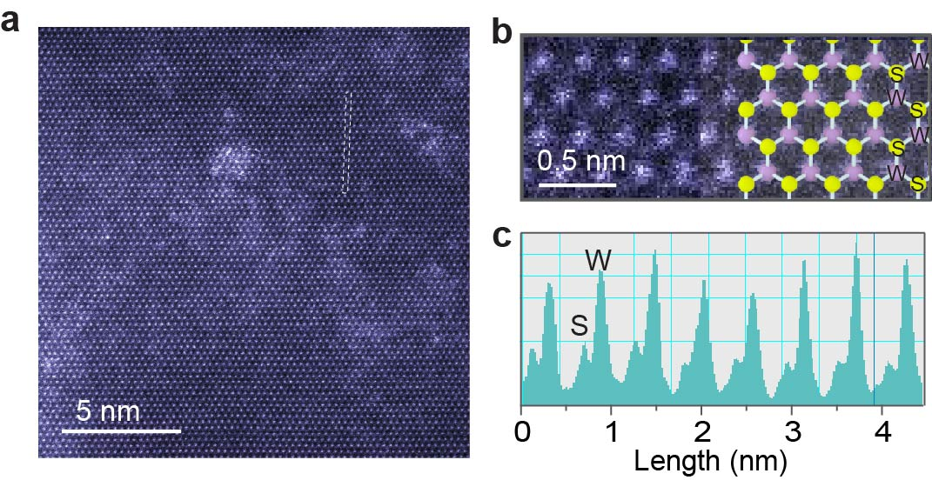
Supplementary Fig. 37. Atomic-resolution STEM analysis of grown WS₂ monolayer (a) Atomic-resolution STEM-ADF image and (b,c) the enlarged image and intensity profile from a.
Supplementary Fig. 38. XPS characterization of WS₂ film transferred on HOPG by PMMA method. XPS spectra of W 4f (right) and S 2p core levels (left) of WS₂ on HOPG (red line). XPS data of WS₂ stoichiometric single crystal (SC) are also shown for comparison purposes (Green shaded curves, as acquired under the same condition of the WS₂ monolayer (ML). The similarity between the ML and SC intensity indicates a nearly stoichiometric ML.

Supplementary Fig. 39. ARPES intensity plot showing the valence band dispersion of WS₂ monolayer along GM and GK high symmetry direction at 295 K. Schematic of Brillouin Zone with G, M, K high symmetry point are is shown in the inset.

Reference
1. Moulder J.F., Stickle W.F., Sobol P.E., Bomben K.D.J.G.S.T.i.n.c.r.f.t.r. Handbook of X-ray photoelectron spectroscopy: a reference book of standard spectra for identification and interpretation of XPS data, 1992. 2000, (2000).

2. Park Y., Ahn C., Ahn J.-G., Kim J.H., Jung J., Oh J., et al. Critical Role of Surface Termination of Sapphire Substrates in Crystallographic Epitaxial Growth of MoS2 Using Inorganic Molecular Precursors. ACS Nano 2023, 17, 1196-1205 (2023).

3. Zhang X., Huestis P.L., Pearce C.I., Hu J.Z., Page K., Anovitz L.M., et al. Boehmite and Gibbsite Nanoplates for the Synthesis of Advanced Alumina Products. ACS Appl. Nano Mater. 2018, 1, 7115-7128 (2018).

4. Kloprogge J.T., Duong L.V., Wood B.J., Frost R.L. XPS study of the major minerals in bauxite: Gibbsite, bayerite and (pseudo-)boehmite. J. Colloid Interface Sci. 2006, 296, 572-576 (2006).

5. Liu P., Kendelewicz T., Brown G.E., Nelson E.J., Chambers S.A. Reaction of water vapor with α-Al2O3(0001) and α-Fe2O3(0001) surfaces: synchrotron X-ray photoemission studies and thermodynamic calculations. Surf. Sci. 1998, 417, 53-65 (1998).

6. Coustet V., Jupille J. High-resolution electron-energy-loss spectroscopy of isolated hydroxyl groups on α-Al2O3(0001). Surf. Sci. 1994, 307-309, 1161-1165 (1994).

7. Hsu P.H.J.M.i.s.e. Aluminum hydroxides and oxyhydroxides. 1977, (1977).

8. Kelber J.A. Alumina surfaces and interfaces under non-ultrahigh vacuum conditions. Surf. Sci. Rep. 2007, 62, 271-303 (2007).

9. Hsu P.H. Aluminum Hydroxides and Oxyhydroxides. Minerals in Soil Environments, 1989, pp 331-378.

10. Causà M., Dovesi R., Pisani C., Roetti C. Ab initio characterization of the (0001) and (101̄0) crystal faces of α-alumina. Surf. Sci. 1989, 215, 259-271 (1989).

