The utility of physical activity questionnaires among African origin populations; lost in translation?
Jessica C. Davies¹, Candice Choo-Kang², Larske Soepnel¹, Hayli Geffen¹, Asanda Mtintsilana¹, Chad Africa¹, Pascal Bovet^{3,4}, Bharathi Viswanathan⁴, Kweku Bedu-Addo⁵, Jacob Plange-Rhule^{5Ψ}, Prince Oti Boateng⁵, Kingsley Apusiga⁵, Oscar Akunor Dei⁵, Terrence E. Forrester⁶, Estelle V. Lambert^{7,11}, Nandipha Sinyanya⁷, Brian T. Layden^{,8,9}, Jack A. Gilbert¹⁰, Gertrude Ecklu-Mensah¹⁰, Cara Joyce², Amy Luke², Lara R. Dugas ^{1, 2}

¹Division of Epidemiology and Biostatistics, School of Public Health, Faculty of Health Sciences, University of Cape Town, Cape Town, South Africa
² Public Health Sciences, Parkinson School of Health Sciences and Public Health, Loyola University Chicago, Maywood, IL, USA
³University Center for Primary Care and Public Health (Unisanté), Lausanne, Switzerland
⁴Ministry of Health, Victoria, Republic of Seychelles
⁵Department of Physiology, School of Medical Sciences, Kwame Nkrumah University of Science and Technology, Kumasi, Ghana
⁶Solutions for Developing Countries, University of the West Indies, Mona, Kingston, Jamaica
⁷Health through Physical Activity, Lifestyle and Sport Research Centre (HPALS), Department of Human Biology, Faculty of Health Sciences, University of Cape Town
⁸Department of Medicine, University of Illinois at Chicago, Chicago, Illinois, USA
⁹Jesse Brown Veterans Affairs Medical Center, Chicago, Illinois, USA
¹⁰Department of Pediatrics, Center for Microbiome Innovation, University of California San Diego, La Jolla, CA, USA
¹¹School of Health and Medical Sciences, Faculty of Health, Engineering & Sciences, University of Southern Queensland, Australia

Corresponding Author: Jessica C. Davies; Division of Epidemiology and Biostatistics, School of Public Health, University of Cape Town, Cape Town, South Africa; jess.davies@uct.ac.za

^{Ψ}Deceased

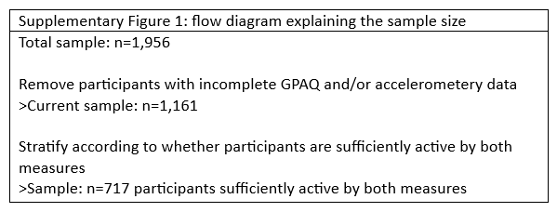

Supplementary Table 1: 2x2 table of whether participants are sufficiently active or not, by obesity status (n = 1,161)
 | Obese (n = 479) |  | Not obese (n = 682)
 | Meets WHO guideline of >=150min MVPA per week | Doesn’t meet WHO guideline of >=150min MVPA per week | Meets WHO guideline of >=150min MVPA per week | Doesn’t meet WHO guideline of >=150min MVPA per week
Meets GPAQ criteria >600 METmin/week | 49 (10.2) | 217 (45.3) | 224 (32.8) | 227 (33.3)
Doesn’t meet GPAQ criteria >600 METmin/week | 30 (6.3) | 183 (38.2) | 65 (9.5) | 166 (24.3)
Sensitivity | 0.62 (0.50, 0.73) |  | 0.78 (0.72, 0.82)
Specificity | 0.46 (0.41, 0.51) |  | 0.42 (0.37, 0.47)
Data are presented as counts (percentage), sensitivity and specificity are presented with 95% confidence interval in brackets. WHO: World Health Organization; MVPA: moderate-to-vigorous intensity PA; GPAQ: global physical activity questionnaire.

Supplementary Table 2: 2x2 tables of whether participants are sufficiently active or not, by site
 | Ghana (n = 183) |  | South Africa (n = 254) |  | Jamaica (n = 238) |  | Seychelles (n = 280) |  | United States (n = 206)
 | Meets WHO guideline of >=150min MVPA per week | Doesn’t meet WHO guideline of >=150min MVPA per week | Meets WHO guideline of >=150min MVPA per week | Doesn’t meet WHO guideline of >=150min MVPA per week | Meets WHO guideline of >=150min MVPA per week | Doesn’t meet WHO guideline of >=150min MVPA per week | Meets WHO guideline of >=150min MVPA per week | Doesn’t meet WHO guideline of >=150min MVPA per week | Meets WHO guideline of >=150min MVPA per week | Doesn’t meet WHO guideline of >=150min MVPA per week
Meets GPAQ criteria >600 METmin/week | 57 (31) | 83 (45) | 88 (35) | 72 (28) | 52 (22) | 83 (35) | 49 (17.5) | 106 (38) | 27 (13) | 100 (49)
Doesn’t meet GPAQ criteria >600 METmin/week | 7 (4) | 36 (20) | 30 (12) | 64 (25) | 20 (8) | 83 (35) | 34 (12) | 91 (32.5) | 4 (2) | 75 (36)
Sensitivity | 0.89 (0.79, 0.95) |  | 0.75 (0.66, 0.82) |  | 0.72 (0.60, 0.82) |  | 0.59 (0.48, 0.70) |  | 0.87 (0.70, 0.96)
Specificity | 0.30 (0.22, 0.39) |  | 0.47 (0.38, 0.56) |  | 0.50 (0.42, 0.58) |  | 0.46 (0.39, 0.53) |  | 0.43 (0.35, 0.51)
Data are presented as counts (percentage), sensitivity and specificity are presented with 95% confidence interval in brackets. WHO: World Health Organization; MVPA: moderate-to-vigorous intensity PA; GPAQ: global physical activity questionnaire.

Supplementary Table 3: 2x2 table of whether participants are sufficiently active or not, by sex (n = 1,161)
 | Men (n = 450) |  | Women (n = 711)
 | Meets WHO guideline of >=150min MVPA per week | Doesn’t meet WHO guideline of >=150min MVPA per week | Meets WHO guideline of >=150min MVPA per week | Doesn’t meet WHO guideline of >=150min MVPA per week
Meets GPAQ criteria >600 METmin/week | 185 (41.1) | 140 (31.1) | 88 (12.4) | 304 (42.7)
Doesn’t meet GPAQ criteria >600 METmin/week | 49 (10.8) | 76 (16.8) | 46 (6.5) | 273 (38.4)
Sensitivity | 0.79 (0.73, 0.84) |  | 0.66 (0.57, 0.74)
Specificity | 0.35 (0.29, 0.42) |  | 0.47 (0.43, 0.51)
Data are presented as counts (percentage), sensitivity and specificity are presented with 95% confidence interval in brackets. WHO: World Health Organization; MVPA: moderate-to-vigorous intensity PA; GPAQ: global physical activity questionnaire.

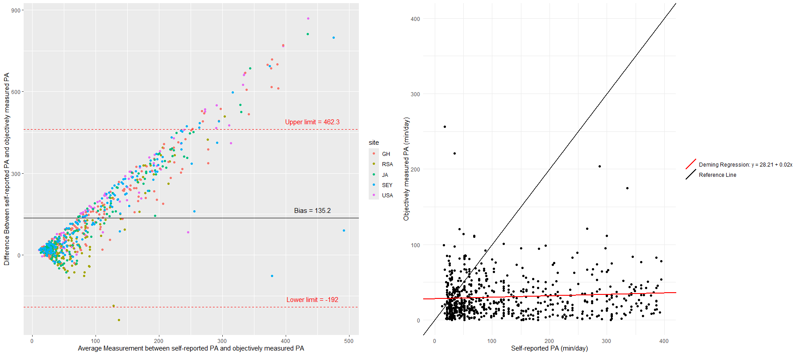
Supplementary Figure 2: Agreement between objectively measured and self-reported PA (n = 717)
Panel A: Bland-Altman plot showing the agreement between objectively measured and self-reported PA. The black line represents the bias (the mean difference between objective and self-reported values). The red lines indicate the limits of agreement (bias ±1.96 times the standard deviation of the differences). Each point represents an individual’s difference between objectively measured and self-reported PA, plotted against the average of the two measures.
PA: physical activity; y = 28.21 + 0.02x: Deming regression formula.

