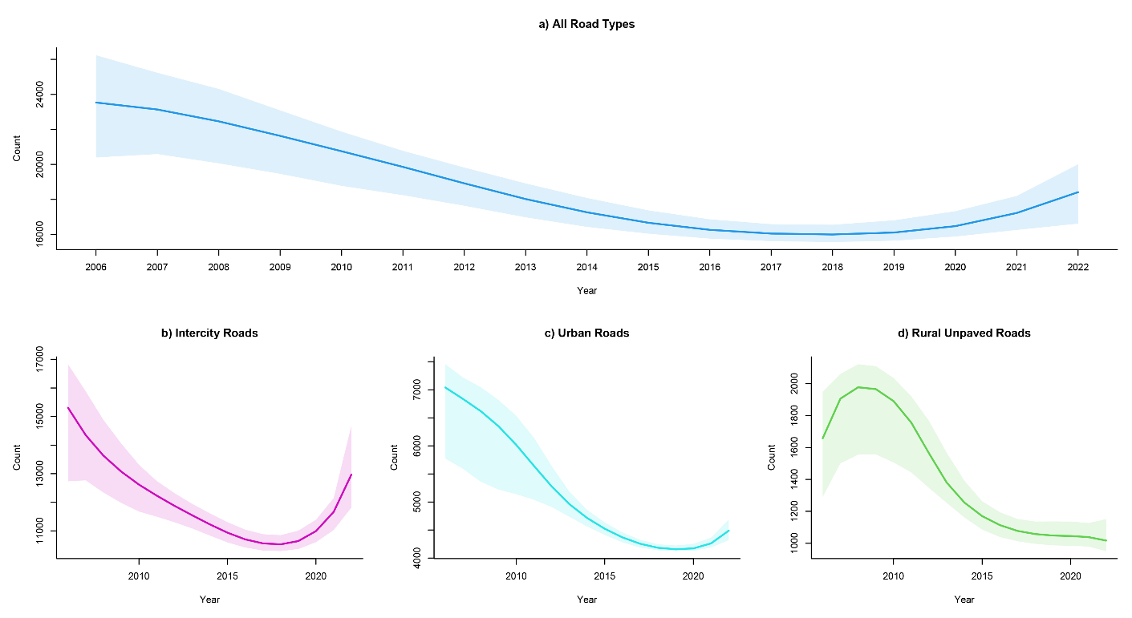
Figure S1: Trends in the Number of Traffic Accidents by Road Type Using a Cubic Growth Mixture Model. (a) All Road Types, (b) Intercity Roads, (c) Urban Roads, (d) Rural Unpaved Roads.

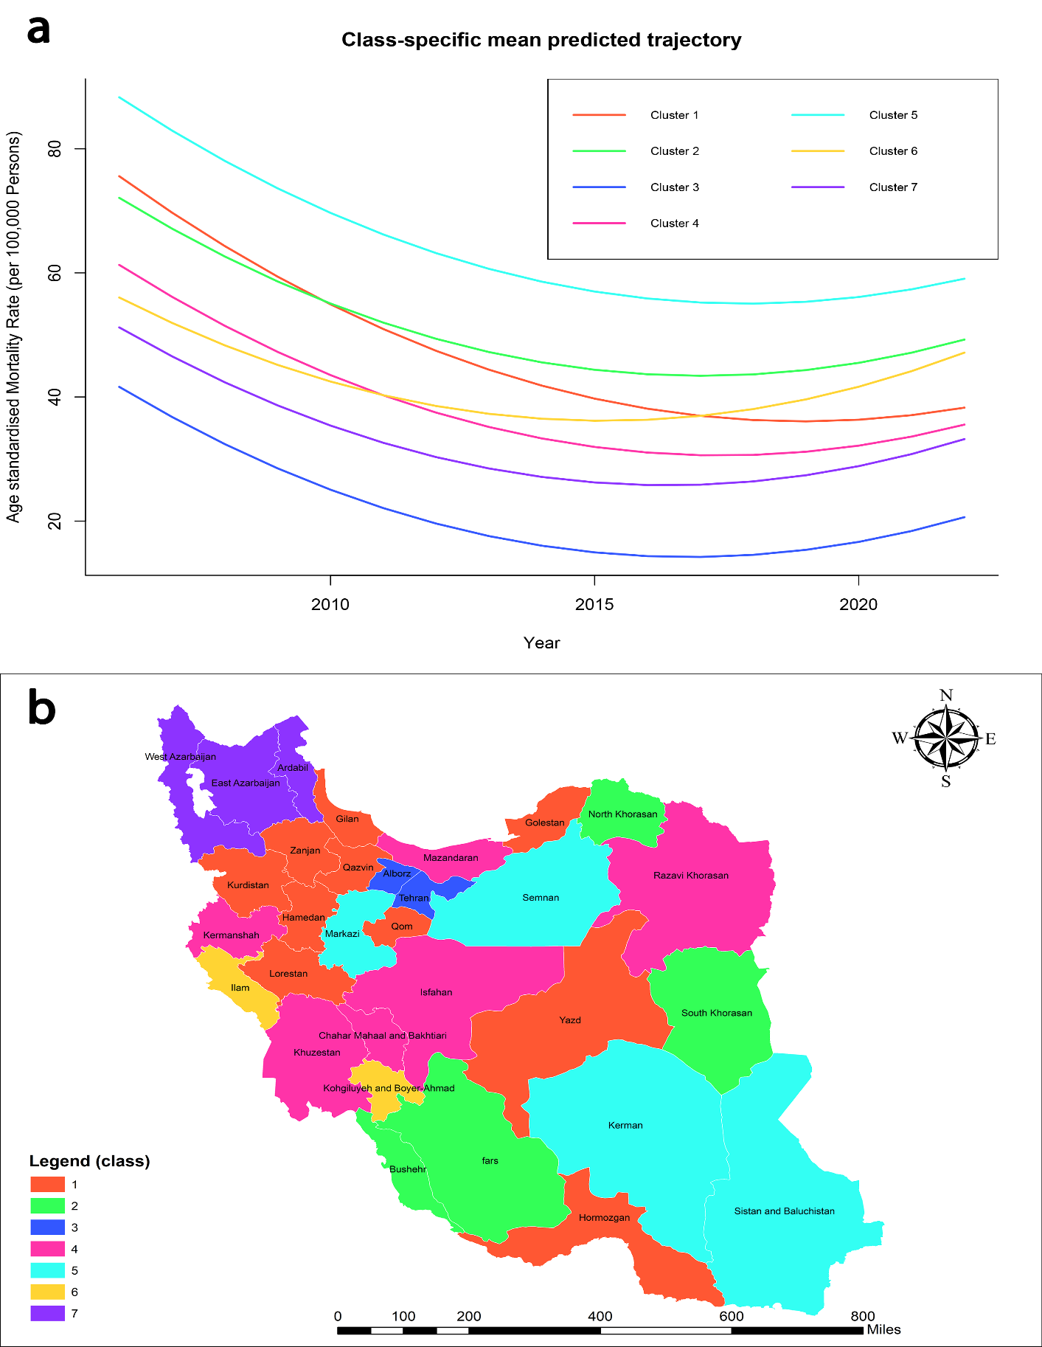
Figure S2: Growth mixture model results for age-standardized mortality rates (ASMR) trends in traffic accidents for males
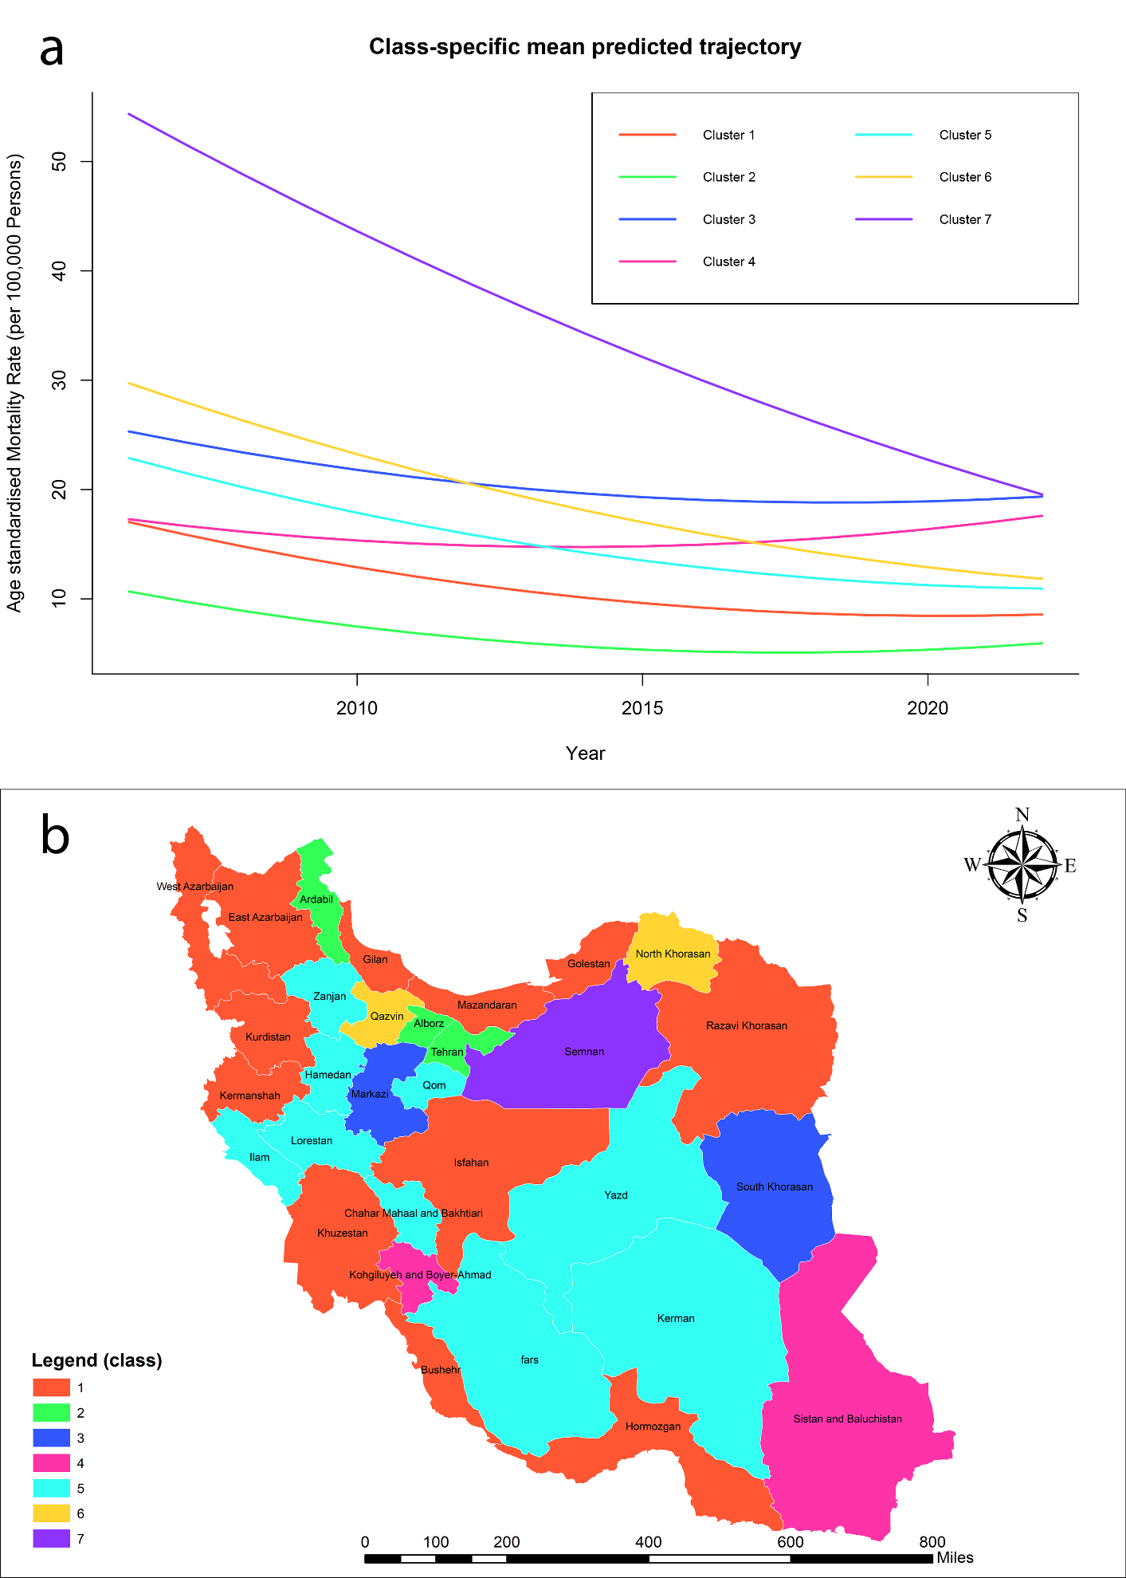
Figure S3: Growth mixture model results for age-standardized mortality rates (ASMR) trends in traffic accidents for males

Table S1. Characteristics of traffic accidents in Iran from 2006 to 2022
Variable |  | Urban Roads | Intercity Roads | Rural Unpaved Roads | Unknown Location | Total | Crammer's V
Place of Death | At the Scene | 30023 (33.4%) | 124083 (60%) | 11869 (48%) | 1125 (45.9%) | 167100 (51.6%) | 0.1794
Place of Death | During transfer to the hospital | 6121 (6.8%) | 15568 (7.5%) | 2656 (10.7%) | 172 (7%) | 24517 (7.6%) | 0.1794
Place of Death | At hospital | 52721 (58.7%) | 66372 (32.1%) | 10063 (40.7%) | 1118 (45.6%) | 130274 (40.2%) | 0.1794
Place of Death | At home | 963 (1.1%) | 674 (0.3%) | 124 (0.5%) | 38 (1.5%) | 1799 (0.6%) | 0.1794
Victims Role | Driver | 31627 (37.3%) | 83168 (43.2%) | 11953 (50.8%) | 999 (45.2%) | 127747 (42.2%) | 0.2721
Victims Role | Passenger | 39724 (46.8%) | 24546 (12.8%) | 4371 (18.6%) | 495 (22.4%) | 69136 (22.8%) | 0.2721
Victims Role | Pedestrian | 13470 (15.9%) | 84646 (44%) | 7221 (30.7%) | 716 (32.4%) | 106053 (35%) | 0.2721
Accident Mechanism | Vehicle-to-Vehicle Collision | 32071 (38%) | 100830 (52.5%) | 10166 (43.4%) | 824 (38%) | 143891 (47.6%) | 0.2795
Accident Mechanism | Vehicle-pedestrian collision | 39737 (47.1%) | 24629 (12.8%) | 4377 (18.7%) | 489 (22.5%) | 69232 (22.9%) | 0.2795
Accident Mechanism | Vehicle-fixed object collision | 6162 (7.3%) | 9273 (4.8%) | 995 (4.2%) | 118 (5.4%) | 16548 (5.5%) | 0.2795
Accident Mechanism | Vehicle-animal collision | 45 (0.1%) | 605 (0.3%) | 93 (0.4%) | 7 (0.3%) | 750 (0.2%) | 0.2795
Accident Mechanism | Vehicle overturns | 6092 (7.2%) | 54850 (28.5%) | 7375 (31.5%) | 686 (31.6%) | 69003 (22.8%) | 0.2795
Accident Mechanism | Vehicle fall | 342 (0.4%) | 1937 (1%) | 439 (1.9%) | 46 (2.1%) | 2764 (0.9%) | 0.0274
Light Conditions | Night | 32499 (56.4%) | 78225 (56.9%) | 9945 (62%) | 968 (59.2%) | 121637 (57.2%) | 0.0274
Light Conditions | Day | 19947 (34.6%) | 45037 (32.8%) | 4464 (27.8%) | 509 (31.2%) | 69957 (32.9%) | 0.0274
Light Conditions | Twilight | 5202 (9%) | 14135 (10.3%) | 1640 (10.2%) | 157 (9.6%) | 21134 (9.9%) | 0.0274
Mode of Transport for Victim | Ambulance | 53255 (91.1%) | 120701 (87.1%) | 11958 (74%) | 1375 (79.9%) | 187289 (87.1%) | 0.0932
Mode of Transport for Victim | Police | 323 (0.6%) | 925 (0.7%) | 134 (0.8%) | 10 (0.6%) | 1392 (0.6%) | 0.0932
Mode of Transport for Victim | Passing vehicles | 3895 (6.7%) | 14572 (10.5%) | 3713 (23%) | 262 (15.2%) | 22442 (10.4%) | 0.0932
Mode of Transport for Victim | Other | 1013 (1.76%) | 2435 (1.76%) | 353 (2.18%) | 74 (4.30%) | 3875 (1.8%) | 0.0932
Cause of Death | Head trauma | 45532 (56.8%) | 96375 (52.6%) | 13356 (59.9%) | 1263 (55.5%) | 156526 (54.4%) | 0.0684
Cause of Death | Bleeding | 6642 (8.3%) | 13533 (7.4%) | 1777 (8%) | 187 (8.2%) | 22139 (7.7%) | 0.0684
Cause of Death | Multiple trauma | 20271 (25.3%) | 57154 (31.2%) | 5513 (24.7%) | 588 (25.8%) | 83526 (29%) | 0.0684
Cause of Death | Burns | 244 (0.3%) | 3165 (1.7%) | 146 (0.7%) | 54 (2.4%) | 3609 (1.3%) | 0.0684
Cause of Death | Asphyxia | 664 (0.8%) | 692 (0.4%) | 114 (0.5%) | 18 (0.8%) | 1488 (0.5%) | 0.0684
Cause of Death | Multiple Causes | 6751 (8.4%) | 12205 (6.7%) | 1384 (6.2%) | 167 (7.3%) | 20507 (7.1%) | 0.0684

Table S2. Growth Mixture Models Results for Age-Standardized Mortality Rates Due to Traffic Accidents in Iran (2006-2022)
Model | Term | Coefficient | Standard Error | Wald Statistic | p-value
Overall | Intercept | 48.134 | 1.317 | 36.554 | <0.001
Overall | Slope | -3.668 | 0.337 | -10.891 | <0.001
Overall | Quadratic Term | 0.139 | 0.018 | 7.617 | <0.001
Male | Intercept | 73.866 | 1.845 | 40.031 | <0.001
Male | Slope | -5.947 | 0.472 | -12.601 | <0.001
Male | Quadratic Term | 0.236 | 0.025 | 9.258 | <0.001
Female | Intercept | 22.012 | 0.918 | 23.968 | <0.001
Female | Slope | -1.374 | 0.235 | -5.849 | <0.001
Female | Quadratic Term | 0.042 | 0.013 | 3.326 | <0.001

Table S3. Model Performance Evaluation for ASMR Trends
Gender | Number of Latent Classes | Log-likelihood | Entropy | AIC | BIC | Model NO.
Overall | 2 | -1776.52 | 0.954 | 3569.036 | 3580.508 | 1
Overall | 3 | -1683.3 | 0.991 | 3390.590 | 3407.798 | 2
Overall | 4 | -1637.34 | 0.955 | 3306.677 | 3329.621 | 3
Overall | 5 | -1551.38 | 0.973 | 3142.758 | 3171.437 | 4
Overall | 6 | -1528.42 | 0.983 | 3104.846 | 3139.262 | 5
Overall | 7 | -1514.95 | 0.982 | 3085.896 | 3126.048 | 6
Overall | 8 | -1499.5 | 0.982 | 3063.003 | 3108.890 | 7
Female | 2 | -1563.62 | 1.000 | 3143.245 | 3154.717 | 8
Female | 3 | -1425.45 | 0.999 | 2874.894 | 2892.102 | 9
Female | 4 | -1380.89 | 0.975 | 2793.781 | 2816.725 | 10
Female | 5 | -1343.9 | 0.988 | 2727.796 | 2756.476 | 11
Female | 6 | -1343.8 | 0.987 | 2735.605 | 2770.021 | 12
Female | 7 | -1307.81 | 0.995 | 2671.622 | 2711.774 | 13
Female | 8 | -1292.8 | 0.992 | 2649.609 | 2695.496 | 14
Male | 2 | -1938.71 | 0.995 | 3893.423 | 3904.895 | 15
Male | 3 | -1858.71 | 0.989 | 3741.427 | 3758.634 | 16
Male | 4 | -1787.29 | 1.000 | 3606.587 | 3629.530 | 17
Male | 5 | -1779.09 | 0.977 | 3598.179 | 3626.859 | 18
Male | 6 | -1765.49 | 0.953 | 3578.981 | 3613.397 | 19
Male | 7 | -1756.66 | 0.965 | 3569.324 | 3609.475 | 20
Male | 8 | -1756.68 | 0.960 | 3577.369 | 3623.256 | 21

Table S4. Latent Class Growth Mixture Models parameters
Model | Class | Intercept | Slope | Quadratic Term
Overall (with Six Classes) | Class 1 | 54.940 | -3.236 | 0.139
Overall (with Six Classes) | Class 2 | 88.911 | -5.562 | 0.139
Overall (with Six Classes) | Class 3 | 39.021 | -3.432 | 0.139
Overall (with Six Classes) | Class 4 | 53.508 | -3.909 | 0.139
Overall (with Six Classes) | Class 5 | 29.315 | -3.346 | 0.139
Overall (with Six Classes) | Class 6 | 45.499 | -3.557 | 0.139
Male (with Seven Classes) | Class 1 | 81.918 | -6.577 | 0.236
Male (with Seven Classes) | Class 2 | 77.530 | -5.674 | 0.236
Male (with Seven Classes) | Class 3 | 46.952 | -5.559 | 0.236
Male (with Seven Classes) | Class 4 | 66.905 | -5.855 | 0.236
Male (with Seven Classes) | Class 5 | 94.135 | -6.074 | 0.236
Male (with Seven Classes) | Class 6 | 60.596 | -4.801 | 0.236
Male (with Seven Classes) | Class 7 | 56.349 | -5.371 | 0.236
Female  (with Seven Classes) | Class 1 | 18.274 | -1.288 | 0.042
Female  (with Seven Classes) | Class 2 | 11.692 | -1.055 | 0.042
Female  (with Seven Classes) | Class 3 | 26.401 | -1.132 | 0.042
Female  (with Seven Classes) | Class 4 | 17.982 | -0.739 | 0.042
Female  (with Seven Classes) | Class 5 | 24.340 | -1.505 | 0.042
Female  (with Seven Classes) | Class 6 | 31.558 | -1.877 | 0.042
Female  (with Seven Classes) | Class 7 | 57.235 | -2.934 | 0.042

