SUPPLEMENTARY APPENDIX A
Structure and assumptions of the population simulation models
We wished to examine the relationship between the probability of extinction of a population within a defined time period and its carrying capacity, and to assess how this shape is affected by life-history characteristics of the species and the level of environmental stochasticity it is subject to. To do this, we constructed four population viability models of increasing complexity and ran simulations for a range of their input parameters. In each model, the number of individuals in the population following time step $dt$is governed by the number of individuals at the previous time step $t$, and the population growth rate during that time step by the following relationship:
$$\begin{aligned}N_{t+dt}={N_{t}+r}_{t}*N_{t}\#\left(A1\right)\end{aligned}$$
where $N_{t}$ is the number of individuals at $t$ and $r_{t}$ is the growth rate at $t$. The models are characterized by different forms of the growth rate $r$ and their realisation of environmental stochasticity. Importantly, in all models discussed here, the realised value of $N_{t+dt}$ is an integer from a Poisson distribution with an expectation value of $N_{t+dt}$. This discretization represents a source of demographic stochasticity in all of our models.
Model A
The simplest realisation of the growth rate $r$ in our models is a logistic density dependent growth rate, with some environmental stochasticity, the equation for which is as follows:
$$\begin{aligned}r_{t}=r_{max}*\left(1-\frac{N_{t}}{K}\right)dt+Q_{t},\#\left(A2\right)\end{aligned}$$
where $r_{max}$ is the maximum growth rate of the population, $K$ is the carrying capacity of the population, and $Q_{t}= Q\sqrt{dt}$, $Q \sim N(0,σ)$ is the environmental stochasticity term, which is drawn from a normal distribution with mean zero and with standard deviation $σ\sqrt{dt}$. This formulation includes, but does not separately identify, some of the mechanisms for density dependence affecting demographic rates, such as influences on survival and age-specific fecundity caused by competition for food, predation patterns, and disease. We adopted annual timescales because many sources of environmental stochasticity, such as the effects of weather, vary substantially from year to year. Moreover, for most species breeding cycles occur annually, and hence data on growth rates is typically expressed as annual. Thus, following the application of a timestep of one year (i.e. $dt=1$), the annual growth rate of the population becomes:
$$\begin{aligned}r_{t}=r_{max}*\left(1-\frac{N_{t}}{K}\right)+Q_{t},\#\left(A3\right)\end{aligned}$$
for which $r_{max}$ and $Q_{t}$ are defined as the maximum annual growth rate, and annual stochastic variation respectively.
Model A as described so far considers only one sex, so we adapt it into a two-sex model of a sexually-reproducing species by considering the total population as two distinct populations of males and females with separate carrying capacities $K_{m}$ and $K_{f}$, each equal to half total $K$. In Model A, male and female growth rates are independent of each other, but at each time interval share the same realised environmental stochasticity as captured by $Q_{t}$ (i.e. both sexes are subject to the same environmental pressures). Equations (B1) and (B3) generate expected real numbers of males and females at each time step, which are then converted to integer values via the Poisson process. This is done separately for males and females and hence the number of individuals of each sex are able to deviate from each other over time.

Simulation setup for Model A
To model a population with given values of $r_{max}$ and $σ$, we initialized the population at its carrying capacity with an equal number of males and females such that at $t=0$:
$$\begin{aligned}N_{t=0, males}+N_{t=0,females}=K_{males}+K_{females}=K\#\left(A4\right)\end{aligned}$$
We then ran the simulation for 100 time intervals (100 years). If at any point the population of either males or females (or both) reached zero, the population was considered to be extinct. We repeated this process for 10000 separate populations and then calculated the probability of extinction $P\left(E_{t≤100} \right)$ as the proportion of those 10000 runs that went extinct within 100 years. We did this for various combinations of $r_{max}$ and $σ$. The choice of values for those parameters is discussed below in the choice of input parameters section (Appendix C). We carried out this process for integer $K$ values geometrically distributed between 0 and 3 million, since we are interested in the shape of the relationship between $P_{E}$ and $K$.

Model B
Next, we adapted Model A such that the growth rates for males and females were no longer independent of each other, instead being dependent on the total number of males and females combined; we call this Model B. The growth rate in Model B is described as follows:
$$\begin{aligned}r_{t, sex}=r_{max}*\left(1-\frac{N_{t, males}+N_{t, females}}{K_{males}+K_{females}}\right)+Q_{t},\#\left(A5\right)\end{aligned}$$
where $r_{t, sex}$ is the growth rate at $t$ for the given sex. As before, $Q_{t}$ is normally distributed with mean zero and standard deviation $σ$, and applied to both sexes in the same way at each time step. Note that this means that at a given time step the growth rate for both sexes is the same. We ran Model B simulations across the same parameter space as Model A.

Model C
For the next model, we began to introduce more complex population processes. Unlike models A and B, in which demographic stochasticity is governed only by differences in the outcomes of the Poisson processes in generating integer numbers of individuals from real numbers, Model C includes an additional source of demographic stochasticity arising from monogamy and biparental care. In this model, the fecundity of the population is reduced in the presence of a disparity between the populations of each sex arising from the stochastic processes. Conceptually, this model aims to represent species in which individuals require long-term access to at least one member of the opposite sex during the breeding season to reproduce successfully.
To implement this, firstly we defined a modified growth rate $r_{t}^{'}$ in the following way:
$$\begin{aligned}{r^{'}}_{t,B}+1=S_{a}+V_{t,B}\#\left(A6\right)\end{aligned}$$
here, each side of the equation is effectively the population multiplier between time $t$ and $t+dt$; in models A and B, this was simply $r_{t}+1$: the existing population plus a per-adult growth rate. We then reformulated this multiplier by the introduction of $S_{a}$: the annual probability of survival for an adult in the population, and $V_{t,B}$: the number of ‘recruits’ to the adult population per adult at time $t$, where $B$ is the age at recruitment to the adult population - i.e. a time to maturity, or age at first breeding. To account for the potential mismatch between the number or males and females at time $t-B$ and consequent impact on fecundity, we defined $V_{t,B}$ in the following way:
$$\begin{aligned}V_{t,B}=\frac{N_{t-B}}{N_{t}}*{(r}_{t-B}+1-S_{a})*\frac{\min\left(N_{m,t-B},N_{f,t-B}\right)}{\max\left(N_{m,t-B},N_{f,t-B}\right)}\#\left(A7\right)\end{aligned}$$
where $N_{m,t-B}$ and $N_{f,t-B}$, and $r_{t-B}$ are the number of males and females, and growth rates as calculated by either model A or B, at time $t-B$ respectively. Putting equations A6 and A7 together, and adding annual environmental stochasticity $Q_{t}$ as before, we get the modified growth rate:
$$\begin{aligned}r_{t,B}^{'}=S_{a}-1+\frac{N_{t-B}}{N_{t}}*{(r}_{t-B}+1-S_{a})*\frac{\min\left(N_{m,t-B},N_{f,t-B}\right)}{\max\left(N_{m,t-B},N_{f,t-B}\right)}+Q_{t}.\#\left(A8\right)\end{aligned}$$
For the sake of demonstration, here we combine equations (B1) and (B8):
$$\begin{aligned}N_{t+dt}=S_{a}N_{t}+ N_{t-B}*\left(r_{t-B}+1-S_{a}\right)*\frac{\min\left(N_{m,t-B},N_{f,t-B}\right)}{\max\left(N_{m,t-B},N_{f,t-B}\right)}+ N_{t}Q_{t}.\#\left(A9\right)\end{aligned}$$
Broken down by term, the number of individuals at $t+dt$is the number of existing adults expected to survive, plus the number of adolescent individuals reaching adulthood (modified for any sex disparity at time $t-B$), plus the environmental stochasticity term affecting any noise in the number of adults: excess deaths or excess arrivals.
The values of $S_{a}$, $B$, and $r_{max}$ are related to each other in the following way, as can be obtained by rearrangement of Equation 17 in Niel and Lebreton (2005):
$$\begin{aligned}B=\frac{1}{r_{max}}-\frac{S_{a}}{e^{r_{max}}-S_{a}}\#\left(A10\right)\end{aligned}$$
to allow the calculation of $B$ values from combinations of $S_{a}$ and $r_{max}$. Using this approach, we then ran simulations for Model C across the same parameter space as used previously, but now introducing the new parameter $S_{a}$. When running simulations of the pre-existing parameter space for different values of $S_{a}$ the total parameter space can be become unmanageably large, so we used values for $S_{a}$ between 0.35 and 0.95 in increments of 0.15. This range is based upon a compilation of estimated annual survival rates of birds provided by Bird et al (2020).

Model D
In Models A, B, and C, $Q$ was drawn each time step from a normal distribution centred at zero (standard deviation of $σ$) independent from previous values of $Q$. In the final model we introduce temporal autocorrelation to the environmental stochasticity term. This is motivated by the real-world observation that periods of adverse environmental conditions tend to be clustered rather than fluctuate independently from year to year, as we assumed in Models A-C (Green et al. 2020). To do this, we took the simple approach of having the environmental noise ‘random walk’ at each time step, with a tendency to return to a central value of zero. The implementation of this process is as follows:
$$\begin{aligned}Q_{t+1}=(1-Z) *Q_{t}+ ε_{t}\#\left(A11\right)\end{aligned}$$
where $Q_{t}$ is the realised value of the environmental stochastic noise at time $t$, $Z$ is a reversion factor: the tendency of the process to move toward zero. $Q_{t}$ is the realised value of stochastic noise at the previous timestep (set at zero for the first timestep), and $ε_{t}\sim N(0,σ)$ is a white noise process with standard deviation $σ$, as before. Choosing Z=1 yields the normally distributed stochastic increment used in Models A, B, and C.
We combined the growth rate model from Model C with this new realisation of environmental stochasticity to form Model D. We conducted simulations of Model D across the previous parameter space, but now introduced the new parameter $Z$, which we ran for values of 0.01, 0.25, 0.5, and 0.75.

SUPPLEMENTARY APPENDIX B
Choice of input parameters
To generate plausible values for $r_{max}$ we applied the demographic invariants method (DIM), which is based upon a study by Charnov (1993). Equation 17 in Niel and Lebreton (2005) describes the DIM relationship as follows:
$$\begin{aligned}e^{r_{max}}=\exp\left[{\left(B+\frac{S_{a}}{e^{r_{max}}-S_{a}}\right)}^{-1}\right]\#\left(B1\right)\end{aligned}$$
where $B$ is the age at first breeding, and $S_{a}$ is the annual probability of adult survival. Using data on the values for $B$ and $S_{a}$ for all ~10,000 of the world’s bird species listed in the supplementary materials of Bird et al. (2020) we recursively solved equation B1 for each species to generate a range of plausible values for $r_{max}$. We took the 10th and 90th percentiles of the calculated values to bound our parameter space and used 15 values of $r_{max}$, linearly spaced between 0.055 and 0.774. For the standard deviation of the environmental stochasticity term $σ$, we chose to use $σ$ values between 0.05 and 0.55 in intervals of 0.03. The upper limit of $σ=0.55$ was sufficient to capture all valid runs, for reasons described in the analysis section.
Overall, our choices of $σ$ and $r_{max}$ yield 255 parameter combinations, meaning that we ran a total of just over 450 million individual simulations for model A. All models were written in Python (the underlying code for which is available at: https://github.com/thomasball42/pvm_curve_modelling).
Some of these combinations of $σ$ and $r_{max}$ we considered to be invalid within our modelling framework. If $σ$ is too large compared to $r_{max}$, population growth is never able overcome environmental stochasticity, leading to an unstable population that is always at risk of extinction regardless of the carrying capacity $K$. We are able to derive this relationship analytically in the case of single-sex, parthenogenic populations (see appendix E), but the inclusion of an additional sex and Poisson process complicates the derivation, thus we consider this empirically.
We regarded combinations of input parameters that lead to this effect to be unrealistic within our framework; our models aimed to explore the relationship between carrying capacity and extinction risk over medium timescales for stable populations. Given that currently extant species typically originated millions of years ago and usually at least hundreds of thousands of years ago (Barnosky et al. 2011), a population for which $P_{E}>0$ within 100 years at large K would be likely to have gone extinct by the present day. We found that this phenomenon occurred by or before $σ=0.55$ for all models and values of $r_{max}$, hence our choice of this upper limit for this input parameter.
To remove these runs from our results we simply excluded runs with any parameter combinations for which there were no data points at which $P_{E}=0$ for any value of K up to 3 million. With this approach, it is possible that we exclude some simulation sets that might reach $P_{E}=0$ given an even higher carrying capacity than we took to be our upper limit. However, by inspection of our result-space we posit this this may only have occurred for some Model D runs with $Z=0.01$. For practical purposes, the majority of simulations express clear asymptotic behaviour with an asymptote at $P_{E}=0$ well before a carrying capacity of 3 million is reached, so we think that these exclusion criteria are appropriate.

SUPPLEMENTARY APPENDIX C
Fitting functions describing the shape of the relationship of $P_{E}$ to $K$
To fit functions relating $P_{E}$ to $K$ for our selected combinations of input parameters we used the optimize.curve_fit function from the Scipy Python library (Virtanen et al. 2020), which attempts to find the optimal parameters to fit a chosen function to the provided data. However, we found that the fitting process for the extended Gompertz model (main text Equation 1) was very sensitive to initial values of $γ$, which we describe as the ‘shape parameter’ of the curve. It was thus necessary to provide approximate starting values to get the best fit. We achieved this by transforming the function as follows:
$$\begin{aligned}\ln{[-\ln{P_{E}]}}=a+b*K^{γ}\#\left(C1\right)\end{aligned}$$
where symbols have their previous meanings. For a range of $γ$ values between -5 and 5 in increments of 0.05 we tested for linear correlation between $\ln{[-\ln{P_{E}]}}$ and $K^{γ}$; the initial $γ$ value that achieved the best coefficient of determination was then used to seed the fitting optimisation function along with the corresponding values for $a$ and $b$. As is described in the main text this allowed to us to achieve fits with $r^{2}$>0.999 for a large portion of the curves.

SUPPLEMENTARY APPENDIX D
Figure D1. An example of a modelled relationship of the probability of extinction in a 100-year period $P_{E}$ to carrying capacity $K$ derived from a published model in which demographic rates of brown bears were assumed to vary among years according to upon empirical observations of the variance of environmental stochasticity in demographic rates and assumptions about demographic stochasticity (Shaffer & Samson 1985). The circles show values from Table 1 of Shaffer & Samson’s paper. We fit Equation 1 to those data by non-linear least squares, with $a$, $b$, and $γ$ values of 3.148, 0.2043, and 0.907 respectively.

SUPPLEMENTARY APPENDIX E
The continuous time counterpart of a population process $X_{t}$can be expressed as the logistic stochastic differential equation given by
$\begin{aligned}dX_{t} = rX_{t} \left(1 + K^{-1}X_{t}\right) dt + σX_{t} dW_{t}, X_{0}= x_{0}, \#(E1)\end{aligned}$
for all times $t ≥0$, where r is the growth rate, K is the carrying capacity and W_{t} is the standard Brownian motion, here calibrated with a geometric diffusion coefficient $σX_{t}$. Note that (E1) can be interpreted as a deterministic logistic ODE perturbed by either environmental fluctuations or by random shifts in the growth rate. We impose$K, σ≥0$. It is known that this equation has an unique positive definite solution given by
$$\begin{aligned}X_{t}=\frac{\exp\left(σW_{t}+\left(r-\frac{σ^{2}}{2}\right)t\right)}{x_{0}^{-1}+\frac{r}{K}\int_{0}^{t}{\exp\left(σW_{s}+\left(r-\frac{σ^{2}}{2}\right)s\right)}ds}\#(E2)\end{aligned}$$
One can recognize how this solution converges to the deterministic case for $σ→0$. Its probabilistic behavior $P\left(x,t\right)≔P\left(x,t | x_{0,}0\right)$ is fully described by the Kolmogorov forward equation given by
$$\begin{aligned}∂_{t}P\left(x,t\right)=-∂_{x}\left[rx\left(1+K^{-1}x\right)P\left(x,t\right)\right]+\frac{σ^{2}}{2}∂_{xx}\left[xP\left(x,t\right)\right].\#(E3)\end{aligned}$$
Setting the left-hand side to zero and solving the FPE under the normalization requirement given by $\int_{0}^{∞}{P\left(x,t\right)dx}=1$ and the initial condition $P\left(x,0\right)=δ\left(x-x_{0}\right)$, where $δ$ is the Dirac delta function, yields the stationary distribution P(x) of (E2). If $\left(r>\frac{σ^{2}}{2}\right)$ holds, letting $t →∞$ one obtains the species’ stationary distribution P(x) is the Gamma distribution $Γ\left(1-\frac{2r}{σ^{2}},\frac{σ^{2}}{2}\frac{K}{r}\right)$
given by
$$\begin{aligned}P\left(x\right)≔Γ\left(1-\frac{2r}{σ^{2}},\frac{σ^{2}}{2}\frac{K}{r}\right)=Γ{\left(\frac{2r}{σ^{2}}-1\right)}^{-1}{\left(\frac{σ^{2}}{2}\frac{K}{r}\right)}^{\frac{2r}{σ^{2}}-1}x^{\frac{2r}{σ^{2}}}\exp\left(-x\frac{2r}{σ^{2}K}\right),\#(E4)\end{aligned}$$

Where $Γ\left(a\right)$is the (convergent) Gamma function $Γ\left(a\right)=\int_{0}^{∞}{y^{a-1}e^{-y}dy}$. If $r<σ^{2}/2$, then the stationary distribution is degenerate and the species become extinct i.e. the process goes to zero with t → ∞ almost surely (thus certainly going below the low threshold X_{t} = 1). Clearly if r < 0 then it’s trivially seen that the species process X_{t} converges to 0 asymptotically, but there exist
positive growth rate values for which the species still is driven to extinction by the intensity of the environmental fluctuations. The long-run average of the process (E2) is thus
$$\begin{aligned}E_{t→∞}\left[X_{t}\right]=\frac{K}{r}\left(\frac{2r}{σ^{2}}-1\right)\frac{σ^{2}}{2}\#(E5\end{aligned})$$
We now are interested in the survival probability, which involves setting an absorbing (i.e. "no return") boundary X_{T} = 1, where T is the (random) time of extinction. We therefore restrict the achievable states of the diffusion to X_{t} ∈ [1,∞). With this in mind, let us now calculate the quantity given by
$$\begin{aligned}S\left(x\right)=\int^{x}{\exp\left(-\int^{y}{\frac{2r}{σ^{2}}}\left(\frac{1}{z}-\frac{1}{K}\right)dz\right)dy=\int_{1}^{x}{z^{-\frac{2r}{σ^{2}}}}\exp\left(\frac{2r}{Kσ^{2}}\left(z-1\right)\right)dz},\#(E6)\end{aligned}$$
since x > 1 always. This function is also known as the scale function for the population process driven by (E1), and its corresponding speed function
$$\begin{aligned}m\left(x\right)=\frac{x^{\frac{2r}{σ^{2}}-2}}{σ^{2}}\exp\left(-\frac{2r}{Kσ^{2}}\left(x-1\right)\right)\#\end{aligned}$$
One can immediately notice that S(∞) = ∞, as the integrals do not converge, implying that the upper boundary of infinity is not achievable. This implies that the probability p_{e}(x) of the species process X_{t} with initial state x to reach carrying capacity before being extinct (i.e. hitting 1 “from the right”) is given by
$$\begin{aligned}p_{e}\left(x\right)=\frac{S\left(x\right)-S\left(1^{+}\right)}{S\left(K\right)-S\left(1^{+}\right)}=\int_{1}^{x}{z^{-\frac{2r}{σ^{2}}}}\exp\left(\frac{2r}{Kσ^{2}}z\right)dz{\left(\int_{1}^{K}{y^{-\frac{2r}{σ^{2}}}}\exp\left(\frac{2r}{Kσ^{2}}y\right)dy\right)}^{-1}\#\left(E7\right)\end{aligned}$$
Let us now study the expected time to extinction for a general initial population X₀ = x. The corresponding expected time to extinction T(x) defined as the first average time τ at which X_{τ} = 1:
$$\begin{aligned}T\left(x\right)≔g\left(x\right)=E\inf_{τ}\left[X_{τ}=1 | X_{0}=x\right],\#(E8)\end{aligned}$$
which is obtained via the boundary value problem
$$-1 = (rx\left(1-K^{-1}x\right)∂_{x}g\left(x\right)+σ^{2}x^{2 }∂_{xx} g(x), g(1) = 0, g(∞) = 1$$
and for the population process starting at carrying capacity (i.e. x = K) is given by
$$\begin{aligned}T\left(K\right)=2\int_{1}^{K}{y^{-\frac{2r}{σ^{2}}}}\exp\left(\frac{2r}{Kσ^{2}}y\right)\int_{y}^{∞}{\frac{z^{\frac{2r}{σ^{2}}-2}}{σ^{2}}}\exp\left(-\frac{2r}{Kσ^{2}}z\right)dzdy.\#(E9)\end{aligned}$$
It is a simple exercise to evaluate this nested integral numerically for different parameter values. Figure E1 plots T(K) as a function of K, as well as presenting two comparisons between population processes across the threshold $r=\frac{σ^{2}}{2}$, which is the determinant for existence of a non-extinct stationary distribution. The left-hand panel of Figure E1 shows how increasing carrying capacity (here jointly with initial condition, since $x_{0}=K$) has substantially decreasing returns to scale with respect to the expected time to extinction T.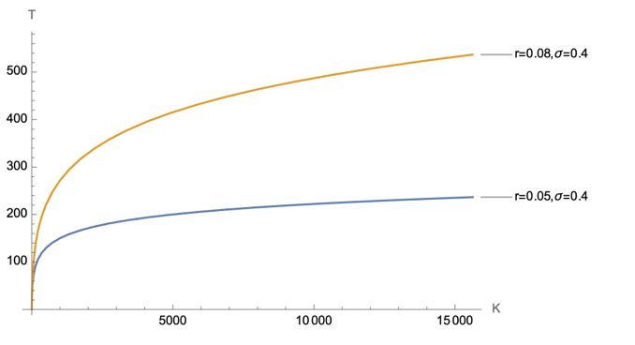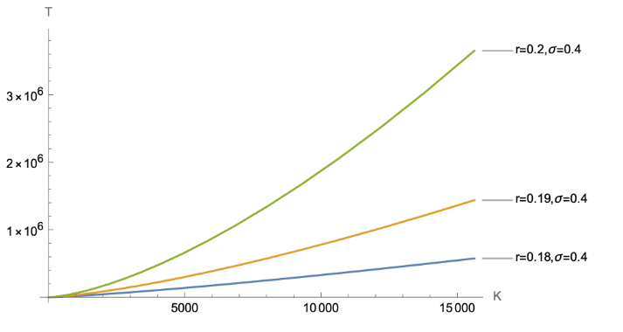
Figure E1: Time to extinction for a population starting at $x_{0}=K$ as function of carrying capacity K. Left panel: below threshold, right panel: above threshold
This is intuitive: if the ecosystem structure does not allow for a stationary state around the carrying capacity, given by (E5), then increasing initial population level and carrying capacity will not substantially affect the expected time to extinction. On the other hand, the right-hand panel of Figure E1 shows how a system whose population parameters well exceed the threshold exhibits a time to extinction with a convex relation with respect to K.
Let us now study the probability of persistence. At any time t, the population process X_{t} obeying
(A1) has a transition density P(x,t) satisfying the FPE (E3). The absorbing condition at extinction X_{t} = 1 implies requiring solving (E3) with the added boundary condition
$$\begin{aligned}P\left(1,t | x_{0},0\right)=0,\end{aligned}$$
as there must be no probability flow of the process once the boundary is hit, whilst always satisfying the initial condition $P\left(x,0 | x_{0,}0\right)=δ\left(x-x_{0}\right).$
Solving the stationary FPE with the absorbing boundary condition (E9) yields the following probability distribution P^{abs}(x) at t → ∞ of the species under the extinction threat at X_{t} = 1:
$$P^{abs}\left(x\right)=N\left(Θ\right)P^{N}\left(x\right)-\frac{1}{x}\frac{\int_{1}^{∞}{z^{r/σ^{2}}}\exp\left(\frac{rx}{Kσ^{2}}z\right)dz}{\int_{1}^{∞}{z^{r/σ^{2}}}\exp\left(\frac{r}{Kσ^{2}}z\right)dz} ,$$

where the normalization constant N(Θ) is a function of the model parameters, and P^{N}(x) is the un-normalized stationary distribution of the population process without the absorbing boundary at 1.
The “total” survival probability at t, $P_{S}\left(t | x_{0},0\right)$ implies integrating the transition density P(x,t) over all possible states $x∈\left[1,∞\right)$:
$$P_{S}\left(t | x_{0},0\right)=\int_{1}^{∞}{P\left(x,t\right)dx}$$
noticing that
$$P_{S}\left(0 | x_{0,}0\right)=\int_{1}^{∞}{δ\left(x-x_{0}\right)}, x_{0}>1,$$
and the distribution of the extinction time T can be derived from this measure by taking the derivative with respect to time:
$$\begin{aligned}P_{T}\left(t | x_{0},0\right)=-∂_{t}P_{S}\left(t | x_{0},0\right)=-\int_{1}^{∞}{∂_{t}P\left(x,t\right)dx},\#(E10)\end{aligned}$$
Using the fact that the KFE must always be satisfied, this means that one can substitute (E3) and obtain
$$P_{T}\left(t | x_{0},0\right)=-\int_{1}^{∞}{-∂_{x}\left[rx\left(1+K^{-1}x\right)P\left(x,t\right)\right]}+\frac{σ^{2}}{2}∂_{xx}\left[xP\left(x,t\right)\right]dx$$
$$=\left(rx\left(1-K^{-1}x\right)P\left(x,t\right)-∂_{x}\left[σ^{2}x^{2}P\left(x,t\right)\right]\right){\left.​\right|}_{x=1}^{x=∞}$$
= $-{\left.σ^{2}x^{2}∂_{x}P\left(x,t\right)\right|}_{x=1}$ $(E11)$
as the probability flow P is 0 in 1. Since we also have that
$$\begin{aligned}P_{T}\left(0 | x_{0,}0\right)=σ^{2}x^{2}δ\left(x-x_{0}\right){\left.​\right|}_{x=1}=0\#(E12)\end{aligned}$$
then we obtain the probability of “forever persistence” $P_{S}\left(∞ | x_{0}\right)$ as the integral over all times $t∈\left[0,∞\right)$:
$$\begin{aligned}\int_{0}^{∞}{P_{T}\left(t | x_{0,}0\right)dt}=-\int_{0}^{∞}{∂_{t}P_{S}\left(t | x_{0,}0\right)}=P_{S}{\left(t | x_{0},0\right)}_{t=0}^{t=∞}=1-P_{S}\left(∞ | x_{0}\right).\#(E13\end{aligned})$$
However, there is no closed form solution for the transition density$P\left(x,t | x_{0},0\right)$. We can now go further in the analysis by exploiting the fact that the simulations are done starting at carrying capacity, i.e. x₀ = K. Intuitively, at t = 0 the drift is zero and in dt the increment dX₀ is only determined by its diffusive part, which is equal to $y_{0}=σx_{0}dW_{0}$. Centering the process on $y →x -K$, changing time for Y such that $t →t+ dt$ and after a straightforward Lamperti transform, we now focus on the Ito process $Y_{t}$ given by
$$dY_{t}=-ρY_{t}dt+σdW_{t}, Y_{0}=y_{0},$$
where $ρ= r/K$, under the absorbing boundary of the extinction threshold $\overline{Y}=K-1$. This is an Ornstein-Uhlenbeck process, that in the original coordinates is equivalent to a population process initially shocked away from K and reverting towards it at speed $r/K$. The advantage of this approximation is that it allows us to study further the form of $(E13)$, since for the Ornstein-Uhlenbeck the form of the transition density is well known. As per the standard approach, we study the first-passage time distribution $(E10)$ for Y_{t} into Laplace space:

$$\tilde{P_{T}}\left(λ | Y_{0}\right)=\int_{0}^{∞}{e^{-λt}P_{T}\left(t | \overline{Y},0\right)dt}=e^{\frac{ρ\left(Y_{0}^{2}-{\left(K-1\right)}^{2}\right)}{2σ^{2}}}\frac{D_{-λ/ρ}\left(-Y_{0}\sqrt{2ρ/σ^{2}}\right)}{D_{-λ/ρ}\left(-\left(K-1\right)\sqrt{2ρ/σ^{2}}\right)}$$

where D_{λ}(z) is the parabolic cylinder function, and can be written as a spectral decomposition
whose eigenvalues are the zeroes of the denominator $D_{-λ/ρ}\left(-\left(K-1\right)\sqrt{2ρ/σ^{2}}\right)$ (Ricciardi and Sato, 1988). One can then invert each term to obtain the required passage time distribution $P_{T}\left(t | Y_{0}\right)$ as an (infinite) weighted sum. Following Giorgini et al. (2020), for large t and "large" $K-Y_{0}$ (so with $K$ large with respect to$σx_{0}dW_{0}$, which in the original coordinates corresponds to the initial environmental fluctuation $dX_{0}$ not to reach “too close” to the extinction threshold 1), only the first eigenvalue of the spectrum contributes significantly, and we can write the limit

$$\begin{aligned}\lim_{K-Y_{0}→∞}{P_{T}}\left(t | Y_{0}\right)=\frac{1}{t_{1}\left(K\right)}\exp\left[-\frac{t}{t_{1}\left(K\right)}\right],\#(E14)\end{aligned}$$
where one has
$$t_{1}\left(K\right)=\frac{K}{r\left(K-1\right)}\sqrt{2πσ^{2}}\exp\left(\frac{r{\left(K-1\right)}^{2}}{Kσ^{2}}\right) .$$
The survival probability for large$K-Y_{0}$, as shown before, is then given by the time integral
of (E14), and is given by
$$\begin{aligned}P_{S}\left(t\right)∼\exp\left[-\frac{\left(K-1\right)ρ}{\sqrt{2πσ^{2}}}\exp\left(-\frac{{\left(K-1\right)}^{2}ρ}{2}\right)t\right] , \#(E15)\end{aligned}$$
which, remembering that $ρ= r/K$ and fixing time to any given amount T, is a Gompertz curve in $K$.

APPENDIX F
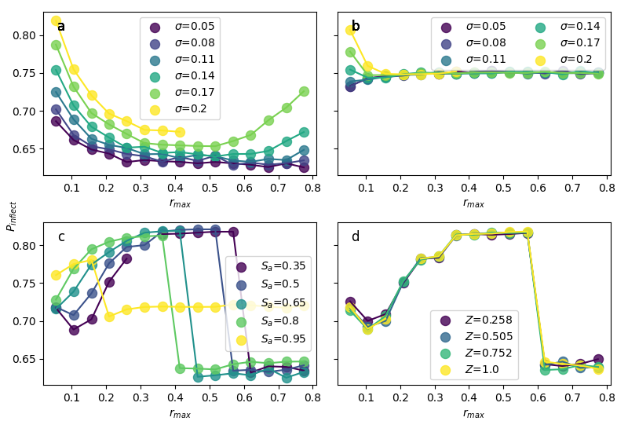
Figure F1. The $P_{E}$ value at the point of inflection ($P_{inflect}$) on the fitted extended Gompertz curve against $r_{max}$ , when varying $σ$ in (a) Model A and (b) Model B. Then (c) fixing $σ$ = 0.08 but varying $S_{a}$ in Model C. Finally, (d) setting $S_{a}$ = 0.35 and $σ$= 0.08 but varying $Z$ in Model D.

SUPPLEMENTARY APPENDIX G
Rationale underlying the calculation of K₁₀, the carrying capacity at which the expected probability of extinction in 100 years $P_{E}$ is 0.1
In addition to using our simulation results to describe relationships between $P_{E}$ and $K$, we also wished to assess the effects of values of input parameters on a single summary statistic chosen to represent variation among modelled species’ populations in their susceptibility to extinction during a period of 100 years. For this purpose, we chose to estimate, based upon our fitted Gompertz functions, the $K$ value for which the probability of extinction in 100 years was 0.1 (10%). We call this $K_{10}$. We chose this particular statistic because the same probability is also used in IUCN Red List classification as the only criterion (Criterion E) which explicitly refers to the probability of extinction in a defined time period. To classify a species as Vulnerable, which is the least endangered of the three categories of species considered to be at risk of global extinction which are not already Extinct or Extinct in the Wild, Criterion E requires that the modelled probability of extinction in 100 years is 10% or greater (IUCN 2001). An extinction probability of 5% or 10% in 100 years was initially suggested as an acceptable level of risk by Shaffer (1981). Criterion E definitions for the other two categories (Critically Endangered and Endangered) involve higher probabilities of extinction over a comparable period than does Vulnerable, but the definitions are more complicated and therefore more difficult to link with our simulation results. We therefore think that $K_{10}$ is a straightforward and appropriate statistic that aligns well with the IUCN Red List criterion referring to extinction risk which separates all globally threated species from other, less threatened species (Near Threatened and Least Concern), given that a species’ population is potentially at risk because of consequences of having small population size due to low carrying capacity, rather than from having a population undergoing a sustained decline. We calculated K₁₀ from the three fitted parameters of the Gompertz function ($a$, $b$ and $γ$) as
$$\begin{aligned}K_{10}={\left(\frac{\ln\left(-\ln\left(0.1\right)\right)-a}{b}\right)}^{-γ}\#\left(G1\right)\end{aligned}$$
Figure G1 shows the relationship between $K_{10}$ and input parameters for Model C and Model D. In Model C, varying $S_{a}$ against $K_{10}$ has a hump-shaped relationship to $r_{max}$ (Figure G1a) with lower values of adult survival $S_{a}$ shifting the position of the hump toward lower $r_{max}$ values. In Model D, $K_{10}$ increases slightly with decreasing values of $Z$, reflecting greater temporal autocorrelation in the environmental stochasticity faced by the population, with the strongest impacts at $r_{max}$ = 0.4.
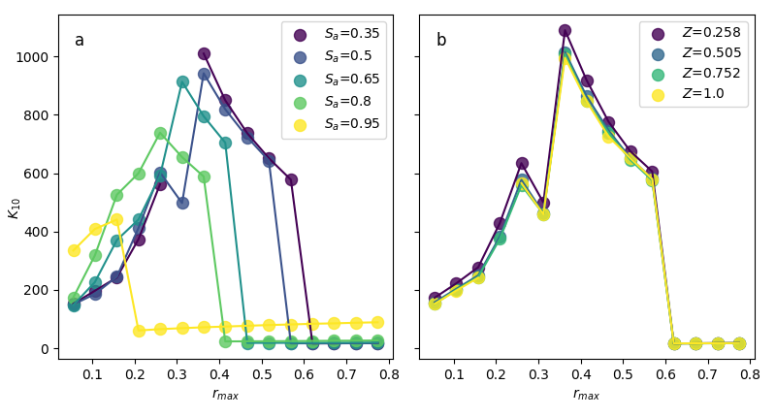
Figure G1. The relationship between $K_{10}$ and $r_{max}$ for varying values of $S_{a}$ in (a) Model C, and the relationship between $K_{10}$ and $r_{max}$ for various values of $Z$ and a constant $S_{a}$ = 0.35 in (b) Model D.

References
Barnosky, A., Matzke, N., Tomiya, S. et al. (2011). Has the Earth’s sixth mass extinction already arrived?. Nature 471, 51–57. https://doi.org/10.1038/nature09678
Bird, J. P., Martin, R., Akçakaya, H. R., Gilroy, J., Burfield, I. J., Garnett, S. T., ... & Butchart, S. H. (2020). Generation lengths of the world's birds and their implications for extinction risk. Conservation Biology, 34(5), 1252-1261.
Charnov, E. L. (1993). Life history invariants. Some explanations of symmetry in evolutionary ecology. Oxford University Press, Oxford, United Kingdom.
Giorgini, Ludovico T., Woosok Moon, and John S. Wettlaufer. "Analytical survival analysis of the ornstein–uhlenbeck process." Journal of Statistical Physics 181.6 (2020): 2404-2414.
Green R.E., Gilbert G., Wilson J.D., Jennings K. (2020). Implications of the prevalence and magnitude of sustained declines for determining a minimum threshold for favourable population size. PLOS ONE 15(2): e0228742. https://doi.org/10.1371/journal.pone.0228742
IUCN. (2001). IUCN Red List Categories and Criteria: Version 3.1. IUCN Species Survival Commission. IUCN, Gland, Switzerland and Cambridge.
Niel, C. and Lebreton, J. D. (2005). Using Demographic Invariants to Detect Overharvested Bird Populations from Incomplete Data. Conservation Biology, 19: 826-835. https://doi.org/10.1111/j.1523-1739.2005.00310.x
Ricciardi, Luigi M., and Shunsuke Sato. "First-passage-time density and moments of the OrnsteinUhlenbeck process." Journal of Applied Probability 25.1 (1988): 43-57
Servén D., Brummitt C. (2018). pyGAM: Generalized Additive Models in Python. Zenodo. DOI: 10.5281/zenodo.1208723
Shaffer, M.L. & Samson, F.B. (1985) Population size and extinction: a note on determining critical population sizes. American Naturalist 125: 144-152.
Shaffer, M.L. (1981) Minimum population sizes for species conservation. BioScience 31:131-134.
Virtanen, P., Gommers, R., Oliphant, T. E, et al. (2020) SciPy 1.0: Fundamental Algorithms for Scientific Computing in Python. Nature Methods, 17(3), 261-272.

