Supplementary Figures & Figure Legends

Supplementary Figure 1
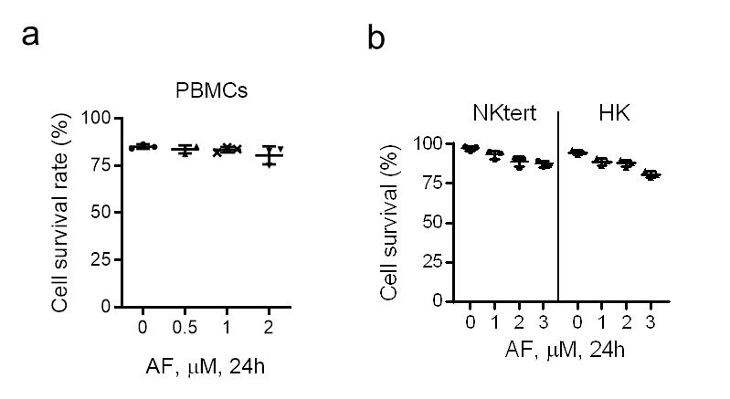
Supplementary Figure 1. Cytotoxic effect of AF on various types of normal cells (PBMC and stromal cells). (a and b) Effect of AF on the viability of peripheral blood mononuclear cells (PBMC) (a) and stromal cells (NKtert and HK cells) (b), analyzed by annexin V-PI assay (n = 3). For a-b, data are presented as mean ± SD.
Supplementary Figure 2
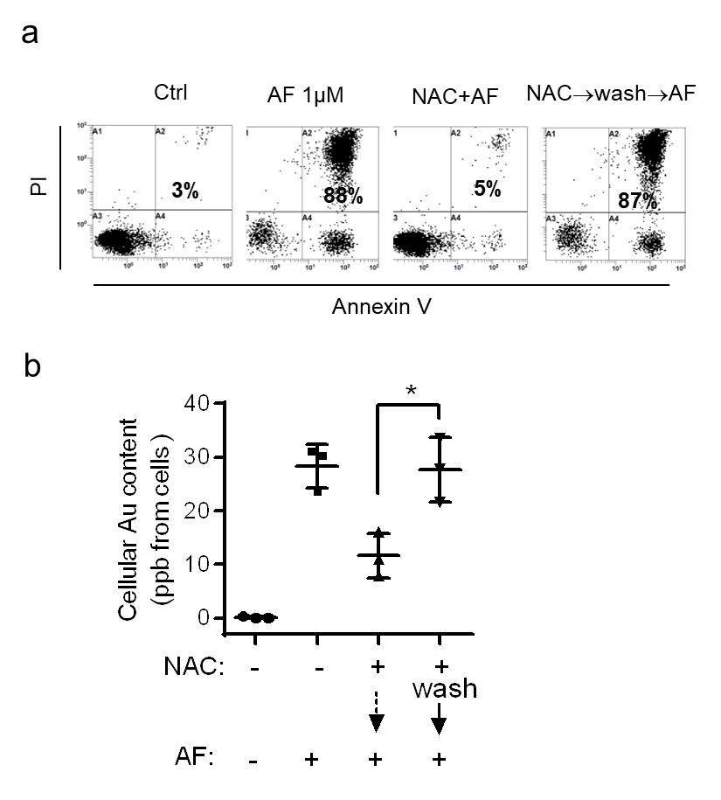
Supplementary Figure 2. Impact of NAC on cellular AF uptake and cell viability in AF-treated cells. (a) JeKo-1 cells were pre-treated with 2 mM NAC for 4 hours, then washed twice with fresh medium or without washing as indicated. The cells were then incubated with 1 µM AF for 20 hours. Representative data of three independent assays were shown. The number in each panel shows % of dead cells. (b) Measurement of cellular AF uptake in Raji cells, indicated by intracellular Au content measured by ICP-MS. Raji cells were pre-treated with 2 mM NAC for 4 hours, then washed twice with fresh medium or not, followed by 2 µM AF treatment for 2 hours (n = 3). For a and b, data are presented as mean ± SD; *p<0.05.
Supplementary Figure 3
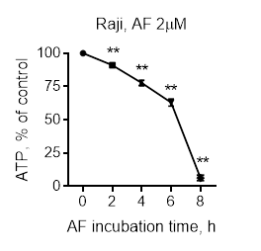
Supplementary Figure 3. Effect of AF on cellular ATP in lymphoma cells. Depletion of cellular ATP by AF in Raji cells (n = 3). Data are presented as mean ± SD; **p<0.01.

Supplementary Figure 4
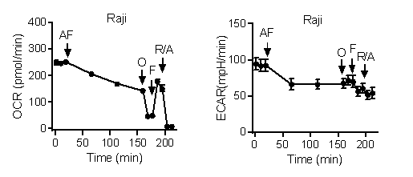
Supplementary Figure 4. Effect of AF on OCR and ECAR in lymphoma cells. Raji cells were sequentially treated with AF (1-2 μM as indicated), oligomycin (O, 1 μM), FCCP (F, 1 μM), and rotenone/antimycin A (R/A, 0.5 μM). OCR and ECAR were measured by a Seahorse XF24 analyzer (n = 4). Data are presented as mean ± SD.

Supplementary Figure 5
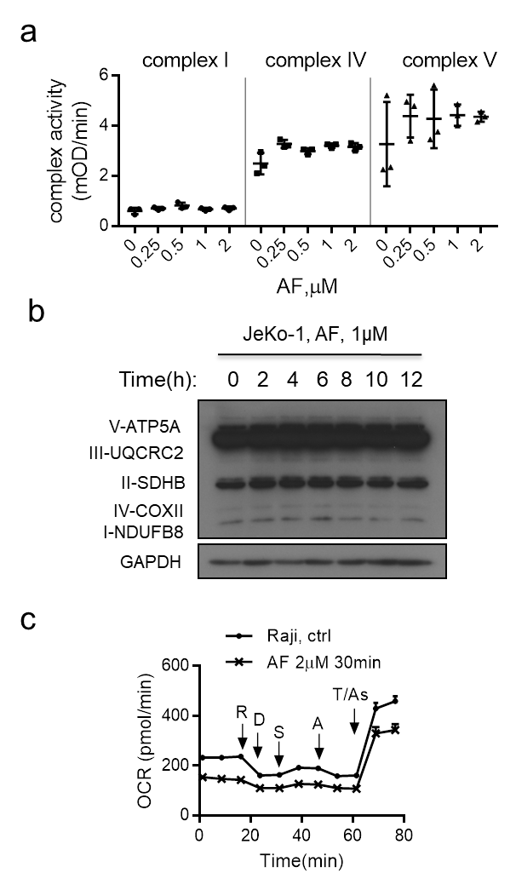
Supplemental Figure 5. Impact of AF on mitochondrial respiratory function in lymphoma cells. (a) Analysis of the impact of AF on the activities of mitochondrial complex I, complex IV and complex V (n = 3). (b) Effect of AF on expression of mitochondrial respiratory complexes, measured by western blot analysis (n = 3). Representative data were shown as mean ± SD. (c) Real-time measurement of OCR in Raji cells pre-treated with or without AF (2 μM, 30 minutes) using Seahorse XF24. Specific inhibitors rotenone (R, 2 µM), digitonin (D, 15 µg/ml), succinate (S, 10 mM), antimycin A (A, 2 µM), TMPD/ascorbate (T/A, 100 µM/5 mM) were then sequentially injected as indicated. n = 4 independent experiments; data are presented as mean ± SD.

Supplementary Figure 6
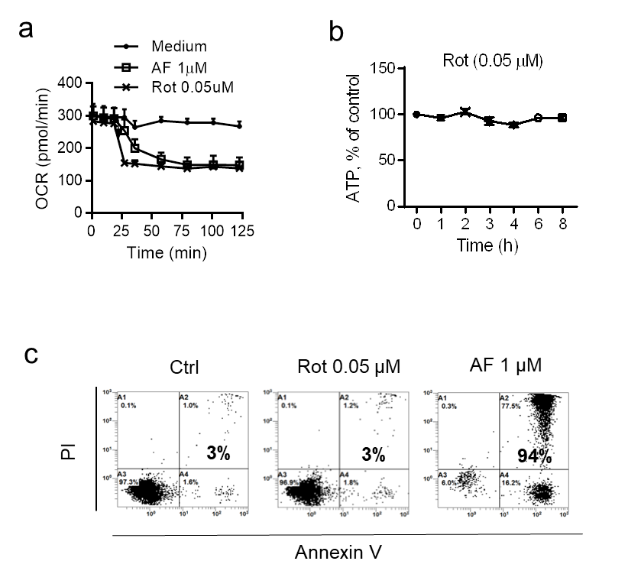
Supplementary Figure 6. Comparison of AF and rotenone on cellular energy metabolism and cell viability. (a) Inhibition of mitochondrial respiration by rotenone (Rot, 0.05 µM) and AF (1 µM) in JeKo-1 cells. OCR was measured by a Seahorse XF24 analyzer (n = 4, data are presented as mean ± SD). (b) Effect of rotenone (0.05 µM) on cellular ATP level, data are presented as mean ± SD. (c) Comparison of rotenone and AF on cell viability. JeKo-1 cells were incubated with the indicated concentration of rotenone or AF for 24 hours. Cell viability was measured using annexin-V/PI staining followed by flow cytometry analysis. The number in each panel shows % of dead cells (n = 3 independent experiments, representative data are shown).

Supplementary Figure 7

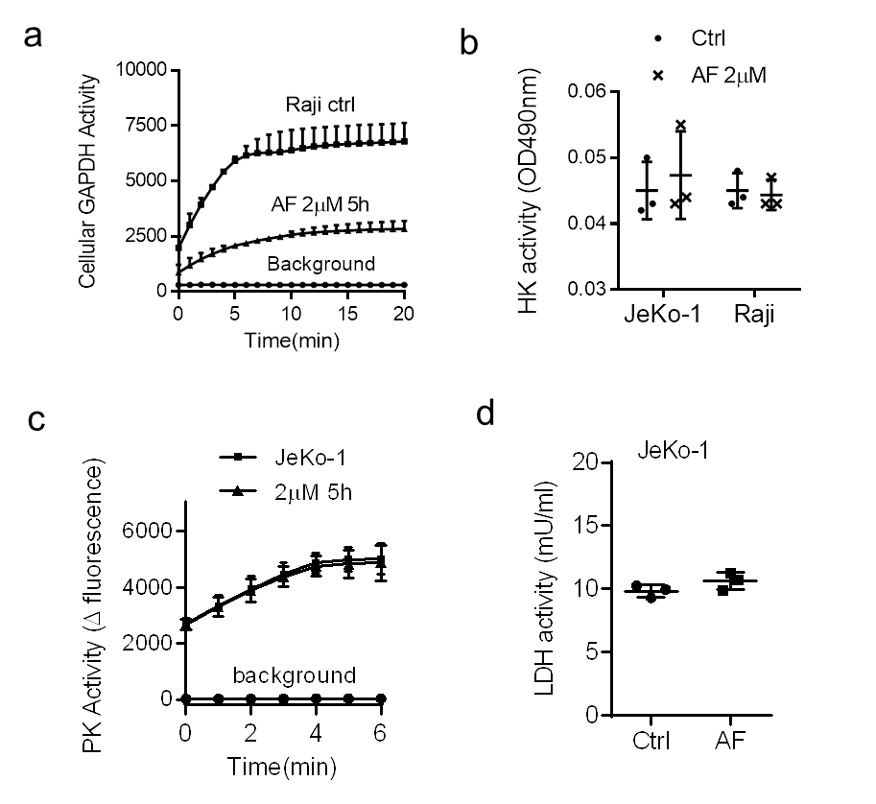
Supplementary Figure 7. Effect of AF on glycolytic enzymes. (a) Inhibition of GAPDH enzyme activity by AF. Raji cells were incubated with or without 2 μM AF for 5 hours, and protein lysates were analyzed for GAPDH activity. (b) JeKo-1 and Raji cells were incubated with or without 2 μM AF. Protein lysates were analyzed for hexokinase (HK) activity. (c-d) JeKo-1 cells were incubated with or without 2 μM AF for 5 hours. Protein lysates were then analyzed for pyruvate kinase (PK) activity (c) and lactate dehydrogenase (LDH) activity (d). All assays were performed at least in 3 independent experiments; data are presented as mean ± SD.

Supplementary Figure 8
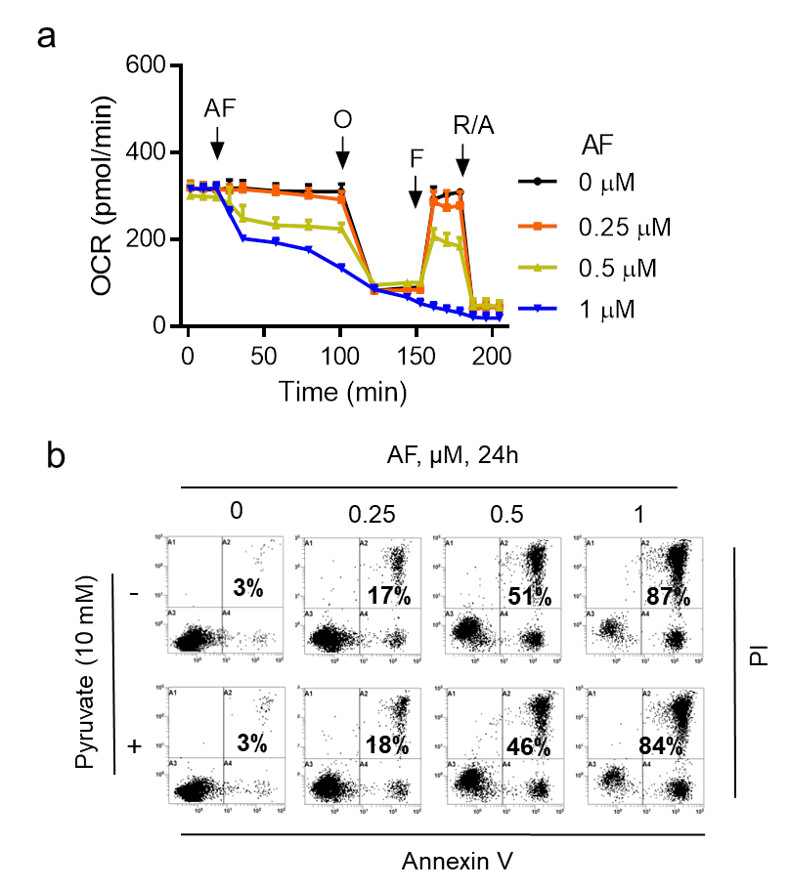
Supplementary Figure 8. Inability of pyruvate to reverse AF-induced mitochondrial inhibition and cytotoxicity. (a) JeKo-1 cells were incubated in medium supplemented with 10 mM pyruvate, and OCR was measured in the presence of the indicated concentrations of AF (n = 4 replicate experiments; data are presented as mean ± SD). (b) JeKo-1 cells were incubated with the various concentrations of AF in the presence or absence of pyruvate as indicated. Cell viability was measured using annexin-V/PI staining followed by flow cytometry analysis. The number in each panel shows % of dead cells (n = 3 independent experiments, representative data are shown).

Supplementary Figure 9

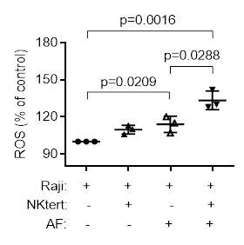
Supplementary Figure 9. ROS level in AF-treated lymphoma cells with or without stromal co-culture. Raji cells were treated with 1 μM AF in the presence or absence of stromal cells for 1 hour and the ROS level was detected by Hydroethidine analysis (n = 3 independent experiments). Data are presented as mean ± SD.

Supplementary Figure 10
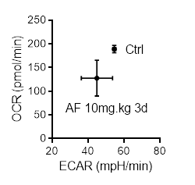
Supplementary Figure 10. AF-induced double Inhibition of mitochondrial respiration and glycolysis in vivo. Nude mice bearing JeKo-1 tumors were treated with normal saline or AF (10 mg/kg/day i.p.) daily for 3 d (n = 3 per group), primary cells from the tumor were isolated, and OCR and ECAR were measured and plotted.

Supplemental Methods
Cell and Cell culture: Human stromal cell line NKtert, human lung cancer cell lines SK-MES-1, A549, HCC827, human myeloid leukemia MV411, human lymphoma cell line U937, human colon cancer cell line HT29, human pancreatic cancer cell lines BxPC-3, AsPC-1, Capan-2 were purchased from American Type Culture Collection (ATCC) (Rockville, MD, USA). Human myeloid leukemia ML-1 cells were from Sigma. Human myeloid leukemia cell line MOLM-13 were from Deutsche Sammlung von Mikroorganismen und Zellkulturen (Brunswick, German). Human lymphoma cell lines Daudi, JeKo-1, NAMALWA, Raji, human ovary cancer cell line SK-OV-3, human leukemia cell line HL-60, human gastric cancer cell linesMGC803, HGC27, human pancreatic cancer cell line PANC-1, human colon cancer cell lines HCT116, LoVo, Caco-2, CW-2, RKO, DLD-1, SW480, LS174T, human liver cancer cell lines HuH-7, SK-HEP-1, human lung cancer cell line NCI-H460 were obtained from the Cell Bank of the Chinese Academy of Sciences (Shanghai, China). Raji, HK, Nktert, Daudi, NAMALWA, A549, MV411, MOLM13, ML-1, HL-60, MGC803, HGC-27, AsPC-1, DLD-1, CW-2, NCI-H460, SW480, U937, HCC827, AsPC-1 and CW-2 cells were cultured in RPMI 1640 medium (GIBCO BRL, Paisley, UK) supplemented with 10% fetal bovine serum (FBS, Invitrogen Life Technologies). HCT116, SK-OV-3, Capan-2 cells were cultured in McCoy’s 5A medium (GIBCO BRL, Pailey, UK) with 10% FBS. JeKo-1 was cultured in RPMI 1640 medium with 20% FBS. HuH-7, BxPC-3, PANC-1 cells were cultured in DMEM medium (GIBCO BRL, Pailey, UK) with 10% FBS. LoVo cells were cultured in F12K medium (GIBCO BRL, Paisley, UK) with 10% FBS. RKO, SK-HEP-1, LS174T, SK-MES-1, Caco-2 cells were cultured in MEM medium (GIBCO BRL, Pailey, UK) with 10% FBS. Cell line authentication was performed using short tandem repeat (STR) genotyping method (Microread, Beijing, China). Test for mycoplasma was done every half year to ensure that all cell lines used in this study were free of mycoplasma contamination.
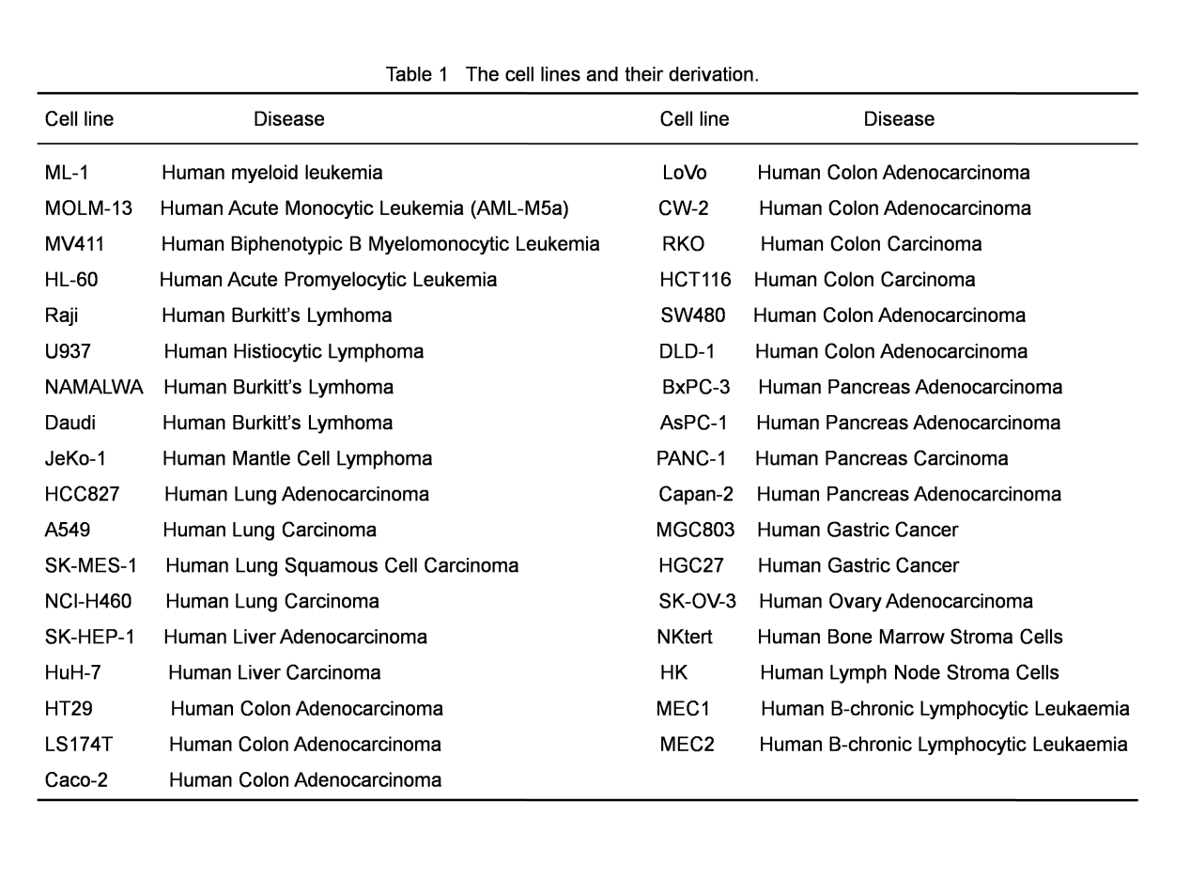
The primary lymphoma and lymphnoditis cells from lymph node biopsy samples were obtained from patients diagnosed with diffuse large B cell lymphoma, mantle cell lymphoma and lymphnoditis at Sun Yat-Sen University Cancer Center after proper informed consent. The fresh lymph node specimens were minced under sterile conditions, and cells were suspended in RPMI 1640 medium followed by filtration through a 70-μm cell strainer to remove tissue debris and cell clusters. The primary lymphoma and lymphnoditis cells were cultured in RPMI 1640 medium containing 10% FBS and penicillin-streptomycin.
Peripheral blood mononuclear cells (PBMCs) were isolated from blood samples of healthy adult donors using Ficoll-PaqueTM PLUS (GE Healthcare Bio-Sciences, Uppsala, Sweden) gradient centrifugation. Blood (15 mL) from healthy donors was diluted with equal volume of normal saline and the diluted mixture was then carefully layered on top of 20 mL Ficoll-PaqueTM PLUS in a 50 mL conical tube. After centrifugation at 400x g for 25 minutes, PBMCs located at the plasma-Ficoll-PaqueTM PLUS interface were transferred into a new 50 mL conical tube, washed three times with normal saline and cultured in RPMI 1640 medium containing 10% FBS.
Studies using human lymphoma samples were reviewed and approved by Committee for Ethical Review of Research involving Human Subjects of Sun Yat-Sen University.
MTS assay: Suspension cells (3-5×10⁴ cells per well) or adherent cells (2-7×10³ cells per well) were seeded in triplicate in 96-well plates. The cells were then exposed to AF for 72 hours. At the end of incubation, 20µL of MTS reagent was added and incubated at 37°C for 3 hours. Absorbance at 490nm was measured using a MultiSkan plate reader (Thermo, Helsinki, USA).
Transfection: Silencing of TrxR1 and TrxR2 expression in Raji cells and HCT116 cells by siRNA were performed using Neon Transfection System (Invitrogen Life Technologies) and Lipofectamine™ RNAiMAX Transfection Reagent. Raji cells at 10⁷/mL and siRNAs of TrxR1 and TrxR2 were mixed, the cell suspension was subjected to a single pulse of electroporation (1400V), and then cultured for 48 hours. HCT116 cells were seeded in 6-well plates at 2×10⁵ cells/well and incubated overnight to allow cell attachment. The cells were then transfected with a mixture of siRNAs against TrxR1 and TrxR2 using Opti-MEM and Lipofectamine™ RNAiMAX for 48 hours. A non-specific scramble siRNA was used as control.
Western blot analysis: Cells were harvested, washed with ice-cold PBS and lysed in lysis buffer (containing RIPA, phosphatase inhibitor and protease inhibitor) for 15 minutes on ice. Cell debris was removed by centrifugation at 12000x g for 15 minutes at 4°C. Protein lysates were analyzed by standard SDS-PAGE and then transferred to a nitrocellulose membrane. Protein bands of interest were revealed by blotting with respective antibodies.
Measurement of cellular Au content: Cells (1×10⁷) were incubated with AF for 2 hours, washed twice with PBS, and then re-suspended in 1 mL nitric acid, followed by incubation at 60°C for 1 hour. The samples were diluted in 9 mL double distilled water and the Au content was measured using Agilent 7500ce inductively coupled plasma mass spectrometry (ICP-MS).¹
Measurement of intracellular ATP: Cellular ATP content was determined using the ATP-based CellTiter-Glo luminescent Cell Viability kit (Promega, Madison, USA) according to the manufacturer’s instructions. 100μL cell suspension (1×10⁵/mL) were transferred in triplicate in 96-well plates and equal volume of detecting reagent provided by the ATP-based CellTiter-Glo luminescent Cell Viability kit was added to each well, rocked gently for 2 minutes and incubated at 37°C for 10 minutes. Luminescence was measured using a luminescent plate reader (Thermo, Helsinki, USA).
Assay for ROS generation by TrxR1: Human recombinant thioredoxin (Trx-1) and human thioredoxin reductase (TrxR1) were reconstituted in PBS at 1mg/mL. Working concentrations of 5 μg/mL and 2.5 μg/mL for Trx-1 and TrxR1 were used, respectively, in a reaction mix containing 50 μM NADPH, 20 μM Lucigenin with or without AF (25 μg/mL). The reaction mix was incubated at 37°C for 5 minutes following by incubation at room temperature in dark for 5 minutes, and the intensity of luminescence (indicative of ROS level) was measured by a TD20/20 luminometer (Turner BioSystems, Sunnyvale, CA).

Reference
1. Wu WJ, Zhang Y, Zeng ZL, et al. beta-phenylethyl isothiocyanate reverses platinum resistance by a GSH-dependent mechanism in cancer cells with epithelial-mesenchymal transition phenotype. Biochem Pharmacol. 2013; 85(4): 486-496.

