Supplemental Materials
Contents：
Figures S1 to S4
Table S1

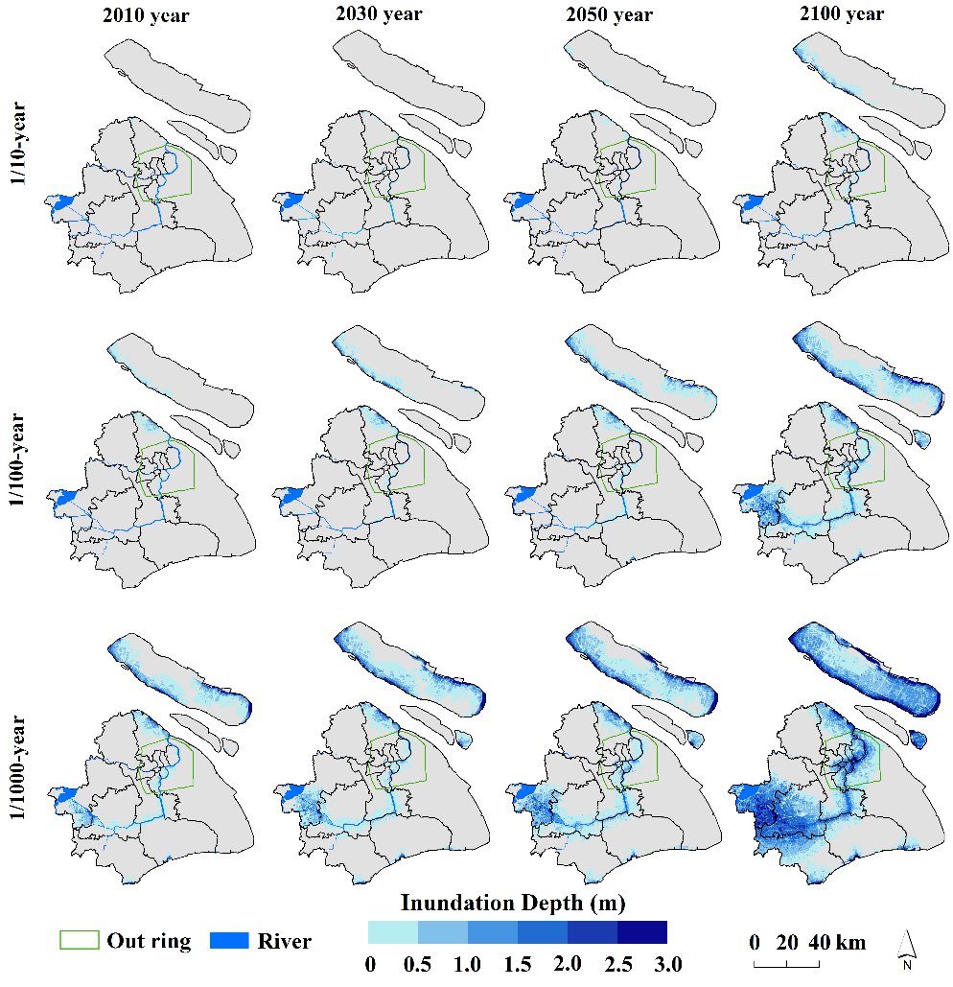
Fig. S1 Inundation maps with extent and maximum depth caused by extreme flooding as a function of return periods under the RCP2.6 scenario

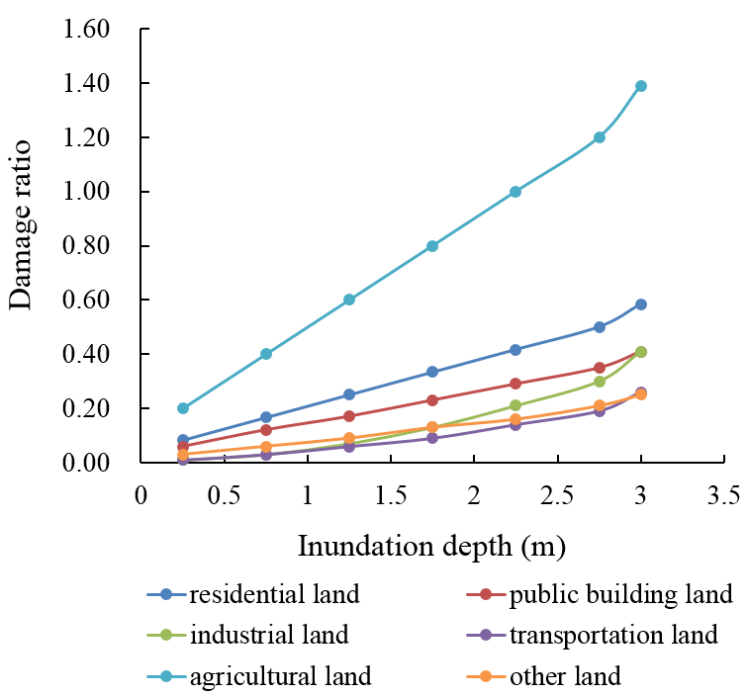
Fig.S2 Vulnerability curves of different land use types

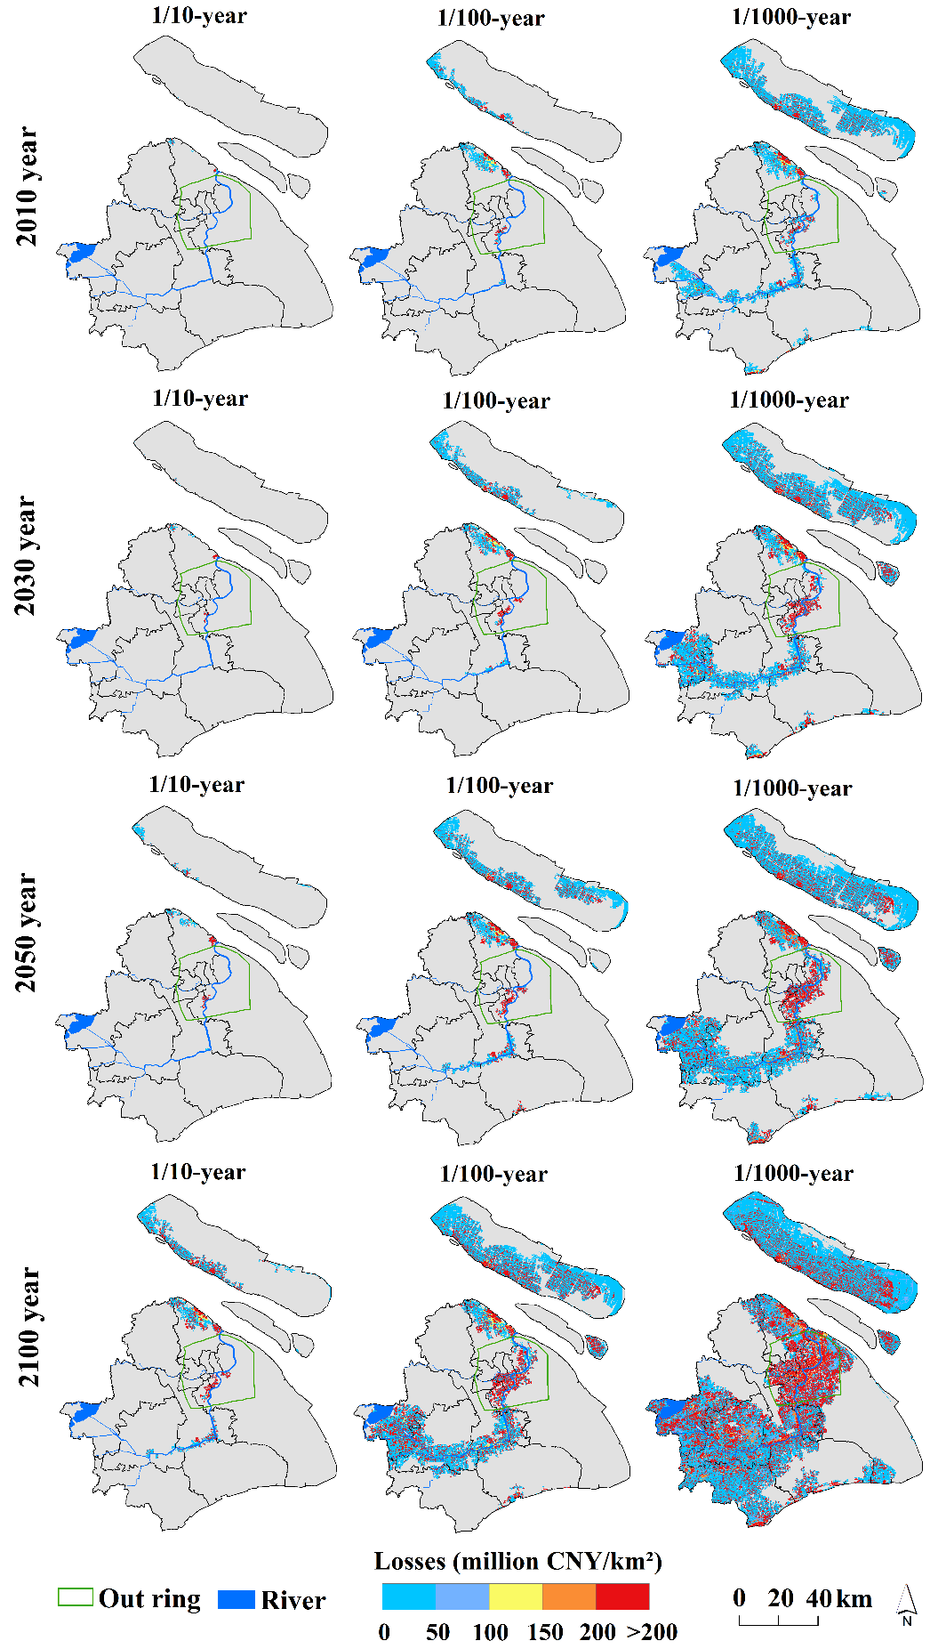
Fig. S3 Distribution of loss per unit area (increased land price) under the extreme storm flood scenarios in Shanghai under the RCP2.6 scenario

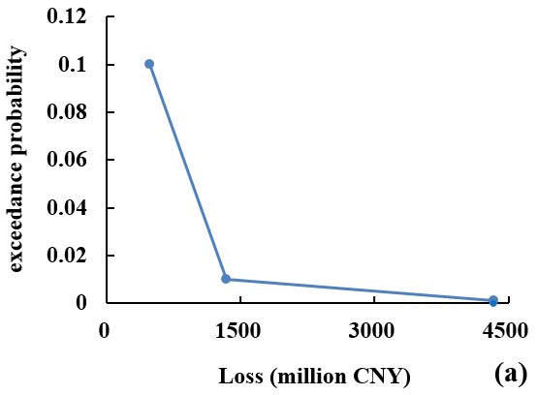 | 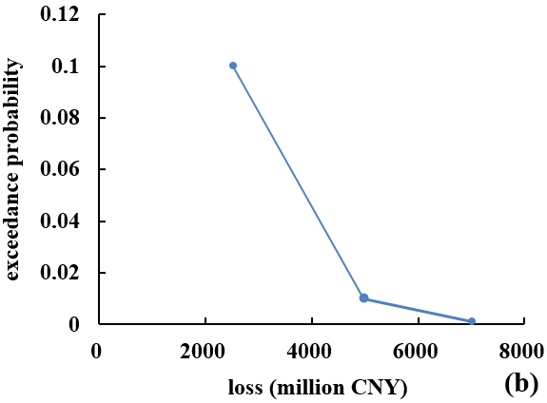 | 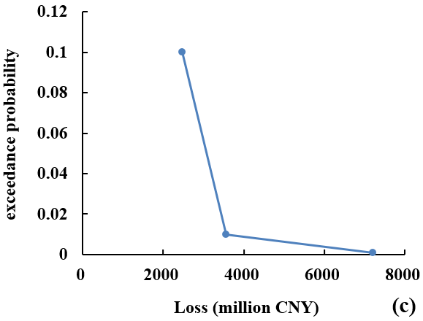
Fig. S4 Probability-loss curves of extreme storm flooding for land use in Shanghai in 2030(a), 2050(b), 2100(c) under RCP8.5 scenarios

Table S1 Expected annual damage (EAD) of land use under the RCP2.6 scenario (unit: million CNY)
 | year
 | 2010 | 2030 |  | 2050 |  | 2100
 |  | Land price unchanged | Land price rise | Land price unchanged | Land price rise | Land price unchanged | Land price rise
Residential land | 28.8 | 37.5 | 38.7 | 44.4 | 45.7 | 101.8 | 104.8
Industrial land | 22.0 | 15.8 | 16.3 | 21.9 | 22.5 | 68.7 | 70.8
Public building land | 21.7 | 40.2 | 41.4 | 46.8 | 48.2 | 107.8 | 111.0
Transportation land | 6.9 | 7.9 | 8.1 | 8.5 | 8.8 | 24.2 | 25.0
Agricultural land | 0.5 | 0.3 | 0.3 | 0.4 | 0.4 | 0.8 | 0.9
Other land | 12.6 | 9.5 | 9.8 | 10.2 | 10.5 | 24.1 | 24.8
Total | 92.4 | 111.3 | 114.6 | 132.1 | 136.1 | 327.5 | 337.3

