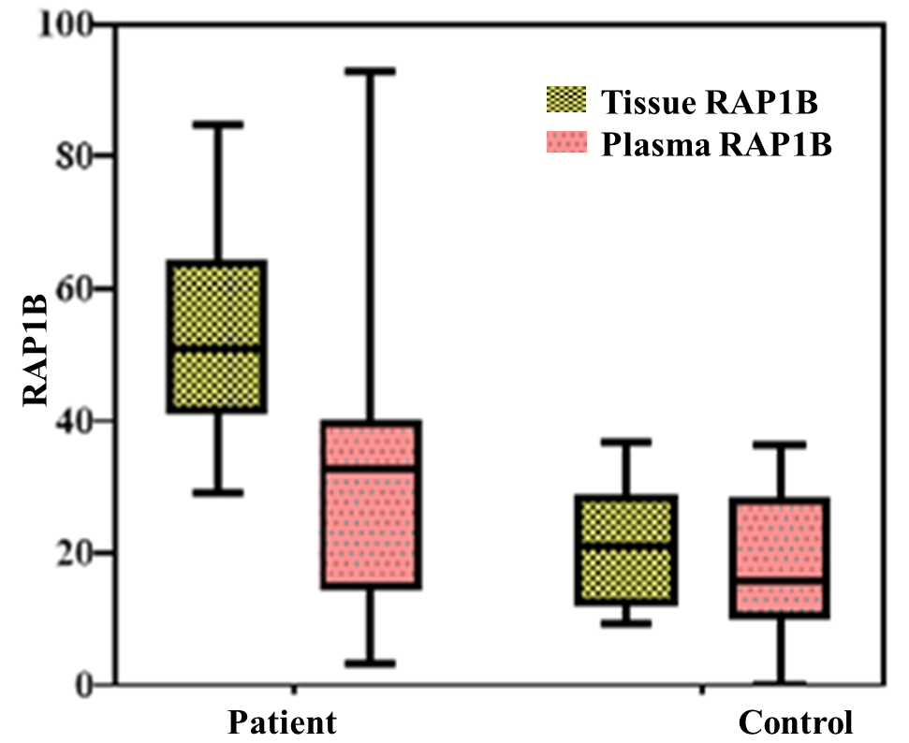

Supplementary Figure 1: Box plot of RAP-1b protein level in clinical samples.The median of RAP-1b concentration (ng/ml) for CRC patients were higher in plasma samples in comparison with those of control persons (32.67vs. 15.7, p=0.004) as well as in tissue specimens (51 vs. 21, p (<0. 001).

