Supplementary information for

Highly Selective Synthesis of Interlocked Carbazole-based Cages and their Application in Effective Solar-driven Water Evaporation
Ming-Yu Lu^{1,2}, Jian-Xin Yang¹, Ya-Ning Xu³, Yin-Hang Chai¹, Xiao-Qian Wan¹, Ying Zhao^{1,}*, Dan Tian^{3,}*, Francisco Aznarez¹, Li-Long Dang^{1,2}*, and Lu-Fang Ma^{1,2}

¹College of Chemistry and Chemical Engineering, Luoyang Normal University, Luoyang 471934, P. R. China. These authors contributed equally: Ming-Yu Lu, Jian-Xin Yang, Ya-Ning Xu.
²College of Chemistry, Zhengzhou University, Zhengzhou 450001, P. R. China.
³Co-Innovation Center of Efficient Processing and Utilization of Forest Resources, College of Materials Science and Engineering, Nanjing Forestry University, Nanjing 210037, P. R. China.
*E-mail: zhaoyingchem@126.com, tiandan@njfu.edu.cn and danglilong8@163.com
Contents
- General considerations 2
- Synthesis and experimental methods 2
- NMR spectra 7
- Near-infrared photothermal conversion research 17
- Water contact test 26
- X-ray crystallography details 26
- References 31

- General considerations
All reagents and solvents were purchased from commercial sources and used as supplied unless otherwise mentioned. The starting materials [Cp*RhCl₂]₂ (Cp* = η5-pentamethylcyclopentadienyl) were prepared by literature methods.^{1,2} NMR spectra were recorded on Bruker AVANCE I 400 spectrometers at room temperature and referenced to the residual protonated solvent. Proton chemical shifts are reported relative to the solvent residual peak (δ H = 3.31 (CD₃OD)). Coupling constants are expressed in Hertz. Elemental analyses were performed on an Elementar Vario EL III analyzer.

- Synthesis of compounds 1, 2, 3, 4, 5, 6, 7, 8
2.1. Preparation of compound 1 (Molecular-tweezer-like 1)
IIn order to synthesize building block E1, add AgOTf (30.8 mg, 0.12 mmol) and [Cp*RhCl₂]₂ (18.5 mg, 0.03 mmol) to a (3 mL) methanol . The container containing the mixture was sealed in tin foil and stirred at room temperature for several hours, then the white AgCl precipitate was filtered out by centrifuthe supernatant. Then 2,5-dihydroxycyclohexa-2,5-diene-1,4-dione (16.8 mg, 0.03 mmol) and NaOH (2.4 mg, 0.06 mmol) were added to the filtrate. Then the mixed solution was stirred at room temperature for 8 h to give a earthy brown solution. Building block E1 was obtained. L1 (9.6 mg, 0.03 mmol) was added to the solution. The mixture was stirred at room temperature for another 8 h to give a dark earthy brown solution. Finally, the single crystals were grown by liquid diffusion, and the nonpolar solvent ether was added to the mixed solution of methanol and acetontrile,. The product was recrystallized from a diethyl ether mixture to afford earthy brown block-shaped crystals (1). Elemental analysis Calcd for C₂₀₀H₁₈₈O₄₀N₁₂F₂₄S₈Rh₈ (Mr=4935.43 ): C, 48.67; H, 3.84; N, 3.41. Found: C, 48.47; H, 3.74; N, 3.31. ¹H NMR (500 MHz, CD₃OD, ppm, with respect to Cp*Rh): δ = 8.08 (d, 2H, J = 3.5 Hz, pyridyl-H_{a}), δ = 7.51 (d, 2H, J = 2.0 Hz, pyridyl-H_{b}), δ = 7.18 (d, 1H, J = 8.5 Hz, carbazolyl-H_{d}), δ = 6.78 (d, 1H, J = 7.0 Hz, carbazolyl-H_{c}), δ = 6.69 (s, 1H, carbazolyl-H_{e}), δ = 5.97 (s, 1H, benzoquinonyl-H_{f}), δ = 1.83 (s, 15H, Cp*-H_{g}).
2.2. Preparation of compound 2 (Molecular-tweezer-like 2)
In order to synthesize building block E2, add AgOTf (30.8 mg, 0.12 mmol) and [Cp*RhCl₂]₂ (18.5 mg, 0.03 mmol) to a (3 mL) methanol . The container containing the mixture was sealed in tin foil and stirred at room temperature for several hours, then the white AgCl precipitate was filtered out by centrifuthe supernatant. Then 5,8-dihydroxynaphthalene-1,4-dione (5.7 mg, 0.03 mmol) and NaOH (2.4 mg, 0.06 mmol) were added to the filtrate. Then the mixed solution was stirred at room temperature for 8 h to give a green solution. Building block E1 was obtained. L1 (9.6 mg, 0.03 mmol) was added to the solution. The mixture was stirred at room temperature for another 8 h to give a dark green solution. Finally, the single crystals were grown by liquid diffusion, and the nonpolar solvent ether was added to the solution of methanol.The product was recrystallized from a diethyl ether mixture to afford green block-shaped crystals (2). Elemental analysis Calcd for C₂₁₆H₁₉₆O₄₀N₁₂F₂₄S₈Rh₈ (Mr=5135.67): C, 50.52; H, 3.85; N, 3.27. Found: C, 50.32; H, 3.75; N, 3.17. ¹H NMR (500 MHz, CD₃OD, ppm, with respect to Cp*Rh): δ = 8.30 (d, 2H, J = 6.0 Hz, pyridyl-H_{a}), δ = 7.51 (d, 2H, J = 6.5 Hz, pyridyl-H_{b}), δ = 7.72 (d, 1H, J = 4.5 Hz, carbazolyl-H_{d}), δ = 7.48 (s, 1H, carbazolyl-H_{e}), δ = 7.27 (d, 1H, J = 9.5 Hz, carbazolyl-H_{c}), δ = 6.44 (d, 2H, naphthyl -H_{f}), δ = 1.64 (s, 15H, Cp*-H_{g}).
2.3. Preparation of compound 3 (Molecular-tweezer-like 3)
The first step is to add AgOTf (30.8 mg, 0.12 mmol) and [Cp*RhCl₂]₂ (18.5 mg, 0.03 mmol) to a (3 mL) methanol. The container containing the mixture was sealed in tin foil and stirred at room temperature for several hours, then the white AgCl precipitate was filtered out by centrifuthe supernatant.Subsequently 2,5-dibromo-3,6-dihydroxycyclohexa-2,5-diene-1,4-dione (8.93 mg, 0.03 mmol) and NaOH (2.4 mg, 0.06 mmol) were added to the filtrate. Then the mixed solution was stirred at room temperature for 8 h to give a brown solution, which contains building block E3. A suitable pyridine ligand L1 (9.6 mg, 0.03 mmol) was added to the solution. The mixture was stirred at room temperature for another 8 h to give a dark brown solution. In the end, upon the addition of isopropyl ether, a dark brown solid was precipitated and collected. The product was recrystallized from a diethyl ether mixture to afford dark brown block-shaped crystals (3). Elemental analysis Calcd for C₂₀₀H₁₈₀O₂₄N₁₂Br₈F₂₄S₈Rh₈ (M = 5130.62): C, 45.23; H, 3.42; N, 3.17. Found: C, 45.13; H, 3.32; N, 3.06. ¹H NMR (500 MHz, CD₃OD, ppm, with respect to Cp*Rh): δ = 8.13 (d, 2H, J = 16.5 Hz, pyridyl-H_{a}), δ = 7.56 (d, 2H, J = 23.5 Hz, pyridyl-H_{b}), δ = 7.18 (d, 1H, J = 60.0 Hz, carbazolyl-H_{d}), δ = 6.77 (d, 1H, J = 35.0 Hz, carbazolyl-H_{c}), δ = 5.96 (s, 1H, carbazolyl-H_{e}), δ = 1.71 (s, 15H, Cp*-H_{g}).
2.4. Preparation of compound 4 (Tetranuclear macrocycle 4)
The first step is to add AgOTf (30.8 mg, 0.12 mmol) and [Cp*RhCl₂]₂ (18.5 mg, 0.03 mmol) to a (3 mL) methanol . The container containing the mixture was sealed in tin foil and stirred at room temperature for several hours, then the white AgCl precipitate was filtered out by centrifuthe supernatant.Subsequently 2-(1H-benziMidazol-2-yl)-1H-benziMidazole (7.03 mg, 0.03 mmol) and NaOH (2.4 mg, 0.06 mmol) were added to the filtrate. Then the mixed solution was stirred at room temperature for 8 h to give a yellow solution, which contains building block E4. A suitable pyridine ligand L1 (9.6 mg, 0.03 mmol) was added to the solution. The mixture was stirred at room temperature for another 8 h to give a dark yellow solution. In the end, upon the addition of isopropyl ether, a dark yellow brown solid was precipitated and collected. The product was recrystallized from a diethyl ether mixture to afford dark yellow brown block-shaped crystals (4). Elemental analysis Calcd for C₁₁₆H₁₁₈O₁₂N₁₄F₁₂S₄Rh₄ (M =2668.15): C, 52.22; H, 4.46; N, 7.35. Found: C, 52.12; H, 4.36; N, 7.25.
2.5. Preparation of compound 5 (Interlocked cage 5)
Firstly, AgOTf (30.8 mg, 0.12 mmol) and [Cp*RhCl₂]₂ (18.5 mg, 0.03 mmol) were added to (3 ml) methanol at room temperature. The container containing the mixture was sealed in tin foil and stirred at room temperature for several hours, then the white AgCl precipitate was filtered out by centrifuthe supernatant. Then 2,5-dihydroxycyclohexa-2,5-diene-1,4-dione (16.8 mg, 0.03 mmol) and NaOH (2.4 mg, 0.06 mmol) were added to the filtrate. Secondly, the mixed solution was stirred at room temperature for 8 h to give a earthy brown solution.Building block E1 was obtained. L2 (9.49 mg, 0.02 mmol) was added to the solution. The mixture was stirred at room temperature for another 8 h to give a dark earthy brown solution. In the end, upon the addition of diethyl ether, a dark earthy solid was precipitated and collected. The product was recrystallized from a diethyl ether mixture to afford dark earthy brown block-shaped crystals (5). Elemental analysis Calcd for C₃₀₀H₂₈₀O₆₀N₁₆F₃₆S₁₂Rh₁₂ (M = 7373.12): C, 48.87; H, 3.83; N, 3.04. Found: C, 48.67; H, 3.73; N, 2.89. ¹H NMR (500 MHz, CD₃OD, ppm, with respect to Cp*Rh): δ = 8.71 (d, 2H, J = 5.5 Hz, pyridyl-H_{a}), δ = 8.54 (d, 2H, J = 5.5 Hz, pyridyl-H_{i}), δ = 8.14 (d, 2H, J = 5.0 Hz, pyridyl-H_{b}), δ = 8.02 (s, 1H, carbazolyl-H_{e}), δ = 7.95 (d, 2H, J = 5.5 Hz, carbazolyl-H_{h}), δ = 7.57 (d, 2H, J = 5.0 Hz, phenyl-H_{f}), δ = 7.24 (d, 2H, J = 9.0 Hz, phenyl-H_{g}), δ = 6.90 (d, 1H, J = 5.0 Hz, carbazolyl-H_{d}), δ = 6.35 (d, 1H, J = 8.5 Hz, carbazolyl-H_{c}), δ = 6.04 (s, 1H, benzoquinonyl-H_{k}), δ = 1.85 (s, 15H, Cp*-H_{j}).
2.6. Preparation of compound 6 (Interlocked cage 6)
Firstly, AgOTf (30.8 mg, 0.12 mmol) and [Cp*RhCl₂]₂ (18.5 mg, 0.03 mmol) were added to (3 ml) methanol at room temperature. The container containing the mixture was sealed in tin foil and stirred at room temperature for several hours, then the white AgCl precipitate was filtered out by centrifuthe supernatant. Then 5,8-dihydroxynaphthalene-1,4-dione (5.7 mg, 0.03 mmol) and NaOH (2.4 mg, 0.06 mmol) were added to the filtrate. Secondly, the mixed solution was stirred at room temperature for 8 h to give a green solution. Building block E2 was obtained. L2 (9.49 mg, 0.02 mmol) was added to the solution. The mixture was stirred at room temperature for another 8 h to give a dark green solution. In the end, upon the addition of diethyl ether, a dark green solid was precipitated and collected. The product was recrystallized from a diethyl ether mixture to afford dark green block-shaped crystals (6). Elemental analysis Calcd for C₃₁₂H₂₉₂O₆₀N₁₆F₃₆S₁₂Rh₁₂ (M =7529.35): C, 49.77; H, 3.91; N, 2.98. Found: C, 49.64; H, 3.83; N, 2.87. ¹H NMR (500 MHz, CD₃OD, ppm, with respect to Cp*Rh): δ = 8.75 (d, 2H, J = 5.0 Hz, pyridyl-H_{a}), δ = 8.56 (d, 2H, J = 7.0 Hz, pyridyl-H_{i}), δ = 8.15 (d, 2H, J = 1.5 Hz, pyridyl-H_{b}), δ = 7.94 (d, 2H, J = 9.0 Hz, carbazolyl-H_{h}), δ = 7.72 (d, 2H, J = 5.5 Hz, phenyl-H_{f}), δ = 6.44 (d, 2H, naphthyl -H_{k}), δ = 7.50 (d, 2H, J = 10.0 Hz, phenyl-H_{g}), δ = 6.63 (d, 1H, J = 8.0 Hz, carbazolyl-H_{d}), δ = 6.59 (s, 1H, carbazolyl-H_{e}), δ = 6.03 (d, 1H, J = 8.0 Hz, carbazolyl-H_{c}), δ = 6.04 (s, 1H, benzoquinonyl-H_{k}), δ = 1.77 (s, 15H, Cp*-H_{j}).
2.7. Preparation of compound 7 (Interlocked cage 7)
Firstly, an appropriate weight of AgOTf (30.8 mg, 0.12 mmol) and [Cp*RhCl₂]₂ (18.5 mg, 0.03 mmol) were added into a 3mL methanol solution and stirred at room temperature and away from light for 8 h. Stop stirring until a large amount of white precipitate appears, and remove the precipitate, reserving the filtrate. Subsequently 2,5-dibromo-3,6-dihydroxycyclohexa-2,5-diene-1,4-dione (8.93 mg, 0.03 mmol) and NaOH (2.4 mg, 0.06 mmol) were added to the filtrate. Then the mixed solution was stirred at room temperature for 8 h to give a dark brown solution, which contains building block E3. L2 (9.49 mg, 0.02 mmol) was added to the solution. The mixture was stirred at room temperature for another 8 h to give a dark dark brown solution. Then, upon the addition of diethyl ether, a dark brown solid was precipitated and collected. The product was recrystallized from a diethyl ether to afford complex (7). Elemental analysis Calcd for C₃₀₀H₂₆₈O₆₀N₁₆F₃₆S₁₂Br₁₂Rh₁₂ (M = 8319.87): C, 43.31; H, 3.25; N, 2.69. Found: C, 43.21; H, 3.15; N, 2.59. ¹H NMR (500 MHz, CD₃OD, ppm, with respect to Cp*Rh): δ = 8.64 (d, 2H, J = 6.0 Hz, pyridyl-H_{a}), δ = 8.46 (d, 2H, J = 6.0 Hz, pyridyl-H_{i}), δ = 8.09 (d, 2H, J = 4.0 Hz, pyridyl-H_{b}), δ = 8.15 (d, 2H, J = 6.5 Hz, carbazolyl-H_{h}), δ = 8.04 (s, 1H, carbazolyl-H_{e}), δ = 7.88 (d, 2H, J = 8.0 Hz, phenyl-H_{f}), δ = 6.51 (d, 2H, J = 8.0 Hz, phenyl-H_{g}), δ = 6.26 (d, 1H, J = 8.5 Hz, carbazolyl-H_{d}), δ = 5.50 (d, 1H, J = 9.0 Hz, carbazolyl-H_{c}), δ = 1.93 (s, 15H, Cp*-H_{j}).
2.8. Preparation of compound 8 (Hexanuclear cage 8)
Firstly, an appropriate weight of AgOTf (30.8 mg, 0.12 mmol) and [Cp*RhCl₂]₂ (18.5 mg, 0.03 mmol) were added into a 3ml methanol solution and stirred at room temperature and away from light for 8 h. Stop stirring until a large amount of white precipitate appears, and remove the precipitate, reserving the filtrate. Subsequently 2-(1H-benziMidazol-2-yl)-1H-benziMidazole (7.03 mg, 0.03 mmol) and NaOH (2.4 mg, 0.06 mmol) were added to the filtrate. Then the mixed solution was stirred at room temperature for 8 h to give a yellow solution, which contains building block E4. L2 (9.49 mg, 0.02 mmol) was added to the solution. The mixture was stirred at room temperature for another 8 h to give a dark yellow solution. Then, upon the addition of diethyl ether, a dark yellow solid was precipitated and collected. The product was recrystallized from a diethyl ether mixture to afford complex (8). Elemental analysis Calcd for C₁₈₂H₁₈₂N₂₀F₁₈S₆O₁₈Rh₆ (M = 4089.34): C, 53.46; H, 4.49; N, 6.85. Found: C, 53.36; H, 4.39; N, 6.75. ¹H NMR (500 MHz, CD₃OD, ppm, with respect to Cp*Rh): δ = 8.23 (d, 2H, J = 5.5 Hz, pyridyl-H_{a}), δ = 8.16 (d, 2H, J = 6.5 Hz, pyridyl-H_{i}), δ = 8.02 (d, 2H, J = 5.5 Hz, phenyl-H_{k}), δ = 7.72 (d, 2H, J = 6.5 Hz, pyridyl-H_{b}), δ = 7.60 (d, 2H, J = 4.5 Hz, carbazolyl-H_{h}), δ = 7.58 (d, 2H, J = 5.5 Hz, phenyl-H_{l}), δ = 7.29 (s, 1H, carbazolyl-H_{e}), δ = 7.92 (d, 2H, J = 6.5 Hz, phenyl-H_{f}), δ = 7.31 (d, 2H, J = 6.5 Hz, phenyl-H_{g}), δ = 7.22 (d, 1H, J = 8.0 Hz, carbazolyl-H_{d}), δ = 7.11 (d, 1H, J = 8.5 Hz, carbazolyl-H_{c}), δ = 1.93 (s, 15H, Cp*-H_{j}).

- NMR Spectra
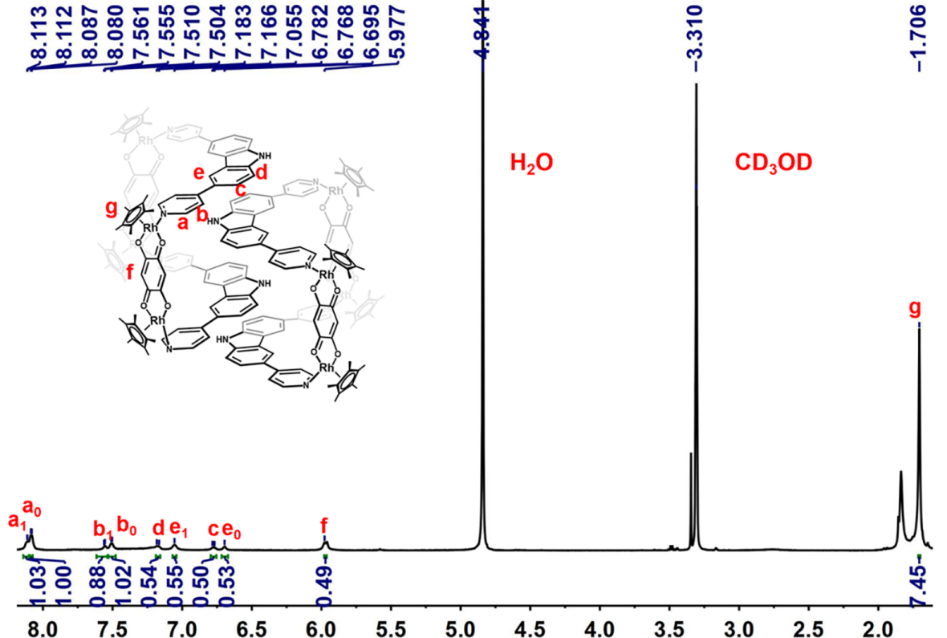
Supplementary Figure 1. The ¹H NMR (500 MHz, CD₃OD, ppm) for Molecular-tweezer-like 1 (24.5 mM, with respect to Cp*Rh).

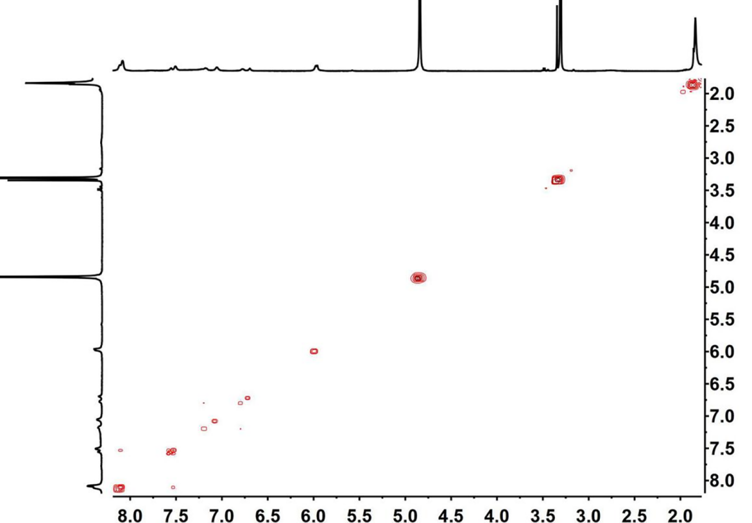
Supplementary Figure 2. The ¹H-¹H COSY NMR (500 MHz, CD₃OD, ppm) for Molecular-tweezer-like 1 (24.5 mM, with respect to Cp*Rh).

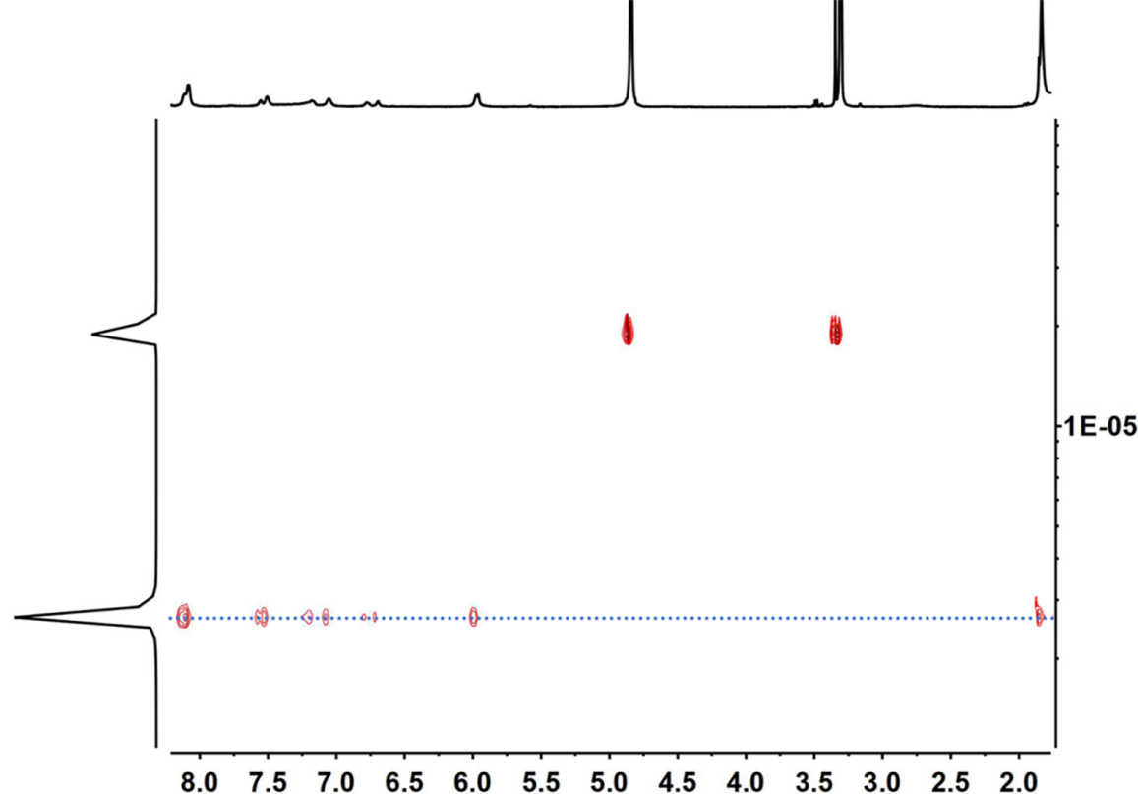
Supplementary Figure 3. The ¹H DOSY NMR (500 MHz, CD₃OD, ppm) for Molecular-tweezer-like 1 (2.59 × 10⁻⁶ cm²/s) (24.5 mM, with respect to Cp*Rh).

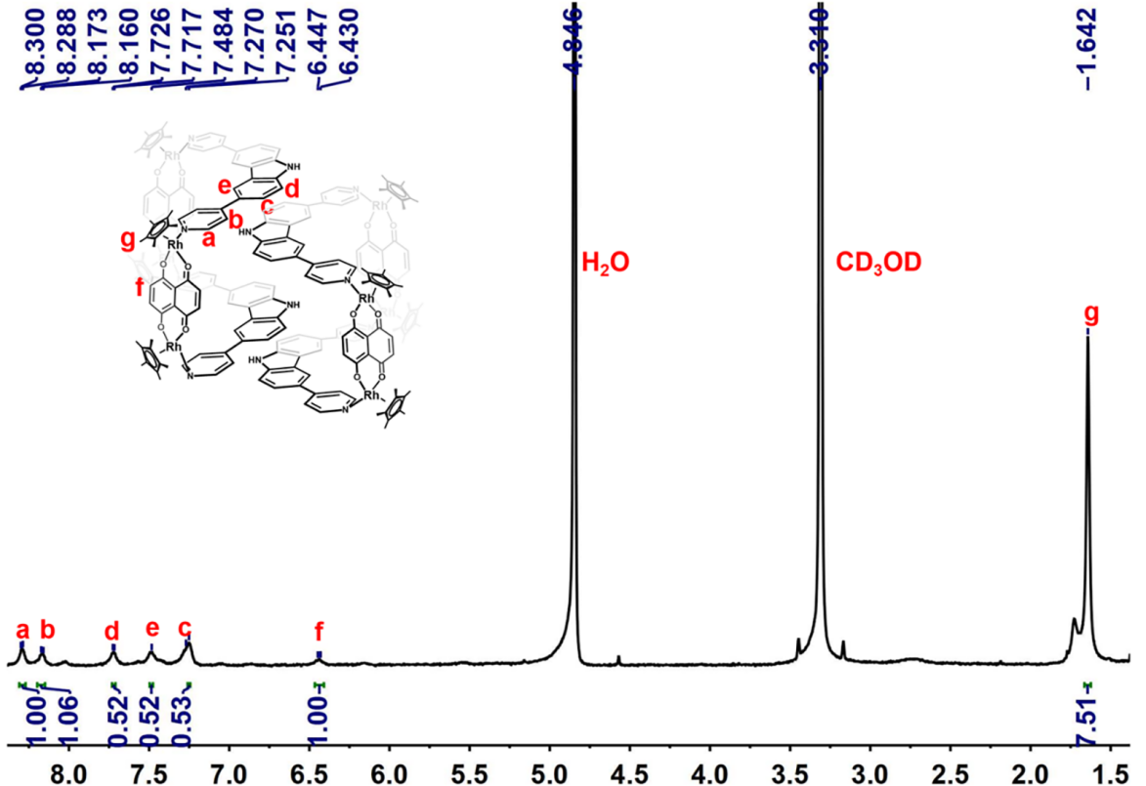
Supplementary Figure 4. The ¹H NMR (500 MHz, CD₃OD, ppm) for Molecular-tweezer-like 2 (24.5 mM, with respect to Cp*Rh).
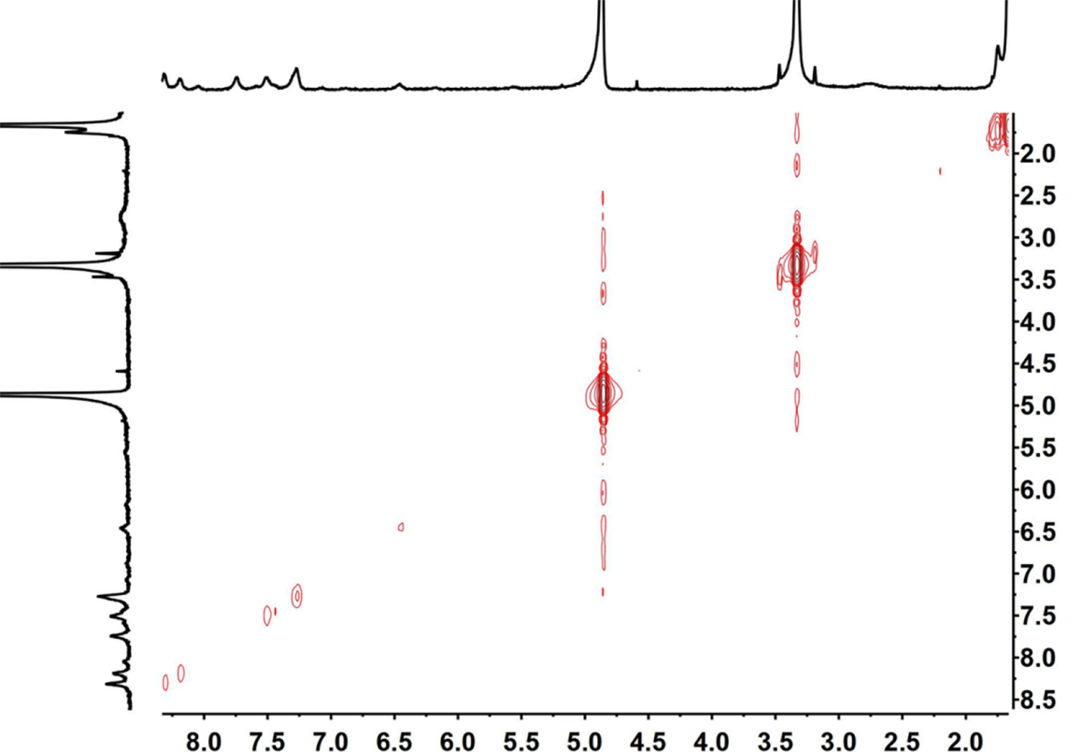
Supplementary Figure 5. The ¹H-¹H COSY NMR (500 MHz, CD₃OD, ppm) for Molecular-tweezer-like 2 (24.5 mM, with respect to Cp*Rh).

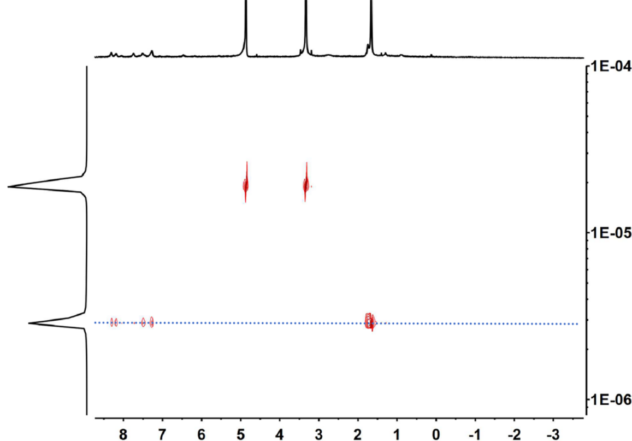
Supplementary Figure 6. The ¹H DOSY NMR (500 MHz, CD₃OD, ppm) for Molecular-tweezer-like 2 (2.65 × 10⁻⁶ cm²/s) (24.5 mM, with respect to Cp*Rh).
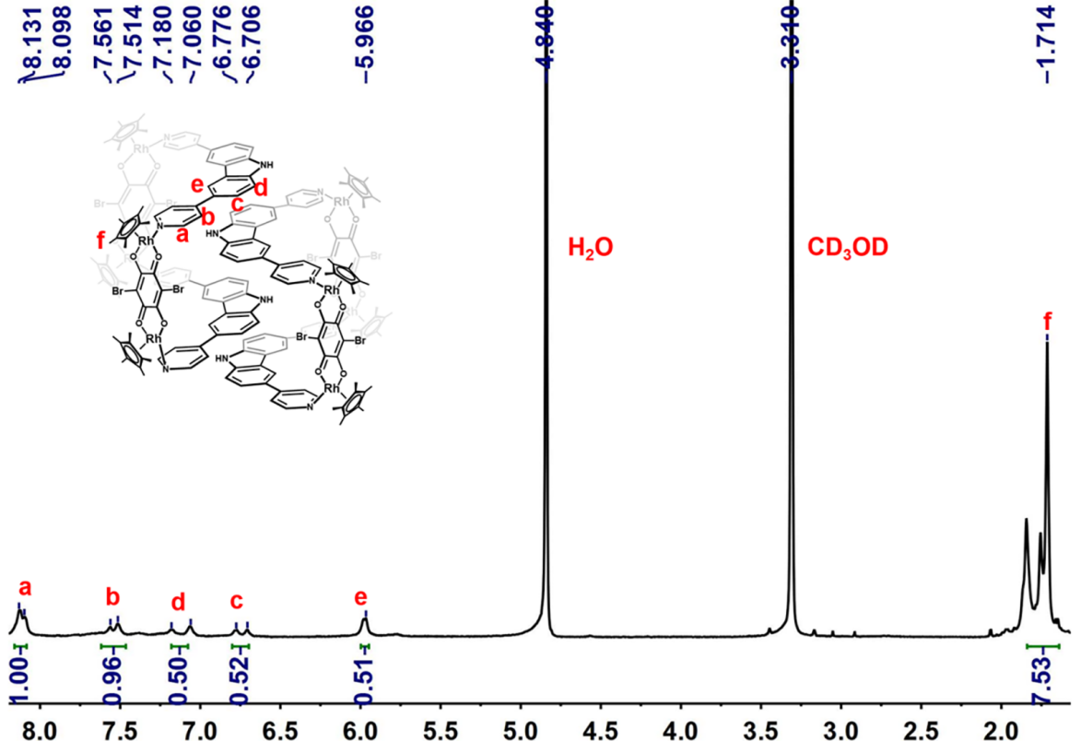
Supplementary Figure 7. The ¹H NMR (500 MHz, CD₃OD, ppm) for Molecular-tweezer-like 3 (24.5 mM, with respect to Cp*Rh).

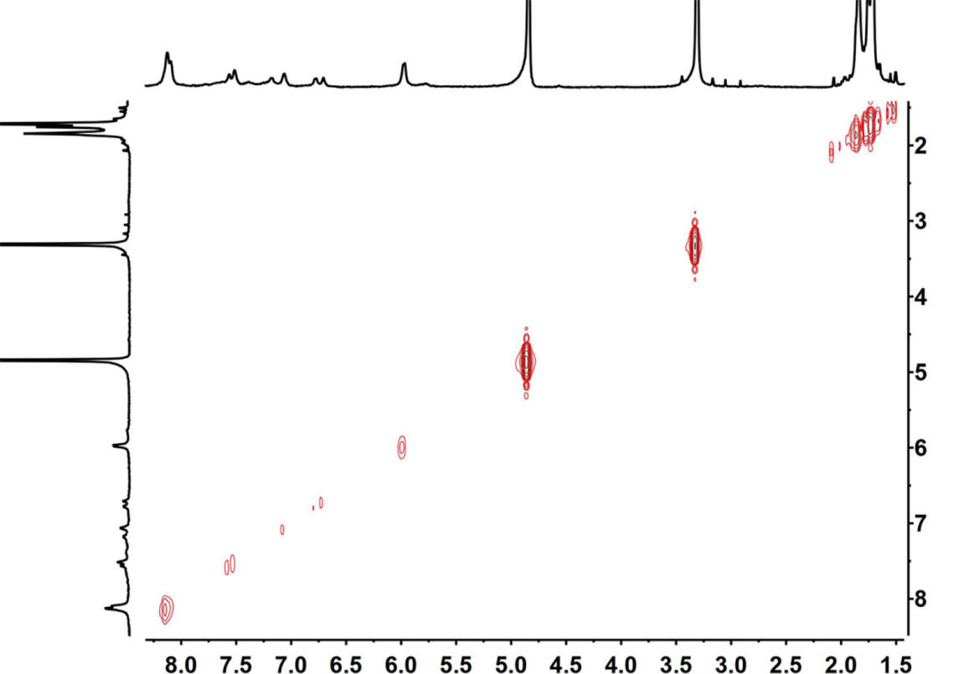
Supplementary Figure 8. The ¹H-¹H COSY NMR (500 MHz, CD₃OD, ppm) for Molecular-tweezer-like 3 (24.5 mM, with respect to Cp*Rh).

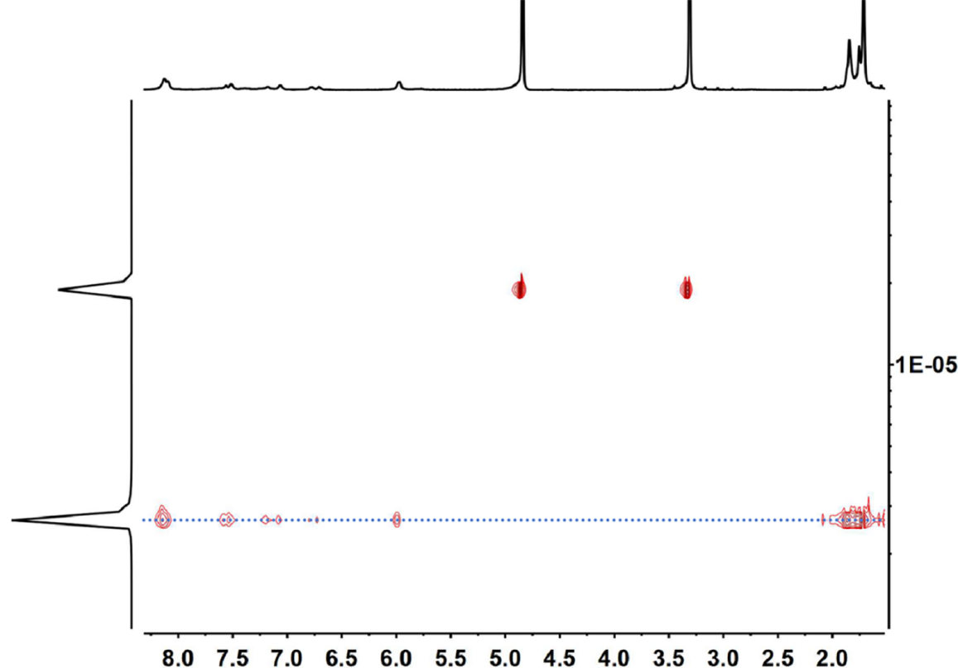
Supplementary Figure 9. The ¹H DOSY NMR (500 MHz, CD₃OD, ppm) for Molecular-tweezer-like 3 (2.49 × 10⁻⁶ cm²/s) (24.5 mM, with respect to Cp*Rh).

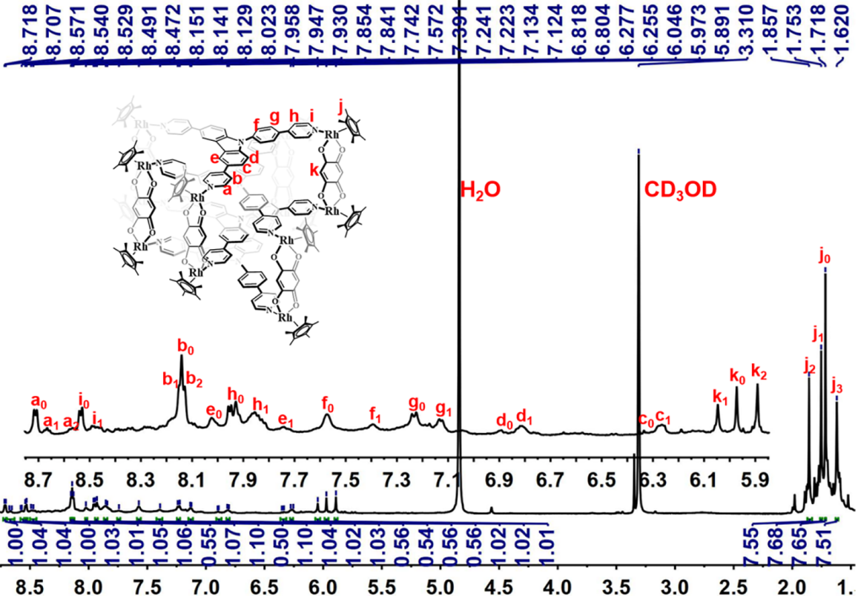
Supplementary Figure 10. The ¹H NMR (500 MHz, CD₃OD, ppm) for Interlocked cage 5 (19.5 mM, with respect to Cp*Rh).
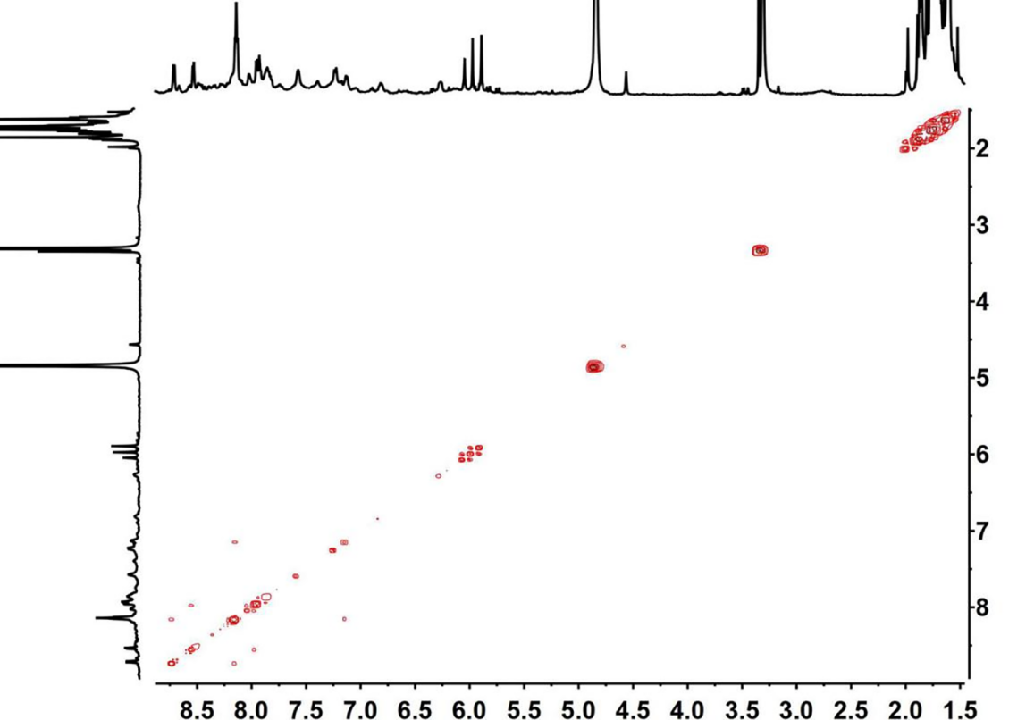
Supplementary Figure 11. The ¹H-¹H COSY NMR (500 MHz, CD₃OD, ppm) for Interlocked cage 5 (19.5 mM, with respect to Cp*Rh).

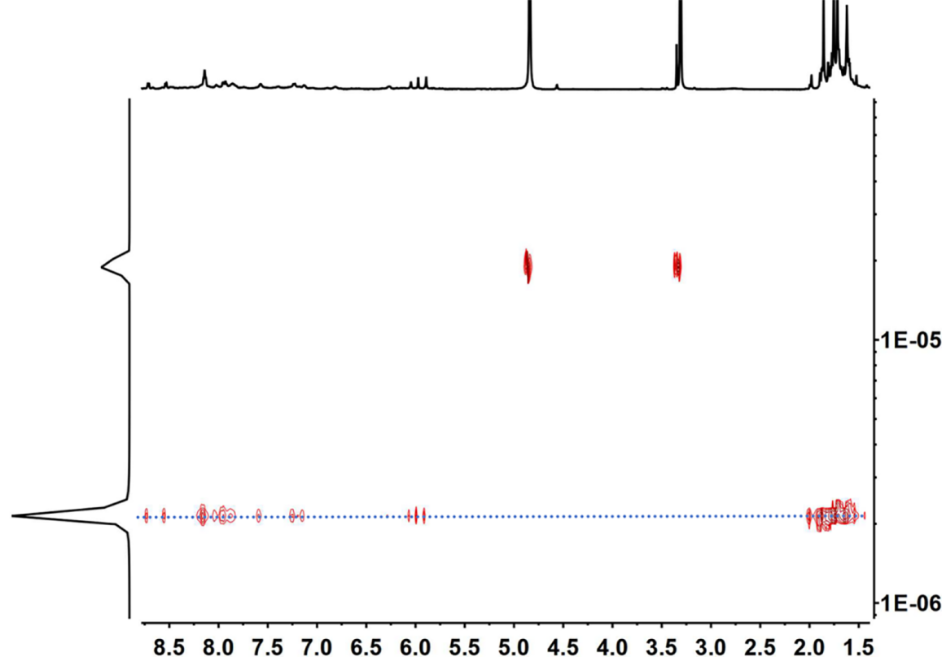
Supplementary Figure 12. The ¹H DOSY NMR (500 MHz, CD₃OD, ppm) for Interlocked cage 5 (2.05 × 10⁻⁶ cm²/s) (19.5 mM, with respect to Cp*Rh).
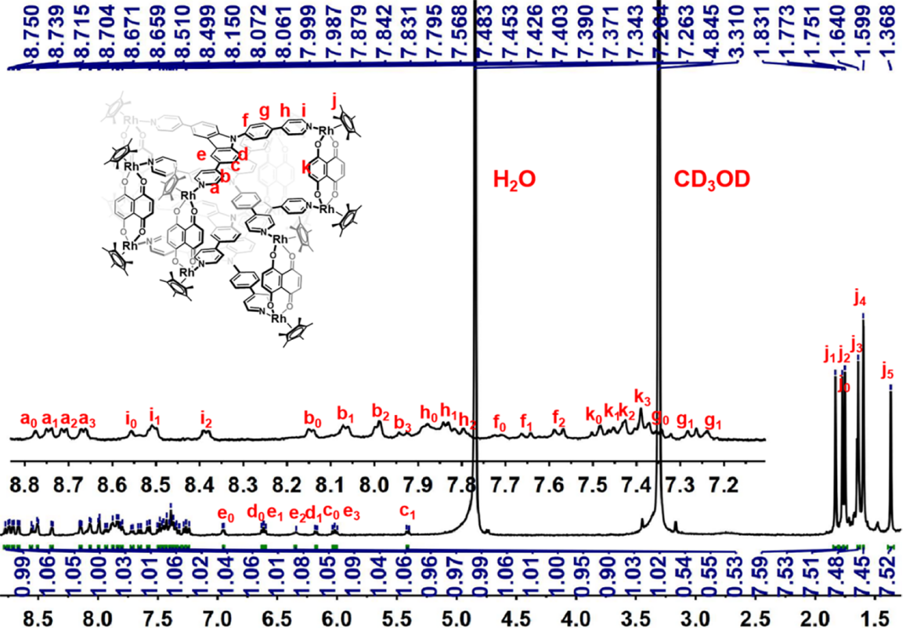
Supplementary Figure 13. The ¹H NMR (500 MHz, CD₃OD, ppm) for Interlocked cage 6 (19.5 mM, with respect to Cp*Rh).

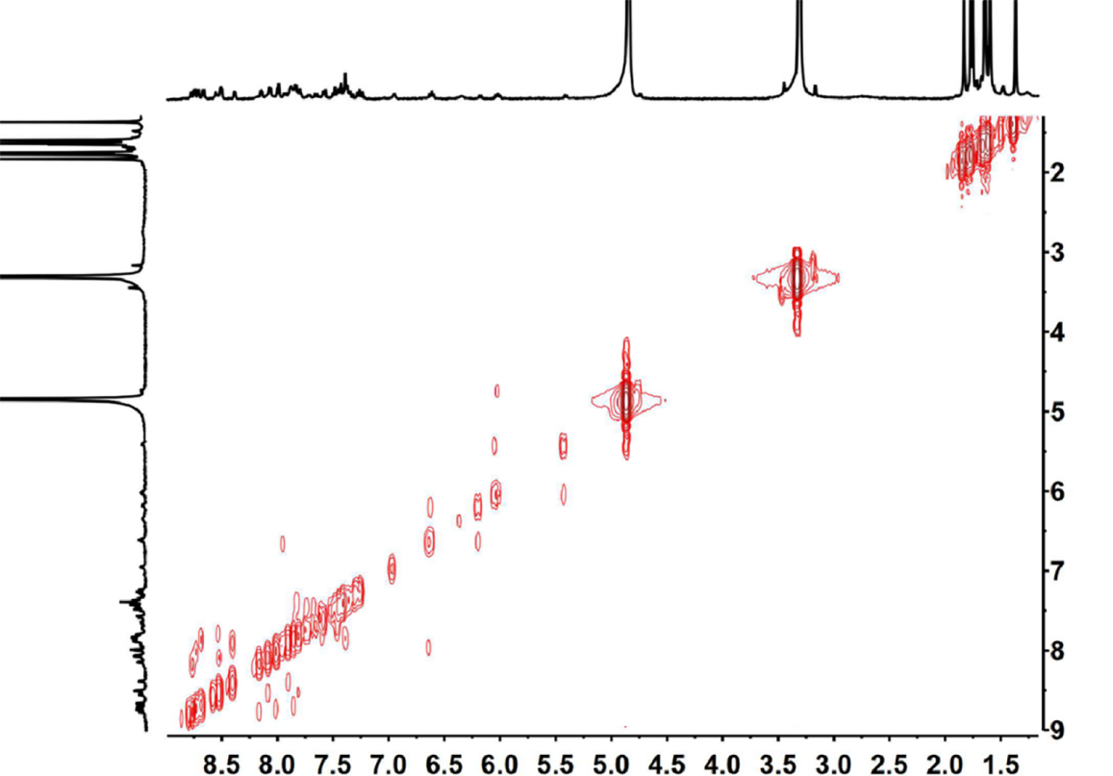
Supplementary Figure 14. The ¹H-¹H COSY NMR (500 MHz, CD₃OD, ppm) for Interlocked cage 6 (19.5 mM, with respect to Cp*Rh).

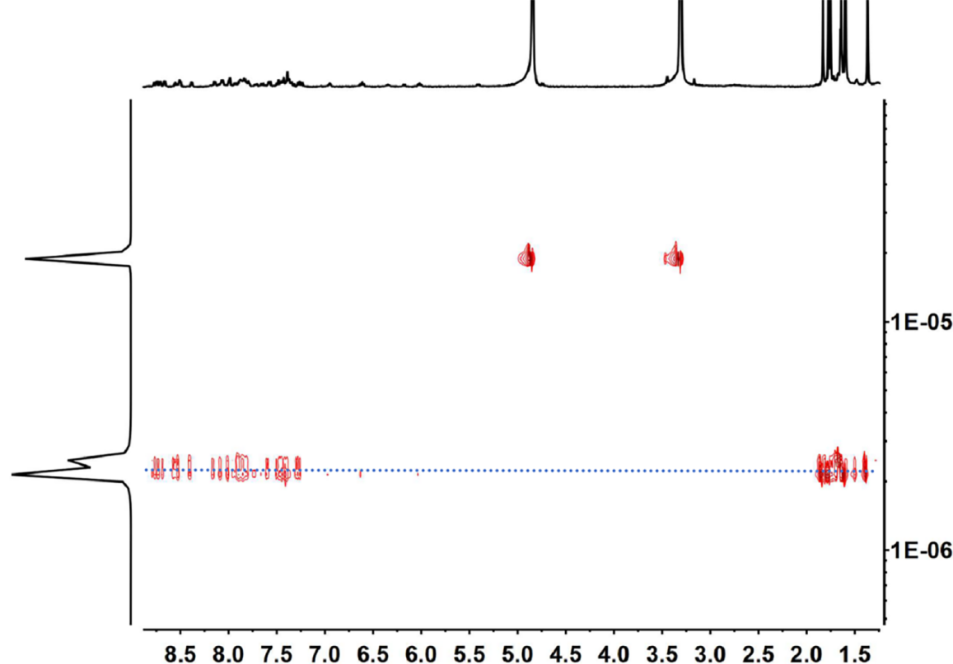
Supplementary Figure 15. The ¹H DOSY NMR (500 MHz, CD₃OD, ppm) for Interlocked cage 6 (2.05 × 10⁻⁶ cm²/s) (19.5 mM, with respect to Cp*Rh).

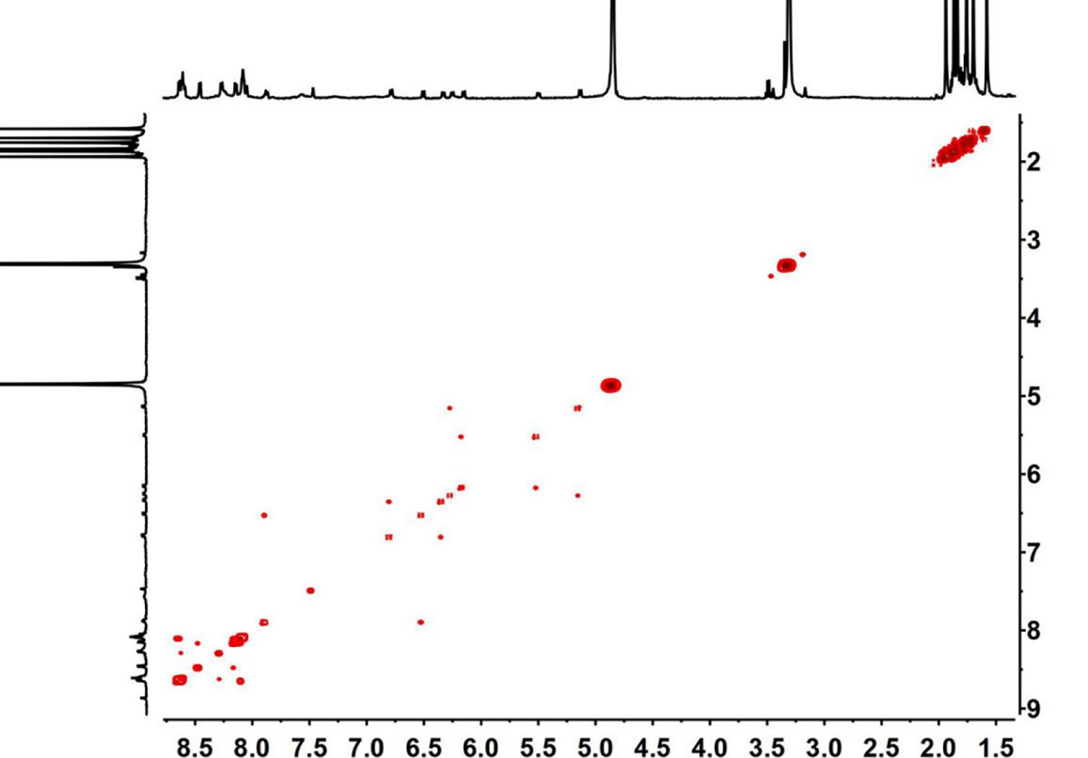
Supplementary Figure 16. The ¹H-¹H COSY NMR (500 MHz, CD₃OD, ppm) for Interlocked cage 7 (19.5 mM, with respect to Cp*Rh).

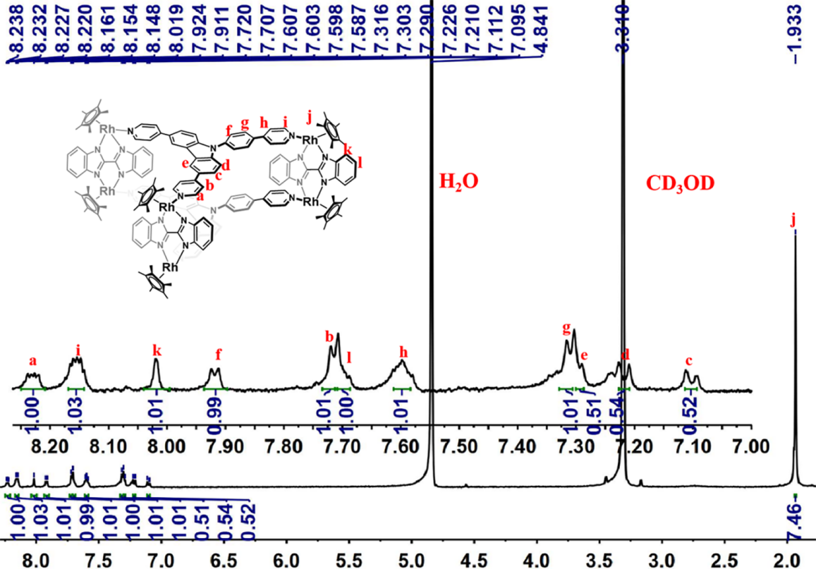
Supplementary Figure 17. The ¹H NMR (500 MHz, CD₃OD, ppm) for Hexanuclear cage 8 (20.5 mM, with respect to Cp*Rh).

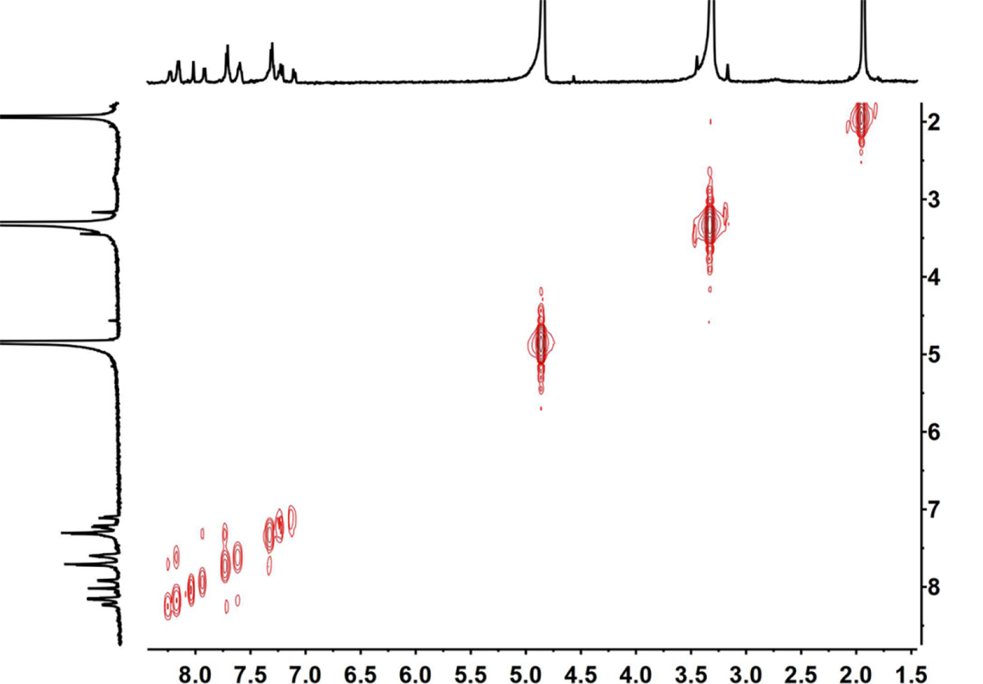
Supplementary Figure 18. The ¹H-¹H COSY NMR (500 MHz, CD₃OD, ppm) for Hexanuclear cage 8 (20.5 mM, with respect to Cp*Rh).

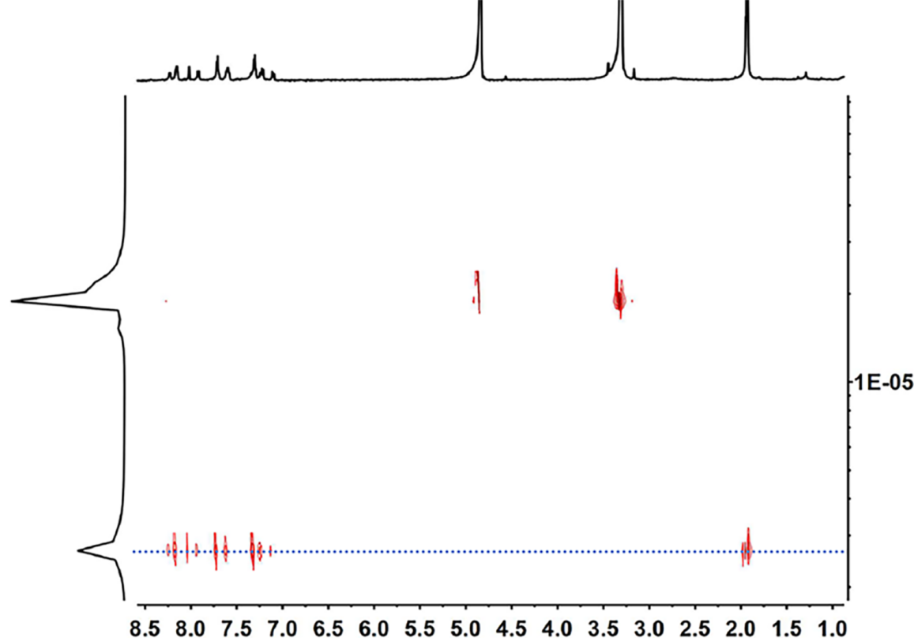
Supplementary Figure 19. The ¹H DOSY NMR (500 MHz, CD₃OD, ppm) for Hexanuclear cage 8 (2.69 × 10⁻⁶ cm²/s) (20.5 mM, with respect to Cp*Rh).

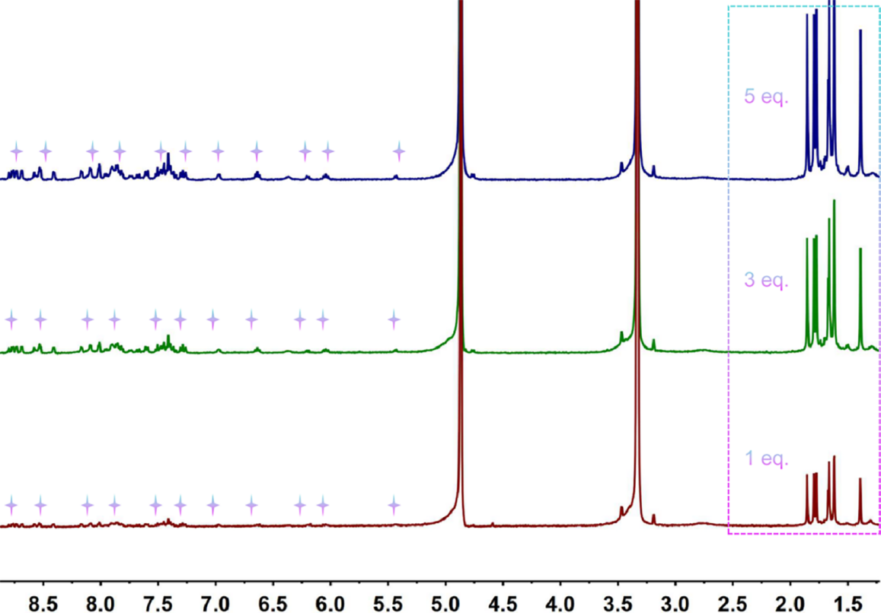
Supplementary Figure 20. ¹H NMR spectrum (500 MHz, CD₃OD, ppm) of showing stability in Interlocked cage 6 upon increasing of compounds from 1 eq. to 5 eq. (25.0 mM, with respect to Cp*Rh).

- Near-infrared photothermal conversion research
Experimental details
To guarantee same amount of conjugated-π area, the applied molar ratio of the three topologies 5 / 6 / 7 was 1 : 1 : 1. Compound 5 (14.01 mg, 0.0019 mmol)，Compound 6 (14.31 mg, 0.0019 mmol) and Compound 7 (15.81 mg, 0.0019 mmol) were added into a solvent of CH₃OH (5ml). After the solid dissolved absolutely, 3.0 ml of this solution was taken into quartz spectrophotometer cell (1 × 1 × 5 cm) to measure its absorbance and put into the bright spot of a laser with 730 nm wavelength at different current intensities. Temperature variation of the solution was detected by an infrared camera.
The methanol solution in each contained complex 5, 6, 7, were put a 0.7 ml sample vessel. And then, they were put under a laser and temperature variation were detected by a same infrared camera. Equations used to calculate near-infrared photothermal conversion efficiency were exhibited as follows:
η = hS(ΔT_{sample}–ΔT_{solvent}) / I(1-10^{-A}) (1)
hS = ∑mC_{p}/τ_{s} (2)
τ_{s} = -t/lnθ (3)
θ = (T_{amb}–T)/(T_{amb}–T_{max})(4)
Thereinto, C_{p} = 2.51 KJ/(Kg·K), ΔT_{solvent} = 2.2 ℃. I = 0.6 W/cm², h is the heat transfer coefficient and S is the surface area of the container. τ_{s} is the sample system time constant, m is the mass of the products,Thus, ∑mC_{p} = m _{(methanol)} C_{p(methanol)} = ρ_{(methanol)} V_{(methanol)} C_{p(methanol)} = 0.791×0.7×2.51 = 1.3898 J·K⁻¹.
ΔT_{solvent} = 2.2 ℃. where I is the laser power and A₇₃₀ is the absorbance of the samples at the wavelength of 730 nm.
Strictly speaking, volume of mixed solvent was not simple addition of two component. However, the deviation was small enough to ignore it.

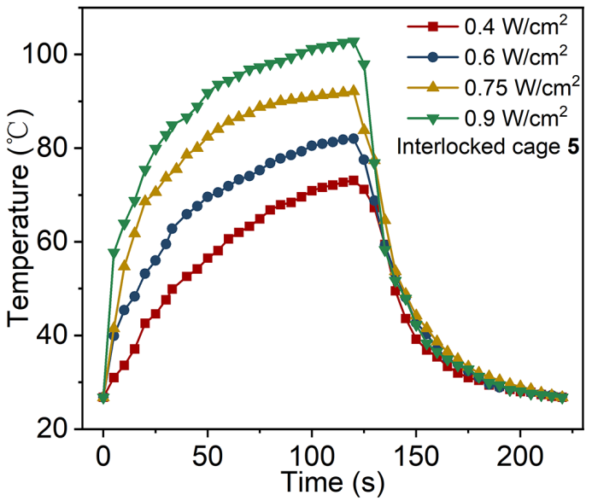
Supplementary Figure 21. NIR photothermal conversion curves of Interlocked cage 5 (solid)

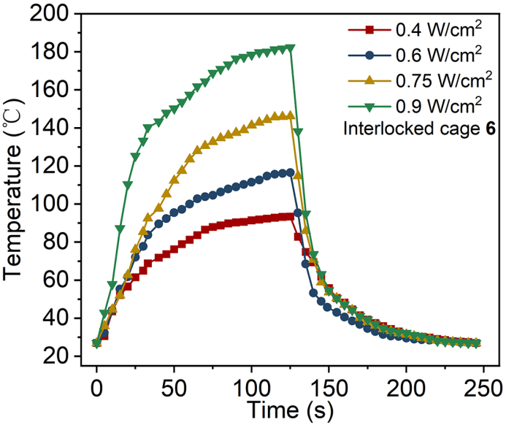
Supplementary Figure 22. NIR photothermal conversion curves of Interlocked cage 6 (solid)

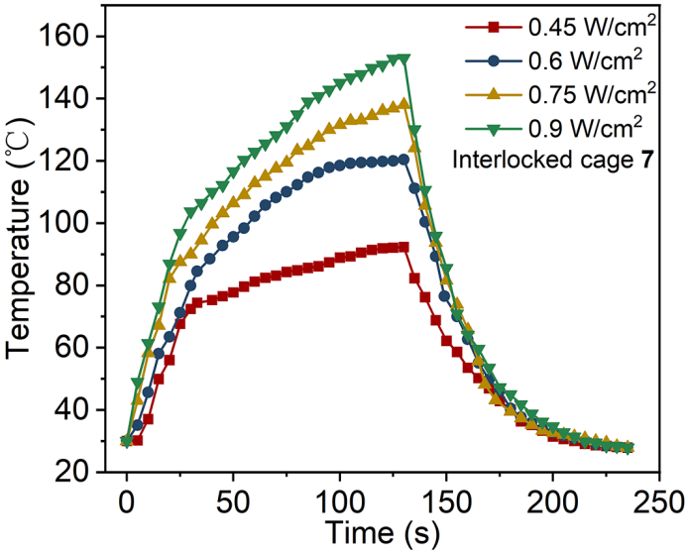
Supplementary Figure 23. NIR photothermal conversion curves of Interlocked cage 7 (solid)
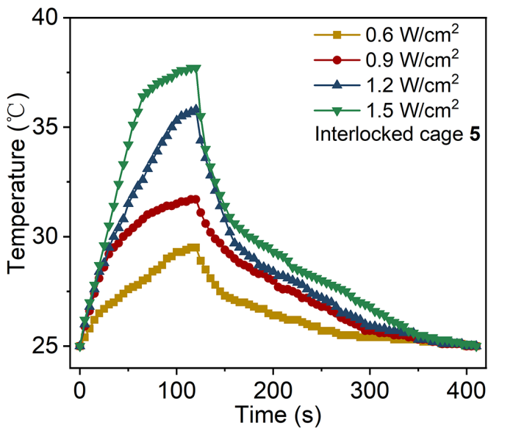
Supplementary Figure 24. NIR photothermal conversion curves of Interlocked cage 5 (in CH₃OH)

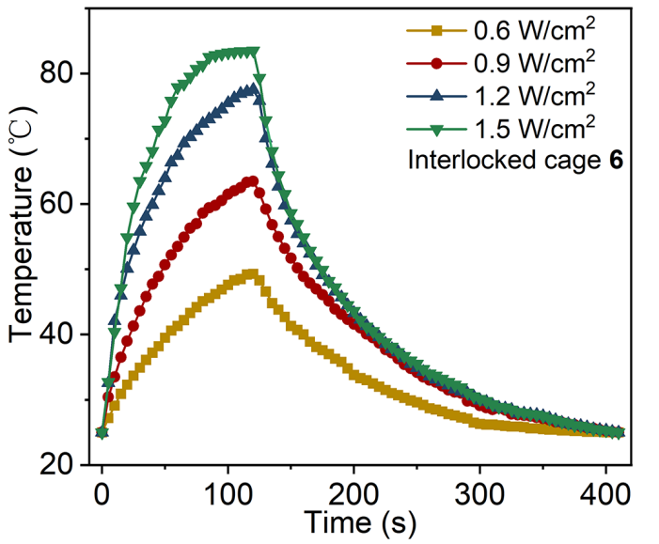
Supplementary Figure 25. NIR photothermal conversion curves of Interlocked cage 6 (in CH₃OH)

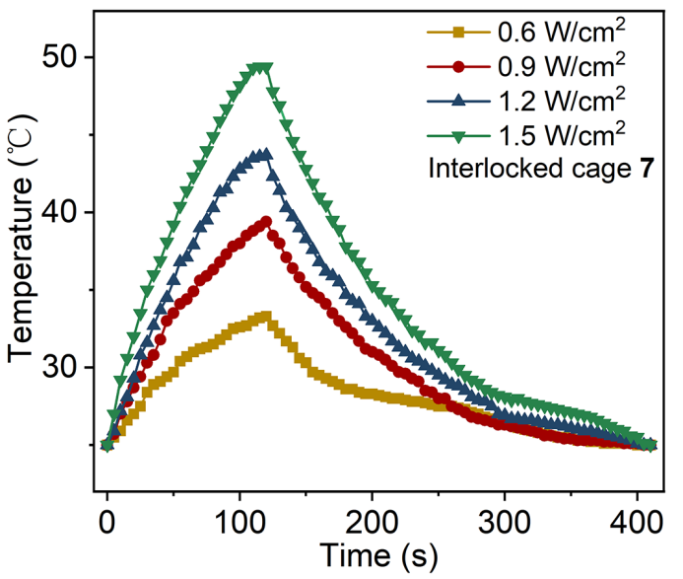
Supplementary Figure 26. NIR photothermal conversion curves of Interlocked cage 7 (in CH₃OH)

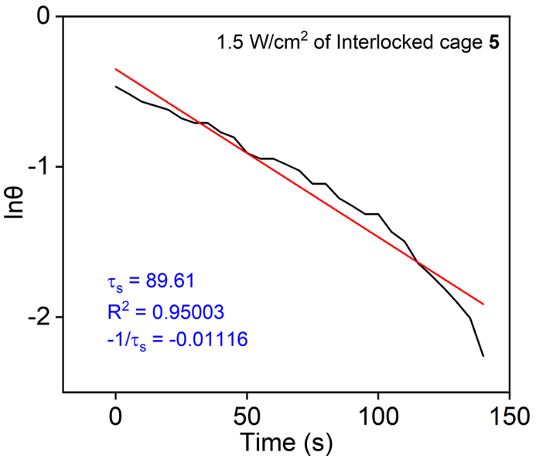
Supplementary Figure 27. Fitting linear of lnθ-t of 1.5 W/cm² of Interlocked cage 5 in methanol.
Near-infrared photothermal conversion efficiency η of 5 of 1.5 W/cm² was calculated by equations above. A fitting linear of lnθ-t was obtained by Eqs (3) and (4), by which τ_{s} was calculated as 89.61 s. Thus, hS = 1.3898/89.61 = 1.55 × 10⁻² J·K⁻¹·S⁻¹. ΔT_{sample} = 12.7 ℃ (37.7 - 25). A₅ = 0.336 (Fig. 4d in main text). η₅ = 1.55 × 10⁻² × (12.7 – 2.2)/[1.5 × (1 – 10^{-0.336})] = 20.1 %.

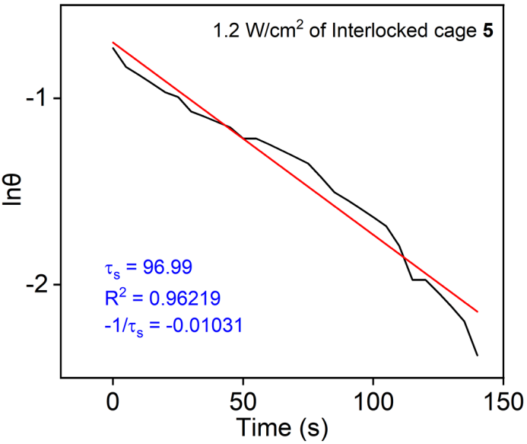
Supplementary Figure 28. Fitting linear of lnθ-t of 1.2 W/cm² of Interlocked cage 5 in methanol.
Near-infrared photothermal conversion efficiency η of 5 of 1.2 W/cm² was calculated by equations above. A fitting linear of lnθ-t was obtained by Eqs (3) and (4), by which τ_{s} was calculated as 96.99 s. Thus, hS = 1.3898/96.99 = 1.43 × 10⁻² J·K⁻¹·S⁻¹. ΔT_{sample} = 10.8 ℃ (35.8 - 25). A₅ = 0.336 (Fig. 4d in main text). η₅ = 1.43 × 10⁻² × (10.8 – 2.2)/[1.2 × (1 – 10^{-0.336})] = 19.0%.

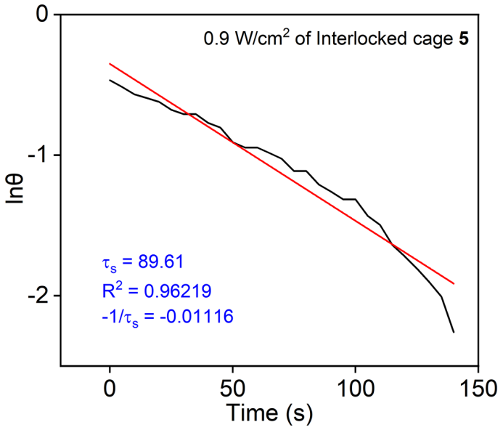
Supplementary Figure 29. Fitting linear of lnθ-t of 0.9 W/cm² of Interlocked cage 5 in methanol.
Near-infrared photothermal conversion efficiency η of 5 of 0.9 W/cm² was calculated by equations above. A fitting linear of lnθ-t was obtained by Eqs (3) and (4), by which τ_{s} was calculated as 89.61 s. Thus, hS = 1.3898/89.61 = 1.55 × 10⁻² J·K⁻¹·S⁻¹. ΔT_{sample} = 6.7 ℃ (31.7 - 25). A₅ = 0.336 (Fig. 4d in main text). η₅ = 1.55 × 10⁻² × (6.7 – 2.2)/[0.9 × (1 – 10^{-0.336})] = 14.3 %.

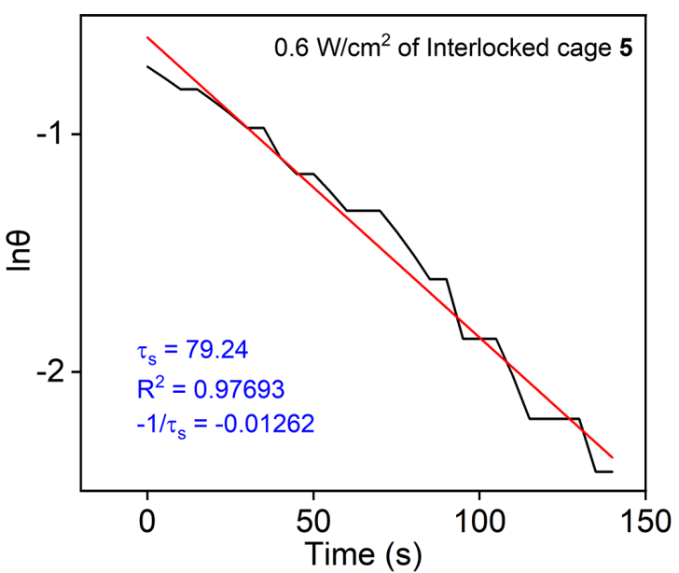
Supplementary Figure 30. Fitting linear of lnθ-t of 0.6 W/cm² of Interlocked cage 5 in methanol.
Near-infrared photothermal conversion efficiency η of 5 of 0.6 W/cm² was calculated by equations above. A fitting linear of lnθ-t was obtained by Eqs (3) and (4), by which τ_{s} was calculated as 79.24 s. Thus, hS = 1.3898/79.24 = 1.75 × 10⁻² J·K⁻¹·S⁻¹. ΔT_{sample} = 4.5 ℃ (29.5 - 25). A₅ = 0.336 (Fig. 4d in main text). η₅ = 1.75 × 10⁻² × (4.5– 2.2)/[0.6 × (1 – 10^{-0.336})] = 12.4 %.

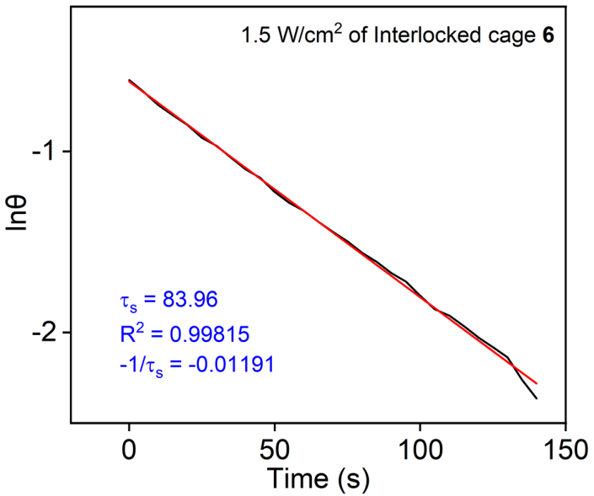
Supplementary Figure 31. Fitting linear of lnθ-t of 1.5 W/cm² of Interlocked cage 6 in methanol.
Near-infrared photothermal conversion efficiency η of 6 of 1.5 W/cm² was calculated by equations above. A fitting linear of lnθ-t was obtained by Eqs (3) and (4), by which τ_{s} was calculated as 89.36 s. Thus, hS = 1.3898/89.36 = 1.55 × 10⁻² J·K⁻¹·S⁻¹. ΔT_{sample} = 55℃ (80 - 25). A₆ = 0.843(Fig. 4d in main text). η₆ = 1.22 × 10⁻² × (55 – 2.2)/[1.5 × (1 – 10^{-0.843})] = 63.9 %.

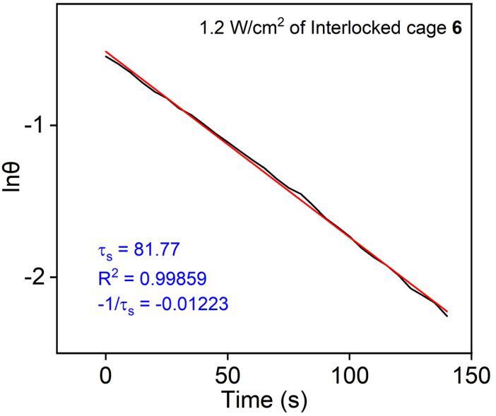
Supplementary Figure 32. Fitting linear of lnθ-t of 1.2 W/cm² of Interlocked cage 6 in methanol.
Near-infrared photothermal conversion efficiency η of 6 of 1.2 W/cm² was calculated by equations above. A fitting linear of lnθ-t was obtained by Eqs (3) and (4), by which τ_{s} was calculated as 81.77 s. Thus, hS = 1.3898/81.77 = 1.69 × 10⁻² J·K⁻¹·S⁻¹. ΔT_{sample} = 49 ℃ (74- 25). A₆ = 0.843 (Fig. 4d in main text). η₆ = 1.69 × 10⁻² × (49 – 2.2)/[1.2 × (1 – 10^{-0.843})] = 77.3 %.

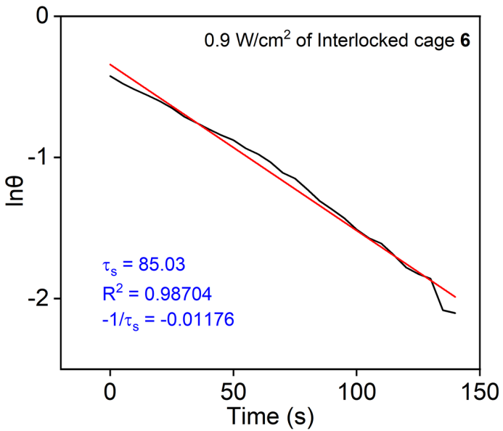
Supplementary Figure 33. Fitting linear of lnθ-t of 0.9 W/cm² of Interlocked cage 6 in methanol.
Near-infrared photothermal conversion efficiency η of 6 of 0.9 W/cm² was calculated by equations above. A fitting linear of lnθ-t was obtained by Eqs (3) and (4), by which τ_{s} was calculated as 85.03 s. Thus, hS = 1.3898/85.03 = 1.82 × 10⁻² J·K⁻¹·S⁻¹. ΔT_{sample} = 35 ℃ (60 - 25). A₆ = 0.843 (Fig. 4d in main text). η₆ = 1.82 × 10⁻² × (35 – 2.2)/[0.9 × (1 – 10^{-0.843})] = 69.5 %.

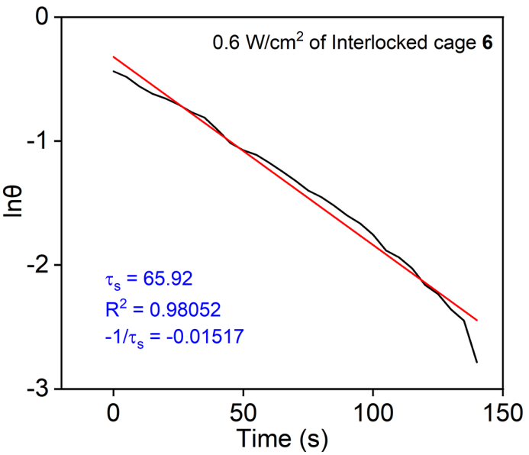
Supplementary Figure 34. Fitting linear of lnθ-t of 0.6 W/cm² of Interlocked cage 6 in methanol.
Near-infrared photothermal conversion efficiency η of 6 of 0.6 W/cm² was calculated by equations above. A fitting linear of lnθ-t was obtained by Eqs (3) and (4), by which τ_{s} was calculated as 65.92 s. Thus, hS = 1.3898/65.92 = 2.11 × 10⁻² J·K⁻¹·S⁻¹. ΔT_{sample} = 20.8 ℃ (45.8 - 25). A₆ = 0.843 (Fig. 4d in main text). η₆ = 2.11 × 10⁻² × (20.8 – 2.2)/[0.6 × (1 – 10^{-0.843})] = 76.3%.

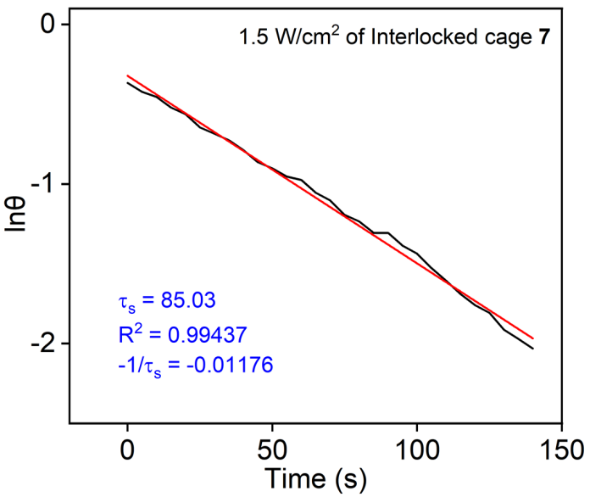
Supplementary Figure 35. Fitting linear of lnθ-t of 1.5 W/cm² of Interlocked cage 7 in methanol.
Near-infrared photothermal conversion efficiency η of 7 of 1.5 W/cm² was calculated by equations above. A fitting linear of lnθ-t was obtained by Eqs (3) and (4), by which τ_{s} was calculated as 85.03 s. Thus, hS = 1.3898/85.03 = 1.63 × 10⁻² J·K⁻¹·S⁻¹. ΔT_{sample} = 24.4 ℃ (49.4 - 25). A₇ = 0.501 (Fig. 4d in main text). η₇ = 1.63 × 10⁻² × (24.4 – 2.2)/[1.5 × (1 – 10^{-0.503})] = 35.3 %.

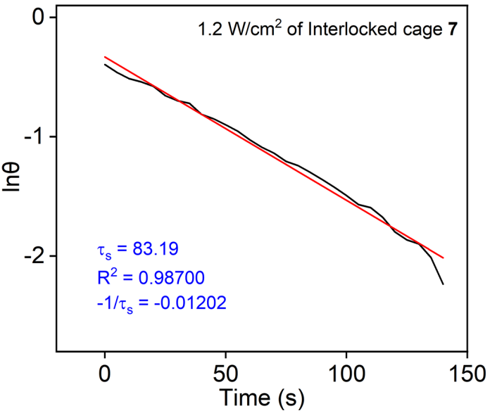
Supplementary Figure 36. Fitting linear of lnθ-t of 1.2 W/cm² of Interlocked cage 7 in methanol.
Near-infrared photothermal conversion efficiency η of 7 of 1.2 W/cm² was calculated by equations above. A fitting linear of lnθ-t was obtained by Eqs (3) and (4), by which τ_{s} was calculated as 83.19 s. Thus, hS = 1.3898/83.19 = 1.67 × 10⁻² J·K⁻¹·S⁻¹. ΔT_{sample} = 18.6℃ (43.6 - 25). A₇ = 0.501 (Fig. 4d in main text). η₇ = 1.67 × 10⁻² × (18.6 – 2.2)/[1.2 × (1 – 10^{-0.503})] = 33.3%.

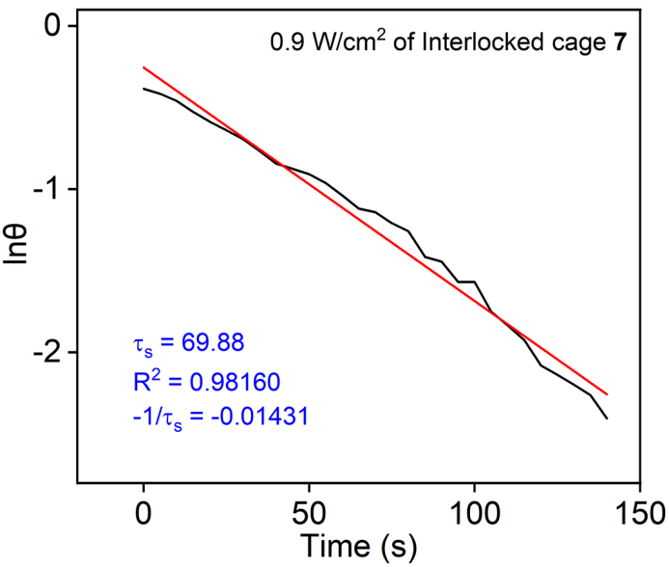
Supplementary Figure 37. Fitting linear of lnθ-t of 0.9 W/cm² of Interlocked cage 7 in methanol.
Near-infrared photothermal conversion efficiency η of 7 of 0.9 W/cm² was calculated by equations above. A fitting linear of lnθ-t was obtained by Eqs (3) and (4), by which τ_{s} was calculated as 69.88 s. Thus, hS = 1.3898/69.88 = 1.98 × 10⁻² J·K⁻¹·S⁻¹. ΔT_{sample} = 14.4 ℃ (39.4 - 25). A₇ = 0.501 (Fig. 4d in main text). η₇ = 1.98 × 10⁻² × (14.4 – 2.2)/[0.9 × (1 – 10^{-0.503})] = 39.3 %.

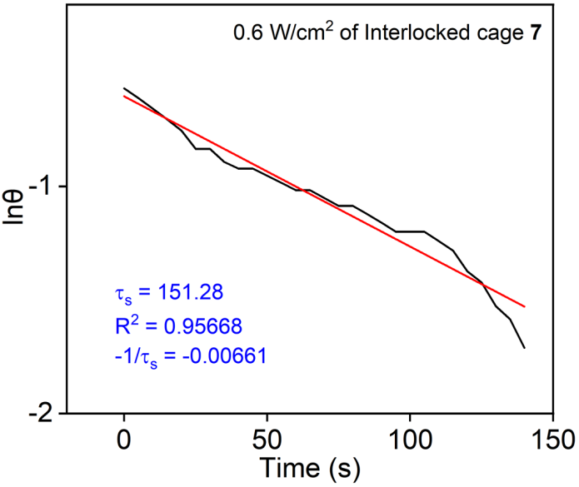
Supplementary Figure 38. Fitting linear of lnθ-t of 0.6 W/cm² of Interlocked cage 7 in methanol.
Near-infrared photothermal conversion efficiency η of 7 of 0.6 W/cm² was calculated by equations above. A fitting linear of lnθ-t was obtained by Eqs (3) and (4), by which τ_{s} was calculated as 151.28 s. Thus, hS = 1.3898/151.28 = 0.91 × 10⁻² J·K⁻¹·S⁻¹. ΔT_{sample} = 8.3 ℃ (33.3 - 25). A₇ = 0.501 (Fig. 4d in main text). η₇ = 0.91 × 10⁻² × (4.7 – 2.2)/[0.6 × (1 – 10^{-0.503})] = 13.6 %.

- Water contact test
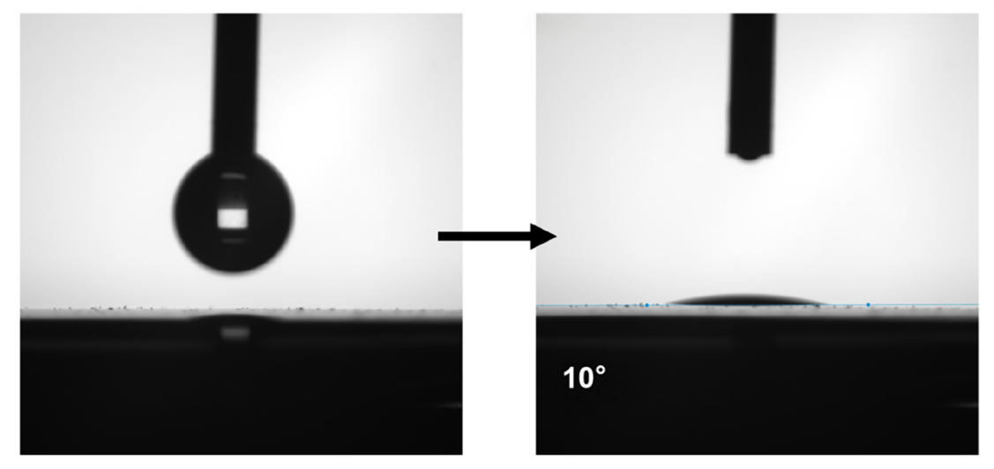
Supplementary Figure 39. Water contact of cellulose membrane.

- X-ray crystallography details
Single crystals of compounds 2, 3, 5 and 6, suitable for X-ray diffraction study were obtained at room temperature. X-ray intensity data of them were collected at 150 K on a CCD-Bruker SMART APEX system. In these data, the disordered solvent molecules which could not be restrained properly were removed using the PLATON Squeeze routine.
In asymmetric unit of compound 2, A solvent mask was calculated and 1323 electrons were found in a volume of 4535\%A^3^ in 1 void per unit cell. This is consistent with the presence of 9[CF₃SO₃] per formula unit which account for 1314 electrons per unit cell.
In asymmetric unit of compound 3, A solvent mask was calculated and 1288 electrons were found in a volume of 5624\%A^3^ in 1 void per unit cell. This is consistent with the presence of 4.5[CF₃SO₃] per formula unit which account for 1314 electrons per unit cell.
In asymmetric unit of compound 5, A solvent mask was calculated and 3320 electrons were found in a volume of 10938\%A^3^ in 3 voids per unit cell. This is consistent with the presence of 11.5[CF₃SO₃], 0.25[CF₃SO₃] per formula unit which account for 3431 electrons per unit cell.

Table 1 Crystal data and structure refinement for 2.
Identification code | P-1
Empirical formula | C₂₁₆H₁₉₆O₄₀N₁₂F₂₄S₈Rh₈
Formula weight | 5135.67
Temperature/K | 150.00
Crystal system | triclinic
Space group | P-1
a/Å | 15.1059(5)
b/Å | 22.4303(9)
c/Å | 37.6847(13)
α/° | 75.117(2)
β/° | 87.804(2)
γ/° | 71.666(2)
Volume/Å³ | 11701.4(7)
Z | 4
ρ_{calc}g/cm³ | 1.500
μ/mm⁻¹ | 6.005
F(000) | 5346.0
Crystal size/mm³ | 0.15 × 0.15 × 0.15
Radiation | GaKα (λ = 1.54178)
Index ranges | -14≤ h ≤ 15, -22 ≤ k ≤ 22, -37 ≤ l ≤ 27
2Θ range for data collection/° | 2.177 to 50.483
Reflections collected | 126441
Independent reflections | 24438 [R_{int} = 0.0853, R_{sigma} = 0.107]
Data/restraints/parameters | 24438/3273/2042
Goodness-of-fit on F² | 1.031
Final R indexes [I>=2σ (I)] | R₁ = 0.0922, wR₂ = 0.1913
Final R indexes [all data] | R₁ = 0.1230, wR₂ = 0.2036
Largest diff. peak/hole / e Å⁻³ | 1.571/-1.671
CCDC number | 2400896

Table 2 Crystal data and structure refinement for 3.
Identification code | P21/n
Empirical formula | C₂₀₀H₁₈₀O₂₄N₁₂Br₈F₂₄S₈
Formula weight | 5130.62
Temperature/K | 150.00
Crystal system | monoclinic
Space group | P21/n
a/Å | 19.9240(8)
b/Å | 27.1078(10)
c/Å | 25.9815(9)
α/° | 90
β/° | 104.644(2)
γ/° | 90
Volume/Å³ | 13576.7(9)
Z | 4
ρ_{calc}g/cm³ | 1.508
μ/mm⁻¹ | 6.875
F(000) | 6120.0
Crystal size/mm³ | 0.15 × 0.15 × 0.15
Radiation | GaKα (λ = 1.54178)
Index ranges | -23 ≤ h ≤ 22, -28 ≤ k ≤ 32, -29 ≤ l ≤ 31
2Θ range for data collection/° | 2.813 to 67.559
Reflections collected | 102917
Independent reflections | 24007 [R_{int} = 0.1354, R_{sigma} = 0.147]
Data/restraints/parameters | 24007/1684/1071
Goodness-of-fit on F² | 1.0085
Final R indexes [I>=2σ (I)] | R₁ = 0.1387, wR₂ = 0.2606
Final R indexes [all data] | R₁ = 0.2351, wR₂ = 0.3148
Largest diff. peak/hole / e Å⁻³ | 1.795/-0.955
CCDC number | 2400898

Table 3 Crystal data and structure refinement for 5.
Identification code | P21/n
Empirical formula | C₃₀₀H₂₈₀O₆₀N₁₆F₃₆S₁₂Rh₁₂
Formula weight | 7373.12
Temperature/K | 150.00
Crystal system | monoclinic
Space group | P21/n
a/Å | 30.2830(10)
b/Å | 32.1268(12)
c/Å | 36.5647(14)
α/° | 90
β/° | 94.511(2)
γ/° | 90
Volume/Å³ | 35463(2)
Z | 4
ρ_{calc}g/cm³ | 1.568
μ/mm⁻¹ | 6.342
F(000) | 16882
Crystal size/mm³ | 0.15 × 0.15 × 0.15
Radiation | GaKα (λ = 1.54178)
Index ranges | -30 ≤ h ≤ 33, -34 ≤ k ≤ 35, -40≤ l ≤ 40
2Θ range for data collection/° | 1.825 to 59.256
Reflections collected | 21206
Independent reflections | 51070 [R_{int} = 0.1864, R_{sigma} = 0.103]
Data/restraints/parameters | 51070/6161/3409
Goodness-of-fit on F² | 1.094
Final R indexes [I>=2σ (I)] | R₁ = 0.1055, wR₂ = 0.2223
Final R indexes [all data] | R₁ = 0.1899, wR₂ = 0.2598
Largest diff. peak/hole / e Å⁻³ | 1.501/-1.206
CCDC number | 2400897

Table 4 Crystal data and structure refinement for 6.
Identification code | P21/c
Empirical formula | C₃₁₂H₂₉₂O₆₀N₁₆F₃₆S₁₂Rh₁₂
Formula weight | 7529.35
Temperature/K | 150.00
Crystal system | monoclinic
Space group | P21/c
a/Å | 29.175(3)
b/Å | 26.200(2)
c/Å | 28.400(2)
α/° | 90
β/° | 113.682(4)
γ/° | 90
Volume/Å³ | 19881(3)
Z | 4
ρ_{calc}g/cm³ | 0.983
μ/mm⁻¹ | 64.285
F(000) | 6016
Crystal size/mm³ | 0.154 × 0.1 × 0.1
Radiation | GaKα (λ = 1.54178)
Index ranges | -29 ≤ h ≤ 25, -26 ≤ k ≤ 26, -26 ≤ l ≤ 28
2Θ range for data collection/° | 2.362 to 51.089
Reflections collected | 83179
Independent reflections | 21140 [R_{int} = 0.1180, R_{sigma} = 0.082]
Data/restraints/parameters | 21140/2536/1351
Goodness-of-fit on F² | 1.109
Final R indexes [I>=2σ (I)] | R₁ = 0.1778, wR₂ = 0.3968
Final R indexes [all data] | R₁ = 0.2771, wR₂ = 0.4505
Largest diff. peak/hole / e Å⁻³ | 0.800/-0.492
CCDC number | 2400895

- References
- C. White, A. Yates and P. M. Maitlis, η5 -Pentamethylcyclopentadienyl) rhodium and -iridium compounds. Inorg. Synth., 1992, 29, 228-234.
- T. Wu, L. H. Weng and G. X. Jin, Sunlight induced cycloaddition and host–guest property of self-assembled organometallic macrocycles based on a versatile building block. Chem. Comm., 2012, 48, 4435-4437

