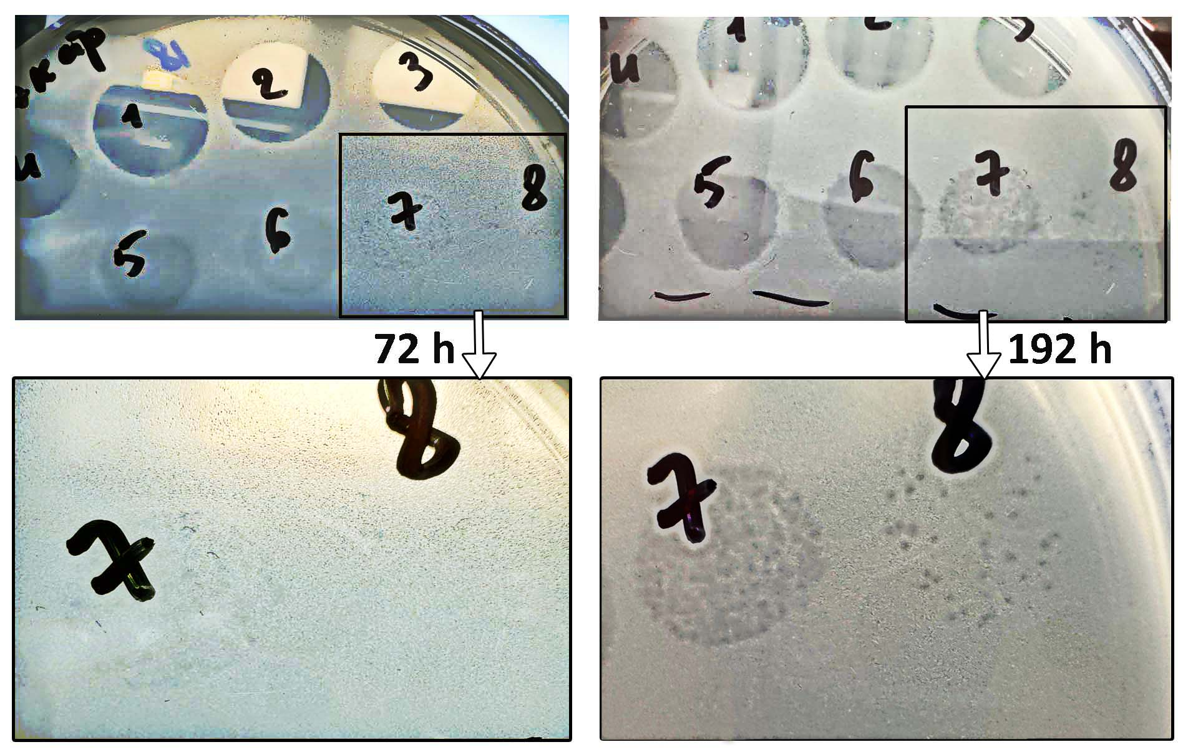
Supplementary Fig. S1 Gradual appearance of visible plaques over eight days. The figure shows a lawn of Pseudomonas fluorescens cells, on which a series of tenfold dilutions of the PfAn1 bacteriophage strain was applied. It can be seen that small plaques form gradually over several days.

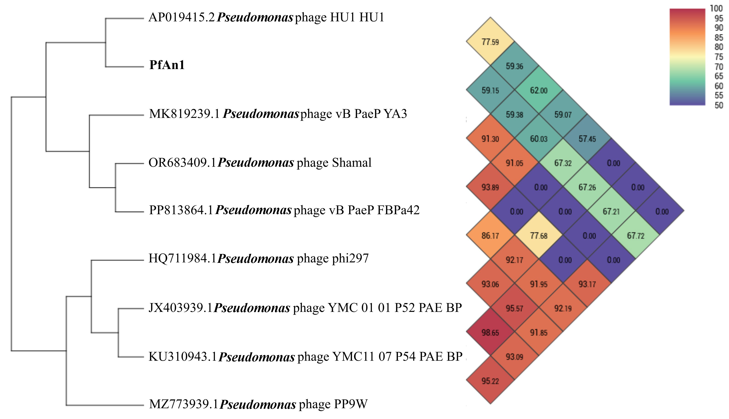
Supplementary Fig. S2 Heatmap and dendrogram based on the closest relatives identified using OrthoANIu among 1375 Pseudomonas phages. OrthoANI was calculated with OAT v.0.93.1. Bacteriophage PfAn1 formed a cluster with lytic cold-active phage HU1 infecting P. lactis. Other phage infect P. aeruginosa and, like bacteriophage HU1, belong to unclassified Caudoviricetes.
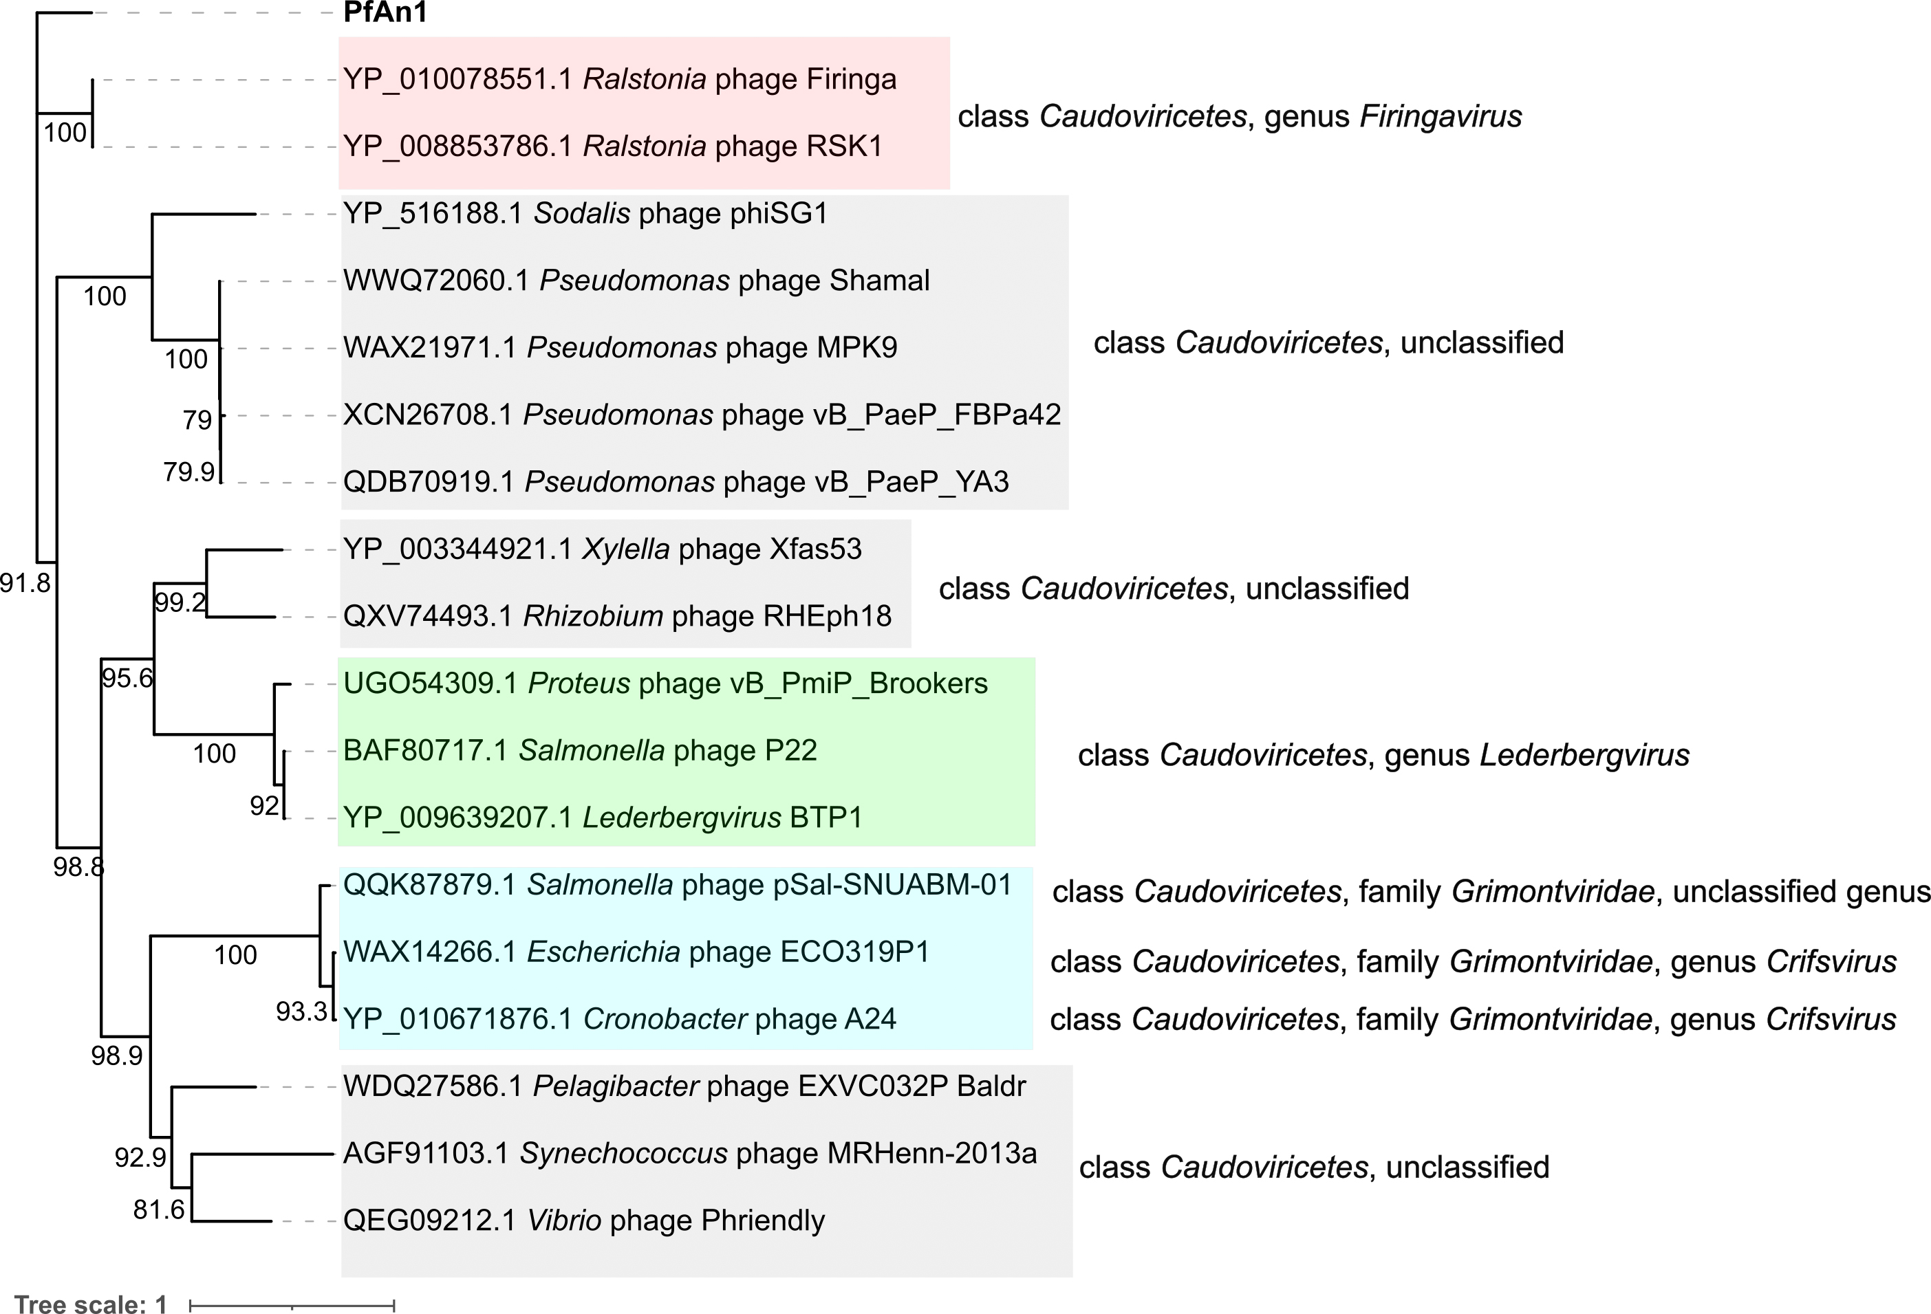
Supplementary Fig. S3 Phylogenetic tree analysis of the terminase large subunit of phage PfAn1. The amino acid sequences of the terminase large subunits were compared using the IQ-Tree in the analysis. Best model - LG+I+G4. In the terminase large subunit-based tree, it was most closely related to phages Firinga and RKS1 belonging to the genus Firingavirus. Unclassified Pseudomonas phages and P22-like bacteriophages also appeared to be closely related phages.
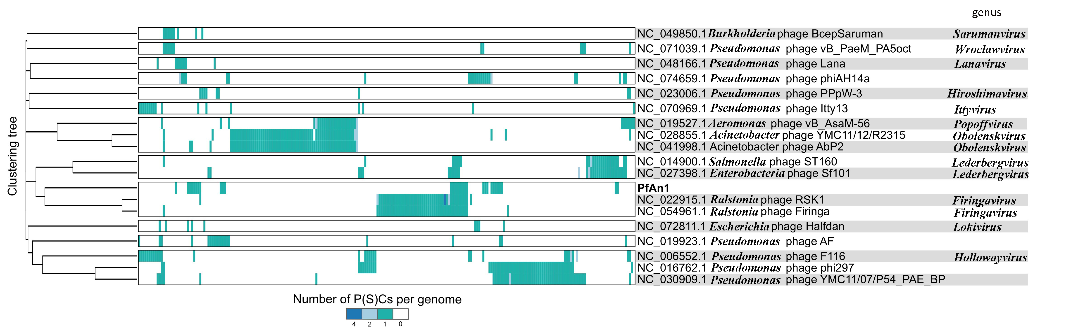
Supplementary Fig. S4. Integrated visualization of the viral clustering output of VirClust. A dataset composed of viral genomes deposited in RefSeq226 and similar in some proteins or a set of proteins to phage PfAn1. At the first level, proteins are grouped based on their reciprocal BLASTP similarities into protein clusters, or PCs. At the second level, PCs are grouped based on their Hidden Markov Model (HMM) similarities into protein superclusters, or PSCs. Heatmap representation of the protein cluster distribution in the viral genomes. Rows represent the individual viral genomes. Columns represent the individual protein clusters. Colors encode the number of each PC per genome, with white signifying the PC absence, and the other colors signifying various degrees of replication. Hierarchical tree calculated using the protein cluster-based intergenomic distances.

