Dear editor and reviewers,
Greetings!
We would like to submit the revised manuscript entitled “Synthesis and Applications of Polymorphic CeO₂ and AgI/CeO₂ Nanocomposites (IJME-D-24-00338)” to you for a further review and publication in the journal(Journal of Materials Science: Materials in Engineering). Based on the reviewers’ comments, we have made revisions in a point-to-point manner (see below for details). We hope you will find that the revised manuscript now meets the standards of the journal. (We have set the font color of valuable suggestions you made to blue.Additionally, the contents of the first revision have been highlighted in yellow within the manuscript, and the contents of the second revision have been highlighted in blue.)
Synthesis and Applications of Polymorphic CeO₂ and AgI/CeO₂ Nanocomposites
The presented manuscript is again submitted for review after the authors have responded to the comments. Unfortunately, the authors did not take into account the reviewer's comments. It is true that in the cover letter they respond to individual reviewers' comments, and although they declare changes in the manuscript, they are not introduced.
Response: Thank you for your valuable suggestion on our manuscript, We made the peer-to-peer changes as you suggested, and hope you can accept it.
1、There is still inconsistency in the naming of synthesized nanocomposites. In subsection Synthesis of flower-like CeO₂/AgI composites the samples are named as: e.g. 20%-CeO₂/AgI while in chapter Photocatalytic performance analysis they are given as e.g. 20%-AgI/CeO₂. Changing the names of described samples introduces unnecessary chaos.
Response: Thank you for your comment. We have harmonized the original text with the name AgI/CeO₂.
2、The XRD figures have not been enlarged so are still difficult to verify.
Response: Thank you for this valuable feedback. We zoomed in on the XRD graphs.
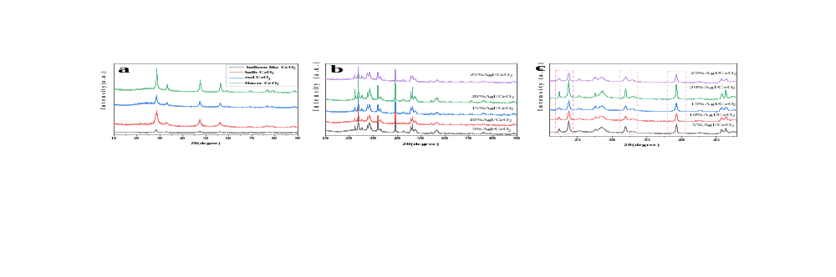
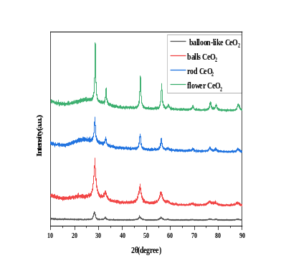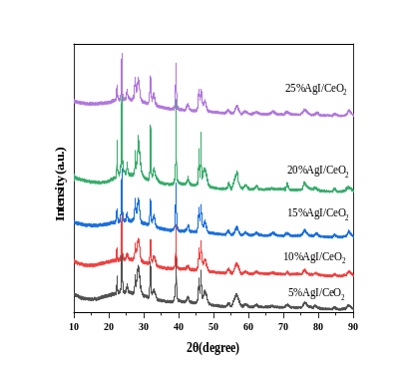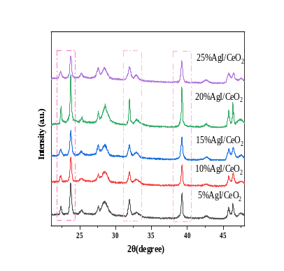
3、In subsection UV-vis characterisation the authors mark the energy gap of the phases obtained by the Kubelka-Munk method. Unfortunately, the entire manuscript does not contain a description of the method. Should the reader guess? In this chapter the authors have included Figure 6, which consists of two parts a and b. The description provided concerns only Figure 6a, part b is omitted. Figure 6b also requires a comment.
Response: Thank you for your valuable suggestions. We have reworked this section.
Based on the UV diffuse reflectance test results, the energy band positions of AgI, CeO₂ and AgI/CeO₂ nanocomposite catalysts can be calculated by the following equations:
$E_{CB}=χ−Ee−0.5Eg$(2)$$E_{VB}=E_{CB}+Eg (3)$$
Where: X is the absolute electronegativity of the semiconductor, Ee is the energy of the free electrons in the hydrogen atom, and Eg the band gap of the semiconductor. E_{VB} is valence band energy, E_{CB} is conduction band energy. As shown in Figure 6 b. The CeO₂ and AgI values were calculated to be 3.12 eV and 1.52 eV respectively, the AgI/CeO₂ nanocomposite catalyst has a band gap of 2.88 eV, which is significantly smaller than the band gap width of CeO₂ alone. AgI/CeO₂ has more photocatalytic activity.
4、The paragraph in the Discussion section has not been corrected yet. In this chapter it is written: "Ag nanoparticles were successfully deposited on the surface and in the pores of CeO₂ nanoflowers using the silver-ammonia-assisted method". From the previously described synthesis it does not follow that the tested catalysts were obtained using metallic silver! Also in this paragraph in sentence Agi/CeO₂ nanocomposite catalysts were successfully prepared should be AgI/CeO₂ nanocomposite catalysts were successfully prepared.
Response: Thank you for this valuable feedback. We deleted the sentence you mentioned. We apologize for this avoidable error, we have changed this detail and again we are deeply sorry.
Thank you very much for your consideration. According to your valuable suggestions, we have made targeted amendments to the article. We look forward to your favorable decision.

Yours sincerely,
Yuguang Lv
yuguanglv@163.com

