Table S1: X-ray crystallographic statistics for co structures between C. albicans Yck2 and 1e, 1f, 2a and 2b
Structure | Yck2 + 1e | Yck2 + 1f | Yck2 + 2a | Yck2 + 2b
PDB code | 9EDV | 9EDW | 9EDX | 9EDY
Data collection
Space group | R 3 | R 3 | R 3 | R 3
Cell dimensions  a, b, c (Å)  α, β, γ, (°) | 91.99, 91.99, 117.96  90, 90, 120 | 92.18, 92.18, 118.2  90, 90, 120 | 91.71, 91.71, 118.95  90, 90, 120 | 91.49, 91.49, 119.17  90, 90, 120
Resolution, Å | 29.18 – 2.42 | 66.14 – 2.33 | 29.11 – 2.03 | 47.64 – 2.30
R_{merge}ª | 0.065 (2.903)* | 0.094 (2.113) | 0.059 (2.138) | 0.117 (1.341)
R_{pim}^{b} | 0.032 (1.437)* | 0.050 (1.277) | 0.029 (1.044) | 0.090 (1.138)
CC_{1/2}* | 0.999 (0.374) | 0.980 (0.265) | 1.00 (0.439) | 0.988 (0.321)
I / σ(I) | 15,1 (0.7) | 8.0 (0.9) | 19.2 (1.0) | 5.3 (0.7)
Completeness, % | 99.9 (99.9) | 99.9 (100) | 100 (99.9) | 99.9 (99.2)
Redundancy | 14.7 (10.1) | 8.9 (7.4) | 10.2 (10.4) | 4.5 (3.3)
Refinement
Resolution, Å | 29.18 – 2.42 | 66.14 – 2.33 | 29.11 – 2.03 | 47.62 – 2.30
No. unique reflections: working, test | 14202, 625 | 15954, 822 | 24095, 1205 | 16481, 976
R_{work}/R_{free}^{c} | 23.9/29.4 (43.9/49.0) | 27.0/29.0 (43.2/44.5) | 21.7/23.9 (35.6/34.5) | 20.5/23.8 (34.1/37.0)
No. atoms  Protein  Inhibitor  Solvent  Water | 2469  24  1  0 | 2469  23  1  7 | 2469  24  2  77 | 2460  23  3  76
B-factors  Protein  Inhibitor  Solvent  Water | 119.1  102.9  106.0  N/A | 99.1  89.3  93.9  72.0 | 71.9  82.1  88.5  69.7 | 69.7  61.8  80.6  65.9
R.m.s. deviations  Bond lengths, Å  Bond angles, ° | 0.003  0.587 | 0.003  0.553 | 0.003  0.513 | 0.002  0.476
Ramachandran plot  Favored, %  Allowed, %  Outliers, % | 92.8  7.2  0 | 94.8  4.9  0.3 | 90.5  9.1  0.4 | 94.4  5.6  0
*All values in brackets refer to highest resolution shells.
ªR_{merge} = Σ_{hkl}Σ_{j}|I_{hkl.j}-I_{hkl}|/Σ_{hkl}Σ_{j}I_{hk,j}, where I_{hkl,j} and〈I_{hk,j}〉are the jth and mean measurement of the intensity of reflection j.
^{b}R_{pim} = Σ_{hkl}√(n/n-1) Σ^{n}_{j=1}|I_{hkl.j}-I_{hkl}|/Σ_{hkl}Σ_{j}I_{hk,j}
^{c}R = Σ|F_{p}^{obs} – F_{p}^{calc}|/ΣF_{p}^{obs}, where F_{p}^{obs} and F_{p}^{calc} are the observed and calculated structure factor amplitudes, respectively.

Table S2: Pharmacokinetic parameters of GW, 1e, 1f, 2a and 2b.

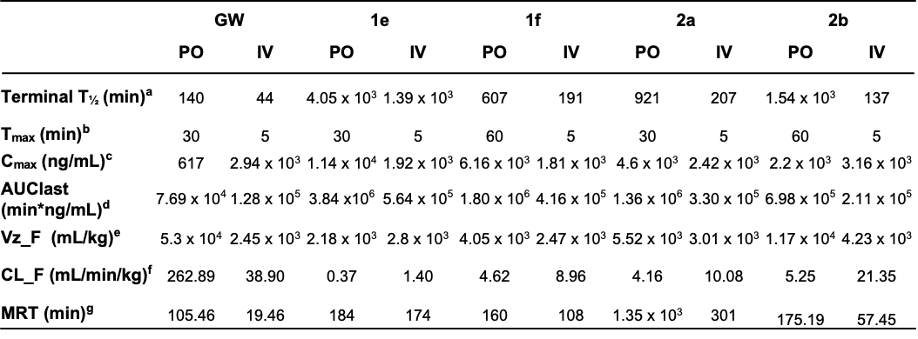
a Time required for the total concentration of molecule to be reduced in mouse plasma by one half. b Time required for drug to reach its maximal concentration. c Maximum drug concentration reached in the plasma. d Area under the time/plasma concentration curve representing total exposure to drug experienced by subjects at the end of the study. e Volume of drug distribution based on terminal elimination phase post-administration. f Total body clearance following administration. g Median residence time. Phoenix 64 WinNonlin 8.3.1.5014 was used to calculate PK parameters.

Table S3: Strains used in this study
Strain name | Strain ID | Species | Genotype | Source
CaSS1 | CaLC6106 | C. albicans | ura3::imm⁴³⁴/ura3::imm⁴³⁴ his3::hisG/his3::hisG leu2::tetR-GAL4AD- URA/LEU2 | ^{1,2}
CaSS1 tetO-YCK2/yck2∆ | GRACE YCK2 | C. albicans | As CaSS1 tetO-YCK2/yck2::HIS3 | ^{1,2}
DPL15 | CaLC990 | C. albicans | Clinical isolate, FKS1^{T1922C}/ FKS1^{T1922C} | ³
DPL15 Eno1-GFP | CaLC6194 | C. albicans | As DPL15 ENO1/ENO1-GFP-NAT | ^{3,4}
SC5314 | CaLC155 | C. albicans | Prototrophic | ⁵
pTEF1-GFP | CaLC8737 | C. albicans | SC5314 RPS10::pTEF1-GFP-SAT1/RPS10 | This paper

References
1. Roemer T, Jiang B, Davison J, et al. Large-scale essential gene identification in Candida albicans and applications to antifungal drug discovery. Mol Microbiol. 2003;50(1):167-181. doi:10.1046/j.1365-2958.2003.03697.x
2. Fu C, Zhang X, Veri AO, et al. Leveraging machine learning essentiality predictions and chemogenomic interactions to identify antifungal targets. Nat Commun. 2021;12(1):6497. doi:10.1038/s41467-021-26850-3
3. Singh SD, Robbins N, Zaas AK, Schell WA, Perfect JR, Cowen LE. Hsp90 governs echinocandin resistance in the pathogenic yeast Candida albicans via calcineurin. Mitchell AP, ed. PLoS Pathog. 2009;5(7):e1000532. doi:10.1371/journal.ppat.1000532
4. Caplan T, Lorente-Macías Á, Stogios PJ, et al. Overcoming fungal echinocandin resistance through inhibition of the non-essential stress kinase Yck2. Cell Chem Biol. 2020;27(3):269-282.e5. doi:10.1016/j.chembiol.2019.12.008
5. Jones T, Federspiel NA, Chibana H, et al. The diploid genome sequence of Candida albicans. Proc Natl Acad Sci U S A. 2004;101(19):7329-7334. doi:10.1073/pnas.0401648101

