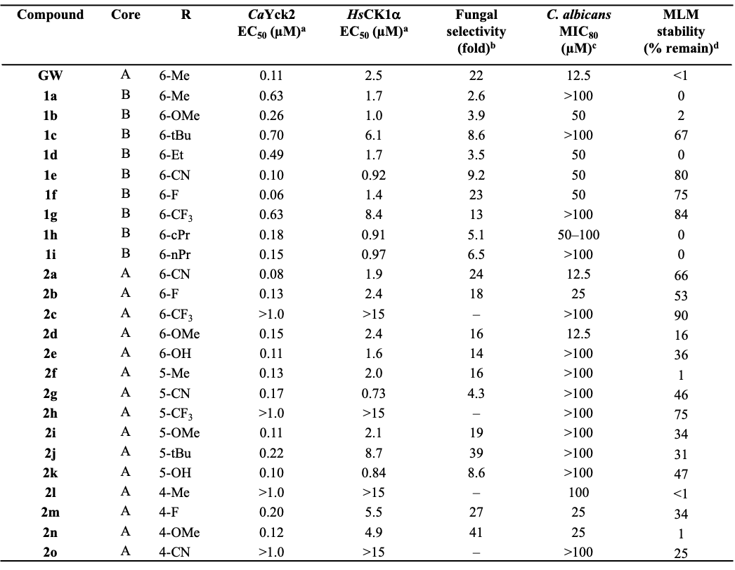
a Inhibition of kinase activity determined in two-fold dose-response assays.
^{b Ratio of HsCK1α IC}₅₀ ^{/ CaYck2 IC}₅₀.
c Inhibition of wild type C. albicans fungal growth.
d Compound remaining after 30 min incubation in mouse liver microsomes (MLM) determined by LC-TOFMS.
Core A
Core B
Table 1. Bioactivity and metabolic stability of GW analogs

