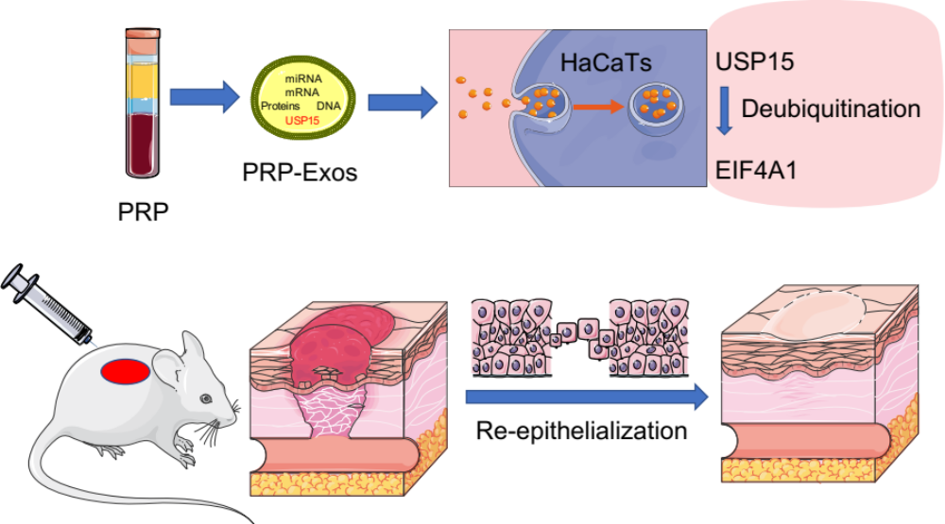
USP15 is one of main mRNA in PRP-Exos, which could be take into HaCaTs, subsequently deubiquitinating EIF4A1, then, accelerate re-epithelialization and promote wound healing.

